A RESEARCH REPORT FOR DATA CENTRE DESIGN

Programme: BSc (Hons) Cloud Computing
Module: Data Centre Technologies
Module code: ACUA6000
Lecturer: Koushik Modak
Student: Marin Zaharidov, 1814694
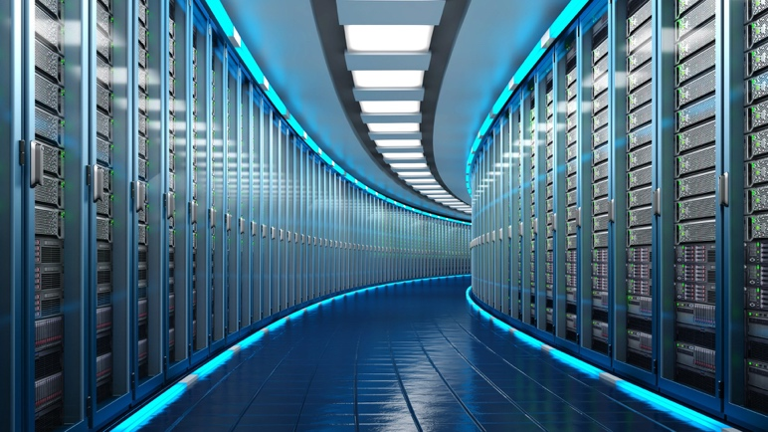
(Source [4])

Abstract— The present server farms have gotten exceptionally unpredictable and have totally incorporated themselves into each aspect of their addressed association. Associations require Internet confronting administrations and applications to be accessible at any piece of the day or night. These associations have understood that with concentrated processing and profoundly accessible parts, their mechanical presence with clients can be extraordinarily upgraded. The production of a framework supporting such high accessibility takes various parts and assets to work ideally. [1]
--------------------------------------------------------------------------------------------------------------------------------

I. INTRODUCTION

Many companies use central data centers to avoid building and maintaining separate data centers and are looking for and adopting new methods to improve data center energy efficiency. From large enterprises, market sharing companies, and even social media, the amount of data generated has increased in different aspects. Although the Internet has brought good news to the world with the connectivity and speed it provides, only with the help of data centers, thousands of gigabytes of data can still be generated and stored and can be quickly retrieved from anywhere.

The data center is indispensable, and more importantly, having an environmentally friendly and low-maintenance data center. [1]

II. BACKGROUND

The server farm is an industrialized construction of different scales, which can be prepared to meet the various requirements of workers and related organization equipment. There are various kinds of workers, for example, mail workers, game workers, application or data set workers, and web workers. A worker is a gadget or program that permits information to be shared or imparted over an organization through satellite or fiber optic link, which assists with empowering the worker to straightforwardly speak with different workers anyplace on the planet.

Since server farms assume a fundamental part in getting worldwide data, they need to work ideally. One of the necessities of these server farms is the requirement for steady and refined force supplies. The objective of the server farm is to be ready for action 24 hours every day. Another arrangement of prerequisites is identified with the actual necessities of the hardware stockpiling climate. These are the need, for instance, a very much planned environment control climate that controls temperature and dampness. The server farm should likewise think about the danger of misfortune from inside and outer components. This prompts the requirement for numerous degrees of safety to forestall calamitous occasions. Server farms need all around prepared work force to deal with these delicate gadgets, and reinforcements should be constantly gotten to forestall any information or administration misfortune. Server farms can be found anyplace on the planet and can be confided in 24 hours every day. Cautious administration of your necessities will assist with guaranteeing the nature of your administrations. [2]
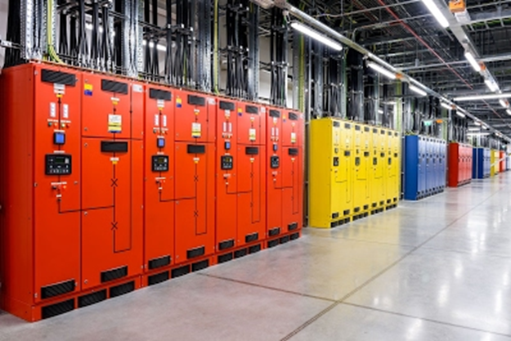Figure 1. Example of Data Center
(Source [4])

Why we need Data Centres?
With the developing interest for Internet-based organizations and the requirement for nonstop correspondence through email and a wide range of web-based media, server farms have arisen. These developing organizations and interpersonal interaction destinations should have the option to give nonstop Internet administrations to address the issues of buyers all throughout the planet. What follows is the need to store a ton of data to help your business measures. The server farm gives a protected off-site area to store a lot of data. As organizations incorporate more computerized or upgraded measures into their everyday tasks, the expanding interest for quick Internet associations, the craving for consistent business activities, and the expanding interest for extra room have prompted the development of these devoted offices with many workers. The entirety of this currently makes in any case difficult to reach markets open whenever, permitting them to grow and foster their business.[2]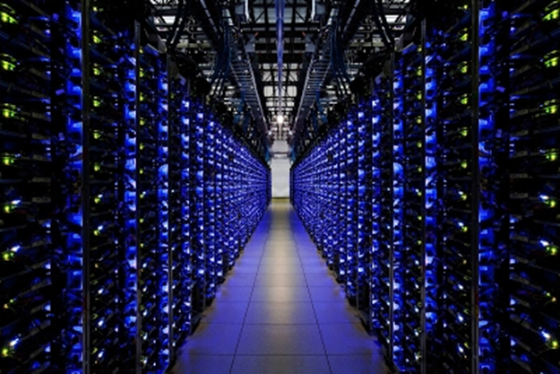
Figure 2. Example of Data Center (Source [5])

III. THE 4 Vs

The worth of the new information will come from the crossing point of rich information types. To acknowledge esteem, IT should incorporate and total this information such that leaders can use for examination to drive business improvement. The four Vs are:

- Volume, characterized as the complete number of bytes related with the information.

- Speed: Defined as the rate at which information is devoured. As the exchange volume expands, the worth of a solitary information point will in general decrease more rapidly over the long haul.

- Assortment: Defined as the intricacy of this sort of information.

- Inconstancy characterized as various methods of deciphering the information.

Another significant factor is the utilization of "green" advances to lessen energy utilization and further develop energy proficiency. In the realm of server farms, space, power utilization, security and equipment are cost boundaries to adding esteem, of which the greatest expense is the worker. [2]

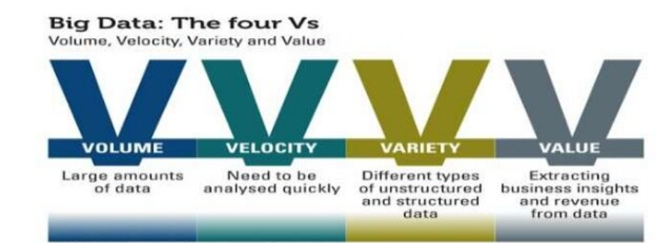
Figure 3. Definition 4 Vs
(Source [5])

IV. RESEARCH METHODOLOGY

Qualitative research methodologies are best for many thorough descriptions of educational processes and occurrences. Case studies, phenomenological studies, ethnographic studies, narrative studies, and mixed methods studies are all common qualitative designs. The approach is like a rigorous art, with the researcher serving as both instrument and analyzer, and the product is frequently a strong narrative in the form of a story. Grounded theory, which emphasizes the emergence of meaning hidden in data, is one significant approach for making sense of qualitative data.
In our situation, qualitative data analysis is required for Data Centre design, which is aided by software that are useful for activities such as coding, retrieval, sorting, and other sorts of pattern searching. [3]

V. DESIGN

Planning a cutting-edge server farm isn't just quite difficult for engineers, yet in addition an endeavor to anticipate what's to come. The server farm should give the assets to run the present status of the application, however it should likewise give extra potential to forthcoming undertakings and prerequisites.

- Not with standing energy productivity, power conveyance, and thickness, there are numerous different issues that should be considered in the server farm configuration measure. When planning server farms today, there are numerous advancements that can work on the effectiveness of server farm foundation gear, for example, cooling or force supplies.

- Uninterruptible Power supply (UPS) hardware is additionally a kind of gear with the possibility to further develop productivity, however notwithstanding workers, cooling hardware is yet the principal power purchaser. Effective equipment gear and tasks that permit thought of the unique conduct of the server farm can save energy, yet in addition assist with working on the warm steadiness of server farm activities. Server farm plan techniques and cycles are evolving quickly, and new advances keep on arising, particularly in server farm cooling. [3]

UPS gadgets produce a lot of warmth that should be shipped from the server farm, notwithstanding the workers. Fundamentally, as per the actual law of energy saving, the energy that enters the framework is equivalent to the energy that leaves the framework. On account of a server farm, this implies that the energy of the burned-through power is typically the type of warmth moved by hot air or water. [12]

Virtualization of the Data Centre

The virtualization was initially acquainted with work on the upkeep and adaptability of the worker. Virtualization permits administrators to relocate virtual machines to various workers ceaselessly the movement of execution administrations. The relocation permits the virtual exchange of the machine between workers inside a period of-administration idleness (in milliseconds) and a couple of moments of modest reach. Ongoing patterns have applied this idea to move whatever number virtual machines as could reasonably be expected to a solitary worker and that isn't as of now required and turn off "void" workers. This is by and large known as worker coordination and permits impressive energy reserve funds. [11]

HVAC (Heating, Ventilation, and Air Conditioning) systems

The refrigeration data center and the coolant of the server room must eliminate this heat from all devices on the server and data center. In this task, the cooling system requires considerable energy, but also needs an intelligent design option to avoid faults or heat problems.
If the data center is located at a place where the annual air temperature often falls below a threshold, you can use free cooling to provide the refrigeration of the data center and air conditioning. [3]

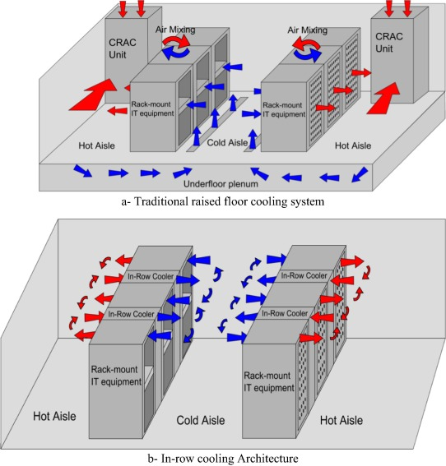
Figure 4. Cooling system design
(Source [6])

Little server farm or individual worker room apply cooling to the room with the computer room cooling unit (CRAC). The cooling of the worker room is liable for eliminating the warmth produced by all electrical gadgets in the worker room. The Crah unit in the worker room should deal with this end. There are a few unique ways to deal with disperse the virus air given by the Crah unit. The virus air that emerges from Crah enters the bed brought and leaves it up in the control of cold entries. The worker eliminates the air and uses it to cool the electrical segments. [3]
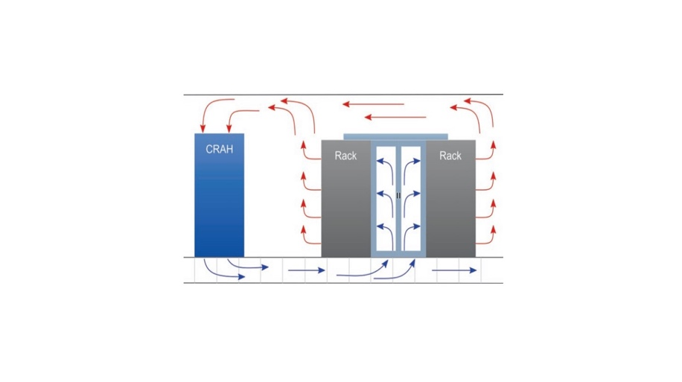
Figure 5. CRAC structure
(Source [7])

The increase in energy demand and the increase in the thermal density of data centers lead to additional research on energy savings technology. The development of server integration and dynamic load management has arisen in combination with the success of virtualization technology. Server integration technology attempts to concentrate applications that run on virtual machines as less servers as possible. You can deactivate the server that does not handle the virtual machine or put it in suspension mode. With the request, the dynamic use of virtual machines can result in significant differences in the active servers in the data center. [3]

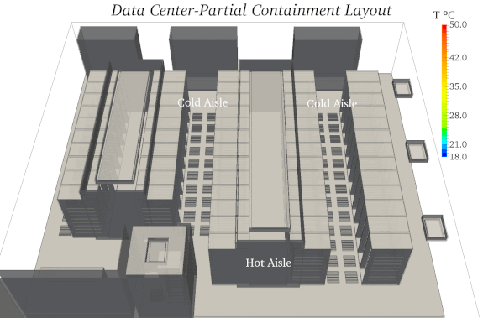
Figure 6. Data Centre thermal design
(Source [9])

VI. SAFETY and SECURITY

Safe data centers should be constructed in the correct location using the corresponding configuration. Safety has limited damping areas, blocking barriers and entry points throughout the site. A cured core is required with a safety layer, safety device, surveillance chamber and dissuading movement for the detection of pumps. Building it is necessary to protect the machine, and the building must have a safe air handling.
• Data centre recovery plan: resume the operation of the data center.
• The site's site is a backup data center to the main data center.
• Information for planning management and important applications.
• Data security arranging: Ensure information from inside and outer dangers. The conceivable unwinding includes forestalling risky occasions and limiting misfortunes and misfortunes related with the event. Preferably, it is liked to forestall occasions, yet given its range, yet it is difficult to forestall cataclysmic events. It is difficult to forestall occasions like tropical storms and tremors, however thinking about the principal proper addresses and plans, it is feasible to decrease the effect of those occasions. Ideally, intelligent decisions can avoid or minimize losses. As an example, we have selected a building that makes a flood easy to occur in flood and healing facilities, such as the implementation of a building with an earthquake, which facilitates it occurring in the flood. [5]

Security
All the systems that support and exist within the data center are protected by security. Within the data center, there are many different types of security, ranging from the physical security of the building to staff safety and access. Because there is so much data around this topic, it was decided that it would be a useful topic to cover in a lecture about its integration into the data center. The issue was also picked because it is inextricably linked to the data center's infrastructure system, which aids in data center management.[5]
The research purpose is to provide insight into the critical systems that surround security. The most important feature of a data center is physical security.
In several ways, data centers appear themselves as safe sites by putting high-quality locking mechanisms in place, high-tech access authentication systems in place, and monitoring systems in place to prevent harmful activity both outside and inside the data center. As solutions to every business will be presented design with a variety of concepts, each with its own set of advantages. [5]

Heat and Water prevention

Another important aspect of data center security is the prevention of heat and water. If these two preventative procedures aren't in place, the data center could be vulnerable to fires and flooding.
In a data center environment, these two dangers present difficulties to manage. Typically, fire suppression systems employ water sprinklers to extinguish fires as soon as they are detected. Water is difficult to utilize in the data center because of the high number of electrical components, and data loss is a significant concern.
Water, on the other hand, can be a problem since it can short circuit electrical components beneath raised flooring without causing any noise or warning.[6]

VII. SAFETY AND RISK MANAGEMENT

When a risk occurs, the threat finds the way to commercial infrastructure and the environment and occurs when vulnerability is exploited to allow violation of the threat. Understanding the threat and its possibilities is an important part of risk management. You can increase the impact value for assets and estimate the amount of risk of damage.
IT systems and services consist of many relevant components. To understand this relationship, these dependent components and entities should be identified. [5]
Gap an assistance or framework in that segment works with the detail of the resource chain of command and the level. The segments can be equipment, programming and associations, yet substances can be human, functional pictures and associations: all can be delegated resources. Arrange these resources and gathering them into classes and qualify them. To obviously recognize the degree of hazard, every resource should be allocated a worth. One of the significant stages to perform danger evaluations is to decide the worth of the resources that require security.

Another significant theme is to have a speedy and quick instrument for dangers. Building an extremely shrewd framework to foresee if the following effect can be made, it will foster debacle recuperation conduct and further develop your business coherence plan.

It is difficult to give all out security to all dangers, yet it is feasible to give powerful security to most dangers and risks.[6]

Examples of sources of threats are human and computer attacks and malicious access. The "threat source" that can be caused by the last humanity or nature can be cautious as human error, ignoring and training, such as piracy, cyber-attacks and accidents.

You can pick where to put your application to meet your inertness, accessibility, and solidness necessities. District is the sending space of GCP assets in the locale. Consider a zone a solitary flaw area inside the zone. To send shortcoming lenient applications with high accessibility and assist with forestalling startling disappointments, convey applications across various zones in a single area. [6]
In modern data centers, they are installing the first battery-based system to replace generators in hyperscale data centers. The system will help keep our users' searches, emails and videos mobile without the pollution associated with burning diesel and can also be used as an asset to strengthen the network. The first major company to promise to use 24/7 carbon-free power operations in all our data centers and campuses around the world, and we are working hard to complete it by 2030. This high-end system is the quality of our ultra-large data center shifts flexible scheduling to accommodate IT tasks in the most abundant low-carbon energy era.

We do not store each user's data on one machine or a group of machines but distribute all data (including our own) on multiple computers in different locations. Then we divide and replicate data between multiple systems to avoid single points of failure. We randomly name these data blocks as an additional security measure so that the human eye cannot read them. [5]

At the point when you work, our worker will naturally back up your basic information. Along these lines, when a mishap happens, if your PC crashes or is taken, you can restart and run shortly.
At long last, we stringently screen the area and status of each hard drive in the server farm. We obliterate out of date hard drives in a laborious multi-step interaction to forestall information access. The server farm is ensured by different layers of safety to forestall any unapproved admittance to your information. We utilize a safe edge guard framework, extensive camera inclusion, biometric validation, and staff accessible day in and day out. Also, we implement severe access and security arrangements in the server farm and guarantee that all representatives get security-centered preparing. [6]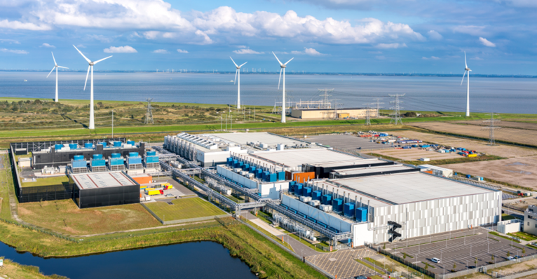
Figure 6. Energy Saving Data Center in Europe
(Source [9])

VIII. ENERGY SAVING

Energy and cost savings A US General Services Administration (GSA) case study related to Google products shows that by switching to Google applications, they can reduce office computing costs, energy use and carbon emissions by 6590%. Additionally, our research shows that companies using Gmail have reduced the environmental impact of their email services by 98% compared to companies using email on local servers. [4]
We use detailed measurement standards and continue to promote double the effort with half the effort, serve more users, and reduce energy waste. [4]

Role of the Cloud

Previously, organizations could decide to assemble their own server farm or utilize an oversaw specialist co-op or an oversaw administration accomplice. Following the later course changed the possession and financial matters of running the server farm, however the significant delay needed to send and deal with the innovation exists. The ascent of Infrastructure as a Service (IaaS) from cloud suppliers, for example, Amazon Web Services and Microsoft Azure gives organizations an alternative to arrange virtual server farms in the cloud with only a couple of snaps of the mouse. [8]

IX. DISASTER RECOVERY

We have also taken strong disaster recovery measures. For example, if there is a fire or any other interruption, we will automatically and seamlessly switch data access to another data center so that our users can continue to work without interruption. Even in the event of a power outage, our emergency backup generator can continue to power our data center. A disaster recovery (DR) site is a facility that an organization can use to restore and restore its technical infrastructure and operations when your main data center is unavailable. [9]

Many mechanisms can be established within the data center to avoid disasters from happening, but if these systems do not perform as intended, they are of no use to the data center.
Another essential aspect of disaster recovery systems to consider is how data centers test and create test processes to guarantee that the systems adopted perform as expected.
Systems such as onsite data backups and offsite storage solutions will be reviewed, along with the advantages and disadvantages of each. Other than record technology, solutions based on removable media will be examined, as well as how they integrate into the data center today. Data on contacts, emergency staff contact information, and recommendations on how to restore the data center's functionality in the event of a major disaster should be preserved in safe areas to help with these test procedures.[9]
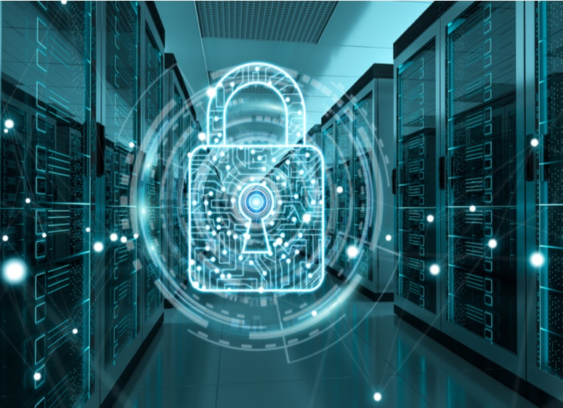

Figure 7. Security for Data Center
(Source [8])

SAN (Storage Area Network), NAS and NVMe
A Storage Area Network (SAN) is a customized, high-speed network that allows users to access storage at the block level. Hosts, switches, storage elements, and storage devices are often connected utilizing a variety of technologies, topologies, and protocols in SANs. SANs can also connect numerous locations. A storage area network (SAN) delivers storage devices to a host in such a way that they appear to be locally attached. The usage of various types of virtualizations allows for this streamlined presentation of storage to a host. [7]

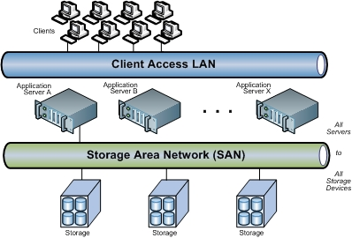
Figure 8. SAN example
(Source [13])

Network-attached storage (NAS) is a file-level storage system that allows networked devices to access stored data more easily. Along with storage area networks (SAN) and direct-attached storage, NAS is one of the three basic storage topologies (DAS). NAS provides networks with a single storage access point with built-in security, management, and fault tolerance. [7]
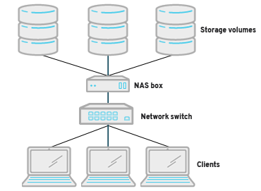
Figure 9. NAS example
(Source [13])

And most popular now is Nonvolatile memory express (NVMe).
In an increasingly digital world, everything is getting faster, which means that data must move faster. Traditional storage protocols such as Small Computer System Interface (SCSI) and Advanced Technology Attachment (ATA) have been around for decades and are reaching their limits. NVMe is a storage protocol designed to speed up the transmission of information between the system and solid-state drives and greatly increase the speed of data transmission.
SAN is generally used to:
- Improve application availability (e.g., multiple data paths)
- Improve application performance (e.g., offload storage functions, isolate networks, etc.)
- Improve utilization and storage efficiency (for example, consolidate storage resources, provide tiered storage, etc.) and improve data protection and security. [7]

The SAN also often plays an important role in the organization's business continuity management (BCM) activities. SAN is usually based on Fiber Channel (FC) technology, which uses Fiber Channel Protocol (FCP) for open systems and proprietary variants for mainframes. In addition, the use of Fiber Channel over Ethernet (FCoE) makes it possible to move FC traffic over existing high-speed Ethernet infrastructure, and to converge IP and storage protocols on a single cable. [7]

Other technologies can also be used, such as Internet Small Computing System Interface (iSCSI), which is often used in small and medium organizations as a cheaper alternative to FC, and InfiniBand, which is commonly used in high-performance
computing environments. In addition, gateways can be used to move data between different SAN technologies. [7]

Example for a Data Center Architecture.

A big company network with a main campus site in the university connecting small, medium, and large sites is depicted in the sample high-level topology diagram shown in Figure 10.
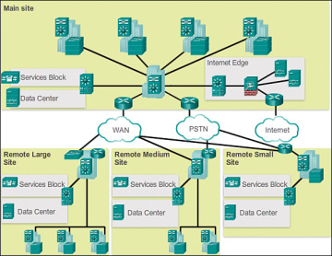
Figure 10. Network Design in Campus site.
(Source [15])

Figure 11 shows another example three-layer hierarchical network design. It's worth noting that each structure employs the same hierarchical network paradigm, which includes access, distribution, and core layers.[14]

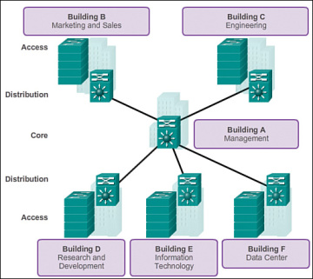
Figure 11. Three Layer Network Design.
(Source [15])
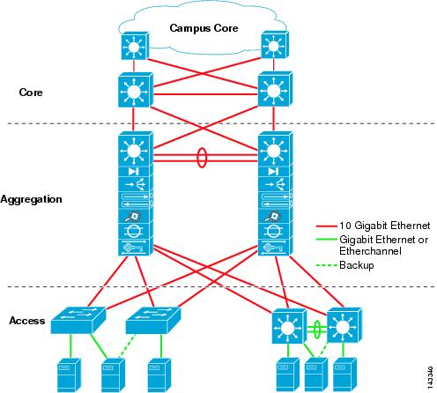
Figure 12. Basic Layer Design [15]
(Source [15])

A "collapsed core" is the point at which the dispersion layer and center layer capacities are executed by a solitary gadget. The essential inspiration for the fell center plan is decreasing organization cost, while keeping up with the greater part of the advantages of the three-level hierarchical model. [15]

The model in Figure 13 has imploded the appropriation layer and center layer usefulness into multi-facet switch gadgets. [14]
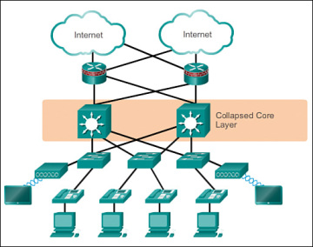
Figure 13. Collapsed Core Layer
(Source [15])

The progressive organization model gives a particular structure that permits adaptability in network plan and works with simplicity of execution and investigating.[14]

X. CONCLUSION

Each industry, including medical care, promoting, retail, and so on, produces a huge number of gigabytes of new data in different structures, like client information, income, online media, business recordings, and so forth, to give some examples. It is significant that every one of the information produced all throughout the planet is put away in a profoundly secure where the necessary information can be recuperated in a brief time frame. The server farm makes the way for various freedoms for the utilization of innovation. Be that as it may, building a server farm with ideal assets is the greatest test, and various techniques to further develop server farm proficiency have been utilized and examined. Many organizations utilize focal server farms to abstain from building and keeping up with isolated server farms. Accordingly, the server farm offices have turned into a shelter for this innovation. Many huge organizations are searching for and taking on new techniques for building server farms to accomplish the "green" Internet. [13]

This examination gives us that the need of server farms is quite possibly the main pieces of every new situation. A large portion of the associations and the IT ventures are offering on the web types of assistance to their clients in which case the exchange of information related data is likewise included. In this situation, the exploration effectively carries out the needful boundary dependent on the server farm where the fundamental perspective is to improve results toward the formative angle. In any case, the administration and management job are additionally imperative to make the right choice regarding the new data centre design. The resilience level, acknowledgment, and energy utilization are at the necessary level without influencing the activity cycle. [9]

REFERENCES

[1] C. Mahood, Data center design & enterprise networking. 2017.
[2] O. Geet, Data center optimization strategies, 1st ed. 2019.
[3] A. Santos, P. Gaspar and H. Souza, "New Data Center Performance Index: Perfect Design Data Center—PDD", Climate, vol. 8, no. 10, p. 110, 2020. Available: 10.3390/cli8100110.
[4] M.., "DESIGN OF GREEN DATA CENTER", International Journal of Research in Engineering and Technology, vol. 03, no. 05, pp. 373-377, 2014. Available: 10.15623/ijret.2014.0305068.
[5] W. Du, "Design and Implementation of Data Center Network Security", Advanced Materials Research, vol. 694-697, pp. 2308-2312, 2013. Available: 10.4028/www.scientific.net/amr.694-697.2308.
[6] F. Fang and X. Yu, "Design and Implementation of Next-Generation Data Center Infrastructure", Applied Mechanics and Materials, vol. 513-517, pp. 1316-1319, 2014. Available: 10.4028/www.scientific.net/amm.513-517.1316.
[7] D. Guides and D. Centre, "Data Center Design Guides", Cisco, 2021. [Online]. Available: https://www.cisco.com/c/en/us/solutions/design-zone/data-center-design-guides/data-center-design-guides-all.html. [Accessed: 20- Aug- 2021].
[8] S. Shapiro, "Data Center Design: Which Standards to Follow?", Data Center Knowledge, 2021. [Online]. Available: https://www.datacenterknowledge.com/archives/2016/01/06/data-center-design-which-standards-to-follow. [Accessed: 20- Aug- 2021].
[9] "Data and Security – Data Centers – Google", Google Data Centers, 2021. [Online]. Available: https://www.google.com/about/datacenters/data-security/. [Accessed: 20- Aug- 2021].
[10] C. Center, "What Is Data Center Security?", Cisco, 2021. [Online]. Available: https://www.cisco.com/c/en/us/solutions/security/secure-data-center-solution/what-is-data-center-security.html. [Accessed: 20- Aug- 2021].
[11] "Data Center & Network Infrastructure Solutions | CDW", Cdw.com, 2021. [Online]. Available: https://www.cdw.com/content/cdw/en/solutions/data-center-and-network-infrastructure.html. [Accessed: 20- Aug- 2021].
[12] J. Kerravala, "What are data centers? How they work and how they are changing in size and scope", Network World, 2021. [Online]. Available: https://www.networkworld.com/article/3599213/what-are-data-centers-how-they-work-and-how-they-are-changing-in-size-and-scope.html. [Accessed: 20- Aug- 2021].
[13] K. Rusdiana, l. linawati and I. Oka Widyantara, "Green Data Center Design of Udayana University", Majalah Ilmiah Teknologi Elektro, vol. 15, no. 2, pp. 39-44, 2016. Available: 10.24843/mite.1502.07.
[14] C. Press, "Hierarchical Network Design Overview (1.1) > Cisco Networking Academy Connecting Networks Companion Guide: Hierarchical Network Design | Cisco Press", Ciscopress.com, 2021. [Online]. Available: https://www.ciscopress.com/articles/article.asp?p=2202410&seqNum=4. [Accessed: 24- Aug- 2021].
[15]"Data Center Architecture Overview", Cisco, 2021. [Online]. Available: https://www.cisco.com/c/en/us/td/docs/solutions/Enterprise/Data_Center/DC_Infra2_5/DCInfra_1.html. [Accessed: 24- Aug- 2021].

