Are staff and students confident in using technology to collaborate?
Component 2 – Research Report
Student Name: Tunde Brigitta Petkes
Student number: 2124153
Lecturer Name: Yohan Mendis
BMSW4003_BIRM
Digital Skills and Research Methods

Table of Contents
1 Abstract 3
2 Introduction 3
3 Research design 4
3.1 Research question 4
3.2 Methodology 4
3.2.1 Research philosophy 4
3.2.2 Research approach 4
3.2.3 Research design 4
3.2.4 Sampling size and technique 4
3.2.5 Data collection method 5
3.2.6 Data analysis 5
3.3 Ethical consideration 5
4 Results 6
5 Discussion 8
6 Conclusion 10
7 References 11
8 Appendix 12

Abstract
Technology is a factor that is slowly taking the world under its control, which is a good thing as it brings forth innovation and steps for a brighter future. Since the field is vast, it also encompasses collaboration – an activity that is now a major part of educational institutions. Hence, the purpose of this report is to find out how confident the students and the staff members of the targeted university are when it comes to using technology for online collaboration. The study was quantitative in nature, meaning it would test the themes procured by the findings, which were done so with an online survey. The results were mixed, as the respondents reported both confidence and anxiety amidst this matter. The research ended with important recommendations for the university in question, which were based upon the findings discovered by the study.

Introduction
The presence of technology has led to a higher expectation amongst the modern learner towards the digital approaches to teaching and learning. Students are "Digital Scholars" who make use of every technology to gain information and hop into all forms of research. The teaching staff is also found motivated to make use of technology to learn new competencies and adhere to digital education (Gillett-Swan 2017). There is an inner willingness to adhere to the latest concept of teaching by the staff engaging in Technology Enhanced Learning (TEL). This sort of learning help extends quality learning for the students and builds an enthusiasm to mitigate all barriers to teaching staff to exhibit the mobile learning system effectively. Ali (2019) identified a lack of confidence in staff to adhere to the latest technology for teaching and collaboration as they find it difficult to create an interactive environment using technology as they believe in face-to-face interactions.
However, this project is aimed to identify whether the staff and students are confident to make use of technology to collaborate. The report will also highlight the methods used to gather data and will analyze the results using graphical interpretation. Based on the study, an insight into the modern technology use between students and staff is highlighted, and the level of confidence is also examined.

Research design

Research question
The research is aimed to answer the following research question
Are staff and students confident in using technology to collaborate?
Based on the research question, the research will focus on the level of confidence in using the latest technology by the staff and students. These technological instruments include the use of Microsoft Teams and One Drive. Individuals often feel anxious about using this technology to collaborate and connect with their peers and colleagues, and therefore the research is focused on identifying the user and the challenges faced in making effective use of these technologies to work confidently.

Methodology

Research philosophy
The selected research philosophy for the current research is positivism, as the study is dependent on quantitative data. By adhering to the positivism philosophy, answering the research question becomes easy and allows for the collection of factual knowledge.

Research approach
The selected approach for the current study is deductive because positivism philosophy is selected. By adopting the deductive approach, scientific investigation is conducted, and the research moves from a general to a particular approach. The deductive approach also allows for identifying the level of confidence in using technology by the staff and students and provides in-depth information related to the topic.

Research design
For the investigation of the current topic, the explanatory research design is most appropriate. Since the research is not aiming to develop a new theory or generate a new concept, rather, the focus is given to existing research where knowledge is restricted (Rahi, 2017). By explanatory design, in-depth information is collected regarding the topic.

Sampling size and technique
Appropriate sample size is important for the research and leads to proper sampling to extract reliable findings from the study (Taherdoost 2017). However, for the current study, the use of non-probability sampling technique was selected under which the convenience sampling was used to gather the desired data. The reason to opt for convenience sampling is that it is easy to collect and implement and is useful in gathering data from the participants (Etikan et al., 2016). These participants are marked as a convenient source of data as data is collected from the available pool of candidates. The data was collected from 50 students to have insights into their use of technology.

Data collection method
The method used for collecting data in this research is primary, which is also called first-hand data. For the collection of primary data, questionnaires were used, which were shared with the participants online via email. The questionnaire was based on a nominal scale and Likert scale. With the aid of the Likert scale, participants were able to show their negative and positive responses to a statement. This was important for the research to assess the level of confidence in using technology; respondents’ opinions and attitude matters.

Data analysis
The most challenging part of the research which helping extract meaningful findings from the data collected. Since the data is primary and is collected via questionnaire, therefore the graphical interpretation of data is the most useful method. It helps in visualizing, analyzing and interpreting data effectively.

Ethical consideration
This part is most crucial and requires much importance as without it; research may fail. Since the research was based on collecting primary data, therefore, it must be ensured that participant anonymity must be maintained. The personal data collected from the participant should be anonymous. The participants are also provided with the right to leave at any point if they are not willing to continue the questionnaire. Moreover, it was also assured that unauthorized personnel are not provided with any excess data to avoid any misuse in future. The questions were also made, keeping in mind that participants were not hurt by any questions.

Results
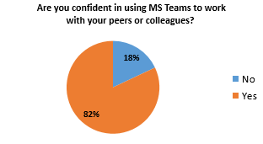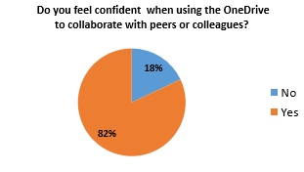

When participants were asked whether they were confident in using Ms Teams and One Drive to collaborate, 82% agreed to the statement, whereas 18% answered no. This shows an increasing acceptance of the use of technology and a high level of confidence when dealing with these technical mechanisms.
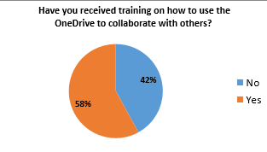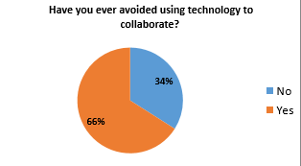
Next, when participants were inquired about whether they had received training before the use of One Drive, 58% answered yes, whereas 42% answered negatively. Moreover, participants also avoid using technology to collaborate, as 66% often avoided it, whereas 34 answered no. This suggests that merely half of the participants are trained to use technology but are still reluctant to use it for collaboration.
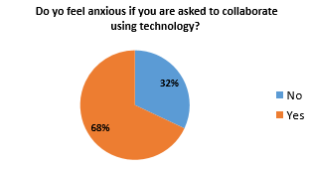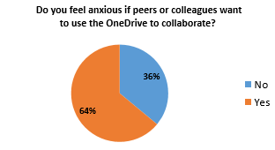
There is still a lack of confidence identified in the participants despite knowledge and training. About 68% and 64% of participants felt anxious when collaborating using technology and OneDrive.
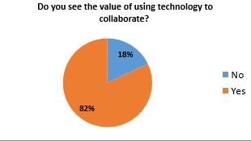

The value of collaborating via technology is agreed upon by 82% of participants.
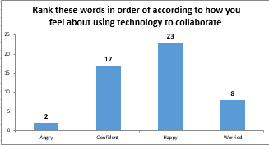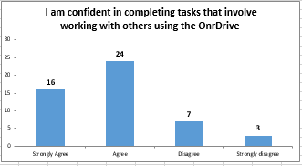
The majority of the participants were found to be happy and confident in using technology, and the accomplishment of tasks using OneDrive was also successful.
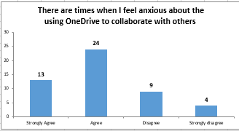

Despite the confidence, participants still feel anxious about collaborating via OneDrive.
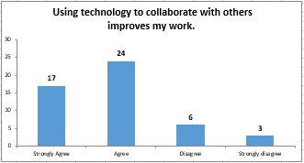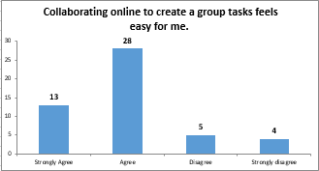
A strong agreement was observed on the statement of whether technology improves the work or not. The improvement of work is associated with the easiness of collaborating online by creating groups and working together. About 28% of participants agreed that collaborating online is easy for them and aids in group tasks.

Discussion
By appraising the results acquired by this survey, it can be said that the responses appeared a bit mixed. For starters, the answers to the survey are considered to be valid as the response rate was 100%, indicating that every respondent in the set sample had dutifully interacted with the survey. Hence, the responses should be apprehended in a sincere light. By looking at them this way, the responses and the participants’ views are a bit mixed. At some points of the survey, they have claimed that they are confident when it comes to using digital technology to collaborate with others online, but on some other points, they claim that they still feel anxious and jittery when dealing with such type of technology. The survey had specifically highlighted OneDrive, as it is the Microsoft tool that encompasses all its significant software whose main purpose is to make people collaborate. In the case of this platform, the responses were again mixed, as the respondents declared that they felt confident whenever they used OneDrive to collaborate with others, but also felt anxious doing the same activity. This showcases the conviction that maybe the respondents were uncertain when it came to using technological tools for online collaboration. It is vital to note here that online collaboration is mostly used by the respondents, especially the students, for informal and social purposes, and they scarcely use it for education. Therefore, proclaiming that they are confident in using technology for collaboration, but still feel anxiety creeping up on them whenever they try to do it showcases that they know the basics of such platforms, like OneDrive, but are afraid of messing things up when using them for important purposes, like classroom activities.
It is also essential to note here that the sample consisted of both students and teachers, notifying the notion that these uncertainties lie in both the student body and the teaching staff, or at least to some extent. Fortunately, the room for improvement in this matter is clear, because the respondents are aware of the value of online collaboration, even if some of them do not receive training for this purpose. Furthermore, it is vital to compare these findings with the ones attained by previous research, to see how comparable they are, and whether the results are compatible or contradictory to each other. Firstly, Gündüz et al. (2016) in their study noted that an online-based learning environment was positive for students as it created a more dynamic nature towards participation in collaboration. The study also claimed that most of the students were very confident with these collaboration tools. In the light of the current study, these findings are complementary. An online learning environment is also considered to be effective here for education because it boosts the students' confidence and makes them engage among themselves and with their teachers, thus fostering a good ambience. The current study also found that students were fairly confident when it came to using technological tools for online collaboration, which is why these results matched. Secondly, another study, this one done by Martin et al. (2020), said that in the means of online collaboration, there were some student attributes to be taken into consideration, and that are communication, time management, and technical competencies. Through its findings, the study claimed that students believed that managing time and being competent with technology was much more important than having communication skills. The current study both agrees and disagrees with this sentiment. To begin with, student attributes were indeed important when it came to online collaboration, but the students here held communication to be more valuable than technical competencies, even if they did claim it was valuable as well on its own. Lastly, Hatlevik (2017) made a point of how teachers needed the confidence to master the basic online collaboration tasks, and the current study wholeheartedly agrees with this point, as the confidence level is considered to be crucial.

Conclusion
In conclusion, it can be proclaimed that the research question has been answered – both the staff and the students feel confident when it comes to using technology for collaboration. Evidently, this confidence level does not go all the way up, as the study found out that the same students and teachers who claim that they are fairly confident in using online tools for collaboration also said that they sometimes felt anxious in doing the same task. This shows a clear bout of uncertainty, indicating that the knowledge of using such tools is limited, which allows for a limited sense of confidence that is not permitted in the long run. By conducting the study, which was quantitative in nature and used graphical interpretations to attain its findings, the procurement of the results showed these mixed responses among the staff and students of the targeted university. Hence, it can be deduced that the university should pay more adherence to its students and its staff members in the means of online collaboration using technology, which is significantly important because of the rise of modernization and the aftermath of an event like the COVID-19 pandemic. Being equipped with these skills is necessary for an era like the contemporary one.

References
Ali, W., 2019. The Efficacy of Evolving Technology in Conceptualizing Pedagogy and Practice in Higher Education. Higher Education Studies, 9(2), pp.81-95.
Etikan, I., Musa, S.A. and Alkassim, R.S., 2016. Comparison of convenience sampling and purposive sampling. American journal of theoretical and applied statistics, 5(1), pp.1-4.
Gillett-Swan, J., 2017. The challenges of online learning: Supporting and engaging the isolated learner. Journal of Learning Design, 10(1), pp.20-30.
Gündüz, A.Y., Alemdag, E., Yasar, S. and Erdem, M., 2016. Design of a Problem-Based Online Learning Environment and Evaluation of its Effectiveness. Turkish Online Journal of Educational Technology-TOJET, 15(3), pp.49-57.
Hatlevik, O.E., 2017. Examining the relationship between teachers’ self-efficacy, their digital competence, strategies to evaluate information, and use of ICT at school. Scandinavian Journal of Educational Research, 61(5), pp.555-567.
Martin, F., Stamper, B. and Flowers, C., 2020. Examining Student Perception of Readiness for Online Learning: Importance and Confidence. Online Learning, 24(2), pp.38-58.
Rahi, S., 2017. Research design and methods: A systematic review of research paradigms, sampling issues and instruments development. International Journal of Economics & Management Sciences, 6(2), pp.1-5.
Taherdoost, H., 2017. Determining sample size; how to calculate the survey sample size. International Journal of Economics and Management Systems, 2.

Appendix

Questionnaire
- Are you confident in using MS Teams to work with your peers or colleagues?
- Yes
- No

- Do you feel confident when using OneDrive to collaborate with peers or colleagues?
- Yes
- No

- Have you received training on how to use OneDrive to collaborate with others?
- Yes
- No

- Have you ever avoided using technology to collaborate?
- Yes
- No

- Do you feel anxious if you are asked to collaborate using technology?
- Yes
- No

- Do you feel anxious if peers or colleagues want to use OneDrive to collaborate?
- Yes
- No

- Do you see the value of using technology to collaborate?
- Yes
- No

- Rank these words in order according to how you feel about using technology to collaborate.
- Angry
- Confident
- Happy
- Worries

- I am confident in completing tasks that involve working with others using OneDrive
- Strongly agree
- Agree
- Disagree
- Strongly disagree

- There are times when I feel anxious about using OneDrive to collaborate with others
- Strongly agree
- Agree
- Disagree
- Strongly disagree

- Using technology to collaborate with others improve my work
- Strongly agree
- Agree
- Disagree
- Strongly disagree

- Collaborating online to create a group task feels easy for me.
- Strongly agree
- Agree
- Disagree
- Strongly disagree

