Student Name: Kathryn Walton
P Number: 1901027
Programme of Study: Fine Art
Module: M4X01560

Tasks in the order I received them:
Task One: Semiotic Analysis (Ryan task) = 525 words
Task Two: Manifesto (Julia Task) = 551 words
Task Three. (Jon Task) = 523 words

Task One: Semiotic Analysis (Ryan’s task)

For my observation analysis I will be focusing on a television advert which was released in the UK around the year 2007. The name of this campaign is called Hooked but was quite quickly removed from the screens considering the advert faced around ‘774 complaints’ (Griffin, 2013) against it since it was “offensive, frightening and distressing – particularly to children” (Sweney,2007).
The advert starts with a busy and stressful environment (an office workplace), a man is talking on the phone with someone planning to meet up. As soon as the man puts the phone down he looks agitated and stressed, as if he needs a break. The background noise becomes distant and whispers begin, everything in the background carries on but no noise disturbs this man except the whispers. As if someone or something is telling him to do it, tempting him like an addiction. Shortly the whispers stop but then out of nowhere a hook pierces through his cheek and begins to drag him along his workplace, causing him and the camera view to become disorientated and confused of what is going on. Whilst this is happening, a horrible and dramatic sound Is being played as if it was a horror movie. Eventually the hook leads him to a door which then opens to the outside and the horrible noise stops, everything seems calm and more relaxed considering the hook is no longer dragging him somewhere. This is then followed by the man lighting a cigarette and then a voiceover: “The average smoker needs over 5000 cigarettes a year. Get unhooked. Call 0800 169 0 169 or visit getunhooked.co.uk” (Macleod, 2007)
When I first watched this advert, I was confused by the hook grabbing the man randomly and dragging him, but considering I smoke I considered it relatable in a sense of agitation. Sometimes I’m unable to have a cigarette break when doing work, which leads me to get stressed out over the smallest of things. After watching this advert a couple more times it made more sense on why that hook dragged him towards the door to go outside. This is because I believe that stress can make us do stupid things, especially by putting us off doing work. This then makes it harder if you mix stress with addiction of smoking. Smoking is bad enough but when its mixed with stress people automatically smoke more just because it gives the same effect of having a break. Although this advert was a good way to advertise addiction, I believe that this was dramatic considering smokers don’t hear whispers or even get dragged by a hook. Addiction is a serious thing, in which many people may have it a lot worse than others but being dragged by a hook on national tv across the UK is too far. I believe it was good that they offered a help website and contact number at the end of the advert, for anyone who was struggling with a smoking addiction. The advert broadcasted how dangerous smoking is, but I believe it could’ve been examined in a better and clearer way to show the horrific side effects of addiction

Bibliography
Macleod, D. (2007). NHS Get Unhooked From Smoking - The Inspiration Room. Available at: http://theinspirationroom.com/daily/2007/get-unhooked/ (Accessed 15th December 2019)
Griffin, E. (2013). NHS Hooked anti-smoking campaign. Persuasion and influence. Available at: http://persuasion-and-influence.blogspot.com/2013/02/nhs-hooked-anti-smoking-campaign.html (Accessed 15 Dec. 2019)
Unhooked advert campaign, available here: https://www.youtube.com/watch?v=PSSReIEhrZw
Task Two: Manifesto (Julia’s Task)
1. Old ways won’t open new doors, try not to repeat history
2. Your feelings are valid, speak up for what you believe
3. “The bravest thing I did was continuing my life when I wanted to die” – Juliette Lewis
4. “If you’re going through hell, keep going” – Winston Churchill - Things get better even when you believe they wont
5. “This is not a one-time thing; this is our entire future” – Greta Thunberg
6. Try something new at least every day, go out of your comfort zone and explore what the world has prepared for you.
7. “You look back over the course of your lifetime. You're not gonna think, I wish I owned a better phone, I wish I spent more time on the internet, I wish I spent more time at work or sleeping. It's not gonna be any of those kinds of things. It's gonna be I wish I spent more time with the people I love” – Gary Lewandowski
8. Make sure you leave your mark on this world and make all your ancestors proud for what they did to get you here - Take every chance you get thrown at you

Keywords and images
Repeat history
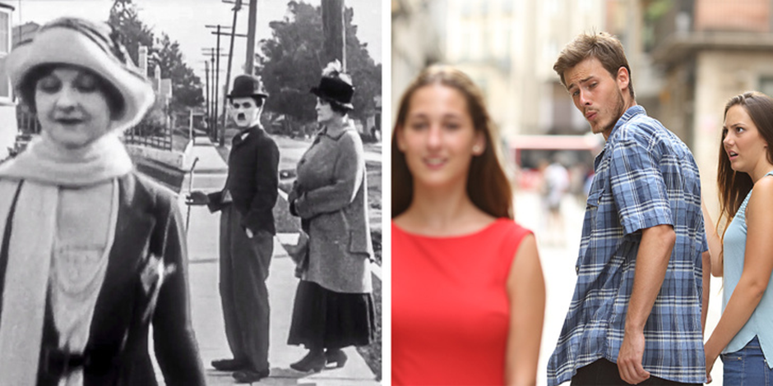

“Pay Day” 1922 a Charlie Chaplin film poster
“Disloyal man with his girlfriend looking at another girl”
1. Old ways won’t open new doors, try not to repeat history
It is well known that a lot of conspiracy theories are roaming the internet about history recurrence, for example I read in an online blog that scientists had discovered a repeat repetition in the rise and fall of empires, dictators, wars and political conflict (Markollin, 2016). Scientists have been trying to figure out the repeat in history for many decades, in which they have now resulted in seeing similarities in a mathematical solution. I believe that if we carry on letting our history define what we do, that of course history will repeat itself. Likewise, if we don’t let go of our past, we will never change and in some ways our history can show up whilst in the present, keeping us from learning and growing into something else.
Keywords and Images
Our entire future
5. This is not a one-time thing; this is our entire future” – Greta Thunberg
Greta Thunberg is an inspirational Swedish climate activist who is sixteen years old. Her speeches inspire me because she speaks loudly about issues that everyone chooses to ignore. She first learned about the climate change when she was eight but was confused on why everyone knew they could help change, but instead chose not to talk about it. I believe that she has done so much inspirational work and it has helped to change many young people’s outlook on our climate change, which is something to be proud of at such a young age! Thunberg has gained 3.74m followers on her twitter, where she posts many of her debates, crisis calls about certain countries and even about people that are standing up for worldwide problems such as Arshak Makichyan who “peacefully stood up for everyone’s future”(Thunberg, 2019) but was put in detention for 6 days. Then she said the quote and I instantly thought yes, this is our future, we need to think about reality and the consequences we will face if we don’t start making any changes. It is well known that a lot of conspiracy theories are roaming the internet about history recurrence, for example I read in an online blog that scientists had discovered a repeat repetition in the rise and fall of empires, dictators, wars and political conflict (Markollin, 2016). If we carry on letting our history define what we do, that of course history will repeat itself. If we don’t let go of our past, we will never change and in some ways our history can show up whilst in the present, keeping us from learning and growing into something else.
Keywords and images
The course of your lifetime.
7. “You look back over the course of your lifetime. You're not gonna think, I wish I owned a better phone, I wish I spent more time on the internet, I wish I spent more time at work or sleeping. It's not gonna be any of those kinds of things. It's gonna be I wish I spent more time with the people I love” – Gary Lewandowski
I first heard this through a song named GFY by Dennis Lloyd, but soon came to realise that it was from a Ted talk by Gary Lewandowski. Lewandowski is a “professor of psychology, accomplished speaker, and writer” (Lewandowski, 2019) and is recognised worldwide due to his Ted talks with over a million views. We need a relationship as they are the most important thing to help us adapt to change in our lives, and when we don’t have it, we suffer the consequences of facing certain mental health problems like depression and anxiety. An article I read described a mother’s pain of being completely fine one moment and the next feeling as if she shouldn’t be alive, she explained that her scar on her left wrist is a reminder about how her “mental health can construct a vast distance between me and my values.” (Obordo, 2017).

Bibliography
Novak, M. (2018). Did Charlie Chaplin Invent the Distracted Boyfriend Meme?. Paleofuture.
Available at:
https://www.google.co.uk/amp/s/paleofuture.gizmodo.com/did-charlie-chaplin-invent-the-distracted-boyfriend-mem-1826726244/amp (Accessed 23 Dec. 2019)

Markolin, P. (2016). Cliodynamics, the science that predicted Trump and a surge of violence to come. Medium.
Available at:https://medium.com/@checkironically/does-history-repeat-itself-31eaf74a4456 (Accessed 23 Dec. 2019)
BBC. (2019). Who is Greta Thunberg, the #FridaysForFuture activist? BBC News.
Available at: https://www.bbc.co.uk/news/world-europe-49918719 (Accessed 23 Dec. 2019)
Thunberg, G. (2019). Greta Thunberg profile. Twitter.
Available at: https://twitter.com/gretathunberg?lang=en
(Accessed 23 Dec. 2019)

Lewandowski, G. (2019). Gary W. Lewandowski. JR
https://www.garylewandowski.com/
(Accessed 23. Dec. 2019)

TED Talk: Break-Ups Don't Have to Leave You Broken
Available at: https://www.youtube.com/watch?v=Cw2qD87KDHc
(Accessed 23. Dec. 2019)

Sharry, J. (2018). The importance of relationships and belonging.
Available at: https://www.irishtimes.com/life-and-style/health-family/parenting/the-importance-of-relationships-and-belonging-1.3405948
(Accessed 23. Dec. 2019)
Obordo, R. (2017). How mental health problems affect relationships: 'They're scared that this time you might die.’
Available at: https://www.theguardian.com/lifeandstyle/2017/mar/31/how-mental-health-problems-affect-relationships-theyre-scared-that-this-time-you-might-die
(Accessed 23. Dec. 2019)

Task Three: Jon’s Task

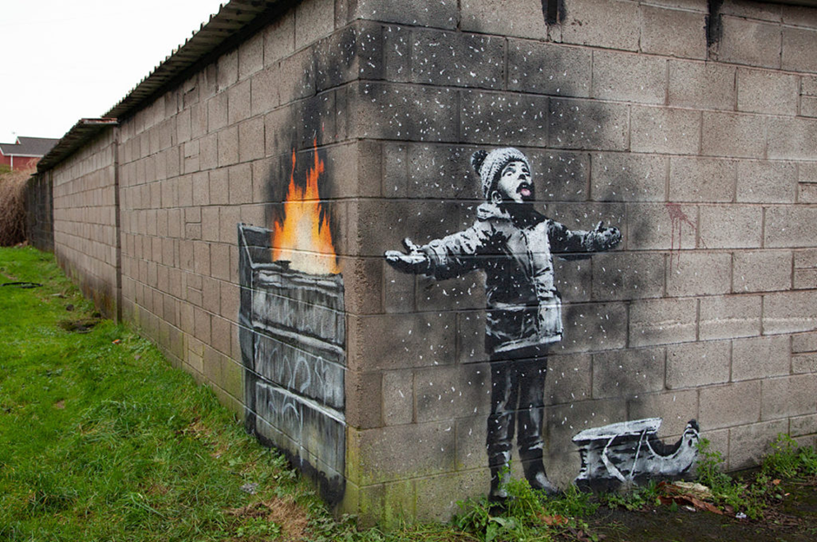
Neuendorf, H. Image 1. (2018). A Very Banksy Christmas?
A practical reflection of a piece of artwork called ‘season’s greetings’ by Banksy.
This image represents a little boy which seems innocent towards being out in the snow catching it on his tongue, but as you look at it from a different perspective you can see that it is actually coming from a bin on fire, polluting the air around him.
PM2.5 is a fine inhalable particle which pollutes the air, a single hair on your head is about “70 micrometres in diameter” (anonymous, 2018) which makes it around approximately 30 times bigger. After finding a graph online whilst searching for statistics, it showed that the highest levels tended to occur during the winter and spring 2018. But the mean calculation in month form for 2018 was in May, this was (13.2m3) for roadside and (13.4 m3) for urban background sites.
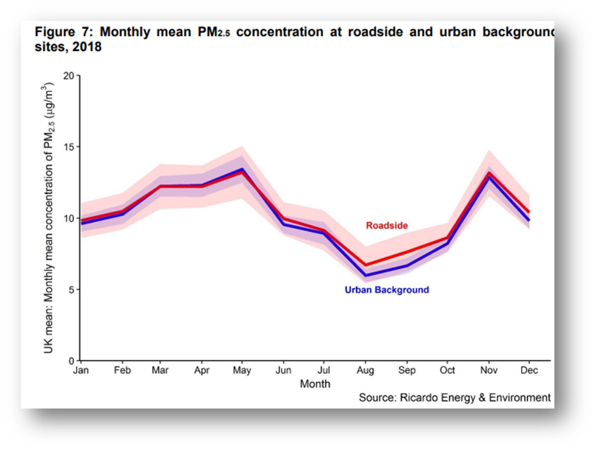 Image 2. (2019). Department for Environment, Food and Rural Affairs.

I’ve always been a fan of Banksy’s artwork, because he speaks in a very political and bold tone. He focuses his work on Important topics of the world, just like this piece where he has turned his focus on pollution and how it is damaging everyone, even the young and innocent. His identity has always been kept secret which I believe makes his artwork just as special, he doesn’t want the fame like every other artist, he just wants political and climate issues to be seen for what they are. His work is very inspiring to me and always will be, I feel as if it’s the only reality that most people will see in the face of this world. This is because many problems are hidden away from the world, we don’t realise how bad things are until they’re handed in front of us.
Today Banksy is still very popular, in fact his latest piece was a video which was published December 2019 in Birmingham on Instagram by Banksy himself and was titled “God Bless Birmingham” (Krol, 2019). The video took around twenty-minutes to get the perfect shot, but it starts off with a homeless man named ”Ryan” (Banksy, 2019” which is setting up his place to sleep for the night on a bench. The video then pans out to show reindeers taking off but with no slay or Santa Clause, but Ryan is laying where Santa clause would’ve been. There’s faint music in the background which is a cover of ‘I’ll Be Home for Christmas’ by Heather Hammers. I believe that it really hit once I realised the power behind something so simple yet beautiful, showing how unfortunate some are, especially during Christmas time.
For the future I would like to most definitely focus on more powerful things in the world that need speaking up about, we need to raise awareness of things around us. We are here once and surely, we should all help the world and people around us, not everyone is as lucky as some. Banksy is one of many great artists that inspire me to become the young woman I am today, and I am forever grateful to of been able to research about him and gain my own opinions about the world’s development and changes.

Bibliography
Unknown. (2018). Particulate Matter (PM) Pollution. EPA. Available at: https://www.epa.gov/pm-pollution/particulate-matter-pm-basics
(Accessed 05. Jan. 2020)
Neuendorf, H. Image 1. (2018). A Very Banksy Christmas? Available at: https://news.artnet.com/art-world/banksys-port-talbot-1424842
(Accessed 05.Jan. 2020)
Faulconbridge, G. Banksy 'snow' pollution mural sold for over $130,000. Available at: https://www.reuters.com/article/us-britain-banksy/banksy-snow-pollution-mural-sold-for-over-130000-idUSKCN1PC18X
(Accessed 05. Jan. 2020)

Image 2. (2019). Department for Environment, Food and Rural Affairs. Available at: https://assets.publishing.service.gov.uk/government/uploads/system/uploads/attachment_data/file/796887/Air_Quality_Statistics_in_the_UK_1987_to_2018.pdf
(Accessed 05. Jan. 2020)
Banksy. (2019). ‘God Bless Birmingham’ video. Available at: https://www.instagram.com/p/B52l1NkHa71/
(Accessed 05. Jan. 2020)
Hammers, H. (2015). ‘I’ll Be Home for Christmas (cover).’ Available at: https://www.youtube.com/watch?v=Mn4uXe_umAw
(Accessed 05. Jan. 2020)

