

Name of Student: Wafa Wajeeh Nasser
Student number: 1703942
Module code: LCMB7000
Module Title: MBA General Management
Name of Instructor: Gladius Kulothungan

HUMAN RECOURCE MANAGEMENT (A2)

International Techno Corporation

Table of Contents
Abstract 2
Introduction 2
Human Resource Strategies and its Deployment 3
Staffing Retention 6
Staffing: Recruitment and availability of skilled local labour 9
Change Management 12
Conclusion 14
References 16

Abstract
Human resource management is considered a strategic approach used to manage the workforce and/or employees associated with the corporation (Armstrong, 2011). This report's main purpose is to assess the influence, importance and implementation of the human resource management strategies which affects the human resource management program at my own organization called “International Techno Corporation”. Being the HR director of the firm, I have implemented a wide range of strategies that can help in making the team members feel appreciated, values and to have a sense of belongingness in the organization (Pilbeam, 2010). In addition to this, the report also articulated the development and deployment of international human resource management at the organization. The findings reflected that how my company is required to utilize and focus on using change management, recruitment, and retention strategic programs in order to elevate its employees' motivation level and thus persuade them to perform more effectively by offering them reimbursement career development opportunities and rewards.

Introduction
Human resource management is responsible for managing the people in the company, with a focus on policies and procedures (Armstrong, 2014). This management of employees helps the company maximize their performance and thus enable the corporation to gain a competitive advantage (Briscoe, 2007). Being the HR director, it is my responsibility to deal with the staffing audits, management personnel, training and development, job evaluation and payment management, such as salary management and staffing. Social workers maintain flexibility in business relations or system planning and the importance of collective bargaining and government policies (Kushwaha, Yadav, and Prasad, 2018).
This report will focus on reviewing importance and implementation of the human resource management strategies which affects the human resource management program at my own organization called “International Techno Corporation” particularly in staff retention, recruitment, and change management. Hence, this paper will highlight the strategies that are required to be implemented within the company to maximize employee performance and thus make team members feel valued and appreciated at the company. My company is called “International Techno Corporation” that deals with the cloud computing system and advanced artificial intelligence technology. Being the HR director of the organization, I believe it is my responsibility to tackle the different issues that are encountered in the organization when establishing and running the business on the international level. It helps in managing the productivity and performance in an effective manner.

Human Resource Strategies and its Deployment
Since 2015, human resources have focused on various strategies such as integration and acquisition, management, work relations, uniqueness, and non-discrimination (Patricia Ordóñez, et al., 2014). In today's global workplace, many companies are committed to staffing and maintaining employees' rights and knowledge. The human resources department participates in providing management to attract employees, thereby reducing the risk of employee turnover (Bach & Edwards, 2013). (Torrington, 2017). It also requires extensive HR planning which helps in specializing in hiring skilled individuals, training and developing employees, and building stronger relationships with employees (Collings et al., 2017). The training of development professionals ensures that employees are trained and continuously developed. This is done through training programs, performance evaluations, retention, and compensation programs (Gibb, 2011). The human resource department is also indebted to resolve the problems of workers, such as threats or discrimination. Employee benefits include the development of payment systems, parental leave plans, income, and other reimbursements (Muller, 2013).
Ridgway (2019) revealed that it is vital for companies to deploy new and effective human resource management strategies within the corporation to increase employees' level of motivation to perform more efficaciously. In this concern, this section of the report will critically suggest the deployment of human resource management strategies, particularly in the area of change management, staff retention, and recruitment, to help the company to encourage employees during the intense situation that has emerged due to Brexit and COVID-19 in the United Kingdom. In terms of external factors, it is considered that the changes in social-cultural demands, along with the variation in the political environment of the United Kingdom, have entirely reshaped the paradigm of Techno Corporation.
This political event has posed different sanctions and rules on the human resource management process of the commercial sector. Ridgway (2019) further revealed that one major factor, which has made Brexit highly stimulating for the commercial sector is that many employees/labors from different European countries who were earlier working in British companies in the UK are now going back to their respective nations. The respective workers were working at lower wages, whereas now they will be replaced by UK-based citizens who demand greater reimbursements and wages.
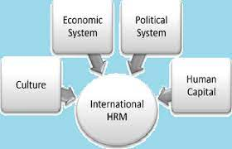
Figure 1: International HRM and its elements
(Edward and Bach, 2012)
I am emphasizing mainly on the recognizing the IHRM elements so that I can carry out proper HR planning on the basis of which I can execute the strategies in the company. The elements of IHRM are presented in figure 1 which mainly includes the culture of the workplace, economic system, political system and the human capital.

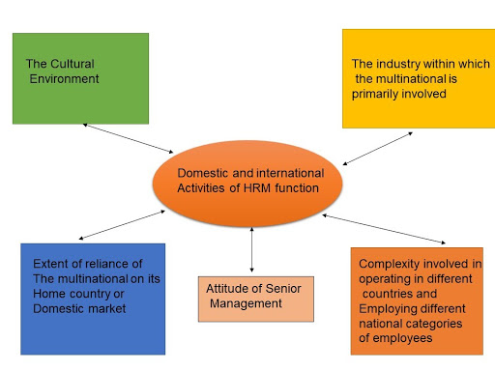
Figure 2: HRM and IHRM activities and function
(Schuler, Jackson and Storey, 2001)
To address all the elements of the IHRM it is important to carry out different activities which includes managing the senior sector, understating the complexity of operating in different countries, dealing with an extensive range of employees and maintaining the cultural environment.

Staffing Retention
Staff and employee retention is a human resource management area where significant change is required to motivate employees at my company is based on the staff retention (Carolina Machado & Pedro, 2014). The staff retention process mainly revolves around encouraging employees' intention to stay in the organization rather than quitting their job for another opportunity. In order to execute the staff retention strategies in my organization, I implied the control theory. The Control theory by Barrows and Neely (2012) centers around control system which ought to be forced at all levels of an association. There are various types of control which an association can use to get the ideal outcomes, for example, hierarchical construction, conduct controls like standards and strategies of an association or effective performance management. These outcomes must be consistent with the destinations and objectives of a general association.

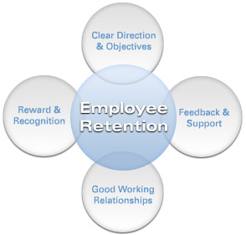
Figure 3: Employee Retention Process
(Das and Baruah, 2013)
The employee retention process that I included in my HR planning includes the four aspects as shown in the figure 3. I figured out that it is important to have skilled labor in my team so the first step is to identify talent in the individuals and plan to enhance the talent wherever appropriate. Secondly, when it is verified that there is skilled and effective employees in the team, the reward and recognition system must be introduced as it tends to boost the good working relationships in the workplace.
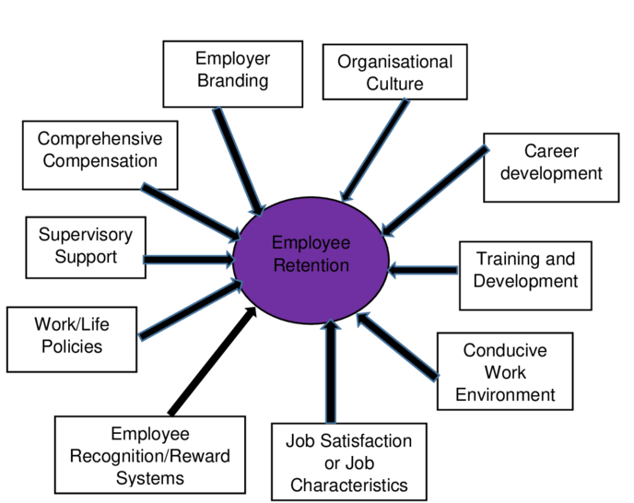
Figure 4: Employee Retention aspects
(Cloutier et al., 2015)
The employee retention strategies that I will execute in my company includes the following:
- The importance of rewards and recognition can be understood by reviewing the human resource motivation theory that suggests that employees prefer staying in the organization that offers them fiscal and non-fiscal benefits in the form of bonuses, salary increments, and/or certifications.
- Other than this, my company would offer career development opportunities to keep employees motivated and retained.
- As an HR Director of the human resource management team of my company, the staff can be retained by introducing rewards and recognition programs for employees who perform well. Other than this, employees who visit the office during the COVID-19 era will be given extra pay. The desire to attain extra pay will force employees to visit the office, and thus it will become possible for my company to resume their work.
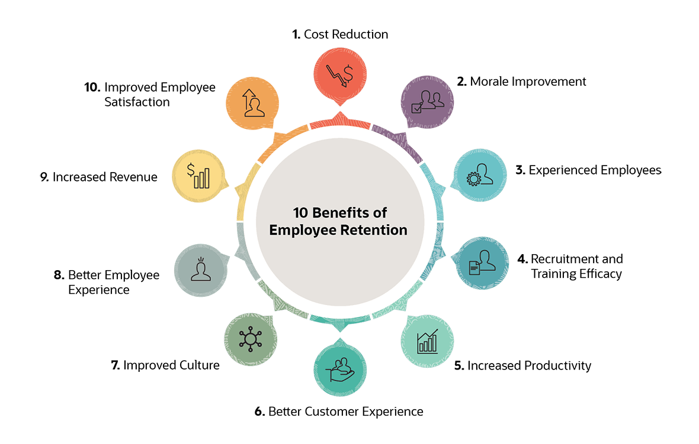
Figure 5: Employee Retention Benefits
(Cloutier et al., 2015)
Moreover, displaying good behavior at the workplace where the senior management team acknowledged employees' effort is considered an effective approach for employee retention. Hence, with this strategic plan, the employees in my organization will feel valued, appreciated, and more importantly, they will develop a sense of belonging to the organization as their hard work and dedication will be acknowledged, and they will be given fiscal advantage for their performance as well.

Staffing: Recruitment and availability of skilled local labour
One of the most significant aspects of the human resource management program is based on recruitment, which mainly emphasizes hiring employees and training the existing workforce to become more competent and proficient for the company to accomplish the targeted goals and objectives (Zhang, et al., 2018). For this aspect, I have implemented the goal setting theory of motivation by Locke.
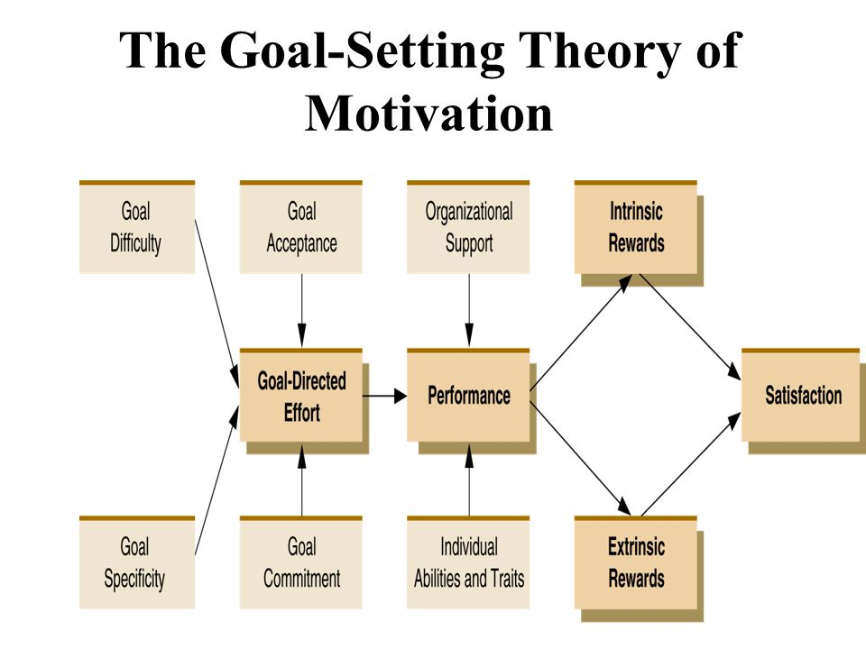
Figure 6: The Goal Setting Theory
(Locke and Latha, 2006)
By considering the goal setting theory, I would be able to carry out the tasks that I have planned for the HR department in a more measurable and precise manner. Such as, it would allow me to carry out the training and development programs and retention process for the employees in a better cost-effective manner. The SMART technique for goal-setting can be adjusted pleasantly to the main rule of the Locke and Latham theory, which advances clearness. Guaranteeing that a goal is explicit, quantifiable, attainable, applicable and time-bound can help intensify an undefined goal, for example, "I need to make more deals." This sort of goal is almost difficult to gauge, and it's not especially rousing, all things considered. Goal setting and errand execution continue along a comparable track, Locke and Latham say, when a goal is sufficiently provoking to be inspiring however not so troublesome that it is difficult to achieve (Latham and Lee, 1986). Accomplishing a harmony between yearning yet feasible goals isn't in every case simple, yet it can take advantage of two common human senses. On the other hand, numerous individuals adapt to the situation, some of the time astonishing even themselves. Given this dynamic, composing testing group goals can now and then be simpler for entrepreneurs, who can add a cordial cutthroat component as a motivation.
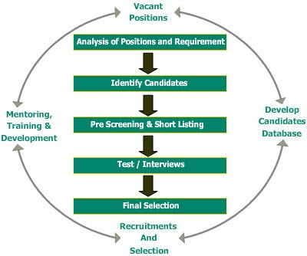
Figure 7: Recruitment process
(Edwards and Bach, 2012)
The company currently follows a conventional recruitment model in which it first displays the job advertisement on different platforms and portal. The applicants are invited for the face-to-face interview to the headquarter and then the final decision of recruitment is taken by the HR Manager. However, this recruitment model is not feasible during the COVID-19 era, as candidates cannot be invited to the office for a face-to-face interview (Collings, et al., 2021). In this concern, the company is suggested to focus on digitalizing its recruitment process by introducing online interviews. One major factor that makes this proposed human resource strategy effectual for my company is that it will make the potential candidates feel valued as the company for their safety gives them an opportunity to give online interviews. Hence, they will get encouraged to work at this organization. As a result, the company will get more skilled labors during this intense situation.
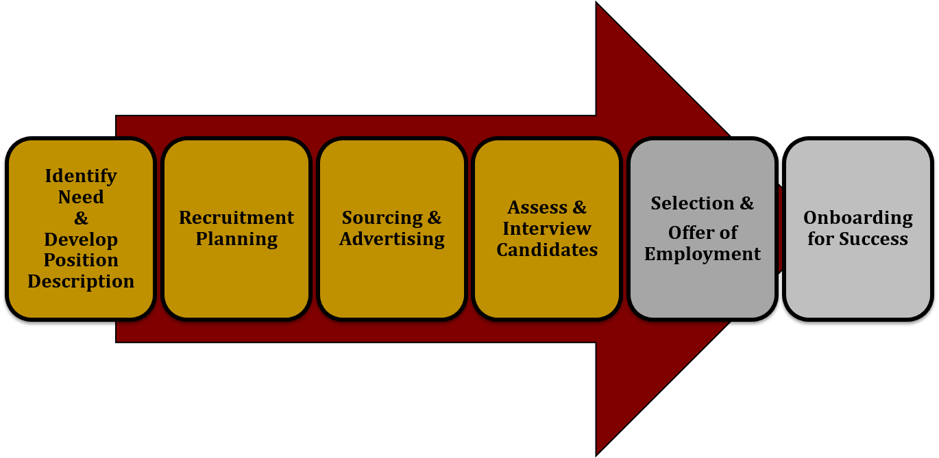
Figure 8: Overall recruitment program and selection
(Das and Baruah, 2013)
Apart from this, it is also suggested that the recruited employees must be given proper training to enhance their competence and proficiency to perform more effectively (Peerzadah, Mufti, and Nazi, 2018. This training program will help employees feel valued when they invest in training them to improve their skills and traits. Hence, this will increase the employee’s dedication to be more loyal to the organization and thus perform more effectively to make my company more successful.

Change Management
Change, mainly positive change, is considered to be one of the essential elements of any corporation as it helps the company to introduce new programs, activities, and practices that show consistency with newer trends and paradigms (Lengnick-Hall, Neely, and Stone, 2019).
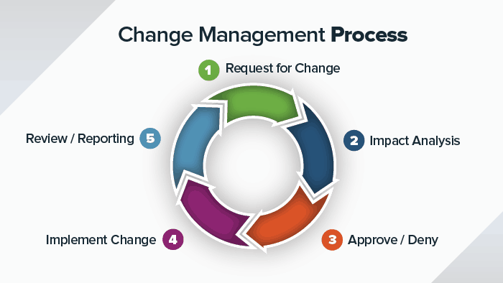
Figure 9: Change Management Process
(Shalender and Yadav, 2019)
My organization is also essentially in need to introduce different human resource management practices and activities to motivate employees to perform more effectively. For example, the company as per the Kottler’s eight steps to change has come up with new strategies that are more beneficial. The first change, which is required to be introduced at International Techno Corporation is that it needs to introduce flexible timings for workers as now employees prefer working in an environment where they do not have to follow a strict structure. In fact, they are given the liberty to work as per their own desire and attributes. Hence, employees must be given more freedom to make strategic decisions and thus complete the project in their own way. This change will help employees feel more valued as their perception will be encouraged and acknowledged by the company.
Another change, which is considered essential for the company’s human resource management planning, is based on performance appraisal. This strategic process will assist the company in identifying the strengths and weaknesses of the workforce. Hence, through this identification, the company will introduce a strategic action plan to overcome the weakness using the strengths they entail. Moreover, a change in the organizational environment must be introduced by replacing the autocratic leadership style with the democratic leadership style that assures that the opinion of employees is given preference. With this strategic action, the employees will feel encouraged and valued as their opinions will be considered by the senior management team for making a strategic decision (Shalender and Yadav, 2019). .
Apart from this, the company must also focus on bringing change in its employee management and handling process by introducing a diversity program that ensures all employees are treated equally and respectfully. This will assist the company in promoting collaboration and collectiveness within the corporation.
The strategic model, which is required to be followed to make this change management program successful based on Lewin Change Model. All programs will be unfreezing at the preliminary stage to determine the required changes in the human resource management program. The second phase will focus on the change/medication in which the required changes will be introduced. The last phase is based on refreezing in which all new programs are introduced in the organization.
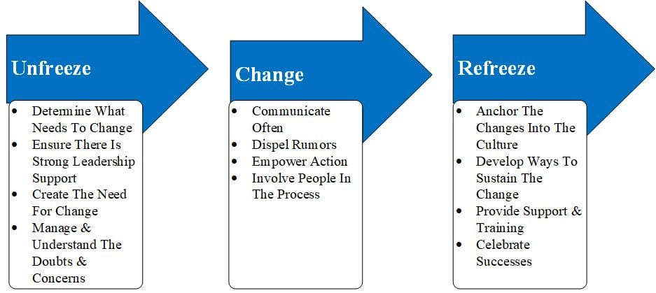
Figure 10: The Lewin Change Model
This phase will ensure that the new diversity programs, training programs, employee health and safety programs, etc are introduced at my company to increase employee motivation and loyalty with the company.

Conclusion
In terms of internal human resource management practices at my Corporation, it has been considered that the company mainly relies on innovation and creativity in its automobile production and administration. Hence, the company has to keep employees encouraged to take part in the innovation and creativity designing process of automobile. However, employees' changing demands, such as greater compensation and rewards, make it problematic for the company to enforce employees to contribute in the innovation and development programs. As a result, the company needs to train its employees while offering reimbursement to ensure that its team members get motivated to play a vital role in enabling the company to become more innovative and creative.
In this concern, it has been proposed that my company must focus on using change management, recruitment, and retention programs to elevate the motivation level of its employees and thus persuade them to perform more effectively by offering them reimbursement career development opportunities, and rewards.

References
- Allen, 2012; Sparrow, 2004). Anwar, et al., 2020; Kidwell, Eddlestonand Kellermanns, 2018).
- Allen, D.G. (2012) Managing employee turnover [electronic resource] dispelling myths and fostering evidence-based retention strategies. 1st ed. Phillip C. Bryant (ed.). [New York, N.Y.] (222 East 46th Street, New York, NY 10017) Business Expert Press
- Anwar, N., Mahmood, N.H.N., Yusliza, M.Y., Ramayah, T., Faezah, J.N. and Khalid, W., 2020. Green Human Resource Management for organisational citizenship behaviour towards the environment and environmental performance on a university campus. Journal of Cleaner Production, 256, p.120401.
- Armstrong, M. (2011) Armstrong’s handbook of strategic human resource management. Fifth edition. London, Kogan Page.
- Armstrong, M. (2014) Armstrong’s handbook of human resource management practice,13th edition. Stephen Taylor (ed.). London, Kogan Page. Torrington, D. (2020) Human resource management. Eleventh edition. Harlow, England, Pearson.
- Armstrong, M. (2016) Armstrong’s handbook of management and leadership for HR: developing effective people skills for better leadership and management. Fourth edition. London, England; Philadelphia, Pennsylvania; New Delhi, India; London, England ; Philadelphia, Pennsylvania ; New Delhi, India :; London, England ; Philadelphia, Pennsylvania ; New Delhi, India :, Kogan Page.
- Barrows, E. and Neely, A., 2012. Managing Performance in Turbulent Times. Wiley, Hoboken.
- Briscoe, D.R. (2007) International human resource management [electronic resource]: policy and practice for multinational enterprises . 3rd ed.
- Cloutier, O., Felusiak, L., Hill, C. and Pemberton-Jones, E.J., 2015. The Importance of Developing Strategies for Employee Retention. Journal of Leadership, Accountability & Ethics, 12(2).
- Collings, D.G., Nyberg, A.J., Wright, P.M. and McMackin, J., 2021. Leading through paradox in a COVID‐19 world: Human resources comes of age. Human Resource Management Journal.
- Coomber, I., 2017. Vauxhall: Britain's Oldest Car Maker. Fonthill Media.
- Das, B.L. and Baruah, M., 2013. Employee retention: A review of literature. Journal of business and management, 14(2), pp.8-16.
- David G. Collings, Kamel Mellahi, & Wayne F. Cascio (eds.) (2017a) The Oxford handbook of talent management / [electronic resource]. Oxford University Press. Gibb, S. (2011) Human resource development: foundations, process, contexts. 3rd edition. Basingstoke, Palgrave Macmillan.
- Edwards, M.R. and Bach, S., 2012. Human Resource Management in Transition. Managing Human Resources: Human Resource Management in Transition, pp.1-17.
- Heery, E. (2017) A dictionary of human resource management / [electronic resource]. 3 ed. Mike Noon (ed.). [Oxford] :, Oxford University Press.
- Holbeche, L. (2009) Aligning human resources and business strategy [electronic resource] . 2nd ed. Amsterdam; Boston, Butterworth-Heinemann.
- Hugh. Scullion & David G. Collings (eds.) (2011) Global talent management [electronic resource] New York, Routledge.
- Kidwell, R.E., Eddleston, K.A. and Kellermanns, F.W., 2018. Learning bad habits across generations: How negative imprints affect human resource management in the family firm. Human Resource Management Review, 28(1), pp.5-17.
- Kushwaha, P., Yadav, P. and Prasad, J., 2018. Impact of enterprise resource planning on human resource management in automobile sector: Statistical analysis. Journal of Statistics and Management Systems, 21(4), pp.601-615.
- Latham, G.P. and Lee, T.W., 1986. Goal setting. Generalizing from laboratory to field settings, 101, p.117.
- Lengnick-Hall, M.L., Neely, A.R. and Stone, C.B., 2018. Human resource management in the digital age: Big data, HR analytics and artificial intelligence. Management and technological challenges in the digital age, pp.13-42.
- Locke, E.A. and Latham, G.P., 2006. New directions in goal-setting theory. Current directions in psychological science, 15(5), pp.265-268.
- Muller, M. (2013) The manager’s guide to HR [electronic resource]: hiring, firing, performance evaluations, documentation, benefits, and everything else you need to know. 2nd ed. New York: AMACOM American Management Association; Society for Human Resource Management.
- Patricia Ordóñez de Pablos & Robert D. Tennyson (eds.) (2014b) Strategic approaches for human capital management and development in a turbulent economy [electronic resource]. Hershey, PA, Business Science Reference.
- Peerzadah, S.A., Mufti, S. and Nazir, N.A., 2018. Green Human Resource Management: A Review. International Journal of Enhanced Research in Management & Computer Applications, 7(3), pp.790-795.
- Pilbeam, S. (2010) People resourcing and talent planning: HRM in practice. Fourth edition. Marjorie Corbridge (ed.). Harlow, England, FT Prentice Hall.
- Randall S. Schuler & Lisbeth M. Claus (eds.). Abingdon [England] ;; New York, NY :, Routledge. Carolina Machado & Pedro. Melo (eds.) (2014a) Effective human resources management in small and medium enterprises global perspectives. Hershey, Business Science Reference.
- Ridgway, M., 2019. Brexit: human resourcing implications. Employee Relations: The International Journal
- Schuler, R.S., Jackson, S.E. and Storey, J., 2001. HRM and its link with strategic management. Human resource management: A critical text, 2, pp.114-130.
- Shalender, K. and Yadav, R.K., 2019. Strategic flexibility, manager personality, and firm performance: The case of Indian Automobile Industry. Global Journal of Flexible Systems Management, 20(1), pp.77-90.
- Sparrow, P. (2004) Globalizing human resource management [electronic resource]. Chris. Brewster & Hilary Harris (eds.). London; New York, Routledge.
- Stephen Bach & Martin R. Edwards (eds.) (2013) Managing human resources: human resource management in transition. 5th ed. Hoboken, New Jersey, Wiley.
- Zhang, Y., Liu, S., Liu, Y., Yang, H., Li, M., Huisingh, D. and Wang, L., 2018. The ‘Internet of Things’ enabled real-time scheduling for remanufacturing of automobile engines. Journal of cleaner production, 185, pp.562-575.

