

BA BUSINESS MANAGEMENT

Group assignment

Module: Academic skills
Code: LCBB4006
Lecturer: Dr Lizeta Demetriou
Name: Biserka Dimitrova, Milena Adzhemova, Nezabravka Vasileva, Nikol Stoyanova, Tanya Garabinska
Student ID:2131057,2129045 ,2129046 ,2130583,2129044

SUBMITTED ON THE 5^{th of} September 2022

Table of contents
- Introduction…………………………………………………………………………………...3
- Time management…………………………………………………………………………...3
2.1. The importance of time management as a student……………………………….3
2.2. The importance of time management in the workplace …………………………5
2.3. Factors affecting time management………………………………………………..6
2.4. Recommendations on how to improve time management skills………………...6
3. Teamwork………………………………………………………………………………………7
3.1. Teamwork benefits…………………………………………………………….……7
3.1. Problems in the team, their meaning and how to avoid them………………….8
4. Conclusion………………………………………………………………………………….….9
5. References List……………………………………………………………………………….10

Introduction
Time management and Teamwork are abilities, that help students to have better performance at school, to develop their thinking, as well to enjoy their study and receive high grades. Time management is the skill, showing them how to organise their time to achieve quick, easy success and to spend more time with the things love to do. Effective time management in school involves the learner applying time-saving strategies and making the most use of their time. According to Cottrell (2019) time management is equal to study success and student success are affected by two time-based factors: how much is the spent time and how well is used. Lack of time management skills can have a major negative impact on the studying and learning process as one can fail to accomplish his or her learning goals. Students are responsible for organising their study time, which can be a huge challenging task. Another challenge is the ability of teamwork.
Teamwork is the process whereby a group of people pool their resources and skills to work together and achieve a common goal. (Mackall, 1998) Working as a team is advantageous and may provide much better results at business, at school, or even at the university. A company needs highly engaged teams because when they collaborate, they are more effective communicators, more productive, and motivated, which increases profitability and enhances customer service. The ability to make decisions and solve problems has significantly improved. Employee responsibility for the work process is increased as a result.
This essay evaluates the importance of time management and teamwork in future academic work and work please.

Time management
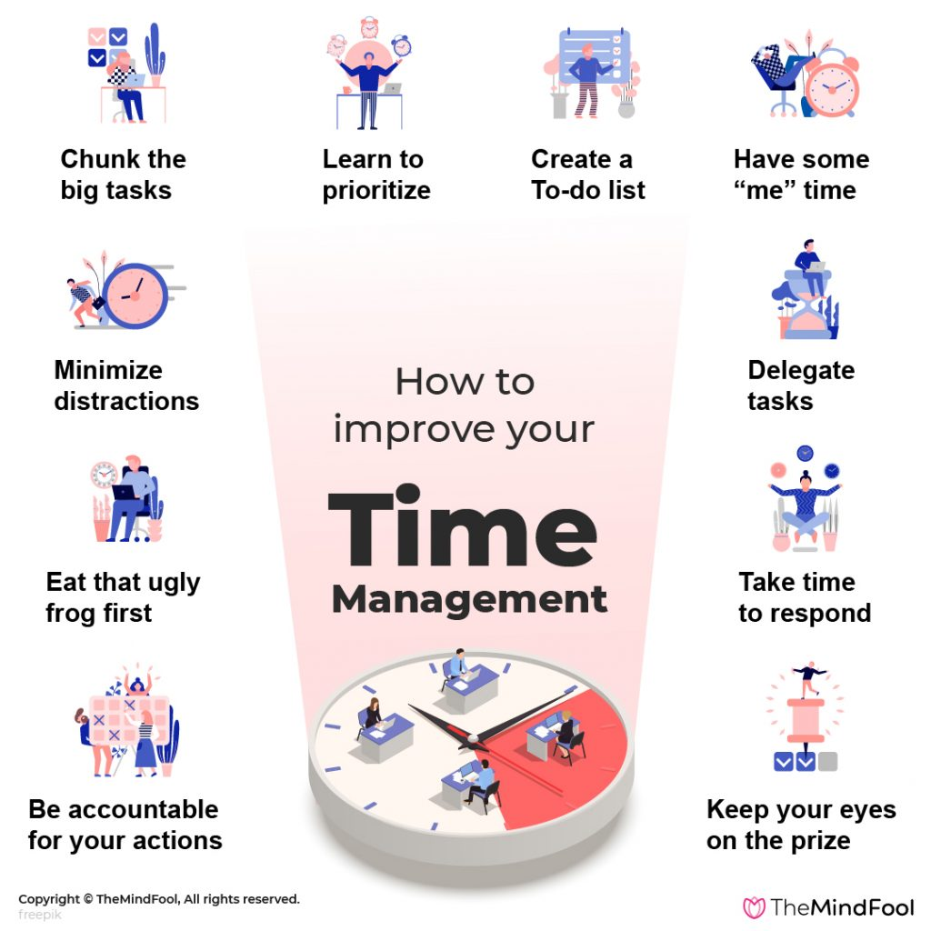

The importance of time management as a student

Time management matters for students as it can increase their study success. A student is likely to perform well in his or her studies if they put more time into various study tasks. Students are likely to achieve well if they effectively manage the time they use to study (Razali et al., 2018). Well-managed time means that one has time for basic things such as sleeping and eating properly. It means that one can learn to juggle various study demands, including personal interests, social life, family, and personal commitments. Effective time management means that one feels confident in approaching different matters, which means that they do not miss out or forget important things.
Time management is of great importance for future academic work. According to Luardo et al. (2019), proper time management is essential in the learning process as it makes one more effective. Rather than being caught up in multitasking, time management allows one to focus on one activity. This allows the student to give their best at the activity, which can result in the faster achievement of personal learning goals (Luardo et al., 2019). For example, if a student wants to improve his or her grades in certain subjects at a learning institution, managing study time and scheduling extra time to work on the subject can help in improving the grades faster. As such, in future academic work, effective time management can help one achieve academic goals faster.
Time management is also important in learning as it can help students prioritise their work. When coming up with a study timetable, having effective time management skills can allow one to focus on the more urgent and essential tasks (Adams and Blair, 2019). This can improve the learning session as students can manage to create time depending on the urgency and requirements of the tasks. This makes it possible for students to complete the essential and important tasks on time as they can plan and set a considerable amount of time to achieve them (Adams and Blair, 2019). This increases one's chances of success in the study process in future academics because one can complete both individual and group work on time.
Effective time management can help prevent procrastination. Procrastination, according to Wolters and Brady (2021), is a slippery slope that can result in students being highly stressed and frustrated with the learning process, which can affect their grade levels. Effective time management also makes it possible for students to allocate sufficient time to research a topic well, which can improve their ability to handle assignments and tasks (Wolters and Brady, 2021).
A student should learn how to manage distraction and procrastination. Cottrell (2019) asserts that effective study depends on the student’s state of mind, time, and space. Effective learning also depends on how the student organises his or her study materials to suit their learning styles. As such, to manage time during the study, the first step is to create a state of mind that allows one to study effectively. According to Cottrell (2019), students have a major challenge in getting into the right studying mood. This can be due to distractions such as phone calls, texting and tweeting, housework, TV, browsing online, and endless cups of coffee. This can result in one focusing on different things rather than getting down to study.
A successful study session is one where students can learn without distractions. To achieve this, it is important to identify and manage distractions (Cottrell, 2019). Managing distractions can be achieved by identifying the time-eating danger zones. The most common form of distraction is online. Although the sites can be useful in one’s learning process, they can distract students by taking too much of their time. This can lead to easily moving from the main purpose of learning. It is important to notice the danger zones that eat into one’s time. Setting a considerable amount of time in these danger zones and sticking to the time limits can improve the time-management process of the student. This shows that identifying and managing distractions can improve the study sessions of the students.
Effective time management can benefit a student’s future academic journey as it can boost their self-confidence and provide them with improved career opportunities. Baker et al. (2019) argue that effective time management allows one to complete his or her work on time. This can have a positive impact on students as it creates a sense of accomplishment and confidence in one’s capabilities. By completing a to-do list, one can have these feelings, which can motivate him or her to improve their time management skills. Based on the fact, that it can improve a student's chances of succeeding in their career journey (Baker et al., 2019), having effective time management skills can impact a student’s journey outside the academic journey.

The importance of time management in the workplace

Effective time management skills can have several benefits for employees. One benefit is that it can result in improved and better performances. Laybats and Tredinnick (2019) assert that effective time management can improve how one works in an organization. This is based on the fact, that he or she can understand the required tasks and the amount of time that should be given to each task. Understanding the required tasks can help the employee make a perfect schedule, which can help in the effective management of time (Laybats and Tredinnick, 2019). Sticking to time can help decrease the possibility of procrastination. This can improve the working process of the employees as they can spend less time deciding on the required tasks to be accomplished (Laybats and Tredinnick, 2019). Time management skills can help one focus on the most essential tasks and avoid activities that waste their time. This can improve the employee's overall productivity.
Time management in the workplace is essential as it can make it possible for people to deliver work on time. Effective time management means that employees can prioritise the most essential tasks and complete them on time, as well it can be challenging for them to keep track of deadlines without time management strategies (Indradevi, 2020). However, time management skills make it easy for one to concentrate on the most urgent tasks, which allows to keep their deadline.
Time management skills are essential in the workplace as they can help in improving the quality of work.

Factors affecting time management

Time management for students is affected by several distractions and challenges. The greatest distraction for most students is social media. Cottrell (2019) asserts that in the social media era, students spend a lot of time juggling through different social media apps such as Facebook, Instagram, Twitter, and YouTube. The constant urge to keep checking social media platforms is based on the fact, that people feel like they are missing out on something important. Another challenge in time management for students is poor concentration. Students are more likely to drift during study time due to the inability to maintain focus. This can also be affected by the fact that students lack a to-do list, which means that they can fail to accomplish much when studying (Öksüz, Guvenc, and Mumcu, 2018). For example, when searching for something online, some tasks can remain undone. This can affect students’ learning process.

Recommendations on how to improve time management skills

Effective time management can be integral to the learning process of students. As such, Cottrell (2019) recommends several strategies that students can use to save time. The first strategy is to save time when making notes, which means that one should only focus on ensuring that notes are legible and useful. Another strategy is saving time by copying between files, where one can use software such as Google Docs and Dropbox (Cottrell, 2019). Students can also save time by making the most of spare moments, which can include activities such as listening to revision points or lecture materials when on activities such as queuing. Students can also manage their time by saving time by reading and looking for notes. Another time management technique, as asserted by Cottrell (2019), is saving time in writing references by using electronic referencing tools for developing ready-to-use citations. Students can save time by using word limits to focus their energy, which means that one should ensure that they should write as per the recommended number of words in assignments. Students can save time organising information by using tools such as the Macmillan Student Planner, which can avoid wasting time coming up with manual lists.
Another strategy for achieving effective studying is creating the right environment. One can achieve this by making a conscious note regarding the type of environment that suits his or her study style. Some students can prefer having background noise during studying, while others can prefer a quiet environment. Some students can learn better in a library, while others can learn better at home. Some are individual learners, while others prefer group learning. As such, a student needs to identify the right environment that suits his or her learning style as it can improve the learning results.

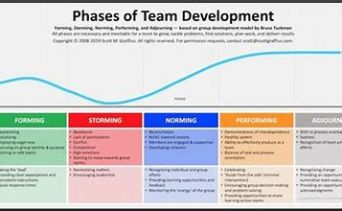
Teamwork

Models: Tuckman’s Stages of Team Development
Teamwork benefits

Teamwork is the process whereby a group of people pool their resources and skills to work together and achieve a common goal. (Mackall, 1998)
Working as a team is advantageous and may provide much better results at business, at school, or even at the university. A company needs highly engaged teams because when they collaborate, they are more effective communicators, more productive, and motivated, which increases profitability and enhances customer service. The ability to make decisions and solve problems has significantly improved. Employee responsibility for the work process is increased as a result.
The model's prominence reflected its era, a reaction to both the paucity of relevant research and the expanding role of groups in the workplace. By outlining the novel ways that individuals were collaborating, assisting group members in comprehending how the development process was progressing, and giving consultants a tool to forecast the stages of growth in groups, it proved helpful in practise. (Bonebright, 2010)
In the model's initial phase, called "testing and dependency," participants become familiar with the task at hand and set behavioural norms and parameters. The second stage is a period of intergroup conflict that is marked by division and polarisation over interpersonal problems. Cohesion, the third stage, is when members embrace one another's quirks and voice their ideas. This phase involves creating mutually understood mental models and learning how to cooperate effectively. According to the first concept, the group develops "functional role relatedness" in the last stage. The group acts as a "problem-solving tool" by adapting and taking on responsibilities that will improve the task activities. Task performance is supported by structure. Roles become functional and adaptable, and group energy is directed toward the goal. The fifth stage was established, called "adjourning," based on this analysis.
The model was often discussed in management and practitioner literature because it was simple to use, comprehend, and adapt to a variety of scenarios.
The small group development model developed by Tuckman and Jensen has a distinctive history since it has been heavily cited by both academic researchers and HRD practitioners and it is still one of the most frequently used group development models in education. (Bonebright, 2010)
This assignment serves as a great example of teamwork. The tasks were distributed fairly among the team members, and while we all supported one another, we concentrated on finishing the work at hand. The productivity increases when a larger team is involved. Each team member offers their viewpoint, and the choice is made by the entire group. The team is more motivated and involved in the process when they are working together since the workload is dispersed. This is how working together has led to the development of solid connections. Working as a team fosters dependable friendships and boosts efficiency in the workplace or university.
Tuckman's concept is applicable to a wide range of situations and settings. It may be used to simply create a new team within an organisation to complete a task or project. This approach can also aid individuals in comprehending that disagreements, negative emotions, and other undesirable results are occasionally possible in a team, particularly while it is first forming. This is a result of many ways of thinking, cultures, and understandings, yet it may also result in several achievements.

Problems in the team, their meaning and how to avoid them
It is important that every member of the team knows the core values of the company or group and does not violate them. An atmosphere of fear and silence can mask the presence of problems. When a person is afraid and silent, this can lead to very serious consequences. Such members will also not ask for help, because this would show their incompetence. Creating a culture in the company or group where people can freely communicate with each other is fundamental in forming a team. Feedback should be encouraged, and constructive criticism should not be taken as a personal insult. When the team is silent, it means that people are afraid of conflict. The conflict itself, which develops constructively, can reveal many hidden problems, but also opportunities. In the dispute and the exposure of different points of view, it often raises new ideas. The discussion in the team, the encouragement to ask questions and give an opinion is an important key to the group's success. When people are aware of the goals, it is easier for them to complete their tasks. Work out a strategy to achieve your goal. Identifying people who block change and talking frankly to them can make it easier for the rest of the team to work.
Conclusion
In conclusion time management is integral to a student’s learning journey and it is important for them to have effective time management skills. Time management skills can have positive impact on both academic and professional life. These skills help students to priorities their tasks and achieve their learning goals better. In the workplace they are important because they allow employees to improve their productivity and efficiency.
Effective time management is to have advantage of superior value tasks, to avoid procrastination, to prevent from activities, which waste a time, to planning the activities in front, to do the work on time and before the deadlines. It allows individuals to do more and better work in a reduced amount of time.
Time management is the most important skill ever and fortunately it can be developed. Therefore, online can be found a lot of programs for timesaving as time management planers or to-do lists.
It is easy do download any of them, even on mobile phone and even for free.
Everybody knows the meaning of the time and in this report was shown the benefits of time management. Although this work showed one more so important skill, and this was the teamwork.
We are born as a member of community /family, school, work, friends, etc/. Each person is different and unique, and each has different qualities and skills. One member will have analytical thinking, second will take care for deadlines, third will be aware for any treats, forth will see the opportunities. Time management and teamwork are mainly classified as Academic Skills, but they are also skills for everyone part of humans’ life.

References List:
Adams, R.V. and Blair, E., (2019) Impact of time management behaviours on undergraduate engineering students’ performance. Sage Open, 9(1).
Amida, A., Algarni, S. and Stupnisky, R., (2020) Testing the relationships of motivation, time management and career aspirations on graduate students’ academic success. Journal of Applied Research in Higher Education.
Baker, R. et al (2019) Does inducing students to schedule lecture watching in online classes improve their academic performance? An experimental analysis of a time management intervention. Research in Higher Education, 60(4), pp.521-552.
Cottrell, S. (2019) The study skills handbook. 3 rd. ed. London: Bloomsbury Publishing.
Indradevi, R. (2020) Workplace spirituality: Successful mantra for modern organization. Journal of Critical Reviews, 7(6), pp.437-440.
Laybats, C. and Tredinnick, L. (2019) Increasing importance of knowledge management in the workplace. Business Information Review, 36(4), pp.146-148.
Luardo, A., et al. (2019). The Benefits of Time Management on Academic Performance of Grade 12 ABM Students in BCP SY 2018-2019. Ascendens Asia Singapore–Bestlink College of the Philippines Journal of Multidisciplinary Research, 1(1).
Razali, et al. (2018) ’The impact of time management on students’ academic achievement’. In Journal of Physics: Conference Series, 995(1). IOP Publishing.
Wolters, C.A., and Brady, A.C. (2021) College students’ time management: A self-regulated learning perspective. Educational Psychology Review, 33(4), pp.1319-1351.
Mackall, D. (1998) Teamwork skills. 3rd ed. Chicago: Ferguson Pub.

Bonebright, D. (2010) ‘40 years of storming: a historical review of Tuckman's model of small group development’, Human Resource Development International, 13(1), pp.111-120.

