BMIH5007
Financial Management for the Hotel Industry

Student Name: Lavinia Irina Stan
Student ID: 1912876
Lecurer’s Name: Tristan Hawkins

Table of Contents
Introduction 2
Total revenue 2
Market position 3
Growth potential 5
Financial commitment to CSR 6
Recommendation 8
Conclusion 9
Reference 10

Introduction
The analysis focuses on the financial management of the hotel industry. This analysis is about a conducting about an in-depth analysis and a differentiation in between both of the prominent players In the hospitality industry which are Mandarin Oriental Hotel Group and Premier Inn. The objective of the report is to evaluate the respective approaches to financial management. The objective is to focus on evaluating the approaches to the financial management system. In considering most of the critical areas the effects of the financial performance and the sustainability is also going to be discussed appropriately.

Total revenue
Mandarin Oriental Hotel Group
Mandarin Oriental Hotel Group is a global hotel investment and the management group with luxury hotels, residences and resorts for an after destinations in all over the world. The hotel has been receiving a global recognition and awards for its outstanding services and quality management system (Mandarinoriental, 2023). This also carries a stronger pipeline of hotels and residences under the development process. The group carries an equity-based interest in several properties and the adjustment about the net assets which is worth about 4.8 Billion on 30th June 2023 (Drury, 2021).
Focusing on the overall revenue of the company Mandarin Oriental Hotel Group it is observed that the current recorded revenue of the company is 0.45 Billion Dollars. In the year 2022, the company ben made a selling rate of 0.45 Billion which increased over the year 2021. In the year 2021, the revenue amounted to 0.31 Billion. In the year 2019, it recorded as 21 Million. The revenue is the overall amount of income that a company has been generating from the sales of the goods or services. Rather than the earnings not any of the expenses have been subtracted (Companiesmarketcap, 2023).
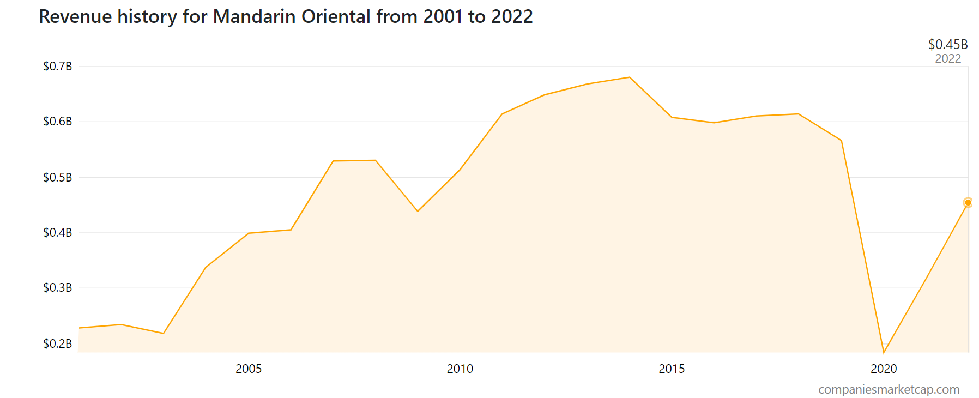
Figure 1: Revenue of Mandarin Oriental Hotel Group
(Source: companies market cap, 2023)
Premier Inn
The rate of the revenue of the company Premier Inn is mainly focusing on the business segment from the year 2019 to 2020 which was ended in the year 2022 to 2023. Focusing on the revenue from the accommodation it is observed that it is much higher than the beverage and food segment. In the year 2022/2023 it has been generating 1895 Million British pounds. As a focus on the profit rate, it is observed that The company Premier Inn has surpassed the pre-pandemic levels as one of the biggest budget hotel chains benefits from a demand surge in demand from cost-conscious holidaymakers (Statista, 2023). The company Premier Inn runs almost 900 hotels in both Germany and the UK as well as the restaurant chains which include Bar and Block, Beefeater and Brewers Fayre. It is going to benefit from the business scale of the company it also makes a combination between cost inflation and labour shortages. The expectation of the company’s Beat analysis it is observed that it has been reported 375 Million pretax profit for the year on March 3rd. In the year 2022, it is recorded at 58 million euros. On the other hand, in the year 2020, it improved by 34% as compared to the previous year (The Guardian, 2023).

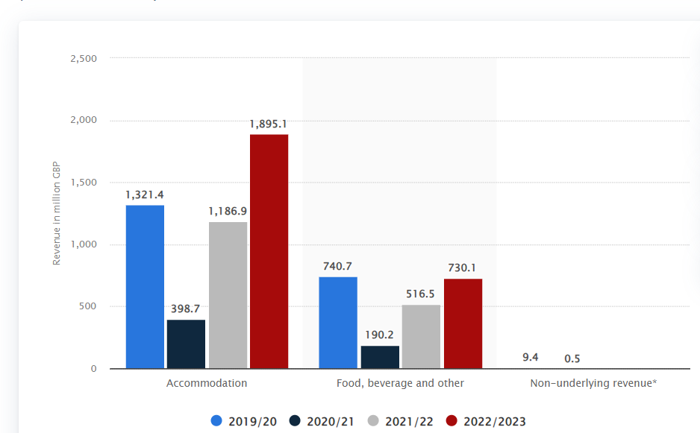
Figure 2: Revenue of Premier Inn
(Source: Statista, 2023)

Market position
Mandarin Oriental Hotel Group
The Mandarin Oriental Hotel Group has been committed to making a sustainable profitability and a long-term values of the stakeholders, the significance of the company has been benefitting the global brand recognition, proper management system and a stronger financial resources and controls. Mandarin Oriental Hotel Group have a strong and long-lasting goodwill for performing an excellent of guest service (Markets, 2023). A properly defined and energised culture of the company has been proving the efforts of each of the Mandarin Oriental Hotel Group for continually improving the services and giving them to their guests. The company has been focusing on the quality management system and continuous improvement which has led to the group improving the systems and processing them which guided the management generations in the efforts to pursue excellence efforts (Seal, 2019). The hotel has been gaining an improvement of 43.29% which amounts to 316.90 and 454.10 million while the net profit has been improving on the other hand in some of the sections the company have also gotten some loss which was 49.50m. The company has been acquiring 49% of the famous historic level of Bangkok. The marketing investment of the company has had a maximum effect on the brand (Mandarin Oriental, 2023).
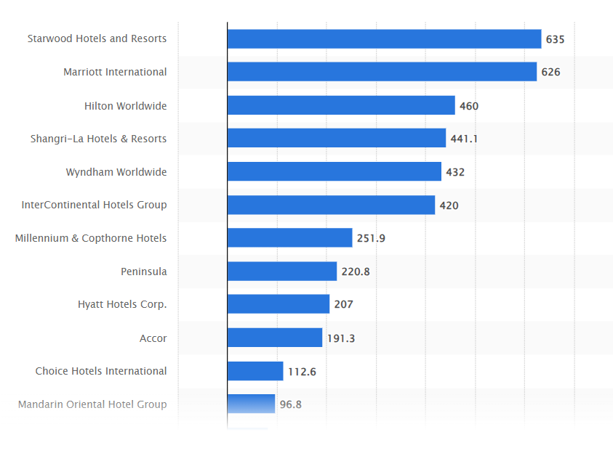
Figure 3: Market position of Mandarin Oriental Hotel Group
(Source: Statista, 2023)
Premier Inn
In the company Premier Inn In the overall hotel market in the UK between 2011 and the year 2015 together with having a forecast till the year 2021. The overall share of the company in the UK has been expected for a period. This will reach about 11 per cent in the year 2021. It is going to be marked an improvement in the market share which is almost doubled with the initial share. The Premier Inn is also one of the leading hotel chains in the UK. As focusing the shares in the company Premier Inn it is gained at 3% to a rate of 31.52 Euro as this been revealed which is improved to the market share in the department of hotel chain market of UK (Statista, 2016).
Focusing on the company observation it is observed that th overall accommodation performance of sales was ahead of 8.9% for a wider market structure. With chafing an overall market growth of 4.1% in the time of 11.4% of the hospitality sector in the UK. In a lockdown, the sales accommodation sales have been falling at 55.2% with the occupancy rate at 49.3%. The group sales were down by 55.6% in the third quarter by 70.2% (Sharesmagazine, 2021).
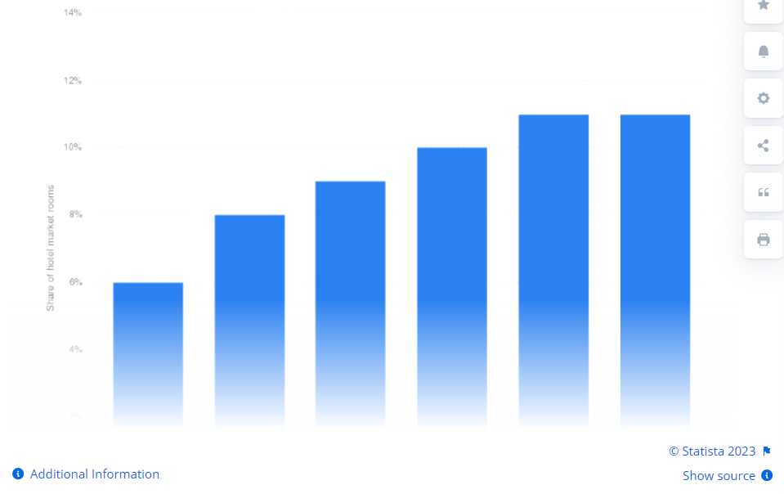
Figure 3: Market position of Premier Inn
(Source: Statista, 2023)

Growth potential
Mandarin Oriental Hotel Group
Though the company is a recognisable brand, has a base of loyal customers and has a robust development system, the company is positioned with the long-term improvement. This has been combining the revenue including turnover of the subsidiary hotels of the group for 100% of associated revenue, managed hotels and joint ventures. The financial performance of the company is improved in a significant manner as compared to the year 2020. However, the result has remained below the pre-pandemic levels with the underlying losses at 68 million euros. Combining the overall revenue of the hotel management been increased it to 78% in the year 2021 as this has been compared to the previous year. This has been benefitting from the relaxation level in travelling-based restrictions in most of the the parts of the world in the middle of 2021 (Mandarin Oriental, 2023).
The company has been boosted by covid 19, various receipts like government support from Europe, Rent concessions from Tokyo and the insurance of business interruption that has been proceeding for hotels in the USA. The adjusted net asset value per share is reflecting both of the independent valuations of the group. There was also a non-trading recorded loss of 74 million (Walker, 2021).
Premier Inn
The company Premier Inn is also focusing on gaining greater opportunities to expand it to Ireland and Britain as the independent hoteliers have been getting squeezed out of the business market. The company share of the company been rose to 5% after the company had been driving an improvement in adjusting the profits at 413 Million for the year 2023. This year the revenue has increased to 2.6 Billion. The share has increased to 18% in the past year as the company has been recovering from the pandemic and the plans for driving ahead with the expansion plans in Germany (Quinn, 2023).
Having a reduction in the hotel supply chain combined with the stronger demand of the project has created a greater opportunity for improving the Ireland and UK footprint from 110000 to 125000 rooms. The citing data that the independent hotels have been declined in a substantial manner in the period of the pandemic. It is believed that the operation-based challenges have been causing a shortage and a cost-based inflation which has been putting further pressure on th independent department. This is helping in creating a structural growth opportunity for the company all over the UK (Atrill and McLaney, 2021).

Financial commitment to CSR
Mandarin Oriental Hotel Group
Mandarin Oriental Hotel Group's competitive advantages are boosted through CSR efforts. Corporate social obligations are referred to as CSR. There are four aspects to the corporate obligations that apply to every company. These obligations fall under the categories of financial, legal, moral, and charitable obligations.
The economic responsibility
Businesses have a moral obligation to be profitable. For a firm to last over the long term, it must be lucrative.
The legal responsibility
Businesses have a legal obligation to follow the law. To conduct business in the market, organizations must adhere to a number of laws and regulations. They must adhere to ethical business principles. Both the federal and state governments produce these regulations .
The Ethical Responsibility
Doing what is right is a business's ethical obligation. A company has to have a moral code that directs it to act morally when appropriate.
Philanthropic responsibility
Being a good corporate citizen is a business's charitable duty. Businesses must by their very nature be charitable. Businesses have a duty to contribute back to society on their own initiative.
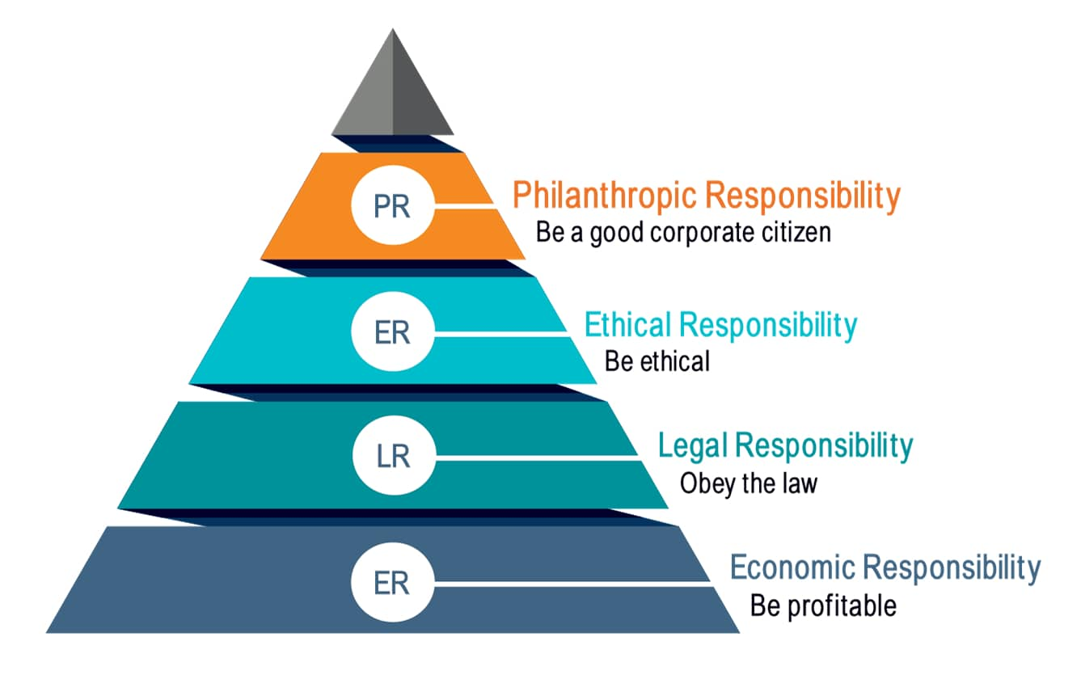
Fig 7: CSR of Mandarin Oriental Hotel Group
(Source: Green Business Bureau, 2022)
Premier Inn
Premier Inn uses CSR analysis to address and take into account the ethical, social, and environmental concerns in its supply chain. As a result, it can be claimed that CSR has been crucial in establishing the Premier Inn brand among investors, workers, and clients. The four sections that makeup Premier Inn's financial commitment to CSR are broken down below.
The economic responsibility
The company has been preparing the latest community after a new hotel or restaurant has been opened. The company has been supporting for sponsoring each of the team members of the latest sites (Premier inn, 2023).
The legal responsibility
Of giving a quality and affordable rates to the hotels for the guests in helping them live and work well has a positive effect in all over the world. With having no barriers to entry and the limit with the ambition to give a meaningful work career development chances for the team (Whitbread, 2023).
The ethical responsibility
In giving the quality and the affordability rates for hotels and for the guests in helping them live and work well is also affecting positively (Whitbread, 2023).
Philanthropic responsibility
The company plays a major role in this process. By charity fundraising or giving work experience chances are one of the biggest elements in the company (Premier inn, 2023).
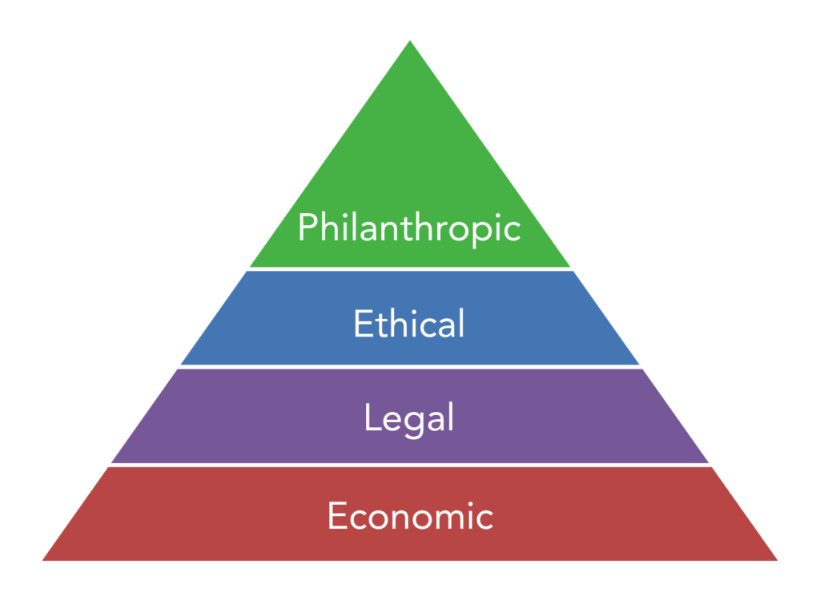
Fig 8: CSR analysis of Premier Inn
(Source: Lumen Learning, 2023)

Recommendation
Recommendation for Mandarin Oriental Hotel Group
It must build more reasonably priced hotels for individuals with lesser incomes if it wants to grow its company further. The costs of the rooms should decrease as a result of the impending inflation because fewer individuals will have cash on hand. Recently, Marriott International signed a contract with the career-development start-up Aminitae. We will be able to provide new job seekers with useful training for skills and opportunities thanks to this program.
Recommendation for Premier Inn
It may be suggested to the business to raise the financial elements' proportion. Because of this, the business may create more income streams than it does now. They are able to obtain a better rate of financial growth as a result. Additionally, it may be advised that the business step up its market research efforts. It could support the company's financial expansion.

Conclusion
Premier Inn and the Mandarin Oriental Hotel Group are both in the hospitality sector. The report's goal is to assess the various financial management strategies. The goal is utilized to concentrate on assessing the methods for the financial management system. The consequences of financial performance and sustainability are correctly examined when looking at most of the essential sectors.

Reference
Atrill, P. and McLaney, E. (2021). Management Accounting for Decision Makers, FT Prentice Hall.
Companiesmarketcap. (2023). Mandarin oriental (M04.SI) - revenueCompaniesMarketCap.com - companies ranked by market capitalization. Available at: https://companiesmarketcap.com/mandarin-oriental/revenue/#:~:text=According%20to%20Mandarin%20Oriental’s%20latest,sale%20of%20goods%20or%20services (Accessed: 17 October 2023).
Drury, C. (2021). (11th Ed) Management and Cost Accounting, London, Prentice Hall.
Green Business Bureau (2022) The CSR pyramid: Economic, legal, ethical, and philanthropic responsibility, Green Business Bureau. Available at: https://greenbusinessbureau.com/topics/csr/the-csr-pyramid-economic-legal-ethical-and-philanthropic-responsibility/#:~:text=Carroll's%20 pyramid%20 imposes%20a%20four,importance%20of%20 each%20 CSR%20 dimension. (Accessed: 17 October 2023).
Lumen Learning, (2023) Human Resources Management, Lumen. Available at: https://courses.lumenlearning.com/wm-humanresourcesmgmt/chapter/what-is-corporate-social-responsibility/ (Accessed: 17 October 2023).
Mandarin oriental. (2023). Business profile - corporate site. Available at: https://photos.mandarinoriental.com/is/content/MandarinOriental/corporate-business-profile (Accessed: 17 October 2023).
Mandarin oriental. (2023). Mandarin Oriental International Limited - Corporate Site. Available at: https://photos.mandarinoriental.com/is/content/MandarinOriental/corporate-19arMOIL (Accessed: 17 October 2023).
Mandarinoriental. (2023). Luxury 5 Star Hotels & Resorts Worldwide. Available at: https://www.mandarinoriental.com/en/investors/regulatory (Accessed: 17 October 2023).
Markets. (2023). FT.com. Available at: https://markets.ft.com/data/equities/tearsheet/summary?s=M04%3ASES (Accessed: 17 October 2023).
Premier inn. (2023). Force for Good | About Us | Premier Inn. Available at: https://www.premierinn.com/gb/en/why/force-for-good.html#:~:text=Reducing%20waste,-All%20waste%20from&text=We’re%20working%20to%20remove,refills%20at%20over%203000%20sites (Accessed: 17 October 2023).
Premier inn. (2023). Force for Good | About Us | Premier Inn. Available at: https://www.premierinn.com/gb/en/why/force-for-good.html#:~:text=Community,or%20providing%20work%20experience%20opportunities (Accessed: 17 October 2023).
Quinn, E. (2023). Premier inn eyes growth in Ireland and Britain amid squeeze on independent hoteliers, Irish Examiner. Available at: https://www.irishexaminer.com/business/companies/arid-41124373.html#:~:text=Premier%20Inn%20owner%20Whitbread%20said,climbed%20to%20%C2%A32.6bn (Accessed: 17 October 2023).
Seal, W. (2019). (6th Ed) Management Accounting, London, McGraw Hill.
Sharesmagazine. (2021). Shares Magazine. Available at: https://www.sharesmagazine.co.uk/news/shares/premier-inn-owner-whitbread-grows-market-share-during-lockdown (Accessed: 17 October 2023).
Statista. (2016). Whitbread: Premier Inn Hotel Room Share 2011-2021 statistic, Statista. Available at: https://www.statista.com/statistics/755691/premier-inn-share-of-hotel-market-rooms-united-kkingdom-uk/ (Accessed: 17 October 2023).
Statista. (2023). Whitbread Revenue by Business Segment 2023, Statista. Available at: https://www.statista.com/statistics/739891/revenue-whitbread-united-kingdom-uk-by-segment/ (Accessed: 17 October 2023).
The Guardian. (2023). The Guardian. Available at: https://www.theguardian.com/business/2023/apr/25/premier-inn-whitbread-pre-covid-profits-deals (Accessed: 17 October 2023).
Walker, J. (2021). Introduction to Hospitality, Harlow, Pearson.
Whitbread. (2023). Whitbread PLC. Available at: https://www.whitbread.co.uk/about-us/#:~:text=OUR%20PURPOSE,development%20opportunities%20for%20our%20teams (Accessed: 17 October 2023).
Whitbread. (2023). Whitbread PLC. Available at: https://www.whitbread.co.uk/about-us/#:~:text=OUR%20PURPOSE,development%20opportunities%20for%20our%20teams (Accessed: 17 October 2023).

