Module 6

Contents

Project Proposal P2
Introduction P11
Literature Review P15
Methods P23
Findings P30
1. Analysis and Exploration P30
2. Design Construction P33
3. Evaluation and Reflection P38
Conclusion P68
References P71
Appendices P77
Figure 1: Teaching Strategy Outline P12
Figure 2: Teaching Strategy (Colour-Coded) P35

Project Proposal

1.Project Title: Singing in Regional Accents: Why, How and When to incorporate accent training in singing lessons. A Strategy for Singing Teachers

2.The Context

This study is a continuation of my previous research into singing in accents. It focuses on practical teaching strategies developed from my own experience as a Singing teacher and also as a (spoken) Voice and accents teacher. The research responds to my aspirations to build a pedagogical bridge between my work across the disciplines of Singing and Voice/Accent training for musical theatre actors. Since embarking on this topic almost 2 years ago, my work has evolved from teaching Singing, Voice and Accents as separate disciplines in a conservatoire setting, to helping to reshape course content in order to provide a more integrated and holistic vocal training experience. Data gathered in Module 3 revealed the challenges many student singers have in moving away from a default US accent when singing despite mastering several other regional accents in spoken Voice lessons. Further to this, it revealed general enthusiasm amongst singing teachers for more in-depth knowledge on how to coach accents to singers (Unpublished, 2022). Recent anecdotal experience in the teaching studio has suggested there is an increased demand on musical theatre students to sing using their own native accents, regardless of character. Acknowledging this shift has persuaded me to refocus my interest in accent training to consider the audience’s thirst for authenticity in performance, as apposed to merely enabling versatility and increasing the actor’s accent ‘toolkit’ (Oram, 2021). It reaffirms the concept of the voice as representing the ‘persona’ of the performer (Kayes, 2018) and how this may interfere with accent training.

There is a growing demand for actors to perform ‘themselves’ rather than soley presenting a fictional character; there are on-going debates regarding whether or not an actor should attempt to adopt another accent (Harvey, 2023). With the multitude of musical styles that may occur within the genre of musical theatre, questions are raised around the adoption and training of accents; discussions around when and if to learn a new accent rather than simply how seem highly relevant amidst frequent discourse on cultural appropriation (Young, 2008, p. 2), and the wider cause to combat discrimination and out-dated stereotypes in drama training institutions (Oram, 2021).

The commonality of Estuary English (EE) and Multicultural London English (MLE) in and around London has meant that Received Pronunciation (RP) and Cockney are no longer dominant London accents (Altendorf, 1999). Where some drama training institutions have steadily reduced the focus on these accents, they are considered by many as essential skills to be learned, and are very much a part of Voice and Accent training in the institutions where I work. Nonetheless, we are now a far cry from historical theatre voice training methods, which strongly encouraged actors to adopt RP as their default spoken accent (Rodenburg, 1998).

There is now more widespread use of certain linguistic features, such as the labio-dental fricative (V) replacing the dental fricative (TH) in amongst young British people, regardless of class background (Altendorf,1999). Such features may still be considered vocal ‘faults’ by singing teachers (Mckinney, 2005), but it is hoped that this study will provide clarity and guidance around ‘appropriate’ accent features for singing, helping to balance artistry and creativity with authenticity and highly personal linguistic attributes.

The development of my teaching strategy has required the consideration of fundamental similarities and differences between speech and singing. Whilst acknowledging that they utilise the same physiological equipment for phonation (Wolfe et al., 2008), it is important to acknowledge the resonant properties (formant structure) and presence of vibrato in the singing voice (Sundberg, 1977; Sundberg, 1995; Horii, 1989, cited by Lavan, 2019, p. 93). When a person sings, their natural speech rhythm and intonation are adapted to align with a “predefined musical rhythm and melody” (Lavan, 2019, p. 93). Anecdotal experience working in conservatoire settings has led me to notice that actors are somewhat left to their own devices if they are required to sing in accents, having been taught accents solely in (spoken) Voice classes. It is hoped that my research will be of a transdisciplinary nature (Heizmann et al., 2021, p. 2), aiming to provide a useful teaching resource to singing teachers to better serve the industry expectations of their students.

3.The Justification

My research into the representation of regional accents on the musical stage has been spurred by the evolution of British-staged musicals produced over recent years; there has been an increase in the representation of British accents. The politically-charged pieces such as Theatr Clwyd’s (2018) staging of The Assassination of Katie Hopkins and National Theatre/Sheffield Theatres’ (2023) Standing at the Sky’s Edge, in addition to British-accented Broadway transfers including Wicked and Shrek, has led to casting directors requesting a wider range of accents than the ‘Standard US’ or RP typically required of long-running commercial musicals. Less successful attempts at British regional accents in musicals do not go unnoticed by theatre critics (O’Hanlon, 2016), and, due to the limited time a dialect coach may spend with cast members, it is reasonable to expect much of the accent groundwork to have been covered in Drama school training. Anecdotal experience in my teaching studio has raised my awareness of an increased demand for actors to sing in their own native accents, often needing to demonstrate this in songs in different styles at the same audition. The challenges that may arise from transitioning between spoken and sung text, and the tendency for actors to default to US accents when singing (Unpublished, 2022), led me to develop a teaching strategy for Singing in Regional Accents. I am profoundly aware that this strategy now calls for the critical analysis of other experienced Singing and Voice teachers; I hope to improve upon it as well as ignite broader discussions surrounding accent training and representation on the musical theatre stage.

My research responds directly to a conscious move towards wider representation on the British stage. Performance ethnographer Madison (2005) points out the potential consequences that representation can have on audiences: “how people are represented is how they are treated” (p. 4). The idea that representation shapes not only its subjects but its objects (Donovan, 2019, p. 8) highlights the potential significance of casting, and draws to attention the concept of ‘self’ (Cook, 2018). Whilst acknowledging the potentially rhetorical usage of stereotyping on the musical stage, we can still consider theatre as being a “mirror to the nation” (Orr, p. 273). Actor (and accent) training must seek to adhere to the wider representation of cultural minorities on stage and screen.

I believe that the representational power at play in live theatre extends into learning on a wider level, and potentially suggests a greater social cause for the values of my teaching strategy to be put into practice. Patinka (2020) calls for the “reworking and rethinking of individual biases” (p. 168) with regard to dictating learning content and vocal repertoire lists for student singers. I hope to extend this idea into accent work for musical theatre singers training at conservatoire level, allowing for flexibility and inclusion when it comes to the representation of any cultural background on stage.

4. The Intended Impact

I hope that my research will lead to the improvement of my teaching strategy for singing in regional accents; it will ask the following question:

How useful is my strategy in helping singers to integrate any regional accent in sung text?

I also seek responses to the following questions:

How important is it for a character’s accent to be integrated into their songs in a musical?

Should students be encouraged to sing primarily in their own native accents, regardless of character?

Should ‘standard’ accents such as RP, General American be taught in musical theatre training institutions?

I hope that this research can help to inform Singing teachers of developments in the field of Accent training and promote wider acceptance of all accents and sociolinguistic features in spoken and sung text. By considering the possible limitations of my strategy when applied to different musical genres, I hope this will help to open a discussion around expectations on accent authenticity in musicals.

5.The Outlined Intention

I have chosen to follow a Design-Based Research Model (DBR) through which to conduct my research, as it seems apt for the educational purposes of my research; the potential systemic changes ignited by my teaching strategy seek to “influence the learning and practice” of my singing teacher colleagues (Barab, 2014, p. 151).

I will employ a qualitative approach to my research.

I will incorporate methodological triangulation (Bekhet and Zausniewski, 2012), using the following methods:

1.Document Analysis/Literature Review. My teaching strategy is based upon thorough analysis of all forms of literature, including books, webinars, scientific papers, peer-reviewed articles, newspaper articles,
2.Survey Questionnaire. 8-10 Teacher participants will be sent a closed questionnaire on the subject of teaching accents to singers. They will then complete and return the questionnaire via email.
3.Focus Group. This will take the form of an online group meeting including myself as facilitator, plus 6-8 teacher participants. Focus group members will be a combination of experienced freelance Singing teachers who work in a variety of establishments and in the wider musical theatre industry. The focus group meeting will take place via Zoom. The aim of the focus group is to discuss the value of my teaching strategy as well as wider questions surrounding methods of accent training on musical theatre courses.
4. Semi-structured interviews. This stage may be omitted if sufficient data are collected from the focus group. I may choose to interview a selection of the same participants from the focus group. Data will be collected either from semi-structured questionnaires, which will be emailed to the participants. Or, semi-structured interviews will be conducted on zoom; they will be recorded and transcribed.
5. Journal. My own auto-ethnographic account will be drawn from journals detailing recollections of my teaching experience. It will be used as anecdotal evidence to supplement the data collected from my focus group, questionnaire and/or interviews. These data will inform potential improvements to the content and focus of the teaching strategy that I design.

Participants for the focus group, interviews and questionnaires will all be experts in the field of Singing Teaching. They will work in musical theatre training institutions in higher educational conservatoire settings. Communication to participants (including the conducting of the focus group and potential interviews) will be remotely, via email and zoom. The research location will be home-based.

Data Collection: This will be a combination of data from my literature review, questionnaire and focus group and/or semi-structured interviews plus reflective analysis of anecdotal evidence from my teaching practice documented in my journal accounts. When analysing data from the focus group, I will be led by Onwuegbuzie et al.’s (2009) qualitative framework of Micro-interlocutor Analysis (p. 15).

Final Report: Using an iterative cycle, I will ask for feedback from the focus group and/or interviewees on the teaching strategy and make necessary adjustments.

The chart below details my proposed timeline for the completion of my research:

 | 2023 |  |  |  |  |  |  | 2024
Task | June | July | Aug | Sept | Oct | Nov | Dec | Jan | Feb | March
Select research topic and agree with tutor
Complete and Submit Ethics Form
Write Proposal
Write Introduction
Write Literature Review
Write Methods
Conduct Focus Group and Interviews
Write Findings
Write Conclusion
Submit First Draft
Write Presentation Slides
Edit First Draft
Submit Assignment
Final Presentation Preparation

6.The Ethics and Insider Research

Risk to the participants:

I will be recording the focus group and interviews and transcribing the data so there may be the risk of some personal data being disclosed, thus impacting the participants.

There is also a risk of unintentional psychological discomfort to the teacher participants, due to the possibility of the material reshaping the way they think about accent training. They may feel their deeply held beliefs and practices are being scrutinised. I will mitigate these risks by ensuring the teachers’ anonymity.

I will ensure that I fully value the teachers’ expertise and their participation in my project.

Risk to the Investigator:

There may be some conflict of interest with the expert participants as they are also educators that may provide their own teaching strategies.

The expert participants will be freelance practitioners across different institutions. They will be under no obligation to apply my teaching strategy to their practice. Their own teaching methods will not be scrutinised. I will remain respectful of their expertise throughout the focus group and interviews and I will value their input.

7.Personal Learning Outcomes

-To improve my research skills, notably regarding data collection and analysis from a focus group, which will be a new challenge for me.
-To provide singing teachers with up-to-date knowledge on the evolving methods for accent teaching and equip them with a ready-to-use resource for accent integration into song.
-To engage with a group of industry professionals and learn from their experiences and views.
-To build upon existing research in the fields of Linguistics as well as Voice and Singing pedagogy; the fundamental ways in which accents can be learned will be considered alongside evolving industry requirements for singing actors and ways in which performers are coached in accents and singing.

References

Altendorf, U. (1999). “Eʃtulary English: Is English going Cockney?” Moderna Språk, 93(1), 2–11. https://doi.org/10.58221/mosp.v93i1.9709
Barab, S. (2014). Design-based research: A methodological toolkit for engineering change. The Cambridge Handbook of the Learning Sciences, Second Edition, 151–170. https://doi.org/10.1017/CBO9781139519526.011
Bekhet, A. K., & Zauszniewski, J. A. (2012). Methodological triangulation: An approach to understanding data. Nurse Researcher, 20(2), 40–43. https://doi.org/10.7748/nr2012.11.20.2.40.c9442
Cook, Amy. Building Character: The Art and Science of Casting. Ann Arbor: University of Michigan Press, 2018.
Donovan, R. (2019). CUNY Academic Works Broadway Bodies : Casting , Stigma , and Difference in Broadway Musicals Since " A Chorus Line " ( 1975 ) How does access to this work benefit you ? Let us know !
Heitzmann, N., Opitz, A., Stadler, M., & Sommerhoff, D. (2021). Cross-Disciplinary Research on Learning and Instruction – Coming to Terms. May. https://doi.org/10.3389/fpsyg.2021.562658
Kayes, G. (2018). This is a Voice. London: Welcome Collection.
Lavan, N., Burton, A. M., Scott, S. K., & McGettigan, C. (2019). Flexible voices: Identity perception from variable vocal signals. Psychonomic Bulletin and Review, 26(1), 90–102. https://doi.org/10.3758/s13423-018-1497-7
Madison, D. Soyini. Critical Ethnography: Method, Ethics, and Performance. Los Angeles: SAGE, 2012.
Mckinney, J. (2005). The Diagnosis and Correction of Vocal Faults: a manual for teachers of singing and for choir directors. Waveland Press Inc.
Onwuegbuzie, A. J., Dickinson, W. B., Leech, N. L., & Zoran, A. G. (2009). A Qualitative Framework for Collecting and Analyzing Data in Focus Group Research. International Journal of Qualitative Methods, 8(3), 1–21. https://doi.org/10.1177/160940690900800301
Oram, D. (2021). Decentering Listening: Toward an Anti-Discriminatory Approach to Accent and Dialect Training for the Actor. Voice and Speech Review, 15(1), 6–26. https://doi.org/10.1080/23268263.2020.1842455
Orr, B. (2022). ‘Laboratories of subjectification: characters and stereotypes in late Stuart and Georgian theatre’. Stereotypes and Stereotyping in Early Modern England: Puritans, Papists and Projectors, 265–284. https://doi.org/10.7765/9781526119148.00016
Patinka, P. M. (2021). Representations in Vocal Repertoire. December, 161–171.
Rodenburg, P. (1998). The Actor Speaks. London:Methuen.
Unpublished. (2022). “Modules 3, 4 and 5”. MA Voice Pedagogy. University of Wales, Trinity St. David.
Wolfe, J., Garnier, M., & Smith, J. (2009). ‘Vocal tract resonances in speech, singing, and playing musical instruments’. HFSP Journal, 3(1), 6–23. https://doi.org/10.2976/1.2998482
Young, J. O. (2008). Cultural Appropriation and the Arts. In Cultural Appropriation and the Arts (Issue April 2008). https://doi.org/10.1002/9780470694190

Website References

Harvey, C. https://www.telegraph.co.uk/tv/0/michael-sheen-best-interests-interview/
Accessed 20th June, 2023

Agustin, J. https://www.musicaltheatreeducators.org/blog/diversity-in-the-traditional-musical
Accessed 20th June, 2023

O’Hanlon, D. https://www.londontheatre.co.uk/theatre-news/news/a-question-of-accents
Accessed 24th June, 2023

Project Title: ‘Singing in Regional Accents- Why, How and When to Incorporate Accent Training in Singing Lessons’. Investigating a Strategy for Singing Teachers.

Introduction

This study evolves from previous investigations into singing in regional accents, which I have undertaken over the past two years. My journey into this topic goes a little further back, however, taking the form of three preliminary stages in my research:

- Anecdotal evidence gained firstly as a performer, whilst tackling musical and operatic roles in a wide variety of British regional accents. Secondly, as a Singing teacher whilst helping musical theatre performers respond to different accent demands. I subsequently undertook teacher training in Speech and Accents (through training courses with Knight Thompson Speechworks) and now work in the dual roles as Voice and Accents and Singing teacher to Musical Theatre students within higher educational performing arts settings.

- Researching theoretical and best practice influences from the fields of Voice and Singing pedagogy (on teaching methods), Linguistics (on accent evolution) and Motor Learning (on skill acquisition).

- The creation of a teaching strategy as outlined below (see Appendix 1 for full strategy).

Figure 1.
‘Singing in Regional Accents- Why, How and When to Incorporate Accent Training in Singing Lessons’.

Step 1. Student voice analysis
Step 2. Articulatory drills
Step 3. Accent breakdown
Step 4. Comparison of native and new accent
Step 5. Re-moulding the oral posture in speech
Step 6. Musical Experimentation
Step 7. Song analysis
Step 8. Exploring effort with accent integration
Step 9. Changing emotions
Step 10. The full performance

This strategy draws together theoretical and practical findings with my own teaching and performing experience. The strategy provided the stimulus for my own critical reflection in Module 5 (Unpublished, 2023).

I consider the next essential stage in my research to obtain criticism from a wider audience in order to review my teaching strategy (Appendix 1). This investigation will provide the platform for experienced singing teachers to provide their criticism.

Demands on musical theatre performers’ vocal skillsets evolve in accordance with changing trends in theatre and musical styles. The British musical is flourishing; musical theatre writers such as Stiles and Drewe (Appendix 2) and other prolific artists with commercial profiles including Tim Minchin (Appendix 3) and Sting (Appendix 4) have paved the way for the representation of many diverse British regional accents in musicals.

Learning accents is not a new development in performing arts training, but the way in which accents are taught has changed considerably. The range of accents that singing actors may need in their performing careers are ever-growing, and the emphasis has shifted from actors needing to “collect” a toolkit of accents to aiming for versatility to adapt to any accent in the depiction of ‘real world’ characters (Knight, 2018, p.5). The strong shift towards the “de-standardisation of accents” studied on Acting programmes (Pollard, 2020, p. 6; Oram, 2021, p.7) poses questions as to whether or not this should also be considered for musical theatre students, who have historically been required to master passable General American (Appendix 5) accents in order to take on roles across the musical theatre canon (O’Hanlon, 2016).

When performers move from spoken to sung text, their accents are susceptible to potential vowel and consonant quality changes due to alterations in pitch, and subsequently language form (Gibson, 2015, cited by Krudthong, p. 8). Furthermore, when faced with adopting one of the increasing number of British accents (Hughes et al., 2013, p. vii), amongst which one may find more physiological differences than in any other English accented country (Wikipedia, 2023), singers might find themselves grappling with accent features, such as nasality in Scouse (Knowles, p. 138), which might be at odds with the often-desired high velum position for singers (Sundberg, 1977; Singwise, 2023). Singers must relinquish the potentially strongly identifying prosodic feature of the English accent (Wells, 1982, cited by Vaissiere, 2004, p. 2; Tahon et al., 2018) to the musical melody of the song in question, thus relying on other accent features for continuation.

It is also helpful to consider the origins of accent evolution being to prevent speakers from other regions from understanding; accents are a language ‘disguise’ of sorts (Dunbar, 2023). This is entirely at odds with the central unifying objective of intelligibility sought by several influential voice and singing practitioners (Knight, 2012; Rodenburg; Ginsburg et al., 2011; Sharpe and Rowles, 2021). Questions arise regarding authenticity and compromise, particularly where musical genres are concerned. I hope to address these issues as I progress.

My aims and objectives for this project are as follows:

Aims:
-To begin the process of evaluating the usefulness of my teaching strategy, by opening up a discussion with other Singing teachers.

-To make improvements to my strategy with the long-term goal of implementing it into my teaching studio and sharing it amongst teacher colleagues.

Objectives:
-To analyse existing literature on teaching accents and delve deeper into the question of authenticity and its relevance to singing actors adopting regional accents.

-To identify knowledge gaps in literature on singing in accents and make use of the insight and experiences of fellow teaching colleagues on this topic to then inform my strategy.

Literature Review

This literature review, and the teaching strategy proposed within it, serve as a continuation of previous research into singing in regional accents, carried out over the past two years. Previous studies have exposed interest from fellow singing teachers for a teaching strategy to be developed to assist musical theatre students to sing in a wide variety of regional accents, and as a result of students’ general preference towards singing in US accents (Rhodes, 2022). My literature review will describe, elaborate and evaluate (Baumeister and Leary, 1997, p. 311) the theories behind my teaching strategy.

I have reviewed my theoretical findings and exposed gaps in knowledge, both of which support the creation of my strategy. Here is a brief summary of my rationale and findings from my previous research, detailing some of the central themes in this topic.

Accent Neutralisation and Americanisation

Singers of contemporary and commercial music (CCM) show preference towards singing in US accents. This is likely due to cultural influences in pop music (Setter, cited by Rudgard, 2015), but also because of potential preference of the “more sonorous” US vowels when singing (Morissey, cited by Gibson and Bell, 2012, p. 144). Accent neutralisation and Americanisation is usually detected in vowel phoneme features such as the unrounded vowel or monothongisation (Krudthong, 2019, p. 8)

Despite the lack of research into perceived preference of accents amongst musical theatre singers, the growing prevalence of CCM influences in musicals on Broadway and the West End (Edwards, 2023) mean that findings from research in this genre are highly relevant.

Changes in Vowels from Speaking to Singing

The introduction of wider pitch ranges and vibrato in sung text (Bozeman, 2013, p. 4; Wooding, 2016, P. 762) result in vowel modification (aggiustamento) (Hollien et al., 2000; Sundberg, 1994) due to the rate of intensity modulation during vibrato (Lester-Smith et al, 2021, p. 7). Recent research by Herbst et al. (2023) reveals that, on acoustical grounds, Belting (Appendix 6) on all vowel sounds is not possible.

Pitch and Authenticity of Accent

Accent authenticity can be established more clearly through spoken text and lower pitched sung text; research into Marlene Dietrich’s use of Sprechstimme (Appendix 7) support this (Bell, 2011, p. 636).

Once again, more research into accent integration and pitch in the musical theatre genre would be beneficial.

The Audience’s role in Intelligibility

The singer can only do so much to ensure intelligibility (Fine & Ginsborg, 2007b); the perception of sung text depends to a certain extent on the listener. (Ginsburg et al., 2011, p. 2). Prevailing accent teaching methods promote the role of the active listener (Knight, 2012; Sharpe and Rowles, 2021; Ennser-Kananen et al., 2021, p. 325; Oram, 2021, p. 21).

Musical ability correlates to ability to tackle new accents

It is likely that more experienced singers will find learning new accents less challenging than beginner singers (Coumel et al., 2019).

The Presence of Speech Melody and Accent Integration

The conversational tone brought about by speech melody, whereby composers consciously interweave music and lyrics (Zuim, 2012, p. 3) enhances ease of accent integration.

This concept is important when considering both the pitch range of a song, and musical genre, due to the prevalence of speech melody in post-Golden Age musicals (Zuim, 2012).

The De-stigmatisation of Regional Accents in Mainstream Culture

Accentism (Appendix 8) still prevails (Oram, 2021, p), but there is a growing demand to combat negative stereotyping and prejudice through the means of widening regional accent representation across the media and film industries (Sigee, 2020)

There is work yet to be done to de-stigmatise accent prejudice; I hope to draw this issue to the attention of Singing teachers, and involve them with the dual task of:

1.Practically enabling actors to sing in any regional accent
2.Legitimising all articulatory features in sung text

Why, How and When to assist singers with accents
In consideration of the diversity of musical genres within the wider context of musical theatre repertoire (Green et. al, 2013, p. 1), I have decided to draw the reader’s focus towards the ‘Why, How and When’ to use my strategy. I hope to bring more clarity and practicability to the strategy as a teaching tool, and also illuminate topics for future research.

Why

The case for “affective accent coaching” (Oram, 2022) is strong; the cultural demand for authenticity, which “permeates all areas of cultural production” (Schulze, p. 251) has resulted in the musical theatre stage often presenting more than just an escapist spectacle (Wood, 2022) and placing further demands on singing actors to produce something ‘real’; training methods must keep up with this demand.

The quest for the authentic is not new, with reports of real-life experiences being merged with the theatrical in live events as far back as ancient Greek Drama (Appendix 9), and more recently through the Realism movement of the early 19th Century, as audiences sought to “eliminate all distinctions between art and life” (Schulze, 2018, p. 5). The recent resurgence of autobiographical musicals by way of Verbatim (Appendix 10) or Jukebox styles (Appendix 11) require an even more intensified level of ‘realness’ in the delivery of the text. The cause for the performer to ‘get it right’ supersedes preconceptions that this sentiment belongs only within the context of Western Classical Singing (Bostridge, p. xv). Schulze (2018) suggests that the trend towards docu-style performance is politically motivated, representing a “way of re-establishing trust and truth, where these values have been found lacking in institutions and media that had formerly endowed with them” (p. 195).

The Jukebox musical has further impact on the training of musical theatre singers; in Palmer’s (2020) exercises for singing actors, she differentiates between a “true impersonation” and an “impression”. The concept of practicing physical and vocal traits until they become “habits” (Palmer, 2020) ties in with well-documented theories on motor learning (Schmidt, 2019; Verdolini, 2022; Moss), and is more relevant than ever for today’s musical performer as they may face the task of performing a celebrated icon. Vocally speaking, the Jukebox formula varies from allowing relative freedom to casting directors with the “dramaturgy by song hook” (Green, 2018) formula, within which actors representing any regional accents would take on roles in musicals such as Mamma Mia, through to the more prescriptive autobiographical format which calls for a like-for-like impersonation, such as Tina Turner-the musical and Beautiful-the Carole King story (Appendix 12).

In a podcast on the subject of authenticity in CCM singing, Naismith (2022) brings in the added complexity of the original artist’s sound often being compressed by sound engineers, which further complicates the quest for the ‘authentic’ if an actor seeks to reproduce a sound that has been mass produced in the recording studio.

How

Vowel Modification

The frequent changing and blending of voice qualities that occurs in musical theatre singing (Kayes and Welch, 2017, p.3; Green et. al, 2014, p. 4) is of great significance to the performer attempting to continue a regional accent from spoken to sung text. Vowel modification is common practice amongst male and female singers in the G4-D5 range, but it is very much dependent on the singing style, occurring more in musical theatre singing than in Western Classical singing (Titze, 2011, p. 312). A common modification is to replace the /u/ with an un-rounded /ɔ/ (Titze, 2011, p. 311). Although singers might be instructed to try to maintain the same spoken vowel sounds when belting (Speed, 2023), recent research by Herbst et al. (2023, p. 3) confirms the impossibility of maintaining like-for-like vowels from spoken into sung text. Considering this, it seems likely that singers will need to find a compromise when integrating accent work into sung text; inevitable vowel modification strengthens the need for detailed articulatory ground work across all accent features, including consonants, in order to achieve a sound that is perceived to be authentic to the listener.

Genre-specific work

In acknowledgement of the varied vocal tract set-ups required for different genres and voice qualities, Kayes and Welch (2017) recommend identifying the genre in question from the out-set of the lesson, possibly trying a “scale-in-genre” task to enable the teacher to identify “underlying genre-distinctive vocal behaviour on the part of the singer” (Kayes and Welch, 2017, p. 7). In the understanding that a student may habitually adopt a particular genre-specific vocal set-up, and the near certainty that vowels may be modified for pitch and voice quality, a strategy to assist with accent integration needs to account for this and potentially include detailed vocal analysis and preliminary exercises to promote versatility in voice quality, pitch and vowel adaptability.

The Effect of Emotion on Accents

The sung text may undergo yet another compromise when one is “passionately connected to a moment” (Rodenburg, 1998, p. 129). Rodenburg, a voice coach whose work continues to influence today’s acting students (Smurthwate, 2023), points out the futility in aiming for perfection where accents are concerned. She persuades that perfection is not even achieved by native speakers, and that attempting to achieve this can result in a “rigid” performance (p. 129). It is also worth considering that some accent features may not be consonance with the desired sung quality or style; this may include repeated glottal attack as featured in certain accents, including Cockney (Rodenburg, p. 130; Palmer, 2020, p. 100).

Articulatory Trends

Trends in articulation undergo much scrutiny in the western classical singing world, notably with variation in the production of an /l/ (dark or light) or /r/ (trilled [r] or velarized [ʁ] (Ophaug and Stenbrenden, 2017, p. 1). Other than anecdotal disgruntling amongst singing teachers, there is little in the way of written documentation on attitudes towards accent features in musical theatre singing. But with the prevalence of the relatively recent phenomenom of l-vocalisation (Johnson and Britain, 2007, p. 302) (Appendix 13) and TH-fronting (Eriksen, 2015) (Appendix 14) across many British dialects in spoken form (Helder, 2022, p. 3), and the continued evolution of spoken language (Johnson and Britain, 2007) there could be further shifts in articulation across the musical theatre genres. Ophaug and Stenbrenden (2017) are keen to point out that articulatory details should take “second fiddle” to the more important resonant qualities of the vocal apparatus (p. 1). It has been reported that it is acoustically difficult to differentiate between vocalised and velarized (dark) L sounds due to them both having vowel-like sounds (Hall-Lew and Fix, 2011). This supports the notion of giving articulatory freedom to the performer and further supports a continued movement away from the idea of vocal “faults” (McKinney, 2005).

When

It is advisable to see accent integration in song as being an optional style choice, with moveable parameters when it comes to authenticity, influenced by theatrical style and audience expectations. Some accents and styles may result in more variation than others, with the greatest room for interpretation to be expected in the pop category of musicals.

Estuary English (EE) (Appendix 15), for instance, has overtaken Cockney as being one of the prevailing South East accents (Rosewarne, 1984, cited by Stredova, 2007, p. 6); its prevalence in the media has accelerated the move away from historical traditions of influential personalities adopting Received Pronunciation as representing the “best English” (Agha, 2003; Milroy, 2001). The rise of the Brit-Pop ‘sound’ (Scott, 2010, p. 104) and the integration of CCM in musical theatre has resulted in this bearing influence on pop musicals, which may now involve a blend of EE and General US (Appendix 16) accents, leaving the actor with even more articulatory adjustments to make if their native spoken accent differs from these.

Ethical Considerations

A person’s accent may reveal as much of one’s education and socio-economic status (historically defined as social class) as one’s geographical upbringing; furthermore it may invoke perceptions on social status and solidarity (Cole, 2021, p. 25). It would be advisable for a teacher to remain sensitive to this if discussing a student’s native accent.

Where accent coaching in general is concerned, wider questions surrounding the inclusion of ‘general’ or ‘standard’ accents in performing arts training institutions remains. Where the argument for teaching actors all possible speech sounds but no specific accents (Knight, 2012) might provide a strong pedagogical framework for drama students, the musical theatre singer is arguably very likely to need generalised US accents (O’Hanlon, 2016). Furthermore, given the inevitability of an accent undergoing some modification in sung text, this may give greater cause for the learning of a generalised version of an accent, in order for the singer to secure a baseline articulatory setup from which to explore and adapt, depending on the musical style. If introducing a specific accent for students to learn, it could be presented as “a model for strategies for learning other accents.” (Pollard, 2020, p. 8); it could provide the “how of learning the key sounds of an accent as opposed to focusing on the what” (Pollard, 2020, p. 8). The language we use to frame accent coaching, and the structuring of course content for musical theatre students must be considered.

Conclusion

When considering accent teaching methods, it is helpful to refer to Vermeulen and van den Akkers’ proposed term “Metamodernism” (cited by Schulze, 2018, p. 2)- to provide “ a temporary label, a shorthand if you will, to describe the current state of affairs”.

Palmer’s (2020) teaching guide provides the most recent holistic learning aid for the spoken voice, designed specifically for musical theatre singers. It stresses the importance of practicing an accent in its spoken form first to establish the laryngeal setting (p. 166) and offers an acknowledgement of vowel modification and accent compromise for sung text (p. 98). It also offers much in the way of spoken voice exercises for musical theatre singers and considers vocal health. As an extension to this resource it has been my intention to create a tool that considers sung voice qualities amongst other variables including pitch, rhythm and genre that might have an impact on the ability to transfer accent features into sung text, and to produce a easy-to-use strategy that focuses on the act of singing in an accent.

My teaching strategy is designed to be flexible and the singing teacher remains a “guide” (Kayes, 2023) to help navigate genre and character expectations; I anticipate changes will be required as the theatrical landscape evolves.

Methodology

Ontology and Epistomology

Before selecting my research design, I must consider my views on social reality-my ontological standpoint (Williams and May, 1996, P69). In turn, I will consider how this influences my epistemological views, which frame what can be regarded as legitimate knowledge (Williams and May, 1996, P69) and, furthermore, how this knowledge comes to be ‘known’ (Whitehead and McNiff, 2006, p. 23).

I align myself with the Relativist’s standpoint, acknowledging the “multiples truths” (Easterby-Smith et al., 2015, P. 19) of my students and fellow teaching colleagues as well as my own personal ‘truth’, informed by my teaching and performing experiences. To expatiate my position, my students may feel a physiological action quite differently to one another, and my fellow teaching colleagues may view their students’ progress and perceived input of effort in different ways. I apply the Relativist’s approach to both my teaching and research.

Considering my ontological and epistemological standpoints, I have selected a qualitative approach to my research. Qualitative research may refer to “persons’ lives, stories, behaviour, but also about organizational functioning, social movements, or interactional relationships” (Strauss and Corbin, 1990, p. 17). This aligns with my investigation into the lived experiences (Van Manen, 1990, p. 10) of singing teachers and their interactional relationships with their students. Furthermore, it considers the wider implications of teaching methods within higher educational establishments, and in the theatre industry at large. The subjective experiences of public audiences, henceforth, are also brought into question.

Reasoning

I recognise the limitations of relying on experience alone, with the risk of it being “haphazard and uncontrolled” (Walliman, 2001, p. 8), and I consider Walliman’s suggestion that combining experience with reasoning provides the “foundation of modern research” (Walliman, 2001, p.9).

I intend to apply abductive reasoning to my investigation, involving moving between Inductive and Deductive reasoning (Saunders et al, 2003, cited by Walliman, 2001, P. 8). I will apply Inductive reasoning by forming theories through the analysis of my data. Qualitative researchers reject the deterministic idea that human behaviour can be predicted (Armstrong, 2010, P. 833). Where I accept that I cannot predict the outcome of my research, my approach to reasoning will involve some hypothesising. Deductive reasoning will be integrated through hypotheses based on my own anecdotal experience. To give an example, the following hypothesis will be considered:

It is likely that my teacher participants will share experiences of students encountering difficulty singing in regional accents. It is also likely that they will have different approaches to helping their students tackle challenges with accents.

In acceptance that Research is different to Experience and Reasoning (Walliman, P.8), my research will combine experience, reasoning and data from literature to result in a rigorous study that provides the foundations for a practical way to improve the teaching of accents to singers.

Paradigm

Considering both my ontological and epistemological standpoints, I have chosen to frame my research within a Transformative paradigm. This accepts that there are multiple realities that are socially constructed, but it seeks to expose the social, political, economic, ethnic, gender, age and disability values that define these realities (Mertens, 2007, p. 216). A researcher working under the Transformative paradigm may seek to expose issues of inequality and make “sustainable change” within a community (Mertens, 2007, P. 218). I aim to consistently return to the root of my research questions, which seeks to find constructive criticism for my teaching strategy, with the overriding aim to improve teaching methods and, in turn, the students’ experience within the wider communities of performing arts conservatoire settings and the musical theatre industry. Further to this, my research is fuelled by the aim to align updated methods of coaching accents within a spoken voice setting with that of a singing lesson environment. Where (spoken) voice teachers are steadily moving away from RP as being the “somatic norm” for correct speech (Oram, 2019, p. 15), singing teachers are somewhat less informed of the necessary changes in attitude towards correcting vocal faults and accepting all regional accents as legitimate for use on stage.

A qualitative approach is considered legitimate within a Transformative framework, and, as an insider researcher I intend to form an “active link” with the participants of my study (Mertens, 2007, P. 218).

Methodology

As my research is a continuation from Module 5, in which I developed my teaching strategy, it seems apt that I continue the same methodological approach, and so I will once again adopt a Design Based Research (DBR) framework for this investigation. I have found Wang and Hannafin’s (2005) definition of the philosophy behind DBR to be particularly helpful:

…a systematic but flexible methodology aimed to improve educational practices through iterative analysis, design, development, and implementation, based on collaboration among researchers and practitioners in real-world settings, and leading to contextually-sensitive design principles and theories. (Wang and Hannafin, 2005, p.5)

The ‘real-world’ settings that provide the environment for my research include the higher educational establishments in which singing actors undertake musical theatre training; they also reach beyond this, into the wider musical theatre industry. Unlike Experimental Design Research (EDR), in which one might execute strict experimental control, DBR allows for the unpredictable, “messy” educational environment (Abdallah and Wegerif, 2014, p. 8), which provides the context for my research, and in which it is difficult to distinguish or isolate the variables. Furthermore, (and unlike Action Research), DBR allows me the duplicate role of being the researcher and the observer (Bakker and Eerde, 2015, p. 435). It is the reciprocity between research and practice (Mckenney and Reeves, 2012, p. 28) that underpins the DBR philosophy; my project hopes to use existing theories and practices in the process of finding “real world” solutions (Mckenney and Reeves, 2012, p. 7) to accent training for singers.

Although DBR can be used as a standalone paradigm (Abdallah and Wegerif, 2014, p. 2), I shall incorporate it within my transformative paradigm, with the goal being to make a positive change to my (and that of my fellow teaching colleagues) teaching approach; it carries the wider social implications of inclusivity in actor training institutions. The cyclical nature of DBR is apt for transformative research, which has “an agenda for reform” (Creswell, 2012, p. 38). I hope to provide “usable knowledge” (Lagemann, 20020, cited by Mckenney and Thomas, 2012, p. 7) in the form of my teaching strategy, which can eventually be shared amongst my colleagues and other teachers within the fields of Singing and Voice.

There is much scope for flexibility within the non-linear DBR approach (Mckenney and Reeves, 2012, p. 3). DBR research will typically start with the initial exposure of a problem (Abdallah and Wegerif, 2014); in my case this was uncovered in previous research in Module 3, which exposed the challenges that student performers face in tackling regional accents in sung text (Unpublished, 2022).

I shall be guided by the following stages of DBR, outlined by Mckenney and Reeves (2012):

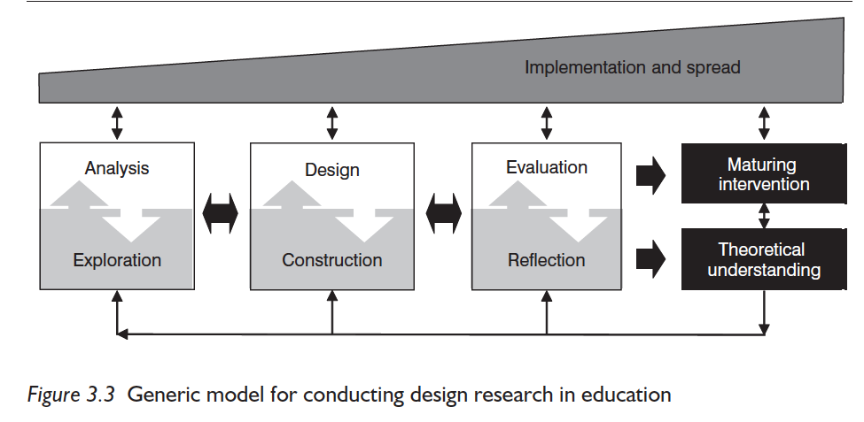

(McKenney and Reeves, p. 88-93)

In order make this approach compatible with my time span (Abdallah and Wegerif, 2014, p. 13), and the specific circumstances of my project, my research will be carried out within one iterative cycle, taking the form of a pilot project-the first of potentially several more iterative cycles. This project forms part of a larger study that I hope to develop after applying my teaching strategy to practice.

Methods

By combining the following methods of research I hope to achieve the necessary triangulation that should result in useful and rigorous data (Bekhet and Zauszniewski, 2012).

1. Literature Review. This will take the form of a narrative literature review, allowing me to focus on “experience” (Clandinin and Connelly, 2000, p. 50). Data from the literature review will influence my teaching strategy and potential improvements to it.

2. Survey Questionnaire: I will construct a 10-question closed survey questionnaire, which will be sent out to singing teachers. The survey should provide a relatively efficient and inexpensive way to collect data (Clifford et al., 1997, P. 93) I will undertake Convenience sampling (Easterby-Smith et al., 2015, p. 228) by using the Voice Study Centre to call out to singing teachers of musical theatre students in higher education. I will allow the survey to snowball (Dusek et al., 2015, p. 281) in order to reach as many willing participants as possible who meet the criteria.

3. Development of Teaching Strategy. I will return to the teaching strategy that I created for Module 5; this will be reviewed and presented for critical feedback from a group of 6-8 teacher participants (prior to their participation in a focus group).

4.Focus Group: I will conduct a focus group incorporating the Purposive sampling (Easterby-Smith et al., 2015, p. 228) of 6-8 teacher participants. The participants will be a combination of freelance Singing and (spoken) Voice and Accent teachers, all working in a variety of higher education settings and with undergraduate and/or postgraduate musical theatre performers. Each Focus Group participant will have a minimum of 5 years teaching in their field. I will be present throughout the focus group session, as a moderator to the discussion. It will be conducted remotely, via Zoom.

It is hoped that the “explicit use of group interaction” provided by the focus group will produce data and insights that would otherwise by less accessible without the interaction found within a group (Morgan, 1988, p. 12).

5. Auto-ethnographic Journal: This will take the form of a reflective diary, which I intend to keep throughout the course of my investigation. It is anticipated that the autobiographical style of writing will help me to “connect the personal to the cultural” (Ellis and Bochner, 2000, p. 739); I shall reflect on the potential usefulness of my teaching strategy in the studio.

I intend to incorporate my methods within the DBR framework at the following times:

- Analysis and Exploration: I will analyse data from my literature review and journal data and hone my research question
- Design and Construction-construct my rationale
- Evaluation and Reflection: I will carry out data analysis of my focus group and teacher surveys. I shall use Onwuegbuzie’s model for analysing focus group data (Appendix 17)

Insider Research and Ethics

As an insider researcher I will be socially situated (Lave, 2011) amongst students and fellow singing teachers. I am aware of the advantages that insider research may bring to this topic, but equally aware of the ethical implications and potential risks of my research (Saidin and Yaacob, 2016, p. 853). Various measures have been taken to ensure strong ethical practice:
My research has full ethical approval from the University of Wales (Appendix 18). I intend to be guided by Easterby-Smith et al’s (2015) ethical principles (Appendix 19).

Adverse Outcomes and Risks

The following risks will be acknowledged and taken into account:

-A participant’s potential willingness to please affecting their responses

I will ensure careful wording of questions so that participants know that their performance is not being judged.

-Participants influencing one another’s responses, thus devaluing my data

Participants will be encouraged to speak freely in the focus group, and reminded that they will remain anonymous. In acknowledgement of the potential challenges in extracting data from focus groups (Gil et al 2008, P. 293), I intend to rigorously apply a structured method for data analysis (see p).

-Jeopardizing relations amongst singing teacher colleagues that are known to me

I will ensure that there is no intended criticism of current practice, but that this project seeks to provide scope for future developments of current practices.

Bias

I acknowledge the potential risks of being highly involved in the design, development and implementation of my teaching strategy (Barab and Squire, 2004, cited by Anderson and Shattuck, 2012, p. 20). I intend to use reflexive bracketing (Gearing, 2004) as a means of tackling bias in a constructive way, by adopting the following principles:

- Acknowledging the Researcher’s internal suppositions: I have noticed that it seems more difficult for my student singers to sing in their own British regional accent, as opposed to other regional accents.
- Setting boundaries for the temporary suspension of the Researcher’s suppositions: I, the researcher, will ensure that my own judgments do not influence the participants’ responses of either my survey or focus group.
- Reintegration of the Researcher’s personal suppositions: This will happen during the analysis stage of the investigation in order to ensure that my (the researcher’s) suppositions did not influence the findings.
(Gearing, 2004, p. 1444)

Findings

Throughout this section I intend to complete a DBR cycle of analysis, design construction and evaluation and reflection (Mckenney and Reeves, 2012, p. 88) to assess the usefulness of the practical teaching strategy (see Appendix 1) that I developed in Module 5 and have since begun to modify. It has been renamed: ‘Singing in Regional Accents-Why, How and When to incorporate accent coaching in singing lessons’.

1.Analysis and Exploration

I will use the theory obtained from my literature review to inform possible improvements to the design (Macleod, p. 167) of my teaching strategy-in-development; I will make connections with and bring rigour to anecdotal evidence formed from my journaling (Macleod, p. 168).

The headings in this section refer to themes that have arisen from connecting theory to anecdotal evidence. I will reflect upon the theories within my literature review and make relevant links to anecdotal evidence obtained from my journaling activity (written in italics).

Industry Demands On Singers to use their own accents

JR June 2023: I coached a 3rd year musical theatre student who had been asked by her agent to prepare a ballad and a pop song in her own accent for an upcoming audition.

JR June 2023: Discussion with a Voice and Accents coach about whether or not musical theatre students needed to work on scripts in their own accents. The voice coach did not think that students were often asked to use their own accents in auditions and for roles in musicals, stating a preference for them to focus on General American and RP.

JR June 2023: Discussion with in-house agents at a musical theatre conservatoire institution where I work. The three agents were unanimous in their experiences of changing demands of the industry in terms of accents. They increasingly receive requests for performers to use their own accents in auditions for both speaking and singing roles. One agent reports that we are “moving away from the ‘tell a funny joke in your own accent’ for Billy Elliot castings.” It is now becoming more commonplace for own accent representation to be expected throughout an audition, not simply as a gimmick.

My own hypothesis regarding an increased demand on students to act and sing in their own accents was strongly supported by the agents’ confirmation that actors are frequently asked to audition in their own accent. Schulze’s (2018) suggestion that the general wish for “genuine experience or some sort of reality that is perceived as not fake” (p. 296) suggests that my own (and the agents’) observations align with current trends towards authenticity reflected in contemporary culture. The doubt expressed by the voice and accents coach regarding the need for students to use their own accent suggests that more sharing of industry knowledge (demands and expectations) amongst colleagues could be useful.

Vowel Modification in Belted sounds

JR June 2023: A student sings “Still Hurting” by Robert-Brown’s ‘The Last Five Years’ in her own Estuary English accent. She finds the belted sounds on certain vowels difficult. ‘Go’ and ‘wall’ were easier with a General American vowel placement.

Research by Herbst et al. (2023) confirms the impossibility of maintaining the same speech vowel set up for belted sounds. Sharing this knowledge with other vocal teachers and students could be valuable, along with helping students to find the optimum vowel set up depending on the pitch, voice quality and accent.

Expectations of authenticity: Impersonation versus Impression

JR May 2023: I coached a student on pop song “Stupid Cupid” in preparation for a ‘Mamma Mia’ audition. A conversation around expectations of the Mamma Mia ‘sound’ ensued; the text needed to be spoken with a specific British accent but sung in a generic pop style, unspecific accent. However, as with other students I had observed, the tendency with pop is to default towards US sounds, adding in rhoticity and US vowel placement.

This is another example of British students defaulting towards US accents when singing pop. Caution should be taken in cherry-picking from US sounds for pop style purposes but not accents specifically.

Research Questions

The analytical process above gives justification to the following research questions, which I hope my continued research will begin to answer:

-How useful is my strategy in helping singers to integrate any regional accent in sung text?

-How important is it for a character’s accent to be integrated into their songs in a musical?

-Should ‘standard’ accents such as RP and General American be taught in musical theatre training institutions?

2.Design Construction

I constructed a Logic Model (Mckenney and Reeves, 2012, p. 120-121), which provided a broader outline of the necessary inputs, leading to the intended outcomes of my teaching strategy.

Inputs-what is needed | Processes-activities | Outputs-immediate results | Outcomes-effects | Impact-measureable change
Teacher motivation | Complete the teaching strategy | Strategy design Completed | Increase in resources for singing teachers | Substantial improvement in teachers’ ability to assist singers with accent work
Student motivation | Share the strategy amongst singing teachers | Strategy received by teachers | Teachers better equipped for helping students | Substantial improvement in students’ ability to sing in accents
Lesson Materials-music, piano | Implement the strategy into singing lessons | Strategy successfully integrated into singing lessons | More integration of Singing and (spoken) Voice work for musical theatre students | Students gain more knowledge and autonomy regarding how to apply spoken and sung voice work to their audition material
Industry knowledge (musical theatre) | Awareness campaign amongst wider teaching community | Students and Teachers fully informed of strategy | Increased awareness of challenges faced by musical theatre performers where accents are concerned | Teacher questionnaires and focus groups lead to greater awareness of industry needs

Skeleton Design

The logic model brought further clarity to the aims and desired outcomes of the strategy. Following this, I constructed a skeleton design, which enabled me to “identify core design features and distinguish these from supporting ones” (Mckenney and Reeves, 2012, p. 122).

Design Task | Materials/Resources | Activities/Processes | Implementation
Self-Analysis | Guidance on vocal tract posture | Expert coaching. Conversation. Note-taking. | Teacher and student. Student makes observations first
Experimentation | IPA chart. Sheet Music. Script. Piano | Articulatory drills. Identification of key lexical sets of accent. Comparison of new accent to native accent. Pitch interval exercises for achieving optimum vowel placement. Identification of least and most effortful musical passages. | Teacher and student. Teacher leads. Once the exercises have been mastered, the student can try these individually in practice sessions.
Performance | Sheet music. Piano | Explore acting choices with accent in place. Adjust as necessary | Either in class with teacher and student present, or individual work by student in practice sessions

Viewing the outline of the strategy in the framework above provided me with additional clarity as to the structure of the exercises; it brought emphasis to the overall goal of the strategy. Although I made it clear that it can be used as a ‘cherry-picking’ format, the skeleton design reminded me of the importance of including each of the three main design tasks for every student, with the experimentation section accounting for most of the work to be done within a singing lesson.

Prototype

The prototype of my teaching strategy detailed below takes the form of a program component-an “indirect” (Mckenney and Reeves, 2012, p. 128) resource designed for singing teachers to implement into their own lessons. The new strategy design includes improvements made thus far as a result of my own personal reflections in Module 5 (Rhodes, 2022) and continued theoretical research. The following key improvements have been implemented:

-A more thorough exploration of potential vowel modification.
-Including more spoken accent exercises before sung text, to fully integrate prosody and engage both sides of the brain (Wilson, 2013, p. 300)
- Simplification of some sections to accommodate the less experienced teacher and/or singer
Teaching Strategy Content
The teaching strategy is colour-coded to indicate the three main components as highlighted by the skeleton model. I have indicated where theoretical evidence from my literature reviews (Module 5 and 6) supports each component.
Figure 2
‘Singing in Regional Accents- Why, How and When to Incorporate Accent Training in Singing Lessons’

Step 1. Student voice analysis
Step 2. Articulatory drills
Step 3. Accent breakdown
Step 4. Comparison of native and new accent
Step 5. Re-moulding the oral posture in speech
Step 6. Musical Experimentation
Step 7. Song analysis
Step 8. Exploring effort with accent integration
Step 9. Changing emotions
Step 10. The full performance
Step 1. Student Voice Analysis
Theory: Accents may be affiliated with class-related attitudes (Cole, 2021, p. 1); teachers are instructed to approach this self-analytical and deeply personal component of the strategy with sensitivity and awareness of potential code-switching (Drummond) within the formality of a singing lesson.

Step 2. Articulatory Drills
Theory: Prevailing accent coaching methods promote versatility (Knight, 2012; Oram, 2021). Including adjustments in pitch brings in the added complexity of unavoidable vowel modification towards higher pitched notes (Titze, 2011, p. 311)

Step 3. Accent Breakdown
Theory: Current models for accent coaching promote the understanding of lexical sets (Appendix 19) as an essential part of the process (Sharpe and Rowles, 2021; KTS, 2012). Methods of how and when to integrate IPA symbols for accent coaching divides opinion amongst spoken voice coaches (Armstrong, 2016, p. 38) and singing tutors (Jochim et. al, 2020, p. 63) and so this is included as an optional aid in the strategy.

Step 4. Comparison of Native and New Accent
Theory: Singing before speaking in an accent might prove less challenging when concerning accents which involve a vastly different articulatory set up to the speaker’s native accent (Margulis et al., 2015, p. 6), therefore making this comparison in the early stages of learning an accent could be beneficial.

Step 5. Re-moulding the Oral Posture in Speech
Theory: Leading voice and accent practitioners recommend speaking in an accent before attempting to sing in it (Rodenburg, KTS), which supports the inclusion of this exercise, but teachers should consider the theory noted in Step 4 (see above).

Step 6. Musical Experimentation
Theory: Musical theatre songs may contain a plethora of different vocal styles, requiring a multitude of different voice qualities from the singer (Kayes and Welch, 2017). Original cast recordings will have huge influence over how a song is sung by student singers (Germeten, 2023).

Step 7. Song Analysis
Theory: American accent features are the most prevalent accents heard by pop singers, irrespective of where the singer is from (Rudgard, 2015); this should be noted by teachers and students when considering genre.

Step 8. Exploring Effort with Accent Integration
Theory: Singing in accents within a model pitch range is most likely less effortful than at higher pitches (Bell, 2011, p. 636), which supports this exercise.
In the understanding that some vowel modification is likely to occur on belted notes depending on the accent (Herbst et al., 2023), working the most challenging sections of a song in isolation may be beneficial.

Step 9. Changing Emotions
Theory: When a person reaches a point of high emotion, their accent may be susceptible to change (Rodenburg, 1998).

Step 10. The Full Performance
Theory: Any one accent may have numerous variations or idiolects (Hazen, 2020, p. 513); acknowledging this in accent coaching is hugely important as an actor must consider the accents adopted by fellow cast members.

3. Evaluation and Reflection

Survey Analysis

A 10-question survey questionnaire (Appendix 20) was sent out as a convenience sample via the Voice Study Centre. Participants who met the following criteria were invited to respond:

-Singing teachers to musical theatre students in higher education establishments and beyond. This includes Foundation, Diploma, BA level or above.

It was hoped that the survey would snowball, and participants were invited to forward to colleagues that met the criteria. The survey remained open for 4 weeks, after which data was collected for analysis using Survey Monkey software. The survey allowed for tick-box answers only, with no individual comments so as to provide clear, numerical data to supplement my other data. 21 responses were received, which was fewer than originally hoped for, but the results obtained provide some valuable qualitative data nonetheless.

Firstly, I applied pattern coding (Walliman, p. 263) as a means of focusing the data and identifying themes that may influence subsequent rounds of data analysis. After analysis of the results I formed a memo of further themes, which were later considered through the analysis of my focus group data.

Memo

Below is a list of themes identified through the analysis of my teacher survey.

-The relevance and potential usefulness of my teaching strategy for teachers of musical theatre performers
-The quest for authenticity in accent work
-Authenticity is subjective where accents are concerned
-Genre is not the sole influence upon accent integration success
-The cause for differentiating between the teaching of accents on Acting courses and on Musical Theatre courses
-The usefulness of IPA references in my teaching strategy
-Effort in terms of difficulty of accent integration is subjective
-Certain articulatory features are considered problematic for singers

Explanation of Themes

This section details how my survey results support the themes I have extracted:

-The relevance and potential usefulness of my teaching strategy for teachers of musical theatre performers

Results from questions 1, 5 and 8 uphold the relevance and potential usefulness of my teaching strategy.

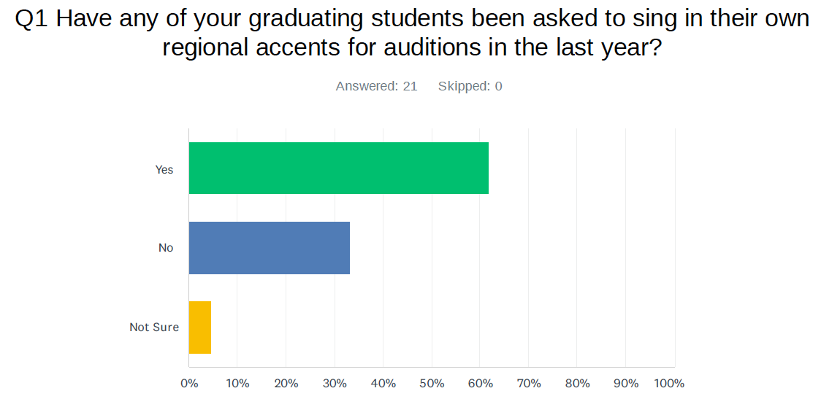

Result: 62% of respondents ticked YES to this question. The fact that the majority of the teachers have noticed that their students have been asked to sing in their own accents reaffirms the relevance of my teaching strategy, and upholds previous research in the literature review and my journaling regarding the current demands for authenticity in accent work. The significant proportion of those who have not noticed this request does not necessarily mean that their students have not been asked to sing in any regional accents; it might suggest that they been singing in an accent different to their own.

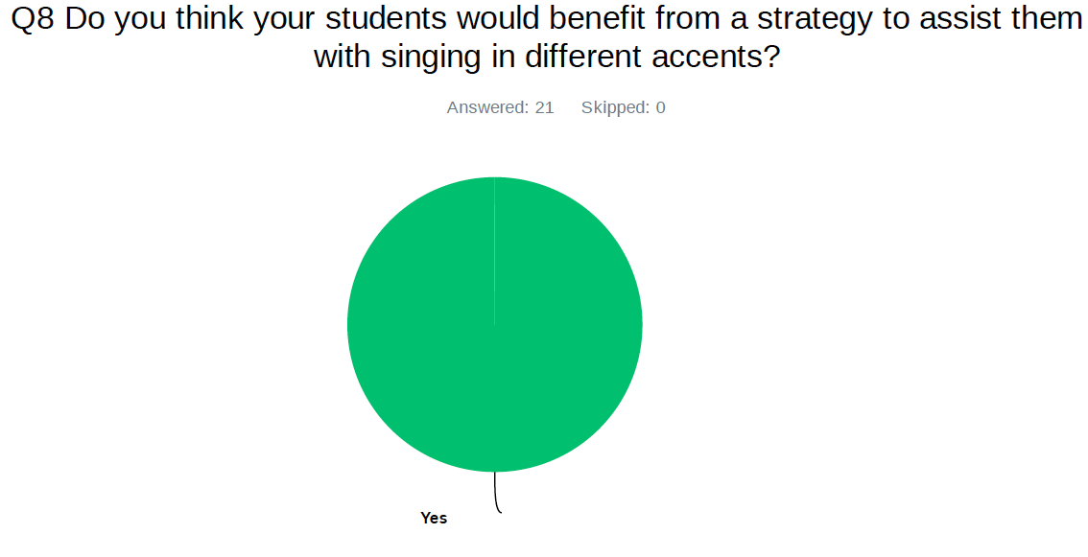

Results

The resounding YES from this question once again upholds the relevance of my teaching strategy and implies its usefulness to the students it is intended to serve. This result also supports previous findings from a teacher survey in Module 3 (Rhodes, 2022), in which all teachers stated that they would like to be better informed on accent integration in the form of a strategy.

-The quest for authenticity in accent work

Results from question 5 reveal that the singer’s native accent is brought into focus sometimes for most singing teachers, giving some indication that an authentic sound is sought after at times.

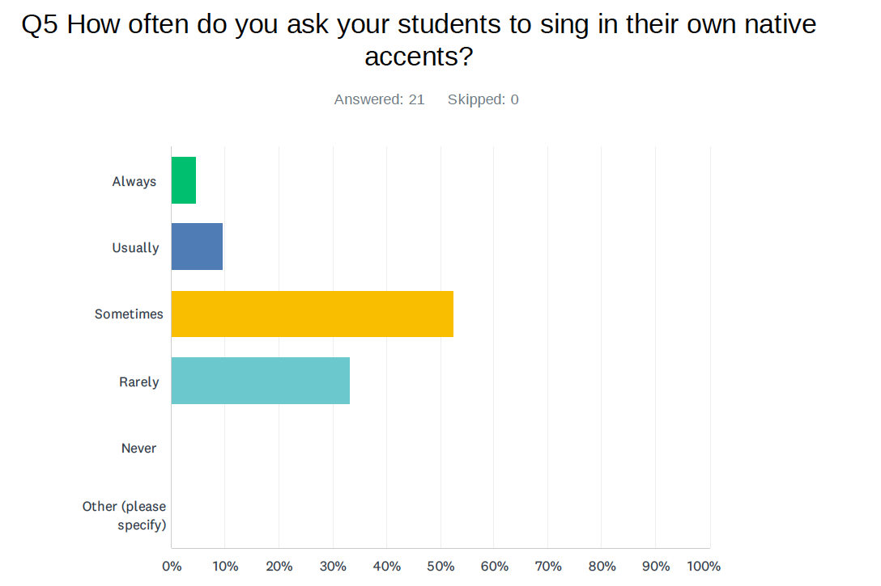
Results

A significant majority of singing teachers sometimes ask their students to sing in their own native accents, with all teacher participants having done this at some point. This question does not account for the reasons as to why this request might have taken place, but it is indicative of the following:

The singer’s authentic spoken sound and habitual spoken oral posture may be of significance when they sing.

Both the relevance of the teaching strategy and the quest for authenticity are upheld by these results.

-Authenticity is subjective where accents are concerned

Results to question 3 reveal that the perceived level of difficulty in singing in an accent may vary depending upon the listener’s judgement or definition of an authentic accent. Results to question 10 imply there is some variation as to whether an authentic sound is always important.

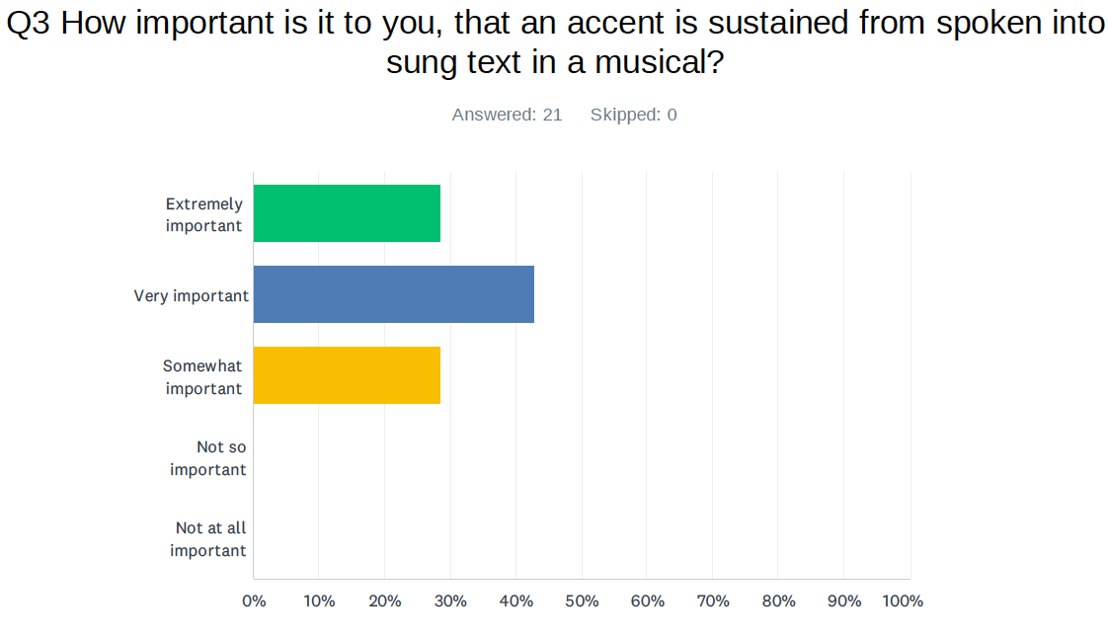

Results

All teachers agree that accent integration is important, but the variation in strength of importance is significant; it is suggestive of previous findings that the quest for authenticity of an accent may vary depending upon genre. With this in mind, it upholds my decision to make the teaching strategy in a non-linear ‘cherry-picking’ format, in the expectation that some genres of music may have a greater need for detailed accent work than others.
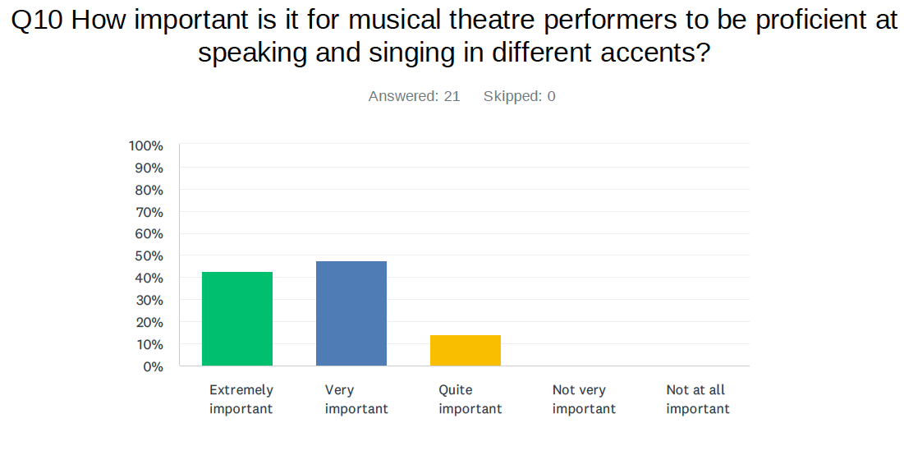

Results

All singing teachers believe it to be important for performers to speak and sing in different accents. The variation in terms of strength of feeling once again implies that the importance of accent integration should be considered case-by-case. It implies variation in terms of importance where authenticity of an accent is concerned in a musical.

-Genre is not the sole influence upon accent integration success

The pie chart displaying results from question 2, reveals divided opinion, and some uncertainty as to which musical style might prove more challenging for non-US accent integration.

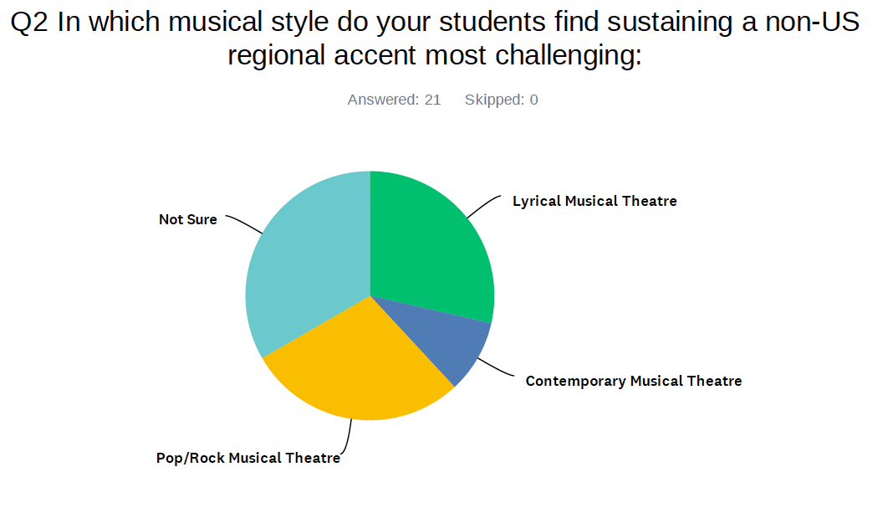

Results

A significant proportion (33%) of the teachers were not sure which style their students find singing in accents most challenging, and with no clear indication of preference for the other categories. This result could indicate the following:

Genre alone may not influence accent integration success

Genre might not be a clear or singular deciding factor when it comes to difficulty in singing in accents. This result supports previous research that other factors such as pitch or voice quality will influence ease of accent integration.

-The cause for differentiating between the teaching of accents on Acting courses and on Musical Theatre courses

Results from question 4 unanimously uphold the viewpoint that accents should be taught to musical theatre students. Opinions surrounding how to select accents for musical theatre students to learn remains largely subjective.

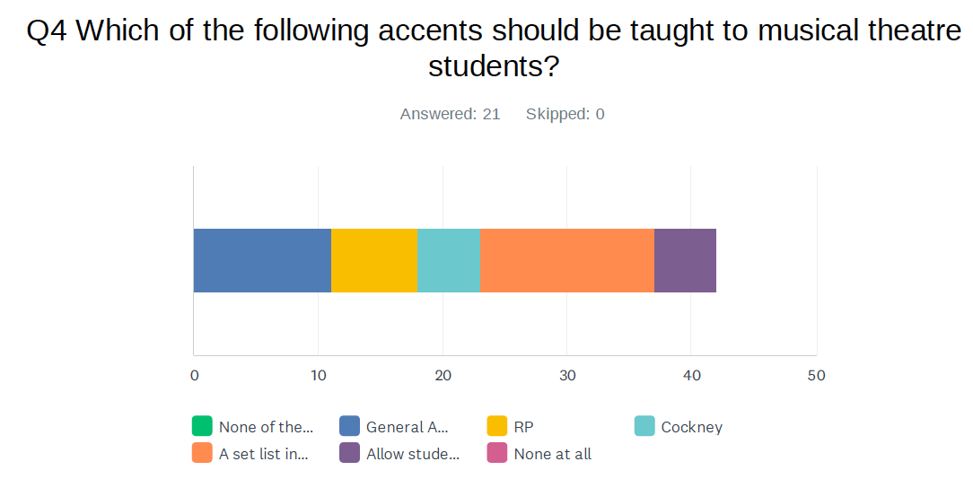

Results

All participants think that accents, in whatever form, should be taught to musical theatre students, with a majority of 67% showing preference for a set list of British and American accents to be taught. Where this method of teaching accents somewhat jars with current teaching trends for actors (KTS, Sharpe Hayden) that favour a less prescriptive approach, it is important to note that these results represent teachers of musical theatre students rather than actors of spoken text alone. It seems it might be important to differentiate between the teaching of accents on Acting courses and on Musical Theatre courses.

-The usefulness of IPA references in my teaching strategy

The mixed responses from question 6 suggest that the IPA symbols may be of value to a significant proportion of teachers using my teaching strategy, but not to all.

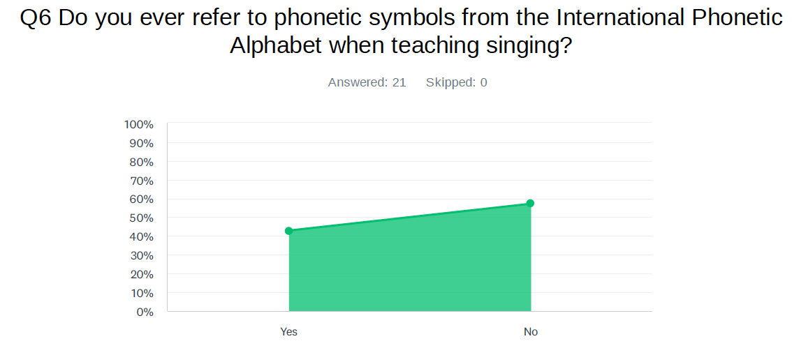

Results

The results show an almost even split of 43% stating that they do refer to the IPA when teaching, with a slight majority of 57% stating that they do not refer to the IPA.

Further questions are prompted by this response:

-For those that do refer to the IPA chart, how often does this occur?
-For those that do not refer to the IPA chart, is this because they do not have prior training in it, or that they do not value it as being useful in a singing lesson?

Without currently knowing the answers to the further questions, this result shows that the IPA references in my teaching strategy may be of use to a significant proportion of the teachers that use it.

-Effort in terms of difficulty of accent integration is subjective

Results from question 7 demonstrate that many of the teachers find it difficult to measure the level of difficulty in singing in an accent as experienced by their students. I have made comparisons between these results and those taken from the survey sent out to students in Module 3.

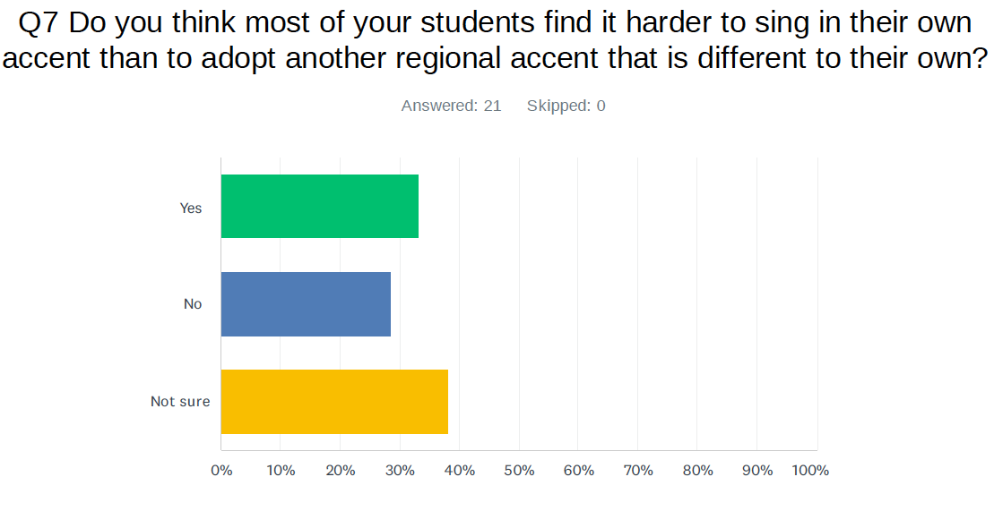

Results

38% teachers are not sure whether their students find it more difficult to sing in their own accents than another. This result could indicate the following:

-These teachers have not had the opportunity to listen and compare their students singing in their own accent and then another.
-It is difficult to ascertain the difficulty of a task when undertaken by another

A slight majority of those teachers that selected the other boxes, chose the YES box, suggesting that teachers have observed more difficulty in singing in native accents than in other accents. This result, although only a marginal majority, upholds previous research from a student survey undertaken in Module 3, which revealed an overwhelming majority of students found singing in their own accents to be more challenging (Rhodes, 2022). The discrepancy between the student survey and this current teacher survey suggest the difficulty in measuring the perceived subjective experience of a student by a teacher. It reaffirms the need for effort to be identified by the student primarily.

-Certain articulatory features are considered problematic for singers

Results from question 9 suggest that a wide range of features might present as problematic when integrated in sung text. It also suggests that out-dated notions of articulatory features as “faults” (Mckinney, 2005) still prevail where singing is concerned.

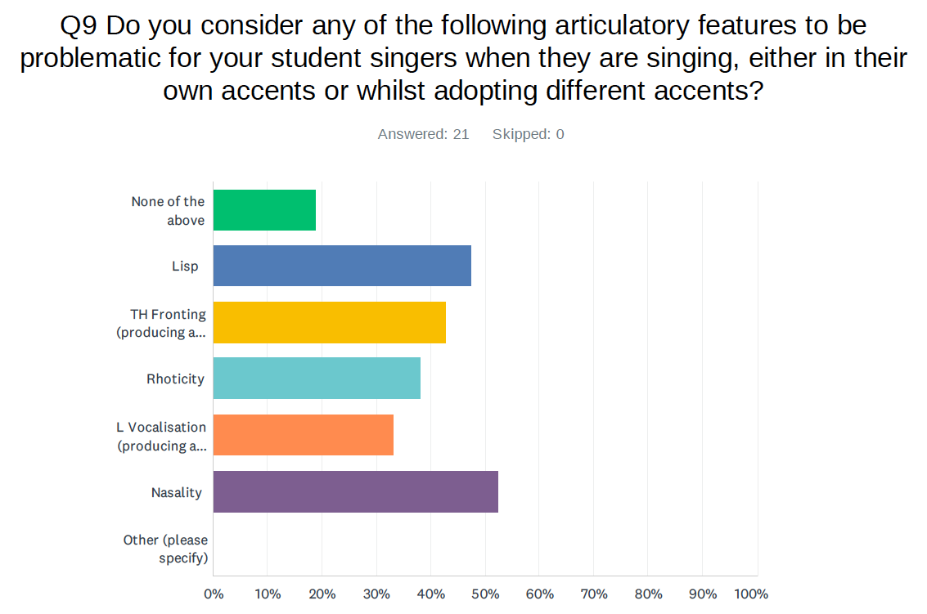

Results

All of the articulatory features listed present as being problematic for a significant proportion of the singing teachers. The examples listed include accent-related features as well as other articulatory habits such as lisping. The list was deliberately diverse in order to ascertain whether or not accent-related features may be more or less problematic than non-accent-related features.

Further questions are prompted by these findings, and answers to the following would be beneficial:

-Are the articulatory features problematic because:

a. They hinder the musical style or desired quality of the voice?
b. They hinder the intelligibility of the sung text?
c. The teacher simply does not like the sound?

Although the questions above remain unanswered, the concepts of subjectivity in terms of favouring one articulatory feature over another and accentism are brought to the foreground here, as well as a clear need for accent integration into song to be flexible, allowing for compromise where certain accent features are not desired, for whatever reason.

Focus Group Analysis

Focus group composition

I had originally planned to invite both (spoken) Voice teachers and Singing teachers to join my focus group. However, after reflecting upon the central purpose of my project being to review and improve upon a teaching tool for singing teachers, I decided to only include participants who were primarily singing teachers. They represented a broad range of skills and experience thus upholding the known benefits of collaborating with a multidisciplinary team (Mckenney and Reeves, 2012, p. 114). The following 7 participants (3 male, 4 female) gave their consent to participate (Appendix 22); they are referred to anonymously as follows:

Participant 1 (P1): Technical Singing teacher, repertoire coach, musical director and composer/arranger
Participant 2 (P2): Technical Singing teacher
Participant 3 (P3): Technical Singing teacher and accompanist
Participant 4 (P4): Technical Singing teacher and West End performer
Participant 5 (P5): Technical Singing teacher, accompanist and singer
Participant 6 (P6): Technical Singing teacher and singer
Participant 7 (P7): Technical Singing teacher and singer

The participants each hold at least 5 years experience teaching singing and work across several leading musical theatre training institutions in London. The variety amongst this team allowed for “different lenses for viewing the design challenge” (Mckenney and Reeves, 2012, p. 114). They were diverse in the following areas:

-Skillset
-Gender
-Age (range from 30-55)
-Experiences
-Native accents

The focus group took the form of a relaxed discussion held over zoom and it lasted 1 hour. Prior to the meeting, the participants were sent a copy of my working teaching strategy to read. It was hoped that the investigation would benefit from the collaborative efforts in evaluating the workability of my strategy (Mckenney and Reeves, 2012, p. 113). I provided occasional interjections in the form of conversation prompts, but I aimed to allow the conversation to flow as naturally as possible, and to take a neutral stance, showing neither agreement nor disagreement with the comments made.

The focus group was recorded and I carried out a full transcription using otter.ai software and further manual editing in order to achieve the most rigorous analysis (Onwuegbuzie, 2009, p. 4). This transcript (Appendix 21) has been analysed, alongside my own notes taken during the meeting. To add further rigour, I analysed data from the group as a unit, and the individual as influenced by Onwuegbuzie’s (2009) micro-interlocutor method, which included analysing non-verbal communication (p. 7). The following analyses represent an amalgamation of techniques influenced by both Onwuegbuzie’s (2009) method and Saldena’s (2012) advice on coding.

Coding Process

I applied the following methods of coding:

1.Descriptive coding of positive and critical feedback (Magnitude Coding)
2.Descriptive coding of other relevant topics
3.Pattern coding
4.Evaluation Coding

Magnitude Coding

As a first cycle of data analysis, I employed Descriptive coding (Saldena, 2013, p. 88) of the positive and critical feedback received (Magnitude coding), which are grouped accordingly into two categories:

Positive Feedback

My teaching strategy received much positive feedback from the focus group. The word cloud below illustrates the positive words offered by the group members in response to reading my teaching strategy.
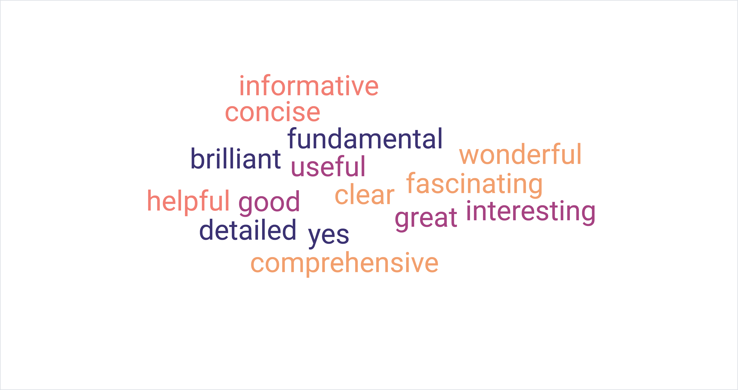
Here are some key examples of more detailed positive comments delivered by group members:

Relevance

The following comments reiterate the relevance of the strategy to the teachers’ experience in the 1-1 studio:

P2: “My initial reaction was, how great because it's something that is dealt with a lot. And it tends to be something that is slightly freewheeled.”
P1: “It links in the different departments…”

Sparking Teacher Interest

There was a general feeling of interest and excitement around the topic of helping singers with accents; these comments reaffirmed the potential usefulness of my strategy:

P3: “I would love there to be a course for singing teachers on this.”
P3: “I love this because it appeals to my like slightly geeky, like needing to be ordered side.”
P6: “I had several ‘aha’ moments. And they made me very happy.”
P6: “I thought oh god, yes, of course.”

Usability

Several comments suggest the strategy is a user-friendly resource, offering important and helpful information:

P2: “I thought it was really, really useful.”
P4: “I think having some sort of plan and strategy, especially for accents that you're not so familiar with is a really good idea.”
P1: “It's really nice to just have, I don't know, just like more of a concise way of saying it.”
P7: “As a resource it is incredibly comprehensive.”
P6: “I got quite a lot out of reading it and it's stuff I will be able to use.”
P5: “I think it's definitely a model you should try.”

Informative

Several teachers indicated that they had learned much from reading the strategy:

P6: “The information itself is fantastic.”
P5: “There was a lot that I learned myself.”
P6: “The information is wonderful.”
P6: “If you're an educator, then it it's just simply fascinating, and oh, my God, give me more.”
P1: “This is so well detailed and very informative.”

Transformative

Participant 1 was particularly enthusiastic for the potential improvements that the strategy could make to a broader musical theatre curriculum:

P1: “If something like this was ingrained into the teaching curriculum for that entire BA course or whatever it is, I think it would have such a wonderful effect.”

Presentation

The following positive comments indicate that the 10-steps were well presented:

P6: “I thought it was brilliantly laid out.”
P6: “It's so clear.”
P5: “I really liked the breakdown.”
P1: “It's so detailed.”

Critical Feedback

Knowledge Pre-requisites

Though unintentional, reading the strategy left some teachers doubting their existing knowledge:

P6: “My concern would be not having the knowledge myself of what the accent should sound like.”
P5: “I don't think I've got the knowledge of accents in other parts of the UK and the nuances of those, I think I'd have to make it very general.”

Information

Participants 2 and 5 seemed to read the strategy as if from a student’s perspective, and it left them concerned that it was too much information or too complex for the student:

P2: “It is a huge chunk of information for them to learn.”
P5: “When I was reading through that, that document, I thought, oh my gosh, this is actually quite complex.”

Target Audience/Context

Participant 6 also seemed to read the strategy from a student’s perspective:

P6: “But from a student perspective, and I wasn't sure what our capacity, how we were supposed to be looking at it from a student point of view.”

Time

There was a general feeling that time limitation in the 1-1 singing teaching studio was a concern in terms of including detailed accent work:

P6: “I just wish we had more bloody time with the students. So we could go into that kind of detail.”
P1: “As singing teachers, we just we wish we had more time with our students.”
P3: “How specific is it possible to be in this format as a singing teacher in a singing lesson in, like a 1-1 30-minute singing lesson, where you've got to get someone to sing it.”

Communication

Participant 6 expressed concern over potential discrepancies between accent advice offered in a (spoken) Voice lesson and Singing lesson:

P6: “But we still moderate vowels in order to make them sound that way when you're singing, as opposed to when you're speaking. So that could be an awful lot of conflicting information for students, if they're getting it for both ends, unless both sets of teachers are on the same page and say, ‘This is what we’re doing’.”

Pattern Coding

In order to acknowledge key themes raised in the discussion that were neither positive nor critical, I undertook another cycle of descriptive coding. This 2nd cycle of coding involved re-grouping these descriptive codes (below in italics) into pattern codes (below in bold) (Saldena, 2013, p. 209):

Singing Teachers’ Experiences with Accents
Participants 2 and 4 indicated they had been guessing when it came to helping singing students with accents:
Guesswork
P2: “It tends to be something that is slightly free-wheeled”
P4: “Freewheeling is a good expression, just kind of winging it”
US vs British accents
Comments from participants 4 and 5 reveal the prevalence of US accents in musical theatre singing, with British accents presenting as more challenging than US accents:
Focus on US accents
P4: “I like to say apart from American because they sing in American so often. So I feel like we're really equipped on dealing with that accent, but not necessarily with many others.”

British accents are more difficult

P5: “I think possibly British accents are much more complex to understand and to teach as well.”

Singing Teacher’s Role

Participants 6 and 4 suggested that accent work was a lower priority to general technical work in singing lessons, suggesting the need for a specialist accent coach to teach accents. Participant 4 suggests that accent work can sometimes interfere with technique. These comments indicate that the teaching strategy is perhaps not altogether clear in it providing additional rather than replacement help with accent work learned in (spoken) Voice lessons.

Prioritising Technique

P6: “I'm not used to having to work in that level of detail for an accent, because I'm still usually trying to get them singing properly.”

P4: “We struggle at the best of times with a lot of them to reduce tension, you know, release everything. And then you add in another accent that potentially puts them into a, you know, strange position. And then that has a knock on effect to their singing technique.”

Delegate to Accent Coach

P6: “We need to go to a voice coach or you need to go to somebody, an accent coach and get this recorded so we can analyse those vowels.”

Authenticity and Accent Stereotypes

Participants 1 and 2 highlight the discrepancy between their understanding of an accent, and a student’s impression of their own accent, and consider the potential demand from an audience for an accent stereotype:

Stereotyping

P1: “I think that they take it quite personally, obviously, when you want to break down where they're even from themselves. And how authentic that is to the stereotype of the accent that makes sense.”

P2: “If you're working with someone from the north or Yorkshire and they think they're doing their accent. And they may not be making the sounds they think they're making.”

Participants 2 and 1 reiterate the potential need to make an accent sound ‘obvious’ for the sake of theatrical storytelling; this might be at odds with the student’s (and teacher’s) impression of authenticity of an accent:

Meeting audience expectations

P2: “ I don't really speak the same as many people from where I'm from. And I would need to make changes to make it obvious to people where I'm from. So the authenticity and the expectations, I think is really key.”

P1: “So at what point then, do we vocal coaches go, Okay, what's gonna sound more commercially appealing? And what's going to be more? I don't know, true to the, to the, to the accent.”

The question of detail-how much or how little-was brought into question as the teachers pondered the sometimes conflicting demands of a paying audience and an accent expert:

Detail

P5: “I suppose it depends on how specific or detailed you want to be with those sorts of accents.”

P5: “I sort of understand my own accent, and so I could probably teach that, but I don't think I've got the knowledge of accents in other parts of the UK and the nuances of those, I think I'd have to make it very general.” all nod

Participants 1 and 2 highlighted the potential demand for authenticity and its impact on casting, bringing another dimension to the complex debate around stereotyping for theatrical purposes, authenticity and accent training:

Authenticity at all costs

P1: “Especially these days with new writers that I keep working with who want naturalism and authenticity and everything that comes with that…and a lot of them are cast, because they're not being technical…they're making these damaging noises, because it's meant to be authentic.”

P2: “…aren't people wanting very much to cast authenticity? So sometimes, I really feel sorry for the people who learned all this stuff and studied and acquired all these skills or drama school. And they might actually do the accent, or portray a character better than somebody who has a lived experience when it comes to the skill of dealing with the material that's there.”

Vowel Modification

There was a general consensus that all of the participants advocated some adjustment of vowels in singing:

Common practice

P6: “We all use vowel moderation at the best of times.”

P4: “You'd have to adjust all the vowels, so it'd be making them understand that even though they've learned in voice class, it's don't go wherever the vowel is, you can't actually assume.” all nod

Where all participants seemed to agree (verbally and non-verbally) that vowels were often modified by singers, participants 4, 1 and 7 agreed that this is often dependent on voice quality:

Voice quality and vowels

P4: “If it's a challenging song, melodically range wise…1 and 7 nod you have to dilute the accent for the safety of the voice, if that makes sense.”

P4: “You simply cannot belt a tight ‘oo’, you just can't do it.”

Use of IPA symbols

The participants were divided in their experience and opinions on using IPA symbols in singing lessons; a suggestion of having a key in the strategy was made:

Appreciation of Phonetics

P6: “I think phonetics are phenomenal.”
P3: “I love phonetic symbols, I like having it. So I think in terms of having it in what you've done, I don't think it hurts to have it as much as just if it's useful. And then if you can put a key or something as well, like, it then kind of checks the box for people who can use it and people who can't use it, or people who are learning to use it…”
P4: “I find it incredibly useful.”
P6: “If I've got a good key, it's fantastic.”

Negative Student Experience

P6: “They don't understand or read phonetics.”
P6: “What they can do is what word do you have that rhymes with that so you can write it into your music so we can get this authentically.”
P4: “But they're thrown so much new information, these kids whether they can take it on as well, some of them probably can really easily. And then a lot of them probably can't.”

Negative Teacher Experience

P6: “I'm not interested in having just the symbols, I don't hold that much information in my head.”
P5: “I mean, it's complicated. I've never actually studied it properly.”

Application

P4: “I studied phonetics at college, and I still use it today in my script work and my songs. And I think it's one of the things that once you've learned it, and it's in there, it's in there.”

P2: “In terms of IPA, if there was one sound that needs to be understood and recognised and communicated out of that person, teachers it has to be schwa.” 6 and 7 nod.

Style and Accents

There was some discussion around the prevalence of US accents in pop music, and the expectations of a pop/rock ‘sound’ in pop musicals. Participant 7 brought further nuance to this conversation, in introducing the idea that style might be inadvertently affected by the chosen accent, citing the example of the US and French versions of the musical Amelie:

Style Influences accent

P7: “… to what degree does the accent lead the style of the song, like, for example, with Amelie, if you're going to sing it in an American accent, that it's going to lend itself to a certain way of approaching those noises via like, slightly belty. Or whereas if you take it in a more sort of French accent direction, this style is going to be completely different.”

Prevalence of US accents in Pop

P5: “There are British artists that when you listen to them, they sound American.”

P4: “I think it was pop music that is this kind of neutral. Slightly American, like a mid Atlantic. Pop based music into a different bracket. Because when people sing pop in a straight British RP accent, it's really cringe, isn't it?”

Class

The discussion around class and stereotyping of accents further highlighted the discrepancy between meeting audience expectations of an accent and striving for more specificity to better represent the individual:

Expectation

P7: “you get this idea of class and what's accepted versus, you know, artistic integrity and stuff like that. It's just, I mean, it's a fascinating conversation, but it's kind of murky.”

Offensive stereotyping

P1: “I think it does perpetuate stereotypes when we move into generalisation and I think we can do better.”

Articulatory ‘Faults’

Participants 2 and 6 highlighted the prevalence of TH-fronting, with participant 2 suggesting it is not necessarily accent-specific. Participant 6 expressed a strong dislike for the prevalence of TH-fronting in student singers, suggesting it is hugely problematic if it is not removed when singing, largely from the technical stance of needing the tongue to be further forward:

TH-Fronting

P6: “But the TH thing for me is a profound issue.”

P6: “… from a technical point of view that tongue has to be further forward, you're not going to be able to do anything.”

P2: “That TH issue…comes up in pretty much most British accents I can think of. And it's not. I don't think it's in every case, led by region.”

Participant 6 expressed the need to remain sensitive when discussing articulatory habits with students:

Student Consent

P6: “I do actually check in with them. Are you aware? And are you comfortable with me discussing this?”

Participants 2 and 6 highlight the potential confusion between accent features, articulatory problems and poor articulation:

Articulatory habits

P2: “Where is the line between an accent and either a speech defect or a level of formality of accent or laziness in accent?” 6 nods

P2: “It's speech habit, which might be separate from accent.”

Learning Accents

Participants 4 and 7 advocate the learning of many accents for musical theatre students, suggesting the benefits lie beyond simply truthful representation on stage; participant 7 believes it may have a positive impact on ear-training, in keeping with their musical education. Participant 4 offers the somewhat contradictory suggestion that learning accents might, in fact be futile due to casting trends for more authentic, native accents:

Quantity

P7: “I just think, yeah, learning this stuff, and as much of it as you possibly can, while some get overwhelmed, as long as they've got access to it, then it helps so much more than just the ability to do an accent, I think.”

Importance of learning accents

P4: “So I think it's really important in any setting, to for students to be given the opportunity to learn accents. And then putting those accents into songs is another whole thing.”

P7: “…, but just an overall development perspective, because learning stuff like accents, develops your ear, and your ears useful for all sorts of things.”

Futility of learning accents

P4: “I just wonder in the way casting is happening at the moment aren't people wanting very much to cast authenticity. So sometimes, I really feel sorry for the people who learned all this stuff and studied and acquired all these skills or drama school. And they might actually do the accent, or portray a character better than somebody who has a lived experience when it comes to the skill of dealing with the material that's there.”

Application

Participants 2 and 5 advocate the implementation of accent work into singing training within group lessons:
Group Learning

P2: “Students get the confidence to bounce off each other.”

P5: “the good thing about group classes…was that everybody in the room could try what the one student was working on…So maybe, in terms of integrating accents, that particular setup would be very useful in terms of training undergrads and post grads.”

Mixed Analysis: Matrix for assessing level of consensus in the group

Before drawing conclusions, I decided to view some of the data relating to my key research questions in numerical terms. This provides a mixed analysis to supplement qualitative data; it is hoped that by enumerating the frequency of a particular viewpoint, it will “expand the data set” (Onwuegbuzie, 2009, p. 9).

Question | P1 | P 2 | P 3 | P 4 | P 5 | P 6 | P7
1.Is the teaching strategy useful? | SE | SE | SE | SE | SE | SE | SE
2.Do you refer to IPA symbols when teaching? | ND | SE | SE | SE | SD | SE | ND
3.Should accents be taught to Musical theatre students? | SE | SE | SE | SE | SE | SE | SE
4. Do you consider any articulatory features to be problematic? | SD | SE | ND | ND | ND | SE | ND

A= Indicated agreement (verbal or non-verbal)
B= Indicated dissent (verbal or non-verbal)
SE= Provided significant statement or example suggesting agreement
SD= Provided significant statement or example suggesting dissent
ND= Did not indicate agreement or dissent (non response)

The table above displays the following results:

- 7 out of 7 participants found my teaching strategy useful.
- 4 out of the 7 participants refer to IPA symbols when teaching. Participant 5 showed strong feelings against using the IPA. Participants 1 and 7 did not offer any comments.
- 7 out of 7 participants advocate teaching regional accents to musical theatre students.
- Participants 2 and 6 strongly agreed that they find some articulatory features to be problematic for singers. Participant 1 did not agree. Participants 3,4,5 and 7 did not comment.

Evaluation Coding

In order to focus on making necessary improvements to my teaching strategy, I employed Evaluation coding (Saldena, 2013, p. 120), which amalgamated codes from my critical feedback with the other pattern coded topics. The key below details the coding process leading to each individual evaluation code:

Process
Magnitude Coding +/-
Descriptive Coding or ‘In Vivo Coding
REC (recommendation coding tag) with a specific memo or action for following up

Evaluation Codes

-Knowledge and Experience Pre-requisites: ‘free-wheeling’/Teacher self-doubt
REC: Ensure teachers understand that this strategy is designed to support existing accent work in (spoken voice lessons). Prior (teacher) training in accents is not needed

-Information: Overload
REC: Re-work layout to ensure separation of exemplars from the main ‘steps’ in the strategy. Simplify wording where possible

-Target Audience: Confusion
REC: Clarify that this is aimed at teachers, not to be handed directly to students

-Time: Concern over time limitations
REC: Suggest that the strategy is used as a reference tool; it could be implemented over time. Manage teacher expectations as to what they might cover in a given session. Highlight the suggestion to ‘cherry-pick’ the exercises suitable.

-Communication: Potential conflicting advice
REC: Ensure communication between Voice and Singing departments. Promote discussion on singing in accents in spoken voice classes.

-Singing Teacher’s Role: Technique vs accents
REC: Promote my strategy for incorporating accents as an integral part of technical singing work, as apposed to independent accent work.

-+Inclusion of IPA: Divisive
REC: Include a IPA key as an appendix to strategy, enabling teachers to refer to it if they wish

+Learning Accents: Vital for musical theatre performers but authenticity is desired
REC: Promote the learning of new accents, but encourage versatility over quantity of accents to learn

+-Application of Strategy: Discussion around group settings
REC: Consider applying strategy within a group lesson setting as well as offering to Singing teachers to apply as needed in the 1-1 studio

+Musical style and accent influence one another: Accent influenced by style. Style influenced by accent
REC: Provide further exercises and examples where pop/rock vowel sounds may need altering to accommodate accent expectations

-Accent Habits: Certain articulatory habits (notably TH-fronting) considered faults
REC: Provide examples where all articulatory features can be legitimised in singing in order to align accent training and attitudes in singing lessons with spoken voice lessons. Continue to work to achieve common vocabulary to use concerning articulatory habits in singing lessons.

-Accent Stereotyping for Industry expectations and Class-based accent practice: Authenticity vs commercial expectations of an accent
REC: Promote the detailed learning of an accent alongside the teaching and learning of ‘general’ accents to meet with audience expectations. Remain sensitive to students’ feelings about their own accent, class and stereotyping.

Conclusion

Through the analysis of my data from a broad range of sources, I have combined theoretical with anecdotal evidence to validate the creation of my teaching strategy and evaluate its usefulness. The process has also illuminated some potential ways to further improve the strategy before it is shared more widely amongst teacher colleagues.

Following the three steps of analysis and exploration, design and construction and Evaluation and Reflection as recommended by the DBR methodology (Reeves and Mckenney, 2012) led to clear revelations as to the successful features of my strategy as well as making “revision recommendations” (Reeves and Mckenney, 2012, p. 129) by noting areas of potential improvement. To summarise, here is the plan with regards to making changes to the strategy:

Components to remain in my strategy:

-The 10 steps as outlined below:

Step 1. Student voice analysis
Step 2. Articulatory drills
Step 3. Accent breakdown
Step 4. Comparison of native and new accent
Step 5. Re-moulding the oral posture in speech
Step 6. Musical Experimentation
Step 7. Song analysis
Step 8. Exploring effort with accent integration
Step 9. Changing emotions
Step 10. The full performance

-The overall structure with the exemplar provided as a guide
-Optional use of IPA symbols
-The added articulatory exercises

Components to change:

-I will remain flexible as to how the strategy is implemented; a group setting or workshop for staff training could be beneficial to both teachers and students
-I will revisit each step of my strategy and simplify the language and instructions where possible

Components to add:

-An IPA key to support those that wish to refer to IPA symbols
- Additional exercises promoting vowel modification for pop/rock singing and to encourage experimentation singing with potentially ‘problematic’ articulatory features.
-A second exemplar to demonstrate the necessary flexibility of the strategy where Pop/Rock songs are concerned

The evolution of accent training

This investigation had a particular focus on developing a useful teaching strategy, but broader conclusions can be made regarding the teaching of accents to musical theatre students within a conservatoire environment. Findings from my literature review, journaling and focus group have brought to light the thirst for authenticity in the arts, which, in line with the quest for diversity, equity and inclusion, has influenced the training of accents to actors. There is a growing dislike of the term ‘general’ where accents are concerned (Oram, 2016; Caban; 2020), and also with the concept of presenting student actors with prescriptive accent lists to learn (Oram, 2016; Knight, 2012). However, perhaps controversially, results from my focus group and surveys overwhelmingly support the learning of specific accents for musical theatre students, who must fulfil a greater variety of criteria in performance (Kayes and Welch, 2018).

The concept of authenticity is subjective (Scully, 2015, p. 34); an accent portrayal may meet the approval of one audience member, but provoke offence towards another. With this in mind, it seems important to promote the learning of both detailed idiolects and generalised versions of accents, whilst acknowledging the expected malleability of vowels within rock/pop musical styles. Students should be encouraged to consider both their own perception of an authentic accent, and the desired (or expected) accent of the audience/casting director.
Potential areas for future research

The investigation has opened up some potential areas for further research including:

-Vowel modification: investigate the practice and challenges in pop/rock musicals with regards to achieving authenticity in terms of character and musical style
-IPA symbols and accent training: investigate the usefulness and methods of implementation for musical theatre singers
-Intelligibility in sung text in Musical Theatre: assess the intelligibility of sung text in relation to different regional accents

Project Limitations

The survey questionnaire provided clear numerical data reflecting opinions and experiences of a range of singing teachers. However, this provoked further questions, which could only be answered by more specific questioning, requiring individual responses. Future research may require individual interviews or a more open style of survey in order to gain a more in-depth understanding. Furthermore, despite allowing the survey distribution to snowball, I had hoped to receive more responses; future research will benefit from greater efforts to generate more data.

The focus group provided a platform for expansion on some of the central themes, but once again, more in-depth questioning is required. This project was restricted by time, however, upon reflection, more detailed responses might have been rendered if the focus group was reduced to 3 or 4 participants. Where a wider consensus as to the overall success of my teaching strategy was generated, more thorough exploration of individual themes would have benefited the investigation.

References
Abdallah, M., & Wegerif, R. (2014). ‘Design-Based research (DBR) in educational enquiry and technological studies: A version for PhD students targeting the integration of new technologies and literacies into educational contexts’. 1–25. http://0-files.eric.ed.gov.opac.msmc.edu/fulltext/ED546471.pdf
Altendorf, U. (1999). ‘Eʃtuary English: Is English going Cockney?’ Moderna Språk, 93(1), 2–11. https://doi.org/10.58221/mosp.v93i1.9709
Armstrong, J. (2010). Naturalistic Inquiry. In N. J. Salkind (Ed.), Encyclopedia of Research Design (1st ed., pp. 880–885). SAGE.
Bekhet, A. K., & Zauszniewski, J. A. (2012). ‘Methodological triangulation: An approach to understanding data’. Nurse Researcher, 20(2), 40–43. https://doi.org/10.7748/nr2012.11.20.2.40.c9442
Bell, A. (2011). ‘Falling in love again and again: Marlene Dietrich and the iconization of non-native English’. Journal of Sociolinguistics, 15(5), 627–656. https://doi.org/10.1111/j.1467-9841.2011.00516.x
Bostridge, I. (2023). Song and Self: A Singer’s Reflections on Music and Performance. London: Bloomsbury.

Clandinin, D. J., & Connelly, F. M. (2000). Narrative inquiry: Experience and story in qualitative research. San Francisco, CA: Jossey-Bass.

Costley, C. (2010). ‘Doing work based research’. Key concepts for the insider-researcher, DOI: https://dx.doi.org/10.4135/9781446287880.n1

Coumel M, Christiner M, Reiterer SM. ‘Second Language Accent Faking Ability Depends on Musical Abilities, Not on Working Memory’. Front Psychol. (2019) Feb 12;10:257. doi: 10.3389/fpsyg.2019.00257. PMID: 30809178; PMCID: PMC6379457.

Dunbar, R. (2023). ‘Why Only Humans Have Language’. Recorded lecture. Voice Study Centre.
Dusek, G. A., Yurova, Y. V., & Ruppel, C. P. (2015). ‘Using social media and targeted snowball sampling to survey a hard-to-reach population: A case study’. International Journal of Doctoral Studies, 10, 279–299. https://doi.org/10.28945/2296
Easterby-Smith et. al (2015). ‘Management research & Business Research’. In SAGE Publication LTD.
Ellis, C., & Bochner, A. P. (2000). ‘Autoethnography, personal narrative, reflexivity: Researcher as subject’. N. K. Denzin & Y. S. Lincoln (Eds.), Handbook of
Qualitative Research (pp. 733-768). London: Sage.
Brunsvik Eriksen, I. (2015). ‘From L Vocalisation to TH Fronting: A Study of Five Consonant Variables in Estuary English’.
Gearing, R.E. (2004). ‘Bracketing in Research: A Typology’ , Qualitative Health Research, Vol. 14, p.14429-1449, DOI: 10.1177/1049732304270394 ·

Germeten, G.V. (2023). ‘Exploring Original Cast Recordings as “Vocal Scripts”: Navigating “Vocal Omnivorousness” and Learning “The Sungs” of Musical Theatre’, Voice and Speech Review, 17:1, 66-82,DOI: 10.1080/23268263.2021.2010898

Ginsborg et al. (2011). ‘Have we made ourselves clear? Singers and non-singers’ perceptions of the intelligibility of sung text’. International Symposium on Performance Science. ISBN 000-00-00000-00-0

Green, K., Freeman, W., Edwards, M., & Meyer, D. (2014). ‘Trends in musical theatre voice: An analysis of audition requirements for singers’. Journal of Voice, 28(3), 324–327. https://doi.org/10.1016/j.jvoice.2013.10.007
Hall-Lew, L., & Fix, S. (2012). ‘Perceptual coding reliability of (L)-vocalization in casual speech data’. Lingua, 122(7), 794–809. https://doi.org/10.1016/j.lingua.2011.12.005
Hazen, K. (2020). ‘Idiolect’. December 2006. https://doi.org/10.1016/B0-08-044854-2/01481-4
Helder, R. (2022). ‘The Development and Spread of L Vocalisation in Great Britain and the United States’.
Hughes, A., Trudgill, P., Watt, D. (2013). English Accents and Dialects. London and New York: Routledge.
Jochim, M., Lmu, M., Klasen, V., & Tu, M. (2020). Strategies and Suggestions for Singing in Foreign. 63–67.
Johnson, W., & Britain, D. (2007). ‘L-vocalisation as a natural phenomenon: explorations in socio-phonology’. Language Sciences, 29(2–3), 294–315. https://doi.org/10.1016/j.langsci.2006.12.022
Kayes, G., & Welch, G. F. (2017). ‘Can genre be ‘ Heard ’ in Scale as Well as Song Tasks ?’
Knight, D. (2012) Speaking with skill : an introduction to Knight-Thompson Speechwork. London: Methuen Drama.
Krudthong, S. (2019). ‘An Investigation of Accent Neutralisation in British 90 ’ S Songs : a Case Study of Popular Music’. The 2019 International Academic Research Conference in Zurich, 99–105.
Madison, S. (2005). ‘Introduction to critical ethnography’. Theory and Method, 911, 1–16.
Margulis, E. H., Simchy-Gross, R., & Black, J. L. (2015) “Pronunciation difficulty, temporal regularity, and the speech-to-song illusion”. Frontiers in Psychology, 6(JAN), 1–7. https://doi.org/10.3389/fpsyg.2015.00048
Maxwell, J. A. (2010). ‘Using numbers in qualitative research’. Qualitative Inquiry, 16(6), 475–482. https://doi.org/10.1177/1077800410364740
Mckenney, S. and Reeves, T.C. (2012). Conducting Educational Design Research. Abingdon: Routledge.
Mckinney, J. (2005). The Diagnosis and Correction of Vocal Faults: a manual for teachers of singing and for choir directors. Waveland Press Inc.
Méndez, M. G. (2014). ‘Autoethnography as a research method: Advantages, limitations and criticisms’. Colombian Applied Linguistics Journal, 15(2), 279. https://doi.org/10.14483/udistrital.jour.calj.2013.2.a09
Mertens, D. M. (2007). ‘Transformative Paradigm: Mixed Methods and Social Justice’. Journal of Mixed Methods Research, 1(3), 212–225. https://doi.org/10.1177/1558689807302811
Naismith, M.L. (2022). Podcast: “Authenticity in singing, teaching CCM singers and differences to classical”-with Dr. Marissa Lee Naismith.
Onwuegbuzie et. al. (2009). ‘A Qualitative Framework for Collecting and Analyzing Data in Focus Group Research’. International Journal of Qualitative Methods, 8(3), 1–21. https://doi.org/10.1177/160940690900800301
Ophaug, W. and Strendenden, G.F. (2017). ‘Laterals in Singing and Speech’. Journal of Singing. 2017, 74 (1), 61-76.

Oram, D. (2021). ‘Decentering Listening: Toward an Anti-Discriminatory
Approach to Accent and Dialect Training for the Actor’. Voice and Speech Review, 15:1, 6-26, DOI:10.1080/23268263.2020.1842455

Palmer, C. (2020). Voice and Speech for Musical Theatre: A Practical Guide. London: Methuen.
Pollard, A. M., & Pollard, A. M. (2020). DigitalCommons @ University of Nebraska - Lincoln Toward a Culturally Sensitive Approach to Student Centered Accent and Dialect Coursework - THEA 403 : Advanced Voice - Accents & Dialects – A Peer Review of Teaching Project Benchmark Portfolio.
Rodenburg, P. (1998). The Actor Speaks: Voice and the Performer. London: Methuen.
Saidin, K. (2016). ‘Insider Researchers: Challenges & Opportunities’. Proceedings of The ICECRS, 1(1), 849–854. https://doi.org/10.21070/picecrs.v1i1.563
Schmidt, R.A. and Lee, T. D. (2019). Motor Control and Learning: A Behavioural Emphasis. (6th ed.). Human Kinetics. Champaign. Ilinois.
Schulze, D. (2018). Authenticity in Contemporary Theatre and Performance: Make it Real. London: Methuen
Scott, D. B. (2010). ‘“The Britpop Sound”. Britpop and the English Music Tradition’. London: Routledge.
Scully, M. (2015). ‘The Problem of a Subjective Authenticity and the Articulation of Belonging among the Irish in England—A Psychosocial Approach’. Qualitative Research in Psychology, 12(1), 34–44. https://doi.org/10.1080/14780887.2014.958369
Sharpe, E. and Rowles, J.H. (2021). How To Do Accents. Revised 2nd ed. London: Methuen Books.

Smurthwate, N, (2023). “Vocal Coach Patsy Rodenburg: ‘The voice is about communicating-how to show yourself’. The Stage. https://www.thestage.co.uk/obituaries--archive/archive/vocal-coach-patsy-rodenburg-the-voice-is-about-communicating--how-you-show-yourself
Speed, A-M. (2023) ‘Better Beautiful Belting’. The Voice Explained. Estill Voice International.
Strauss, A. and C. J. (1990). Basics of Qualitative Research. SAGE Publications.
Středová, A. (2007). ‘Changing views on “Estuary English”’. Bachelor Thesis, Masaryk University. http://is.muni.cz/th/64639/ff_b/Bakalarska_prace.pdf
Sundberg, J. (1977). ‘The acoustics of the singing voice’. Scientific American (Vol. 236, Issue 3, pp. 82–84, 86, 88). https://doi.org/10.1038/scientificamerican0377-82
Vaissière, J., & Mareüil, P. B. De. (2004). ‘Identifying a language or an accent : from segments to prosody’. Midl, 1–5.
Valentine, K. D., & Kopcha, T. J. (2013). ‘Conducting educational design research’. Educational Media International (Vol. 50, Issue 3). https://doi.org/10.1080/09523987.2013.843832
Van Manen, M. (1990). Researching Lived Experience: Human Science for an Action Sensitive Pedagogy. State University of New York Press.
Verdolini, K. (2022). Webinar. Voice Study Centre. ‘Perceptual Motor Learning in Voice Training’. 28th July.
Walliman, N. S. R. (2001). ‘Your research project : a step-by-step guide for the first-time researcher’. New Delhi Sage Vistaar. https://doi.org/1849204624
Wang, F., & Hannafin, M. J. (2005). ‘Design-based research and technology-enhanced learning environments’. Educational Technology Research and Development, 53(4), pp5-23.

Wells, J. C. (1995). ‘Transcribing Estuary English: a discussion document’. SHL. 8: 261-267. UCL P&L.

Whitehead, Jack and McNiff, Jean (2006). Action Research Living Theory, Sage Publications Ltd, London.

Website References

Brantley, B. (2019). ‘What’s Broadway got to do with it?’ More Pop Musicals’. https://www.nytimes.com/2019/09/04/theater/broadway-pop-musicals.html.
Accessed on 17.07.23

Britannica. (2023). https://www.britannica.com/art/Sprechstimme
Accessed on 26.10.23

Dialect Blog. (2011). http://dialectblog.com/2011/05/26/the-trubbow-with-l-vocalization/. Accessed on 20.07.23

Edwards, Matthew. (2023).‘The Truth About Pop/Rock Musicals’. https://auditioningforcollege.com/musical-theatre/the-truth-about-poprock-musicals/#:~:text=As%20you%20can%20see%20above,rock%20based%20and%2038%25%20traditional. Accessed on 17.07.23

Green, J. (2018).https://www.nytimes.com/2018/04/23/theater/review-summer-the-donna-summer-musical-broadway.html. Accessed on 18.07.23

O’Hanlon, D. (2016). ‘A Question of Accents’. https://www.londontheatre.co.uk/theatre-news/news/a-question-of-accents
Accessed on 14. 08. 23

Rudgard, O. (2015). ‘Why you put on an American accent when you sing’. The Telegraph. https://www.telegraph.co.uk/culture/music/rockandpopmusic/11720137/Why-you-put-on-an-American-accent-when-you-sing.html
Accessed on 13.07.23

Sigee, R. (2020). ‘Are authentic accents important in film and tv?’ tps://www.bbc.com/culture/article/20200116-are-authentic-accents-important-in-film-and-tv.
Accessed on 14.08.23

West End Live (2022). https://www.google.com/search?sxsrf=AB5stBj-m87WZ_1oQqBDrothr550nW7fJg:1689772551650&q=six+the+musical+west+end&tbm=vid&sa=X&sqi=2&ved=2ahUKEwjUw8Sl7ZqAAxVRWUEAHT5XD7MQ0pQJegQICxAB&biw=1336&bih=646&dpr=1#fpstate=ive&vld=cid:38b142ec,vid:M6RIYCIBamo
Accessed on 19.07.23

Wikipedia 1 (2023). https://en.wikipedia.org/wiki/Regional_accents_of_English#:~:text=The%20UK%20has%20the%20most,British%20accent%22%20does%20not%20exist.
Accessed on 13.07.23

Wikipedia 2 (2023). https://en.wikipedia.org/wiki/General_American_English
Accessed on 26.10.23

Wikipedia 3 (2023). https://en.wikipedia.org/wiki/Estill_Voice_Training#:~:text=Belting%3A%20Belting%20or%20belt%20quality,it%20as%20%22happy%20yelling%22.
Accessed on 26.10.23

Wikipedia 4 (2023).
https://en.wikipedia.org/wiki/Documentary_theatre#Verbatim_theatre
Accessed on 27.10.23

Wikipedia 5 (2023).
https://en.wikipedia.org/wiki/Jukebox_musical
Accessed on 27.10.23

Wikipedia 6 (2023).
https://en.wikipedia.org/wiki/L-vocalization
Accessed on 27.10.23

Wikipedia 7 (2023).
https://en.wikipedia.org/wiki/Th-fronting
Accessed on 27.10.23

Wikipedia 8 (2023).
https://en.wikipedia.org/wiki/Lexical_set#:~:text=A%20lexical%20set%20is%20a,share%20a%20certain%20vowel%20phoneme.
Accessed on 27.10.23

Wood, A. (2022). ‘Why musicals need escapism escapes me’. https://www.whatsonstage.com/news/why-musicals-need-escapism-escapes-me_56522/
Accessed on 14. 08. 23

Appendices

- Teaching Strategy:

Singing in Regional Accents: Why, How and When to incorporate accent training in singing lessons. A Strategy for Singing Teachers

Foreword

This strategy is designed to help musical theatre students in their 2nd and 3rd year of study integrate accents into singing. It is assumed that these students will have had some accent training prior to this. It is also assumed that the singing teacher will have a good grasp of vocal anatomy and be familiar with the Estill Figures.

Following previous research (Unpublished, 2022), which revealed that many students will prefer to default to US accents when singing, it is hoped that this step-by-step guide will be of particular use when addressing non-American regional accents. The steps do not necessarily need to be followed in a particular order; there is an option of ‘cherry-picking’ exercises from this guide depending on the student’s experience and expertise with accents.

Through this process the student singer is invited to explore in detail their own speaking voice and accent before considering the character’s accent and other artistic requirements of the sung text. The teacher is urged to remain sensitive at all times to the student’s attitude towards accents and voice; preconceived ideas surrounding class, identity and correctness may influence their opinion on how they speak.

The Steps

Step 1. Student Voice Analysis

Step 2. Articulatory Drills

Step 3. Accent Breakdown

Step 4. Comparison of Native and New Accent

Step 5. Re-moulding the Oral Posture in Speech

Step 6. Musical Experimentation

Step 7. Song Analysis

Step 8. Exploring Effort with Accent Integration

Step 9. Changing Emotions

Step 10. The Full Performance

Things to consider:
Timing of articulatory features: Whilst experimenting with this accent work, you may notice that one of the key differences between speaking and singing in an accent is the timing of the formation of certain articulatory features. When sustaining longer notes, the singer has a choice about when, if and how to move through a dipthong, add or remove rhoticity, lip-rounding or aspirated ‘t’ for instance.
Acting and Emotion: Changing the dramatic intention behind a given line, or building or decreasing the intensity of the emotion may have an impact on how the text is articulated which, in turn may impact upon the accent work. Once again, remain flexible and open to this happening, but have an awareness of the impact that changing emotion can have on articulation and intelligibility.
Musical Genre and Expectations of Authenticity
It is important to remain flexible when integrating accents into singing. Accent authenticity can be established clearly through spoken text and lower pitched sung text, but prosody and groove will be guided by the melody and rhythms in the music. Intelligibility of text is hugely important, although strength of articulation required will vary depending upon vocal style.

Experience of the student
It is likely that the more experienced singers will find learning new accents less challenging than those for whom singing is more challenging.

Measuring the new accent against the student’s attractor state
If the new accent being studied is far away from the speaker’s attractor state, it is likely that it will be easier to sing in that to speak in. Consider moving more quickly through the initial stages so as to begin to explore pitch and singing with this accent.
The Audience as an Active Listener
The more clustered the accent features are, the harder the audience must work to listen. This means that for an accent with tightly clustered strong features, such as Scouse, the audience will have to listen more actively than for an accent such as Cardiff, with less clustered features. Expect even greater differentiation according to different styles of song: tempo and note duration, for instance may interfere with the timing of accent features.

Aim for attentive, energised articulation work in performance!

Step 1. Student Voice Analysis

Identify the oral posture (Knight, 2012, p. 106) or attractor state (Estill, 2005a) of the student’s speaking voice.

Here are some pointers for consideration:

Tone: Consider Estill’s body cover conditions of the true vocal folds-Thick; Thin; Stiff; Slack (Steinhauer, 2017, p. 108)
Musicality Does the student span a large pitch range when speaking? Are there large inflections within their conversational speech?
Laryngeal height Does the student’s larynx rest in a noticeably high or low set place when speaking?
Resonance: Presence or absence of Twang
Breath: As well as listening out for general breathy tones, notice the student’s onset and offset of sound, use of glottal both as an onset and intervocalic.
Zone: If the student prefers a visual aid, it can be useful to consider the articulatory movement of a speaking voice as coming from different zones. Note where the voice is placed according to the zones indicated below:

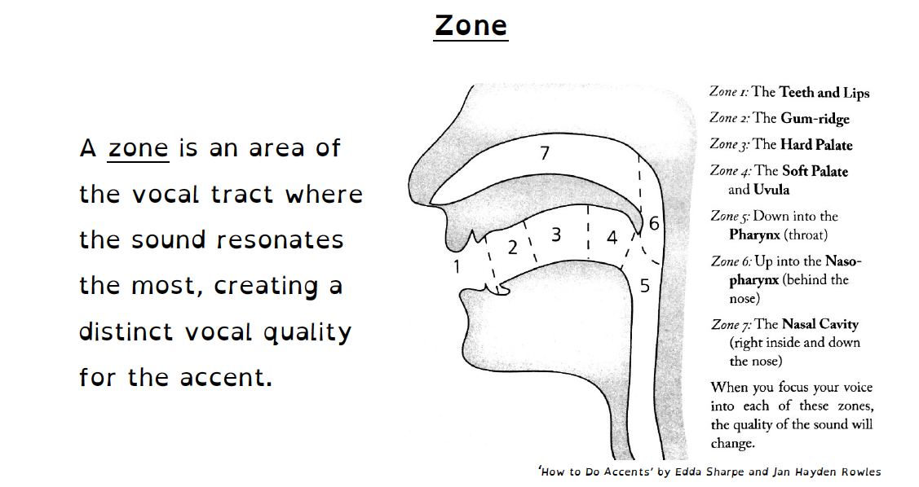

(Sharpe and Rowles, 2021)

When discussing articulatory movement of an accent, consider the following:

- Jaw height
- Jaw advancement or retraction
- Tongue-arching or cupping. Forward or back high or low
- Tongue root-advancement or retraction
- Channelling (widening and flattening) or bunching (narrowing and thickening) the tongue
- Relaxation or tensing of the cheeks into the teeth
- Advancement or retraction of the lip corners
- Pursing or relaxation of the lips
- Raising or lowering the velum
- Bracing the side edges of the body of the tongue against the teeth
(Knight, 2012, p. 106-107)

Unique or Interesting Features
Notice any interesting or unique articulatory features that the student may have (lisp, hypersibilance, hyponasality etc), but the idea is for the student to offer their observation first.

This step can be done fairly efficiently within the first few minutes of the lesson or during general conversation. Rather than the teacher remarking upon the student’s voice, it is important to take a sensitive approach, perhaps asking the student to firstly describe their own sound and accent and gently helping them to articulate this.

It is prudent to note if the student has been made aware of their articulatory features in a negative way in the past. Remain sensitive at all times and aim to provide an exploratory activity for the student to expand their vocal options, rather than a corrective regime to change bad habits.

Step 2. Articulatory Drills

Preliminary Exercise: Isolation of Articulatory Features

-Lip Pursing then lip spreading
-Velum high then low
-Tongue root advancement then retraction

Select one articulatory movement at a time and adjust it, whilst maintaining the other features of the oral posture as a ‘home base’. Either use a short phrase or simply just one word to experiment with.

Articulatory Drills

1.Fricative glide on Zzz through the musical interval pattern 1-5-1, starting in a comfortable modal pitch register, then moving up a semitone at a time.

2. Glide through the same pattern 1-5-1, this time on the vowel throughout, starting in a comfortable modal pitch register, then moving up a semitone at a time. Repeat using a different vowel each time.

Starting Set-up for Vowels

Vowel | i | E | A | O | U
Tongue Height | Close | Close-mid | Open | Close-mid | Close
Tongue Backness | Front | Front | Front | Back | Back

3.Repeat Step 2, this time making one adjustment to your initial articulatory setting before trying each set of vowels. Move up a semitone each time and explore a wide range of pitches.

Articulators to try changing

-Lip Pursing then lip spreading
-Velum high then low
-Tongue root advancement then retraction

Notice any articulatory adjustments you are making to maintain the same vowel sound whilst negotiating higher pitched notes.

4. Repeat Step 2 again, this time attempting to try different voice qualities as you explore pitch and articulatory adjustments.

Aim to explore: Cry, Sob, Speech, Twang and Belt

Again, notice any articulatory adjustments you are making to maintain the same vowel sound whilst negotiating higher pitched notes.

Step 3. Accent Breakdown

What accent am I aiming for?

Break down the accent using the following prompts which combine principles from KTS (Caban, 2020) and Sharpe-Haydn (2021):

People: Discuss the character that you are playing and select one or two real-life people that speak this accent for reference. Ideally, have a selection of recordings to listen to (there are many resources online:)
Prosody and Groove: The musicality and rhythmic pulsing of the accent, noting upwards or downwards inflections, pitch range. The groove of an accent may be described as a wring, press, flick, dab, glide, float, punch and slash.
Place: Aim to contextualise the accent, noting where it is spoken geographically
Posture: Explore the articulatory features of this accent. Discuss the zone (refer to previous diagram) that it rests in.

(see Accent Breakdown Exemplars attached for reference)

Step 4. Comparison of native and new accent

Identify similarities and differences between the selected accent and the student’s own accent (it may be surprising how many features are similar to their own accent; if so, it is easier to acknowledge those that are already habitually in place, rather than unlearning and relearning them).

Try speaking a few phrases to compare native and new accent.

Step 5. Re-moulding the Oral Posture in Speech

Phonetics: Look at the KIT list (Appendix 1) in this accent.

Try some practice sentences (Appendix 2).

If possible, try some of the dramatic text taken from the scene before the song that you are about to sing (or any text spoken by the character in the show). Failing this, speak some of the song lyrics in the accent.

Step 6. Musical Experimentation

BEFORE YOU MOVE ONTO YOUR CHOSEN SONG

Select some KIT words and/or practice sentences and explore some pitch intervals (try moving from 1-3-1 then 1-5-1).

Notice which features remain ‘in tact’ and which features lose strength or clarity
Notice which features feel more challenging to sustain when singing at different pitches

Having this knowledge BEFORE embarking on specific repertoire will arm the singer with more control and expectations regarding changing effort levels. It should also give them confidence to be playful with the accent and not feel ‘wrong’.

Step 7. Song Analysis

Exercise: Sing through the song

Discuss:

-What style of music is the song written in?
-In what context is the song to be performed in? (The student may be working towards an audition or an entire musical production)
-How challenging is this song for you? (1-10)
-What is the pitch range of the song?
-Identify the most challenging vocal sections. What is it that is challenging?
-Identify the least challenging vocal sections. Why does this feel least challenging?
-What accent do you typically (perhaps accidentally) sing this song in? Is this the accent that you now wish to sing it in?

Step 8. Exploring Effort with Accent Integration

Take the least effortful section of the song as selected by the student. Try it now in the selected accent.
Apply accent features one at a time, working on vowel sounds first, before adding consonant features.

Repeat this exercise now with the most effortful section of the song. Experiment with removing and reinserting different accent features to discover where the effort lies, and indeed, if certain features are more effortful to maintain at higher or louder sections, for instance.
Find the most comfortable level of accent integration for your character and for you as a singer.

Return to these questions as you experiment:

Is the text intelligible?
Am I meeting the dramatic and vocal requirements of the song?

Work through short (8-bar) sections of the song before attempting to sing through.

Step 9. Changing Emotions

Using Alfred’s (2014) approach to ‘actioning’ the text, begin to ‘action’ the song lyrics, using an 8-bar section at a time and trying out different actions before settling for one. Notice the impact the action has on the articulation.

Make a note of how articulatory movement and/or voice quality may alter according to changing actions.

(See exemplars for guidance).

Step 10. The Full Performance

Once you have successfully ‘actioned’ the lyrics and explored the physicality of the character, sing the full song through complete with the selected accent.

Exemplar

Applying accent work (RP, Yorkshire and Estuary English (EE) to the following song:

Sondheim’s Anyone Can Whistle

This song has been selected as it could justifiably be sung in any accent. Although it is typically sung in a US accent in the musical, which may be the default accent preferred by the singer, the vocabulary in the lyrics do not suggest a dialect, nor are there any geographical references. Although the character in the musical is female, there is no reason why it cannot be sung by either a female or male voice in any comfortable key.

(Follow the exercises in Steps 1-3 as instructed above. See accent breakdowns below for Step 4).

Step 5. Re-moulding the Oral Posture in Speech

Scene extract: Anyone Can Whistle

The highlighted text below offers an example of spoken dialogue that could be used through playful experimentation using the chosen accent, prior to singing in it.

Deliver the highlighted text aiming to maintain the posture (including the zone) and prosody of the accent chosen:

RP (zone 2)
Yorkshire (zone 5)
EE (zone 3)

HAPGOOD:
Woman of science? You're a fake! You really want your Cookies to take those waters! You'd like to soak in them yourself!
FAY:
All right. Yes, I would. I need a miracle.
I can't laugh-not really. I can't whistle.
HAPGOOD:
Nonsense.
FAY:
No, it's true, I can't play the piano by ear. When I was little I walked into a music store, I sat down at a shiny grand piano-and I played. Well, you can take piano lessons, use a metronome, learn, control and order. But you can't take lessons in whistling. So-your woman of science. Every walk I take, every street, every year, I wait. My mouth waits-but I can't.
Anyone Can Whistle
Anyone can whistle,
That's what they say
Easy.
Anyone can whistle
Any old day
Easy.
It's all so simple:
Relax, let go, let fly.
So someone tell me why
Can't I?
I can dance a tango,
I can read Greek
Easy.
I can slay a dragon
Any old week
Easy.
What's hard is simple.
What's natural comes hard. Maybe you could show me How to let go,
Lower my guard,
Learn to be free.
Maybe if you whistle,
Whistle for me.
I can slay a dragon
Any old week
Easy.
What's hard is simple.
What's natural comes hard. Maybe you could show me How to let go,
Lower my guard,
Learn to be free.
Maybe if you whistle,
Whistle for me.

Step 6. Musical Experimentation

Lexical Sets
Some common lexical sets that occur in this song are listed below in the 3 accents:

Lexical Set | Song Lyrics | RP | Yorkshire | EE (actor fills in according to accent on the continuum)
GOAT | Show | [ʃəʊ] | [ʃoː]
FACE | Maybe | [ˈmeɪbi] | [meːbe]
NURSE | Learn | [lɜː(r)n] | [ɬɜ̞ːn]
THOUGHT | All | [ɔːl] | [ɒːɬ]

Choose a song lyric from one of the common lexical sets. Experiment with changing the pitch, first sustaining on different notes, and then moving between 1-5-1:

Step 7. Song Analysis

Musical Style: Lyrical ballad
Character: Fay (Female doctor)
Pitch Range:

Step 8. Exploring effort with accent integration

Here is a suggestion for what might be perceived as being the least effortful section to begin accent work with:
Why? This section involves singing at a low pitch, potentially similar to the speaking pitch range of the character, thus offering a seamless transition from speaking to singing.
Once established through speaking, accent features are likely to be easily transferred to this pitch range.
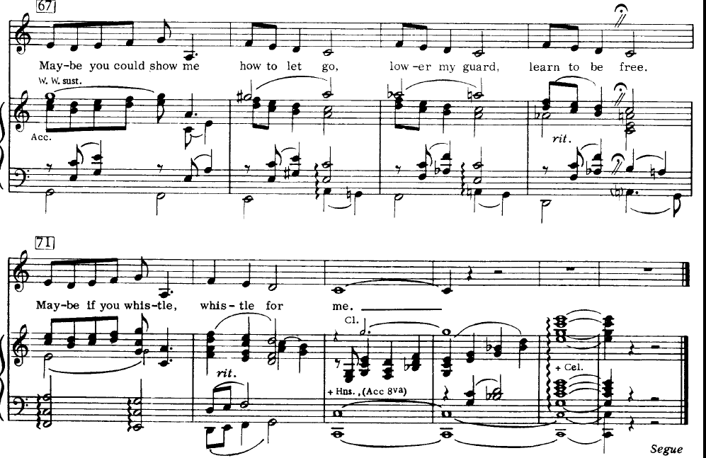

Here is a suggestion for what might be perceived as being the most challenging vocal section:

Why? This section involves ascending interval leaps, which might prove most technically challenging for a singer. It also involves sustaining notes for longer durations, thus exposing the accent in a different way to speaking, and forcibly changing the groove.

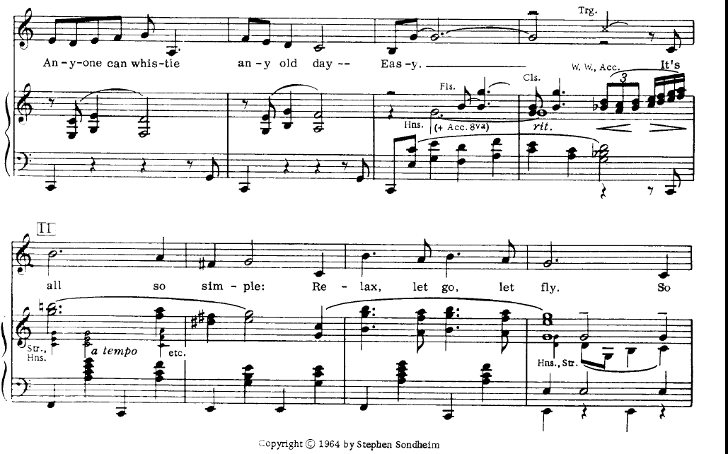
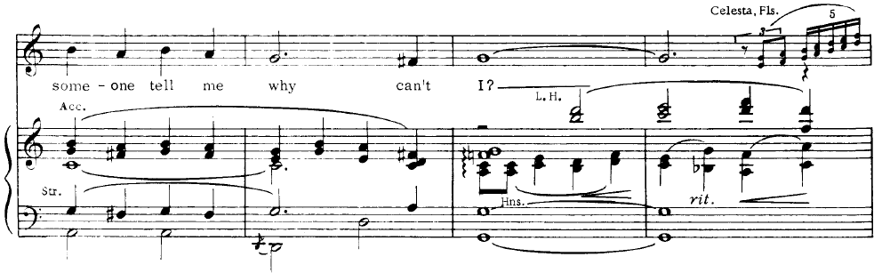

Potential challenges when attempting to move away from the US accent in this song:
Vowels and Dipthongs:
-the THOUGHT lexical set will be altered considerably from US in both RP and EE, resulting in a more closed vowel, with added lip rounding in EE. This could potentially cause problems if the lip-rounding is brought in early on the sustained 3-beat note on ‘it’s all’.
‘It’s all…’ could be worked in isolation to find the correct vowel placement for the accent and resonance. Experiment with the timing of this and aim to find a compromise.

Lyrics | RP | Yorkshire | EE
It’s all | [ɪts ɔːl] | [ɪ̞ts ɒːɬ]

-the GOAT sounds may involve lip rounding through the dipthong with RP with possible added nasality with EE, but in the Yorkshire accent, it might be monothonged.
‘Let go, let fly’, for instance could be worked in isolation to find the optimum placement of the dipthong (if this is sung).
Lyrics | RP | Yorkshire | EE
Let go, let fly | [lɛt ɡəʊ lɛt flɑɪ] | [ɬɛt ɡoː ɬɛt fɬɑɪ]

Consonants
-The ‘t’ sound would not typically be aspirated in a US accent
-The ‘l’ sound in ‘whistle’ would typically be dark in both RP and Yorkshire, similar to US. In EE it might be vocalised involving lip-rounding. Again, experiment with the timing of the lip-rounding on this sound.
Lyrics | RP | Yorkshire | EE
whistle | [ˈwɪsl] | [ˈwɪsl]

Step 9. Changing Emotions
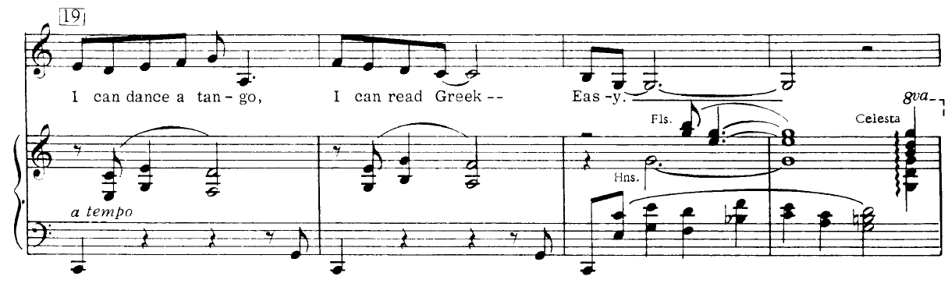
Isolated lyrics: I can dance a tango, I can read Greek. Easy.
Suggested direction | Potential Impact on Voice | Potential Impact on Accent and Articulation
To Tell a Secret | Increased aspiration | Breathy onsets
To Boast | Louder dynamic | Added twang
To Tell a Joke | Increased aspiration, changing facial muscular involvement | Loss of intelligibility

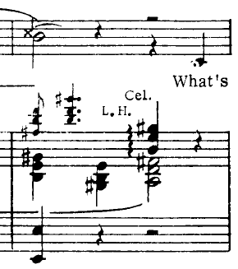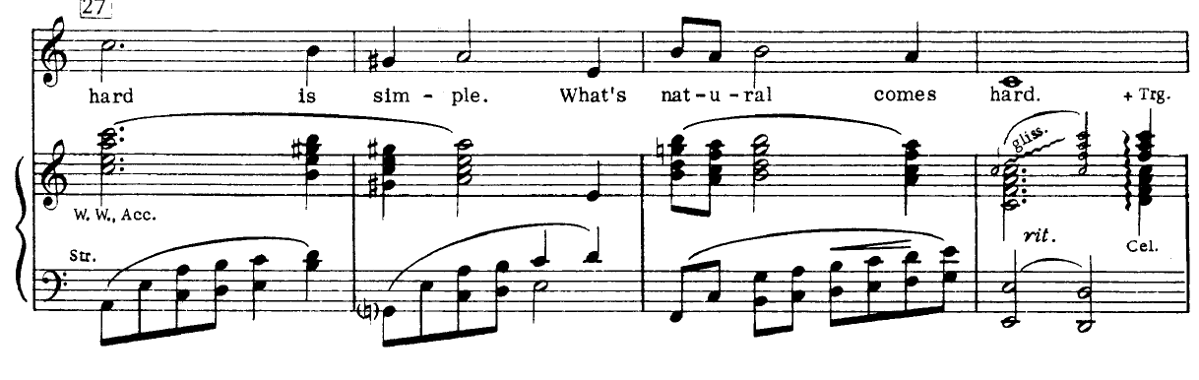
Isolated lyrics: What’s hard is simple, what’s natural comes hard.
Suggested direction | Potential Impact on Voice | Potential Impact on Accent and Articulation
To express frustration | Increased aspiration | Lengthened consonants
To express anger | Louder dynamic, thicker vocal fold set-up | Longer fricatives, accented onsets
To express sadness | More thyroid tilt, quieter dynamic, thinner vocal fold set-up | Less twang

Step 10 The Full Performance
Sing through the entire song (Appendix 3) with the accent now integrated, ensuring you are fully committed to the dramatic intentions behind each line.
3 x accent breakdowns

1. RP

Place and People (Context)

The Received Pronunciation (RP) accent is a traditional accent of England
meant to be free from any regional influences, however is most commonly
associated with Southern England and the “home counties”. It is estimated
only 2% of the UK population speak with an RP accent, as it is much more
common in modern day to mix RP sounds with London sounds (reffered to
as “Estuary”). Other names for RP include General British, Standard
Southern English (SSE), Public School Pronunciation, BBC English, The
Queen’s English and Oxford English. While originally developed and taught
as the “correct” way of speaking for students in public schools, the RP
accent in modern day exists as a regional accent of the south of England. It
is important to remember that RP is no more correct than any other
accent, and is in no way a “neutral” accent. (Hajir, 2022, p. 15)

Posture
Zone 2 (Zone 1 heightened RP) (Sharpe Hayden)

Consonants
Rhoticity: Non-Rhotic
The RP accent is non-rhotic (r is not pronounced after a vowel sound,
unless in between two vowels). When it isn’t dropped, R is pronounced as a voiced alveolar approximant [ɹ]. (Hajir, 2022, p. 16)

L sound. The RP accent uses light l [l] at the beginning of words, but dark l [ɫ] in the
middle or at the end of words. One exception is -ly endings which are
pronounced with light l. (Hajir, 2022, p. 16)

Vowels
BATH → /ɑ/
BATH should use the same long a vowel as in PALM (if you are Irish, you
might pronounce PALM like TRAP so be careful!).
THOUGHT → /ɔ/ (merged with NORTH and FORCE)
The vowel in THOUGHT is the same as in non-rhotic NORTH and FORCE.
LOT and CLOTH → /ɒ/
This is a sound not commonly used in American accents. It is a shorter,
rounder sound than the /ɑ/ used in General American. (Hajir, 2022, p. 16)

Prosody
The groove can be described as a float (Laban)
(Hajir, 2022, p. 15)

2. Yorkshire

Place and People
The General Yorkshire accent is a generalization of accents spoken in the
Yorkshire counties. It is sometimes referred to as “Standard Northern” (but
we won’t use that term). This version of a Yorkshire accent has some key
features of Yorkshire accents, but is missing any regional variation that
would be found in someone native to Yorkshire. It is a good starting point
for a Yorkshire accent or if someone just asks for “Northern”, but you will
want to do more research and listening to get a more specific accent for a
character if you are cast. (Hajir, 2022, p. 17)

Posture
The General Yorkshire accent is generally spoken in zone 5. (Sharpe and Rowles, 2021)

Consonants
R
The General Yorkshire accent is non-rhotic, meaning that r sounds will not
be pronounced after a vowel (unless the r is in between two vowels).
L
The General Yorkshire accent always uses dark l [ɫ]
T
T in the middle or end of a word is glottal (stopped at the vocal folds). [ʔ]
H
H is often (although not necessarily always) dropped at the start of a word.

Vowels
GOAT → /o/ FACE → /e/
The second sound in these usual diphthongs is dropped entirely.
STRUT → /ʊ/
In this accent the STRUT and FOOT groups are merged to sound the same.
BATH → /æ/
Although usually merged with TRAP (as in General American), these words
are in free variation, meaning that pronouncing some BATH words like
PALM is acceptable.
NORTH and FORCE → /ɒ/
These vowels are made further back, and slightly less rounded than in
other British accents, such as RP /ɔ/. But it isn’t a short vowel like in LOT!

Prosody
The intonation of sentences tends to end downward, and doesn’t use a wide range of
pitches along the way.
The groove can be described as a press; a smooth and slow downward trajectory. (Hajir, 2022, p. 17)

3. Estuary English (EE): As a moveable accent between RP and Cockney

Why not fix this accent?

People/Place
Estuary English is an accent associated with the area along the River Thames and its estuary, including London. Well’s definition of Estuary English: "Standard English spoken with the accent of the southeast of England". He views Estuary English as an emerging standard accent of England: an "intermediate" between the 20th-century higher-class non-regional standard accent, Received Pronunciation, and the 20th-century lower-class local London accent, Cockney. There is some debate among linguists as to where Cockney speech ends and Estuary English begins. (Wikipedia, 2022).

Posture

Zone 3. Forward onto the teeth and punched up onto the hard palate.

Features distinguishing EE from RP:
- diphthong shift
- /l/-vocalisation
- /t/-glottalisation
- yod-coalescence
- th-fronting

Other vowel differences
- /iː/ (as in FLEECE) can be realised as [iː], [ɪi] or [əi] with the first two variants predominating. Before the dark l, it is sometimes a centering diphthong [iə]
- /uː/ (as in GOOSE) can be realised in many different ways, such as monophthongs [ʏː], [ɪ̝ː], [ʉː], [ɨː], [ʉ̠ː], [u̟ː] and diphthongs [ɘɵ], [ɘʏ], [ʏɨ] and [ʊu].^{[34]} Front pronunciations ([ʏː], [ɪ̝ː], [ɘʏ] and [ʏɨ]) are more often encountered in female speakers. Before the l, it is always back.
- /ʊ/ can be central (rounded [ʊ̈] or unrounded [ɪ̈] near-front [ʏ], or simply near-back [ʊ], as in RP. Only the last variant appears before the dark l.
- /ɔː/ (as in THOUGHT), according to Przedlacka (2001), can be pronounced in two different ways: diphthongal [oʊ] in closed syllables and [ɔə] or [ɔ̝ə] in open syllables and monophthongal [ɔː]. According to Parsons (1998) it is either [ɔʊ] or [oː] before consonants, and either [ɔə] or [ɔː] at a morpheme boundary.
- /ʌ/ (as in STRUT) can be realised as [ɒ], [ʌ], [ɐ], [ɐ̟] or [æ] with [ɐ] being predominant. The first two variants occur mostly before /ŋ/ The last two variants are more often used by females
- /æ/ (as in TRAP) can be realised as [a], [a̝], [æ], [ɛ̞] or [ɛ] A somewhat retracted front [a̠] has been reported for some speakers in Reading.

Features distinguishing EE from Cockney
Wells suggests that EE differs from Cockney in a few key features.
- EE differs from Cockney in usually not being characterized by h-dropping before stressed vowels (informal example: " 'and on 'eart" for "hand on heart"))
- Th-fronting (e.g. "I fink" for "I think")
- Cockney may have monophthongal realization of the MOUTH vowel ("Sahfend" for "Southend").
(Wikipedia, 2022)
Prosody
Major tones. Downwards inflections. The groove can be described as a FLOAT (Sharpe and Rowles, 2021, p. 155)

References
Alfreds, M. (2014). Different Every Night. London: Nick Hern Books.
Caban, A. (2020). ‘Experiencing Speech’
Estill, J., (2005a). Estill Voice Training Level One. Figures for Voice Control. 2010 Print Version.
Estill, J., (2005b). Estill Voice Training Level Two. Figure Combinations for Six Voice Qualities. 2010 Print Version.
Hajir, J. (2022). Bird College Accent Handbook
Knight, D. (2012). Speaking with skill : an introduction to Knight-Thompson Speechwork. London: Methuen Drama.
Sharpe, E. and Rowles, J.H. (2021) How To Do Accents. Revised 2nd ed. London: Methuen Books.

Steinhauer, K et al. (2017). The Estill Voice Model Theory and Translation (Estill Voice International: Pennsylvania)

Unpublished. (2022). Module 4. University of Wales Trinity St David

Wells, J.C. (1996). Accents of English 2: The British Isles

Appendices
1.Lexical Sets

Lexical Set | GenAm | RP
KIT | ɪ | ɪ
DRESS | ɛ | ɛ
STRUT | ʌ | ʌ
FOOT | ʊ | ʊ
GOOSE | u | u
FLEECE | i | i
NURSE | ɜɹ | ɜ
TRAP | æ | æ
BATH | æ | ɑ
PALM | ɑ | ɑ
START | ɑɹ | ɑ
LOT | ɑ | ɒ
CLOTH | ɑ | ɒ
THOUGHT | ɑ | ɔ
NORTH | ɔɹ | ɔ
FORCE | ɔɹ | ɔ
FACE | eɪ | eɪ
GOAT | oʊ | əʊ
PRICE | aɪ | aɪ
CHOICE | oɪ | oɪ
MOUTH | aʊ | aʊ
NEAR | ɪəɹ | ɪə
SQUARE | eəɹ | eə
CURE | ɔɹ / ʊəɹ | ɜ / ʊə

(Wells, 1996, p. xviii)

2. Practice Sentences

KIT A pretty little bit of English business.
DRESS Don’t expect any pleasant weather next Wednesday.
STRUT The dull young monks rushed in a flood to hunt the buds of the lovely buttercup.
FOOT You should put the cook book on the woolen cushion.
GOOSE Choose a pewter spoon or a beautiful fruit tube.
FLEECE Keith eats a piece of decent cheese beneath green trees.
NURSE The bird perched on the church with a worm.
TRAP The cat dashed to catch the ham that dangled from the bag.
BATH Francis the calf can't dance, laughed Sandra the giraffe, aghast, as the calf
pranced disastrously.
PALM Brahms' sonata kept father calm in the spa with almonds, sultanas and a lager.
START Sergeant Charles was the star of the party with his hearty aria.
LOT Tom’s dog honestly watched the odd swans dodge a yacht.
CLOTH Ross often frothed the coffee and washed the long sausages in Boston.
THOUGHT Paul applauded all the naughty daughters who yawned when taught
with chalk and talk.
NORTH George cavorted with Thor to fortify his short torso for the war in York.
FORCE Of course I adore Nora, roared the porter through the door to the four divorced
boarders.
FACE April felt faint as she campaigned to rein in the wasteful ladies to change their
ways and obey.
GOAT Joan coaxed her beau, Owen, to grow closer, though she loathed his boastful
note.
(Goal) The old soul of the lonely mole controlled the moldy bolder.
PRICE Clive liked a violent knife fight on Friday nights.
CHOICE The boy employed a joist to hoist the moist oysters into the boiling oil.
MOUTH The loud crowd from south of the county wanted to oust the clown out of town,
but they were all mouth.
NEAR Maria was sincere in her weird career, but feared the fierce bearded cashier.
SQUARE Where the pears are scarce, the bears share theirs fairly.
CURE Muriel assured the poor tourists that the insurance was sure to cover Europe.

R Margaret, Linda and Gerry asked Peter if Roland started with 'R'.
L Larry the lazy lamb slept peacefully in the field until hailstones fell.
H (initial) Harry Hobson had a(n) holiday in Hawaii.
TH (unvoiced) It’s a thick, pathetic broth.
TH (voiced) Look at those brothers bathe.
NG The smiling singer was singing with the king.
T (intervocalic) Betty went to the city to get a bit of pretty glitter and some British butter.
TN She climbed a mountain to find some cotton buttons for her mittens.

(Hajir, 2022)

3. ‘Anyone Can Whistle’ from Anyone Can Whistle (Sondheim)
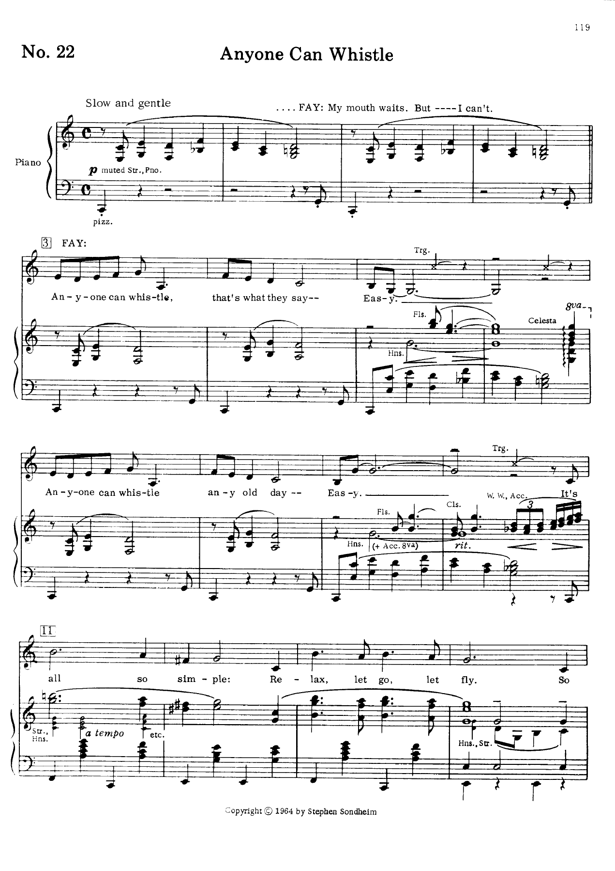
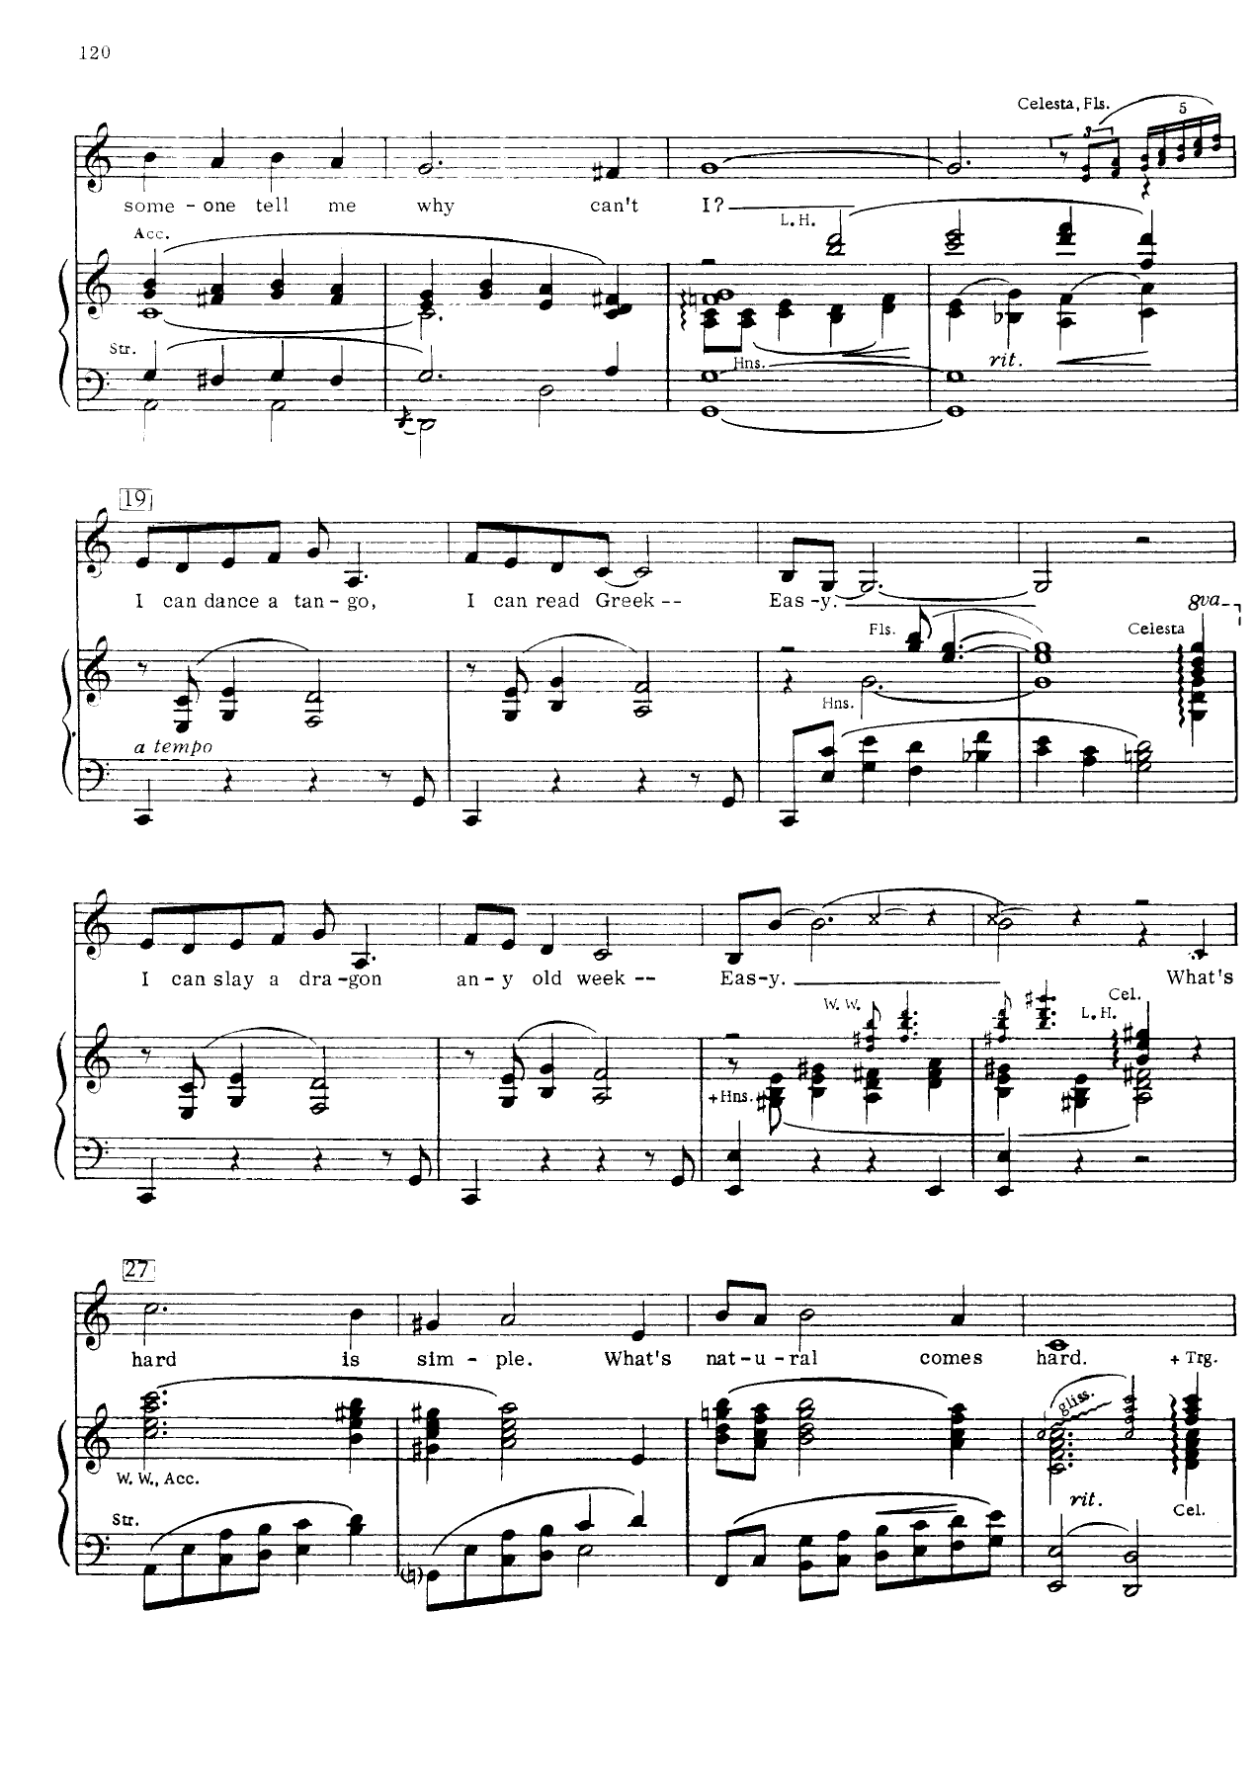

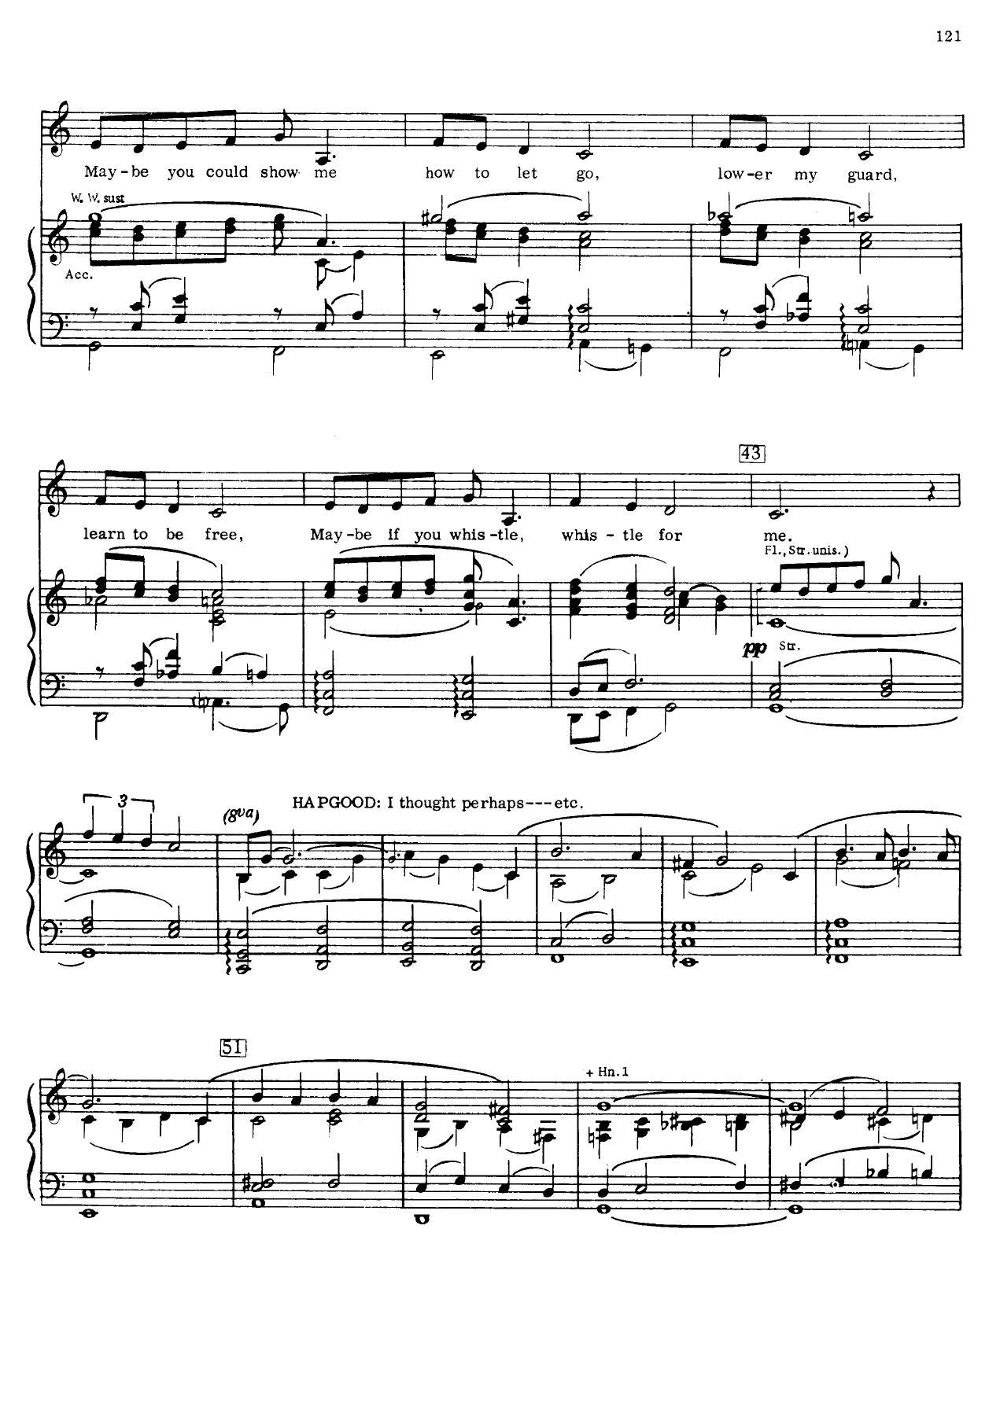

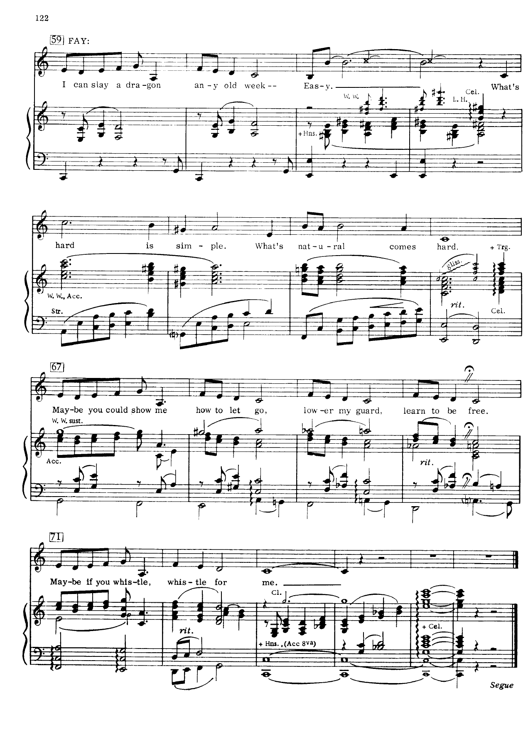

- Anthony Drewe and George Stiles have been collaborating over musical theatre projects for over 30 years. They have been prolific in the British musical theatre scene; their works include Honk! (1993), Peter Pan (1999), Just So (1989) and Betty Blue Eyes (2011).
- Tim Minchin was the composer and lyricist of the hugely acclaimed West End and Broadway production of Roald Dahl’s Matilda, which premiered at the Royal Shakespeare Company in 2009.
- English musician, Sting, composed the score for musical The Last Ship, which premiered in Chicago in 2014. The show was initially inspired by Sting’s 1991 album The Soul Cages, and tells a semi-autobiographical tale of life in the shipping community in Tyne and Wear.
- The General American accent often known in linguistics simply as General American (GA or GenAm), is the umbrella accent spoken by a majority of Americans, encompassing a continuum rather than a specific accent (Wikipedia 2, 2023).
- Belting: Belting or belt quality is a complex setup combining speech quality, twang quality, a tilted cricoid cartilage and raised larynx. Twang is an important component in belt quality. Gillyanne Kayes writes, 'Belting is not harmful if you are doing it right. Jo Estill has described it as "happy yelling". Belt quality also uses clavicular breathing and has the longest closed phase with the highest subglottic pressure and the greatest glottic resistance (Wikipedia 3, 2023).
- Sprechstimme (German for “speech-voice”) is in music, a cross between speaking and singing in which the tone quality of speech is heightened and lowered in pitch along melodic contours indicated in the musical notation. Sprechstimme is frequently used in 20th-century music (Britannica, 2023) Singer and actor Marlene Dietrich became associated with this sound, particularly as her career progressed and her vocal performances rested more prominently in this style (Bell, 2011, p. 645)
- Accentism describes discriminatory or unfair behaviour centred on someone’s accent or language use (futurelearn.com, 2023)
- Greek Drama and authenticity: Cite example of production of Electra in 4th Century, where title role used real ashes of own son to scatter amongst audience (!). The “reality of bereavement and performance intermingle to produce an extraordinary effect on the audience” (p. 4)
- Verbatim Theatre: Verbatim Theatre: “a form of documentary theatre which is based on the spoken words of real people. Strictly, verbatim theatre-makers use real people’s words exclusively, and take this testimony from recorded interviews.” An example of this includes the acclaimed production of London Road at the National Theatre. (Wikipedia 4, 2023)
- Juke Box musicals are staged musicals or musical films in which a majority of the songs are well-known popular music songs, rather than original music. (Wikipedia 5, 2023)
- Biographical musicals based upon the lived experiences of iconic musicians include hits such as Tina Turner the musical (2019) and Beautiful-the Carol King story (2013)
- L-Vocalisation, in linguistics, is a process by which a lateral approximant sound such as [l], or, perhaps more often, velarized [ɫ], is replaced by a vowel or a semivowel. (Wikipedia 6, 2023)
- TH-Fronting is the pronunciation of the English “th” as “f” or “v”. When th-fronting is applied, [θ] becomes [f] (for example, three is pronounced as free) and [ð] becomes [v] (for example, bathe is pronounced as bave). (Wikipedia 7, 2023)
- Estuary English (EE): it is a continuum accent existing on a spectrum between Received Pronunciation and Cockney (Wells, 1995).
- Onwuegbuzie et al (2009) introduced a new way of analyzing focus group data-term micro-interlocutor analysis, which incorporates and analyzes information from the focus group by delineating which participants respond to each question, the order of responses, and the nature of the responses (e.g., non sequitur, rambling, focused) as well as the nonverbal communication used by each of the focus group participants (Onwuegbuzie et al, 2009).
- Ethical consent form:

APPLICATION FOR ETHICAL APPROVAL

In order for research to result in benefit and minimise risk of harm, it must be conducted ethically. A researcher may not be covered by the University’s insurance if ethical approval has not been obtained prior to commencement.

The University follows the OECD Frascati manual definition of research activity: “creative work undertaken on a systematic basis in order to increase the stock of knowledge, including knowledge of man, culture and society, and the use of this stock of knowledge to devise new applications”. As such this covers activities undertaken by members of staff, postgraduate research students, and both taught postgraduate and undergraduate students working on dissertations/projects.

The individual undertaking the research activity is known as the “principal researcher”.

Ethical approval is not required for routine audits, performance reviews, quality assurance studies, testing within normal educational requirements, and literary or artistic criticism.

Please read the notes for guidance before completing ALL sections of the form.

This form must be completed and approved prior to undertaking any research activity. Please see Checklist for details of process for different categories of application.

Delete the Guidance Notes at the end of the form BEFORE submitting your application

SECTION A: About You (Principal Researcher)
1 | Full Name: |  | Jennifer Rhodes
2 | Tick all boxes which apply: |  | Member of staff: | ☐ | Honorary research fellow: | ☐
3 | Undergraduate Student | ☐ | Taught Postgraduate Student | ☒ | Postgraduate Research Student | ☐

4 | Institute/Academic Discipline/Centre: | WAPPAR
5 | Campus: | Carmarthen
6 | E-mail address: | Your email: jenrhodes100@gmail.com
7 | Contact Telephone Number: | 07811 380 702
 | For students:
8 | Student Number: | 2030102
9 | Programme of Study: | MA in Professional Practice (Voice Pedagogy)
10 | Director of Studies/Supervisor: | Nick Samuel

SECTION B: Approval for Research Activity
1 | Has the research activity received approval in principle?  (please check the Guidance Notes as to the appropriate approval process for different levels of research by different categories of individual) |  | YES | ☒ | NO | ☐
 |  |  |  |  | Date
2 | If Yes, please indicate source of approval (and date where known): Approval in principle must be obtained from the relevant source prior to seeking ethical approval | Research Degrees Committee |  | ☐
3 |  | Institute Research Committee |  | ☐
4 |  | Other (write in)  WAPPAR Ethics Board Representative |  | ☒

SECTION C: Internal and External Ethical Guidance Materials
 | Please list the core ethical guidance documents that have been referred to during the completion of this form (including any discipline-specific codes of research ethics, and also any specific ethical guidance relating to the proposed methodology). Please tick to confirm that your research proposal adheres to these codes and guidelines.
1 | UWTSD Research Ethics & Integrity Code of Practice | ☒
2 | UWTSD Research Data Management Policy | ☒
3 |  | ☐

SECTION D: External Collaborative Research Activity
1 | Does the research activity involve collaborators outside of the University? |  | YES | ☐ | NO | ☒
2 | If Yes, please provide the name of the external organisation and name and contact details for the main contact person and confirmation this person has consented to their personal data being shared.as part of this collaboration.
3 | Institution
4 | Contact person name
5 | Contact person e-mail address
6 | Has this individual consented to sharing their details on this form? |  | YES | ☐ | NO |  |  | ☐
7 | Are you in receipt of a KESS scholarship? |  | YES | ☐ | NO |  |  | ☐
8 | Is your research externally funded |  | YES | ☐ | NO |  |  | ☐
9 | Are you specifically employed to undertake this research in either a paid or voluntary capacity? | Voluntary | YES | ☐ | NO |  | ☐
10 |  | Employed | YES | ☐ | NO |  | ☐
11 | Is the research being undertaken within an existing UWTSD Athrofa Professional Learning Partnership (APLP) | If YES then the permission question below does not need to be answered. | YES | ☐ | NO |  |  | ☐
12 | Permission to undertake the research has been provided by the partner organisation | (If YES attach copy)  If NO the application cannot continue | YES | ☐ | NO |  |  | ☐

Where research activity is carried out in collaboration with an external organisation
13 | Does this organisation have its own ethics approval system? | YES | ☐ | NO | ☐
14 | If Yes, please attach a copy of any final approval (or interim approval) from the organisation

SECTION E: Details of Research Activity
1 | Indicative title: | Singing In Regional Accents: A Strategy for Teachers
2 | Proposed start date: | 01.07.2023 | Proposed end date: | 06.03.2024
3 | Introduction to the Research (maximum 300 words)  Ensure that you write for a Non-Specialist Audience when outlining your response to the three points below:  - Purpose of Research Activity  - Proposed Research Question  - Aims of Research Activity  - Objectives of Research Activity  Demonstrate, briefly, how Existing Research has informed the proposed activity and explain  - What the research activity will add to the body of knowledge  - How it addresses an area of importance.
4 | Purpose of Research Activity  To make practical use of existing research into the evolution of accents and accent coaching, updating singing teachers’ knowledge and supporting industry demands by facilitating more diverse representation of accents on stage. To question the concept of authenticity in accent work for musical theatre singers, considering the varied musical styles expected of them. To build a pedagogical bridge between the fields of Singing and Voice, drawing upon research from the fields of Linguistics and Voice Pedagogy. To develop a teaching strategy to help singing actors tackling regional accents.  (this box should expand as you type)
5 | Research Question  -How useful is my strategy in helping singers to integrate any regional accent in sung text?  -How important is it for a character’s accent to be integrated into their songs in a musical?  -Should students be encouraged to sing primarily in their own native accents, regardless of character?  -Should ‘standard’ accents such as RP, General American be taught in musical theatre training institutions?  (this box should expand as you type)
6 | Aims of Research Activity  -Inform Singing teacher colleagues of developments in the field of Accent training  -Promote wider acceptance of all sociolinguistic features in spoken and sung text  -Respond to the shift away from ‘standard’ accents in (spoken) Voice training, and critically analyse this approach for musical theatre training  -Further develop my strategy for teaching accents to singers  -Consider the limitations of my strategy.  (this box should expand as you type)
7 | Objectives of Research Activity  -Equip singing teachers with a resource for helping singers with accents.  -Encourage a common language between Singing and (spoken) Voice teachers when it comes to adjustment of articulatory features.  -Address the concept of authenticity regarding the performer’s speaking and singing voice  -Build upon existing research in the fields of Linguistics as well as Voice and Singing pedagogy; the fundamental ways in which accents can be learned will be considered alongside evolving industry requirements for singing actors and ways in which performers are coached in accents and singing.  (this box should expand as you type)
8 | Proposed methods (maximum 600 words)  Provide a brief summary of all the methods that may be used in the research activity, making it clear what specific techniques may be used. If methods other than those listed in this section are deemed appropriate later, additional ethical approval for those methods will be needed.
9 | I will use a Design-Based Research Model.  I will follow a mixed methods approach combining both qualitative and quantitative methods.  I will incorporate methodological triangulation, using a combination of 3-5 of the following methods:  1.Document Analysis/Literature Review. My teaching strategy is based upon thorough analysis of all forms of literature, including books, webinars, scientific papers, peer reviewed articles, newspaper articles,  2.Survey Questionnaire. Participants will be sent (via email) a copy of my strategy for “Teaching Accents to Singers” along with a closed questionnaire asking for their response to the strategy. They will then complete and return the questionnaire via email.  3. Focus Group. This will take the form of an online group meeting (I will facilitate this) to discuss opinions, recommendations and amendments to the strategy. Focus group members will be a combination of experienced freelance Singing and (spoken) Voice teachers who work in a variety of establishments and in the wider musical theatre industry. The focus group meeting will take place via Zoom. The aim of the focus group is to discuss the value of my teaching strategy as well as wider questions surrounding methods of accent training on musical theatre courses.  4. Semi-structured interviews. I may choose to interview a selection of the same participants from the focus group. Data will be collected either from semi-structured questionnaires, which will be emailed to the participants. Or, semi-structured interviews will be conducted; they will be recorded and transcribed.  5. Journal. My own autoethnographic account will be drawn from journals detailing recollections of my teaching experience. It will be used as anecdotal evidence to supplement the data collected from my focus group, questionnaire and/or interviews. This data will inform potential improvements to the content and focus of the teaching strategy that I design.  Participants for the focus group, interviews and questionnaires will all be experts in the fields of Singing Teaching and/or Voice and Accent Teaching. They will work in musical theatre training institutions in higher educational conservatoire settings.  Data Collection: This will be a combination of data from my literature review, questionnaire and focus group and/or semi-structured interviews plus reflective analysis of anecdotal evidence from my teaching practice documented in my journal accounts.  Final Report: Using an iterative cycle, I will ask for feedback from the focus group and/or interviewees on the teaching strategy and make necessary adjustments.  I will analyse my data through a reflective framework, categorising priorities of my teaching strategy and areas for improvement. I may use descriptive coding to analyse my data. I will produce a written report that includes my proposed written strategy.

10 | Location of research activity  Identify all locations where research activity will take place.
11 | The research will be conducted online over zoom and/or via email and text to individual participants.  (this box should expand as you type)
12 | Research activity outside of the UK  If research activity will take place overseas, you are responsible for ensuring that local ethical considerations are complied with and that the relevant permissions are sought. Specify any local guidelines (e.g. from local professional associations/learned societies/universities) that exist and whether these involve any ethical stipulations beyond those usual in the UK (provide details of any licenses or permissions required). Also specify whether there are any specific ethical issues raised by the local context in which the research activity is taking place, for example, particular cultural and/or legal sensitivities or vulnerabilities of participants.
13 | (this box should expand as you type)

14 | Use of documentation not in the public domain: Are any documents NOT publicly available? | NO | ☒
14 |  | YES | ☐
15 | If Yes, please provide details here of how you will gain access to specific documentation that is not in the public domain and that this is in accordance with prevailing data protection law of the country in question and England and Wales.  (this box should expand as you type)

SECTION F: Scope of Research Activity
1 | Will the research activity include: | YES | NO
2 | Use of a questionnaire or similar research instrument? | x | ☐
3 | Use of interviews? | x
4 | Use of diaries? | x | ☐
5 | Participant observation with their knowledge? | ☐ | x
6 | Participant observation without their knowledge? | ☐ | x
7 | Use of video or audio recording? | x | ☐
8 | Access to personal or confidential information without the participants’ specific consent? | ☐ | x
9 | Administration of any questions, test stimuli, presentation that may be experienced as physically, mentally or emotionally harmful / offensive? | ☐ | x
10 | Performance of any acts which may cause embarrassment or affect self-esteem? | ☐ | x
11 | Investigation of participants involved in illegal activities? | ☐ | x
12 | Use of procedures that involve deception? | ☐ | x
13 | Administration of any substance, agent or placebo? | ☐ | x
14 | Working with live vertebrate animals? | ☐ | x
15 | Other primary data collection methods, please explain in this box  For example, ‘focus groups’. Please indicate the type of data collection method(s) in this box and tick the accompany box. | x | ☐
16 | Details of any other primary data collection method:  I will use a focus group of between 6-8 adult professionals. They will be a selection of singing teachers and voice coaches. The focus group will be conducted remotely, via Zoom. It will be recorded. Participants’ names will remain anonymous. Participation will be optional and I will gain consent of the participants before the focus group commences.  I will keep a journal of my observations made in my own teaching studio. All students’ names will remain anonymous.  (this box should expand as you type) | x | ☐
If NO to every question, then the research activity is (ethically) low risk and may be exempt from some of the following sections (please refer to Guidance Notes).

If YES to any question, then no research activity should be undertaken until full ethical approval has been obtained.

SECTION G: Intended Participants
1 | Who are the intended participants: | YES | NO
2 | Students or staff at the University? | ☐ | x
3 | Adults (over the age of 18 and competent to give consent)? | x | ☐
4 | Vulnerable adults? | ☐ | x
5 | Children and Young People under the age of 18? (Consent from Parent, Carer or Guardian will be required) | ☐ | x
6 | Prisoners? | ☐ | x
7 | Young offenders? | ☐ | x
8 | Those who could be considered to have a particularly dependent relationship with the investigator or a gatekeeper? | ☐ | x
9 | People engaged in illegal activities? | ☐ | x
10 | Others (please identify specifically any group who may be unable to give consent) please indicate here and tick the appropriate box. | ☐ | x
11 | Other – please indicate here:  (this box should expand as you type) | ☐ | x

12 | Participant numbers and source  Provide an estimate of the expected number of participants. How will you identify participants and how will they be recruited?
13 | How many participants are expected? | I expect to conduct a focus group with between 6-8 participants. They shall be selected so as to include a range of experienced Singing and Voice practitioners.  For the semi-structured interviews and closed questionnaires, I will also involve 6-8 participants  (this box should expand as you type)
14 | Who will the participants be? | For both the focus group and questionnaires, the participants will be a selection of Singing and Voice teachers, all of whom work in performing arts higher education in conservatoire-style settings. They will all have experience in teaching Musical Theatre students. They will be familiar with Singing and Voice curriculums on undergraduate training courses. They will work in a range of institutions.  (this box should expand as you type)
15 | How will you identify the participants? | My participants will be selected by my familiarity with their work and standing in the fields of Singing and Voice teaching in higher educational musical theatre training establishments.  I will recruit accordingly from a list of Singing and Voice teachers known to me.  Participants will be contacted by email. All participants will remain anonymous in my report. They will be referred to as participant A, B etc.  (this box should expand as you type)

16 | Information for participants: | YES | NO | N/A
17 | Will you describe the main research procedures to participants in advance, so that they are informed about what to expect? | ☒ | ☐ | ☐
18 | Will you tell participants that their participation is voluntary? | ☒ | ☐ | ☐
19 | Will you obtain written consent for participation? | ☒ | ☐ | ☐
20 | Will you explain to participants that refusal to participate in the research will not affect their treatment or education (if relevant)? | ☒ | ☐ | ☐
21 | If the research is observational, will you ask participants for their consent to being observed? | ☒ | ☐
22 | Will you tell participants that they may withdraw from the research at any time and for any reason? | ☒ | ☐ | ☐
23 | With questionnaires, will you give participants the option of omitting questions they do not want to answer? | ☒ | ☐ | ☐
24 | Will you tell participants that their data will be treated with full confidentiality and that, if published, it will not be identifiable as theirs? | ☒ | ☐ | ☐
25 | Will you debrief participants at the end of their participation, in a way appropriate to the type of research undertaken? | ☒ | ☐ | ☐
26 | If NO to any of above questions, please give an explanation
27 | (this box should expand as you type)

28 | Information for participants: | YES | NO | N/A
29 | Will participants be paid? | ☐ | ☒ | ☐
30 | Is specialist electrical or other equipment to be used with participants? | x |  | ☐
31 | Are there any financial or other interests to the investigator or University arising from this study? | ☐ | ☒ | ☐
32 | Will the research activity involve deliberately misleading participants in any way, or the partial or full concealment of the specific study aims? | ☐ | x | ☐
33 | If YES to any question, please provide full details
34 | I will be using my Mac computer with an inbuilt microphone to conduct the focus group and interviews via zoom. The meeting will be recorded and stored on my password protected laptop, that only I have access to. The recording will be deleted at the end of this assignment.  (this box should expand as you type)

SECTION H: Anticipated Risks
1 | Outline any anticipated risks that may adversely affect any of the participants, the researchers and/or the University, and the steps that will be taken to address them.  If you have completed a full risk assessment (for example as required by a laboratory, or external research collaborator) you may append that to this form.
2 | Full risk assessment completed and appended? |  | Yes | ☐
2 |  |  | No | ☒
3 | Risks to participants  For example: emotional distress, financial disclosure, physical harm, transfer of personal data, sensitive organisational information
4 | Risk to Participant:  I will be recording the focus group and interviews and transcribing the data so there will be the risk of some personal data disclosed.  There is a risk of unintentional psychological discomfort to the teacher participants, due to the possibility of the material reshaping the way they think about accent training. They may feel like their deeply held beliefs and practices are being scrutinised.  (this box should expand as you type) | How will you mitigate the Risk to Participant  I will mitigate this risk by ensuring I use a code for all the participants and having all data stored on my password secured computer of which only I have access.  I will ensure that I fully value the teachers’ expertise and their participation in my project. My teaching strategy is designed to be used as an entirely optional ‘cherry-picking’ of ideas and exercises to be used in their lessons. It is not deigned to replace their own teaching methods, but to supplement them as needed.  (this box should expand as you type)
5 | If research activity may include sensitive, embarrassing or upsetting topics (e.g. sexual activity, drug use) or issues likely to disclose information requiring further action (e.g. criminal activity), give details of the procedures to deal with these issues, including any support/advice (e.g. helpline numbers) to be offered to participants. Note that where applicable, consent procedures should make it clear that if something potentially or actually illegal is discovered in the course of a project, it may need to be disclosed to the proper authorities
N/A

(this box should expand as you type)
6 | Risks to investigator  For example: personal safety, physical harm, emotional distress, risk of accusation of harm/impropriety, conflict of interest
 | Risk to Investigator:  There may be some conflict of interest with the expert participants as they are also educators that may provide their own teaching strategies.  (this box should expand as you type) | How will you mitigate the Risk to Investigator:  The expert participants will be freelance practitioners across different institutions. They will be under no obligation whatsoever to apply my teaching strategy to their practice. Their own teaching methods will not be scrutinised. I will remain respectful of their expertise throughout the focus group and interviews and I will value their input.  (this box should expand as you type)
7 | University/institutional risks  For example: adverse publicity, financial loss, data protection
 | Risk to University:  The risk to the University will be of data protection.  There is the potential risk to the university’s reputation.  (this box should expand as you type) | How will you mitigate the Risk to University:  This will be mitigated by all data being coded to ensure anonymity and securely stored in my computer which has a password and is only accessed by myself. All data will be destroyed at the end of the project.  This will be mitigated by ensuring all communication about the project is made in a professional manner. The expertise and opinions of my participants will be valued at all times.

8 | Disclosure and Barring Service
9 | If the research activity involves children or vulnerable adults, a Disclosure and Barring Service (DBS) certificate must be obtained before any contact with such participants. | YES | NO | N/A
10 | Does your research require you to hold a current DBS Certificate? | ☐ | x | ☐

SECTION I: Feedback, Consent and Confidentiality
1 | Feedback  What de-briefing and feedback will be provided to participants, how will this be done and when?
Participants will have my email address and will be invited to contact me should they wish to see results or ask questions about my findings.

(this box should expand as you type)
2 | Informed consent  Describe the arrangements to inform potential participants, before providing consent, of what is involved in participating. Describe the arrangements for participants to provide full consent before data collection begins. If gaining consent in this way is inappropriate, explain how consent will be obtained and recorded in accordance with prevailing data protection legislation.
I will inform all participants of the nature of the research prior to gaining formal consent via email and give details of their time involvement and what information I am seeking and its purpose. I will send a formal consent form via email for them to sign following expression of their interest to participate.

(this box should expand as you type)
3 | Confidentiality / Anonymity  Set out how anonymity of participants and confidentiality will be ensured in any outputs. If anonymity is not being offered, explain why this is the case.
I will use a code for each participant, the key to which will be stored in a password secured file on my computer.

Participants and their affiliated organisations will not be named in my report writing. They will be referred to as Participant A, B etc.

(this box should expand as you type)

SECTION J: Data Protection and Storage
In completing this section refer to the University’s Research Data Management Policy and the extensive resources on the University’s Research Data Management web pages (http://uwtsd.ac.uk/library/research-data-management/).
1 | Does the research activity involve personal data (as defined by the General Data Protection Regulation 2016 “GDPR” and the Data Protection Act 2018 “DPA”)? | YES | NO
 | “Personal data” means any information relating to an identified or identifiable natural person (‘data subject’). An identifiable natural person is one who can be identified, directly or indirectly, in particular by reference to an identifier such as a name, an identification number, location data, an online identifier or to one or more factors specific to the physical, physiological, genetic, mental, economic, cultural or social identity of that natural person. | x
2 | If YES, provide a description of the data and explain why this data needs to be collected:
Personal data that will be collected includes the email addresses and names of participants, the signed consent forms and the audio/visual recordings made and the transcriptions of these.

(this box should expand as you type)
3 | Does it involve special category data (as defined by the GDPR)? | YES | NO
 | “Special category data” means sensitive personal data consisting of information as to the data subjects’ –  (a) racial or ethnic origin,  (b) political opinions,  (c ) religious beliefs or other beliefs of a similar nature,  (d) membership of a trade union (within the meaning of the Trade Union and Labour Relations (Consolidation) Act 1992),  (e) physical or mental health or condition,  (f) sexual life,  (g) genetics,  (h) biometric data (as used for ID purposes), | ☐ | x
4 | If YES, provide a description of the special category data and explain why this data needs to be collected:
 | (this box should expand as you type)

5 | Will the research activity involve storing personal data and/or special category data on one of the following: | YES | NO
6 | Manual files (i.e. in paper form)? | ☐ | x
7 | University computers? | ☐ | x
8 | Private company computers? | ☐ | x
9 | Home or other personal computers? | x | ☐
10 | Laptop computers/ CDs/ Portable disk-drives/ memory sticks? | x | ☐
11 | “Cloud” storage or websites? | ☐ | x
12 | Other – specify: | ☐ | x
13 | For all stored data, explain the measures in place to ensure the security of the data collected, data confidentiality, including details of password protection, encryption, anonymisation and pseudonymisation:
All data will be kept in password protected computer storage on my personal MAC laptop which will not be shared. Audio/visual data will be transcribed and will be shown to participants to check accuracy of reporting. Any USB sticks used to store or transfer data will be password protected. All participants will be given a unique identifier to ensure confidentiality and this list will be kept securely in the password protected folder.

(this box should expand as you type)
14 | All Data Storage
15 | Will the research activity involve any of the following activities: | YES | NO
16 | Electronic transfer of data in any form? | x | ☐
17 | Sharing of data with others at the University? | x | ☐
18 | Sharing of data with other organisations? | ☐ | x
19 | Export of data outside the European Union or importing of data from outside the UK? | ☐ | x
20 | Use of personal addresses, postcodes, faxes, emails or telephone numbers? | x | ☐
21 | Publication of data that might allow identification of individuals? | ☐ | x
22 | Use of data management system? | ☐ | x
23 | Data archiving? | ☐ | x
24 | If YES to any question, please provide full details, explaining how this will be conducted in accordance with the GDPR and DPA (and/or any international equivalent):
All data will be encrypted and kept in password protected personal MAC computer which will not be shared. Any USB sticks used to store or transfer data will be password protected. All data transfers will be encrypted and password protected. All participants will be given a unique identifier to ensure confidentiality and this list will be kept securely in the password protected folder. The data will be stored until the completion of the project and then deleted. In accordance with the DPA2018, participants will have the right to ask to see what data is held relating to them, and this data will be deleted immediately if the participant requests this, in which case the data will not be used in the project.

(this box should expand as you type)
25 | List all who will have access to the data generated by the research activity:
Only myself, the principal researcher.

(this box should expand as you type)
26 | List who will have control of, and act as custodian(s) for, data generated by the research activity:
Only myself, the principal researcher.

(this box should expand as you type)
27 | Give details of data storage arrangements, including security measures in place to protect the data, where data will be stored, how long for, and in what form. Will data be archived – if so how and if not why not.
All data will be encrypted and kept in password protected cloud storage on my personal MAC Air laptop which will not be shared. Any USB sticks used to store or transfer data will be password protected, and will be reformatted at the end of the project in order to destroy the data. The data will be stored until the completion of the project and then deleted.

(this box should expand as you type)
28 | Please indicate if your data will be stored in the UWTSD Research Data Repository (see https://researchdata.uwtsd.ac.uk/ ). If so please explain. (Most relevant to academic staff)
N/A

(this box should expand as you type)
29 | Confirm that you have read the UWTSD guidance on data management (see https://www.uwtsd.ac.uk/library/research-data-management/) | YES | x
29 |  | NO | ☐
30 | Confirm that you are aware that you need to keep all data until after your research has completed or the end of your funding | YES | x
30 |  | NO | ☐

SECTION K: Declaration
31 | The information which I have provided is correct and complete to the best of my knowledge. I have attempted to identify any risks and issues related to the research activity and acknowledge my obligations and the rights of the participants.  In submitting this application I hereby confirm that I undertake to ensure that the above named research activity will meet the University’s Research Ethics and Integrity Code of Practice which is published on the website: https://www.uwtsd.ac.uk/research/research-ethics/
 | Signature of applicant: | Jennifer Rhodes | Date:  06.06.2023

For STUDENT Submissions:
32 | Director of Studies/Supervisor: |  | Date:
33 | Signature: |  | Date:

For STAFF Submissions:
34 | Academic Director/ Assistant Dean: |  | Date:
35 | Signature: |  | Date:

Checklist: Please complete the checklist below to ensure that you have completed the form according to the guidelines and attached any required documentation:
x | I have read the guidance notes supplied before completing the form.
x | I have completed ALL RELEVANT sections of the form in full.
x | I confirm that the research activity has received approval in principle
 | I have attached a copy of final/interim approval from external organisation (where appropriate)
☐ | I have attached a full risk assessment (and have NOT completed Section H of this form) (where appropriate) ONLY TICK IF YOU HAVE ATTACHED A FULL RISK ASSESSMENT
x | I understand that it is my responsibility to ensure that the above named research activity will meet the University’s Research Ethics and Integrity Code of Practice.
x | I understand that before commencing data collection all documents aimed at respondents (including information sheets, consent forms, questionnaires, interview schedules etc.) must be confirmed by the DoS/Supervisor, module tutor or Academic Director.
x | I have deleted the guidance notes before submitting the PG2 for consideration

RESEARCH STUDENTS AND STAFF ONLY
All communications relating to this application during its processing must be in writing and emailed to pgresearch@uwtsd.ac.uk , with the title ‘Ethical Approval’ followed by your name.
You will be informed of the outcome of your claim by email; therefore it is important that you check your University and personal email accounts regularly.
STUDENTS ON UNDERGRADUATE OR TAUGHT MASTERS PROGRAMMES should submit this form (and receive the outcome) via systems explained to you by the supervisor/module leader.

This form is available electronically from the Academic Office web pages: https://www.uwtsd.ac.uk/academic-office/appendices-and-forms/

Application Process

All staff research projects and all research students must submit the Ethical Approval Form to the University Research Ethics Committee via the Academic Office (pgresearch@uwtsd.ac.uk). Staff research directly in relation to personal study for taught undergraduate or Masters programmes should be submitted via the Institute procedures explained below.

Taught masters and taught undergraduate research Ethical Approval Forms are considered within Institutes. Institutes will provide details of the specific processes for this. Where the Ethical issues within any single ethical application are of particular concern the Institute will refer these to the University Research Ethics Committee. Any student activity that involves the collection of primary data needs to undergo Ethical approval, this includes assignment work as well as dissertations.

Notes for guidance in completion of this form

Section A: About You
Please complete all relevant sections

Section B: Approval for research activity
Research proposals must be approved in principle before applying for Ethical Approval. The proposal approval only becomes final when the ethical approval is received.

The process for proposal approval varies according the individual and programme of study:
- Research students, by application on form PG1 to the Research Degrees Committee
- Taught students by review of research proposal within Institutes (Institutes provide specific details of these processes)
- Staff, by agreement by the Academic Director/Assistant Dean

Section C: External Ethical Guidance materials
Many discipline areas are required to operate with the discipline specific codes of research ethics (for example health, psychology, education etc.), any such codes must be listed and you must tick to confirm that you have consulted with these.

Section D: External Collaborative Research Activity
Provide details of the external collaborative partners, where appropriate you might want to submit a copy of the external collaboration agreement with the Ethical Approval Form. If the partner requires the research to be subject to its own internal Ethical approval process then please provide details of that process and a copy of any final (or interim) approvals received from the organisation.

Section E: Details of Research Activity
Remember that the individuals reviewing this Ethical Approval Form may not have seen your research proposal, and also may not be experts in the specific area of your research. The information provided should therefore be jargon free and clearly stated.

Indicative Title: please use the same title as used on the research proposal.

Purpose: the Ethical approval process will want to ensure that the methods you propose are adequate and appropriate to address the research aims and objectives. Excessive additional data collection can be seen as unethical.

Proposed Methods: the Ethical approval process seeks to ensure that you understand the methods that are intended, and that the implementation of those methods will be appropriate and without unnecessary impact on respondents. This section must explain how the methods described will lead to the collection of necessary and sufficient data, but not excessive data. Please be specific.

Location: this needs to mention geographical location and also local situation (for example, within Local Authority Offices in Cardiff, using a private room but close to other individuals). If you are collecting data within an organisational setting then you need to explain the permissions that you have obtained to do this.

Research Activity outside of the UK: please complete this section in detail, and note any guidance you have received. Also describe your own familiarity (or not) with the location that you will be utilising.

Section F: Scope of Research Activity
Please tick ALL of the research activities that might be undertaken. If any additional types of activity are intended then please add an extra box and describe these.

If you have answered no to all questions in F then sections G and I do not need to be completed. . Signatures are still required in section K.

Section G: Intended Participants
Please tick all categories that might apply.

Numbers & Source: if you are using a series of different methods or research activities please list numbers for each stage/phase. Be clear about how you will find respondents. Will you use intermediaries, and if so how? How will you ensure compliance with your sampling strategy?

Information for participants: all participants should be appropriately informed about the research, what is expected of them and what will happen to the information that they provide. The Ethical review process does not ask to see this documentation, but requires this to be reviewed and approved by the Director of Studies in the case of research students, the supervisor/module tutor in relation to students on taught programmes and the Academic Director/Assistant Dean in relation to staff research.

Section H: Anticipate Risks
All research carries some level of risk. The answers you provide to questions in this section will be reviewed to ensure that you have an appropriate understanding of the type of risks involved and how you can mitigate against these risks. If you have completed a full risk assessment, as required for example for laboratory work, field work, clinical tests, diving operations, or by a collaborative partner, you may append that to this form. In that case, please tick the box indicating this has been provided. You will not then be required to complete Section H.

Risk to participants Think very carefully about how your actions/questions/discussions might affect the people you are involving as participants. You might identify the risk as small but it would still be a risk. Many types of question have the potential to make respondents less content with their life / job; you need to recognise and try to ameliorate any such effects
If these are business owners, time with you may reduce profit.
In some locations physical risk is very real to both participants and yourself, please consider this.

Risk to you, the researcher Think about where you will meet people, if there are any dangers involved in the location. If you are meeting people as individuals think about using a public place. In general do not visit people in their own homes or remote locations. If you are talking to individuals about certain issues think about how their responses might affect you emotionally. What about the risk of collecting insufficient data?

Risk to the University When undertaking your research, you are acting as a member of the University (student or staff). Professionalism is important, so it is important to be well organised and well prepared. Punctuality, clarity etc. are all part of this. What will you do to ensure this? You must ensure you do not harm the good name of the University in any way and do nothing to undermine the reputation of the research it conducts and sponsors. Upholding high standards of conduct and integrity are vital in this regard. You must also conduct the research in such a way to minimise the potential for claims of negligence made against the University, its researchers and any collaborating individual or organisation. In this respect you should always comply with ethical, legal and professional frameworks, obligations and standards as required by statutory and regulatory authorities, as well as the university’s Research Integrity and Ethics Code of Practice. Research misconduct in this respect can take many forms, including:
- fabrication: making up results or other outputs (eg, artefacts) and presenting them as if they were real
- falsification: manipulating research processes or changing or omitting data without good cause
- plagiarism: using other people’s material without giving proper credit
- failure to meet ethical, legal and professional obligations: for example failure to declare competing interests; misrepresentation of involvement or authorship; misrepresentation of interests; breach of confidentiality; lack of informed consent; misuse of personal data; and abuse of research subjects or material
- improper dealing with allegations of misconduct: failing to address possible infringements such as attempts to cover up misconduct and reprisals against whistle-blowers

Adverse Outcomes. Think carefully about the possibilities, and cover here

Section I: Feedback, Consent and Confidentiality

Feedback to participants: outline your approach. Will interview transcripts be shared with respondents to check accuracy? Will summaries of questionnaire analysis be made available to respondents in some way? Will an overview report be provided? How and when?

Informed consent: Draft letter / e-mail / or heading (or footer) section of questionnaire must be approved by DoS/supervisor (if research student), supervisor/module tutor if taught student, or Academic Director / Assistant Dean if a member of staff.
Confidentiality/Anonymity. Explain clearly how you will ensure confidentiality and anonymity.

Section J: Data Protection and Storage
Before completing this section it is necessary to read the University’s Research Data Management information. The questions that follow are designed to ensure compliance with the Data Protection Act as well as established research protocols.

Many research activities will involve electronic transfer of data and use of data management systems in the summarisation and analysis of data. You will need to explain these in relation to compliance with the Data Protection Act.

Think carefully about who will have access to your data, this will include supervisors and examiners. Also that a thesis will be made available via the University library and the British Library system. If you are seeking an access bar for a period of time after completion then mention it here. If you will provide a copy of your findings, or intend to give a presentation, to a facilitating/ supporting/accessing organisation then explain that in this section. But also think about the general principle of data sharing, as explained in the Research Data Management information.

In terms of storage of data please ensure security, and also mitigate against loss of data.

Section K: Declaration
Ensure the appropriate countersignatures have been provided
Look carefully at the checklist and ensure that you comply with and tick all that are relevant to your research.

- Easterby-Smith et. al’s (2015) Ethical Principles.

- Ensuring that no harm comes to participants.
The survey questionnaire will involve simple technology and no physical contact.
- Respecting the dignity of research participants.
Careful wording of the questions will ensure the teacher participants do not feel judged regarding their experience or teaching ability.
- Ensuring a fully informed consent of research participants.
Teacher participants of the survey questionnaire will be informed that, by completing the questionnaire, they are giving their consent for data to be shared.
- Protecting the privacy of research subjects.
The identities and personal data of all participants of the focus group will be protected. Participants of the survey questionnaire will remain anonymous.
- Ensuring the confidentiality of research data.
Data will only be shared with the students and staff at University of Wales, and with the participants upon request.
- Protecting the anonymity of individuals or organisations.
Focus group participants shall be pseudonymised.
- Avoiding deception about the nature or aims of the research.
An explanation of the nature of the research will be given to all participants.
- Declaration of affiliations, funding sources and conflicts of interest.
The project is self-funded, as part of an MA course.
- Honesty and transparency in communicating about the research.
Participants will be invited to ask questions at any point. Participation is optional and participants may withdraw at any time and with no explanation needed.
- Avoidance of any misleading or false reporting of research findings.
I will use the analytical tools on Survey Monkey to collate data from the survey questionnaire. Efforts will be made to ensure accuracy of date and honesty in reporting the findings.
(Easterby-Smith et al., 2015, p. 95).
- A lexical set is a group of words that share a particular phonological feature. A phoneme is a basic unit of sound in a language that can distinguish one word from another. Most commonly, following the work of phonetician John C. Wells, a lexical set is a calss of words in a language that share a certain vowel phoneme (Wikipedia 8, 2023).
- Survey Questionnaire:

Singing In Regional Accents. Survey forming part of MA research at University of Wales. It welcomes participants who meet the following criteria: Singing Teacher to Musical Theatre students in higher education (Foundation, Diploma level or above)

1. Have any of your graduating students been asked to sing in their own regional accents for auditions in the last year?
-Yes
-No
-Not Sure

2. In which musical style do your students find sustaining a non-US regional accent most challenging:
-Lyrical Musical Theatre
-Contemporary Musical Theatre
-Pop/Rock Musical Theatre
-Not Sure

3. How important is it to you, that an accent is sustained from spoken into sung text in a musical?
-Extremely important
-Very important
-Somewhat important
-Not so important
-Not at all important

4. Which of the following accents should be taught to musical theatre students?
-General American
-RP
-Cockney
-A set list including a wide range of British and American regional accents
-Allow students to choose which accents to learn
-None at all

5. How often do you ask your students to sing in their own native accents?
-Always
-Usually
-Sometimes
-Rarely
-Never

6. Do you ever refer to phonetic symbols from the International Phonetic Alphabet when teaching singing?
-Yes
-No

7. Do you think most of your students find it harder to sing in their own accent than to adopt another regional accent that is different to their own?
-Yes
-No
-Not sure

8. Do you think your students would benefit from a strategy to assist them with singing in different accents?
-Yes
-No
-Not Sure

9. Do you consider any of the following articulatory features to be problematic for your student singers when they are singing, either in their own accents or whilst adopting different accents?
-Lisp
-TH Fronting (producing an F for TH sounds)
-Rhoticity
-L Vocalisation (producing a W for L sounds)
-Nasality
-None of the above

10. How important is it for musical theatre performers to be proficient at speaking and singing in different accents?
-Extremely important
-Very important
-Quite important
-Not very important
-Not at all important

21. Focus Group Transcript

PART A
Wed, Jul 12, 2023 7:07PM • 22:42
SUMMARY KEYWORDS
accent, vowel, thought, singing, students, musical theatre, work, making, song, sound, bit, breakdowns, rp, american, brilliant, music, terminology, voice

Thanks. Okay, brilliant. So I'm going to start off by just asking for your initial response to the teaching strategy, just your reactions.

Initial silence. Smiles all round. No one wants to speak

2
My initial reaction was, how great because it's something that is dealt with a lot. And it tends to be something that is slightly free wheeled. We'll just jump in with whatever knowledge or guesswork we have, and just work with what's in? Well, I very often do work with what's in front of me right there. But having more of a kind of structured plan of how to approach that, technically, and how to bring it all together, I thought was really interesting, actually, when you haven't in front of the obvious way of doing it. But I thought it was really, really useful.

Jenny
Fantastic, good to go ahead and raise your hand maybe because there's a few of us. So if it's easier, just to put your hand up to speak, that's probably be the easiest.

4
Yeah, I would say it's something that I think as a singing teacher, I don't think about enough. I think I'm really aware of the American accent and the effect of that on the voice and on the work that we're doing. But beyond the American accent, I don't think I have ever given it enough deep thought and considered the impact that it makes. So I think having some sort of plan and strategy, especially for accents that you're not so familiar with (2 nods), is a really good idea. And yeah, I think it's something that I've not thought about enough and that I freewheeling is a good expression, just kind of winging it, where you know, whatever song a student might bring, kind of on the spot dealing with it, but not actually having any sort of a Oh, yes, when it's this accent, this happens. And we do this and I kind of plan it's a it's a kind of make it up as you go along. I like to say apart from American because they sing in American so often. So I feel like we're really equipped on dealing with that accent, but not necessarily with many others. 5 nods

Jenny
Do hop in anyone?

6
Absolutely similar. I'm not used to having to work in that level of detail for an accent, because I'm still usually trying to get them singing properly. 3 nodsAnd that sounds ridiculous. But there's so much stuff that's fundamental to that I found the breaks that breakdowns and the demonstration of the exercises, I thought it was brilliantly laid out. But I would have I struggled to go through it from an actual reading it perspective. So I thought individually, every piece of information was brilliant. I found some really, I had, I had several aha moments. And they made me very happy. And of course, it couldn't tell you what they are now. But they were but there were one or two. I thought oh god, yes, of course. 4 nods.I'm not sure in what, how you would want to present the information. The information itself is fantastic. But I'm not sure whether the presentation of it is relevant to you at this point.

Jenny
Yeah, it is absolutely relevant. And I will definitely want to delve into that. Because that's something that coming back to this. This is something I did in sort of December, January and coming back to it. And already just yesterday was making some tweaks to it. So that's, that's really valuable. All of that sort of feedback. I've made a note and we'll come back to that. But if I could just have anyone else's sort of initial reactions, that would be really helpful.

5
yeah, now I really liked the breakdown. I think a lot of students even in their singing have. They find it challenging to isolate things all nod in agreement in their singing when we're talking about specific setups. Even like terminology, sometimes they get to the third year, and they're still struggling with some of the Estill terminology, things that we might consider basic. And so transferring that into speech. Actually, when I was reading through that, that document, I thought, oh my gosh, this is actually quite complex. And there was a lot that I learned myself. And I think, especially with non American accents, I remember having a conversation with J about it. sort of the difference between American and and sort of particularly British is that, in his opinion, American, there was only four, maybe five sort of massive differences in the accent that's used across the United States, whereas in, in the UK, though there are huge differences, even between geographically places that are very close together. So I think possibly British accents are much more complex to understand and to teach as well. So it's how we transfer that information in a way that a student will understand all nod if some of them still struggle with even basic singing kind of terminology. Yeah. Thank you.

Jenny
Great. Yeah. Do jump in.

1
Yeah, so I mean, just even glancing through this is so well detailed and very informative. Like I found even today, I think like, but bouncing over what 5 says, the subtleties of British accents, I think, make it really intriguing just to sort of even break down to the students do they even speak and what they think is a stereotypical version of their accent. 2 nods.And then when you when even when, say doing something like wait a bit, when I don't have somebody, they go for a conventional northern Yorkshire accent, and there's so many different variations on where in Yorkshire, you even from, and the differences and then they get confused when you say to them, oh, perhaps change this in your voice? Because this will help. And then? I don't know, I think that they take it quite personally, obviously, when you want to break down where they're even from themselves. And how authentic that is to the stereotype of the accent that makes sense.

2
Got another one.

2
1, I think you're spot on, especially if you're working with someone from the north or Yorkshire and they think they're doing their accent. And they may not be making the sounds they think they're making. There's also the question of when you're doing something in your own accent. Your own accent, like I said, isn't necessarily I think Jenny had something in, in the writing about expectations of authenticity. All nod. So yeah, I don't really speak the same as many people from where I'm from. And I would need to make changes to make it obvious to people where I'm from. So the authenticity and the expectations, I think is really key.1 nods And students working with the sung version of their accent. Need to look at some of the ways in which can you tell I haven't been at work for a year do we get into singing isn't always a set up accepting that the setup, you might have to do something different to get the impression of the same effect.1 and 2 and 6 nods Or something.

6
We all use vowel moderation at the best of times. And certainly for me the only way to make you know if I'm trying to do an o vowel in an RP accent in order to make it not sound nasty and horribly diphthong it's you know, it's an all bow but it's the shape that so many of us are used to do that in moderation and explaining how to do it. Or Okay, let's just sing this vowel together. And actually sing it until they're actually joining you on the vowel sounds you want. Right? What are you doing to achieve that? What's in your head? What vowel sound are you making? Because I think phonetics are phenomenal. And I thought some of your breakdowns were brilliant, but of course they don't necessarily. They don't understand or read phonetics. What they can do is what word do you have that rhymes with that so you can write it into your music so we can get this authentically. My concern would be is not having the knowledge myself of what the accent should sound like. That's much more I would be almost reluctant. Personally, I'd probably say we had somebody who needed to do some serious stuff, right? We need to go to a voice coach or you need to go to somebody An accent coach and get this recorded as line so we can analyse those vows. But I would probably get them to come up with it and tell me what they were feeling. Rather than using the Estill language is not allowed to sometimes think about any one of

4
the things with accents, I always find that, that if you're using a completely different accent, it can cause tension because you're moving your mouth and your tongue and everything in the way that you're you don't normally do that. Now, we, we struggle at the best of times with a lot of them to reduce tension, you know, release everything. And then you add in another add in an accent that potentially puts them into a you know, strange position. And then that has a knock on effect to their singing technique. So it's a much more sort of complex issue than I had given thought to. 2 nodsAnd if you think about the different way that your that your tongue moves, or even jaw placement, I think with some accents, how that could have that could affect and if you think you've sort of struggling at the best of time with their technique with some of them, you throw in an accent that's really, really tricky. And the idea about the vowel adjustment thing as well, because you'd have to adjust all the vowels, so it'd be making them understand that even though they've learned in voice class, it's don't go wherever the vowel is, you can't actually assume don’t all nod do you have to do something to the vowel? So I think that's another layer of the more intelligent student might be able to come over that hurdle. But it's, yeah, there's a lot. There's a lot of layers there.

1
I think what I've found with them is that a lot of them to really differentiate their singing voice from their spoken voice, and what is the authentic way of accessing the accent? But I think they seem to understand it better in speech, interms of breaking it down. So is it is there a spectrum here where I guess for the student do we need to help them? I don't know, I guess to be more authentic to the accent more than to a spoken singing, rather than more of a, you know, focusing on the vowel shape, making it more legato more musical, 2 like does shifting towards more of a spoken singing sound, make it feel less like a song, and more like an accent, I don't feel like, come on, I want something, something's there.

Jenny
I think that's absolutely valid and really useful, because I think that's sort of what I was trying to do with the 10 steps of the strategy to encourage more of a sort of establishing the accent in a speaking modal speech pitch. First, but there's a few things a few of you sort of mentioned about vowel modifications, if we could just sort of delve in on that because obviously, that's a massive part of changing accents. And a massive part of all can sometimes be addressed in singing lessons. So I just want to get your opinions a little bit more and your experiences with vowel modification in potentially accents and potentially in changing voice qualities, for musical theatre students.

2
For me, it's kind of sometimes linked in with I don't know if this would be the right terminology, but the formality of an accent, sometimes working with our P, the odd vowel comes out incredibly clipped really, really heightened. Whereas these days, RP can be anything from your Noel coward to something almost as casual

13:55
as six,

13:58
you know, just normal, everyday current English. And so working out the placement in in terms of society in terms of genre and era of where the actor is going to sit is often led by the vowel shape. Maybe. Yeah.1 and 6 nod

5
I suppose it depends on how specific or detailed you want to be with those sorts of accents. So obviously, I'm from Cardiff. X is from Cardiff. She's a mile and a little bit down the road, but our accents are actually very different. So there's similarities but they're hugely different. And I'm in a city well see, I'm close to the dogs. So there's people from all over the world that historically have come to the city of called. So the accent is a complete mix of so many different things. I think London is possibly the same historically, every 50 years, you know, a group of people have entered the metropolis and somehow, you know, added in their own kind of vowel shapes and the way that they they use to collide something. So I guess you wanting students to be that detailed? Or is it trying to find just kind of a neutral place? But then how do we find that place either, I find that really tricky. I sort of understand my own accent, I think I know the different chord effects. And so I could probably teach those, but I don't think I've got the knowledge of accents in other parts of the UK and the nuances of those, I think I'd have to make it very general.all nod

4
Because it depends on the pitch of the song as well. Because if it's a very female, if it's a very sort of alto, lots of speech quality, then you can be really specific with the accent, because it's in a really safe place, a really easy place for everyone to access. And then as soon as you go, you're doing some high belting or soprano. That's when vowel adjustments become so important that, you know, safety and everything. And I think that's where you have to you're going to have to get a bit looser on the accent because you simply cannot belt a tight oo, you just can't do it. So I think as well as making them understand that if you're just doing the big anarchy, demonstrating the northern accent, if you're doing a song, that kind of stuff that listen, it's just talking around out there, then you can do a strong as an accent as you like. But soon as you're, it's a it's a challenging song, melodically range wise, sorry, then I think it's getting them to understand that that's when you have to dilute it,1 and 7 nod you have to dilute the accent for the safety of the voice, if that makes sense.

7
I think certainly, you know. Like, what interested in terms of that specificity of language comes back to a degree of creative freedom, right? Like if you can be specific about what a character is doing or like what your choice is, in terms of where you're locating them, say, within a city within Cardiff, then you can justify that great, and then you get into the idea of to what degree does the accent lead the style of the song, like, for example, with Amelie, if you're going to sing it in an American accent, that it's going to lend itself to a certain way of approaching those noises via like, slightly belty. Or whereas if you take it in a more sort of French accent direction, this style is going to be completely different. It's still the same song. It's no different character, but a completely different artistic choice. And you kind of then get into that conversation of what you're doing creatively, rather than necessarily getting too bogged down in the sort of like, correctness of anything. It's a bit more subjective. Is that fair?

1
Yeah, I mean, well, I mean, one example that I have classically all the time, so I mean, it was fortunate if I worked on Kinky Boots when it was in the West End. And we all know that classic song history of wrong guys, Charlie, 6 nods that happens where all the girls Bell, Charlie there, and obviously, it produces that nice big B flat belt, when the entirety of that show is Charlie, even Charlie himself, says, Charlie, and no, and I remember people would come into the audition room, and they would do that. And weirdly, I think Cindy Roper said, No, it needs to be Charlie, because musically, I wanted to sound like a rock belt. And that's why it was the way it was. So then that's for now, historically, every single person is now doing that, Charlie, but that's not how they would say Charlie and Northampton. So I think that's just it's, but this is coming from someone I don't know where Cindy Lopez from exactly, but somewhere in America. I don't think she really knew what a Northampton accent was. But for the purposes of the song, she sang more on the music side of it. So at what point then we is, vocal coaches go, Okay, what's gonna sound more commercially appealing? And what's going to be more? I don't know, true to the, to the to the accent, or my guess is that conversation

2
isn't it every time just because something is on the Broadway soundtrack or the West End soundtrack doesn't mean it's the best version, especially when it's something I've really really found with a British accent stuff. You listen to it, and the majority of it is poor. It really isn't convincing at all. And when students are doing a lot of their learning from listening, it's quite hard to almost get them to accept that what they're listening to. Could be done in different way.

5
I think it's also problematic when you've got music because it's essentially pop music or jukebox based show. There are British artists that when you listen to them, they sound American and even though they're from, you know, Inverness, whereas some musical theatre writers, if you're, you know, Andrew Lippa or Adam Cattell, or something, it's, I think much, it's too far away from sort of what we would consider a popular commercial, the popular commercial sound. So is there a difference? Maybe and how that's approached? If it's pop music, or whether it's musical theatre that's just contemporary? I think the broad term,

4
I think would be think about pop artists. It doesn't matter where they're from, they will sing in that kind of mid atlantic pop. I'm thinking of Sharleen Spiteri. She's Scottish.

Maybe there's a couple of them. That sounds so American.

21:06
I didn't know it.

4
I think it was pop music that is this kind of neutral. Slightly American, like a mid Atlantic. Pop based music into a different bracket. Because when people sing pop in a straight British RP accent, it's really cringe, isn't it?

7
But this is and this is where we get into like the ideas of class an expectation that what the expectation of an audience's what expectation of commercial is, and like going back to the history of musical theatre, like of American singers singing that sort of mid-atlantic accent in order to sound a little bit more British, because a higher class American person will want to be sounding a little bit more rp. And you get this sort of weird crossover of accents as people trying to sound what is acceptable, and then you get this idea of class and what's accepted versus, you know, artistic integrity and stuff like that. It's just, I mean, it's a fascinating conversation, but it's kind of murky.

Jenny
This is also so helpful. Thank you. And I'm trying not to sort of show too many kinds of signs of agreement or not, because I want to remain neutral, but thank you.

B
Jenny
Just because we were starting to delve into genre style and authenticity, I just wondered if I could get your feedback on the strategy in front of you. With regards to being it flexible for that purpose, for any purpose.

3
I don't know if this answers the question, but I feel like I ought to say something cuz I've been quiet for half an hour. Sorry. I, so I think it's sort of answering your question. I love this because it appeals to my like slightly geeky, quite like needing to be ordered side. Let's put it that way. However, I am wondering, and this is I don't know whether I'm right or wrong with this, how specific it's possible to be in this format as a singing teacher in a singing lesson in, like a one to 1 30 minute singing lesson, where you've got to get someone to sing it. Where it's not specifically, and this is Devil's Advocate, not specifically, my view, specifically, your job to work. Only on accident, I think we sort of touched on that earlier. And whether, like I say, I really liked the idea of being able to do this. But whether it is the role of the singing teacher in a singing lesson to work on accent first, and whether we should take something that comes to us after it's, you know, seeing a voice coach, and it's had that kind of detail worked on it. Like I think I remember who said it, but like from the speaking point of view, and all that kind of thing. Do we then take what we've got and go Alright, so you've been given this to do this is how it works separately, but let's get using the whole thing. Does that make any sense? Sorry, if that's not answering the note,

2
really useful to have someone else's expertise in that. And then we use our skills to transfer that to the, to the singing. So we wouldn't need to either know a bit ourselves, or have the student be able to really clearly articulate what they understand that the sound so we can then help them transfer that from speech to say, Yeah.

4
I remember, I mean, like, 20 odd years ago, when we were studying an accent, we'd have like a sheet that had all the main, like, a few sentences with examples on and they would have the main vowel, you know, the vowel sounds and any consonants that changed. And it was, you know, to have a sheet on West Yorkshire sheet on South America, this sheet or whatever. So perhaps if a student wanted to study a song from The Secret Garden, and it's a Yorkshire accent, they bring their Yorkshire sound sheet with them to the singing lesson. 3 nodsAnd then when you're working in get I see that's the sound, that's That's the sound of it's your work, because I don't know that the Yorkshire accent in great detail can do a comedy impression. But if you've got that sheet, then you can go okay, that's the sound, but we're, you know, you're, you're singing a top, a flat. So actually, that vowel isn't going to work on a top a flat, so let's adjust that. But at least then you can have a conversation with the student and you've got that sort of, you know, basic accent sheet, 2 and 3 nods or whatever for want of a better idea,

3
also then means that they can go back into the rehearsal room or whatever going, I can make this sound and then if someone in the rehearsal room says to me, that doesn't sound how I want it, then they've got the like, technical grounding, hopefully, to modify from that point on, if that makes sense. However, I will also say I would love there to be a course for singing teachers on this independent or whatever the students are doing. Like, I would like to do this. Just to help inform my singing teaching. So Jenny, if you want to do that, because I would love that.

1
That's great.

04:04
I'm just sorry.

2
Look for how personally people can take and I think we're talking quite generally about accents here. But Jenny, will you more focused on people singing in their own accents, and I think that rather than singing in a different accent and singing in your own accent, has its own issues to to look at from a singing teachers point of view.

Jenny
And that was that I was going to throw out to you actually whether you have found students do you find students have a particular response to singing their own accent? As opposed to taking on another accent?

5
Depends on the accent. Do you find that some students depends Until whether from find x, it's easier to do, as in, they're more capable of manipulating the articulatory system to, to make an accent, do you find that specific accents are more appropriately designed for singing, and that some are more problematic? So again, as a Welsh person, there are certain Welsh accents, which sing very well, the language itself is incredibly musical. I don't know whether some accents don't have the same kind of melody. And so when students are doing their own accent, if some accents are very kind of closed, like he finds in Italian, like closed vowels, when you're essentially closing was 10, rather than using very, very sort of open sounds, some students just have an easier time with their own accent because it lends itself better for what we term sort of good singing.

6
Things like th is an absolute nightmare. Sort of estuary. Absolutely, totally by protracted on all those and just everyone's back here, no vowels whatsoever, because they don't speak. But the th thing for me is a profound issue. And yes, we're talking about accents, and actually, they're singing with their own. This is something that comes across so many times. It's my position to try and sort this th out, I have to say, I do actually check in with them. Are you aware? And are you comfortable with me discussing this and how we get that board? It's not just because it sounds better than terms what particularly have a th in their name and don't introduce themselves properly, it might be your name. But actually, from a technical point of view that tongue has to be further forward, you're not going to be able to do anything.

2
Actually, do you know, where is the line between an accent and either a speech defect or a level of formality of accent or laziness in accent, 6 nods because that th issue isn't specific to any comes up in pretty much most British accents I can think of. And it's not. I don't think it's in every case, led by region. It's speech habit, which might be separate from accent.

1
I think a lot of it with that. I mean, I find it all to do with, I guess, as a teacher, like, what is our job to do? It's mainly to, can you control it? Like, are you aware of it? Can you manipulate it because there will be some shows where, especially these days with new writers that I keep working with who want naturalism and authenticity and everything that comes with that. And a lot of the time when these raw singers get cast, and a lot of them are cast, because they're not being technical, they're being they're making these damaging noises, because it's meant to be authentic. And a lot of the time is singing teachers will go along and go, Oh, my God, you're constricting, you're doing that. This is so un-, this is not sustainable for beyond a year. By the end of this contract, I'd like to see what your voice is like. But I guess the thing I always like to begin with, can you sing in your own voice, and accept that that is your voice. And I find that a lot of the time, especially from a bird perspective, in first year, a lot of the students just don't like their own speaking voice. Never mind putting into a song. So I feel like if you crack that first for me, and then build off of that, I found that I found a bit more progress. And sometimes it is frustrating and emotional, and it'll get very resistant to it. But it's just I guess with that like th and that the th was of the wiv and all that. It I find it just the most successful way of them being more understanding of how to control it.

Jenny
And if I could just dive in there. Did you find the teaching strategy to offer that in terms of stock? What I've tried to do is was give you a basis from which you can start with the students own speaking voice their own articulatory setup and develop muscularity and flexibility from there with the view to being completely adaptable. So that's sort of my question, but also added to that whether you feel individually or collectively whether you need a little bit more guidance when it comes to articulatory habits in inverted commas that you've you find are less conducive to successful singing? Did you feel like you needed a little bit more? Yeah, well,

1
I feel like a lot of, again, I'm only speaking from my own personal experience. But I mean, even just reading what you've given us here, it's so detailed. And it's really nice to just have, I don't know, just like more of a concise way of saying it. Whereas I feel like a lot of the time even for me, sometimes you've got to go off emotion, you can't just keep saying, Oh, this is the Estill model, this is the technical word for it, sometimes you've got to try and find the communication of what you want through other means. So I really find what you've written here to just be so much more concise for me that I feel like, I'll be able to just know exactly what I want to say, in a way that the students can understand what I want.6 nods

3
And also, if they had, for instance, I'm just looking at the bit about articulatory movement, if they had that list in front of them, and you had that list in front of them in front of you. I find like sometimes when you present this kind of information, they get very overwhelmed. 5 and 6 nod. And there's too many technical words, and it's very confusing. So to be able to go right, did you do this? That's step one for them to physically have it in front of them and to be able to see it and go right. Did I do that? Is that the thing that's causing me a problem? No, did I do this because sometimes they're too busy going, that they can't process anything at all. And so I think having it laid out like this, from my perspective as a teacher, and then for the students be able to see it as well. Is quite.

Jenny
You wouldn't like the student to have access to this as well. Because I think, although some of them cherry pick at Yeah, but I think the time,

3
although some of them will look at it and go, that's not for me. I don't need to know that. If you can go yes, but this is the list of the things we've been talking about. So if you even take one thing from that and go, do I know what that means? Do I know what that means? Do I know what that means? At least then you're all on the same page. And they've got guidelines to work back on because like, in terms of practice, when I asked them what they've been practising based on what we did last week, they go, Oh, well, I just sort of sang it through. 1and 6 nod.Okay, great. That's, that's really helpful. Thanks. After all that stuff we did last week. Which bits of this did you find helpful? Like, oh, well, you know, I just I just I just tried sounds okay. But you remember that sound we got to make last week? How did we make it? And then if you get them to really think about it like that? They go, Oh, yeah, no, I can reproduce it. And so I think having something like this for them to see, much like a list of phonetics or whatever they might have, if that helps them might be really useful, because then the teacher and the student are actually looking at the same thing on the same page. Does that make sense? 5 nods.

2
Absolutely, they could even just like highlight or star, the ones that they want to focus on.

6
I, I have to say, I'll go from say sorry, 7, do you want to go ahead? And for me, it's a little bit like the the vocal figures we were given, the kids are given in first terms, right? The students begin with the first home or she they know even the smallest bit about the voice makes loads of sense and has loads of aha! moments. But if they don't know about voice, they have no bloody clue what any of it means. My concern about it-I think your information and the way laid out is absolutely bloody genius for us. For me, so I'm looking at, okay, that gives me x specific exercises I can do. But I will be getting them to make their own notes of how they feel that they're doing it. And this is what you practice because I wouldn't put that in front of them. Access or Okay, I got five minutes on lips. This was yesterday, I looked at one look at everyone, this is not a five minute skim. If I had to go into it really concentrate on I thought it was so clear and so clean, but there is no way I would present it like that to a student, I would want to you know, absolutely simplify it with I think you know, the way you've done some of the vowels. And, you know, I would like a phonetic sheet. This is how you pronounce it. And this, this word, in this accent, whatever would be genius. And then how we produce that, I think is for the teachers. And then for them to however they react to their student come up with it in that language and get the student to write it down how it works for them and how it feels for them in their own language because that way to me goes in far more quickly. They know what they've done.

Jenny
What's everyone's experience and feelings about the inclusion of IPA International Phonetic Alphabet symbols? Yeah, go for it just to give me your feedback on that.

5
I mean, it's complicated. I've never actually studied it properly. So I wouldn't ever post I haven't learned it yet. Maybe I will one day, but I've never personally used it. I think one thing I noticed that they they seem to lack the ability, whether it's singing, whether its act, whatever it is, it's finding a holistic approach to getting all the elements to work together. So they learn music theory, they learn acts on work, they learn singing technique. But I can't remember who who just said it. But you know, they'll come, oh, well, I just I've just been singing it through, 6 and 2 nod as opposed to going well, I've learned music theory, therefore I can I can read these notes. And then they asked you a question about whether to belt it once as well. I mean, you know, this is probably out of your belt range anyway. So it's quite, it's kind of matching up everything and being able to pick all of the elements and bring them to a whole new thing. They really struggle with that. So there's

Jenny
sorry but for you as singing teachers. How useful, do you do you think it is having IPA symbols to refer to?

6
If I've got a good key, it's fantastic. If there's a good key, it's fantastic. I'm not interested in having just the symbols, I don't hold that much information in my head.

Jenny
So actually, the addition of the key might be quite useful in the exemplar part of the strategy. Potentially,

4
I studied phonetics at college, and I still use it today in my script work and my songs, I find it incredibly useful. And I think it's one of the things that once you've learned it, and it's in there, it's in there, but they're thrown so much new information, these kids whether they can take it on as well, some of them probably can really easily. And then a lot of them probably can't. But I think, yeah, a lot of those phonetic symbols. When I'm doing script acting script, in any sort of accent, I still use my phonetic symbols now, but, you know, I got taught them when I was 18. So they're kind of still there. But I personally

3
find the same I love phonetic symbols, I like having it. So I think in terms of having it in what you've done, I don't think it hurts to have it as much as just if it's useful. And then if you can put a key or something as well, like, it then kind of checks the box for people who can use it and people who can't use it, or people who are learning to use it, at least it's there just in case.

2
I think it was a lot of information, a lot of like you were saying around with everything else and learning. It is a huge chunk of information for them to learn. And it almost to a lot of them feels like a whole different thing they have to learn rather than it. Like you said, 5, being a holistic part of what they're doing. In terms of IPA, if there was one sound that needs to be understood and recognised and communicated out of that person, teachers it has to be schwa. 6 and 7 nod.

Jenny
Just in terms of the layout, I think Do you have some useful feedback on the layout and sort of visual appearance of just the perhaps the think of things and the content?

6
It was much more to do with the question was Who, who is it aimed for? Because if you're an educator, then it it's just simply fascinating, and oh, my God, give me more. But from a student perspective, and I wasn't sure what our capacity, how we were supposed to be looking at it from a student point of view. I think our brightest kids would get it because they would understand the relevance and the rest of them would look at it and go, you what now?.

Jenny
Yeah, no, that's really helpful. I mean, this is very much definitely designed for singing teachers. And with that, in the loose sense of dipping into it, rather than feeling like you have to become accent teachers. But I'm, I'm aware that perhaps there is that ambiguity, perhaps that you suddenly have to know the accent before the student didn't and perhaps that needs to be clear, as well. It has a responsibility to bring to the lesson.

7
I'd be tempted like in teaching and reusing it as a resource is incredibly comprehensive, but I'd be tempted to mix up the order of things a little bit in terms of promoting the context and the emotionality a little bit earlier, and thereby promoting a bit more higher order thinking and critical thinking of the student earlier. So you might get a little bit more of a holistic approach from the student that has that emotional package rather than like a strictly technical approach 6 agrees and So it might be that yeah, some of the things that come up in sort of nine attended a little bit later on, are introduced earlier to get the student thinking in that way, maybe. 5 nods

Jenny
Great. Thank you so much. Are there any other sort of final thoughts on on usability of this going forward, either with undergraduate students or students that have already graduated and are working?

5
I think it's definitely a model you should try. I think personally, I've not really done enough kind of study with, with voice work, that's an area for me that I would need to do more as a teacher, I'm much more obviously musically inclined, than texts. So it's something that I personally would needs a huge amount of work on. But it'd be very useful for me to know more about that stuff in much more depth. I think in terms of college, maybe from this point onwards, in terms of how students are trained, traditionally, birds, we always ran rep classes alongside singing lessons. And acting through song lessons were introduced, but they were done slightly differently, say, six, seven years ago. So I suppose the expectation of if colleges are still kind of doing all those different classes where or how you would use that work in that format, or whether it's the expectation that the singing teacher sort of has responsibility of musicalising, that accent from spoken, and

2
that's fantastic about the rep classes, rather than the rep classes being used for what they used to be used for, which was, maybe they could be used for a recap on vocal technique and recap on this type of technique. In a workshop way, so people aren't coming to work on a whole song, it just remembering a phrase two phrases, let's all work on those, because I really enjoyed, you know, the beginnings of the different classes when you were teaching the set songs, and it was much more work shoppy, that would be really useful. I think. Students get the confidence to bounce off each other. And then they're using their voices with each other, they get comfortable with their voices. And yeah, that

5
was, the good thing about those classes when we did them was that everybody in the room could try what the one student was working on. So it was a group exercise. It wasn't just one person doing it. So that format was quite useful, I think. So maybe, in terms of integrating accents, that particular setup would be very useful in terms of training undergrads and post grads.

Jenny
And in terms of accents in general, and how they are introduced to musical theatre students. Do you think they should be taught general accents as in general American? 2 nods And are there any any accents that you consider that they should all be learning or not? Or should they be learning accessible stock?

1
It's interesting, I was actually having this chat with the Diversity Officer at XXXX, because I think it's now book the climate of the industry is now moving towards what is offensive and what's not. And I think it's, it's a valid, it's a valid question, I kind of had to hold on, hold my hand up and go look, all I can do is talk from personal experience and say like, I'm from the northeast, from Newcastle, do I get offended when someone puts on a general northern kind of thing and then it's always linked to class as well. Because a lot of the time in writing, it's always the northern character, that's the bumbling, stupid one where he's poor, and everything that comes with that, and it's the opposite for the RP accent. The RP character is always the posh upper class person who has no empathy like it's I think it does perpetuate stereotypes when we move into generalisation and I think we can do better. So what can we do with our time to give an

Jenny
sorry, within the wider industry and in any conservatoire setting any higher educational performing arts setting? Is it useful for musical theatre students to learn General American accents and a range of other accents?

4
Massive yes for me, because a casting might come through where they need someone who's five or 10 or over, and they need to a general Scandinavian accent. Oh, happened to me literally last week and I got someone to tape something for me. Now we didn't do this Scandinavian accent and collision because you can't do every single accent their college. But I think if you can get get through a basic understanding of as many as you can, some of the students might be able to pick up certain accents really quickly. And that might become a calling card for them for voiceovers for commercials or anything. So I think if you can give them the opportunity to learn accents, some people have crappy accents, they just are, I can't do an Irish accent, I can't do a Scottish accent. I'm sure the right training I could. But there are other accents I managed to pick up really quickly. And they've got me jobs. So I think it's really important in any setting, to for students to be given the opportunity to learn accents. And then putting those accents into songs is another whole thing that this you know, amazing work.

2
Very, and I absolutely agree with you on that. But I just wonder in the way casting is happening at the moment aren't people wanting very much to cast authenticity. So sometimes, I really feel sorry for the people who learned all this stuff and studied and acquired all these skills or drama school. And they might actually do the accent, or portray a character better than somebody who has a lived experience when it comes to the skill of dealing with the material that's there. But I wonder how long the current fashion of, for example, casting a neurodiverse person in a neurodiverse role.

4
I don't know if they put their putting on crazy here in London, and they're all British performers doing American accents. So I think it's always going to be maybe not as much as they used to be. But it's always going to be present. Even if it is just a general American, or something, that's you.

6
You also have to take into account things like the rhyming patterns within song. You know, it's very simple. If the text calls for it, you have to sing it in an accent in an accent whether it's general, you know it all, all the language. If something's talking about a Fall rather than Autumn, that gives you a clue. So they've got to at least be able to do something whether it's general American in our context. Yes, they have to, because tax quite often demands.

7
It, it's necessary, not just from like a are they going to use it perspective, but just an overall development perspective, because learning stuff like accidents, develops your ear, and your ears useful for all sorts of things, whether it's, you know, like, as a musician, as an actor, as a musical theatre performer, not having the access to like learning these skills, is stopping them developing a certain aspect of themselves as a performer and as a person. And also, fashions change. And whilst that's true, who's to say like you said, 2, like, when is it going to change, it might change, it might not, it might continue? Who knows. But if you're not teaching it, now, there'll be a whole generation of performers that don't learn it, because it didn't seem to be going that way. And then they won't be able to adapt 20 years down the line, which would be a shame. And I just think, yeah, learning this stuff, and as much of it as you possibly can, while some get overwhelmed, as long as they've got access to it, then it helps so much more than just the ability to do an accent, I think. And there's

7
no such thing as a neutral accent. So like they they're going to be singing some sort of accent better to equip them with some understanding of it. Right.

28:32
Yeah. Yeah.

Jenny
Thank you, everyone, I think. I think I've probably got enough data. Now. I, I mean, unless there's, I mean, the Zoom is going to end in 10 minutes. And that's it as much as I'd love to sort of delve into a few more topics. If you need to go. Please go. And, and in the meantime, is there any anyone else got anything that you think would be useful to add to the strategy or take away?

5
Have you have you trialed it? Have you done it in a workshop situation with the students whereby you've used?

Jenny
I mean, anecdotally, yes, but not officially, not under kind of controlled settings. No. Partly because of the variables, there's just 1000s of accents that you could try live with. So this is why I decided to really just reach out to singing teachers and

6
so the information is wonderful information. It's so clear. I got quite a lot out of reading it and it's stuff I will be able to use I just wish we had more bloody time with the students. So we could go into that kind of detail.

Jenny
Yeah, yeah, that is thing as well. And I think the way accent trends are going in terms of teaching accents in spoken voice classes is very much that it's now developing articulatory muscular literary skills, rather than throwing a handful of key accents at students. So hopefully together, when singing voice teachers, we will develop

6
mean, that will be a very interesting conversation to have. Because from an acting point of view, from speaking point of view, obviously, it's got to be all the same things. But we're still moderate vowels in order to make them sound that way when you're singing, as opposed to when you're speaking. So that could be an awful lot of conflicting information for students, if they're getting it for both ends, unless both sets of teachers are on the same page and say, This is what you were doing. This is big, this is what we would do. And you see. And that's quite detailed information.

Jenny
Yeah. And I think when it comes to pop rock musicals and jukebox as well, where you might be tasked with playing a kind of a pop icon, as well as speaking in sort of made up, scripted text, and then singing, well known pop songs, that there's a kind of complexity there, potentially. Yeah, does anyone have any final thoughts on pop and rock musicals and authenticity?

5
I think they're going to go back to the, the format of having different pathways. So would would your strategy, adapt to those pathways or would use the same one, so the dance pathway, Triple Threat pathway and an actor pathway? So they all have some training, but the amount of training they get, and the different subjects will differ? So the weighting is different?

Jenny
Yeah, well, I think that's, that's down to the individual singing teacher to decide, and differentiate between students because, yeah, what I'm doing is very much designed for the teachers to use them to make those decisions. And the and, yeah, ideally, this would be done over a number of weeks, months even. But the reality is that we don't always see people for that many sessions.

1
I think, like, does it mean even just like, you know, working across, you know, as a general working as a teacher in drama schools, like if there was more investment, where if something like this was ingrained into the teaching curriculum for that entire ba course or whatever it is, I think it would have such a wonderful effect. And because I think we all know as singing teachers, we just we wish we had more time with our students. And if we don't have them one on one then for the please I wish they had more time just to use their voice. And I feel like this as a system is exactly the right way to go. And it links in the different departments whilst not alienating anything. It seems to be very concise. And as I think it's as grey said, it's all about development, like are they like it's not going to hurt anything, it's only going to develop things in a good way

22. Returned Participant Consent Forms (identities redacted)

Project Title: ‘Singing in Regional Accents- Why, When and How to incorporate accent training in singing lessons. Investigating a Strategy for Singing Teachers.

- I voluntarily agree to participate in this research study, which will form part of a study for an MA in Voice Pedagogy at the University of Wales, Trinity St David.

• I understand that even if I agree to participate now, I can withdraw at any time or refuse to answer any question without any consequences of any kind

. • I understand that I can withdraw permission to use data from my interview within two weeks after the interview, in which case the material will be deleted.

• I have had the purpose and nature of the study explained to me in writing and I have had the opportunity to ask questions about the study.

• I understand that participation involves answering questions about teaching strategies

• I understand that I will not benefit directly from participating in this research.

• I agree to my interview being recorded.

• I understand that all information I provide for this study will be treated confidentially.

• I understand that in any report on the results of this research my identity will remain anonymous. This will be done by changing my name and disguising any details of my interview which may reveal my identity or the identity of people I speak about.

• I understand that disguised extracts from my interview may be quoted in the final report but I will remain anonymous.

• I understand that if I inform the researcher that myself or someone else is at risk of harm they may have to report this to the relevant authorities - they will discuss this with me first but may be required to report with or without my permission.

• I understand that signed consent forms and original audio recordings will be retained in in Camberwell, London until completion of the final dissertation in 2021.

• I understand that a transcript of my interview in which all identifying information has been removed will be retained for a further two years after the final exam.

• I understand that under freedom of information legalisation I am entitled to access the information I have provided at any time while it is in storage as specified above.

• I understand that I am free to contact any of the people involved in the research to seek further clarification and information.

Participant Name- P1
Participant Signature- P1
Researcher Name – Jennifer Rhodes
Date: 10.07.07

Project Title: ‘Singing in Regional Accents- Why, When and How to incorporate accent training in singing lessons. Investigating a Strategy for Singing Teachers.

- I voluntarily agree to participate in this research study, which will form part of a study for an MA in Voice Pedagogy at the University of Wales, Trinity St David.

• I understand that even if I agree to participate now, I can withdraw at any time or refuse to answer any question without any consequences of any kind

. • I understand that I can withdraw permission to use data from my interview within two weeks after the interview, in which case the material will be deleted.

• I have had the purpose and nature of the study explained to me in writing and I have had the opportunity to ask questions about the study.

• I understand that participation involves answering questions about teaching strategies

• I understand that I will not benefit directly from participating in this research.

• I agree to my interview being recorded.

• I understand that all information I provide for this study will be treated confidentially.

• I understand that in any report on the results of this research my identity will remain anonymous. This will be done by changing my name and disguising any details of my interview which may reveal my identity or the identity of people I speak about.

• I understand that disguised extracts from my interview may be quoted in the final report but I will remain anonymous.

• I understand that if I inform the researcher that myself or someone else is at risk of harm they may have to report this to the relevant authorities - they will discuss this with me first but may be required to report with or without my permission.

• I understand that signed consent forms and original audio recordings will be retained in in Camberwell, London until completion of the final dissertation in 2021.

• I understand that a transcript of my interview in which all identifying information has been removed will be retained for a further two years after the final exam.

• I understand that under freedom of information legalisation I am entitled to access the information I have provided at any time while it is in storage as specified above.

• I understand that I am free to contact any of the people involved in the research to seek further clarification and information.

Participant Name- P2
Participant Signature- P2
Researcher Name – Jennifer Rhodes
Date: 10.07.07

Project Title: ‘Singing in Regional Accents- Why, When and How to incorporate accent training in singing lessons. Investigating a Strategy for Singing Teachers.

- I voluntarily agree to participate in this research study, which will form part of a study for an MA in Voice Pedagogy at the University of Wales, Trinity St David.

• I understand that even if I agree to participate now, I can withdraw at any time or refuse to answer any question without any consequences of any kind

. • I understand that I can withdraw permission to use data from my interview within two weeks after the interview, in which case the material will be deleted.

• I have had the purpose and nature of the study explained to me in writing and I have had the opportunity to ask questions about the study.

• I understand that participation involves answering questions about teaching strategies

• I understand that I will not benefit directly from participating in this research.

• I agree to my interview being recorded.

• I understand that all information I provide for this study will be treated confidentially.

• I understand that in any report on the results of this research my identity will remain anonymous. This will be done by changing my name and disguising any details of my interview which may reveal my identity or the identity of people I speak about.

• I understand that disguised extracts from my interview may be quoted in the final report but I will remain anonymous.

• I understand that if I inform the researcher that myself or someone else is at risk of harm they may have to report this to the relevant authorities - they will discuss this with me first but may be required to report with or without my permission.

• I understand that signed consent forms and original audio recordings will be retained in in Camberwell, London until completion of the final dissertation in 2021.

• I understand that a transcript of my interview in which all identifying information has been removed will be retained for a further two years after the final exam.

• I understand that under freedom of information legalisation I am entitled to access the information I have provided at any time while it is in storage as specified above.

• I understand that I am free to contact any of the people involved in the research to seek further clarification and information.

Participant Name- P3
Participant Signature- P3
Researcher Name – Jennifer Rhodes
Date: 10.07.07

Project Title: ‘Singing in Regional Accents- Why, When and How to incorporate accent training in singing lessons. Investigating a Strategy for Singing Teachers.

- I voluntarily agree to participate in this research study, which will form part of a study for an MA in Voice Pedagogy at the University of Wales, Trinity St David.

• I understand that even if I agree to participate now, I can withdraw at any time or refuse to answer any question without any consequences of any kind

. • I understand that I can withdraw permission to use data from my interview within two weeks after the interview, in which case the material will be deleted.

• I have had the purpose and nature of the study explained to me in writing and I have had the opportunity to ask questions about the study.

• I understand that participation involves answering questions about teaching strategies

• I understand that I will not benefit directly from participating in this research.

• I agree to my interview being recorded.

• I understand that all information I provide for this study will be treated confidentially.

• I understand that in any report on the results of this research my identity will remain anonymous. This will be done by changing my name and disguising any details of my interview which may reveal my identity or the identity of people I speak about.

• I understand that disguised extracts from my interview may be quoted in the final report but I will remain anonymous.

• I understand that if I inform the researcher that myself or someone else is at risk of harm they may have to report this to the relevant authorities - they will discuss this with me first but may be required to report with or without my permission.

• I understand that signed consent forms and original audio recordings will be retained in in Camberwell, London until completion of the final dissertation in 2021.

• I understand that a transcript of my interview in which all identifying information has been removed will be retained for a further two years after the final exam.

• I understand that under freedom of information legalisation I am entitled to access the information I have provided at any time while it is in storage as specified above.

• I understand that I am free to contact any of the people involved in the research to seek further clarification and information.

Participant Name- P4
Participant Signature- P4
Researcher Name – Jennifer Rhodes
Date: 10.07.07

Project Title: ‘Singing in Regional Accents- Why, When and How to incorporate accent training in singing lessons. Investigating a Strategy for Singing Teachers.

- I voluntarily agree to participate in this research study, which will form part of a study for an MA in Voice Pedagogy at the University of Wales, Trinity St David.

• I understand that even if I agree to participate now, I can withdraw at any time or refuse to answer any question without any consequences of any kind

. • I understand that I can withdraw permission to use data from my interview within two weeks after the interview, in which case the material will be deleted.

• I have had the purpose and nature of the study explained to me in writing and I have had the opportunity to ask questions about the study.

• I understand that participation involves answering questions about teaching strategies

• I understand that I will not benefit directly from participating in this research.

• I agree to my interview being recorded.

• I understand that all information I provide for this study will be treated confidentially.

• I understand that in any report on the results of this research my identity will remain anonymous. This will be done by changing my name and disguising any details of my interview which may reveal my identity or the identity of people I speak about.

• I understand that disguised extracts from my interview may be quoted in the final report but I will remain anonymous.

• I understand that if I inform the researcher that myself or someone else is at risk of harm they may have to report this to the relevant authorities - they will discuss this with me first but may be required to report with or without my permission.

• I understand that signed consent forms and original audio recordings will be retained in in Camberwell, London until completion of the final dissertation in 2021.

• I understand that a transcript of my interview in which all identifying information has been removed will be retained for a further two years after the final exam.

• I understand that under freedom of information legalisation I am entitled to access the information I have provided at any time while it is in storage as specified above.

• I understand that I am free to contact any of the people involved in the research to seek further clarification and information.

Participant Name- P5
Participant Signature- P5
Researcher Name – Jennifer Rhodes
Date: 10.07.07

Project Title: ‘Singing in Regional Accents- Why, When and How to incorporate accent training in singing lessons. Investigating a Strategy for Singing Teachers.

- I voluntarily agree to participate in this research study, which will form part of a study for an MA in Voice Pedagogy at the University of Wales, Trinity St David.

• I understand that even if I agree to participate now, I can withdraw at any time or refuse to answer any question without any consequences of any kind

. • I understand that I can withdraw permission to use data from my interview within two weeks after the interview, in which case the material will be deleted.

• I have had the purpose and nature of the study explained to me in writing and I have had the opportunity to ask questions about the study.

• I understand that participation involves answering questions about teaching strategies

• I understand that I will not benefit directly from participating in this research.

• I agree to my interview being recorded.

• I understand that all information I provide for this study will be treated confidentially.

• I understand that in any report on the results of this research my identity will remain anonymous. This will be done by changing my name and disguising any details of my interview which may reveal my identity or the identity of people I speak about.

• I understand that disguised extracts from my interview may be quoted in the final report but I will remain anonymous.

• I understand that if I inform the researcher that myself or someone else is at risk of harm they may have to report this to the relevant authorities - they will discuss this with me first but may be required to report with or without my permission.

• I understand that signed consent forms and original audio recordings will be retained in in Camberwell, London until completion of the final dissertation in 2021.

• I understand that a transcript of my interview in which all identifying information has been removed will be retained for a further two years after the final exam.

• I understand that under freedom of information legalisation I am entitled to access the information I have provided at any time while it is in storage as specified above.

• I understand that I am free to contact any of the people involved in the research to seek further clarification and information.

Participant Name- P6
Participant Signature- P6
Researcher Name – Jennifer Rhodes
Date: 10.07.07

Project Title: ‘Singing in Regional Accents- Why, When and How to incorporate accent training in singing lessons. Investigating a Strategy for Singing Teachers.

- I voluntarily agree to participate in this research study, which will form part of a study for an MA in Voice Pedagogy at the University of Wales, Trinity St David.

• I understand that even if I agree to participate now, I can withdraw at any time or refuse to answer any question without any consequences of any kind

. • I understand that I can withdraw permission to use data from my interview within two weeks after the interview, in which case the material will be deleted.

• I have had the purpose and nature of the study explained to me in writing and I have had the opportunity to ask questions about the study.

• I understand that participation involves answering questions about teaching strategies

• I understand that I will not benefit directly from participating in this research.

• I agree to my interview being recorded.

• I understand that all information I provide for this study will be treated confidentially.

• I understand that in any report on the results of this research my identity will remain anonymous. This will be done by changing my name and disguising any details of my interview which may reveal my identity or the identity of people I speak about.

• I understand that disguised extracts from my interview may be quoted in the final report but I will remain anonymous.

• I understand that if I inform the researcher that myself or someone else is at risk of harm they may have to report this to the relevant authorities - they will discuss this with me first but may be required to report with or without my permission.

• I understand that signed consent forms and original audio recordings will be retained in in Camberwell, London until completion of the final dissertation in 2021.

• I understand that a transcript of my interview in which all identifying information has been removed will be retained for a further two years after the final exam.

• I understand that under freedom of information legalisation I am entitled to access the information I have provided at any time while it is in storage as specified above.

• I understand that I am free to contact any of the people involved in the research to seek further clarification and information.

Participant Name- P7
Participant Signature- P7
Researcher Name – Jennifer Rhodes
Date: 10.07.07

