FEASIBILITY STUDY

Winter Wonders Business Expo

Student: Vasile-Alexandru Vasile

Student ID number: 2207749

The module title: International Meetings Management for the Hotel Industry (BMIH6007)

Lecturer: Christopher Wilkin

Date: 28 February 2025



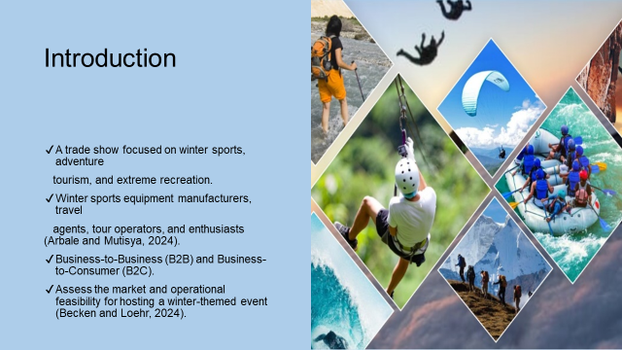

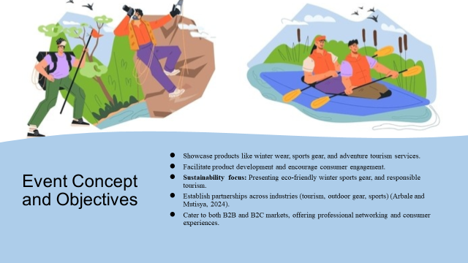

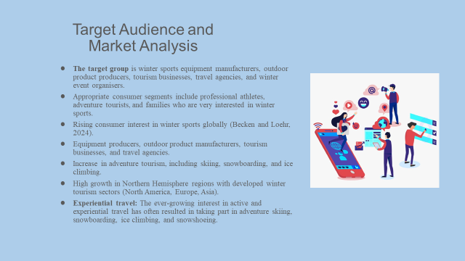

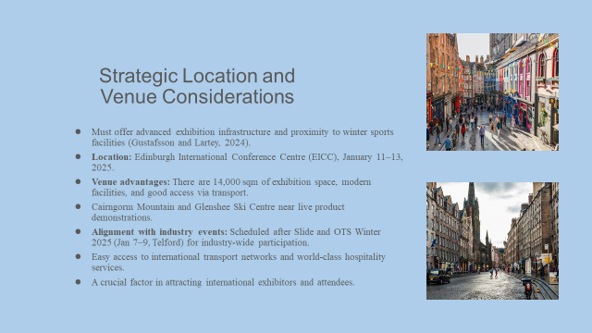

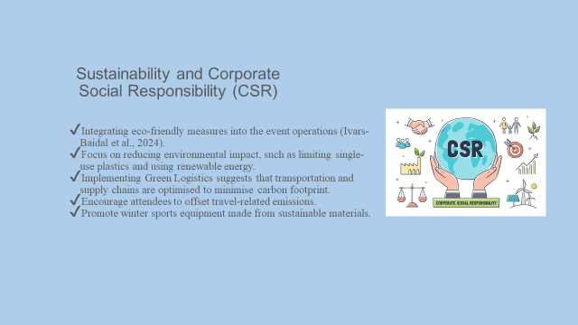

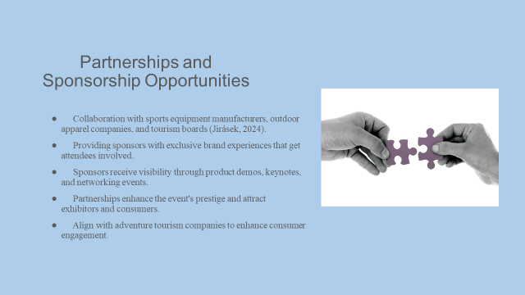

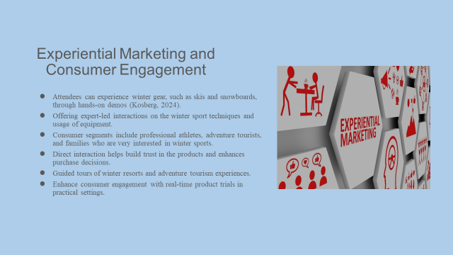

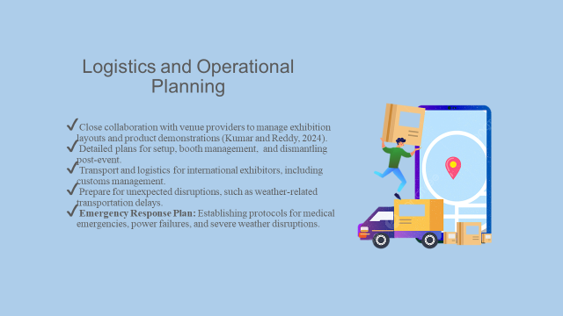

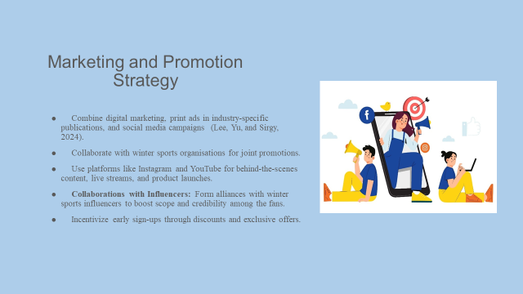

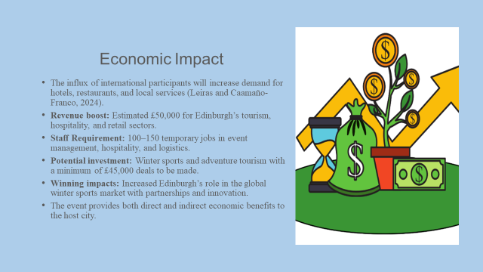

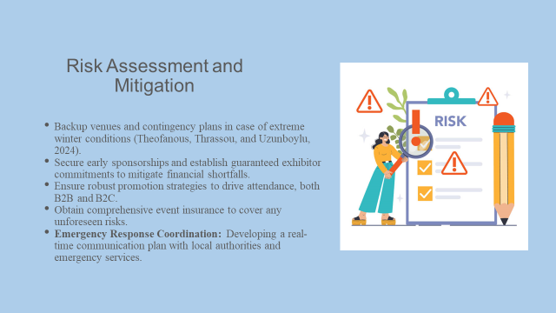

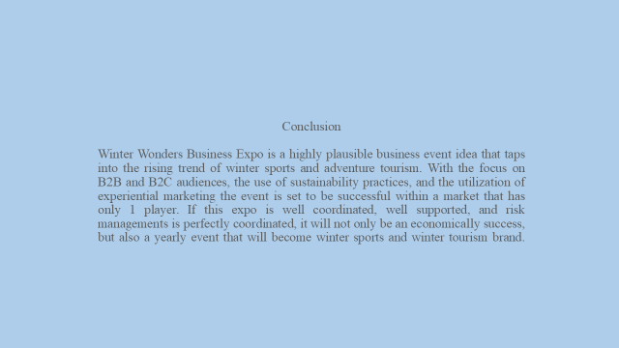

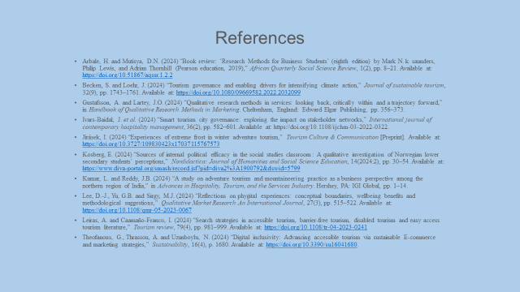

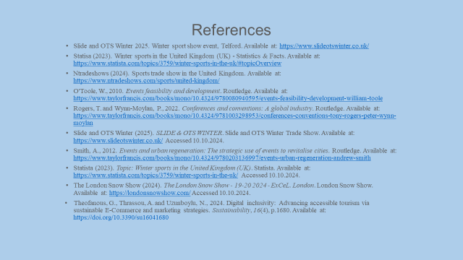

References
- Arbale, H. and Mutisya, D.N. (2024) “Book review: ‘Research Methods for Business Students’ (eighth edition) by Mark N. k. saunders, Philip Lewis, and Adrian Thornhill (Pearson education, 2019),” African Quarterly Social Science Review, 1(2), pp. 8–21. Available at: https://doi.org/10.51867/aqssr.1.2.2
- Becken, S. and Loehr, J. (2024) “Tourism governance and enabling drivers for intensifying climate action,” Journal of sustainable tourism, 32(9), pp. 1743–1761. Available at: https://doi.org/10.1080/09669582.2022.2032099
- Gustafsson, A. and Lartey, J.O. (2024) “Qualitative research methods in services: looking back, critically within and a trajectory forward,” in Handbook of Qualitative Research Methods in Marketing. Cheltenham, England: Edward Elgar Publishing, pp. 356–373.
- Ivars-Baidal, J. et al. (2024) “Smart tourism city governance: exploring the impact on stakeholder networks,” International journal of contemporary hospitality management, 36(2), pp. 582–601. Available at: https://doi.org/10.1108/ijchm-03-2022-0322.
- Jirásek, I. (2024) “Experiences of extreme frost in winter adventure tourism,” Tourism Culture & Communication [Preprint]. Available at: https://doi.org/10.3727/109830423x17037115767573
- Kosberg, E. (2024) “Sources of internal political efficacy in the social studies classroom : A qualitative investigation of Norwegian lower secondary students’ perceptions,” Nordidactica: Journal of Humanities and Social Science Education, 14(2024:2), pp. 30–54. Available at: https://www.diva-portal.org/smash/record.jsf?pid=diva2%3A1900792&dswid=5799
- Kumar, L. and Reddy, J.B. (2024) “A study on adventure tourism and mountaineering practice as a business perspective among the northern region of India,” in Advances in Hospitality, Tourism, and the Services Industry. Hershey, PA: IGI Global, pp. 1–14.
- Lee, D.-J., Yu, G.B. and Sirgy, M.J. (2024) “Reflections on phygital experiences: conceptual boundaries, wellbeing benefits and methodological suggestions,” Qualitative Market Research An International Journal, 27(3), pp. 515–522. Available at: https://doi.org/10.1108/qmr-05-2023-0067
- Leiras, A. and Caamaño-Franco, I. (2024) “Search strategies in accessible tourism, barrier-free tourism, disabled tourism and easy access tourism literature,” Tourism review, 79(4), pp. 981–999. Available at: https://doi.org/10.1108/tr-04-2023-0241
- Theofanous, G., Thrassou, A. and Uzunboylu, N. (2024) “Digital inclusivity: Advancing accessible tourism via sustainable E-commerce and marketing strategies,” Sustainability, 16(4), p. 1680. Available at: https://doi.org/10.3390/su16041680.
- Slide and OTS Winter 2025. Winter sport show event, Telford. Available at: https://www.slideotswinter.co.uk/
- Statisa (2023). Winter sports in the United Kingdom (UK) - Statistics & Facts. Available at: https://www.statista.com/topics/3759/winter-sports-in-the-uk/#topicOverview
- Ntradeshows (2024). Sports trade show in the United Kingdom. Available at: https://www.ntradeshows.com/sports/united-kingdom/
- O'Toole, W., 2010. Events feasibility and development. Routledge. Available at: https://www.taylorfrancis.com/books/mono/10.4324/9780080940595/events-feasibility-development-william-toole
- Rogers, T. and Wynn-Moylan, P., 2022. Conferences and conventions: A global industry. Routledge. Available at: https://www.taylorfrancis.com/books/mono/10.4324/9781003298953/conferences-conventions-tony-rogers-peter-wynn-moylan
- Slide and OTS Winter (2025). SLIDE & OTS WINTER. Slide and OTS Winter Trade Show. Available at: https://www.slideotswinter.co.uk/ Accessed 10.10.2024.
- Smith, A., 2012. Events and urban regeneration: The strategic use of events to revitalise cities. Routledge. Available at: https://www.taylorfrancis.com/books/mono/10.4324/9780203136997/events-urban-regeneration-andrew-smith
- Statista (2023). Topic: Winter sports in the United Kingdom (UK). Statista. Available at: https://www.statista.com/topics/3759/winter-sports-in-the-uk/ Accessed 10.10.2024.
- The London Snow Show (2024). The London Snow Show - 19-20 2024 - ExCeL. London. London Snow Show. Available at: https://londonsnowshow.com/ Accessed 10.10.2024.
- Theofanous, G., Thrassou, A. and Uzunboylu, N., 2024. Digital inclusivity: Advancing accessible tourism via sustainable E-Commerce and marketing strategies. Sustainability, 16(4), p.1680. Available at: https://doi.org/10.3390/su16041680

