Applied Leadership and Management in the Workplace
Module Assignment Submission


Student Name: | Charlotte Knowles
Student Number: | 2329857
Module No: | BMSK5013
Module Title: | Knowledge Management
Statement of Confirmation of Authenticity
By the act of making this submission, the student declares that this is the work of the student named above. The work has not, in whole or in part, been knowingly presented elsewhere for assessment, or where assessment has been built on a previous assessment, this has been identified. Where materials have been used from other sources it has been properly acknowledged. If this statement is untrue, the student acknowledges that an assessment offence has been committed.
Attention is drawn to the plagiarism and unfair practice policies of both the University and of ILM.

Statement of AI Use for assignment: Microsoft Editor used, to check spelling and grammar. Chat Gpt , used to organize my written notes, to print out , for ease of reading. I confirm my notes are available, and drafts should I be called to present as evidence.

Table of contents.
1.Introduction
2. Definition of Knowledge.
2.1. Definition of Knowledge Management.
2.2. Individual vs Organizational Knowledge. Tacit and explicit knowledge.
2 3. The transformation process (SECI MODEL), Knowledge Sharing.
2.4. Application to Family Centre
3. Barriers to Knowledge Management, Governance & Ethical Practice within Family Centre Practice.
4. Typologies & Models of Knowledge Management
4.1. Table of Models Strengths & Weaknesses
5. What is Information & Data?
5.1. DIKW Pyramid. (Data, Information, Knowledge & Wisdom.
5.2. Application to Family centre.
6. Information Systems.
6.1. Family Centre , Information Systems.
6.2. Key Performance Indicators (KPI)
7. Summary of Case study: Within Family Centre to Identify Needs.
7.1. Data & Information collection .
7.2. Information Processing and Report for New Service .
8. Strategy and Plan for New Service.
8.1. Staffing & Coordination.
8.2. Facility &Resource Management.
8.3. Data Tracking & Collection : Family Engagement, Progress.
8.4. Collaboration with Partner Services.
8.5. Key Performance Indicators used for Family Centre.
8.6. Sustainability & Future Expansion.
9. Conclusion.
10. Appendices.
11. References & Bibliography.

1. Introduction

Knowledge Management (KM) is essential for a Family Centre to deliver high-quality services, ensure continuity of care, and informed decision-making. Knowledge Management refers to the capturing, organizing, sharing, of knowledge. It integrates both theoretical and practical knowledge across various disciplines, including information and communication technologies, thus enhancing the Family Centre’s practice .
Managing both tacit (staff experience, community insights, best practice) and explicit knowledge (policies, reports, funding data,) is crucial. Ensuring that valuable expertise is shared across the team, to provide excellence in service delivery.
This report maps out a strategic plan for data management, information storage, and knowledge sharing within the Family Centre.
The report considers some of the key Knowledge Management (KM) models, such as, Wigg, Nonaka & Takeuchi’s SECI Model, and the DIKW Pyramid, which outlines how knowledge is effectively captured, transferred, and utilized.
The models are considered and applied within the context of the Family Centre. The psychology theories and models, used within the Family Centre, are measured against the KM models, to establish best fit.
Using critical thinking skills, a strategic plan, for KM is created, which identifies how a service delivery can be improved. This ensures the Centre remains adaptive and resilient in the face of changing needs of the community.
Scope and impact.
This approach aims to enhance collaboration, improve service quality, and create a sustainable framework for supporting families from birth to 18 years, through the establishment of Key Performance Indicators related to staff training, family engagement, service delivery efficiency, and knowledge-sharing effectiveness.

2. Definition of Knowledge.
Merriam-Webster defines knowledge as "awareness or understanding, especially of an act, a fact, or the truth: actual knowledge" and "awareness that a fact or circumstance probably exists" (Merriam-Webster.com, 2025).

2.1. Knowledge Management (KM)
Knowledge Management (KM) is the systematic approach to capturing, organizing, sharing, and utilizing knowledge to enhance intellectual assets within an organization (Shannak, 2009). It integrates both theoretical and practical knowledge across various disciplines, including information and communication technologies (Mihalca et al., 2008). KM draws on insights from philosophy, cognitive science, social science, management science, information science, knowledge engineering, artificial intelligence, and economics (Kakabadse et al., 2003). A fundamental aspect of KM is the ability to identify essential information, manage it effectively, and transform it into long-term knowledge that can be utilized for improving skills or efficiency.

2.2. Individual vs. Organizational Knowledge.
Knowledge is commonly categorized into two types: Tacit and Explicit knowledge (Hubert, 1996).
Tacit Knowledge.
Tacit knowledge is personal and context-specific, residing in an individual’s mind, behaviours, and perceptions (Duffy, 2000). Since it is experience-based, it is difficult to articulate and formalize (Koenig, 2012). If the Individual leaves an organisation, their tacit knowledge goes with them. Therefore, their knowledge /skills, are lost to the organisation.
Examples of Tacit Knowledge:
- Hands-on skills
- Problem-solving strategies
- Knowledge gained through experience

Explicit Knowledge
Explicit knowledge is structured, documented, and easily shared (Koenig, 2012). It is “codified” in formats, accessible to individuals and organizations. It is property of organisation.
Examples of Explicit Knowledge:
- Standard operating procedures (SOPs)
- Manuals, reports, and policies
- Databases and how-to guides.
Interconnection between tacit and explicit Knowledge.
Tacit and explicit knowledge should not be viewed as separate entities but rather as interconnected and symbiotic within an organization. Milgram's (Group Think Theory, 1963) suggest that when knowledge is not openly shared staff may conform to poor decisions, (conforming to “the group”.) Organizations strive to facilitate the absorption of tacit knowledge from individuals; only then can it be ‘converted’ into explicit knowledge. This is done, by producing documentation (policies, manuals.) and structured learning (training), because the knowledge is then ‘ owned ‘by the organization.
Cohen and Levinthal (1990) describe this as "absorptive capacity," referring to an organization’s ability to recognize the value of new (tacit) information, assimilate it, and apply it for its own ,commercial and operational purposes.
2.3. The Transformation Process: Tacit to Explicit .
Tacit and explicit knowledge interact dynamically, leading to organizational learning and knowledge creation.
Using Nonaka and Takeuchi’s (1995) SECI Model (Socialization, Externalization, Combination, Internalization), the transformation process can be shown within Family Centre.
1. Socialization – Sharing tacit knowledge through observation, practice, and interaction. Staff continually share their individual experience and knowledge. (Vygotsky Sociocultural Theory,1962. learning through social interaction.)
2. Externalization – Converting tacit knowledge into explicit formats such as reports or training materials. (Kolb's experiential learning cycle,1984.) experiences are translated into structured knowledge, within the Centre. E.g. reflective practice, evaluations, Policies, code of practice.
3. Combination – Organizing and integrating explicit knowledge into structured systems. (Piaget cognitive development theory,1952.) structured information is built upon existing frameworks. ( policies, training, code of practice)
4. Internalization – Employees absorbing explicit knowledge and applying it in practice, thereby developing new tacit knowledge. (Gibbs’ Reflective Cycle,1988. staff internalize and refine best practice based on their experience.
**See Fig:1 below
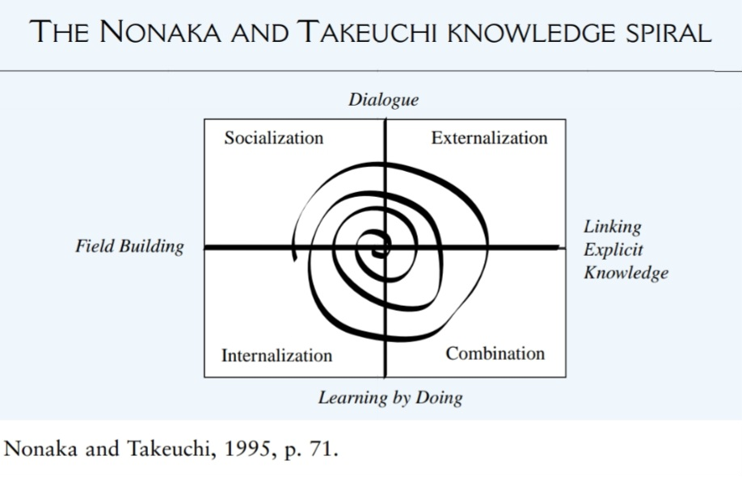
Fig : 1
2.4. Application for Family Centre.
In the Family Centre, this model can be applied to enhance the learning and development of staff and volunteers, thereby creating a cohesive environment, where knowledge is continuously shared for the benefit of the community. By fostering mentorship, teamwork, and collaborative environments, the Family Centre can ensure effective knowledge management and a dynamic cycle of learning and growth.

3. Barriers to Knowledge management, Governance & Ethical Practice, within Family Centre setting.
The running of the Family Centre’s requires, both Knowledge Management, and Ethical Governance, for the delivery of service required. Certain barriers can limit the staff ability to share, store or act, on information. This is due to both , legal and moral obligations. (GDPR, Children Act 1988, Data Protection) and Staff training compliance:
- First Aid
- Food Hygiene
- Fire safety
- Child Protection
Shown Below: examples of barriers encountered by staff: with suggested solutions.
- Barriers to knowledge Management.
Staff at the Centre often face challenges, such as siloed information, lack of time, or insufficient training with digital tools.
For example; attendance data or session evaluations: these, individual files, were stored in locked filing cabinets. Rather than in a shared secure system.
To address this the Staff team could update all files using (TPS) Microsoft Office system, including:
- record keeping,
- registration
- attendance etc.
- Each staff has their own login and password to access the shared OneDrive.
- Staff also received basic training in the digital tools being used. (Office, Excel, QuickBooks.)
2. Governance Gaps.
Knowledge governance requires clear policies. Outlining the responsibility of staff, for recording and evaluation/reviews of information. Unclear roles can lead to errors or missed opportunities.
To prevent this :
- Monthly audits
- Designated lead staff, for certain roles.
- Ensured consistency, accountability & compliance.
3. Ethical considerations.
Ethical barriers can arise when families are not fully informed about how their data is used (e.g. FB Polls) or when more information than necessary is collected. This can undermine trust of families.
- Staff have training in obtaining, informed, consent.
- Minimal data principles.
- Ensuring transparency and confidentiality in every interaction.
4. Moral implications.
This refers to whether information is used in an inclusive and fair way when making decisions. Is it in the best interest of the families?
When planning sessions, bias can occur when only the most confident service users give opinions. Sometimes a conflict of interests can arise.
To overcome these, the Family Centre should,
- Ensure to gain feedback from the ‘quieter members.’
- Separate feedback groups ( e g. Teens, young mums, minority groups)
- Anonymous surveys.
- Outreach.

4. Typologies and Models of Knowledge Management.
The Knowledge Management Cycle;
Typology- this is a ‘hierarchical’ system of categories, to organize objects according to similarity and dissimilarities. (Mandra 2002).
Put simply it means, organising, into groups or categories, based on their similarity or their differences.
Wigg (1993) emphasized that knowledge must be well-organized to be useful, highlighting the importance of completeness, connectedness, and congruency.
Both Wigg, and Burkowitz & Williams (2002) models the authority structure, which impacts decision making. (Milgram’s Theory of Obedience,1961.) Similarly, McElroy (1999) introduced the Knowledge Life Cycle, distinguishing between knowledge production and knowledge integration. Bukowitz & Williams (2000) further mapped the flow of knowledge from tactit to strategic applications. Dalkir’s (2005) model integrates elements of the earlier models to give a holistic approach.

4.1. Table of models strengths and weaknesses.
The table below shows and compares the KM cycles models mentioned previously:
Model | Key stages | Focus, contribution | strengths | weakness
Wigg (1993) | Creation, structuring, formalization, application. | How knowledge is constructed, organised and applied. | Categorise explicit and tacit knowledge. Useful for staff in family centre. | Hierarchal, may be too formal and rigid.
McElroy (1999) | Knowledge production, knowledge integration. | Knowledge is a cycle of creation and use. | Evaluation of practice , by staff. | Model focus on production and profit.
Bukowitz and Williams (2002) | Get, use, learn, contribute, assess, build &sustain. | Emphasises decision making & organisational learning. | Using for structure vs informal knowledge flow | Hierarchal, may not fit family centre well
Meyer and Zack (1999) | Acquisition, refinement, storage, retrieval, distribution, presentation. | Knowledge is a product flowing through a value chain. | Can be used to optimise how family centre, creates, stores and uses knowledge | May be rigid for a social environment like family centre
Dalkir (2005) | Knowledge capture, sharing application. | Integrates similarities of earlier models for a holistic approach. | Useful in creating, storing and using /sharing knowledge in family | Due to holistic approach more suitable to social setting if family centre
Nanaka & Takeuchi,  SECI | Knowledge creation, socialization, externalization, combination, internalization | Transformation process of tacit knowledge to explicit knowledge and interact action with each other | Excellent for understanding how staff share knowledge in family centre | assumes structured environment for knowledge flow.
VRIO | Strategic resource evaluation for competitive advantage | assess the unique value and knowledge of business | Can be used in family centre to unique advantage, e.g., staff expertise, trust of families. | Focus on competitive advantage rather than knowledge

5. What is Information and Data?
Data refers to numeric values or qualitative facts that without context, lack inherent meaning.
Information provides context and meaning to data.
Data can be acquired through various methods, including:
gathering information via interviews or workshops with managers and employees (Heikkilä et al.2016; Kijl and Boersma, 2010; Montemari et al.2019), conducting surveys with customers (Ostin et al. 2021), and utilizing public information, such as government statistics. (Dubosson-Torbay et al. 2002).
These methods generate data that is relevant to specific needs. From this data, knowledge can be applied to analyze, resulting in innovative ideas and solutions that align with an organization’s goals.
Interviews allow for detailed probing and individualized responses, fostering a comprehensive understanding of the participant's perspectives. However, they can be time-consuming and may introduce interviewer bias. Workshops can encourage collaborative discussion and idea generation, benefiting from the collective input of multiple participants. The drawback lies in the potential for, ‘groupthink’, (Janis, 1982), and the challenge of managing diverse opinions.
Surveys are quantitative methods that enable the collection of data from a large sample size, offering statistical relevance and broader applicability. They are efficient in gathering standardized data and can be administered quickly. Despite these advantages, surveys may suffer from low response rates and the risk of superficial answers, as respondents might not provide in-depth information.
Public information, such as government statistics, provides readily available, authoritative data that can support benchmarking and trend analysis. The key advantage is the cost-effectiveness and reliability of this data. However, it may lack specificity and relevance to organizational needs, and there can be a lag in the data's timeliness.

5.1. The DIKW Pyramid: Data, Information, Knowledge, and Wisdom.
The DIKW Pyramid is a conceptual model ( Ackoff ,1989), illustrating , the hierarchical relationship between Data, Information, knowledge, and Wisdom. At the base of the pyramid lies data, the raw and unprocessed facts or numbers with no inherent meaning. Moving up, information emerges from processed data, that gives context and relevance. Knowledge is the next level, where applied information, based on experience and analysis resides. At the pinnacle of the pyramid is wisdom, the ability to make sound judgments and decisions using knowledge. Although, to gather data, knowledge is needed to determine what data to acquire.
The DIKW Pyramid (Ackoff,1989) and Maslow's Hierarchy of Needs (1943) illustrate progressions from basic to advanced levels in data and human development, respectively, but neither overtly show the need to revisit previous levels.
Bloom's Taxonomy (1956) highlights a hierarchy in learning objectives from remembering to creating. Integrating these models in a Family Centre helps meet basic needs and promote growth, ultimately leveraging collective expertise for quality service.
Just as data forms the foundation for higher levels of information, the fulfillment of basic needs enables the pursuit of safety, love, belonging, self- esteem, and ultimately self-actualization.
Information, as processed data with context and relevance, parallels Maslow's safety and social needs, where individuals seek security and meaningful connections. Knowledge, representing applied information, can be likened to Maslow's esteem needs, where competence and respect are cultivated through experience and understanding. Finally, wisdom in the DIKW Pyramid, the pinnacle of sound judgment and decision-making, mirrors Maslow's self-actualization, where individuals achieve their full potential and make enlightened choices.
Both models emphasize the importance of building upon foundational elements to reach higher levels of understanding and fulfillment. Although it is expedient to remember that the levels can interchange with each other, that knowledge and learning are not rigid. In a Family center, recognizing and addressing these hierarchical relationships can enhance resources, evaluation and foster a culture where knowledge and wisdom thrive.
How it can be used in Family Centre:
Data (D) :-"What?" Raw, unprocessed facts or numbers with no inherent meaning.
E.g.: A list of numbers, attendance records for children at a family centre.
Information (I) :- "Who, When, Where?" Processed data with context and relevance.
E.g.: the numbers are put into a report showing attendance, age of children, sessions, numbers , times attendance, days, month during the year.
Knowledge (K):- "How?" Applied information based on experience and analysis.
E.g.: Recognizing that attendance drops in winter due to weather and flu season. School holidays, and festivals, attendance increase.
Wisdom (W) :-"Why?" The ability to make sound judgments and decisions using knowledge.
E.g.: flexible attendance or health awareness, to improve attendance. During cold winter months, offering free cooking/ recipes, of hot winter warmer meals, encourages attendance.

6. Information systems.
Information Systems (IS) are organized systems for the collection, organization, storage, and communication of information. They encompass a broad array of technologies, processes, and methods that serve to manage data, ensure its integrity, and facilitate decision-making within an organization. (Guo, 2013; Hwang, & Kim, 2017). They include:
- control technology for PC, USB, and personal devices.
- network firewalls to detect critical information leaks via email etc.
- Document security , having encryption for important documents, access control and security management of passwords

6.1. Family Centre, Information Systems.
Intuit QuickBooks is an Accounting Information System (AIS) designed to help businesses manage financial transactions, bookkeeping, and accounting processes. It falls under the category of Enterprise Information Systems (EIS) and can also be considered a Transaction Processing System (TPS) since it records, processes, and manages financial transactions.
Update plan to use, QuickBooks by utilizing these functions:
- Management Information System (MIS):
It provides financial reports and insights allows the manager to make informed decisions. The Family Centre can track, Grant funding, financial transactions, manage expenses, and generate reports for funders.
- Decision Support System (DSS):
offer forecasting and budgeting tools that aid decision-making. Eg : allocation of funds for resources.
- Cloud-Based System: QuickBooks Online (QBO):
operates as a Software as a Service (SaaS), providing remote access to financial data. Cloud-based storage, provides secure and accessible storage for data. Remote access ensures that authorized persons, (Manger/ Accountant,) can retrieve information from anywhere, improving efficiency.
- An Accountant service: - manages, wages, HMRC, taxes etc. (not done within F.C)
- Use of Facebook:
The Family Centre uses its own Facebook page to connect with the community, share updates, and conduct polls. These polls are a valuable tool for gathering feedback, for community needs, and engaging with families in a meaningful way.
- Ensuring Safety of Data:
Implementing IS frameworks includes employing security measures : such as data encryption, access controls, and regular backups. These practices protect sensitive data from unauthorized access, loss, or corruption. (Data Protection Act 1998, GDPR, 1998.)
- Microsoft Office:
staff records, training compliance, registration, session attendance, evaluations. Is stored and managed with this. Password protected, cloud storage. Compliance with GDPR, Data Protection.
6.2. Key Performance Indicators (KPIs):
KPIs are critical metrics used to evaluate the success of an organization in achieving its objectives. The Family Centre, KPIs could include measurements ,such as: Number of families attending, client satisfaction rates, program participation levels, and financial sustainability.
To effectively use KPIs, the family Centre can:
- Set specific, measurable goals aligned with its mission. ( e.g. attendance and age of children attending after-school sessions)
- Regularly collect and analyze data to monitor progress.( e.g. Percentage of funds used , when 40% is used , search for new funding ).
- Adjust strategies and activities based on KPI outcomes to ensure continuous improvement.

7. Summary of the Family Centre , Case Study : Process and Identifying Needs.
The Family Centre initially offered support, specifically to “Pre-School” children in Wales, under schemes like Flying Start and Sure Start. This support ceased, once children reached nursery age (3 years), unless there was a younger sibling within the 0-3 age range, within the family. Feedback from parents indicated dissatisfaction with this cut-off, as they felt abandoned and their children still desired access to the Centre.
7.1. Data & Information Collection.
In response, a poll was conducted on Facebook. Questionnaires were distributed through various local channels, such as, Health Centre, Schools, Community Organizations, and direct meetings with stakeholders.
After analyzing the data, the findings revealed a significant gap in support services for children and youth aged 3-18. Specifically, out of 400 families registered, at the Centre, 230 families lost access to services once their children reached the age of 3.
To address this, a plan was proposed, for a new service. Utilizing some of the Models, of Knowledge Management a strategy was created.
The Information System (IS) was used to analyze data and create a Key Performance Indicators (KPIs), specific to the project, thereby enabling the Family Centre to monitor progress effectively.

7.2. Information Processing & Reporting Program of new services:

Funding was sought to extend hours and days of Family Centre service and employ extra youth worker staff. Previous hrs.: - 9 am to 3 pm, over 3 weekdays. Extended hr.: 9 am to 6 pm, offering extra youth service for after school from 3 pm to 6 pm, over 4 weekdays, and Saturday session: 11am-1pm (age 3-7), open play session: 2pm –4pm (age 7-12). (Lottery, Children in Need).
- Employment of specific youth workers to run sessions aged 12-18. Along with Foothold, Community First, at playing fields, 2 pm to 4 pm. (Community Police, YOS team, to engage in sports activities). Saturdays.
- Grant funding that incorporates ages birth to 18 years projects. Staggered services offered: 9 am to 11 am parent toddler, 12 pm to 1 pm lunch club, 2 pm to 3 pm cooking/healthy eating, 3:30 pm after school club. (Welsh Assembly Government grant).
- Analysis Techniques: Quantitative - percentage of families affected (e.g., 230 of 400 lost access). Qualitative - thematic analysis of parental concerns. (FB polls, questionnaire, meetings.)
Comparative Data - insights from other regions with extended Sure Start-like services. (Government statistics)
- Reporting Mechanism: Develop monthly/quarterly reports with visual dashboards for stakeholders (council, funders, community leaders).

8. Strategy & Service Planning.
In order to achieve the envisaged new service plan, certain barriers need to be considered for a successful transition.
These are the areas to be considered and proposed strategies: -
8.1. Staffing & Coordination
- Hire additional youth workers and playworkers to ensure age-appropriate engagement.
- Collaborate with health visitors, school staff, and community police for integrated services.
- Establish a volunteer program (e.g., parents, college students, community mentors) to support activities.
8.2. Facility & Resource Management
- Adjust space allocation for different age groups. (community hall, the new playing field)
- facilities to support play-based learning, youth engagement, and skill-building (e.g., kitchen for cooking classes, after school club, sports areas).
- Grow Project (community garden, food education, grow your food, from planting, to harvesting, cooking, recipes.)
- Implement sign-up systems for sessions to track attendance and manage capacity. (session attendance register)

8.3. Data Tracking & Family Engagement
- CRM System: Record attendance, track progress, and manage referrals. (Microsoft Office, QuickBooks)
- Online Booking & Communication Platform: Allow parents and youth to sign up for sessions and receive updates.
- Automated Feedback Collection: Use SMS/email surveys to evaluate service satisfaction. (FB polls, questionnaire, see Appendix 1.)

8.4. Collaboration with Partners
- Data Sharing Agreements with community services, schools, and YOS teams for holistic support.
- Case Management System for youth services, tracking progress in education, behaviour, and well-being.( Schools, YOS, Community first.)

8.5. Key Performance Indicators used for Centre.

KPI category | example | target
Service engagement | Attendance, session participation | 80% families
Child /family well being | Parent satisfaction, behaviour improvement | 70% positive impact
Staff development | Training compliance, new training completion | 100%  70%
Financial sustainability | Budget efficiency,  new funding | 95% funds used effectively 80% new funding acquired
Community impact, collaboration | Partnership, outreach | Youth engagement

With this KPI, a Monthly report can be generated, to measure success of extended services and engagement attendance which can be presented to Stakeholders including Council representatives, Grant funders and the other Collaborating services.
8.6. Sustainability & Future Expansion
- Grant Renewal & Additional Funding: Explore ongoing funding options through local authority budgets, lottery grants, corporate sponsorships. (see Appendix 2)
- Partnerships with Schools & Businesses: Potential for youth apprenticeships, skill-building workshops.
- Long-Term Impact Studies: Collect longitudinal data on participants' development and wellbeing.
- YOS partnership – reduction in youth offending, through engagement in community projects.

Using these strategies the envisioned New Service Plan, can be achieved and maintained, ensuring sustainable framework of practices, with future expansion. Benefiting the whole community through inclusion, active participation of the families, youth, elders and multi-service collaboration.

9. Conclusion.
In today's evolving society effective knowledge management is essential for fostering innovation, efficiency, within the community. This report highlights the crucial interplay between tacit and explicit knowledge. The complex systems required to manage, share, and apply them strategically. Through integrating KM frameworks such as the SECI model, DIKW pyramid, the Family Centre can transform raw data into actionable insights and sustainable practices.
The case study of the Family Centre, demonstrated how KM, IS, and KPI, can be applied in a real-world setting. The data gathered, highlighted service gaps. In particular, the lack of support, children and families aged 3- 18 years. The Family Centre proposed a “New Service plan,” grounded in community feedback and data-driven decision-making. Utilizing the Information systems, like QuickBooks and CRM tools, service delivery was enhanced. Having the ability to monitor Key Performance Indicators using the KPI data and the reports generated allowed for real time tracking of progression. (Grant funding, Stakeholders, Service collaboration), ensuring sustainability of the Family Centre.
When knowledge is effectively captured, shared, and applied across individuals and systems, the Family Centre, can become more adaptive, to the community they serve. The Family Centre recognises that Governance of information is not only a matter of compliance, but also of ethics. The data collected, is minimal, and managed through secure systems in line with GDPR. Ethical responsibility resides with the manager, to ensure responsible usage. With inclusive, non-discriminatory decision-making families are fully aware of how their data is used, transparency is key to maintain trust of families. They can consent, opt out, or question without prejudice. All staff are fully trained in considering moral implications of data sharing (safeguarding, multi-agency context), balancing confidentiality and protection carefully, throughout their practice.
Through transparent policies, the Family Centre protects the rights, dignity and privacy of all Individual’s it supports. Ensuring every family receives the support they need, through every stage of their journey in life, is paramount to the service delivered.

10. Appendices.

Appendix : 1 .
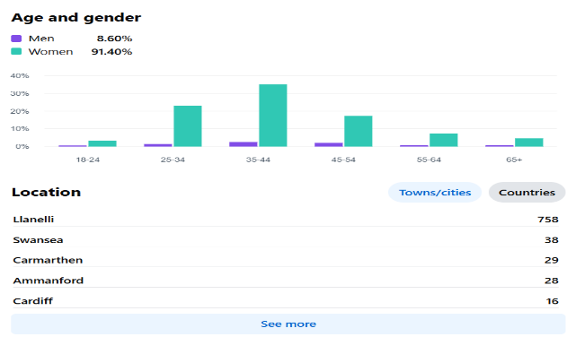
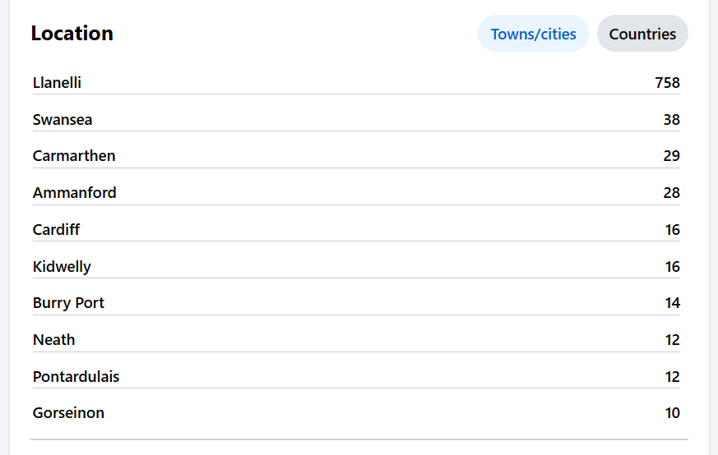

Example of FB Data insights for family centre.**NB. Copyright family Centre FB image.

Appendix 2.

Example of grant funder family centre .

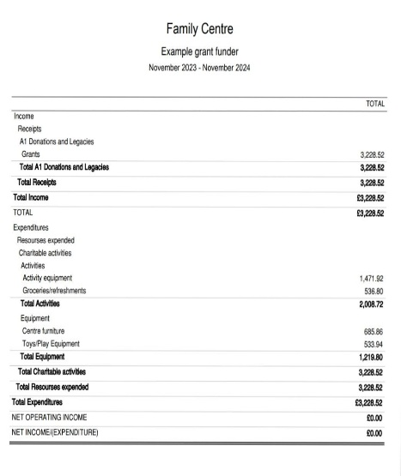

Image **NB. Ownership Family Centre. ** Not actual data.** example.

11. References & Bibliography.
Ackoff, R. L. (1989). From data to wisdom. Journal of Applied Systems Analysis, 16(1), 3–9.

Anderson, L. W., & Krathwohl, D. R. (2001).Revised taxonomy for learning, teaching and assessing. Bloom, B. S. (1956). Taxonomy of educational objectives. Retrieved from [https://psycnet.apa.org](https://psycnet.apa.org)

Bandura, A. (1977). Social learning theory. Englewood Cliffs, NJ: Prentice Hall.

Boisot, M. H. (2002). The creation and sharing of knowledge. Choo, C. W., & Bontis, N. (Eds.), The strategic management of intellectual capital and organizational knowledge. New York: Oxford University Press.

Bollinger, A. S., & Smith, R. D. (2001). Managing organizational knowledge as a strategic asset. Journal of Knowledge Management, 5(1), 8-18.

Bowlby, J. (1978). Attachment theory and its therapeutic implications. Adolescent Psychiatry, 6, 5–33.

Bukowitz, W. R., & Williams, R. L. (1999). The knowledge management fieldbook. Great Britain: Financial Times Prentice Hall
Children Act (1989)c.41 https://www.legislation.gov.uk/ukpga/1989/41/contents

Choo, C. W. (2006). The knowing organization: How organizations use information to construct meaning, create knowledge, and make decisions (2nd ed.). New York: Oxford University Press.

Dalkir, K. (2005). Knowledge management in theory and practice. Boston, MA: Elsevier.

Dalkir, K. (2011). Knowledge management in theory and practice (2nd ed.). Cambridge, MA: Massachusetts Institute of Technology.

Dubosson-Torbay, M., Osterwalder, A., & Pigneur, Y. (2002). E-business model design, classification, and measurements. Thunderbird International Business Review, 44(1), 5–23. https://doi.org/10.1002/tie.1036

HM GOVERNMENT. Data Protection Act 2018, c. 12. https://www.legislation.gov.uk/ukpga/2018/12/contents/enacted

David, D., Cotet, C., Matu, S., Mogoase, C., & Stefan, S. (2018). 50 years of rational-emotive and cognitive-behavioural therapy: A systematic review and meta-analysis. Journal of Clinical Psychology, 74(3), 304-318.

Davenport, T., & Prusak, L. (1998). Working knowledge: How organizations manage what they know. Boston, MA: Harvard Business School Press.

Dieng-Kunz, R., & Matta, N. (Eds.). (2002). Knowledge management and organizational memories. Boston, MA: Kluwer Academic Publishers

Drucker, P. F. (1991). The new productivity challenge. Harvard Business Review, 69(6), 69-79.

Drucker, P. F. (1993). Post-capitalist society. New York: HarperCollins.

Duguid, P. (2005). The art of knowing: Social tacit dimensions of knowledge and the limits of the community of practice. The Information Society, 21(2), 109-118.

Gallemard, J. (2023). 11 essential knowledge management metrics and KPIs for your organisation. Retrieved February 10, 2025, from [https://example.com/top-11-critical-knowledge-management-metrics-and-KPIs](https://example.com/top-11-critical-knowledge-management-metrics-and-KPIs)

Goh, S. C. (2002). Managing effective knowledge transfer: An integrative framework and some practice implications. Journal of Knowledge Management, 6(1), 23-30.

Gorga, E. (2007). Knowledge inputs, legal institutions and firm structure: Towards a knowledge-based theory of the firm. Northwestern University Law Review, 101(3), 1123-1206.

Grant, R. M. (2002). The knowledge-based view of the firm. In Choo, C. W., & Bontis, N. (Eds.), The strategic management of intellectual capital and organizational knowledge. Oxford, UK: Oxford University Press.

Guo, K. H., et al. (2011). Understanding non-malicious security violations in the workplace: A composite behaviour model. Journal of Management Information Systems.

Heiman, B. A., & Nickerson, J. A. (2004). Empirical evidence regarding the tension between knowledge sharing and knowledge expropriation in collaborations. Managerial and Decision Economics, 25(6/7), 401-420.

Heisig, P. (2009). Harmonisation of knowledge management: Comparing 160 KM frameworks around the globe. Journal of Knowledge Management, 13(4), 4-31

Heikkilä, M., Bouwman, H., Heikkilä, J., Solaimani, S., & van der Vorst, J. (2016). From strategic goals to business model innovation paths: An exploratory study. Journal of Small Business and Enterprise Development, 23(1), 112–140. https://doi.org/10.1108/JSBED-02-2015-0021

Hofstede, G. (1984). Cultural dimensions in management and planning. Asia Pacific Journal of Management, 1, 81-99.

Information Commissioner’s Office(1998). (n.d.). Guide to the UK General Data Protection Regulation (UK GDPR).(1998) https://ico.org.uk/for-organisations/guide-to-data-protection/guide-to-the-uk-gdpr/

Janis, I. L. (1982). Groupthink: Psychological studies of policy decisions and fiascoes (2nd ed.). Houghton Mifflin.

Kijl, B., & Boersma, D. (2010). Assessing viability of business models for brokering business information. Electronic Journal of Information Systems Evaluation, 13(2), 115–124.

Kogut, B., & Zander, U. (1992). Knowledge of the firm, combinative capabilities, and the replication of technology. Organization Science, 3(2), 383-397.

Kolb, D. A. (1984). Experiential learning cycle. Kolb’s learning styles & experiential learning cycle. Retrieved from simplypsychology.org

Malkinson, R., & Brask-Rustad, T. (2013). Cognitive behaviour couple therapy-REBT model for traumatic bereavement. Journal of Rational-Emotive and Cognitive-Behaviour Therapy, 31(2), 114-125.

Merriam-Webster’s Collegiate Dictionary. (2020). Springfield, MA: Merriam-Webster.

Mueller, J. T., & Tickamyer, A. R. (2020). Climate change beliefs and support for development: Testing a cognitive hierarchy of support for natural resource-related economic development in rural Pennsylvania. Journal of Rural Studies, 80, 553-566.

Montemari, M., Nielsen, C., & Rondo Brogaard, L. (2019). Managing customer relationships through key performance indicators: A case study on luxury hotels. Journal of Business Research, 100, 416–428. https://doi.org/10.1016/j.jbusres.2018.10.021

Nelson, R., & Winter, S. G. (1982). An evolutionary theory of economic change. Cambridge, MA: Belknap Press.

Nonaka, I., & Takeuchi, H. (1995). The knowledge-creating company: How Japanese companies create the dynamics of innovation. Oxford, UK: Oxford University Press.

Nonaka, I., & Yamaguchi, I. (2022). The SECI model: Knowledge creation in the cycle of subjectivity and objectivity. In Management by eidetic intuition: The Nonaka series on knowledge and innovation. Palgrave Macmillan. [https://doi.org/10.1007/978-981-16-6851-7_10](https://doi.org/10.1007/978-981-16-6851-7_10)

Ostin, K., et al. (2021) – You’ll need to provide the full source details; this appears incomplete. Please verify the full reference (authors, title, journal/book, and link if applicable).

Piaget, J. (1964). Cognitive development in children. Development and learning. Retrieved from simplypsychology.org

Prabhakaran, J. (2021). What is tacit knowledge: Importance, benefits & examples. Retrieved January 28, 2025, from [https://example.com/what-is-tacit-knowledge-importance-benefits-examples](https://example.com/what-is-tacit-knowledge-importance-benefits-examples)

Prabhakaran, J. (2022). Explicit knowledge: Definitions, examples & methods. Retrieved January 28, 2025, from [https://example.com/explicit-knowledge-definition-examples-methods](https://example.com/explicit-knowledge-definition-examples-methods)

HM Government. (2018). Working together to safeguard children: A guide to inter-agency working to safeguard and promote the welfare of children. https://www.gov.uk/government/publications/working-together-to-safeguard-children--2

Shannak, R. O. (2009). Measuring knowledge management performance. European Journal of Scientific Research, 35(2), 242–253. http://www.eurojournals.com/ejsr.htm.

Tassoni, P. (2021). Cache level 3 early years educator for the work-based learner. Didcot: Hachette.

Ty Envys Family Centre, South Cefncaeau; charity number:1082561; - FB data insights example, grant funding example. Retrieved from [https://register-of-charities.charitycommission.gov.uk](https://register-of-charities.charitycommission.gov.uk)

Uma, M. H. (2014). Integration of KM and HRM, its impact on organizational performance. Asian Journal of Management, 5(4), 443-450.

Van de Ven, M., Lara Machado, P., Athanasopoulou, A., & et al. (2023). Key performance indicators for business models: A systematic review and catalog. Information Systems E-Business Management, 21, 753–794. [https://doi.org/10.1007/s10257-023-00650-2](https://doi.org/10.1007/s10257-023-00650-2)

Vygotsky, L. (1978). Vygotsky’s sociocultural theory of cognitive development. Retrieved from simplypsychology.org
Welsh Assembly Government. (2001). Child and adolescent mental health services, everybody’s business, strategy document, September. Retrieved from [http://www.wales.nhs.uk/publications/men-health-e.pdf](http://www.wales.nhs.uk/publications/men-health-e.pdf)

Welsh Assembly Government. (2005). A fair future for our children, child poverty strategy, February 2005, and implementation plan. Retrieved from [http://new.wales.gov.uk/topics/childrenyoungpeople/childpoverty/?lang=en](http://new.wales.gov.uk/topics/childrenyoungpeople/childpoverty/?lang=en)

