BMHP5016
Principles of Health and Social Care Practice

Component 1: Written Assignment (Reflective Report)

Name: Abraham Andom
Student number: 2414479

Table of Contents
1.0 Introduction 3
2.0 Task 1 3
2.1 Person-Centred Care 3
2.2 Partnership Working 4
2.3 Ethics in Health and Social Care 5
3.0 Task 2 5
3.1 Person-Centred Care in Practice 5
3.2 Partnership Working and Integrated Care 6
3.3 Ethical Considerations 7
4.0 Task 3 8
4.1 Description 8
4.2 Feelings 8
4.3 Evaluation 8
4.4 Analysis 9
4.5 Conclusion 9
4.6 Action Plan 9
5.0 Conclusion 10
References 11

1.0 Introduction
This reflection will review the main components of the NHS systems using an analytical framework based on the Health and Social Care Act 2012. The focus of my review will include three important principles that are integral to the delivery of modern health and social care in the UK, namely: person-centred care; partnership working; and ethics. Together, these three principles form the fundamentals for delivering high-quality, safe and effective services in today's NHS.
This report critically analyses the theoretical background and importance of person-centred care, partnership working and ethics within the context of health and social care practice. In reviewing the case study of Mrs C from the NHS England case study, it will demonstrate how each of these three principles can be practically applied. Lastly, self-reflection will be structured around how the three principles relate to personal and professional growth.

2.0 Task 1

2.1 Person-Centred Care
Person-centred care recognises that the individual is an active partner in their own care through the incorporation of their preferences, values, needs and goals into their care decisions (Coulter and Oldham, 2016). It involves viewing the person as more than just a diagnosis and enabling the individual to live the life they feel is important to them. The Care Act 2014 supports this way of working by embedding the wellbeing principle within legislation; local authorities must work to enable the individual to have dignity, autonomy and empower self-control over their lives (Department of Health & Social Care, 2025).
When healthcare professionals are engaged with service users in the development of their care plan, it allows healthcare providers to develop care for the full person and not just care for the person’s medical condition (Al-Tannir et al., 2017). This is also reflected by Maslow's Hierarchy of Needs, which states that a person needs to have their psychological and social needs met along with their physical needs before a person can be considered to have achieved wellbeing (Rojas et al., 2023).
There can be challenges associated with implementing person-centred care due to factors such as time constraints, inadequate staffing levels and organisational targets, which can limit the ability to establish genuine relationships with service users (Guan et al., 2025). Furthermore, when determining the best approach to provide care, ensuring both the service user’s choice is taken into account along with the clinicians’ judgement may lead to tension between the two, especially when there are safeguarding or risk issues (Engle et al., 2021).

2.2 Partnership Working
The Integrated Care Systems (ICS), as shown below, were established under the Health and Care Act 2022; they aim to promote better coordination of services between NHS organisations, local authorities and community services (Lalani et al., 2024).
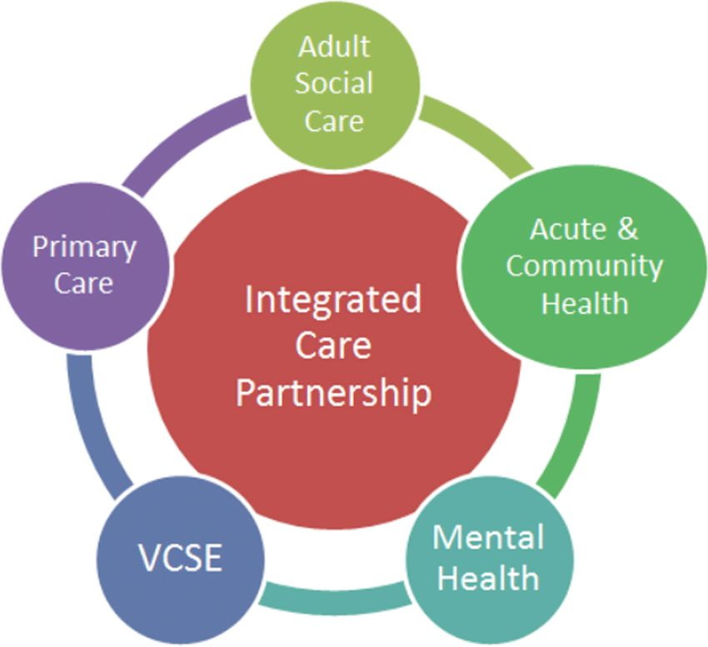
Figure 1: Integrated Care System model
(Source: https://www.researchgate.net/figure/The-Integrated-Care-System-A-Model-Source-49_fig1_358442610)
Bronfenbrenner’s Ecological Systems Theory provides an explanation of the need for collaborative working as this theory identifies that people are affected by numerous connected “systems” which include family, community and larger societal structures (Dickens et al., 2025).
The advantages of working in partnership include enhanced continuity of care, less duplication of services, and an improved ability to manage risk (Reeves et al., 2017). However, there are also challenges which may arise in the areas of role ambiguity, lack of effective communication, differing priorities among organisations, and restrictions on sharing data (Mousazadeh et al., 2025).

2.3 Ethics in Health and Social Care
The Mental Capacity Act 2005 provides for the least restrictive option in all cases, and the best interests of the party lacking capacity and the party making the decision (Alghrani et al., 2016). Ethical awareness also serves to enhance the responsibilities of professional practitioners to protect and preserve the interests of individuals and families by promoting equality and access to services (Health and Care Professions Council, 2024).
When the professional has to choose between the right of the individual to make their own decisions and ensuring the safety of the individual using the services, there will often be ethical dilemmas, specifically when the individual makes a decision to use a service that involves a level of risk (Cicero, 2021). There can also be an ethical dilemma when there are limited resources available for the provision of services; therefore, there are ethical tensions created regarding the fairness of access and prioritisation of care (Afenigus and Sinshaw, 2025).

3.0 Task 2

3.1 Person-Centred Care in Practice
The case study of Mrs C includes an analysis of the cooperation, individualised support, and outcomes provided by NHS England through its case studies of personalised care (NHS England, 2026). The case demonstrates how the provision of personalised care support has resulted in improved health outcomes for people with complex healthcare and social care needs in the UK.
Mrs C suffered from several long-term conditions and was frequently admitted to hospital, receiving fragmented care from a variety of different healthcare professionals, but no coordination between any of them (NHS England, 2026). The introduction of personalised care planning enabled professionals to work closely together with Mrs C to develop an individualised plan based on her priorities, preferences, and goals for the long-term (RCP, 2017). Person-led support improved Mrs C's quality of life while reducing the frequency of her use of unnecessary services (NHS England, 2026).
The use of personalised care planning has shown significant benefits for the patient in terms of feeling heard and feeling empowered regarding their own health (Coulter et al., 2016). Mrs C had a higher degree of confidence in her ability to manage her health as a result of being a part of this model of care. Evidence from the National Institute for Clinical Excellence guidelines supports the use of personalised care planning as a means to enhance self-management and patient satisfaction through the Care Act 2014 well-being principle, which promotes autonomy and control over one’s own healthcare journey (Barnes et al., 2017).

3.2 Partnership Working and Integrated Care
Through the use of partnership working, Mrs C has been able to receive coordinated care and support through the collaboration of a multi-disciplinary team made up of professionals in primary care, community services and social care (NHS England, 2026). These professionals have worked across different professional sectors in a collaborative manner to ensure that Mrs C’s health care is streamlined, which meets the aims of the Health and Care Act 2022 regarding the promotion of Integrated Care Systems (Toh and Haynes, 2022).
The use of a collaborative method of working allowed for information to be shared, duplication to be minimised, and continuity of care to be improved; therefore supporting Mrs C's well-being from both healthcare providers and from her social environment, as well as support networks. This demonstrates the importance of Bronfenbrenner’s ecological theory of development to the delivery of care (Tong and An, 2024). This partnership working also demonstrates the alignment of the NHS 6 Cs of care, as shown below, in particular about the use of communication and coordination of care by the team (NHS England, 2025).
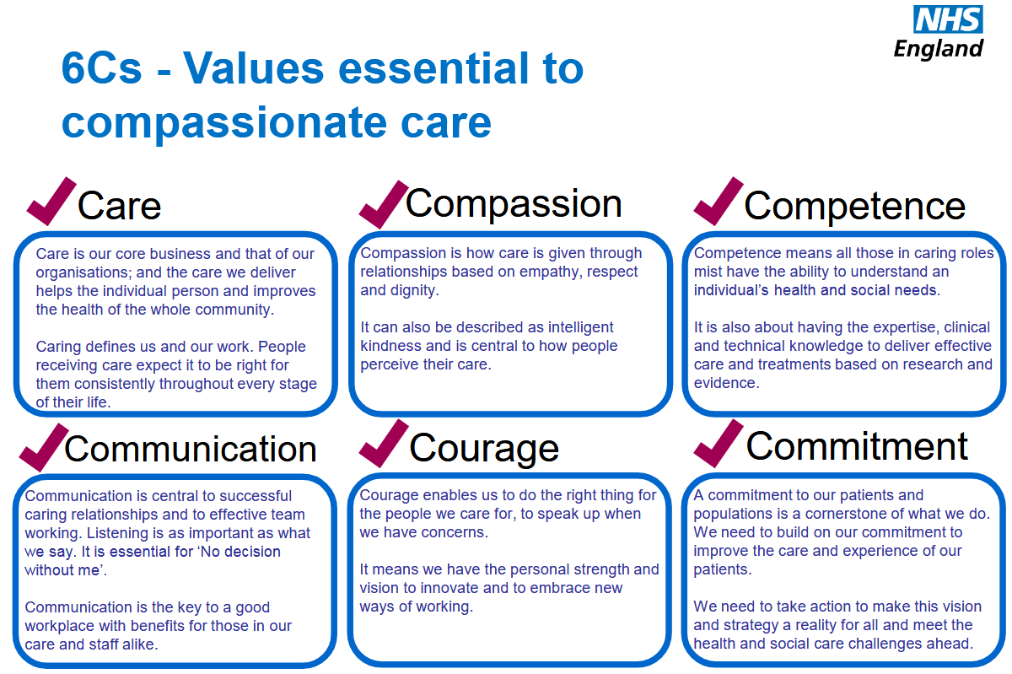
Figure 2: 6Cs of Care
(Source: https://www.england.nhs.uk/6cs/wp-content/uploads/sites/25/2015/03/introducing-the-6cs.pdf)

3.3 Ethical Considerations
Mrs C's care was rooted in ethical principles; the team's respect for her autonomy was supported by the use of shared decision-making and obtaining her consent to facilitate her healthcare planning (Rosca et al., 2023). The principles of beneficence and non-maleficence were evident in the approach to the management of Mrs C, which sought to prevent any harm that may result from multiple admissions to a hospital setting (Varkey, 2021). The principle of justice was also an element of the approach to coordinated healthcare services provided to Mrs C with equitable access; therefore, there was a justifiable basis for treating Mrs C as her individual best interests (Varkey, 2021).

4.0 Task 3

4.1 Description
During my practical placement in a community-based facility, I assisted an aged adult with numerous conditions requiring support from both health and social care services. At one point, the service user refused the service's recommendation to pursue an intervention or treatment because their previous experiences did not align with what they desired as per their preference.

4.2 Feelings
At that point in time, I was in the midst of feeling very confused and somewhat overwhelmed. I wanted to honour the ability of the individual to make decisions regarding themselves; however, my concern was with the possible repercussions to the individual's well-being. I hesitated to share my input during the discussion because I did not believe I had enough experience; however, I realised that the service user had demonstrated a level of disengagement due to their prior experience with disjointed care, which caused me to think about how professionals may inadvertently dismiss personal preferences while attending to administrative duties.

4.3 Evaluation
This situation had both benefits and drawbacks. The meeting allowed for collaborative conversation, which aligns with social values of Integrated Working in the Health and Care Act 2022 (Lalani et al., 2024). Team professionals did try to include service users in decisions, which demonstrated aspects of person-centred care.
The ethical decision-making of the team also resulted in a balancing act of autonomy vs beneficence, where there were ongoing signs of tension within the team. I have learnt from this experience that although there are systems in place to support person-centred practice, the effectiveness of implementation can vary due to different levels of communication and confidence from professionals.

4.4 Analysis
The Care Act 2014 establishes an emphasis on individual dignity and control through the principles of person-centred care, indicating that there was little evidence of applying said principles if one considers the service user in this scenario and their expression of frustration. According to Maslow’s Hierarchy of Needs, an individual must satisfy their psychological needs in order to achieve wellness overall (Rojas et al., 2023). Bronfenbrenner's Ecological Systems Theory supports this conclusion as it looks at the multiple interconnected systems that may affect an individual, and the communication issues exhibited by fragmented communication indicate additional common barriers to person-centred care, such as organisational silos or role-confusion (Dickens et al., 2025).
From an ethical standpoint, the situation illustrated by the service user is closely tied to the Mental Capacity Act 2005, because the service user was determined to possess the capability to make an informed decision, and regardless of other professionals' differing opinions, they had the right to do so (Alghrani et al., 2016).

4.5 Conclusion
I have learnt that the provision of effective practice goes beyond the policies and procedures governing practice to how professionals enact these policies and procedures throughout their daily work. Therefore, to provide high-quality care, I must be proactive, not only in terms of observation of service users, but also through advocacy.

4.6 Action Plan
I will continue to actively participate in multidisciplinary team meetings in future placements; this will develop my confidence to engage with others in a more collaborative manner (Taberna, 2020). I will seek out mentors from experienced professionals so that I am able to develop a better understanding of effective strategies for creating positive working relationships with colleagues (Skills for Health, 2024).
I will also utilise opportunities for continued professional development that relate specifically to personalised care and safeguarding. Furthermore, I will gain experience of volunteering with various community organisations; this will allow me to practice working with people from different cultures and backgrounds (Health Careers NHS, 2026). Finally, I am committed to continuing to use Gibbs’ Cycle as a regular method of evaluating my practice and ensuring my ongoing development (Zhan et al., 2023).

5.0 Conclusion
The report’s analysis has clearly demonstrated the importance and the need for following the ethical principles. Ethics means the principles guiding the choices and actions made by professionals. The ethical principles which are part of professional standards in Health and Care Professions Council codes of practice are that the individual has a right to make decisions about their own life. In the course of providing care services, the professional will make every effort to make those decisions in the best interests of the individual. In doing so, the individual will not be harmed, and the professional will treat the individual fairly and uphold justice to their autonomy and personal rights.

References
Afenigus, A.D. and Sinshaw, M.A. (2025). Ethical Dilemmas and decision-making in Emergency and Critical Care Nursing in Western Amhara region, Northwest Ethiopia: a multi-method Qualitative Study. BMC Nursing, 24(1). doi:https://doi.org/10.1186/s12912-025-02958-5.
Alghrani, A., Case, P. and Fanning, J. (2016). Editorial: The Mental Capacity Act 2005—Ten Years On. Medical Law Review, 24(3), pp.311–317. doi:https://doi.org/10.1093/medlaw/fww032.
Al-Tannir, M., AlGahtani, F., Abu-Shaheen, A., Al-Tannir, S. and AlFayyad, I. (2017). Patient experiences of engagement with care plans and healthcare professionals’ perceptions of that engagement. BMC Health Services Research, 17(1), pp.1–9. doi:https://doi.org/10.1186/s12913-017-2806-y.
Barnes, D., Boland, B., Linhart, K. and Wilson, K. (2017). Personalisation and Social Care Assessment – the Care Act 2014. BJPsych Bulletin, 41(3), pp.176–180. doi:https://doi.org/10.1192/pb.bp.116.053660.
Cicero, F.R. (2021). Behavioural Ethics: Ethical Practice Is More Than Memorising Compliance Codes. Behaviour Analysis in Practice, 14(4). doi:https://doi.org/10.1007/s40617-021-00585-5.
Coulter, A. and Oldham, J. (2016). Person-centred care: What Is It and How Do We Get there? Future Hospital Journal, 3(2), pp.114–116. doi:https://doi.org/10.7861/futurehosp.3-2-114.
Department of Health & Social Care (2025). Care and Support Statutory Guidance. [online] GOV.UK. Available at: https://www.gov.uk/government/publications/care-act-statutory-guidance/care-and-support-statutory-guidance [Accessed 20 Feb. 2026].
Dickens, C., Suarez-Balcazar, Y., Allen-Meares, P. and Brazil, E. (2025). Using Ecological Systems Theory to Enhance Community Health Literacy. HLRP Health Literacy Research and Practice, 9(1). doi:https://doi.org/10.3928/24748307-20241126-01.
Engle, R.L., Mohr, D.C., Holmes, S.K., Seibert, M.N., Afable, M., Leyson, J. and Meterko, M. (2021). Evidence-based Practice and Patient-centred Care: Doing Both Well. Health Care Management Review, 46(3), pp.174–184. doi:https://doi.org/10.1097/HMR.0000000000000254.
Guan, X., Duan, A-min., Xin, G., Oyebode, J. and Liu, Y. (2025). Barriers and facilitators to implementing person-centred dementia care in long-term care facilities in Western and Asian countries: a scoping review. Frontiers in Psychiatry, 15. doi:https://doi.org/10.3389/fpsyt.2024.1523501.
Health and Care Professions Council (2024). Standards of Conduct, Performance and Ethics. [online] Health and Care Professions Council. Available at: https://www.hcpc-uk.org/standards/standards-of-conduct-performance-and-ethics/ [Accessed 20 Feb. 2026].
Health Careers NHS (2026). Volunteering opportunities. [online] Health Careers NHS. Available at: https://www.healthcareers.nhs.uk/explore-roles/doctors/applying-medical-school/gaining-experience-medical-school/volunteering-opportunities [Accessed 20 Feb. 2026].
Lalani, M., Peters, M., Thavapriya Sugavanam, Crocker, H., Caiels, J., Hay, H., Gunn, S., Hogan, H., Page, B. and Fitzpatrick, R. (2024). New Ways of Working to Manage and Improve Quality in Integrated Care Systems in England. International Journal of Health Policy and Management, 14(1). doi:https://doi.org/10.34172/ijhpm.8424.
Mousazadeh, N., Babaieasl, F., Bagherian, S. and Mivehchi, S. (2025). The spectrum of person-centred care: from luxury to necessity: a descriptive qualitative study. BMC Nursing, 24(1). doi:https://doi.org/10.1186/s12912-025-03737-y.
NHS England (2025). The 6 Cs of Care. [online] NHS Professionals. Available at: https://www.nhsprofessionals.nhs.uk/nhs-staffing-pool-hub/working-in-healthcare/the-6-cs-of-care [Accessed 20 Feb. 2026].
NHS England (2026). NHS England» Mrs C’s story. [online] www.england.nhs.uk. Available at: https://www.england.nhs.uk/personalisedcare/comprehensive-model/case-studies/mrs-cs-story/ [Accessed 20 Feb. 2026].
RCP (2017). Patient experience in adult NHS services - NICE guideline. [online] Rcp.ac.uk. Available at: https://www.rcp.ac.uk/improving-care/resources/patient-experience-in-adult-nhs-services-nice-guideline/ [Accessed 20 Feb. 2026].
Reeves, S., Pelone, F., Harrison, R., Goldman, J. and Zwarenstein, M. (2017). Interprofessional Collaboration to Improve Professional Practice and Healthcare Outcomes. Cochrane Database of Systematic Reviews, 6(6). doi:https://doi.org/10.1002/14651858.cd000072.pub3.
Rojas, M., Méndez, A. and Fassler, K.W. (2023). The Hierarchy of Needs: Empirical Examination of Maslow's Theory and Lessons for Development. World Development, 165(1). doi:https://doi.org/10.1016/j.worlddev.2023.106185.
Rosca, A., Karzig-Roduner, I., Kasper, J., Rogger, N., Drewniak, D. and Krones, T. (2023). Shared decision making and advanced care planning: a systematic literature review and novel decision-making model. BMC Medical Ethics, 24(1), p.64. doi:https://doi.org/10.1186/s12910-023-00944-7.
Skills for Health (2024). How to find and become a great mentor | Skills for Health. [online] Skills for Health. Available at: https://www.skillsforhealth.org.uk/article/how-to-find-and-become-a-great-mentor/ [Accessed 20 Feb. 2026].
Taberna, M. (2020). The Multidisciplinary Team (MDT) Approach and Quality of Care. Frontiers in Oncology, 10(85), pp.1–16. doi:https://doi.org/10.3389/fonc.2020.00085.
Toh, C.H. and Haynes, R. (2022). The Health and Care Act 2022: challenges and priorities for embedding research in the NHS. The Lancet, 400. doi:https://doi.org/10.1016/S0140-6736(22)01195-3.
Tong, P. and An, I.S. (2024). Review of studies applying Bronfenbrenner’s bioecological theory in international and intercultural education research. Frontiers in Psychology, 14(14), pp.1–17. doi:https://doi.org/10.3389/fpsyg.2023.1233925.
Varkey, B. (2021). Principles of Clinical Ethics and Their Application to Practice. Medical Principles and Practice, 30(1), pp.17–28. doi:https://doi.org/10.1159/000509119.
Zhan, T., Wang, L., Wang, Y. and Sun, C. (2023). Master of Nursing Specialist Experiences of an Internship through the Use of Written reflections: a Qualitative Research Study. Heliyon, 9(2). doi:https://doi.org/10.1016/j.heliyon.2023.e13299.

