Student Name: Joshua Paul DiFrancesco
P Number: 1909512
Programme of Study: Product & Furniture Design
Module: ADAD4018 Ways of Thinking

Tasks in the order I receive them:
Take One: Manifesto=504 words
Take Two: Observational writing=500 words
Task Three: Practice-based writing = 515

Task one: Manifesto

8 manifestos
- Let your dreams and feelings guide you.
- We develop as the world develops.
- Art is a language that the non-fluent can understand if explained clearly.
- We learn from our failures.
- Your value should be valued by you and only you.
- Time is money.
- With out drive your dreams have no chance.
- To be creative, you must be you.

3 of my choice
- 1. Let your dreams and feelings guide you.
- 2. The world develops as we do.
- 3. To be creative, you must be you.

- Let your dreams and feelings guide you
In a world full of judgement and criticism, it is important to put your dreams and feelings first and not fear the outcome. When the outcome is bad, we tend to hide away and feel sorry for ourselves. But this isn’t always the best of ideas, we should learn from it and let it take a crucial role in our character development.
It states in Levine, W. (2022). Kant, Realism, and the Theory of Ideals. Philosophy & Social Criticism, p.019145372211461. doi:10.1177/01914537221146181. Available at: https://journals.sagepub.com/doi/10.1177/01914537221146181 That “The critique of practical reason thus advances an ideal of autonomy in the classic sense of giving the law to oneself. In setting up reason as the judge in its own trial, Kant renders it the sole arbiter in evaluation its own – and any other – claims to authority.” This is powerful as you should always be the person who judges your own work and its value, and others work and what it means to you. Meaning you will always be the judge of what things mean to you and how it makes you feel.
It is always important to value your work and why you do it, having a reason gives it meaning and in doing this we create a link between the people who understand and can connect and the people that don’t because it gives of a powerful message.

- The world develops as we do
Fig 1. Intelligent Buildings International
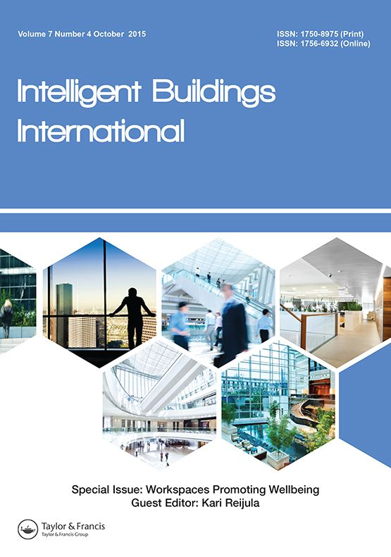
Being in a world full of technology, where does this leave us? Will there be room for us humans or will it become hard for us to fit in? It states in Ross, P. and Maynard, K. (2021). Towards a 4th industrial revolution. Intelligent Buildings International, [online] 13(3), pp.1–3. doi:10.1080/17508975.2021.1873625. Available at: https://www.tandfonline.com/doi/full/10.1080/17508975.2021.1873625 that “ when the founder of the world Economic Forum, Klaus Schwab coined the term ‘Fourth Industrial Revolution’ He was describing an era marked by technological revolution ‘that is blurring the lines between the physical, digital and biological spheres’ (2016). As technological innovation and ‘distribution’ continues to accelerate, the way we live, work and relate to each other and the built environment is fundamentally shifting”. This leaves us thinking, will the world be taken over by technology? Should we be excited or fear it? Or should we just sit back and let it happen?

As technology advances, man made things will turn into machine made so will that leave us with no work? And if it does where will that leave us? As humans it’s in our nature to work, earn and strive towards our goals, but if we have all this new technology will it just take over a do it all for us. As The world rapidly changes, we change and vice-versa. This may leave people who work as CNC operators, designers, and many other things jobless. But will that be rewarded or leave us with nothing to do? Ultimately, we must adapt and move with these changes and do what we can to better the situation and do what we love without being left out.

- To be creative, you must be you.

Making decisions is always hard, but the reason we make them is because we know what we want. By doing this you allow your own opinion to be stronger than anyone else’s and this enables us to be ourselves and not worry about what people think. As it states in Clements-Croome, D. (2022). Editorial. Intelligent Buildings International, 14(5), pp.525–526. doi:10.1080/17508975.2022.2145819. Available at: https://www.tandfonline.com/doi/full/10.1080/17508975.2022.2145819 “A recent study from the Paris Brain institute (ICM) Explains why daylong cognitive work drains one’s energy and can affect decision-making (see article by A. Wiehler et al., In Current Biology 2022, 32(16), 3564-75). Does concentration, memorising, multi-tasking and problem-solving cause the brain to tire and hence decrease its efficacy in making decisions?”. No matter if your tired or not being creative is tiring too but to be creative you must always be you. As humans we always believe things like being yourself can be very tiring but being creative in all ways is what shows you for you and lets others see you for who you really are. Some may argue and say its easy to be yourself but doing this in a creative way can be hard but worrying about it is something else, by worrying we supress our ideas and close in on ourselves but letting go of that allows you to be more creative and most importantly yourself.

Task two: Observational writing
Fig.2 Stonemasons at work.
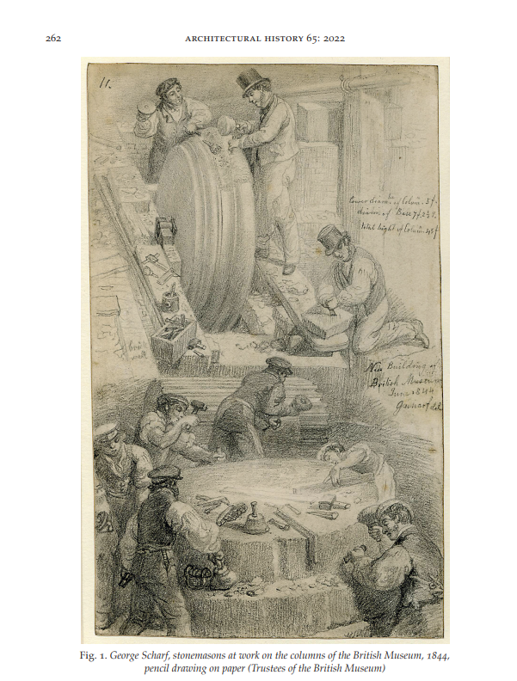
Key Word: Gratitude
In an age defined by growth and knowledge, it is important to remember what we came from and how we evolved. This should be something we have gratitude for, and respect highly. As shown in Fig. 1. Stonemasons at work, you can clearly see that we have evolved from that and this day and age most things which they are doing are machine made or have some type of machine to help us with. But how do people really feel about that? Does it strip us of our personal achievement as we aren’t doing much, or does it make people excited as they can sit back and not have to worry about it? As it states in Sharples, J. (2022) ‘The Workers Who Built the University of Glasgow, 1867-71’ Journal of Architectural History, 261-(292), pp. 1-32. Available at: https://www.cambridge.org/core/services/aop-cambridge-core/content/view/0F4D2CE5F3BD7C0A4FD3A619AF52082D/S0066622X22000120a.pdf/the-workers-who-built-the-university-of-glasgow-186771.pdf ‘ The viewer inevitably speculates about these anonymous men who transformed the face of urban Britain (Fig.1.) who were they What were their backgrounds? What was the pattern of their working lives?’ Do we ask our selves these questions and appreciate their hard work or do we forget what they did and how they did it, and most importantly what’s changed between then and now?
Key Word: Progression
As we progress, the world forgets what we progressed from and just goes with what’s happening. To me the image fig.1. stonemasons at work, speaks a thousand words, and the more I look at it the more grateful I become for what we have. As a qualified stone mason, I understand how hard that job is, even today so to think hundreds of years ago it was way more demanding and physical I feel very empathetic for the people who worked in the stonemason industry yet so proud as they transformed the face of urban Britain.
Key word: hard or easy
How do we progress, and why? As shown in Fig.1. Stonemasons at work, to me the answer is shown in the image. Do we want things to be hard to do or do we want it to be easy? But it’s a personal question we should ask ourselves as I believe hard work is the best type of work as the results are more rewarding, but we also don’t want it to be dangerous so we should act responsibility towards how we do our work and be proud of what we have. As technology has advanced, new ways of completing tasks have been made easier thanks to our advanced machines which make things less effort but also uses up a lot of power and can be very dangerous if not used correctly so in reality it’s only been made easier if you know how to use them correctly, and if not, then nothing has changed.
If things are being made easier to accomplish, where does that leave us? Will the way things work balance out and still allow us to achieve things or will it completely irradicate the meaning of work for humans and the way we live? Although, having things made easier is always nice but is it always what we want and how we want to live? As shown in Fig.1. Stonemasons at work, the stonemasons are putting hard work into what they are doing and as much as people hate doing things like that it always feels good when its finished.

Task three: Practise-based writing
Fig.3. chess pieces

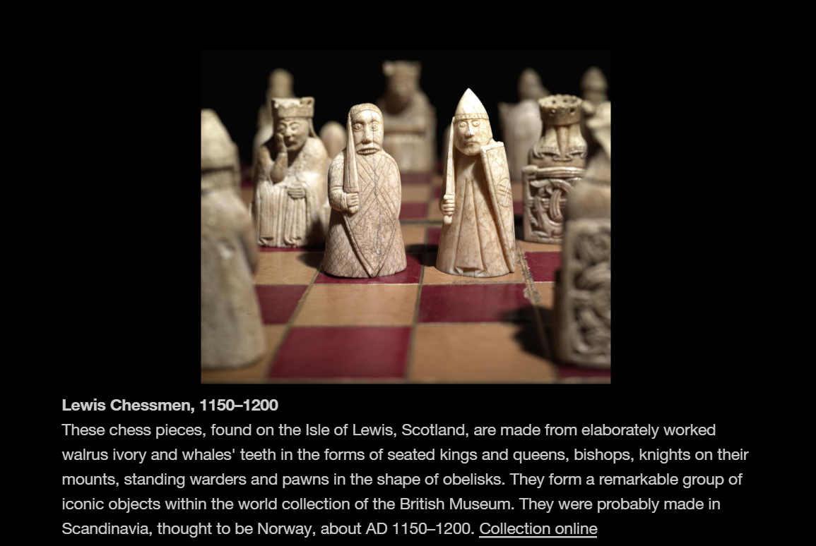
After reading the text in the image above I began to wonder if these animals were killed to make these pieces, and that it was very disturbing to know that they were made from whale’s teeth and Walrus ivory. But after putting some thought into it I started to question myself, were these made for a bigger reason? It states in Artsology (2019). How Death Is Portrayed in Art | Artists dealing with the subject of death. [online] Artsology.com. Available at: https://artsology.com/death-portrayed-in-art.php he believed “his death would end the violence throughout the country”. Which makes me think, were these chess pieces made for a bigger reason? Were they made so that the world could see what us humans had to do for art? And would they try to do anything about it?
It states in HuffPost UK. (2015). A Brief History Of Creative People Grappling With Loss And Death Through Art. [online] Available at: https://www.huffingtonpost.co.uk/entry/death-in-art_n_6849376 that “ Many of us are blind to the realities of loss and mourning until we’re confronted with it head on” which I hope this piece of art did, as I’d hate to believe people agreed with these sort of things.
These chess pieces have a bigger meaning to me than the human eye can see. For me I feel that if the animals were to be killed then all I feel is nothing towards my own kind. Furthermore, would I like human to use me as art when I die? Or even kill me for it? Not at all! But I truly don’t know why or how they were made; all I know is what they were made from so I must ask myself what the reason behind them was.
After looking at Fig.1 chess pieces, I slowly began to think how wonderful the piece of art is. Although I hope the animals weren’t killed to create them, I believe they have a powerful message, and my initial thought has changed. To create art we must be creative, and by doing such things will help give off a powerful message and draw in peoples attention. Weather it’s created from something unpleasant that I don’t agree with, as a human I’m aware of how cruel this world can be and to turn it into something beautiful just says a million words. To me, the chess pieces aren’t just chess pieces, they are more than that. They show us that death can be beautiful as well as give the message of what world we live in and how us humans treat other beings.
In Fig.1 it states that they were made around the year “AD 1150-1200” which just shows us how times have changed and what the world has evolved from. From being cavemen who did some cruel things to live and have fun to where we are now, this leaves me questioning many of things. Have we changed? and if so, what has changed? I know the answers to these, but I still don’t want to believe them. So where does this leave us and the viewers of this piece of art?
Times have changed. In some areas, we have improved and some we have gone downhill but does this advance art or make it worse? Although art has come so far and has had so many positive impacts on this world, it’s also had bad impacts. After giving this some this some thought, I believe this is the wonderful thing about art as it leaves us in the position to be able to judge that.

Bibliography

Sharples, J. (2022) ‘The Workers Who Built the University of Glasgow, 1867-71’ Journal of Architectural History, 261-(292), pp. 1-32. Available at: https://www.cambridge.org/core/services/aop-cambridge-core/content/view/0F4D2CE5F3BD7C0A4FD3A619AF52082D/S0066622X22000120a.pdf/the-workers-who-built-the-university-of-glasgow-186771.pdf
Levine, W. (2022). Kant, Realism, and the Theory of Ideals. Philosophy & Social Criticism, p.019145372211461. doi:10.1177/01914537221146181. Available at: https://journals.sagepub.com/doi/10.1177/01914537221146181
Ross, P. and Maynard, K. (2021). Towards a 4th industrial revolution. Intelligent Buildings International, [online] 13(3), pp.1–3. doi:10.1080/17508975.2021.1873625. Available at: https://www.tandfonline.com/doi/full/10.1080/17508975.2021.1873625
Clements-Croome, D. (2022). Editorial. Intelligent Buildings International, 14(5), pp.525–526. doi:10.1080/17508975.2022.2145819. Available at: https://www.tandfonline.com/doi/full/10.1080/17508975.2022.2145819
Artsology (2019). How Death Is Portrayed in Art | Artists dealing with the subject of death. [online] Artsology.com. Available at: https://artsology.com/death-portrayed-in-art.php
HuffPost UK. (2015). A Brief History Of Creative People Grappling With Loss And Death Through Art. [online] Available at: https://www.huffingtonpost.co.uk/entry/death-in-art_n_6849376

List of figures
Figure 1: Ross, P. and Maynard, K. (2021). Towards a 4th industrial revolution. Intelligent Buildings International, [online] 13(3), pp.1–3. doi:10.1080/17508975.2021.1873625. Available at: https://www.tandfonline.com/doi/full/10.1080/17508975.2021.1873625
Figure 2: George Scharf, Stonemasons at work on the columns of the British Museum, 1844, pencil drawing on paper (Trustees of the British Museum). Available at: https://www.bmimages.com/preview.asp?image=01613474008&badge=true
Figure 3: The British Museum. (n.d.). Collection. [online] Available at: https://www.britishmuseum.org/collection#&gid=1&pid=5.

