Module name: Introducing the Modern Workplace
Module Code: LCBB4003

Assessment 1
Organizational Structure & Culture of HSBC

Student Name: Marina Cretu
Student ID: 2122650
Lecture Name: Dr. Aparna Venkatesan

Content Page

Introduction………………………………………………..
The organizational structure and culture of HSBC………..
Management and Leadership of HSBC……………………
Conclusion…………………………………………………
Referince……………………………………………………

Introduction
The concept of "modern workplace" is very often encountered and used nowadays. It is a notion that combines digitization and innovative technologies with the efficiency and productivity of the company. More and more companies and large organizations choose this term to increase employee activity and profits. This paper will talk about HSBC, one of the world's biggest banking and monetary services organizations. Serving almost forty million customers worldwide. Their network covers sixty-three countries and territories in Europe, Asia, the Middle East, Africa, North America, and Latin America. We will analyze the organizational structure and culture of the company, managerial work, regarding both functions and processes, and the variables that determine management and leadership efficiency.

The organizational structure and culture of HSBC
The success story of HSBC began in March 1865. It was founded by a young Scotsman named Thomas Sutherland in Hong Kong. Also in 1865, only in July, the first office was opened in London. Years followed with many obstacles. And challenges, probably the most difficult years were the years of the first and second world wars. After the Second World War, the bank was able to survive thanks to the large reserves it had, thanks to the well-thought-out management and strategies. From 1950 to 1990 it followed a period of expansion and conquest of new territories for development. The year 1998 was important, namely, this year the bank decided to present its unified logo at the global level. A white and red hexagon could be seen at every headquarters where the bank operated. Now it is the largest bank in Europe and one of the largest worldwide. HSBC provides banking services commercial, retail and private, wealth management, and investment consultancy. It is listed on the London, Hong Kong, New York, Paris, and Bermuda stock exchanges. Its shares are held by around 194,000 shareholders in 130 countries and territories. It is also one of the largest mortgage lenders in the UK (HSBC Group, 2022). The company was divided into three categories, Commercial Banking, Global Banking and Markets, and Wealth and Personal Banking. Currently, in the UK, HSBC has 38,233 employees, 51% of whom are women and 49% men. The most employees are in the Wealth and Personal Banking group, being the largest segment, representing almost half of global revenues in 2020, with Asia and Europe being the most productive regions. HSBC has invested a lot to create a digitalized online platform, which led to an increase in sales channels. They adopted a hybrid work method, which allows employees to fulfill their office requirements at home, so the company focuses on the employee's mental health and well-being. HSBC has a Matrix organizational structure. This structure is characterized by the multiple command system, in which employees have several bosses at the same time. The advantages of this type of structure include greater flexibility about the functional structure, improves formal lateral communication, builds cooperation, and ensures efficient management of human resources through the appropriate allocation of managerial responsibilities. However, this structure also has weak points, the multiple command system can create confusion, work in the project group can raise cooperation problems, and the larger number of managers can raise too many costs. Below in Fig 1. You can see the simplified organizational structure of HSBC, in Fig 2 HSBC’s Executive Committee.

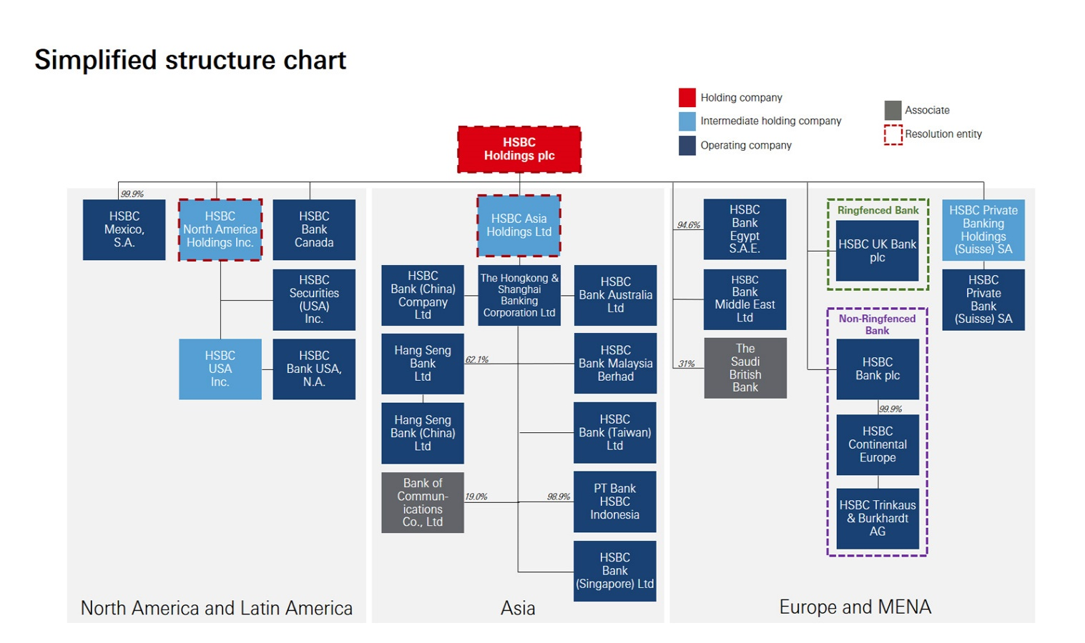
(Fig 1.)

HSBC’s Executive Committee
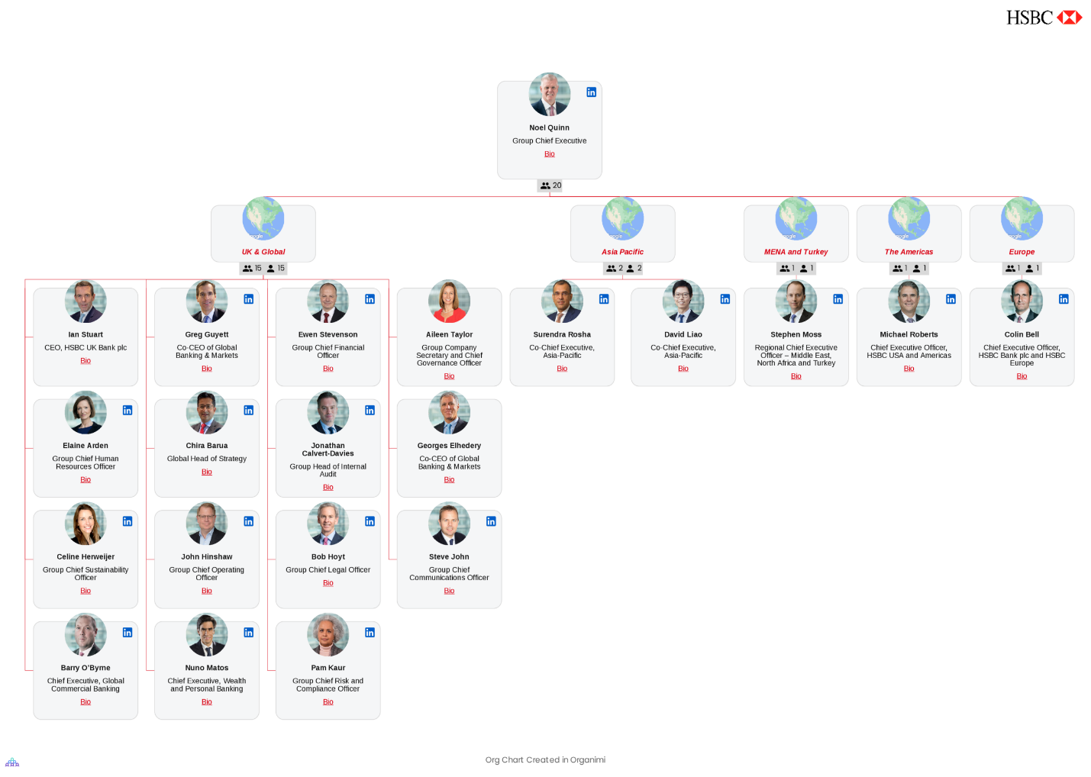
(Fig 2)

The company needs to develop an effective organizational culture. Organizational culture is based on several aspects that include visions and values.
The company's culture is dynamic and adaptable, focused on study and cooperation. They invest in employees through learning and mentoring courses and training. Those at HSBC aim to build an organizational culture where everyone feels included, important, appreciated, and respected. Where every employee feels free and protected. It encourages its employees to be visible and lead by example, to be tolerant, without prejudice and discrimination, to get involved, and help others to become allies. HSBC has eight employee networks, where diversity is promoted within banks, helping to create a culture where every employee feels involved. HSBC has a set of values, to which it strictly adheres to.
They are empathetic and open to the diversity of nations and spoken languages, this allows them to understand the clients and their needs, and to be able to serve them better. They support inclusion, remove barriers, and are open to different opinions.
It offers its clients unique opportunities. It creates connections that allow them to achieve their goals. He takes responsibility and makes sure that he capitalizes on those opportunities with integrity.
In addition to the extensive training offered to employees and all the conveniences within the office, those from HSBC come with a whole package of benefits, which also provide the employee with security and motivation to be productive. This package includes:
- Twenty-five days of leave
- Private medical assistance
- Life insurance
- Special rates for HSBC services
- Special assistance program for employees
- Season ticket loan
HSBC is based on a wide range of policies and systems that help ensure that the bank is well managed, moreover the organization respects the legal provisions of the Governance Code in Great Britain. HSBC has two divisions in terms of management and governance. The first is The Board of Admissions includes all the directors and majority shareholders. The second division is Senior Management, the executive group that supports the group's executive management, being supervised by the Board of Directors.
The board regularly evaluates all reports on performance, perceived failures, risks, as well as relations with investors. Presentations and analyzes of strategy and performance are made. For example, the Group Company Secretary and Chief Governance Officer are liable to report information not only within the board but also to seniors, managing directors, and non-executives. The Group Audit Committee analyzes all actions that include financial reports, and financial control systems. The Group Risk Committee deals with the supervision and management of the risk that the organization may face and the problems related to robberies financial, money laundering, and system abuse. The nomination & Corporate Governance Committee has the function of leading the process and approving the appointments in the administrative boards. The HSBC Board and all its departments are subject to regular assessments. All members of the Council are also subject to periodic performance and reviews. From the beginning, HSBC has concentrated on connecting customers with various opportunities, thus helping them achieve their dreams and ambitions.

Management and Leadership of HSBC
Leadership is a complex system that includes all organizational, social, and personal processes. Leadership means vision, encouragement, enthusiasm, love, energy, passion, obsession, and consistency. Leadership means leading people, respecting your commitments, being competent, having a good attitude, motivating your team, to have good communication. HSBC UK is very transparent in the way they treat not only customers but also employees. Based on four main pillars Commitment, Loyalty, Hard work, and integrity, which made them very competitive and motivated. Employees are motivated to be efficient just by their attitude and their loyalty to the leader, but also through other benefits, which are an incentive for them to have the desire to work and to be satisfied with what they do. They are offered annual vacations, the possibility to grow in the position, salary motivation, flexible work, you can work from home, medical insurance, and many other training and personal development lessons.
Leadership and Management are not similar. Management covers a wider sphere that includes leadership, considered to be a function of management. The manager is the person who ensures the achievement of organizational objectives through planning, organizing, and orienting work toward finality. Some people occupy managerial positions and are not leaders. Over the years the HSBC organization has endured many changes, changes that today keep it at the top of the biggest and most profitable banks in the whole world. Many managers were changed, it was thought and transformed over time. The biggest problems in the interior of the bank were from the management skills of the managers, however, there is a relationship between the progress of the company and the strategies used by the book manager. HSBC is facing a huge rivalry with many challenges and high risks. Nowadays it is increasingly difficult to face the demands of customers and challenges, which is why it is very difficult for a manager to take a correct decision so as not to affect either the position on the market or the shareholders. The management group aims to develop strategies and maintain the organization's reputation. They are responsible for making decisions regarding the execution of strategies, building, protect.

Conclusion
Analyzing the activity of HSBC from its foundation until now, we realize how it managed to become a top organization worldwide. It grew a lot, it managed to obtain a lot of markets and industries. We can safely say that the correct leadership and management, made the company successful today. However, the company possesses a certain uniqueness, it is focused on the future and is very rigid in terms of the future and changes. However, the rivalry and challenges are very great, and the management of HSBC must be prepared and connect to the internal functioning of the company, to help its employees, keep them informed, offer them training and lessons about the banking sector globally, and motivate its employees to work efficiently. Company culture is a fairly important element, equivalent to the success of the company. To be successful and maintain its place among the largest banks, HSBC should re-examine its strategies, examining - and the strong and weak points, opportunities, and threats to which it could be subjected. To reach that desired level of competitiveness, HSBC must ensure that they have the power to develop that competitiveness regarding human capital. Customers are the key element in the success of the organization, therefore the company must be assured that it satisfies the needs of the customers, and respects their expectations, thus increasing the level of loyalty and the profit of the company. As well as with suppliers, HSBC must build a strong relationship with them, a balanced relationship with respect for ethical standards will maintain long-term collaboration. As for competition, HSBC can be affected not only by the largest global banks but also by small, local ones. Besides the fierce competition, the company can be documented by political, economic, social, legal, and technological factors.

Reference
https://www.hsbc.com/who-we-are/purpose-values-and-strategy/our-values
HSBC & Newcastle Building Society Case Studies: Improving Customer Relationship Management (no date). MarketLine, a Progressive Digital Media business.
Gakovic, A. and Yardley, K. (2007) ‘Global Talent Management at HSBC’, Organization development journal, 25(2), p. P201–.
‘HSBC banks on more women at the top’ (2014) Human resource management international digest, 22(6), pp. 18–20. Available at: https://doi.org/10.1108/HRMID-08-2014-0116.
Shah, M. and Clarke, S. (2009) E-banking management issues, solutions, and strategies. Hershey, PA: Information Science Reference.
Horesh, N. (2009) Shanghai’s bund and beyond British banks, banknote issuance, and monetary policy in China, 1842-1937. New Haven, CT ;: Yale University Press. Available at: https://doi.org/10.12987/9780300143621.
https://www.hsbc.com/who-we-are/leadership-and-governance
https://www.hsbc.com/who-we-are/our-people-and-communities/inclusion
https://www.hsbc.com/who-we-are/businesses-and-customers/wealth-and-personal-banking

