University of Wales Trinity Saint David


Wales Institute of Science & Arts

Motorcycle Geometry Analysis and Dynamic Handling Investigation
Motorcycle Engineering ACHA4003

Rhys Williams
2004443

11/2020
Contents
Acronyms 3
Introduction 3
Ducati Panigale 1199 vs Honda CRF 450 3
Internal Gearing 7
KTM Super Duke GT vs Indian Springfield Dark Horse 116 7
Alterations to the bikes 9
Appendix 10

Acronyms

COG – centre of gravity
RPM – revolutions per minute

Introduction
Within this assignment, I will be analysing two bikes that I have personal access to. Measurements will be taken to determine the bike’s geometry designs, their typical use based on the geometry obtained and compare these bikes to another pair that I will source from the internet. The two bikes that I research into will be of a modern design and use. The bikes in question could be of high racing spec, however I feel that it would be more useful to compare the bikes to different classes of motorcycles, such as adventure bikes or cruisers, as these variations would be ideal to compare how the bikes differ in shape to one another.

Ducati Panigale 1199 vs Honda CRF 450

To begin my analysis of the Ducati Panigale 1199, an Italian masterpiece of a superbike, I have taken relevant measurements required for geometry comparisons against other motorcycles and have also constructed a schematic diagram of the motorcycle, illustrating the measurements I have logged.
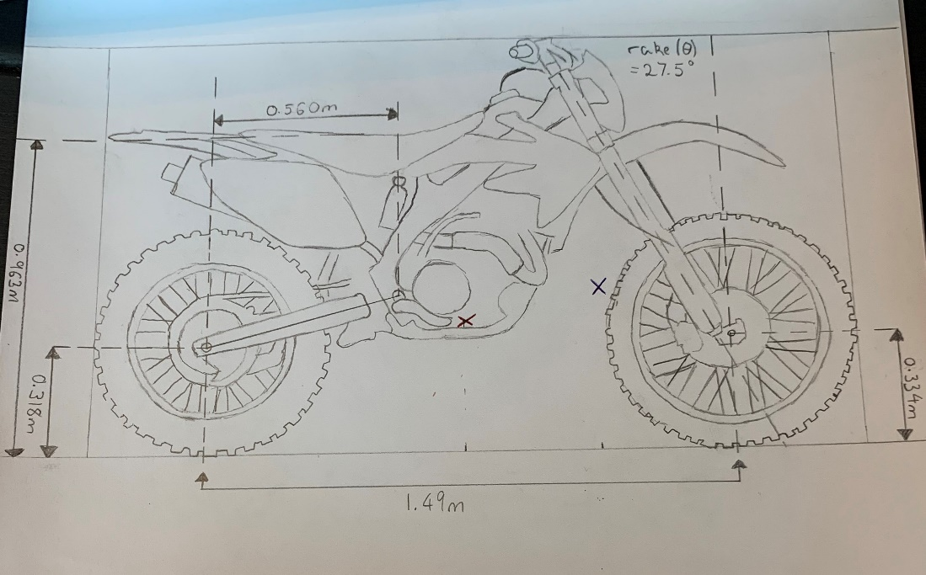
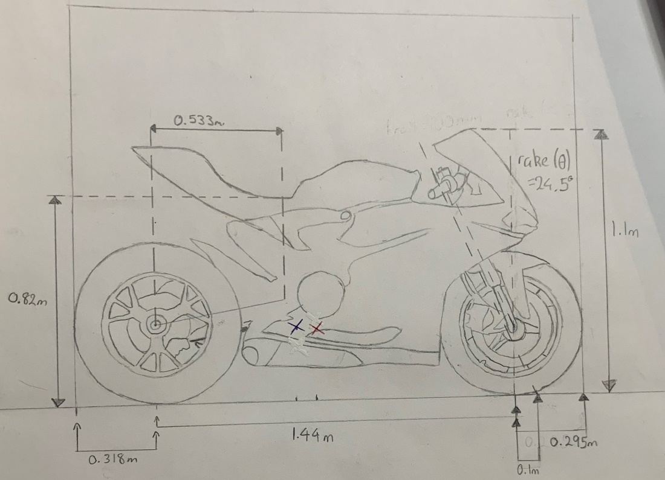
When creating my schematics, I began by going through the list of measurements I obtained from the bikes and labelling them on the bikes, such as wheelbase, wheel radii and rake. I then used the wheelbase to create a scale ratio for converting dimensions of the diagram to real life as it is the largest measurement taken and would be the most accurate length to use as a conversion piece. However, there will be some inaccuracies as 30cm ruler and protractor may not be the most accurate when some dimensions fall between the millimetre lines on the ruler, so it is as accurate as I could be. This pattern of accuracy follows through all my diagrams.

The two bikes I had access to, and chose to compare, are ones of the schematics above: the Ducati Panigale 1199 (2015) and a Honda CRF 450 (2005). I believe they are a good comparison to each other as their use is opposite to one another; one is used for off-road riding/racing and the other used for road riding/racing.
To begin with, the obvious comparison is ride heights. The CRF offers a higher seating position and ground clearance, whereas the Panigale provides lowered positions. Due to the terrain that the bike is intended for, the higher seating position allows the rider to be more flexible and manoeuvrable across the bike to accommodate the riding style for off road use. The increased ground clearance is purpose built for the terrain as riders’ race over jumps, slopes, step up and step downs. Since the surface beneath them is always altering in height, higher ground clearance prevents the under panel from getting dragged through the mud. In terms of the Ducati, the lower seated position and road clearance is due to the bike needing to stay planted to the floor as much as it can. The rider doesn’t need to be climbing over the bike to use their body momentum for jumps, instead the just lean across the sides to use their weight to improve their cornering.
The difference between both bike’s seat and ground clearance heights also means that they will have altered points for their centre of gravity. The process to calculate COG requires an individual to obtain the following geometry for their bike of choice: wheelbase, both wheel radii to calculate the average of the two, the height of the object they will use to weigh the bike at a lifted angle and the angle that the bike sits at once raised. Once the geometry is obtained, they must weigh the chosen bike twice; once on a flat surface and once while the rear is lifted into the object, also while trying not to add weight to the scales at the same time. After all the data listed above is known, the following formula will be implemented to calculate the COG across the x axis.
$$Xcog=\frac{Wr×L}{Wt}$$
Where Wr is the weight on the rear wheel, L is the wheelbase and Wt is the total weight of the bike.
To calculate the COG across the y axis, the following formula is implied.
$$Ycog=\frac{L×(Wr-Wrlifted)}{Wt×tanθ}+Rav$$
Where L is wheelbase, Wr is weight on the rear wheel, Wrlifted is the weight on the rear when lifted, Wt is the total weight, Ɵ is the angle the bike is lifted and Rav is the average wheel radius.

I have noted where the COG is throughout the bike when it is with and without a rider on it: red is the position without a rider and blue is the position with a rider. As expected, since there is increased mass at a higher point on the bikes, the y axis for Cog will increase, however the x axis differs between the two bikes. Before adding a rider to the CRF, the weight split is a near perfect 50:50 ratio, but when I positioned myself on the bike a big amount of the weight is transferred to the front to alter the ratio distribution to 75:25 front to rear. A benefit of this would be increased stability while cornering as a very common riding style would be to plant the front wheel into the berm first, rotate the bike with the rider’s weight and power out the corner by repositioning toward the rear. However, the Panigale starts with a mass ratio of 43:56 for the front to rear weight distribution, but has an opposite effect when seated in a riding position as weight is transferred to the rear instead, changing the ratio to 37:62. Although an opposite to the Honda, it still offers the same benefits, but for different reasons. Riders on the road will avoid sliding the rear end out as it provides a lot of grip due to the enlarged surface area that is in contact with the tarmac. This weight distribution still allows the rider to be very stable and in control while going at high, straight line speeds.
Another difference between both bikes is wheel sizing: both have the same diameter for the rear wheel, but the front wheel on the Ducati is smaller than the Honda’s front wheel by 41mm. The larger front wheel is intended for keeping COG higher up on the bike, but also increasing grip and stability for the front end. Riding in mud isn’t very grippy so having a bigger wheel keeps the bike stable at more angles of lean and allowing it to plough through most amounts of terrain, however it is more prone to drifting out sideways as it has less surface contact than the Ducati’s front wheel. As mentioned previously, a lot of the stability is controlled from the rear end of the bike so dirt bikes, as a whole, don’t require as big of a front tyre: if an individual has issues with too much slip on the front, there are options for wider tyres, but they still won’t be as wide as road riding bikes.
Rake and trail are also driving factors for how the bike will feel riding over certain terrain and how it is driven. Although the difference between the two bikes are not massive, they will impact how the bike feels in motion and how it manoeuvres. Rake is the angle, measured against the vertical axis, passing through the front wheel’s spindle, however manufacturers will have developed the rake to be a fixed angle. Trail is the distance from vertical line crossing the front wheel’s spindle and the angled line which crosses through the middle of the centre of the steering head (Understanding a Motorcycle's Rake and Trail, 2020). The Honda has a larger rake angle of 27.5°, compared to 24.5°, which sets the bar for how long the wheelbase and trail will be. However, since it has a slightly bigger rake that therefore has increased the trail distance. Comparing the two bikes, the bigger trail on the CRF will make it that slight bit harder to steer the bike, however, since the bike is nearly half the weight of the Ducati, in practise, the steering feels a lot lighter. This will also be down to the components used to construct the steering components for the bike, such as forks, bearings, wheels and tyres, etc.
I also measured swingarm lengths for both bikes. The road going bike has a shorter swingarm which enables the COG to be more rear end biased as an increased amount of load is shifted toward the rear wheel. By shifting the COG to the rear, it also benefits from having more grip against its riding surface as the rear tyre has more weight pushing toward the tarmac. The slightly longer swingarm on the dirt bike spreads the COG more toward the centre of the bike, keeping it balanced for when the rider is in the air, and due to the riding surface, it will not suffer much from the potential loss in grip.

Internal Gearing

As well as analysing the geometry of the two bikes, I have identified the internal and external gearing ratios. I have constructed a gearbox calculator to determine how fast a bike is projected to go based on it’s primary, final, internal gearing, wheel diameter and the maximum rpm it will run to. Below are the results that I obtained.
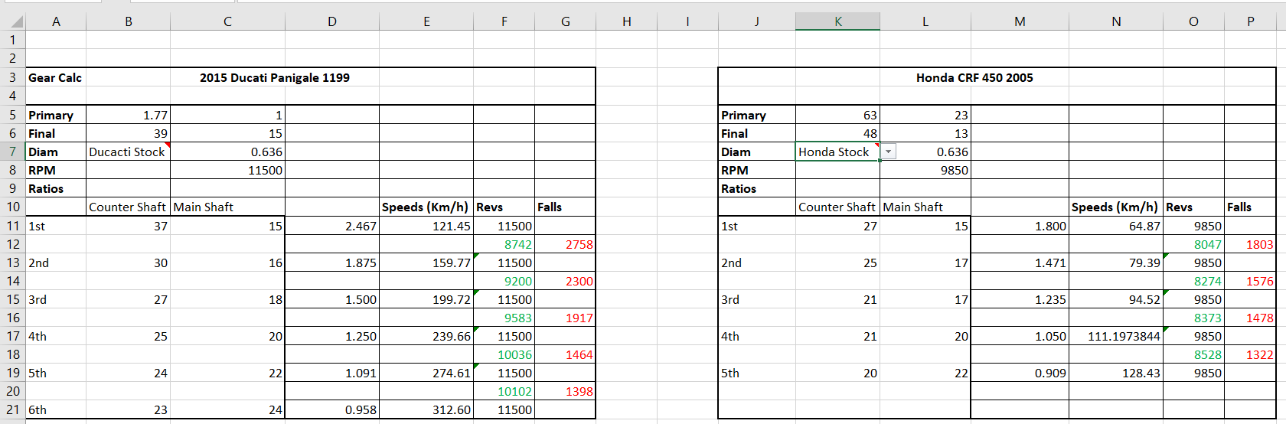
The websites that I was able to find the gearing for both bikes are listed in the appendix. The equation used to calculate is as follows:
$$Speed\left(\frac{km}{h}\right)=\frac{rpm×60×\left(\frac{mainshaft}{countershaft}\right)×\left(\frac{primary in}{primary out}\right)×rear wheel diameter×π}{1000}$$
In the equation, the 60 on the top of the fraction converts revolutions per minute into revolutions per hour and 1000 converts metres to kilometres.
Based on the projected top speeds from the calculator, I believe it doesn’t factor in the forces acting against the bike such as friction, air resistance and other forces not visible to the eye. Looking at the Ducati, the 312km/h translates to 193mph. With that said, I researched into the top speed of the bike and found a news article where they tested just that. They ran the bike to it’s maximum potential and they stated “a tiny flash of the redline at 186mph” (Cope, 2012). I believe this to be a reliable source as “Visor Down” is a well-known and trusted news publisher, within the motorcycle community.
However, in terms of the Honda, I have come across a source (TRUE top Speed of CRF450R, 2011) stating that with factory gearing, the bike ran to 86mph (138km/h), however it doesn’t state what model CRF450 was used. A second source on the within the forum stated they ran a 2008 model to 130km/h which is more likely, however it doesn’t state the riding conditions, terrain and states that there were some exhaust modifications on the bike. Considering both sources, I believe that my gearbox is not far off an actual top speed figure for the CRF450.

KTM Super Duke GT vs Indian Springfield Dark Horse 116

Like mentioned at the beginning of this paper, I believe it would be ideal to compare the first two bikes, which are already polar opposites in design and use, to another pair of bikes which differ from the each other as well as opposing the first pair of motorcycles. The KTM Super Duke GT is classed as a ‘sports tourer’, containing a 1.3litre V-twin engine and pushing 175 horsepower and 141 newton metres of torque. This handful of a bike has been refined to be able to cope at low and high speeds; designed for comfort and cruising, but also being able to speed down the Autobahn at an estimated 159mph (Topspeed.com, 2020).
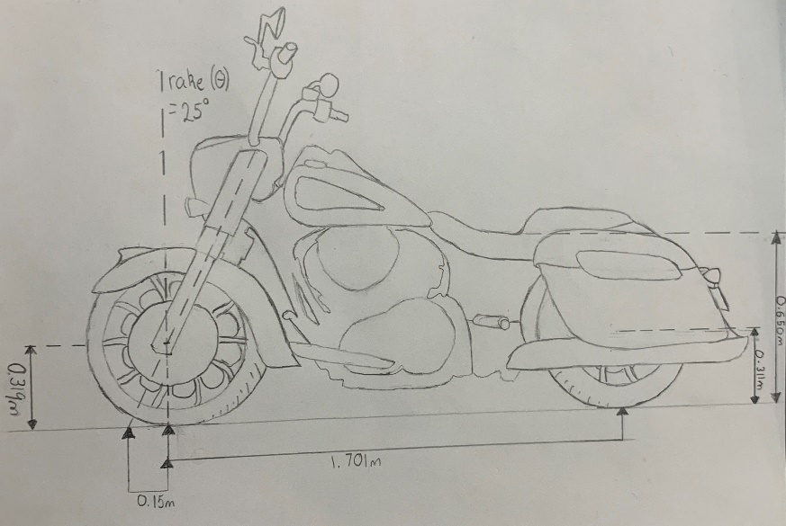
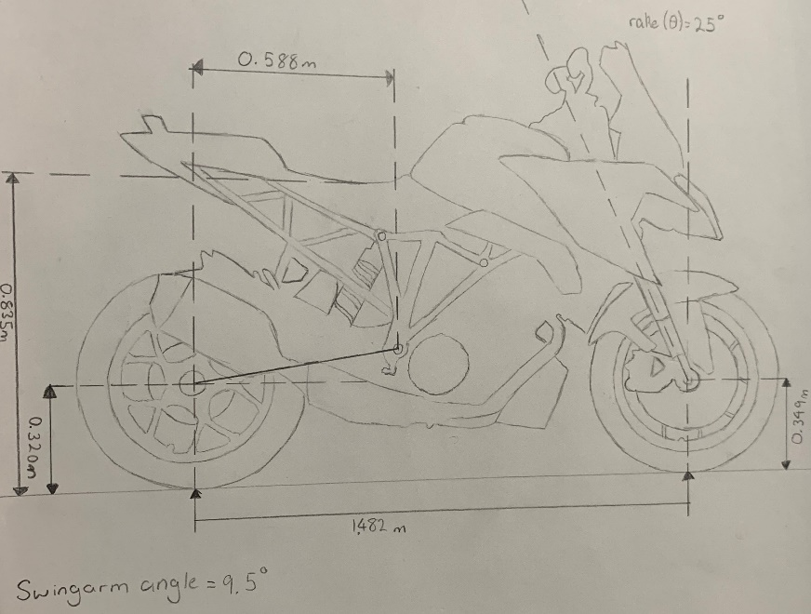
The second bike of choice was the Indian Springfield Dark Horse 116. Fitting in the ‘bagger’ category, it is purpose built for the type of rider that adores a big powerful engine in a bike designed for cruising or enjoying the Saturday ride with friends. Bagger bikes are built to be comfortable for long journeys and offer plenty of power, with a 1890cc engine, alongside vast storage, in bag form, covering the rear wheel with an enclosed style of fairing.

Although both bikes are capable of completing long journeys in comfort, they have both been designed with different styling and riding positions, where the Indian offers a laid-back position for the rider and the Super Duke gives the rider an upright seated position. The difference in seat height from the ground is just over 20cm; almost double the difference of the original two bikes. With the Indian sitting 0.65 metres, it’s COG will be fairly low in conjunction with the KTM.
As anticipated, both bikes carry a lot of weight with them, but due to the low-rider design that the Springfield has, it’s COG will be a fair bit lower than the Duke’s would be, but I believe that both should sit fairly central across the x axis as the engines will carry a big fraction of the mass.
KTM gave the Duke a rake of 25°, but I was surprised to find that the bagger bike has an identical figure. Typically, this style of bike has a larger rake due to their elongated wheelbase, however I believe that it isn’t as large as anticipated as the 116 doesn’t have huge wheels compared to cruisers or choppers. Since the rake is 25°, the trail is a suitable length at 0.15m. This optimises the stability for the slightly larger front wheel at 19 inch while also not making it too heavy to turn at slow speeds.
Although I was able to scale a measurement of 0.588 metres for the length of the Super Duke’s swingarm, I am unable to grasp a length on the Indian due to its enclosed fairing style, although I imagine it to be roughly be around 0.6 metres due to its marginally longer wheelbase.

Alterations to the bikes

In my personal opinion, I believe that the bikes come with optimum geometry and ergonomics, from factory, based on the average rider. However, it is down to the individual that owns their own bike if they were to alter any of the geometries of the bike as they may differ from the ‘average rider’. As a whole, not many people should need to change the dynamics of their bike, unless they are part of the small percentage that can’t accommodate to the ‘average’ person.

Appendix

- Motorcyclespecs.co.za. 2020. 2006 Honda CRF 450X. [online] Available at: <https://www.motorcyclespecs.co.za/model/Honda/honda_crf450x%2005.htm> [Accessed 6 December 2020].
- Motorcyclespecs.co.za. 2020. 2012 Ducati 1199 Panigale. [online] Available at: <https://www.motorcyclespecs.co.za/model/ducati/ducati_1199_panigale%2012.htm> [Accessed 6 December 2020].
- Indian® Motorcycles - UK -. 2020. Indian Springfield Dark Horse. [online] Available at: <https://www.indianmotorcycle.co.uk/indian-springfield-dark-horse/> [Accessed 6 December 2020].
- Motorcyclespecs.co.za. 2020. 2020 KTM 1290 Super Duke GT. [online] Available at: <https://www.motorcyclespecs.co.za/model/ktm/ktm_1290_superduke_GT_20.html> [Accessed 6 December 2020].
- Motorcyclespecs.co.za. 2020. 2020 Indian Springfield Dark Horse 116. [online] Available at: <https://www.motorcyclespecs.co.za/model/Indian/indian_springfield_dark_horse_20.html> [Accessed 6 December 2020].
- Cycle World. 2020. Understanding A Motorcycle's Rake And Trail. [online] Available at: <https://www.cycleworld.com/2015/05/22/cycle-world-tips-and-tricks-understanding-motorcycle-rake-and-trail/> [Accessed 6 December 2020].
- Topspeed.com. 2020. [online] Available at: <https://www.topspeed.com/motorcycles/motorcycle-reviews/ktm/2019-2020-ktm-1290-super-duke-gt-ar182987.html#:~:text=Top%20Speed%3A,159%20mph%20(Est.)> [Accessed 6 December 2020].
- Crfsonly.com. 2020. CRF's Only. [online] Available at: <https://www.crfsonly.com/howto/gearing/motorcycle-gearing-calculator.php> [Accessed 6 December 2020].
- ThumperTalk. 2011. TRUE Top Speed Of CRF450R. [online] Available at: <https://thumpertalk.com/forums/topic/916334-true-top-speed-of-crf450r/> [Accessed 6 December 2020].
- Cope, B., 2012. Flat Out On A Ducati 1199 Panigale. [online] Visordown. Available at: <https://www.visordown.com/features/general/flat-out-ducati-1199-panigale> [Accessed 6 December 2020].

