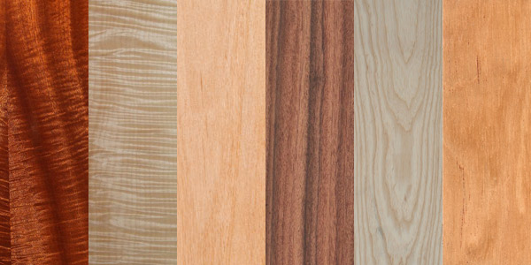

Component Analysis
  - Wooden Guitar NEck
Keenan Pearce | Materials & Manufacturing | 1704659

Brief
You are to analyze a given component in regard to its materials and manufacturing specification, identifying the design features that have necessitated the choice of production and recommend new alternative solutions. This data will be presented in an illustrated report evidencing your research outcomes and conclusions. The component I have chosen to analyze is the wooden guitar neck pictured below.

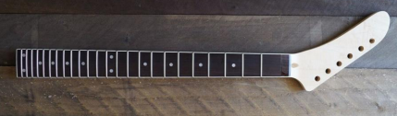

Materials
There are a few materials used on guitar necks, mainly variances of woods. However, you’ve also got Fretwire (Most commonly Steel), Inlay fret markers (Various plastics), the nut (Usually bone or plastic). There is also a long steel bar placed internally along the fretboard called the Truss Rod. This can be adjusted to straighten the fret board to improve playing.
There are many different types of woods used within guitar manufacturing, various materials can give alternative tones, weight and feels.

Neck Woods
These are the most commonly used woods for the guitar neck.
- Maple
- Mahogany
- Rosewood
Looking at the image of the guitar neck I can clearly see the wood used for the neck is Maple. This is commonly used by the manufacture Fender. It gives a very bright tone whilst being very dense and strong resulting in excellent sustain and stability.

Fretboard Woods
These are the most commonly used woods for the guitar fretboard.
- Ebony
- Maple
- Rosewood
Again, looking at the image of the guitar neck, Rosewood can be seen on the fretboard. This material is very common for fretboards. It has a natural oily feel which doesn’t require any finishing. Ebony and maple fretboards have brighter and crispier tones, Rosewood is known for its warm tones with less high end.

Alternative Materials
There have been many experimentations with different materials for guitars. Various plastics such as Polymer and ABS have been used. Mario Maccaferri designed ukuleles and guitars from plastic. However, these are considered a novelty and more of a toy than a musical instrument. Danelectro were able to create affordable guitars from Masonite (a pressboard type wood) back in the 1960s. These were very popular back in those days for beginners because of the price. Fiberglass is another example of an alternative material as demonstrated by an Airline Resonator Guitar. They used this material for its strength properties as well as the manufacturing costs. It was also the “cool-factor” of owning a fiberglass guitar.
Carbon Fiber is my favorite alternative as it is super lightweight and doesn’t get effected by temperature or humidity like woods do. Its made from strands of carbon woven together that turns into sheets of fabric, similar to fiberglass. When being used it is layered up and mixed with resin, this bonds the material and hardens. It is commonly used in Airplanes, Bicycles, Racing Cars and even Space Satellites.
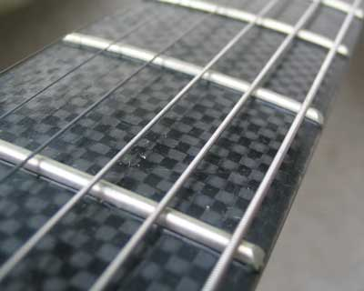

Pros
Sound – If we are talking about an acoustic carbon fibre guitar, one of the first things you will notice is that its much louder than a wooden guitar. The resonance is dramatically improved sounding much richer.
Consistency – In comparison to a wooden guitar, manufacturers and luthiers make a big deal choosing certain grains and ages of wood. This means that no two wooden guitars are identical. However, carbon fibre can be used to produce guitars consistently. There’s no issue duplicating designs as the material is the same every time.
Weight – Carbon fibre is well known for its weight, this is why its commonly used in bicycles and aircraft. Using this material allows manufactures to create lightweight products without compromising durability. Weight is not necessarily a major issue with guitars, however a lighter instrument can be beneficial to the user.
Durability – Known for its outstanding strength to weight ratio, carbon fiber is ideal for guitars. It is very difficult to dent, crack and dent compared to wood, but also will not have any problems with humidity and temperature changes. Making it fantastic for touring and taking around the world without worry of any damage.


Cons
Manufacturing Practicality – Wooden guitars have been around for centuries so it easy to find staff and luthiers to employ to create them. To train people how to use carbon fiber could be a difficult and time-consuming process to perfect. It is no easy job using this material and can take lots of experience.
Costs – Carbon fiber is an expensive material alone, with everything else on top could put a hefty price tag on a guitar. As It’s a fairly new material in the musical instrument industry, research and development can be pricey.
Consistency – Although this was mentioned as pro, it can also be considered a con. Guitars often gain worth by age and even “road worn” instruments can be valuable. A Carbon fiber guitar is not going to gain any major battle scars or tone differences over time. Not a big issue but could be a deal breaker some players.

Manufacturing Process
Guitars are a complex product to create and they are mostly done by hand by expert luthiers. They often use set templates or “Jigs” to consistently create the shape that is required.
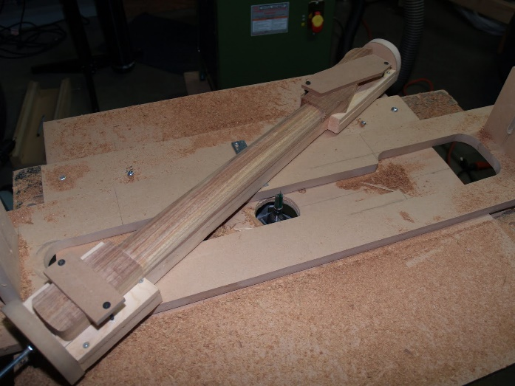
A Guitar neck placed into a “Jig” then being roughly shaped with a router cutting tool
After the neck has been roughly shaped, the underside of the neck is shaped by hand using a plane and sanding tools. Luthiers use gauges to check the 1st and 12th frets curvature.
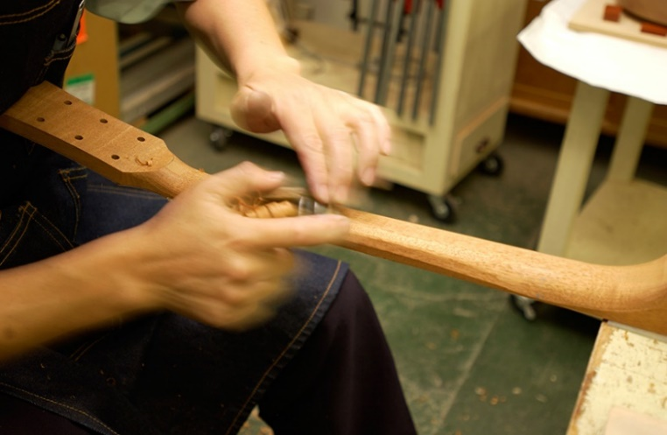
Neck underside being shaped by a luthier
However, some guitar manufacturers use automated machines to speed the process up. For example, CNC machines have improved the industry dramatically. Being able to prove outstanding results, accurately and consistently.
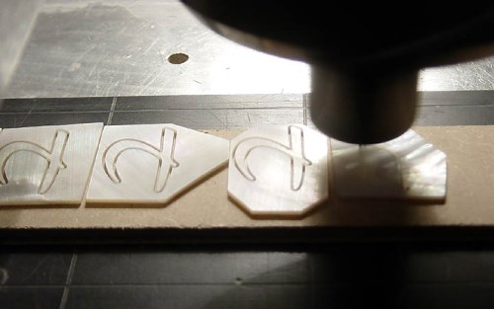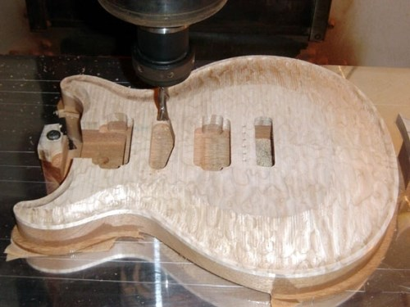
CNC Machine being used on multiple guitar parts
Carbon fiber is used by firstly creating an appropriate mold for the product you want to form. These are usually made from fiberglass or a fine grain wood. These molds would be reused time and time again. They are then coated in some sort of release agent, usually wax or other lubricant. This prevents the carbon fiber and resin from bonding to the actual mold, so you can actually release the part after hardening. Resin is then added to the mold to create a sticky base layer. Layers of the cloth like material are then placed and layered on top of each other until the desired thickness is met. Addition resin would be added in-between each layer to ensure a tough bond. Carbon fiber cloth alone is not very strong at all, only when its saturated in the resin gives its strength.
When the mold is full of the fiber and resin, it needs time to cure and harden. To speed this process up it can be placed into an oven for a few hours. Temperature is important for this, resin will struggle to cure in colder environments below 16°c. When the part has fully hardened it may be required to add a few more layers of resin on the exterior, this is commonly done for atheistic purposes and will not affect the strength of the part.
Post processing of a carbon fiber product requires sanding to give a good look. High grit paper will give a very glossy look, this can then be polished.
Overall I think carbon fiber is a fantastic alternative material for a guitar neck.

Guitar Adventures. (2015). What's the Deal with the Carbon Fiber Guitar? Pros vs Cons. [online] Available at: http://www.guitaradventures.com/carbon-fiber-guitars-pros-vs-cons [Accessed 13 April 2018].
Johnson Bicycles. (2018). TECH.. [online] Available at: http://www.johnsonbikes.com/tech/ [Accessed 13 April 2018].
Monck, C. (2011). How to Make A Guitar Neck In One Hour. [online] Eguitarplans.blogspot.co.uk. Available at: http://eguitarplans.blogspot.co.uk/2011/05/how-to-make-guitar-neck-in-one-hour.html [Accessed 13 April 2018].
Yamaha.com. (2018). How the Electric Guitar is Made. [online] Available at: https://www.yamaha.com/en/musical_instrument_guide/electric_guitar/manufacturing/manufacturing002.html [Accessed 14 April 2018].
Mmsonline.com. (2018). CNC Machining Fuels Guitar Innovations. [online] Available at: https://www.mmsonline.com/articles/cnc-machining-fuels-guitar-innovations [Accessed 14 Apr. 2018].

