Appendix for assignment for ECAD5010

Appendix One

APPLICATION FOR ETHICAL APPROVAL

RESEARCH STUDENTS
This form is to be completed by the student within SIX months for full-time students and TWELVE months for part time students, after the commencement of the research degree or following progression to Part Two of your course.

Once complete, submit this form via the MyTSD Doctoral College Portal at (https://mytsd.uwtsd.ac.uk).

This document is also available in Welsh.

RESEARCH STAFF ONLY
All communications relating to this application during its processing must be in writing and emailed to pgresearch@uwtsd.ac.uk , with the title ‘Ethical Approval’ followed by your name.

STUDENTS ON UNDERGRADUATE OR TAUGHT MASTERS PROGRAMMES should submit this form (and receive the outcome) via systems explained to you by the supervisor/module leader.

In order for research to result in benefit and minimise risk of harm, it must be conducted ethically. A researcher may not be covered by the University’s insurance if ethical approval has not been obtained prior to commencement.

The University follows the OECD Frascati manual definition of research activity: “creative work undertaken on a systematic basis in order to increase the stock of knowledge, including knowledge of man, culture and society, and the use of this stock of knowledge to devise new applications”. As such this covers activities undertaken by members of staff, postgraduate research students, and both taught postgraduate and undergraduate students working on dissertations/projects.

The individual undertaking the research activity is known as the “principal researcher”.

Ethical approval is not required for routine audits, performance reviews, quality assurance studies, testing within normal educational requirements, and literary or artistic criticism.

Please read the notes for guidance before completing ALL sections of the form.

This form must be completed and approved prior to undertaking any research activity. Please see Checklist for details of process for different categories of application.

SECTION A: About You (Principal Researcher)
1 | Full Name: |  | Olivia Louise Blandford
2 | Tick all boxes that apply: |  | Member of staff: | ☐ | Honorary research fellow: | ☐
 | Undergraduate Student | ☒ | Taught Postgraduate Student | ☐ | Postgraduate Research Student | ☐

3 | Institute/Academic Discipline/Centre: | Initial Teacher Education, Yr Athrofa
4 | Campus: | Carmarthen
5 | E-mail address: | 2200504@student.uwtsd.ac.uk
6 | Contact Telephone Number: | 07983526252
 | For students:
7 | Student Number: | 2200504
8 | Programme of Study: | BA Primary Education with QTS
9 | Director of Studies/Supervisor: | Dr Sioned V Hughes

SECTION B: Approval for Research Activity
1 | Has the research activity received approval in principle?  (please check the Guidance Notes as to the appropriate approval process for different levels of research by different categories of individual) |  | YES | ☒ | NO | ☐
 |  |  |  |  | Date
2 | If Yes, please indicate source of approval (and date where known): Approval in principle must be obtained from the relevant source prior to seeking ethical approval | Research Degrees Committee |  | ☐
2 |  | Institute Research Committee |  | ☐
2 |  | Other (write in) ECAD5010 Module lead Julia Holloway |  | ☒ | 18.01.24

SECTION C: Internal and External Ethical Guidance Materials
 | Please list the core ethical guidance documents that have been referred to during the completion of this form (including any discipline-specific codes of research ethics, location-specific codes of research ethics, and also any specific ethical guidance relating to the proposed methodology). Please tick to confirm that your research proposal adheres to these codes and guidelines. You may add rows to this table if needed.
1 | UWTSD Research Ethics & Integrity Code of Practice | ☒
2 | UWTSD Research Data Management Policy | ☒
3 |  | ☐

SECTION D: External Collaborative Research Activity
If there are external collaborators then you should gain consent from the contact persons to share their personal data with the university. If there are no external collaborators then leave this section blank and continue to section E.
1 | Institution
2 | Contact person name
3 | Contact person e-mail address
4 | Is your research externally funded? |  | YES | ☐ | NO | ☒
5 | Are you in receipt of a KESS scholarship? |  | YES | ☐ | NO | ☒
6 | Are you specifically employed to undertake this research in either a paid or voluntary capacity? | Voluntary | YES | ☐ | NO | ☒
7 |  | Employed | YES | ☐ | NO | ☒
8 | Is the research being undertaken within an existing UWTSD Athrofa Professional Learning Partnership (APLP)? | If YES then the permission question below does not need to be answered. | YES | ☒ | NO | ☐
9 | Has permission to undertake the research has been provided by the partner organisation? | (If YES attach copy)  If NO the application cannot continue | YES | ☒ | NO | ☐

Where research activity is carried out in collaboration with an external organisation
10 | Does this organisation have its own ethics approval system? | YES | ☒ | NO | ☐
 | If Yes, please attach a copy of any final approval (or interim approval) from the organisation (this may be a copy of an email if appropriate).

SECTION E: Details of Research Activity
1 | Indicative title: | What are staff and year 3 learners’ perceptions of active feedback?
2 | Proposed start date: | 24.01.24 | Proposed end date: | 19.02.24
Introduction to the Research (maximum 300 words per section)
Ensure that you write for a Non-Specialist Audience when outlining your response to the points below:
- Purpose of Research Activity
- Proposed Research Question
- Aims of Research Activity
- Objectives of Research Activity
Demonstrate, briefly, how Existing Research has informed the proposed activity and explain
- What the research activity will add to the body of knowledge
- How it addresses an area of importance.
3 | Purpose of Research Activity  - To investigate the quality of feedback as an effective assessment for learning strategy throughout the classroom to aid my own professional practice.  - Developing research skills by trialling and evaluating several research skills throughout.  (this box should expand as you type)
4 | Research Question  What are staff and year 3 learners’ perceptions of active feedback?  (this box should expand as you type)
5 | Aims of Research Activity  - To explore staff and learners’ perceptions of assessment for learning.  - To critically evaluate the different research tools throughout  - To further develop personal knowledge and understanding of assessment for learning to improve professional practice.  (this box should expand as you type)
6 | Objectives of Research Activity  - To provide explore active feedback as an effective assessment for learning strategy and approaches used by staff to support and develop pupils’ learning using a questionnaire.  - To interview students to capture their views on active feedback throughout the classroom.  - To conduct a questionnaire with members of staff throughout the setting to capture their views on active feedback throughout the classroom.  - To critically reflect on the process of using different research tools to collect data.  (this box should expand as you type)
Proposed methods (maximum 600 words)
Provide a brief summary of all the methods that may be used in the research activity, making it clear what specific techniques may be used. If methods other than those listed in this section are deemed appropriate later, additional ethical approval for those methods will be needed. You do not need to justify the methods here, but should instead describe how you intend to collect the data necessary for you to complete your project.
7 | Interviews – learners will be involved in a semi-structured interview where they will be invited to respond to key questions. These interviews will be conducted in an informal setting, and I will make notes of and audio record their responses. The learners will not be forced to participate, will be made aware that they do not have to answer any questions and that they can stop at any time. Learners will be asked if they wish to be involved and show that they are happy to continue. I will check on the learner’s feelings regularly. No names will be recorded.  Questionnaires – all staff throughout the school setting will be involved in an anonymous questionnaire, they will be asked to complete the questionnaire. The questionnaires will be sent through emails and will contain all the information needed for staff. They won’t be forced to complete the questionnaire and there will be options for them to skip and pass questions if needed.  (this box should expand as you type)
Location of research activity
Identify all locations where research activity will take place.
8 | A medium sized school in an urban town in South Wales.  (this box should expand as you type)
Research activity outside of the UK
If research activity will take place overseas, you are responsible for ensuring that local ethical considerations are complied with and that the relevant permissions are sought. Specify any local guidelines (e.g. from local professional associations/learned societies/universities) that exist and whether these involve any ethical stipulations beyond those usual in the UK (provide details of any licenses or permissions required). Also specify whether there are any specific ethical issues raised by the local context in which the research activity is taking place, for example, particular cultural and/or legal sensitivities or vulnerabilities of participants. If you live in the country where you will do the research then please state this.
9 | N/A  (this box should expand as you type)

10 | Use of documentation not in the public domain: Are any documents NOT publicly available? | NO | ☒
10 |  | YES | ☐
11 | If Yes, please provide details here of how you will gain access to specific documentation that is not in the public domain and that this is in accordance with the current data protection law of the country in question and that of England and Wales.  (this box should expand as you type)

 | Does your research relate to one or more of the seven aims of the Well-being of Future Generations (Wales) Act 2015? | YES | NO
12 | A prosperous Wales | ☒ | ☐
13 | A resilient Wales | ☒ | ☐
14 | A healthier Wales | ☒ | ☐
15 | A more equal Wales | ☒ | ☐
16 | A Wales of cohesive communities | ☒ | ☐
17 | A Wales of vibrant culture and thriving Welsh language | ☒ | ☐
18 | A globally responsible Wales | ☒ | ☐
19 | If YES to any of the above, please give details:
Assessment for learning is an ongoing teaching and learning strategy used throughout classrooms in Wales to support teaching environments.

(this box should expand as you type)

SECTION F: Scope of Research Activity TICK ALL RELEVANT BOXES HERE
 | Will the research activity include: | YES | NO
1 | Use of a questionnaire or similar research instrument? | ☒ | ☐
2 | Use of interviews? | ☒ | ☐
3 | Use of focus groups? | ☒ | ☐
4 | Use of participant diaries? | ☐ | ☒
5 | Use of video or audio recording? | ☒ | ☐
6 | Use of computer-generated log files? | ☐ | ☒
7 | Participant observation with their knowledge? | ☐ | ☒
8 | Participant observation without their knowledge? | ☐ | ☒
9 | Access to personal or confidential information without the participants’ specific consent? | ☐ | ☒
10 | Administration of any questions, test stimuli, presentation that may be experienced as physically, mentally or emotionally harmful / offensive? | ☐ | ☒
11 | Performance of any acts which may cause embarrassment or affect self-esteem? | ☐ | ☒
12 | Investigation of participants involved in illegal activities? | ☐ | ☒
13 | Use of procedures that involve deception? | ☐ | ☒
14 | Administration of any substance, agent or placebo? | ☐ | ☒
15 | Working with live vertebrate animals? | ☐ | ☒
16 | Procedures that may have a negative impact on the environment? | ☐ | ☒
17 | Other primary data collection methods. Please indicate the type of data collection method(s) below. | ☐ | ☒
 | Details of any other primary data collection method:  (this box should expand as you type) | ☐ | ☒
If NO to every question, then the research activity is (ethically) low risk and may be exempt from some of the following sections (please refer to Guidance Notes).

If YES to any question, then no research activity should be undertaken until full ethical approval has been obtained.

SECTION G: Intended Participants TICK ALL RELEVANT BOXES HERE
If there are no participants then do not complete this section, but go directly to section H.

 | Who are the intended participants: | YES | NO
1 | Students or staff at the University? | ☐ | ☒
2 | Adults (over the age of 18 and competent to give consent)? | ☒ | ☐
3 | Vulnerable adults? | ☐ | ☒
4 | Children and Young People under the age of 18? (Consent from Parent, Carer or Guardian will be required) | ☒ | ☐
5 | Prisoners? | ☐ | ☒
6 | Young offenders? | ☐ | ☒
7 | Those who could be considered to have a particularly dependent relationship with the investigator or a gatekeeper? | ☐ | ☒
8 | People engaged in illegal activities? | ☐ | ☒
9 | Others. Please indicate the participants below, and specifically any group who may be unable to give consent. | ☐ | ☒
 | Details of any other participant groups:  (this box should expand as you type) | ☐ | ☒

Participant numbers and source
Provide an estimate of the expected number of participants. How will you identify participants and how will they be recruited?
10 | How many participants are expected? | There are 32 pupils within the classroom but there will be 8 pupils participating in focus group interviews.  All staff in the setting will be sent a copy of the questionnaire.  (this box should expand as you type)
11 | Who will the participants be? | 8 pupils completing focus group interviews from year 3 Class.  All staff throughout the setting will be provided with a questionnaire to complete.  (this box should expand as you type)
12 | How will you identify the participants? | With the teachers support I will choose the learners who are competent and have the skills to fully participate throughout the interview.  (this box should expand as you type)

 | Information for participants: | YES | NO | N/A
13 | Will you describe the main research procedures to participants in advance, so that they are informed about what to expect? | ☒ | ☐ | ☐
14 | Will you tell participants that their participation is voluntary? | ☒ | ☐ | ☐
15 | Will you obtain written consent for participation? | ☐ | ☐ | ☒
16 | Will you explain to participants that refusal to participate in the research will not affect their treatment or education (if relevant)? | ☒ | ☐ | ☐
17 | If the research is observational, will you ask participants for their consent to being observed? | ☐ | ☐ | ☒
18 | Will you tell participants that they may withdraw from the research at any time and for any reason? | ☒ | ☐ | ☐
19 | With questionnaires, will you give participants the option of omitting questions they do not want to answer? | ☒ | ☐ | ☐
20 | Will you tell participants that their data will be treated with full confidentiality and that, if published, it will not be identifiable as theirs? | ☒ | ☐ | ☐
21 | Will you debrief participants at the end of their participation, in a way appropriate to the type of research undertaken? | ☒ | ☐ | ☐
22 | If NO to any of above questions, please give an explanation
 | (this box should expand as you type)

 | Information for participants: | YES | NO | N/A
24 | Will participants be paid? | ☐ | ☒ | ☐
25 | Is specialist electrical or other equipment to be used with participants? | ☐ | ☒ | ☐
26 | Are there any financial or other interests to the investigator or University arising from this study? | ☐ | ☒ | ☐
27 | Will the research activity involve deliberately misleading participants in any way, or the partial or full concealment of the specific study aims? | ☐ | ☒ | ☐
28 | If YES to any question, please provide full details
 | (this box should expand as you type)

SECTION H: Anticipated Risks

Outline any anticipated risks that may adversely affect any of the participants, the researchers and/or the University, and the steps that will be taken to address them.

If you have completed a full risk assessment (for example as required by a laboratory, or external research collaborator) you may append that to this form.
1 | Full risk assessment completed and appended? |  | Yes | ☐
1 |  |  | No | ☒
2 | Risks to participants  For example: sector-specific health & safety, emotional distress, financial disclosure, physical harm, transfer of personal data, sensitive organisational information
 | Risk to participants:  Participants may feel under pressure to give the correct answer to the questions.  Anonymity  (this box should expand as you type) | How you will mitigate the risk to participants:  Participant will be told that there is no consequence for anything they say. I will make it clear that I want open and honest answers. I will make it clear that the answers they give will affect their education in no way and there will be no repercussions for their actions and answers in regard to the research.  Participants will be reassured that all questions, answers, names and places will be confidential, and no information will be shared regarding the research or the data.  (this box should expand as you type)
3 | If research activity may include sensitive, embarrassing or upsetting topics (e.g. sexual activity, drug use) or issues likely to disclose information requiring further action (e.g. criminal activity), give details of the procedures to deal with these issues, including any support/advice (e.g. helpline numbers) to be offered to participants. Note that where applicable, consent procedures should make it clear that if something potentially or actually illegal is discovered in the course of a project, it may need to be disclosed to the proper authorities
N/A

(this box should expand as you type)
4 | Risks to the investigator  For example: personal health & safety, physical harm, emotional distress, risk of accusation of harm/impropriety, conflict of interest
 | Risk to the investigator:  - Risk of accusation of fabrication or falsification of data.  - Accusation of favouritism or bias.  (this box should expand as you type) | How you will mitigate the risk to the investigator:  I will follow the UWTSD and BERA ethical guidelines when conducting primary research in a school.  I will ensure all steps are competed professionally and remain fair to all participants throughout.  (this box should expand as you type)
5 | University/institutional risks  For example: adverse publicity, financial loss, data protection
 | Risk to the University:  Not behaving in a way that could impact the relationship between school and university.  (this box should expand as you type) | How you will mitigate the risk to the University:  - I will behave in a professional manner, always. I will also collect my data on a password protected file and all data will be confidential and anonymous.  (this box should expand as you type)
6 | Environmental risks  For example: accidental spillage of pollutants, damage to local ecosystems
 | Risk to the environment:  (this box should expand as you type) | How you will mitigate the risk to environment:  (this box should expand as you type)

 | Disclosure and Barring Service
 | If the research activity involves children or vulnerable adults, a Disclosure and Barring Service (DBS) certificate must be obtained before any contact with such participants. | YES | NO | N/A
7 | Does your research require you to hold a current DBS Certificate? | ☒ | ☐ | ☐
8 | If YES, please give the certificate number. If the certificate number is not available please write “Pending”; in this case any ethical approval will be subject to providing the appropriate certificate number. | C5516542537

SECTION I: Feedback, Consent and Confidentiality

1 | Feedback  What de-briefing and feedback will be provided to participants, how will this be done and when?
Possible final report or summary discussion with pupils and staff.
Data used throughout assignment and explained throughout and kept anonymous.

(this box should expand as you type)
2 | Informed consent  Describe the arrangements to inform potential participants, before providing consent, of what is involved in participating. Describe the arrangements for participants to provide full consent before data collection begins. If gaining consent in this way is inappropriate, explain how consent will be obtained and recorded in accordance with prevailing data protection legislation.
I will discuss with my professional tutor and lecturer and inform them of the research I will be undertaking, providing reason and rationale behind the research. However, I will verbally ask the head-teacher/teacher identified to participate whether they wish to participate. I will also ask for their ongoing consent during the research day.

(this box should expand as you type)
3 | Confidentiality / Anonymity  Set out how anonymity of participants and confidentiality will be ensured in any outputs. If anonymity is not being offered, explain why this is the case.
No names will be recorded, and I will not disclose names on individuals. I will ensure that no individual data are made available to schools/parents.

(this box should expand as you type)

SECTION J: Data Protection and Storage NO NEED TO COMPLETE SECTION J

 | Does the research activity involve personal data (as defined by the General Data Protection Regulation 2016 “GDPR” and the Data Protection Act 2018 “DPA”)? | YES | NO
1 | “Personal data” means any information relating to an identified or identifiable natural person (‘data subject’). An identifiable natural person is one who can be identified, directly or indirectly, in particular by reference to an identifier such as a name, an identification number, location data, an online identifier or to one or more factors specific to the physical, physiological, genetic, mental, economic, cultural or social identity of that natural person. Any video or audio recordings of participants is considered to be personal data. | ☐ | ☐
 | If YES, provide a description of the data and explain why this data needs to be collected:
2 | (this box should expand as you type)
 | Does it involve special category data (as defined by the GDPR)? | YES | NO
3 | “Special category data” means sensitive personal data consisting of information as to the data subjects’ –  (a) racial or ethnic origin,  (b) political opinions,  (c ) religious beliefs or other beliefs of a similar nature,  (d) membership of a trade union (within the meaning of the Trade Union and Labour Relations (Consolidation) Act 1992),  (e) physical or mental health or condition,  (f) sexual life,  (g) genetics,  (h) biometric data (as used for ID purposes), | ☐ | ☐
 | If YES, provide a description of the special category data and explain why this data needs to be collected:
4 | (this box should expand as you type)

 | Will data from the research activity (collected data, drafts of the thesis, or materials for publication) be stored in any of the following ways? | YES | NO
5 | Manual files (i.e. in paper form)? | ☐ | ☐
6 | University computers? | ☐ | ☐
7 | Private company computers? | ☐ | ☐
8 | Home or other personal computers? | ☐ | ☐
9 | Laptop computers/ CDs/ Portable disk-drives/ memory sticks? | ☐ | ☐
10 | “Cloud” storage or websites? | ☐ | ☐
11 | Other – specify: | ☐ | ☐
12 | For all stored data, explain the measures in place to ensure the security of the data collected, data confidentiality, including details of backup procedures, password protection, encryption, anonymisation and pseudonymisation:
 | (this box should expand as you type)

 | Data Protection
 | Will the research activity involve any of the following activities: | YES | NO
13 | Electronic transfer of data in any form? | ☐ | ☐
14 | Sharing of data with others at the University outside of the immediate research team? | ☐ | ☐
15 | Sharing of data with other organisations? | ☐ | ☐
16 | Export of data outside the UK or importing of data from outside the UK? | ☐ | ☐
17 | Use of personal addresses, postcodes, faxes, emails or telephone numbers? | ☐ | ☐
18 | Publication of data that might allow identification of individuals? | ☐ | ☐
19 | Use of data management system? | ☐ | ☒
20 | Data archiving? | ☐ | ☐
21 | If YES to any question, please provide full details, explaining how this will be conducted in accordance with the GDPR and Data Protection Act (2018) (and any international equivalents, where appropriate):
N/A

(this box should expand as you type)
22 | List all who will have access to the data generated by the research activity:
 | (this box should expand as you type)
23 | List who will have control of, and act as custodian(s) for, data generated by the research activity:
 | (this box should expand as you type)
24 | Give details of data storage arrangements, including security measures in place to protect the data, where data will be stored, how long for, and in what form. Will data be archived – if so how and if not why not.
 | (this box should expand as you type)
25 | Please indicate if your data will be stored in the UWTSD Research Data Repository (see https://researchdata.uwtsd.ac.uk/ ). If so please explain. (Most relevant to academic staff)
N/A

(this box should expand as you type)
26 | Confirm that you have read the UWTSD guidance on data management (see https://www.uwtsd.ac.uk/library/research-data-management/) | YES | ☐
27 | Confirm that you are aware that you need to keep all data until after your research has completed or the end of your funding | YES | ☐

SECTION K: Declaration
The information which I have provided is correct and complete to the best of my knowledge. I have attempted to identify any risks and issues related to the research activity and acknowledge my obligations and the rights of the participants.

In submitting this application I hereby confirm that I undertake to ensure that the above named research activity will meet the University’s Research Ethics and Integrity Code of Practice which is published on the website: https://www.uwtsd.ac.uk/research/research-ethics/
1 | Signature of applicant: | Olivia L Blandford | Date:  18/01/2024

For STUDENT Submissions:
2 | Director of Studies/Supervisor: | Dr Julia Holloway | Date: 18/1/24
3 | Signature: | Julia Holloway | Date: 18/1/24

For STAFF Submissions:
4 | Academic Director/ Assistant Dean: |  | Date:
5 | Signature: |  | Date:

Checklist: Please complete the checklist below to ensure that you have completed the form according to the guidelines and attached any required documentation:
☐ | I have read the guidance notes supplied before completing the form.
☐ | I have completed ALL RELEVANT sections of the form in full.
☐ | I confirm that the research activity has received approval in principle
☐ | I have attached a copy of final/interim approval from external organisation (where appropriate)
☐ | I have attached a full risk assessment (where appropriate) ONLY TICK IF YOU HAVE ATTACHED A FULL RISK ASSESSMENT
☐ | I understand that it is my responsibility to ensure that the above named research activity will meet the University’s Research Ethics and Integrity Code of Practice.
☐ | I understand that before commencing data collection all documents aimed at respondents (including information sheets, consent forms, questionnaires, interview schedules etc.) must be confirmed by the DoS/Supervisor, module tutor or Academic Director.

RESEARCH STUDENTS ONLY
Once complete, submit this form via the MyTSD Doctoral College Portal at (https://mytsd.uwtsd.ac.uk).

RESEARCH STAFF ONLY
All communications relating to this application during its processing must be in writing and emailed to pgresearch@uwtsd.ac.uk , with the title ‘Ethical Approval’ followed by your name.

STUDENTS ON UNDERGRADUATE OR TAUGHT MASTERS PROGRAMMES should submit this form (and receive the outcome) via systems explained to you by the supervisor/module leader.

Appendix Two



Research School Day
BA2
24/01/24

Rationale
Research Day in School is an important element of the ECAD5010 Module – Researching the Learning – what, how and why am I teaching? The aim of the module is to develop student teachers’ research skills by providing opportunities for them to create a questionnaire and interview questions and to trial these research methods in a school (i.e., PTE2 school).

The overarching research question is ‘What are learners and staff perceptions of AfL?” For the assignment, the student teachers will have to choose a particular aspect of AfL (e.g. feedback, questioning) and then design, trial and critically evaluate their research tools.

Before the Research Day in School the student teachers will have already designed their research tools (questionnaire and interview questions) and submitted an ethics form.

During the Research Day in School the student teacher should be able to carry out the following tasks:
- Distribute and collect questionnaires (school staff and/or pupils)
- Interview a group of children (from PTE2 class) and possibly some of the staff

Following the ‘Research Day in School’, the student teachers will critically evaluate these research tools. Their focus will not be on the data they collected but on the research design, i.e. the effectiveness of their research tools.

EWC Code of Conduct:
An expectation of professionalism as outlined in the EWC’s code of conduct is expected from all stakeholder participants throughout the Research Day.
https://www.ewc.wales/site/index.php/en/fitness-to-practise/code-of-professional-conduct-and-practice-pdf.html

They are also expected to adhere to the BERA Ethical Guidelines for Educational Research (2018) https://www.bera.ac.uk/publication/ethical-guidelines-for-educational-research-2018 and the UWTSD UWTSD Research Ethics & Integrity Code of Practice

ECAD5010 Consent Form

Student teachers must gain the following written consent of the head teacher before trialling their research tools.

To be completed by the school:

I agree to ____________________________________ as a representative of Yr Athrofa to:

-Take photographs \ (Tick accordingly)

-Interview \

-Take video

-Observe \

-Quote school policy documents

-Questionnaires \

Name of Head teacher ________________________ Signed _____________________

Name of school _______________________________

To be completed by the student teacher:

If I am granted such permission, I agree to abide by the ethics embodied within the EWC Code of Conduct and BERA Ethical Guidelines (2018) and will not distribute any such material to audiences beyond the University authorities without their permission.

Name of student teacher: Olivia Louise Blandford Signed: OLBlandford

Student teacher UWTSD e-mail address:2200504@uwtsd.student.ac.uk

Programme (BA Education QTS/ Primary): BA Education

Date: 24/01/2024

Appendix Three

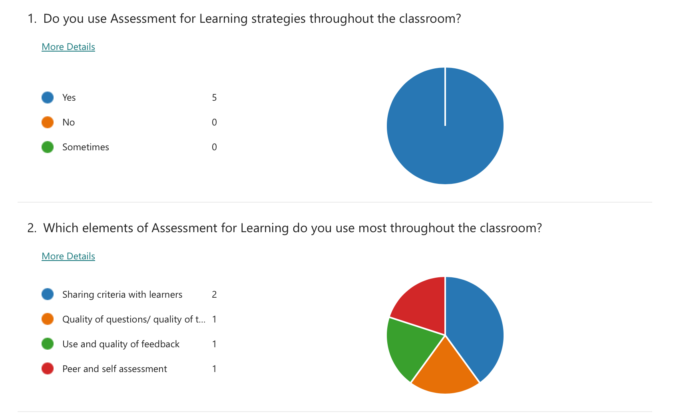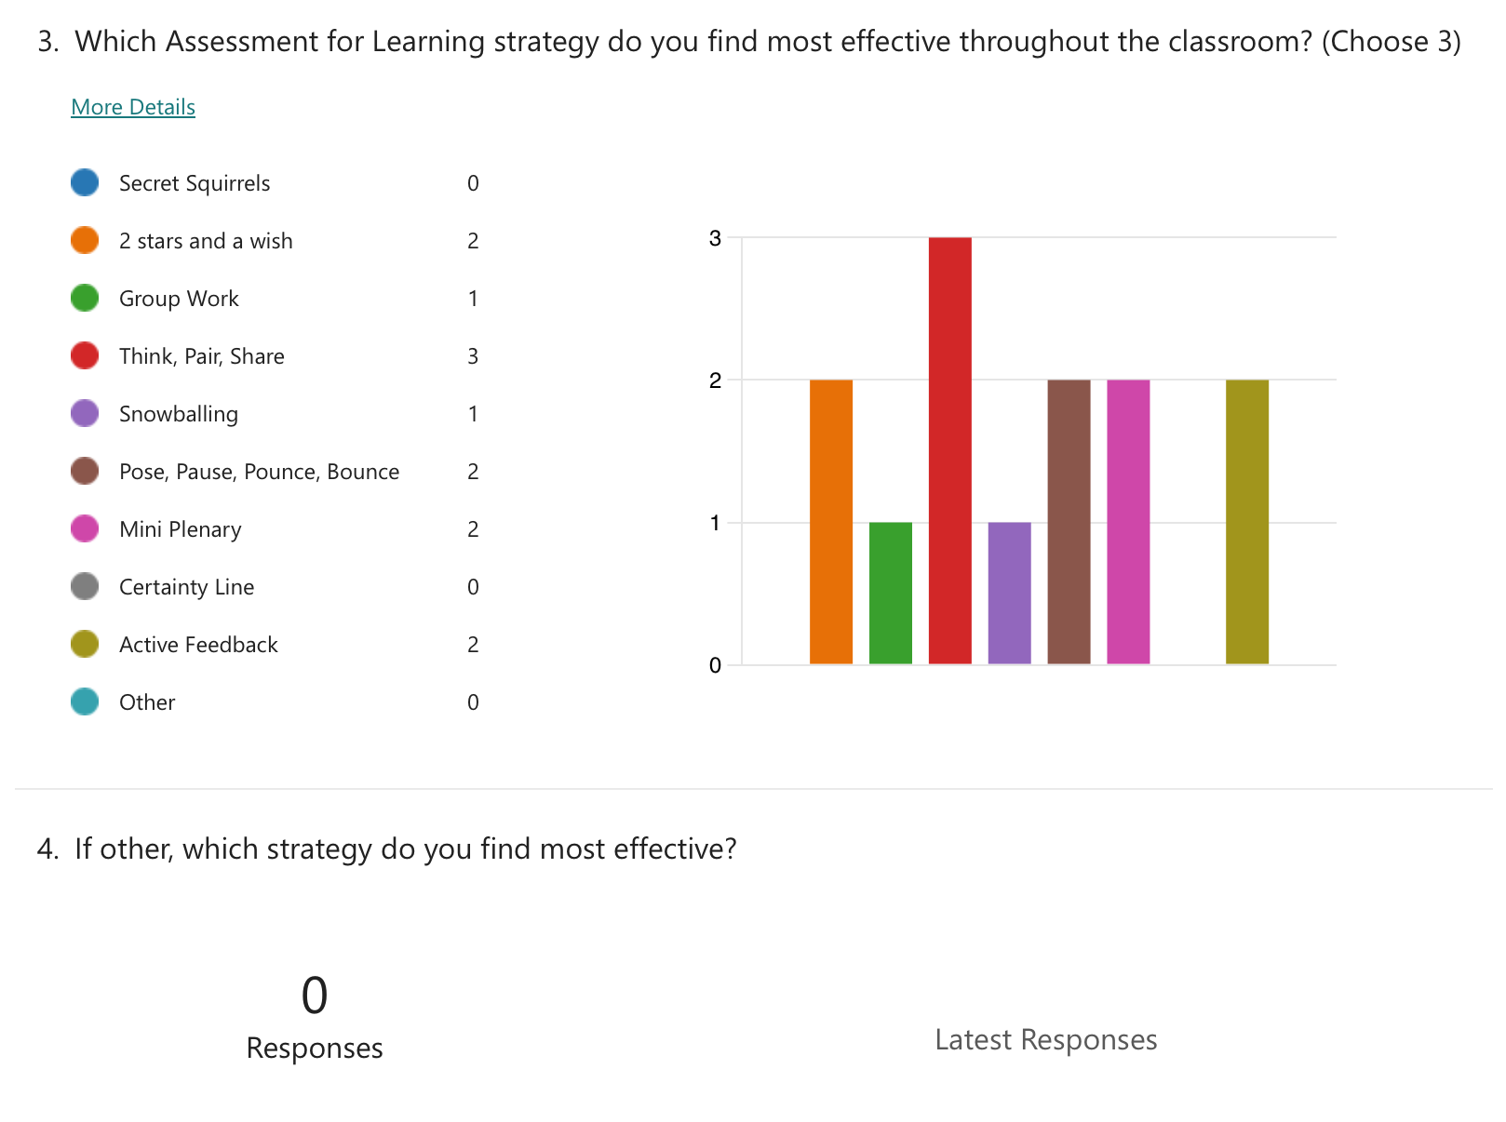

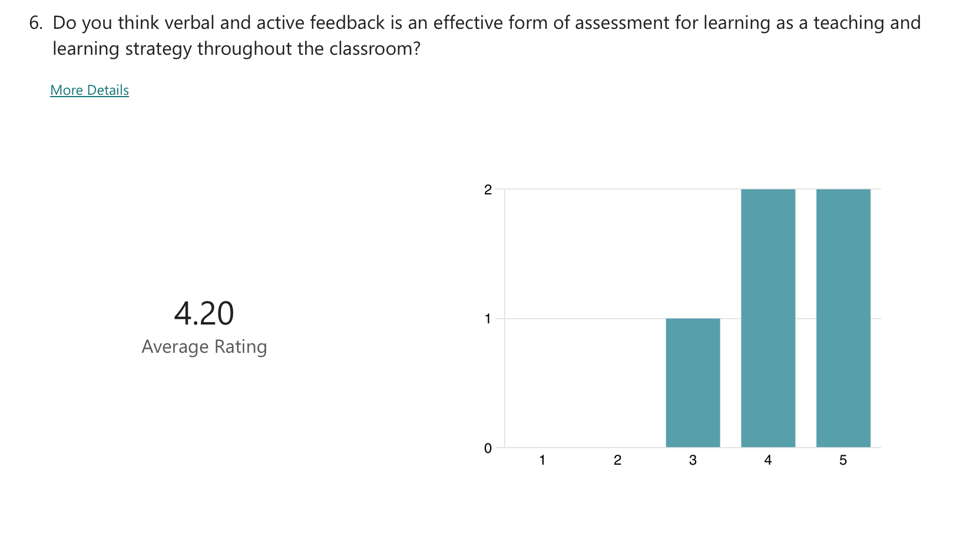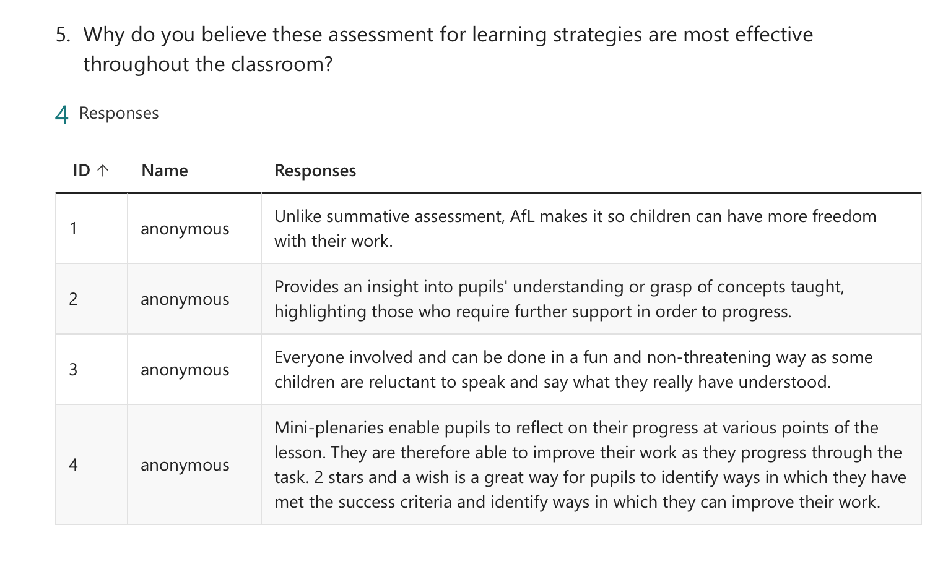

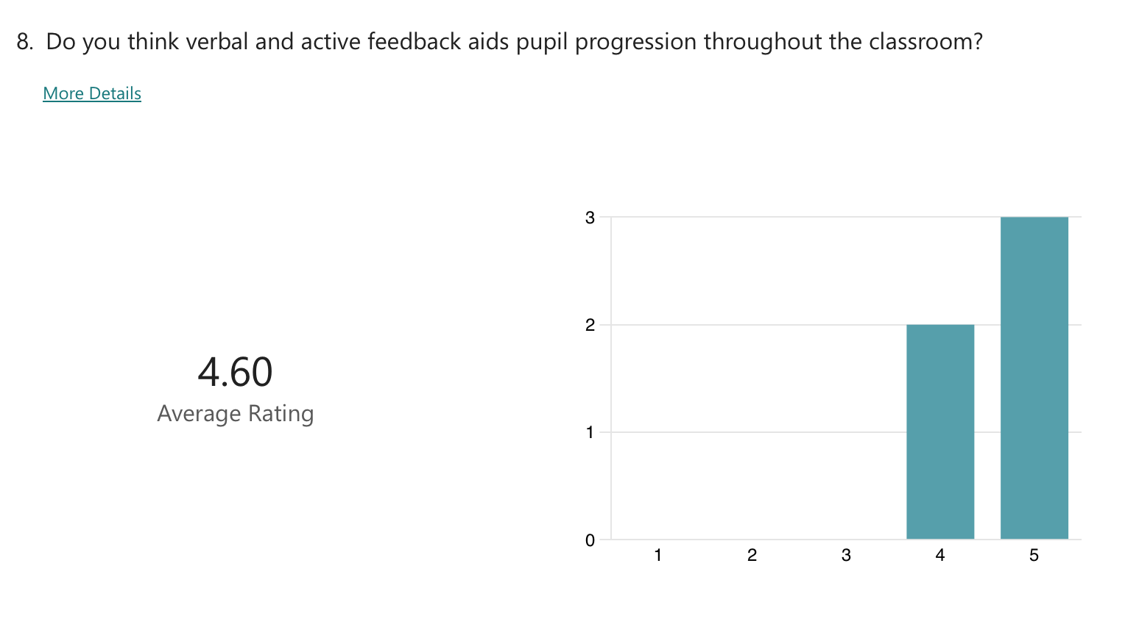

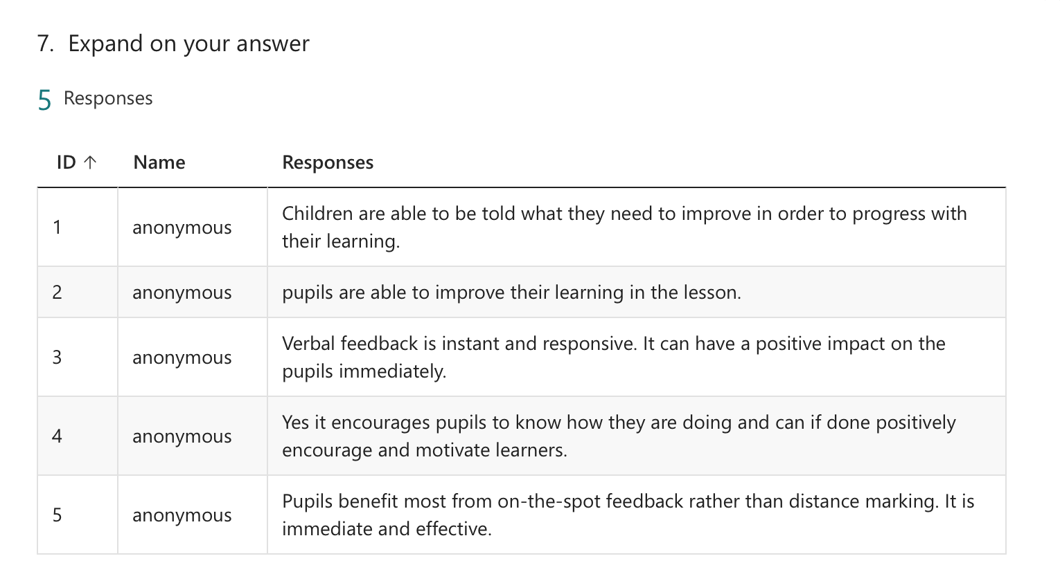

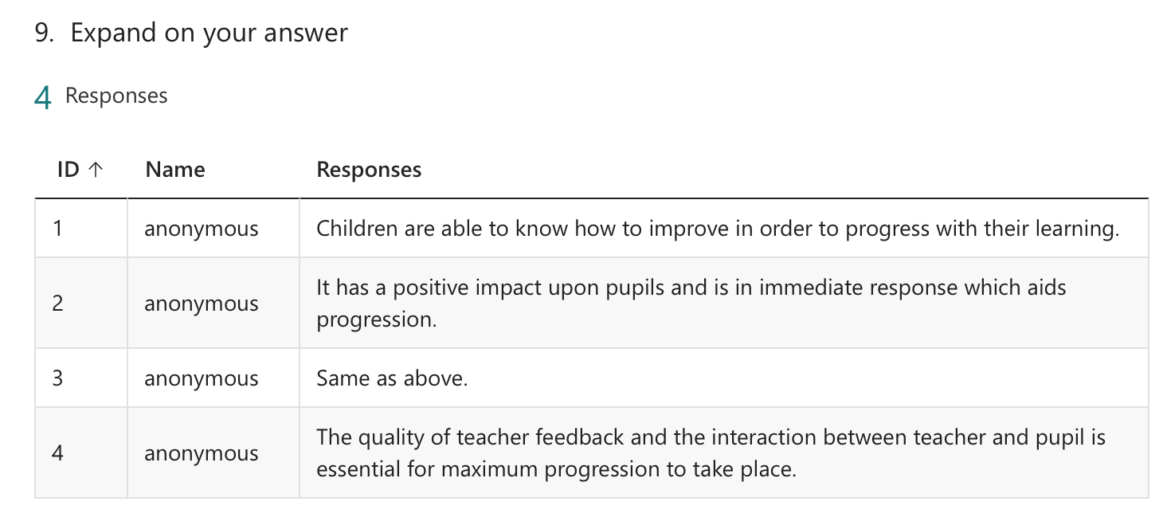
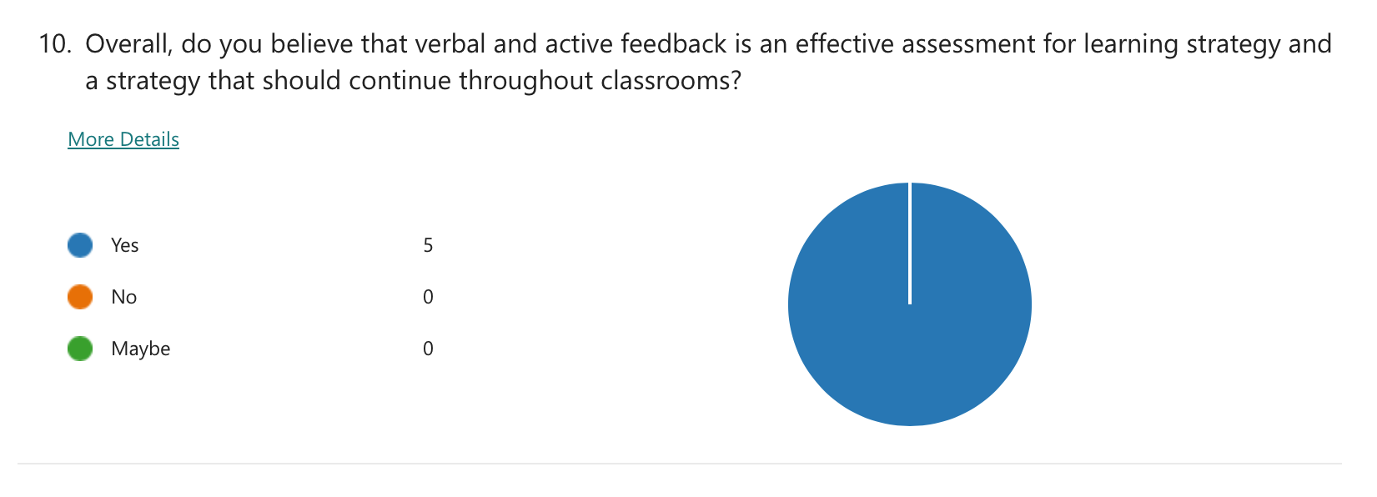

Appendix Four

What are staff and learners’ perceptions of active feedback in the classroom?

Interview Questions for ECAD5010 Research Day
Questions for Pupils.

- Do you know what assessment for learning is?
Tell me about what you know.

- Can you think of any examples where assessment for learning strategies are used in your classroom?

- What is feedback? Tell me about what you might already know.

- How do you feel about your teacher giving you lots of feedback while you complete your work or task?

- How do you feel when your teacher doesn’t give you that feedback?

- Do you use or remember any of the feedback that the teacher gives you that might help you in the future?

