

Practice Quiz

Name: Student ID:

- Choose the correct answer:

- Choose the correct definition of procrastination: (1 mark)

- The action of delaying or postponing something for a later point in time,
- The action completing something with the designated deadline,
- The lack of motivation in completing a task
- When someone is stressed and feels that a task needs to be completed as soon as possible

- Which one of the options below is not a note-taking technique (1 mark)

- Tabular Method
- Mind-Maps
- Linear notes
- The 4D’s

- Choose the correct definition for Tabular Notes: (1 mark)

- The technique used to summarize and compare information,
- The techniques used to find connections between topics mind maps or diagram

- The ____Eisenhower Matrix___________ is a time management tool that stresses the importance of priorities. (2 marks)

- Working memory capacity is the ability to retain information over a period of time. (1 mark)

- False
- True

- Choose the correct in-text citations (1 mark)

- According to Keller and Johnson (1991)
- According to Keller, K. and Johnson, J., (1991)
- According to Katia and John (1991)

- Provide a full reference for the following website: (5 marks)
An online article written by Alice Boyes in 2022 for the Harvard Business Review called How to stop procrastination. This article is available at: https://hbr.org/2022/05/how-to-stop-procrastinating
Boyes, A. (2022) How to stop procrastination. Available at: https://hbr.org/2022/05/how-to-stop-procrastinating (Accessed: 4th March 2025)
- Provide a full reference for the following book: (5 marks)
A book written by Donald Jackson, titled Citing Power, published by RefWorks Publishing House, in Amsterdam, the Netherlands, in 2018
Jackson, D. (2018) Citing Power. Amsterdam: RefWorks Publishing House

- Provide a full reference for the following journal article: (5 marks)
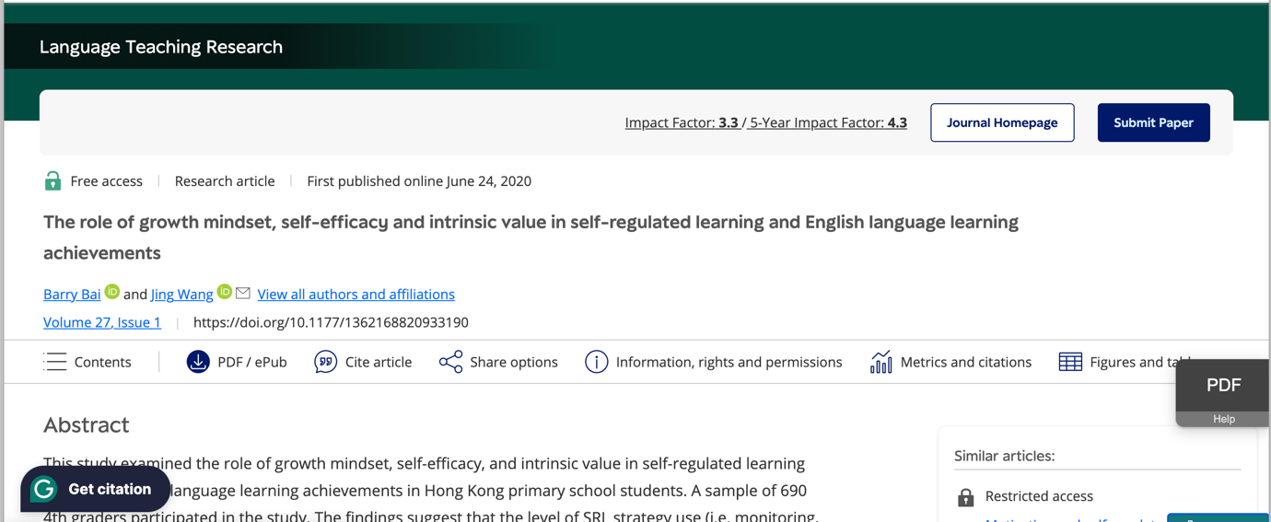
Bai, B., Wang, J. (2020) ‘The role of growth mindset, self-efficacy and intrinsic value in self regulated learning and English language learning achievements’, Language Teaching Research, 27(1), pp. 1-5

- What is wrong with the following in-text citation? (3 marks)

Maria Brown (2016) argues that students should not be allowed to use phones in class due to the distraction they provide.

- Quotation marks missing
- Incorrect name used
- Month missing from the date

Fix the mistake: ______________________________ argues that students should not be allowed to use phones in class due to the distraction they provide.
- ‘et al.’ should be used for: (1 mark)
- Citations with 2 or more authors
- Citations with 3 or more authors
- Citations with 4 or more authors
- References in the reference list with 3 or more authors

- The Diagrammatic Notetaking method is: (1 mark)
- When students write notes in bullet points
- When students compare and contrast information in a table
- When students present information in a diagram

Lucky #13. What would a direct citation of the following line from author Daniel Baker, written in his book Study Skills in 2023, on p. 23 look like in a report? (3 marks)
“Study skills are important for students” (Baker, 2023, p.23)

