The Silent Male Voices of Domestic Violence;
Why are men so often overlooked as victims of Domestic abuse?

Name: Jordan Williams
Student Number: 1816211
Degree Title: Professional Policing Practice
Final Word Count: 7,015

BSc (Hons) Professional Policing Practice

Acknowledgements

First and foremost, I want to give a huge thank you to my amazing tutor Michelle. Thank you for your invaluable knowledge, advice and guidance throughout this dissertation. I will forever be extremely grateful for the help you have given me in the last few months.

Secondly, I want to thank my partner Lee for being my absolute rock through the last 5 years of the university course.
Lee, without you I wouldn’t have been able to finish this degree. Thank you for putting up with my constant moaning, being my shoulder to cry on and for being the best father I could wish for to our daughter, Willow. Thank you for entertaining her straight off a nightshift to allow me to write essays in peace on our days off.

Now lets go and become husband and wife… Hasta La Vista baby!

Declaration

This work has not previously been accepted in substance for any degree and is not being concurrently submitted in candidature for any degree of BA.
Signed: J Williams
Dated: 20/03/2024

STATEMENT 1
This dissertation is being submitted in partial fulfilment of the requirements for the degree of BSc.
Signed: J Williams
Dated: 20/03/2024

STATEMENT 2
This dissertation is the result of my own independent work/investigation, except where otherwise stated.
Other sources are acknowledged by footnotes giving explicit references. A bibliography is appended.
Signed: J Williams
Dated: 20/03/2024

STATEMENT 3
I hereby give consent for my dissertation, if accepted, to be available for photocopying and for interlibrary loan, and for the title and summary to be made available to outside organisations.
Signed: J Williams
Dated: 20/03/2024

STATEMENT 4
I hereby give consent for my dissertation, if accepted, to be available on the university’s IT system to those who have consent to use the system.
Signed: J Williams
Dated: 20/03/2024

Contents Table
Table of Contents
Acknowledgements 2
Declaration 3
Contents Table 4
Abstract 6
Chapter One: Introduction 7
1.1 Introduction 7
1.3 Conclusion 7
Chapter Two: Literature Review 8
2.1 Introduction 8
2.2 Background of Domestic Abuse 8
2.3 Do stereotypes play a part in the lack of reporting of male victims of Domestic Abuse? 10
2.4 Is there enough professional support specifically targeted towards male victims? 12
2.5 Is there are lack of empathy from emergency services? 13
2.6 Conclusion 14
Chapter Three - Research Methodology 15
3.1 Introduction 15
3.2 Ethical Practise 15
3.3 Participant Confidentiality 15
3.4 Research Methods 16
3.6 Sample 17
3.7 Conclusion 17
Chapter Four - Analysis of Results 18
4.1 Introduction 18
4.2 Questionnaire Findings 18
4.2.1 Do you think society’s perception of men, has influenced the lack of reporting of such abuse against male victims? 18
4.2.2 Do you think Domestic Abuse is under reported? 19
4.2.3 Do you think women are capable of being perpetrators of Domestic Abuse? 19
4.2.4 In your opinion, is there enough awareness surrounding male victims of Domestic Abuse? 20
4.2.5 In your opinion, do you believe Domestic Abuse support services are targeted more towards females? 21
4.2.6 Are you aware of any male focused Domestic Abuse support services? 21
4.2.7 Do you believe there is enough support services available for male victims of domestic abuse? 22
4.2.8 In your opinion, is there a lack of empathy from the police and third parties? 23
4.2.9 In your opinion, is there a lack of empathy towards male victims of Domestic Abuse? 23
4.3 Conclusion 24
Chapter 5 – Findings and conclusion 25
5.1 Introduction 25
5.2 Achievement of Objectives 25
5.3 Summary of Findings 26
5.4 Limitations 26
5.5 Conclusion 27
5.6 Recommendations 27
5.6.1 Deliver compulsory Domestic Abuse programmes to Police Officers that focuses on men being equally as likely to be victims as females. 27
7. Bibliography 28
7. Appendices 33
7.1 Appendix One: Questionnaire 33
7.2 Appendix Two: Questionnaire Results 38

Abstract

The predominant academic literature available surrounding domestic abuse in general, focuses mainly on male perpetrated domestic abuse and the female being the stereotypical victim. This is very little research of academic literature on male victims of Domestic Abuse.

The aim of his dissertation is to understand society’s perception on male victims of domestic abuse and the reasons why men are statistically less likely to report being victims of such abuse. It will explore the potential barriers which prevent men from speaking out or seeking help.

Chapter One: Introduction

1.1 Introduction

This dissertation will look at the difficulties which male victims of domestic abuse face. It will investigate the potential influencing factors which contribute to why men are less likely to come forward and report being victims of domestic abuse.

Largely, females are the default and stereotypical victim when reviewing domestic abuse literature. (Josolyn, 2011). There is a huge volume of professional support services and guidance specifically tailored for a female victim target audience, in comparison to male victims.

The purpose of this research is to determine whether male victims of domestic abuse feel they are treated the same as female victims and if they feel they are treated equally by police in comparison to females, and to investigate if there is enough publicity surrounding the topic.

Domestic Violence has a substantial impact on all aspects of policing. During the year of 2019/20 there were 35,687 reported incidents of domestic abuse within South Wales. Only 12,244 of these incidents related to male victims of domestic abuse. (Violence against Women and Girls, N.D) Therefore, it is imperative that front line officers fully understand the broadness and severity of domestic abuse, and most importantly recognising that domestic abuse can happen to any person, regardless of their gender.

1.3 Conclusion

The above chapter sets out the aims and objectives for the purpose of the research project, including a brief background information and highlights why there is a need for further research into this topic. The following chapter is a literature review into existing academic literature relevant to the research topic.

Chapter Two: Literature Review

2.1 Introduction

This chapter will analyse literature based upon male victims of domestic abuse and investigate the potential reasons why men are often over seen as victims of such abuse.

Evidence suggests that whilst identification and reporting of domestic abuse has significantly improved over recent years, it is believed that there are a considerable number of men who are victims of abuse by their female partners but do not report it through official channels due to several contributing factors. (Machado et al, 2017). This dissertation will investigate the potential reasons which may prevent men coming forward to report abuse against them.

To achieve this, this research will have the following objectives:

- To investigate if society and gender stereotypes play a part in the lack of reporting from male victims of Domestic Violence.
- To identify if there is adequate support available, targeted specifically towards male victims of intimate violence.
- Analyse if there is a lack of empathy from emergency services when male victims report such abuse?

It is hoped that by looking into these objectives will help fully understand the extent of the issues whereby domestic abuse is often assumed as a stereotypical female victims and male perpetrator. For the purpose of this dissertation, the term domestic abuse will refer to a male and female, heterosexual relationship. In more recent years, society has become more aware of domestic abuse and the negative effects it can have on an individual. This is supported by frequently changing criminal laws such as the definition of domestic violence changing from intimate partners to including family and extended family members. (Home Office, 2013)

2.2 Background of Domestic Abuse

Despite domestic abuse only becoming a popular topic within recent years, this form of abuse has been around for centuries affecting societies all around the world. It is believed to have been established from the inequalities of men and women historically in society. Historically, men were seen as the more dominant and privileged gender, in comparison to women (Hague and Malos, 1998). According to Benjamin Hine (2020) “much of the early research exploring domestic abuse hypothesize that the abuse stemmed from men’s desire to control and dominate, rooted in historically and socially constructed patriarchal values which emphasise and facilitate male privilege.” Historically, abuse by men to women was viewed as a normal part of marriage, something which women were expected to tolerate within their marriage. (Erez, 2002). During the 1700’s, a law was created which says that it was legal for a man to beat his wife, on the basis that the sick he uses is no thicker than his thumb. (Bridgeman, 2022)

During the early 1900’s, laws were introduced which created abuse between intimate partners a criminal offence. Prior to this, historically male violence against women was viewed as a permissible use of a man’s authority over his wife, also known as ‘wife beating’. (Kennedy, 2011). It was in 1976 when the Domestic Violence and matrimonial proceedings Act was first introduced. This was the first ever legislation dedicated to combating domestic abuse. It gave victims of the abuse new rights by offering them civil protection orders for those most at risk. (Loughborough University, 2018) However, the matter is still commonly under reported with the general assumption is that the abuse is by males to female victims. This is evidenced by the large volume of research that relates to female victims of domestic abuse. The pervasiveness of this has led to the identification of domestic abuse stereotype (Hine, 2019) within literature which justifies abuse against men by females as an act of self-defence (Dutton & Corvo, 2006) In contrary, domestic violence in UK television soap dramas portray female towards male violence as an act of comedy. For example, the scene from Eastenders which showed Kat Slater slapping Alfie Moon across the face following a heated argument. Bystanders and TV audience can be seen and heard laughing at the assault. If this had been portrayed the other way around, it is believed that this scenario would be wholly offensive and unacceptable to its viewers.

As domestic abuse awareness has grown over the years, women have predominantly been seen as the exclusive victim and the male population becoming marginalized, with largely most charities and campaigns are directed towards women. Straus and Gelles (1986) claimed that abuse from females to males was not a concern as it has not ever been raised as a problem publicly. Legislation relating to domestic abuse has grown over the years as society is becoming more aware that the abuse is now more than just a physical act, and that victims require better protection to prevent the abuse from occurring. The definition of abuse has changed many of times however more recently when the Home Office changed the legislation to include 16- and 17-year-olds, and the added in the offence of coercive control. (Home Office, 2013) Currently, the UK government defines domestic abuse as any incident of violence, controlling and or coercive behaviour between any two persons over the age of 16 years old who are either intimate partners or family members. Such abuse covers several different types, such as psychological, physical, sexual, financial, and emotional’ (Home Office, 2013) Nevertheless, despite there being a more comprehensive definition of domestic abuse which covers a range of different types of abuse and relationships, domestic abuse is a daily occurrence within frontline policing. In a recent study, the crime survey for England and Wales estimated 2.4 million adults aged 16 years and over experienced domestic abuse in the year ending March 2022. This statistic consists to a prevalence rate of 1.7 million women and 699,000 men. (ONS, 2022)

According to the research (Broberg, 2022) Mark Brooks, the chair of Mankind Charity said that many opportunities were missed which could have been utilised to help identify male victims of domestic abuse and to understand how to professionally support them when they do come forward. He states that due to the lack of awareness and understanding surrounding male victims of domestic abuse, he believes this is a contributing factor as to why men don’t come forward to report such abuse, adding that men fear that they won’t be believed or taken seriously if they were to find the courage to come forward.

2.3 Do stereotypes play a part in the lack of reporting of male victims of Domestic Abuse?

Historically, males have been viewed as the dominant figure, and as such abuse by men to women was viewed as a normal part of marriage, something which women were expected to tolerate within their marriage. (Erez, 2002). Domestic Abuse is defined in a heterosexual context and is typically hard to identify as the abuse most frequently happens behind closed doors. The social factors surrounding the topic of domestic abuse additionally supports the victimisation of women. “Gender bias have been found to affect people’s perceptions of domestic abuse” (McCarrick, 2016)

There has been lots of awareness surrounding Domestic Abuse over the years which has been documented within popular soap dramas to advocate for violence against women, for example the storyline in Eastenders whereby Chantelle Atkins is murdered by her husband Gray following years of Domestic Abuse. According to Brooks (2020) “broadcasters have tremendous power to influence public perceptions and to raise awareness through their storylines”. In contrast to this, violence against men within the media is intended to be humorous and is often portrayed as a justified response to something the man has done within the context. (Gulas et al, 2014) An example of this is also from Eastenders, in a scene whereby Kat Slater slaps Alfie Moon across the face following a disagreement over Alfie’s spontaneous purchase of the Queen Victoria pub.

Primarily within the available literature, domestic abuse is often described as a physical act of violence, perpetrated by men towards women and which excuses female violence as an act of self-defence. (Dutton & Corvo, 2006) In support of this, recent research has identified that mock jurors are more likely to convict a man in comparison to a woman in domestic abuse murder cases, providing explanations of self-defence and having greater sympathy for women. (Hodelel, Wasarhaley, Rosee Lynch & Goulding, 2014) As a result, men statistically are less likely to report such abuse leaving men often been overlooked, and remain a hidden victim group, despite some researchers and government statistics evidencing their existence for decades. (Cook, 2009)
Arias and Johnson (1989) found in their studies that when men and women were asked to rate violence male to female interactions, they were of the opinion that male-to female aggression is worse than female to male aggression. However, is important to note that this research was conducted some time ago and therefore may be considered an outdated opinion. Furthermore, there is a prominent lack of research surrounding the topic of male victims of domestic abuse and although outdated the information can provide an element of understanding. It could also be argued that due to the significant lack of more recent studies provides justification for the research to be carried out within this topic area.

Tsui (2010) states that regarding societal expectations men are viewed as unacceptable marital violence victims, recognising that such designation could be considered as a social taboo. He states that when men who are physically larger than their abusive partners are hurt, they do not come forward and report the abuse predominantly due to the fear of not being taken seriously or the fear of being made fun of. The most common denominator throughout various studies, suggest that male victims are less likely to come forward and report such abuse against them by their female partners, as they fear that they will not be believed, taken seriously or even fear they may be arrested themselves by being mistaken as the perpetrator. (Douglas et al, 2012). This is further supported by Kaytee Gillis, (2022) who claims that many male victims do not come forward about their abuse due to fears of not being believed, as well as shame and embarrassment.

Domestic abuse does not only apply to physical violence and is in fact much broader than physical violence. Domestic abuse includes harassment, stalking controlling or coercive behaviour, sexual abuse, financial or economic abuse. Elliot (1996) states that domestic abuse is not a gender issue, nor a matter of physical strength and if in fact a matter of power between two persons, ie the male having the ‘power’ within a heterosexual relationship. This opinion is still held and further supported by Jo Aldridge, who states that women are more likely to suffer physical and emotional abuse which results in serious injury or death, adding that domestic abuse against women is rooted in gender inequality with men being seen as the dominant sex (Aldridge, 2020). Kaytee Gillis (2021) claims that female abusers usually operate different to males, partially due to their inability to overpower a male partner who tend to be more physically intimidating, and also due to how females are socialised in our society. As a result of this, states that female abusers usually resort to non-physical forms of abuse on a psychological level, such as revenge seeking behaviours, stalking and emotional abusee. This is coo berated by the findings of Hines et al, (2007) who stated that males accounts of their partners involve threatening to remove children and/or manipulating the systems against them after their relationship has ended.

Further to the above, stereotypes are reaffirmed through the use of the media and TV soap dramas. The media has a significant power and control over how social and cultural norms relating to gender are perceived and how they evolve. (Council of Europe, N.D)
Scenes from BBC’s Eastenders which showed Chantelle Atkins suffering horrific domestic abuse at the hands of her husband, Gray. According to Flaherty (2020) writing for the Echo newspaper; said this scene has left viewers feeling sick calling the domestic abuse storyline a ‘very hard one to stomach’.

Whereas in contrary to the above, soap dramas can often reverse sexism where they portray acts of violence against men by women, as an act of comedy and for entertainment purposes; also known as ‘The female slap’. (Bansal, 2020). According to Beddows (2019) deceptions of violence are often sensationalised or ‘sexed up’ for the sake of entertainment and such simplistic portrayals replicate the myths of gender stereotypes and domestic abuse. A poignant example of this which is also taken from the soap drama Eastenders, is Kat Slater assaulting Alfie Moon. The assault comes after he informed Kat that he had bought The Queen Victoria pub. Bystanders can be seen laughing in the background at the assault on Alfie, which was so violent made him fall to the ground. Bansal (2020) agrees that gender stereotypes are reaffirmed through the use of the media and how the media portrays domestic abuse.

2.4 Is there enough professional support specifically targeted towards male victims?

From reviewing the available resources and documentation available that discusses the topic of male victims of domestic abuse, there is not a great deal of information available. Articles and charities online are largely targeted towards females (Barber, 2023) which could be argued imposes that only females can be victims of domestic abuse however this is far from the truth. It is evident that research around male victims is underreported as men make up 50% of the population (Gov.UK, 2023) it is evident that this topic requires exploration to discover why men underreport and do not seek support from services.

From conducting initial research, there were two main charities that stand out, which are clearly targeted to male victims of domestic abuse. The ratio of the two is significantly less to the volume of domestic abuse charities targeted to women, such as Women’s Aid, Hafan, Calvan DVS, The Salvation Army, Thrive etc. These two male focused charities were Mankind Initiative and Dads Unlimited. Mark Brooks is the chairman and founder of ManKind initiative which is a charity for male victims of domestic violence which was set up nearly 20 years ago. His charity receives calls from men who, on average have been in an abusive relationship for at least three years before reaching out for assistance. He states that over half the men who call our helpline said that they would not have called if the helpline was not anonymous, adding that when men do call out for help at his charity, they tend to be looking for validation or for someone to confirm that they really are victims. (Mankind, 2016)

On 25th September 2017, Dads Unlimited registered as a charitable incorporated organisation by the co-founder Naz. The original purpose of the charity was to bring dads together to discuss their struggles who were going through family breakdown and suffering poor mental health. By 2021, the founder had identified that there was a huge gap in professional services, that support male victims of domestic abuse. As a result, a new service called DAVE (Domestic Abuse Victim Empowerment for Men) was launched to support men in Kent and this service is open to all males, with or without children despite the original name. By 2023, this service expanded to support men across the whole of England and Wales due to the success of their initial set up in Kent. Dads Unlimited (N.D) states that the charity provides support in three areas being supporting male victims of domestic abuse, supporting men going through family separation and men’s mental health.

According to mankind.org (2020) there are 39 domestic abuse organisations with a total of 238 spaces. Only 58 of these spaces are specifically dedicated to men. This figure is equivalent to just 25% of all spaces available. These findings in particular support the argument of male victims of domestic abuse are disadvantaged because the support predominantly available target female victims only, leaving male feeling secluded and under supported. This further supports that there is a desperate need to increase the number of support services which specifically cater for males, to ensure they feel that they are treated equally to women and to reduce the stigma of female on male abuse.

2.5 Is there are lack of empathy from emergency services?

Drijber et al (2012) states “that the most important reason that men do not report abuse is the belief the police would not take any action.” It was noted within this study, that the men who contributed had reported their own experiences of domestic abuse to the police and claim that their reports were not taken seriously. A study conducted by Stets and Straus (1992) found that females were more than 10 times likely to make reported to the police following a domestic incident in comparison to men.

Consequently, in line with the College of Policing’s procedures, it is reinforced into police officers to ensure they take positive action. Meaning, that males are likely to be arrested first, and the female is more likely to contact the police in the first instance. This could play a part of the assumption by male victims, where they feel they would not be believed by police if they were to disclosure, they were a victim of domestic violence, as they are arrested straight away when the female contacts the police.

This is corroborated with McCarrick’s (2016) discovery that males are routinely arrested for allegations made by female victims, and when they disclose that they are a victim of some form of abuse by their female partner during interview, this is largely ignored by police. From McCarrick’s interviews with male victims of domestic abuse, it was noted that even when male victims were to contact the police to report such violence, they are somehow subsequently the one spending the night in a cell despite making the initial contact to police.

The polices response to Domestic Violence has been largely criticised over the years despite the improvements made along the ways since domestic violence was officially deemed a criminal offence. In a report by the HMIC in 2014, headlined as Improving the police response to domestic abuse’ (HMIC, 2014). Within this report, it is documented that improvements were needed to improve the response to domestic violence. Subsequently, a training package implemented by the College of Policing and domestic abuse charity, SafeLives with the intention to improve the police attitude and response to the abuse and gaining a better understanding of the matter as a whole. (SafeLives, 2015)

2.6 Conclusion

It is clear from the research, that domestic violence has been gender stereotyped and perceived as a biased crime, giving complete disregard seeing the males as victims. This is very much shown in the statistics available and ratio of female victim-based support services compared to male victim-based support services. The consequences of this leaves male victims silent about their partners violence and as a result, suffering from poor mental health.

Society’s perception and gender stereotypes are still having an impact on the unlikelihood of men reporting they are victims of violence from their female partners. This is preventing men speaking up in the fear they will not be believed, or be told to ‘man up’ as they are stereotypically seen as more masculine to females and therefor physically stronger.

Overall, the available research clearly suggests that males feel they have a lack of help support services available to them due to the fact there is bare minimum professional support services specifically catered to them.

Chapter Three - Research Methodology

3.1 Introduction

This chapter will provide an overview of the research methods that the researcher will undertake within this dissertation. It will start with outlining the ethical commitment of the dissertation followed by an in-depth explanation of the methods utilised and justification for them. According to (DiscoverPhD’s, 2020) the purpose of research is to advance knowledge through the development of collecting data, analysing results, and forming conclusions. There is currently a lack of information available that explores into the studies of why male victims of domestic abuse are often overlooked by police forces. To develop further knowledge and information surrounding male victims of domestic abuse, the researcher will collect primary data for the purpose of this dissertation. Primary research is described by Bryman (2016) as information personally collected by an individual and gathered for an individual or specific purpose or intention. It is hoped that by conducting the research in this way, will align with the research objectives. It is imperative that the data gathered is reliable and further develop the knowledge and understanding as to why men are often overlooked as victims of domestic abuse.

3.2 Ethical Practise

Prior to the commencement of the dissertation, it is imperative that an ethical approval is permitted. Any research involving humans required ethical approval by the University. Ethical research is honest, transparent, respectful and protects participants. (UWE Bristol, N.D) To ensure that the proposed methods to be used within this research complied with ethical standards, an ethics form was submitted to the university’s ethical team. Within this form, the aims of the dissertation are outlined in addition to a proposal the intended data collection which was by means of questionnaire. As this study is based on a topic of sensitive nature, the ethics form documented that the researcher had considered the potential risk of harm that may be brought on to the participants due to the sensitive nature of the research. Due to this, it was agreed that the research will not include the personal details of victims of domestic violence as by doing so could breach GDPR regulations. The participation will be done on a completely voluntary basis. All participants will be fully informed of the nature of the study and will have the right to withdraw at any time. All information that is submitted will be completely anonymous. At the end of the research, all participants will be sign posted to a range of domestic abuse support networks.

3.3 Participant Confidentiality

“Protecting the privacy of participants would require adhering to ethical rules such as maintaining confidentiality and anonymity when collecting, analysing and reporting data.” (Kang, 2023) Due to the nature of this research, every effort has been made to ensure the research does not include the personal details of victims of domestic abuse as such it is upon the researcher to uphold this principle of protecting the privacy of the individual (Cohen, 2017) Participation is entirely voluntary, and participants will be informed of their right to withdrawal from the research at any time. Confidentially and anonymity are research ethical principles which help in providing informed consent to participants assuring them of the privacy of their data. (Kang, 2023) To ensure that all participants information and responses were stored with complete confidentiality, the responses were stored on a password protective device and the google forms questionnaire was additionally security protected by two factor authentication security settings. The participants were informed how the data would be stored and eventually destroyed at the end of the project. Participants were also informed of their right to exit the research at any point and were also sign posted to Domestic Abuse charities at the end of the research, if they felt affected by participating in the questionnaire.

3.4 Research Methods
The researcher will conduct mixed research approach to collect data from participants, and then display the results into a graph for clear and concise summary of the results. Such approach is the combination of both quantitative and qualitative methods which can produce stronger evidence in your research findings (GOV.UK, 2020) The proposed method in which to undertake the research, is by means of a questionnaire on Google Forms. This approach has been decided as the most appropriate, due to the sensitive nature of the research topic. The questionnaire will be anonymous, to ensure that no personal details are obtained by potential victims of domestic abuse. This method is an effective tool in obtaining research data, due to the research topic and the researcher not anticipating a high figure of participants. Data collection by questionnaire, is the most cost effective and gives the participants anonymity due the research subject. Having an anonymous survey will further benefit the research data collection, as anonymous survey methods promote greater disclosure of sensitive information compared to non-anonymous methods. (Murdoch et al; 2014) Having an anonymous questionnaire, ensures that participants can provide honest and unbiased answers without fear or repercussions of judgement. Therefor the data obtained by method of questionnaire, contributes to the accumulation of knowledge, inform evidence-based decision making and further support the development of effective policies and intervention (Lindemann, 2023) However it is important to mention that although a mixed methods approach has its benefits, it also comes with some disadvantages such as the combination of different methods could require extra time and money, and additionally the interpretation of the results may require more expertise in comparison to using a single research method. (GOV.UK, 2020) The researcher considered other research methods such as a single qualitative method by means of interviewing. Interviews can be conducted over the phone or face to face are affective when the goal is to obtain feedback which is sensitive. Interviews allow the participant and interviewer to have a meaningful discussion, allows the interviewer to gain the participants full attention, to allow discussion of specific objectives and sustain more control over the quality of data received (Marshall, 2016) However it was decided against this method, as this method would be far more time consuming when conducting research within limited timescales. In addition to this, as the research topic is of sensitive nature, it was agreed that participants were less likely to want to come forward and talk about their personal experiences and opinions and may want to hide their identify.

3.6 Sample

Sampling is the selection of a subset of the population of interest in a research study. When carrying out such research, the participation of mass population is not possible, therefor a smaller group also known as a ‘sample’ is relied upon for its data collection (Turner, 2020) To draw valid conclusions from the research method, a probability sampling will be utilised which involves the random selection of participants, which enables the research to make strong statistical inferences and also minimises the risk of selection bias. (McCombes, 2022) In order for the questionnaire to reach its target audience, the questionnaire was disseminated on the researcher’s social media platform Facebook and shared via text message to the researcher’s family and friends. The researcher decided that Facebook would be beneficial in the distribution of the questionnaire, as it has the ability to promote a hyper link which will direct participants directly to the questionnaire meaning it is highly accessible for a wide variety of people, who can participate in the research at the comfort of their own home (Schneider, 2019) The researcher started by sending the hyperlink to the questionnaire to family and friends who consist of predominantly persons employed as police officers and the general public. The researcher requested them to forward onto other individuals not directly known to the researcher. Despite the questionnaire being sent to individuals know directly to the researcher, the research was forwarded on to individuals not known to the researcher and therefor was unable to differentiate who completed each questionnaire and when which minimises the risk of selection bias. The questionnaire was available for period of approximately one month between July 2023 – August 2023, allowing sufficient time to accumulate as many participants as possible. The questionnaire received a total of 54 responses.

3.7 Conclusion

This chapter has discussed the methods used within this research project namely a mixed method approach. The next chapter will review the responses received from the questionnaire and analyse the statistics.

Chapter Four - Analysis of Results

4.1 Introduction

This next chapter will present the results obtained within the survey conducted, explain why each question was answered and to examine the results. Overall, there were 55 respondents to the survey.

4.2 Questionnaire Findings

4.2.1 Do you think society’s perception of men, has influenced the lack of reporting of such abuse against male victims?

This question was asked to ascertain why male victims are statistically less likely to come forward and report being victims of domestic abuse. The participants were asked if they believed that society plays a part in the lack of reporting. As expected, 98.2% of the participants said they agreed which supports the arguments put forward by Tsui (2010).

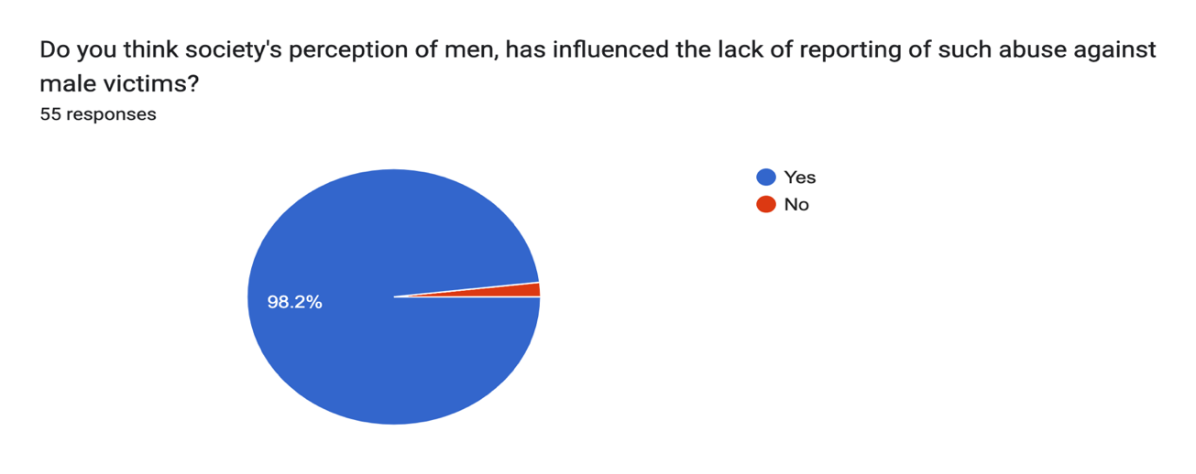

4.2.2 Do you think Domestic Abuse is under reported?

This question was put forward to the participants to gather their opinions on whether they believed that domestic abuse is generally under reported or not. When respondents were asked if they believed domestic abuse is under reported, 80% of respondents answered ‘yes’, 7.3% of respondents answered ‘No’, with 12.7% of respondents answering ‘maybe’. These figures show that the public believe there to be a large percentage of male victims of domestic abuse that are not coming forward to report it. This reflects the findings within the literature review by Cook (2009)

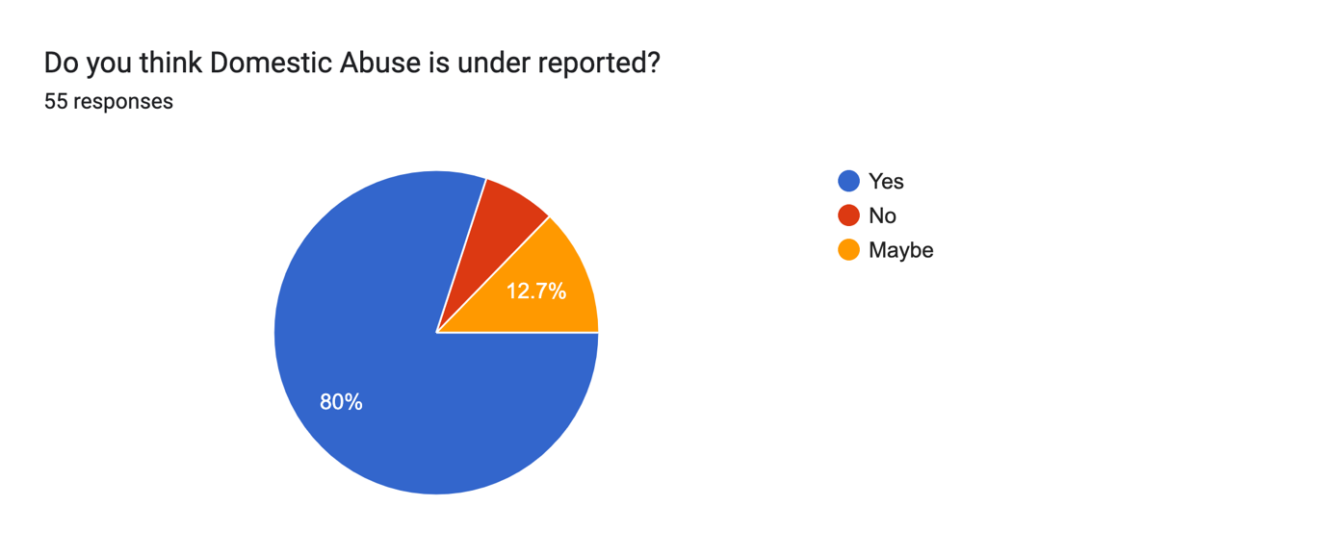

4.2.3 Do you think women are capable of being perpetrators of Domestic Abuse?

This question was asked to ascertain the publics opinion on whether they believed women were able to be perpetrators of Domestic Abuse. 100% of respondents believe that women are capable of being the perpetrators of Domestic Abuse. This clearly represents there is still a significant stigma in current society regarding domestic abuse. If 100% of respondents to the survey, believe that women are in fact capable of being perpetrators of domestic abuse, then it asks the question as to why is there significantly less reporting from male victims.

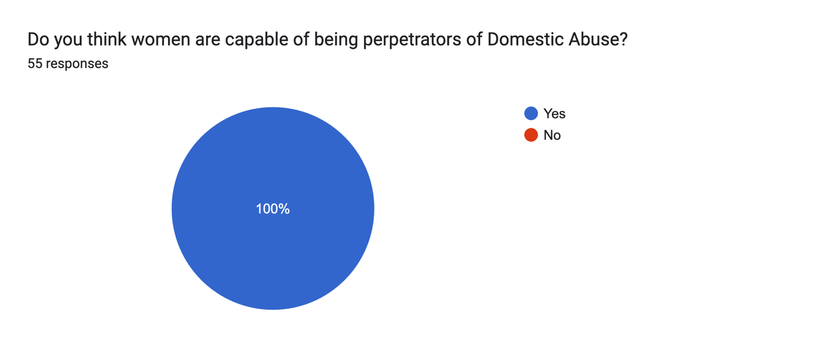

4.2.4 In your opinion, is there enough awareness surrounding male victims of Domestic Abuse?

The participants were asked if they believed there is enough awareness surrounding male victims of domestic abuse, a staggering 98.1% of respondents said ‘No’. With just 1 person 1.9% saying ‘Yes’. These figures reflect the findings in the Literature review by Dads Unlimited (N.D) who noted in 2017 there was a huge gap in professional services that support male victims of domestic abuse. It also supports the findings by Mankind (2020) who state that out of 238 recognised safe spaces from domestic abuse organisations, only 58 of them were dedicated to men. This could be due to stereotyping as discussed by McCarrick 92016) and Tsui (2010).

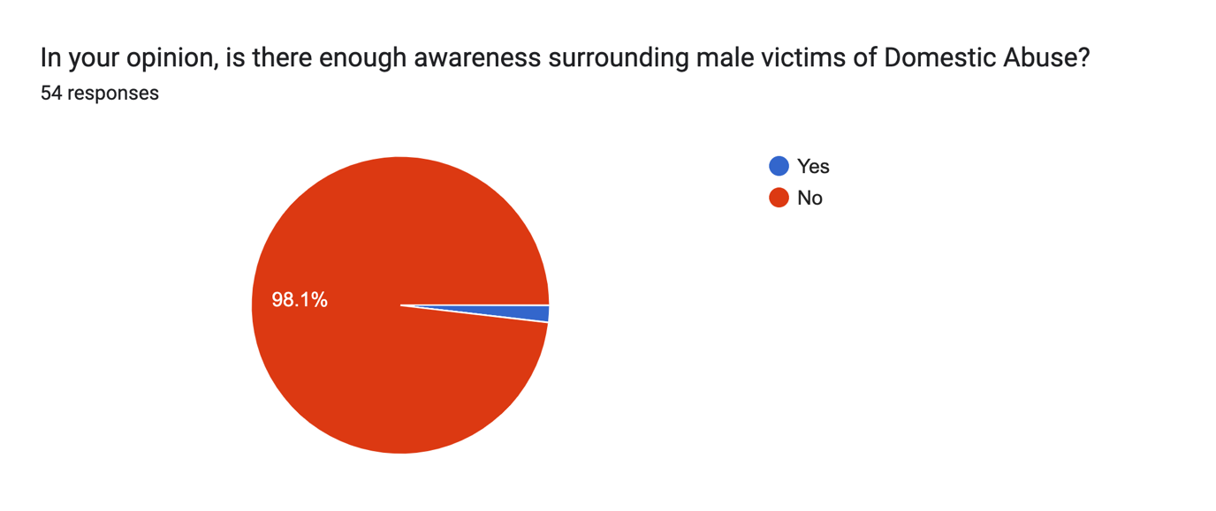

4.2.5 In your opinion, do you believe Domestic Abuse support services are targeted more towards females?

When respondents were asked if they believed domestic abuse support services were more targeted towards females, 90.7% of respondents said ‘Yes’ with 9.3% stating ‘No’. This is similar to the findings by Mankind (2020) highlighted in the literature review.

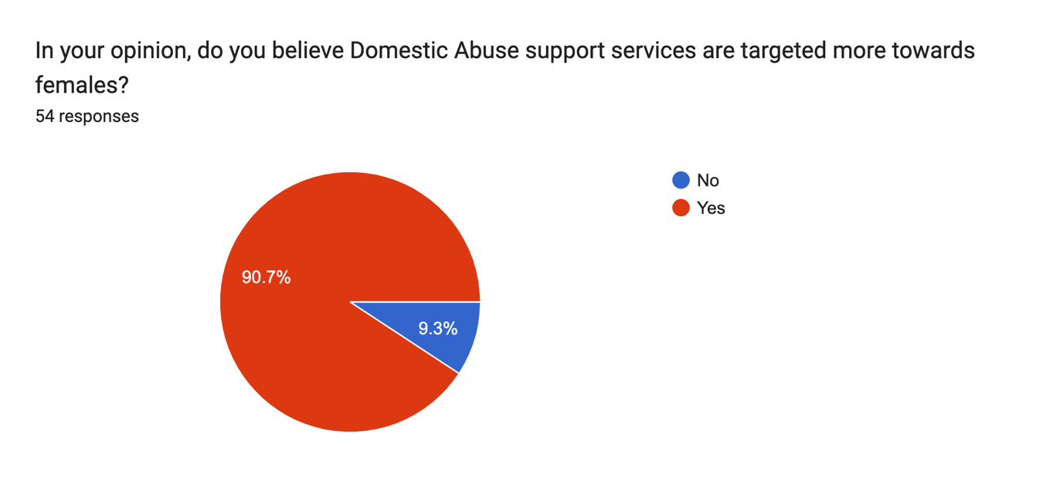

4.2.6 Are you aware of any male focused Domestic Abuse support services?

Participants were asked if they were aware of any male focused domestic abuse support services to establish what services if any, were openly known to the public. 75.9% of respondents said ‘No’, with just 24.1% saying ‘Yes’.

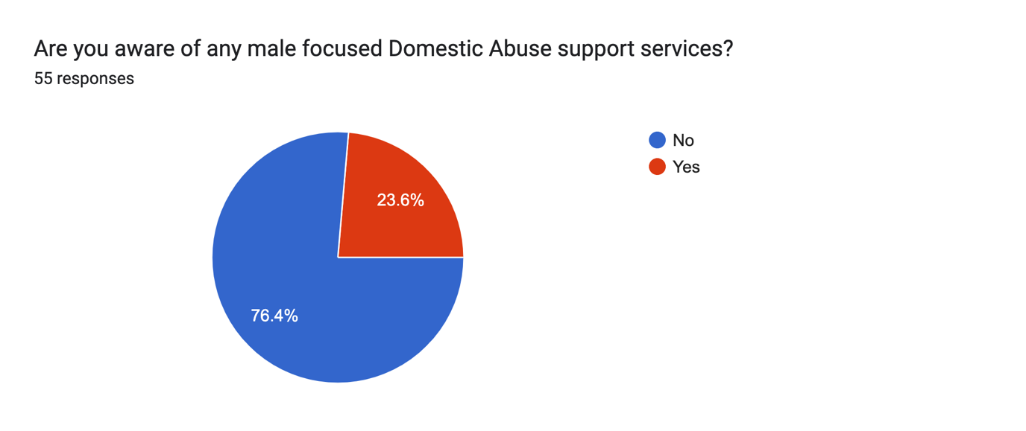

4.2.7 Do you believe there is enough support services available for male victims of domestic abuse?

When participants were asked if they believed there is enough support services available for male victims of domestic abuse, 94.2% responded ‘No’, with 5.8% saying ‘Yes’. This reinforces the findings within the literature review Dads Unlimited (N.D) and ManKind (2020). By reviewing these figures, it is evident that the public believe there is still a significant gap in the help readily available for male victims of domestic abuse. Given how little support there is catered towards male victims, this reinforces societies views and stereotypes, believing that males cannot be victims of such abuse.

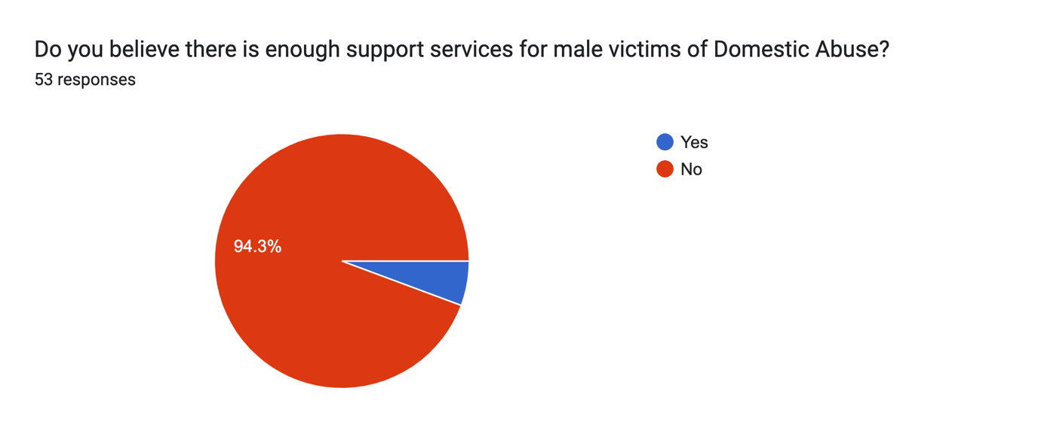

4.2.8 In your opinion, is there a lack of empathy from the police and third parties?

When analysing the data, 62.4% of respondent said ‘Yes’ to whether they believed there is a lack of empathy from the police and third parties towards male victims. 35.8% said ‘No’.

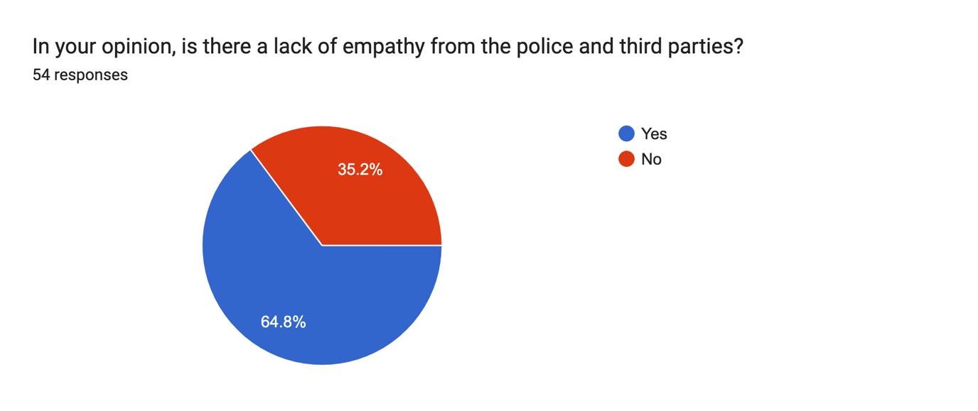

4.2.9 In your opinion, is there a lack of empathy towards male victims of Domestic Abuse?

This question was asked to the participants to gather their opinion on whether they believed there is a general lack of empathy towards male victims of Domestic Abuse. 77.8% responded ‘Yes’ with 22.2% responding ‘No’. This could be due to the findings by Beddows 2019) who states that violence within the media is portrayed as an act of comedy and could have a knock-on effect, leaving men less likely to report such abuse due to the fear of not being taken seriously, as founded by Tusi (2010) and Gillis (2022).

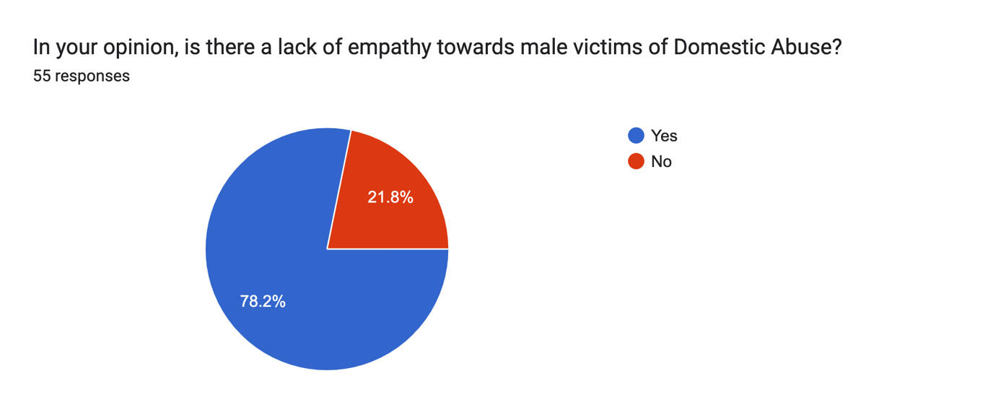

4.3 Conclusion

In conclusion, the research clearly identifies that societies stereotypes of men and the stigmas surrounding male victim domestic abuse are still affecting the willingness of males to come forward and report Domestic Abuse. There is a significant gap in professional services which cater specifically for Male victims, in comparison to female-based organisations which has led the public to believe males are being left out and let down on this basis. This study has supported the findings within the literature review. It is hoped that by researching into a largely under discussed subject, will raise more awareness and additionally change the way in how domestic abuse is perceived as a female only subject.

Chapter 5 – Findings and conclusion

5.1 Introduction

This chapter will discuss the results obtained in order to evaluate and reflect on the success of the research undertaken within the research, including a discussion session focused on self-reflection. From reviewing the data obtained, there is a consistent theme that correlates to the findings reported in this project literature review. This chapter will specifically detail these tendencies and provide recommendations to help raise more awareness, reduce stigmas and improve the support systems available to make victims of intimate partner violence. This chapter will document a conclusion with regards to male victims of such violence when reporting to the appropriate channels, in addition to highlighting the limitations of this specific study.

5.2 Achievement of Objectives

The research objectives were to look at the possibilities to why males are more likely to not report domestic abuse. The study has completed the set objectives

- To investigate if society and gender stereotypes play a part in the lack of reporting from male victims of domestic abuse.

This objective was achieved in Chapter One by analysis of existing literature relating to stereotypes of male and females.

- To identify if there is adequate support available, targeted specifically towards male victims of domestic abuse.

This objective was met in Chapter Four following analysis of responses to the research questionnaire.

- To analyse if there is a lack of empathy from emergency services when male victims report such abuse.

Objective three was achieved in Chapter Four having analysed the responses to the questionnaire and identifying which responses were given from police officers and non-employed police officers.

5.3 Summary of Findings

This dissertation demonstrates that male victims are treated differently compared to female victims of domestic abuse. This is due to the primary research supporting the secondary research within the literature review. When comparing the data, it is evident that we are still facing stigmas in today’s society that make reporting such abuse more difficult for men and for them to seek professional help. 55 persons in total completed in the survey, 28 of which were employed police officers. All 55 participants which equates to 100% of respondents believe that females are capable of being perpetrators of domestic abuse and 54 persons equating to 98% of respondents believe that society’s perception of men, has influenced the lack of reporting domestic abuse against males. In addition to the above, 35 people which equates to 64.8% believe that there is a lack of empathy from the police when they attended domestic relates calls, whereby the male is identified as the victim. The research found that 27 of the participants that contributed to this response were employed police officers. This shows that there is still unconscious bias surrounding the stereotypical victim of domestic abuse and could be argued as supporting evidence that society’s perception of men is in fact preventing men from coming forward and reporting such abuse, as the results document even employed police officers have identified that they believe they have lack of empathy for men when they are identified as a victim. When the respondents were asked if they believed there is enough awareness surrounding males being victims of domestic abuse, 54 persons (98.2%) said that they did not believe there was enough awareness for male victims. Furthermore, the results within the survey documents that the public do not believe that there is sufficient professional support available which is specifically targeted to male victims of domestic abuse, in comparison to female targeted charities such as Women’s Aid. 50 participants (94.3%) said there is not enough support available to male victims, in comparison to 3 persons who said they believed that there is. When victims form the impression that there is no support available to them, they are less likely to report domestic abuse due to the fear of not being believed or not receiving the help and support they require. (Migliaccio, 2001)

5.4 Limitations

Given the broad nature of the dissertation topic, the researcher was subject to limitations which are outside of the researcher’s control. The study itself is limited to 6,500 words. The researcher has limited their research to domestic abuse within heterosexual couples or alternatively intimate relationships involving male and female partners. If the researcher was not limited to a word count, the research topic could have looked further into domestic abuse of those who are in same sex relationships. Furthermore, due to the ethical considerations which are outlined in the ethical consent, male victims have not been solely included within this study, pertinent to the subject objective being that male victims are unlikely to come forward and identify themselves as a victim of domestic abuse. Therefor the researcher disseminated the questionnaire to family and friends, who disseminated further to wider members of the public who were not known directly to the researcher. All of the above limitations may have an impact on the research results, and it is imperative to acknowledge them. The data obtained by the research survey has been a success for the research topic and is beneficial to see for statistics purpose. It provides further clarification surrounding the research aims and objectives as to why male victims may be reluctant to report domestic abuse to police.

5.5 Conclusion

To conclude, it is palpable from reviewing the existing literature and questionnaire findings that society and gender stereotypes are still having a negative impact on preventing male victims of domestic abuse coming forward. Within more recent years, today’s society has never been more inclusive. Within a shift in the acceptance of same sex couples, people who identified as transgender or as part of the wider LGBT+ communities, in addition to equal rights for females and those from minority and diverse communities. It is wondered why that male victims of domestic abuse are not equally accepted in today’s society.

The researcher has ensured that the dissertation project has come from an unbiased stance and investigated the issues which men face when they want to come forward and report such abuse. There are notable gaps in the literature available which investigate specifically into male victims of Domestic Abuse. Some references are 10+ years old. This provides more justification for the need to conduct the research subject. It is hoped by the researcher that this dissertation will raise awareness to the existing issues, in addition to further resources to be established to assist and support men who are victims of domestic abuse to ensure that no one suffers in silence.

5.6 Recommendations

5.6.1 Deliver compulsory Domestic Abuse programmes to Police Officers that focuses on men being equally as likely to be victims as females.

Domestic Abuse training should be reviewed and adjusted to equally view men being possible victims of domestic abuse alongside women. This will equip officers with the current knowledge and understanding that men are also able to be victims of domestic abuse and should be taken into consideration when responding to domestic related incidents. It is suggested that an input is provided from charities that specifically support male victims of domestic abuse when delivering domestic abuse training, to give an insight into how abuse from female to male may look different to male against female abuse and ensuring that consideration is given equally to both genders at all times.

7. Bibliography

About Dads Unlimited (2022) Dads Unlimited. Available at: https://www.dadsunltd.org.uk/about/ (Accessed: May 6, 2023).
Aldridge, J. (2020) “not an either/or situation”: The minimization of ... - sage journals. Available at: https://journals.sagepub.com/doi/full/10.1177/1077801220927079 (Accessed: 16 January 2024).
Arias, I., & Johnson, P. (1989). Evaluations of physical aggression among intimate dyads. Journal of Interpersonal Violence, 4(3), 298–307.
Bansal, S. (2020) The female slap - it’s not okay, LinkedIn. Available at: https://www.linkedin.com/pulse/female-slap-its-okay-sumit-bansal (Accessed: 08 January 2024).

Barber, C. (2023) ‘Providing the right support and care for male victims of domestic abuse’, British Journal of Nursing, 32(1), pp. 20–28. doi:10.12968/bjon.2023.32.1.20.
Barkhuizen, M. (2015). ‘Police reaction to male victims of domestic violence in South Africa’: Case study analysis. Police practice and research, 16 (4), pp. 291-302.

Bates, E., (2017). ‘Hidden victims’: men and their experience of domestic violence.

Beddows, A. (2019) Representation matters - women and violence on screen, Rape Crisis South London. Available at: https://www.rasasc.org.uk/representation-matters-women-and-violence-on-screen/ (Accessed: 08 January 2024).
Bridgeman (2022) Domestic abuse and the ‘rule of thumb’, Who Do You Think You Are Magazine. Available at: https://www.whodoyouthinkyouaremagazine.com/feature/the-rule-of-thumb (Accessed: 16 January 2024).
Broberg, R. (2022). Why are men often overlooked as victims of domestic abuse? [online] The Centre for Social Justice. Available at: https://www.centreforsocialjustice.org.uk/newsroom/why-are-men-often-overlooked-as-victims-of-domestic-abuse [Accessed 1 Feb. 2023].
Brooks, C. (2020) The important role of ‘the soaps’ in safeguarding adults and young people, Ann Craft Trust. Available at: https://www.anncrafttrust.org/the-important-role-of-the-soaps-in-safeguarding-adults-and-young-people/#:~:text=Broadcasters%20have%20tremendous%20power%20to,of%20safeguarding%20through%20their%20storylines. (Accessed: 11 March 2024).

Buttell, F. and Carney, M.M., (2014). Women who perpetrate relationship violence: Moving beyond political correctness. Routledge.

Cook P. W. (2009). Abused men: The hidden side of domestic violence. Praeger Publishers.
Dobash, R. E., & Dobash, R. P. (1979). Violence against wives: A case against the patriarchy.
Douglas, E, Hines, D. and McCarthy, S., (2012). Men who sustain Female-to-Male Partner Violence Associated With Where They Seek Help and How They Rate Those Resources. Violence and Victims, 27(6), pp.871-894.

Dutton D. G., Corvo K. (2006). Transforming a flawed policy: A call to revive psychology and science in domestic violence research and practice. Aggression and Violent Behavior, 11, 457–483

Drijber, B.C., Reijnders, U.J.L and Ceelen, M. (2013) Male Victims of Domestic Violence. Journal of Family Violence. (28) 173-178. DOI: 10.1007/s10896-012-9482-9

Elliott, P. (1996) Shattering Illusions: Same-Sex Domestic Violence in Renzetti, C. M. and Miley, C. H. (eds.) (1996) Violence in Gay and Lesbian Domestic Partnerships. Abingdon: Routledge.

Erez,E., (2002). Domestic violence and the criminal justice system: An overview. Online Journal of issues in Nursing, 7(1), p.4.

Fader, S. (2021). A History Of Domestic Violence: How Much Have Things Changed? | Betterhelp. [online] www.betterhelp.com. Available at: https://www.betterhelp.com/advice/domestic-violence/a-history-of-domestic-violence-how-much-have-things-changed/.

Flaherty, J. (2020) Eastenders’ domestic violence scenes leave viewers feeling ‘sick’, Liverpool Echo. Available at: https://www.liverpoolecho.co.uk/news/tv/bbc-eastenders-domestic-violence-scenes-17915640 (Accessed: 08 January 2024).

Fogg, A. (2008). A scourge that touches everyone. [Online] Available at: https://www.theguardian.com/commentisfree/2008/aug/01/ukcrime.gender (Accessed 26th April 2023)
Gillis, K. (2021) The difficulty of recognizing domestic violence against men, Psychology Today. Sussex Publishers. Available at: https://www.psychologytoday.com/gb/blog/invisible-bruises/202112/the-difficulty-recognizing-domestic-violence-against-men (Accessed: May 5, 2023).
Grady, A., 2002. ‘Female-on-male domestic abuse’: uncommon or ignored. New visions of crime victims.

Gulas, C. (2014) ‘It’s just a joke: Violence against males in humorous advertising’, ITS JUST A JOKE: Violence Against Males in Humorous Advertising, 39(4), pp. 53–67. doi:10.4324/9781315706726-11.

Hague, G.M. and Malos, E.M., (1998). ‘Domestic violence’: Action for change. New Clarion Press.

Hines, D.A. and Douglas, E.M., (2009). Women’s use of intimate partner violence against men: Prevalence, implications, and consequences. Journal of aggression, maltreatment & trauma, 18(6), pp.572-586.

HMIC (2014). South Wales Police’s approach to tackling domestic abuse. [online] Justice Inspectorates. Available at: https://www.justiceinspectorates.gov.uk/hmicfrs/wp-content/uploads/2014/03/south-wales-approach-to-tackling-domestic-abuse.pdf [Accessed 1 Feb. 2023].

HMIC, (2014)
Available at: http://www.justiceinspectorates.gov.uk/hmicfrs/wp-content/uploads/2014/improving-the-police-response-to-domestic-abuse.pdf (Accessed 6th May 2023.
Hodell, E. C., Wasarhaley, N. E., Rose Lynch, K., & Golding, J. M. (2014). Mock juror gender biases and perceptions of self-defense claims in intimate partner homicide. Journal of Family Violence, 29, 495-506. https://doi.org/10.1007/s10896-014-9609-2
Josolyn, S., (2011). Men’s experience of violence and abuse from a female intimate partner: power masculinity and institutional systems (Doctoral dissertation, University of East London).

Kang, E. (2023) The importance of anonymity and confidentiality for conducting survey. Available at: https://www.researchgate.net/publication/370048267_The_Importance_of_Anonymity_and_Confidentiality_for_Conducting_Survey_Research (Accessed: 27 January 2024).

Kenney, K. (2011). ‘Domestic Violence’: Essential Issues. Minneapolis: ABDO Publications.

Kronenberg, (2013). Kronenberg, J., 2013. A brief early history of women's shelters and the movement against domestic violence

Loughborough University (2017). Domestic Violence legislation in England and Wales - Many people consider this to be common law - StuDocu. [online] www.studocu.com. Available at: https://www.studocu.com/en-gb/document/loughborough-university/women-and-crime-victims-offenders-and-survivors/domestic-violence-legislation-in-england-and-wales/16146223 [Accessed 2 Feb. 2023].
Machado, A, Santos, A., Graham-Kevan, N. and Matos, M., 2017. ‘Exploring help seeking experiences of male victims of female perpetrators of IPV’. Journal of Family Violence, 32(5), pp. 513-523.

McCombes, S. (2022) Sampling methods: Types, techniques, & examples, Scribbr. Available at: https://www.scribbr.co.uk/research-methods/sampling/ (Accessed: 11 March 2024).

Male and female populations (2023) GOV.UK Ethnicity facts and figures. Available at: https://www.ethnicity-facts-figures.service.gov.uk/uk-population-by-ethnicity/demographics/male-and-female-populations/latest/#:~:text=Percentage%20and%20counts%20of%20male%20and%20female%20population,%20%2049.9%20%2022%20more%20rows%20 (Accessed: 16 January 2024).

Mankind.org, (2020)
Available at: http://www.mankind.org.uk/statistics/statistics-on-male-victims-of-domestic-abuse (Accessed 16th May 2023).
Mathias T. (2017) Male victims of domestic violence struggle to disclose abuse [Preprint]. Available at: https://www.reuters.com/article/us-health-domestic-violence-men-idUSKCN1UC2EF (Accessed: May 5, 2023).
McCarrick, J., Davis-McCabe, C and Hirst-Winthrop, S. (2016) Men’s Experiences of the Criminal Justice System Following Female Perpetrated Intimate Partner Violence. The Journal of Family Violence. 31 (1) 203-213. DOI:10.1007/s10896-015-9749-z
Mixed methods study (2020) GOV.UK. Available at: https://www.gov.uk/guidance/mixed-methods-study#:~:text=Benefits%20include%3A,results%20than%20each%20individual%20method (Accessed: 11 March 2024).
Moss, R. (2014). Domestic Violence Against Men: Why We Need To Pay More Attention to Vulnerable Males. [Online] Available at: http://huffingtonpost.co.uk/2014/11/06/domestic-violence-against-men (Accessed 6th May 2023).

ONS (2022). Domestic abuse in England and Wales overview - Office for National Statistics. [online] www.ons.gov.uk. Available at: https://www.ons.gov.uk/peoplepopulationandcommunity/crimeandjustice/bulletins/domesticabuseinenglandandwalesoverview/november2022#:~:text=The%20CSEW%20estimated%202.4%20million.
Office for National Statistics. (2015). Chapter 4: Violent crime and sexual offences- Intimate personal violence and serious sexual assault. Retrieved from http://webarchive.nationalarchives.gov.uk/20160105160709/http://www.ons.gov.uk/ons/dc p171776_394500.pdf
SafeLives, (2015)
Available at: http://safelives.org.uk/training/police (Accessed 1st May 2023)

Scarduzio, J. A., Carlyle, K. E., Lockwood Harris, K., & Savage, M. W. (2017). “Maybe she was provoked”: Exploring gender stereotypes about male and female perpetrators of intimate partner violence. Violence Against Women, 23, 89-113. https://doi.org/10.1177/1077801216636240

Schneider, D. (2019) What’s to like? facebook as a tool for survey data collection. Available at: https://journals.sagepub.com/doi/10.1177/0049124119882477 (Accessed: 11 March 2024).

Shipway, L. (2004) Domestic Violence: A Handbook for Health Care Professionals. Routledge Taylor & Francis Group, London.

Shuler, C.A., (2010). ‘Male victims of intimate partner violence in the United States;: An examination of the review of literature through the critical theoretical perspective. International Journal of Criminal Justice Sciences, 5(1), pp.163-173.

Stets, J., and Staus, M. (1992). ‘Gender differences in reporting marital violence’. New Brunswick: Transaction Publishers.

Straus, M. A., & Gelles, R. J. (1986). Societal change and change in family violence from 1975 to 1985 as revealed by two national surveys. Journal of Marriage and the Family, 48:3, 465-479.

Tsui, V. (2014). ‘Male Victims of Intimate Partner Abuse’: Use and Helpfulness of Services. Social Work. 59, (2) 121-130.

Tsui, V., Cheung, M. and Leung, P., (2010). ‘Help-seeking among victims of partner abuse’: Men’s hard times. Journal of community psychology, 38(6), pp. 769-780.

Turner, D.P. (2020) Sampling methods in research design , Headache Journal. Available at: https://headachejournal.onlinelibrary.wiley.com/doi/abs/10.1111/head.13707 (Accessed: 11 March 2024).

Walklate. (2004). New Visions of Crime Victims (2002). Edited By Carolyn Hoyle and Richard Young (Oxford and Portland, ON: Hart Publishing, 243 pp. £25.00 hb). British Journal of Criminology, 44(2), 296–297. https://doi.org/10.1093/bjc/44.2.296

Walby, S and Allen, J., (2004). ‘Domestic violence, sexual Assault & stalking’: Findings from the British crime survey. London: Home Office Research Study.

7. Appendices

7.1 Appendix One: Questionnaire

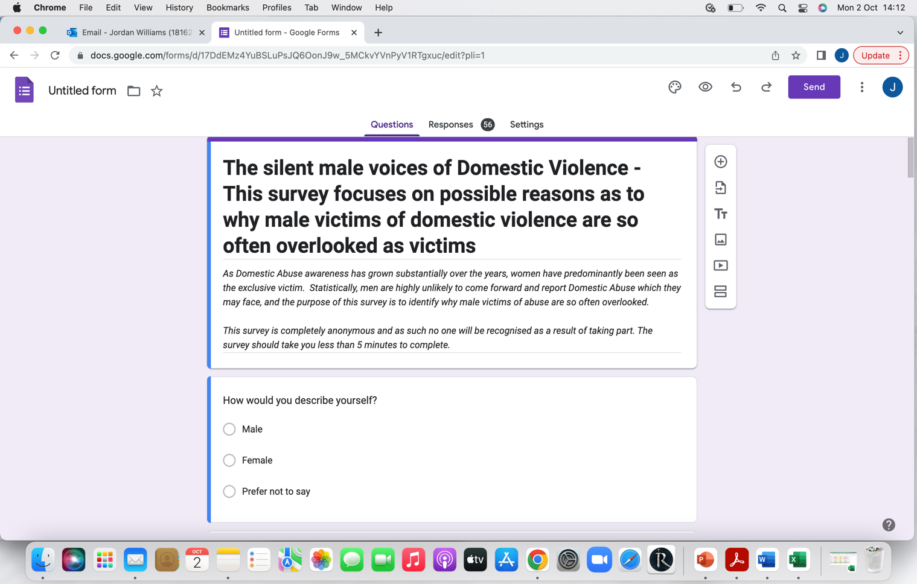

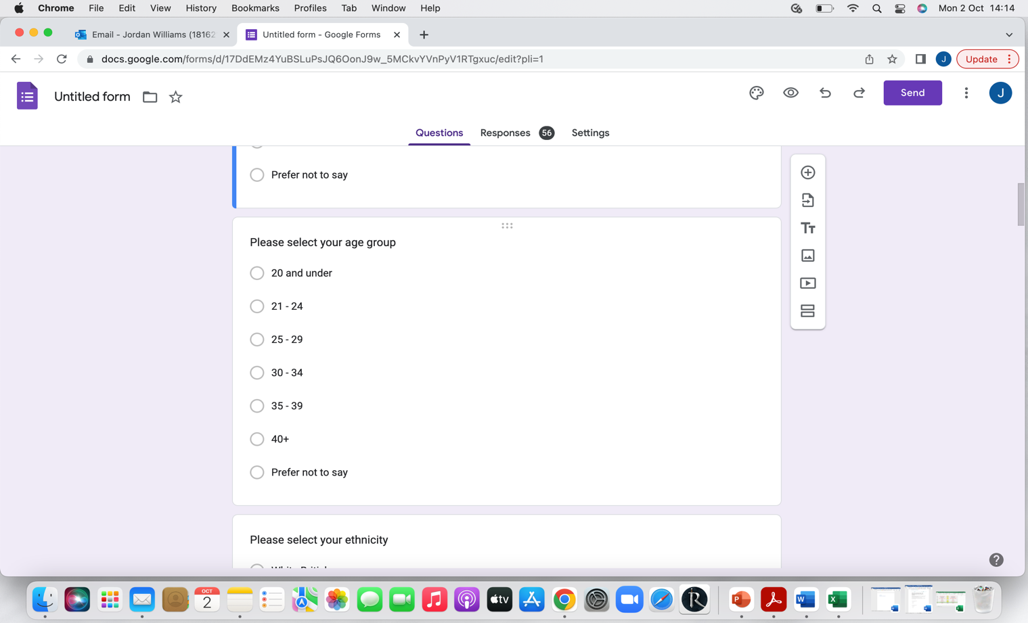

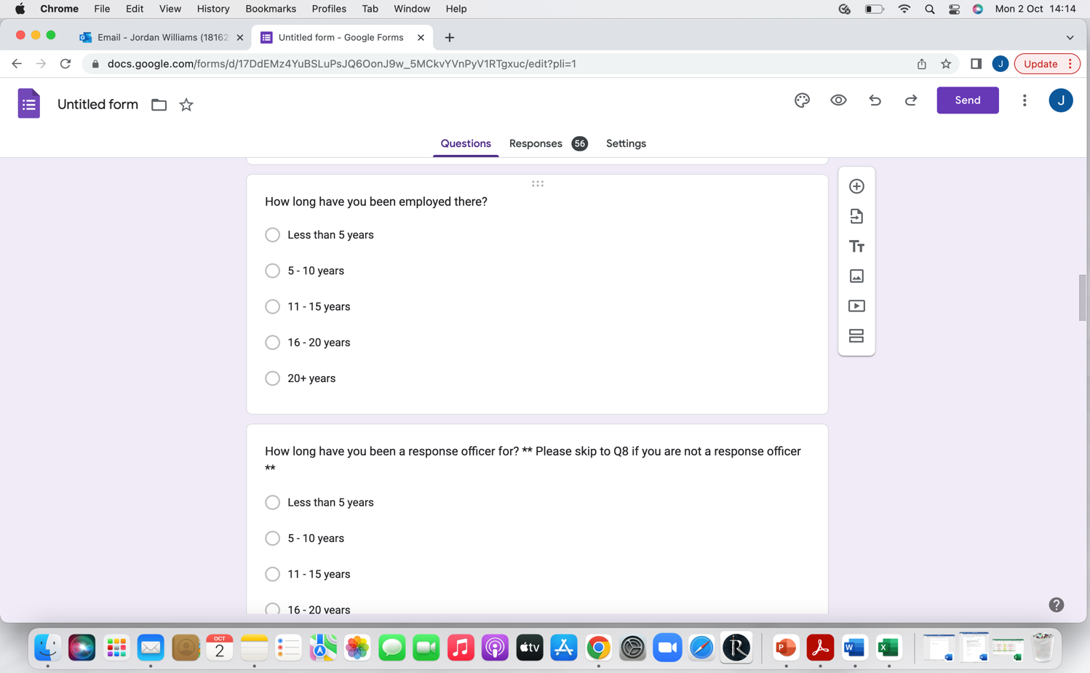

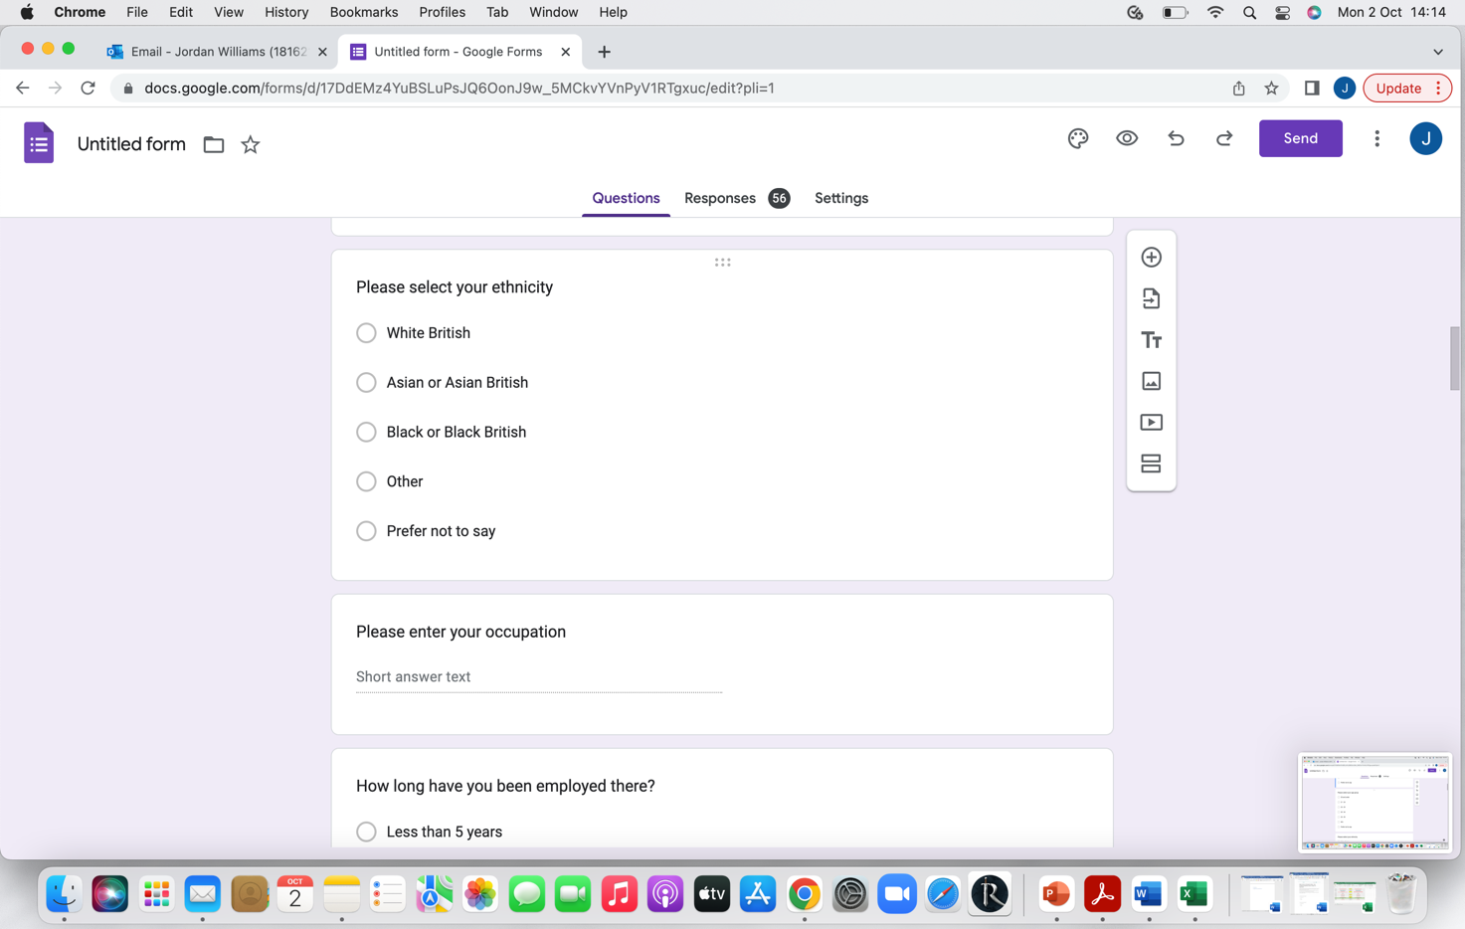

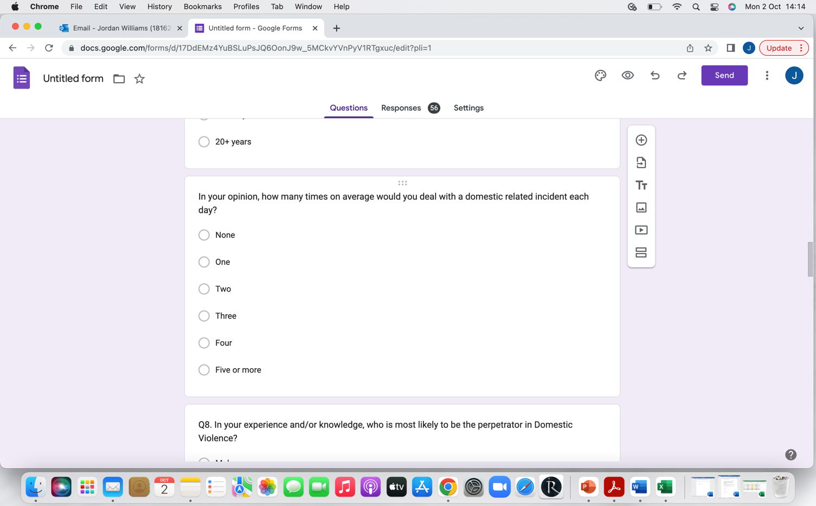

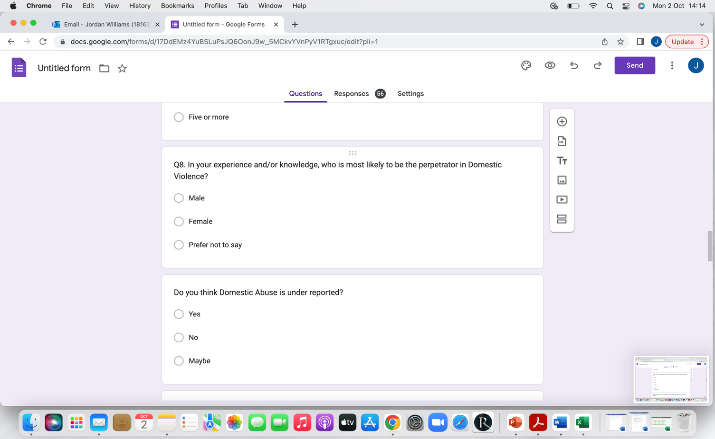

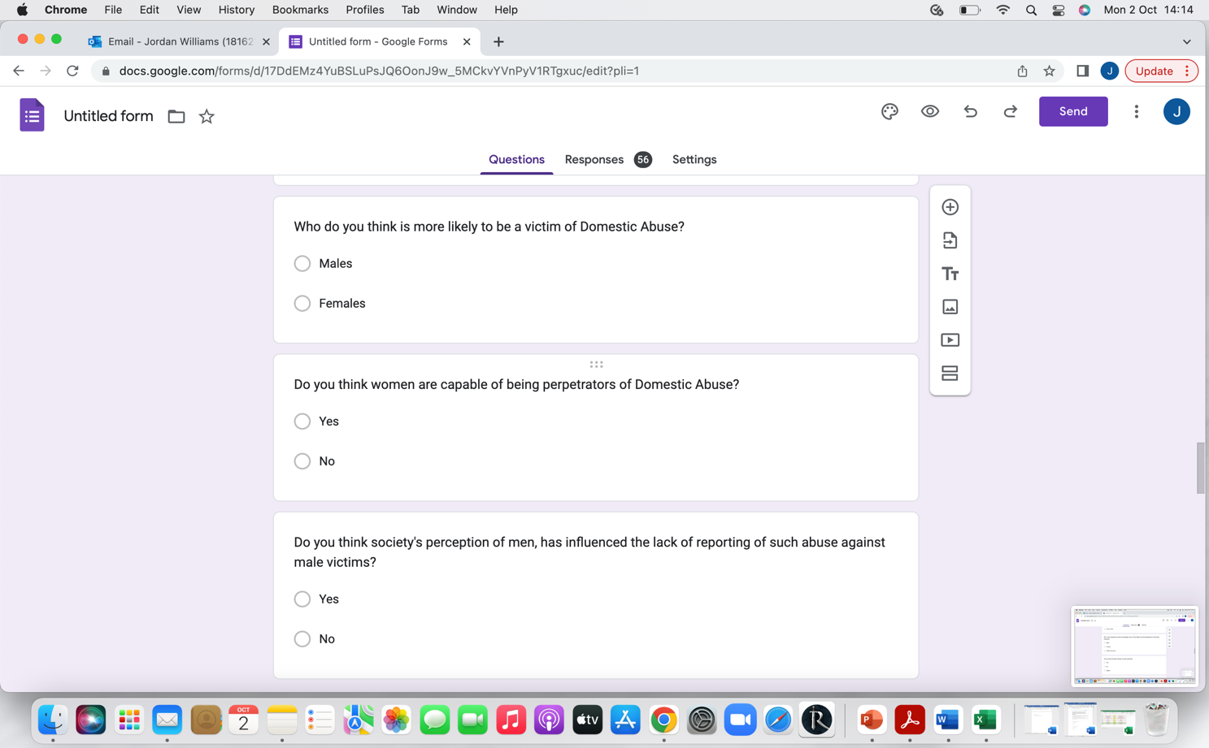

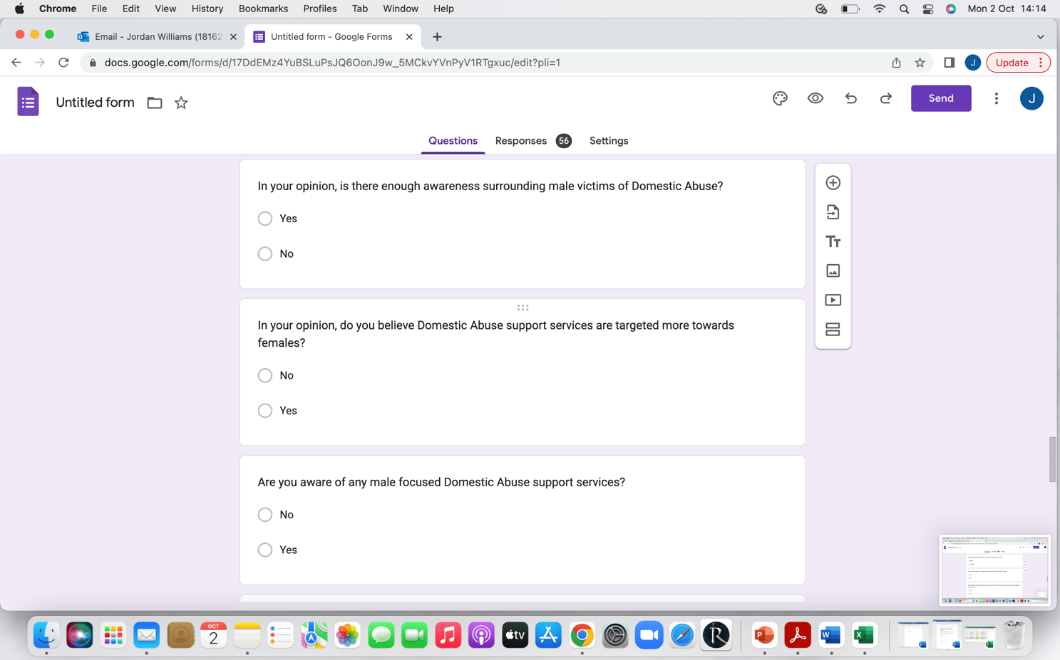

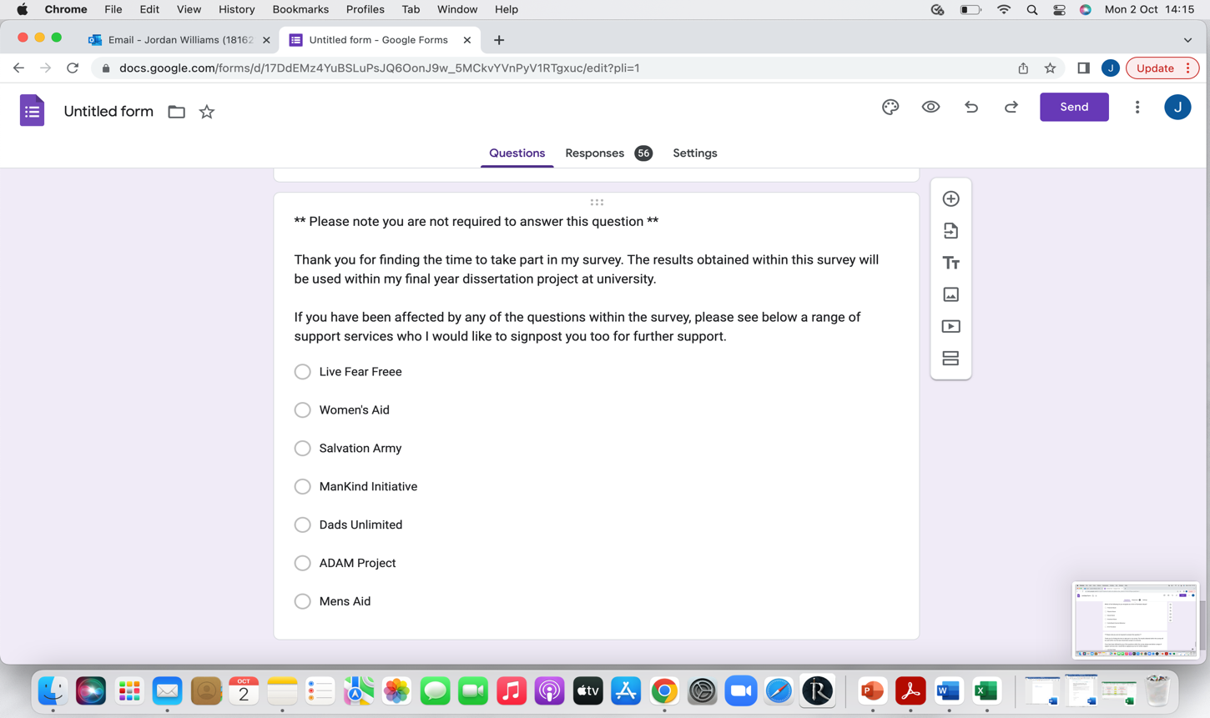
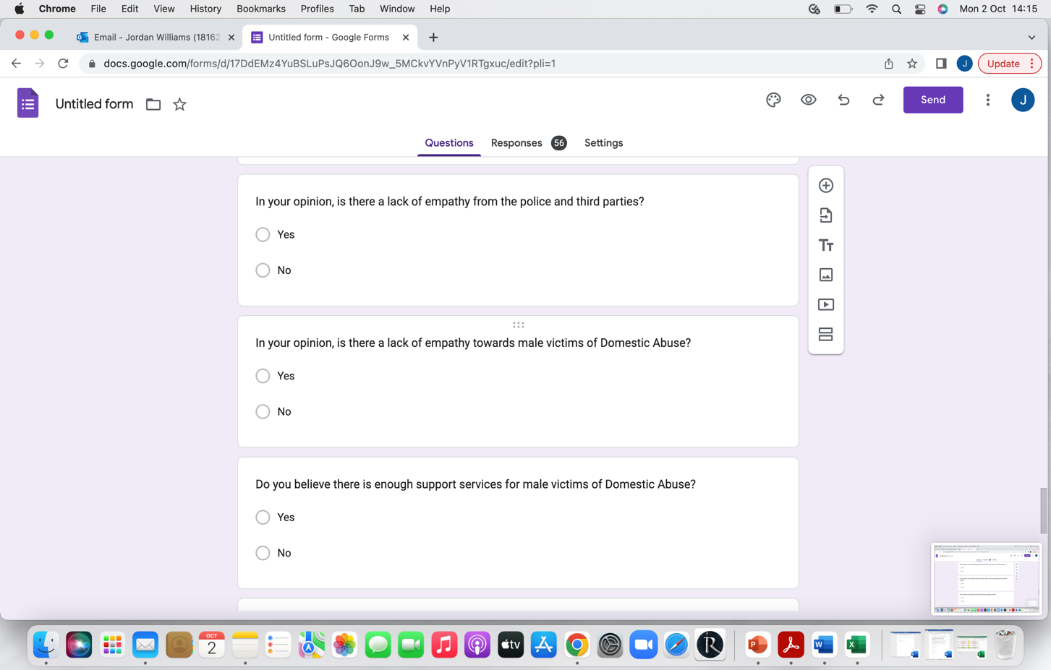
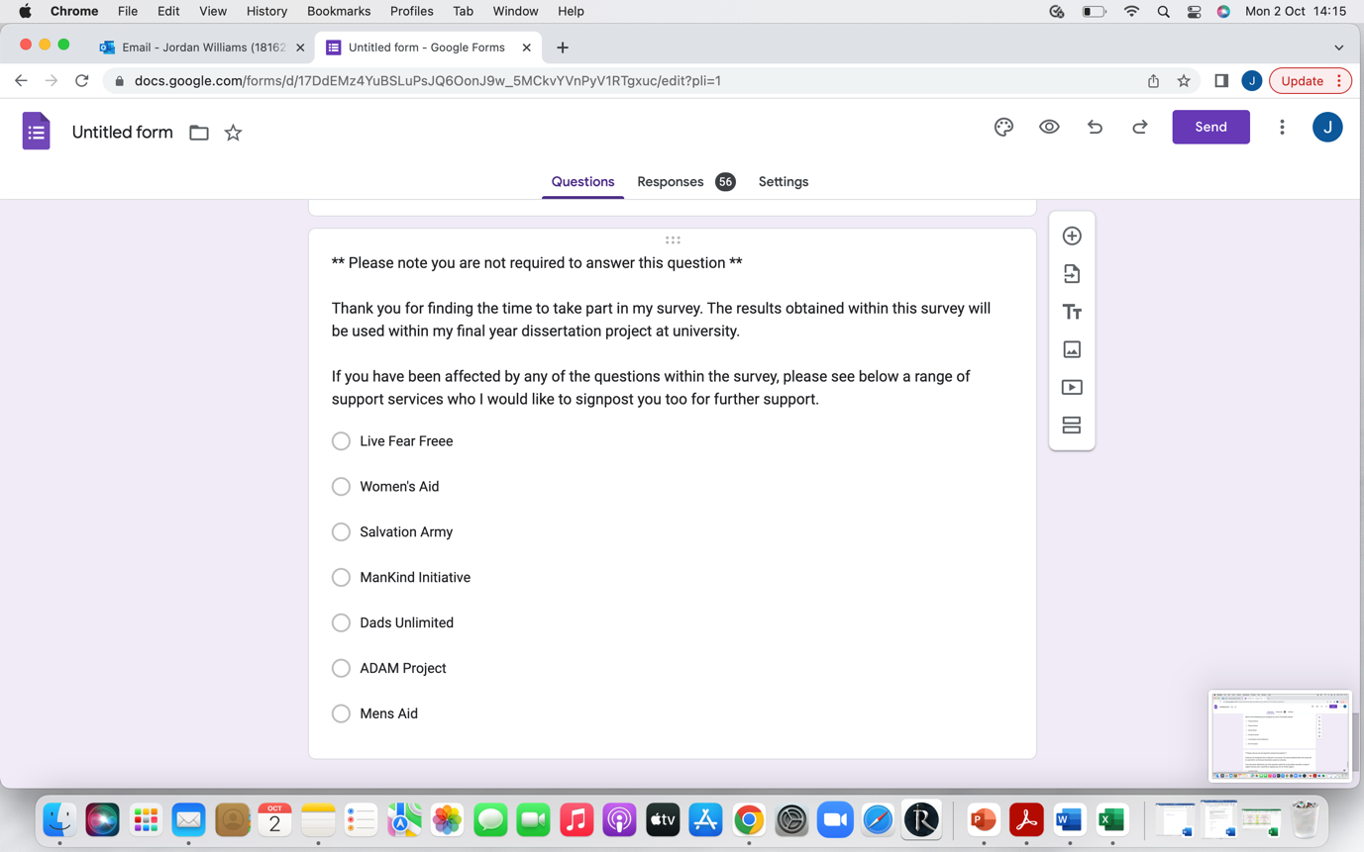\

7.2 Appendix Two: Questionnaire Results



