

Student Name: Dharmesh Bhavanisingh Tanwar

Student ID: 2531862

Module Name: Marketing Management

Module Code: LCMB7024

Lecturer’s Name: Laila Maazouz

Work Count: 2697

Term 1

Table of Contents
1. Introduction 3
2. Task 1: Critical Analysis of the Macro Marketing Environment 4
2.1 Macro Marketing Environment 4
2.2 Macro Factor 1: Technological Innovation (Technological) 5
2.2.1 Impact on Pioneer Organisation (Beyond Meat) 5
2.2.2 Impact on Follower Organisation (Nestlé) 6
2.3 Macro Factor 2: Sustainability and Regulatory Pressure (Environmental/Legal) 7
2.3.1 Impact on Pioneer Organisation (Beyond Meat) 7
2.3.2 Impact on Follower Organisation (Nestlé) 8
3. Task 2: Strategic Responses of Pioneering and Follower Organisations 9
3.1 Pioneering Organisation’s Strategic Responses (Beyond Meat) 9
3.2 Follower Organisation’s Strategic Responses (Nestlé) 10
4. Conclusion 12
REFERENCES 14

1. Introduction
The plant-based meat industry functions as an essential framework to study strategic marketing management because it combines fast product development with changing customer behavior and increasing market rivalry between niche startups and large multinational companies. The report examines how Beyond Meat functions as a pioneering organisation and Nestlé operates as a follower by showing how macroenvironmental forces determine their strategic market position and competitive business results. The global plant-based meat market reached a valuation of about USD 7.17 billion in 2023 and will expand to USD 24.77 billion by 2030 with a compound annual growth rate of 19.4% according to Grand View Research 2024. The industry encounters three major structural obstacles which include price-sensitive customers who doubt ultra-processed products and the rising competitiveness of the market according to Good Food Institute 2023.
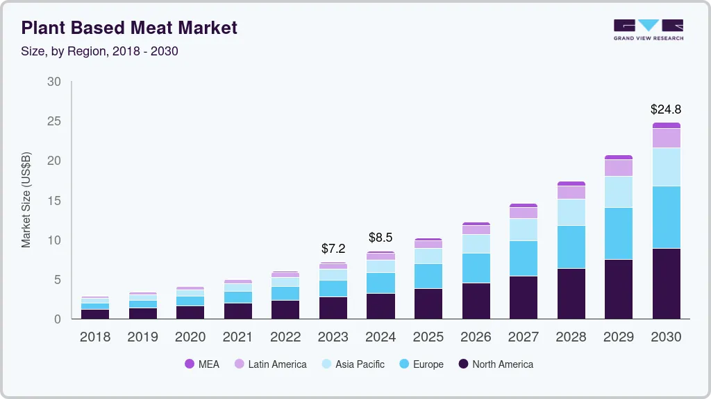
Figure 1: Global Plant-Based Meat Market Growth by Region (2018–2030)
The competitive landscape divided into two distinct strategies, which enable pioneers such as Beyond Meat to succeed through their technological innovations and unique brand identities, while followers like Nestlé achieve market dominance by using their operational efficiency, worldwide distribution systems, and broad product range. The shift shows that companies in the sector now require resource integration and operational scaling abilities to gain competitive advantage beyond their innovation capacities.
The strategic decision-making process requires macro marketing environment analysis because it helps companies discover external factors which create opportunities and threats to their long-term competitive standing. The PESTLE framework enables organizations to systematically assess external forces which include technological innovation and sustainability pressures that most significantly impact their industry. The report begins with a macro factor analysis before assessing the strategic reactions of Beyond Meat and Nestlé through relevant strategic models.

2. Task 1: Critical Analysis of the Macro Marketing Environment

2.1 Macro Marketing Environment
The macro marketing environment consists of external elements which determine organizational strategy yet remain beyond organizational control. Firms use the PESTLE framework which includes political, economic, social, technological, legal and environmental elements to evaluate their business environment while identifying potential strategic risks and opportunities (Kotler and Keller, 2016). The plant-based meat sector operates under multiple industry forces but its most vital components stem from technological advancements and environmental sustainability together with regulatory pressure (Technological) and sustainability requirements (Environmental/Legal) which establish strategic environmental requirements for the market.
The selection of these two factors is justified because they directly determine the capabilities available for supply-side operations and the dynamics which drive customer demand. Technological innovation leads to product quality improvements and cost-effective production methods and unique product features whereas sustainability requirements drive changes in customer buying habits and subsequent rule-making processes. The global plant-based meat market will increase from its 2023 value of USD 7.17 billion to a forecasted USD 24.77 billion by 2030 because of food technology enhancements and environmental worries (Grand View Research, 2024). The industry develops according to these fundamental elements instead of secondary elements which operate in an industry.

2.2 Macro Factor 1: Technological Innovation (Technological)


Figure 2: Technological Innovation in Plant-Based Food Development

2.2.1 Impact on Pioneer Organisation (Beyond Meat)
Beyond Meat uses technological innovation as its primary business opportunity because the company depends on its proprietary food science track record and ongoing product development work for its market position. The company has made major investments into developing plant protein products which replicate meat sensory qualities to create distinct market advantages that help the brand achieve market leadership. The Resource-Based View shows that firms gain competitive advantage through their particular capabilities which provide value yet maintain difficulty for competitors to copy (Barney, 1991).
The same element functions as both an essential organizational resource and a critical structural danger. The costs for ongoing innovation remain extremely high yet Beyond Meat operates under this constraint which limits its financial operations. The company has experienced dropping income rates together with ongoing financial losses which show that its innovation-based growth methods do not achieve profitable expansion (Statista, 2025). The technological knowledge base has spread among competitors which has decreased the exclusive nature of Beyond Meat products thus losing its market differentiation advantage (Lieberman and Montgomery, 1988).
The implication for competitive advantage thus demonstrates permanent instability. Beyond Meat used technological innovation to enter the market however this development now results in the company experiencing higher operational costs combined with reduced capacity to create distinctive product features which limits its potential for ongoing market success.

2.2.2 Impact on Follower Organisation (Nestlé)
Nestlé gains an opportunity from technological innovation because it can use its current resources to support business operations. Nestlé operates as a global company which relies on its extensive research and development facilities together with financial resources to implement existing technologies while improving their operational efficiency. The company uses fast-follower implementation which decreases risks because it allows companies to gain from new innovations without paying for all development expenses (McKinsey, 2023).
Nestlé shows a greater ability to adapt than Beyond Meat. The company's global supply networks together with its cost-effective production methods enable it to provide affordable products which serve as a key advantage for competing against products which cost less than standard meat (Good Food Institute, 2023). The company expands its potential customer base while improving its market presence through this strategy.
Nestlé uses technological innovation as a method to create competitive advantages which can grow their business rather than creating extra operational costs. The company needs strong resource integration capabilities to maintain competitive strength because it does not own a strong market brand identity. The findings show that companies need to use innovation absorption as their main strategic method to achieve success during times of mature competitive competition.

2.3 Macro Factor 2: Sustainability and Regulatory Pressure (Environmental/Legal)
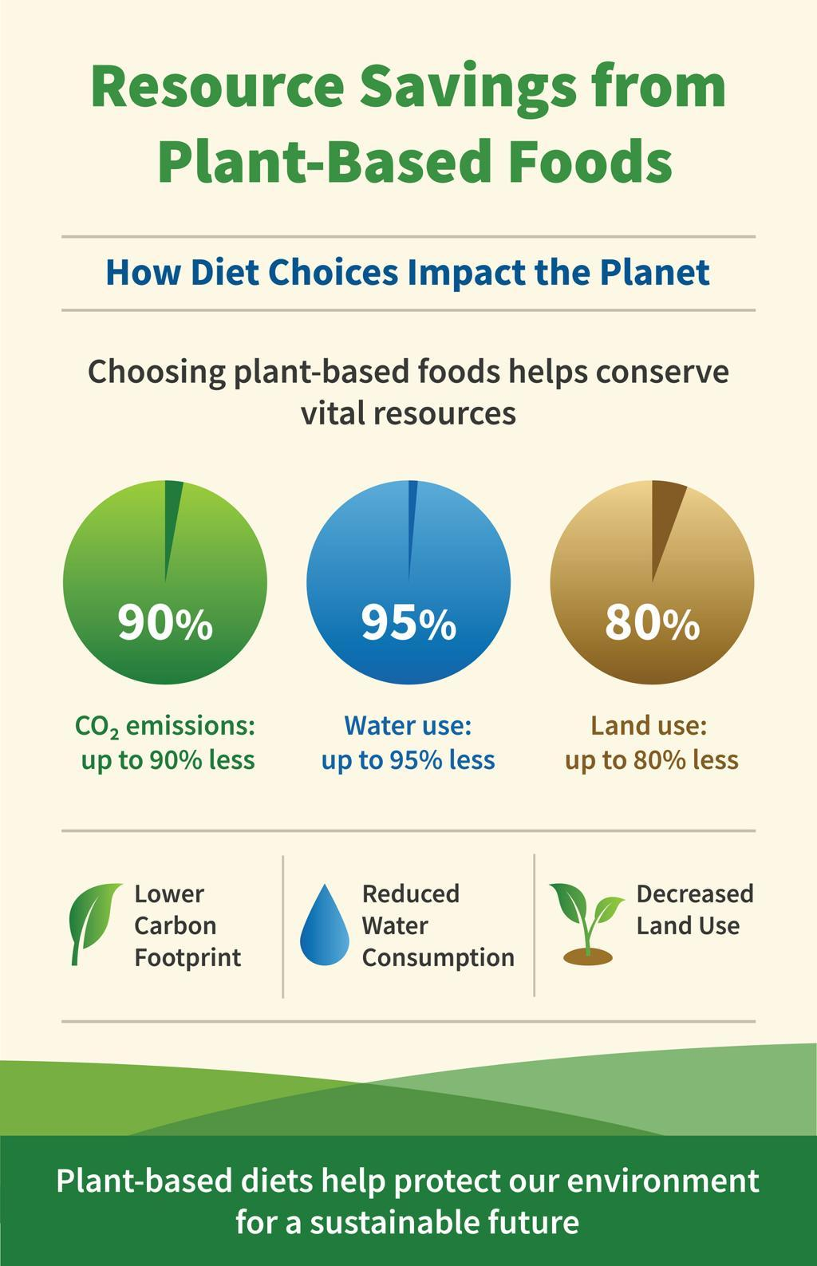
Figure 3: Environmental Impact of Food Production Systems

2.3.1 Impact on Pioneer Organisation (Beyond Meat)
Beyond Meat can achieve sustainable growth because its business model supports both environmental sustainability and ethical consumer spending patterns. Livestock production contributes approximately 14.5% of global greenhouse gas emissions, positioning plant-based alternatives as environmentally favourable substitutes (FAO, 2023). Beyond Meat can use its sustainable food options to meet customer needs while charging higher prices for its products.
Sustainability brings benefits but businesses face two types of danger through its implementation. People now investigate plant-based food products more than ever because they want to know the health benefits and environmental effects of different processing techniques and nutritional profiles (Dickson, 2024). The company must prove its sustainability claims under changing regulatory requirements because of this authenticity risk which requires continuous proof of its claims.
Sustainability creates competitive advantages because it helps businesses stand out from their opponents but it fails to create strong protective barriers for their business. Beyond Meat maintains environmental value alignment but it will face business challenges from changing customer attitudes and impending regulatory measures which will decrease its long-term business viability.

2.3.2 Impact on Follower Organisation (Nestlé)
Nestlé uses sustainability as a strategic path for new business development while it creates risks which threaten its organizational credibility. The firm has expanded its plant-based portfolio as part of its broader ESG commitments, aligning with regulatory expectations and evolving consumer preferences (Nestlé, 2025). The organization uses its global presence to carry out sustainability programs throughout its complete value chain which results in better operational performance and regulatory adherence.
Nestlé currently deals with serious reputational problems because past environmental violations and reports of false environmental practices have damaged its public image (Yucel, 2025). The organization faces trust problems which make it difficult to establish its sustainability claims.
Nestlé shows better ability to handle difficulties than Beyond Meat because it maintains flexible business operations that can adapt to changing market conditions. The organization handles reputational risks through its various business activities which protect financial resources while it grows its plant-based product range. Nestlé increases its market power through sustainable practices which help the company create ethical business practices that match its operational capacity.
The institutional theory framework shows that social groups create legitimacy through their ongoing legitimacy battles (Suchman, 1995). Beyond Meat possesses natural sustainability advantages but Nestlé achieves permanent competitive advantage through its capacity to implement sustainable methods across all organization levels. Sustainability success relies on a business's ability to execute its plans instead of its matching abilities with sustainability financial markets.

3. Task 2: Strategic Responses of Pioneering and Follower Organisations

3.1 Pioneering Organisation’s Strategic Responses (Beyond Meat)
Application of Porter’s Generic Strategies
The company Beyond Meat applies Porter's 1985 pure differentiation strategy through its combination of technological innovation and brand positioning and sustainability narratives to develop exclusive high-value products. The company uses this response mechanism to deal with external environmental factors which include technological progress and sustainability requirements that first allowed it to compete in new markets.
Beyond Meat has dedicated substantial funding to research and development efforts which aim to improve product authenticity by achieving animal meat taste and texture and nutritional value. The business model follows Porter’s differentiation logic because companies create exclusive products which bring better value to customers (Porter, 1985). Beyond Meat employs its ongoing product development process which includes multiple product reformulations to keep its differentiation advantage (Beyond Meat, 2024). The company expanded its business operations into various international retail and foodservice outlets which demonstrates how differentiation helped it establish market presence and increase brand visibility.
The strategy faces growing limitations which prevent it from achieving sustainable results. The industry now allows competitors to copy Beyond Meat's product features because technological capabilities spread throughout the market (McKinsey, 2023). The primary weakness of differentiation strategies appears in innovation-driven markets because companies can duplicate successful products with increasing simplicity according to Lieberman and Montgomery (1988).
Beyond Meat demonstrates its organizational weaknesses through its response to economic circumstances. The company uses R&D funding as its main business operation which leads to increased manufacturing expenses that create higher product prices than both traditional meat products and other market options. During economic downturns, consumers continue to see price as a primary obstacle that prevents them from buying products (Good Food Institute, 2023). The company faces difficulties in transforming its unique market position into financial success because it has lost sales while experiencing ongoing financial losses (Statista, 2025).
The organization has chosen to reduce expenses through employee layoffs and business process changes while keeping high product prices to maintain profit margins. The organization faces two conflicting strategic goals because cost reductions will decrease its ability to create new products while increased prices will make products inaccessible to most consumers. Beyond Meat's strategic response to competition fails to connect its unique value proposition with its operational efficiency.
The business has established itself as an environmentally friendly substitute for conventional meat production by utilizing increasing consumer demand for climate change solutions. The brand used to stand out from competitors but its special identity has received damage from people analyzing ultra-processed foods (Dickson, 2024). The organization gains sustainability benefits because it opens new business opportunities but the process brings potential damage to its reputation.
The strategic approach of Beyond Meat shows how innovative companies face a major obstacle because they create new markets through their innovations yet they find it hard to grow their businesses efficiently. According to the Resource-Based View, competitive advantage relies on two factors: companies require both valuable abilities and effective execution of those abilities for success (Barney, 1991). Beyond Meat loses its ability to compete over time because it fails to merge new product development with cost-effective manufacturing processes.

3.2 Follower Organisation’s Strategic Responses (Nestlé)
Application of Ansoff’s Growth Matrix
The Ansoff Growth Matrix system which Nestlé uses for its diversified growth strategy shows that the company uses market development and diversification as its main growth methods. The organization achieves better results when handling macro-environmental challenges because this method keeps its operational flexibility while simultaneously reducing its exposure to risks. Nestlé expands its plant-based product distribution through market development by using its global distribution network to enter new geographic markets. The company has established plant-based products throughout Europe and North America and its emerging market regions to meet the growing need for alternate protein sources according to Good Food Institute 2024. The company can achieve fast growth through this strategy because it requires no major product development and shows that its distribution capabilities serve as essential business assets.
Nestlé develops its product line through diversification by expanding its plant-based product range into its complete food and beverage collection. The strategy decreases business risks because it enables companies to operate in multiple markets which reduces their reliance on one product line. Market data shows that plant-based food sales reached $28.6 billion in 2024 but certain areas experienced reduced growth because of market saturation and changing consumer tastes according to Good Food Institute 2024. The diversified structure of Nestlé enables the company to manage financial changes without experiencing major economic disturbances. Beyond Meat and Nestlé approach technological advancements with completely different methods. The company chooses to implement existing technologies through its production systems instead of investing in new technology development.

The process enables Nestlé to reduce production expenses while improving operational efficiency which helps the company compete on pricing to extend its market presence according to McKinsey 2023. The process of scientific advancement now serves as a means to increase productivity instead of acting as an obstacle to business success. The financial performance of this strategy provides evidence that it functions effectively. Nestlé achieved stable organic growth and maintained high operating margins during 2024 because the company could remain profitable amid difficult market conditions according to Nestlé 2025. The financial disturbances facing Beyond Meat show the relationship between organizational size and resource combination with competitive edge maintenance. Nestlé maintains its competitive advantage through its product development strategy which brings new market options. The company struggles with sustainability issues because it faces greenwashing accusations and its past environmental violations (Yucel 2025). The company loses legitimacy because these problems exist in a market environment where ethical values have grown more crucial. The global reach of Nestlé enables the company to execute sustainability programs throughout its entire operation which helps to decrease certain sustainability risks. Nestlé shows superior ability to adjust its strategic plans than other companies.

The Ansoff Growth Matrix enables the company to achieve its expansion targets while maintaining effective control of its business risks. The market development process results in organizational growth which helps businesses to stay resilient through their diversification efforts. Nestlé has established multiple product lines which enable the company to compete in various market segments while Beyond Meat relies primarily on its main product line for business growth. The theoretical framework shows that followers can achieve better results than pioneers because they use their superior resources and execution capabilities. The innovation process through which pioneers enter new markets enables followers to gain value by improving their operational efficiency through increased business volumes.

4. Conclusion
The report examined how macro-environmental elements affect competitive relationships and strategic decision-making in the plant-based meat industry by analyzing Beyond Meat as a market leader and Nestlé as a market follower. The analysis showed that technological progress and sustainability demands function as the main macro environmental elements because they generate different effects on various companies. The technological advancements which enabled Beyond Meat to achieve its initial market advantages imposed major cost obstacles while limiting the company's ability to grow its operations. Nestlé used its resources to implement new technology at an optimal pace while the company turned external pressures into organizational benefits. The strategic response analysis showed that the two companies follow completely different methods when competing with each other.

Beyond Meat has lost its early market advantage because competitors copied its unique product design and the company now faces higher costs and lower customer interest. Nestlé achieves its growth objectives through market development and diversification which enables the company to develop sustainable business operations with increased flexibility for future growth and competitive market advantage. The companies need to use environmental scanning processes because these practices help them detect potential external dangers and new business opportunities. The organization requires internal capabilities to handle its operational needs. The report concludes that sustainable competitive advantage in this industry is determined by the capacity to scale and operationalise strategic responses and by innovation leadership.

REFERENCES
Ansoff, H.I. (1957) ‘Strategies for diversification’, Harvard Business Review, 35(5), pp. 113–124. Available at: https://hbr.org/1957/09/strategies-for-diversification (Accessed: 21 March 2026).
Barney, J. (1991) ‘Firm resources and sustained competitive advantage’, Journal of Management, 17(1), pp. 99–120. Available at: https://journals.sagepub.com/doi/10.1177/014920639101700108 (Accessed: 21 March 2026).
Lieberman, M.B. and Montgomery, D.B. (1988) ‘First-mover advantages’, Strategic Management Journal, 9(S1), pp. 41–58. Available at: https://onlinelibrary.wiley.com/doi/10.1002/smj.4250090706 (Accessed: 21 March 2026).
Porter, M.E. (1985) Competitive advantage: Creating and sustaining superior performance. New York: Free Press.
Suchman, M.C. (1995) ‘Managing legitimacy: Strategic and institutional approaches’, Academy of Management Review, 20(3), pp. 571–610. Available at: https://journals.aom.org/doi/10.5465/amr.1995.9508080331 (Accessed: 21 March 2026).
Navarré, C., et al. (2025) ‘Plant-based meat substitutes: environmental and health impacts’, Foods, 14(13), 2312. Available at: https://www.mdpi.com/2304-8158/14/13/2312 (Accessed: 21 March 2026).
Russo, A., et al. (2025) ‘Environmental impact of meat-free consumption’, arXiv preprint. Available at: https://arxiv.org/abs/2504.02899 (Accessed: 21 March 2026).
Nakavachara, V., et al. (2025) ‘Ethical consumption and pricing premiums’, arXiv preprint. Available at: https://arxiv.org/abs/2505.04042 (Accessed: 21 March 2026).
Van den Bedem, L., et al. (2026) ‘Benchmarking plant-based versus animal-based meat’, arXiv preprint. Available at: https://arxiv.org/abs/2603.03370 (Accessed: 21 March 2026).
Yucel, A. (2025) ‘ESG and sustainability decoupling in the food industry’, Sustainability. Available at: https://pmc.ncbi.nlm.nih.gov/articles/PMC12681171/ (Accessed: 21 March 2026).
Anjum, M. (2025) ‘Global outlook on plant-based meat market’, Food and Nutrition Journal, 14(1). Available at: https://www.foodandnutritionjournal.org/volume14number1/global-outlook-on-the-meat-market-and-alternatives-plant-based-and-cultivated-meat-challenges-developments-and-opportunities/ (Accessed: 21 March 2026).
Food and Agriculture Organization (FAO) (2023) Tackling climate change through livestock. Available at: https://www.fao.org/3/i3437e/i3437e.pdf (Accessed: 21 March 2026).
Good Food Institute (2023) State of the Industry Report: Plant-Based Meat. Available at: https://gfi.org/wp-content/uploads/2023/01/2022-Plant-Based-State-of-the-Industry-Report.pdf (Accessed: 21 March 2026).
Grand View Research (2024) Plant-based meat market size report. Available at: https://www.grandviewresearch.com/industry-analysis/plant-based-meat-market (Accessed: 21 March 2026).
McKinsey & Company (2023) The future of alternative proteins. Available at: https://www.mckinsey.com/industries/agriculture/our-insights/alternative-proteins(Accessed: 21 March 2026).
Statista (2025) Beyond Meat financial performance statistics. Available at: https://www.statista.com/topics/5960/beyond-meat(Accessed: 21 March 2026).
Beyond Meat (2024) Annual report and financial statements. Available at: https://investors.beyondmeat.com/static-files/8c146bf8-20c6-49f4-b8f2-b11685ae28eb (Accessed: 21 March 2026).
Beyond Meat (2024) Beyond IV product platform announcement. Available at: https://www.beyondmeat.com/en-US/press/beyond-meat-unveils-its-beyond-iv-platform-the-fourth-generation-of-the-beyond-burger-and-beyond-beef (Accessed: 21 March 2026).
Nestlé (2025) Annual Review 2025. Available at: https://www.nestle.com/sites/default/files/2026-02/annual-review-2025-en.pdf (Accessed: 21 March 2026).
Nestlé (2025) Garden Gourmet product portfolio. Available at: https://www.nestle.com/brands/culinary-chilled-frozen/garden-gourmet (Accessed: 21 March 2026).
Nestlé (2025) Non-Financial Statement (ESG Report). Available at: https://www.nestle.com/sites/default/files/2026-02/non-financial-statement-2025.pdf (Accessed: 21 March 2026)

