  Component One | Student No: | 2219850
 | Module Title: | OPERATING HOTEL FACILITIES
 | Student name: | IOANA ALEXANDRA VARLAN
 | Lecturer: | SCOTT JAMES
Introduction
I have had the chance to learn and improve several essential skills for working in the hospitality business since I joined the Ibis London Thurrock M25 cleaning team. I know how to handle busy plans well, pay close attention to every detail, and do a lot of different kinds of cleaning. Some essential skills covered in this learning journal are time management, communication, and being able to change. It will examine my growth through the lens of KOLB's Learning Cycle from 1984 and find connections between academic ideas and real-world uses at work.
Being a housekeeper at the Ibis London Thurrock M25 means having specific skills that help them do their job well. These skills include cleaning rooms, keeping correct records, and ensuring guests are happy. To begin, one will figure out what skills are needed (Blagoev, Nikolskaya and Popov, 2019). Then, using KOLB's (1984) Learning Cycle as a guide, one will carefully look at those skills.
Attention to detail: One needs to have a good eye for detail to see any flaws, spots, or other issues in the room. This information is essential for the repair team to do their job well and improve the visitors' experience (Kolb, 2015).
Adaptability: This hotel has a patio, bathrooms, a bar, a kitchen and rooms that are easy for people with disabilities to enter. The people who clean the buildings need to be able to adapt to the different needs of each building.
Flexibility: To save money, one should be able to handle different types of bookings in various ways when one has 168 rooms. To meet the wants of their customers, staff members need to know a lot about many different things.
Customer support: Even though cleaning is usually focused on keeping things neat and clean, it is essential to stress how important it is to give excellent service to guests (Hatter and Rehmus, 2014). This means being friendly to guests, quickly answering their questions and worries, and putting their happiness and comfort first.
Understanding of facilities: Knowing when the restaurant, bar and food area are open is fundamental. So that they can give people correct information, the housekeeping staff needs to know all of these details.
Policy compliance: One must fully understand and follow the refund policy. It is essential to clearly explain and enforce this policy to guests to avoid financial problems and keep guests happy (Kadavy, 2020).
Time management: Because each room only has 16 minutes, one must handle one's time well. The people who work in cleaning are expected to organise their tasks well so that they can get them done by the due date while also following strict rules for cleanliness.
KOLB's Learning Cycle: Remember the times one cleaned the house. One wants the most cleaning done in the least amount of time. How have one planned and arranged one's tasks? Have there been times when paying close attention to the little things was the only way to find trouble in a specific area? Think about how well one can tell their coworkers and the repair staff what they need to know. There may have been times when being able to change one's cleaning methods was very important.
This research looks at how theoretical discussions about time management, communication, and being able to adapt can help the hospitality business. How closely do these ideas match up with one's own life? Are there ways one could do better? Personal reflection could lead to ideas for changes to the method or other improvements (Peterson and Kolb, 2017). This could include learning how to handle time, persuade others, and get more education in areas where one thinks one is lacking. When working as a cleaner at Ibis London Thurrock M25, KOLB's Learning Cycle might help people remember important things better. Several strategies can be used to help people in the hotel industry grow personally and professionally. These strategies include thinking about real-life events, watching one's actions, connecting them to academic ideas, and actively trying out changes (Jooss, Burbach and Ruël, 2021).
Conclusion
Being a cleaner at the Ibis London Thurrock M25, this training log has helped me fully understand all the little things I need to do. KOLB's Learning Cycle has been used to test time management, communication, and flexibility carefully. Putting these theoretical ideas together with examples from my business has helped me understand. The trip I just talked about has not only helped me improve my skills but it has also helped me understand the different needs of the hotel industry better.
Word count | 755

Component Two
Room Cleaning Checklist
Damages documentation: One can look into the inconsistencies reported in the damage reports provided to the maintenance workers through the Fols programme (Ljungqvist and Reinmuller, 2018). | Conduct training on how to get the most out of the Fols programme and emphasise the significance of precisely and punctually reporting information. It is essential to devise a means by which damage can be reported promptly to hasten the maintenance staff's response.
Ensuring policy compliance: Guests who violate the hotel's cancellation policy will be responsible for the total cost of the first night of their stay. | By setting up automatic alerts, one can better inform guests about the cancellation policy for their reservations (Whaling, 2020). When a customer is booking, they must be provided with an explanation of the cancellation policy in an understandable and uncomplicated form.
Inadequate consistency: The fact that the cleaning crew only sometimes does a good job is probably the source of the guests' dissatisfaction with their accommodations. | The objective is to compile and consult a standard checklist of everything that must be done to clean a particular room. Audits should be performed regularly to ensure that the plan is implemented and provide guidance on how to enhance performance (Pradhan, 2020).
Restaurant, bar and breakfast hours: Guests may find it inconvenient if other services, including room cleaning, are performed simultaneously. | Ensure that the periods when the restaurant, bar and food service are open do not conflict with the times when cleaning services are provided so that customers are not disturbed. During high occupancy, it is essential to get the most out of available staff to ensure that customers continue to receive quality service and that their rooms remain clean.
Ensuring that the rooms are cleaned to brand standards:
Instruction programmes: Classes in ongoing training will be offered regularly to provide the cleaning crew with the necessary information and abilities (Esteves, Varghese and Worrilow, 2016). As a part of this, one should use efficient cleaning methods, clean the instruments appropriately, and adhere to the brand-approved standards for maintaining a clean environment.
Standardised checklist for cleaning: People recommends compiling a comprehensive and standardised inventory of the items that need to be cleaned. This comprehensive plan covers everything, from the initial walkthrough to the final checks and everything in between. If the Ibis London Thurrock M25 cleaning staff uses this paper as a reference, there is no chance they will overlook any aspect of the cleaning process (Houfey and Areeshi, 2014).
Audits for quality assurance: The frequency with which the rooms' cleanliness will be inspected cannot be stressed enough. Audits will include a combination of random checks, in-depth reviews, and opportunities for comments from those being audited (Tannenbaum and Salas, 2020). Using this feedback approach, one can identify areas that want improvement while simultaneously recognising and rewarding good housekeeping behaviours.
Measures to improve team effectiveness:
Team instruction: Training classes should be held consistently, with topics including time management, effective communication, and using the FOLs programme among the topics covered. One can rest assured that every team member can do their duties effectively.
Methods of communication protocols: There must be distinct communication channels established between the team and the departments it collaborates with (Gage, 2021). This requires submitting damage reports as promptly as possible through the Fols tool and ensuring that every team member knows the daily activities they are responsible for and the most recent information.
Team-building exercises: Participating in activities designed to develop teams is an excellent approach to making the workplace a more positive environment in which employees are willing to offer assistance to one another. This has the potential to lift people's spirits, make it simpler for them to communicate with one another, and increase everyone's level of productivity (Brooks et al., 2019).

Why the checklist is considered most effective:
Adaptability: The versatility of the checklist was prioritised during its development so that it could be applied to a wide variety of settings and components of rooms. By creating individual job lists, one can tailor the cleaning duties to each specific region (Purvis, Mao and Robinson, 2018).
Feedback: Utilising the checklist in conjunction with conducting routine audits and holding feedback meetings makes it much simpler to establish a cycle of continuous development. This ensures that the checklist will remain adaptive and valuable even as the needs and problems being addressed evolve.
Integration in training: Training sessions would benefit from including the checklist because it provides team members with a practical resource for putting what they have learnt into practice.
All-inclusive coverage: The cleaning checklist covers all that must be done to ensure no detail is overlooked, beginning with the initial assessment and continuing to the final checks.

Component Three
Introduction
We try to measure how engaged Ibis London Thurrock M25 staff is by asking them how much they care about their jobs, their coworkers, and the goal of our hospitality business as a whole. Their deeds show that they are willing to go the extra mile by sharing their knowledge, enthusiasm, and dedication.
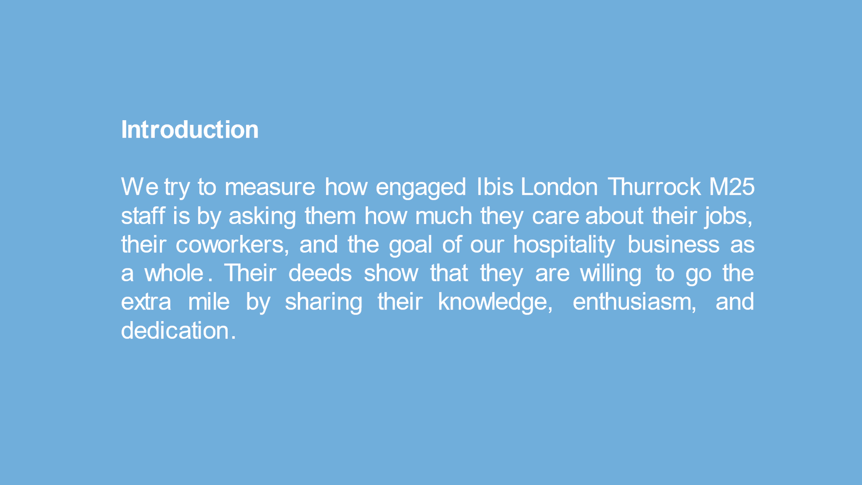
Employee Engagement Model
The Employee Engagement Model is a business approach that aims to make the workplace enjoyable and productive for all workers. As stated above, this strategy puts a lot of weight on team members getting closer to each other and working together to reach the organisation's goals. For this to happen, there must be clear lines of communication and clear expectations. Also, good work must be recognised and rewarded (Raudys, 2023). It is also essential for this approach that there are chances for both personal and organisational growth. Many companies put a lot of value on employee engagement to have a highly motivated, dedicated, and efficient staff. This strategy plan could lead to more business success, higher customer satisfaction, and better output.
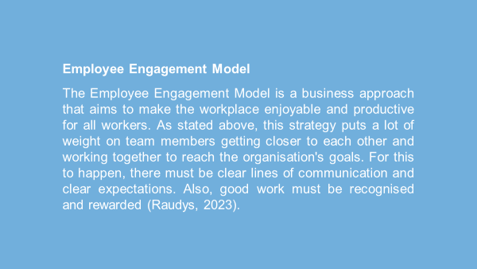
Connect
A big part of how one does engagement is by building good relationships. Team-building activities are done regularly to make the group feel warm and helpful (Mcleod, 2023). Monthly breakfasts, group training events, and celebrations of individual and team successes help the team work together better and focus on their goals. The staff also want to connect this association and the name. This way, one can ensure that everyone on the team knows and follows the guiding principles and does excellent housekeeping.
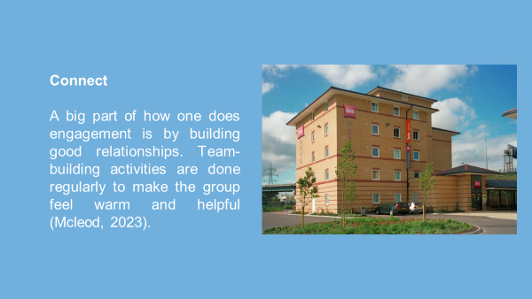
Recognition
A combination of public praise and financial rewards for outstanding work are at the heart of our involvement strategy. They hold regular recognition ceremonies and give performance bonuses to their workers to show how much they appreciate their hard work and dedication (Blagoev, Nikolskaya and Popov, 2019). One-way companies can create a positive and motivating work environment and support a culture of continuous improvement among their employees is to recognise employees for their outstanding work.
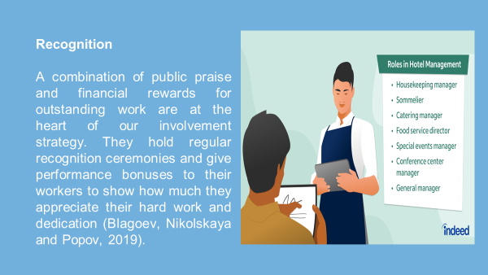
Growth
The company is dedicated to growth, as shown by its ongoing training programmes and workshops that help employees improve their skills (Brooks et al., 2019). Everyone in Ibis London Thurrock M25 company knows that giving employees chances to advance in their careers is critical to keeping them engaged. Putting money into one's professional development not only improves one's skills but also has a big effect on how well the team works together.
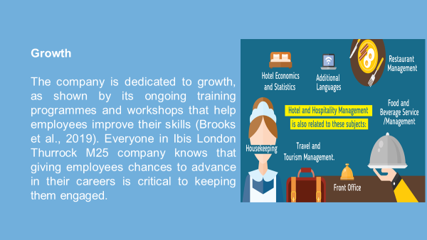
Clarity
Clear and regular contact can get employees more involved in their work. The openness and clarity with which jobs and expectations have been set up make it easy for everyone on the team to see how their work fits into the bigger picture. Our thorough cleaning checklists show precise knowledge of responsibilities. This leads to more accountability and efficiency (Esteves, Varghese and Worrilow, 2016).
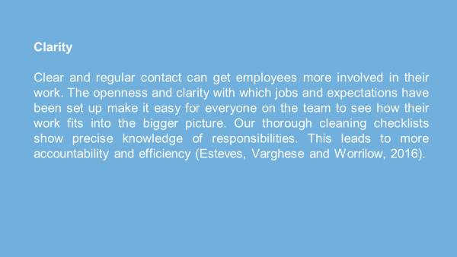
Industry practices
When one studies the best ways to do things in this field, one looks at excellent hotels and well-known people who have found ways to combine the ideas of excellence and employee engagement. Because the Ritz-Carlton values empowering its employees, its staff is known for going above and beyond to help guests (Gage, 2021). Marriott International wants to be sustainable in a good way for the earth and inspires its employees to work on projects that matter. These examples show how the hospitality industry can be more successful by creating a culture that loves its employees and actively supports their personal and professional growth, which aligns with the employee engagement model.
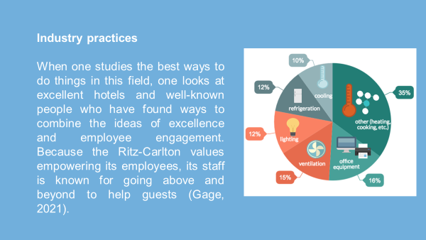
Maintain brand standards
They show that cleaning methods should be the same in all places, including private rooms, public areas, and utilities. Standardised procedures are essential for ensuring guests always get excellent service, according to big names in the business. This piece talks about a few hotels that clean their rooms well to ensure guests have a great stay (Hatter and Rehmus, 2014). To give people a memorable and enjoyable holiday, one needs to be able to predict and go beyond what they expect. This is a visual collection that does an excellent job of showing how complicated sector-wide best practices are. Examples are pictures of neatly arranged cleaning materials, one-of-a-kind cleaning tools, and well-designed rooms.
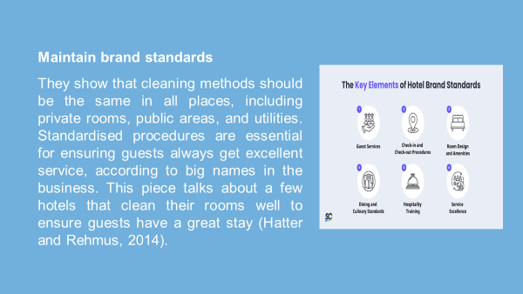
Ensuring health and safety compliance
In the world of cleaning, it is clear that health and safety must come first. This stresses the importance of strictly following health and safety rules to keep everyone on the team and guests safe. Describe the specific steps that were taken to keep workers safe, such as the use of safety gear, the monitoring of cleaning chemicals, and strict rules for handling dangerous materials (Houfey and Areeshi, 2014). Photos of safety signs that are easy to see, team members wearing the right gear, and strict adherence to safety standards while doing different cleaning tasks can help people understand much better.
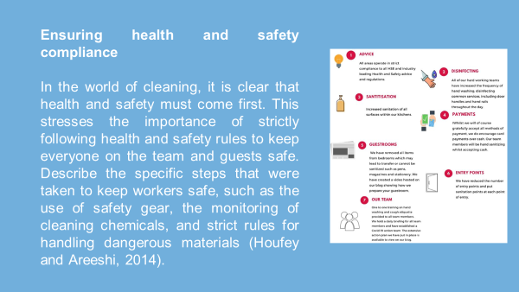
Conclusion
Finally, it is essential to stress the usefulness of using the Employee Engagement Model in our talk. We not only follow the industry's rules but also promise that our housekeeping staff will become a driving force in achieving excellence and going above and beyond our brand's standards by building relationships, making things clear, recognising accomplishments, and helping growth.
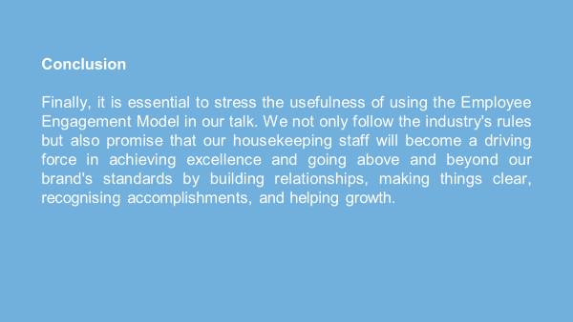

References
Blagoev, V., Nikolskaya, E.Y. and Popov, L.A. (2019) THE HOSPITALITY INDUSTRY: Understanding Hotel Business. Varna University of Management.
Brooks, S.K. et al. (2019) 'Protecting the psychological wellbeing of staff exposed to disaster or emergency at work: a qualitative study,' BMC Psychology, 7(1). https://doi.org/10.1186/s40359-019-0360-6.
Esteves, S.C., Varghese, A.C. and Worrilow, K.C. (2016) Clean room technology in ART clinics: A Practical Guide. CRC Press.
Gage, C. (2021) How to improve your team’s performance. Independently Published.
Hatter, S. and Rehmus, J. (2014) The customer support handbook: How to Create the Ultimate Customer Experience for Your Brand. Cosupport.
Houfey, A.E.- and Areeshi, M. (2014) Keep the environment clean. LAP Lambert Academic Publishing.
Jooss, S., Burbach, R. and Ruël, H. (2021) Talent management innovations in the international hospitality industry. Emerald Group Publishing.
Kadavy, D. (2020) Mind management, not time management: Productivity When Creativity Matters. Kadavy, Inc.
Kolb, D.A. (2015) Experiential learning: Experience as the Source of Learning and Development. Pearson Education.
Ljungqvist, B. and Reinmuller, B. (2018) Clean room design: Minimizing Contamination Through Proper Design. Routledge.
Mcleod, S., PhD (2023) 'Kolb’s Learning Styles and Experiential Learning cycle,' Simply Psychology [Preprint]. https://www.simplypsychology.org/learning-kolb.html.
Nisar, Q.A. et al. (2021) 'Green human resource management practices and environmental performance in Malaysian green hotels: The role of green intellectual capital and pro-environmental behavior,' Journal of Cleaner Production, 311, p. 127504. https://doi.org/10.1016/j.jclepro.2021.127504.
Peterson, K. and Kolb, D.A. (2017) How you learn is how you live: Using Nine Ways of Learning to Transform Your Life. Berrett-Koehler Publishers.
Pradhan, C.S. (2020) Religiosity, superstitious beliefs and mental health of working and Non-Working women. Ashok Yakkaldevi.
Purvis, B., Mao, Y. and Robinson, D. (2018) 'Three pillars of sustainability: in search of conceptual origins,' Sustainability Science, 14(3), pp. 681–695. https://doi.org/10.1007/s11625-018-0627-5.
Raudys, J. (2023) 3 Employee Engagement Models, Theories And Frameworks. https://www.contactmonkey.com/blog/employee-engagement-models.
Tannenbaum, S.I. and Salas, E. (2020) Teams that Work: The Seven Drivers of Team Effectiveness. Oxford University Press, USA.
Whaling, R. (2020) Modern Systems Programming with Scala Native: Write Lean, High-Performance Code without the JVM. Pragmatic Bookshelf.

