

Simona Elisabeta Brendea
Module title: Changemakers: Creativity and Value Creation
Module Code: BMHP5014
Poster and Pitch
Student ID: 2322799

Table of Contents

Contents
1. Poster 3
2. Pitch 4
3. Reference List 7

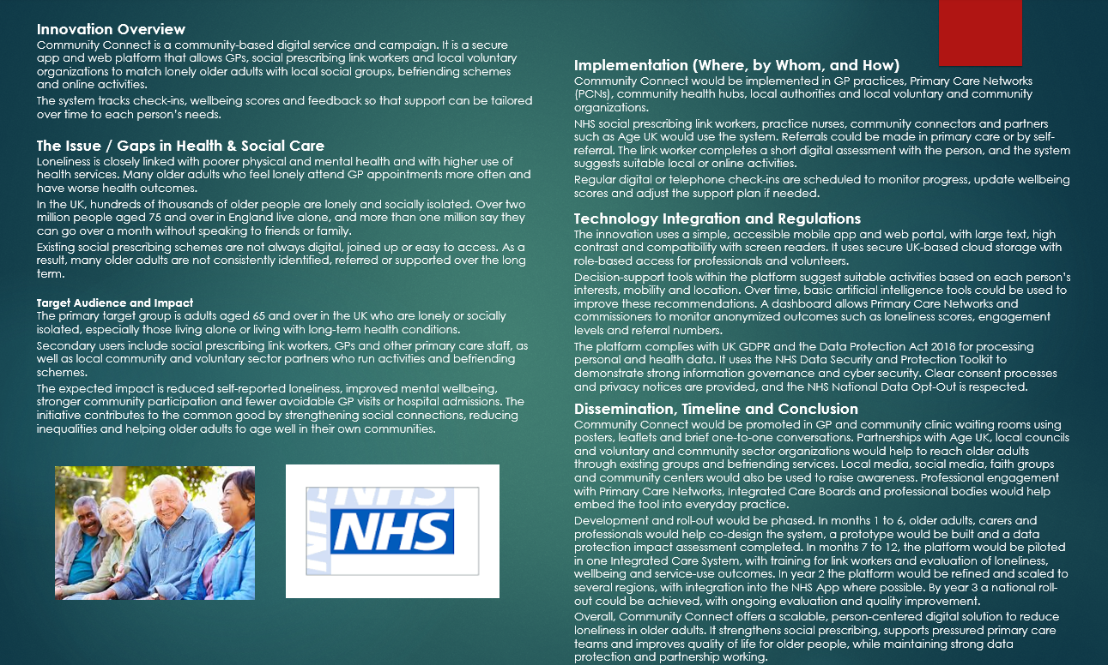
1. Poster

2. Pitch

This proposal details the Community Connect invention and why I think it can help lonely older individuals in the UK. My poster currently covers the basics, but I want to connect it to current policy, law and loneliness and social prescribing research. This service must be shown to decision-makers and the public to be desirable, realistic and required for health and social care.
Later life loneliness is more than just sadness. It is linked to poor physical and emotional health and increases GP and hospital visits (NHS, n.d.).
Around 7% of UK seniors, or 940,000 people, are lonely, and hundreds of thousands go at least a week without speaking to friends or relatives (Age UK, 2024).
Other Age UK data reveals that over 2.2 million over-75s in England live alone and feel neglected or invisible (Housing LIN, n.d.).
This goes beyond personal. Because lonely older persons come more often, recover slower, and need more support, it strains primary, emergency and social care expenditures.
The UK government has declared loneliness a national issue. HM Government (2018) launched “A connected society: a strategy for tackling loneliness”, the first government loneliness strategy in the world.
The policy encouraged departments, local authorities, and volunteer organisations to collaborate on social connection and emphasised local, individualised solutions rather than central programmes (HM Government, 2018; HM Government, 2022).
Community Connect is designed to fit this policy orientation and provide a practical tool for local health and care systems. This does not substitute human interaction. Instead, it helps experts and volunteers organise communication safely and methodically.
Community Connect targets lonely or socially isolated 65-year-olds, especially those living alone or with long-term conditions. Epidemiological evidence reveals that loneliness is frequent in these age groups and strongly linked to frailty, depression, and mortality risk (Age UK, 2024; Brown et al., 2021).
Many seniors prefer to stay in their homes and communities. Not always need new housing; need dependable, frequent connection and help to join activities. Professionals can use Community Connect to identify gaps, uncontacted persons, and local activities with capacity.
Social prescribing is important to the NHS Long Term Plan, supporting the proposal. A national commitment to recruit over 1,000 social prescribing link workers and assist hundreds of thousands of community activity referrals has been made to Primary Care Networks across England (NHS England, n.d.; NHS England, 2019; Brown et al., 2021).
Social prescribing systems may reduce needless GP visits and urgent care use for some groups and improve wellbeing (National Academy for Social Prescribing, 2023).
However, studies demonstrate that many programs use fragmented spreadsheets, manual lists and variable record-keeping. This causes inadequate outcome data, duplication and the danger of some persons losing touch after the first referral. Community Connect fills this gap by providing link workers, GPs and community organisations with a single digital platform.
GPs, nurses, and other staff produce referrals in primary care, and self-referral is allowed. In the platform, the link worker assesses interests, mobility, transit, language needs, and digital skills. The algorithm then recommends local or online activities that meet these qualities from a constantly updated database maintained with Age UK branches, churches, housing associations and small voluntary groups. Each phone call, group session or home visit is recorded with a brief outcome comment and wellbeing scale. This reveals which assistance methods benefit older persons best over time. Link workers can manage their caseload without losing track of clients who need a call or reminder.
A system like this must respect UK health and social care structures. Integrated Care System or local authorities would commission the platform for GP practices, community health hubs, and voluntary sector offices. Staff would need training in software features and non-stigmatizing loneliness discussions. It fits with the government's loneliness strategy to change the discussion about loneliness and empower frontline personnel to talk about it (HM Government, 2018).
Government of the United Kingdom +1
Community Connect encourages statutory and community providers to collaborate because many older individuals utilise numerous services. One single record lets link workers and charity coordinate support instead of working alone.
Privacy and technology are key to this innovation's acceptance. Community Connect processes special category health data, social network, and living situation data. The UK General Data Protection Regulation and Data Protection Act 2018 require lawfulness, fairness, transparency, security, data minimisation, and clear rights for individuals in this type of processing.
Thus, the platform needs privacy-by-design, role-based access so volunteers only see what they need, and plain-language consent information for older individuals. A Data Protection Impact Assessment before launch would identify and mitigate hazards. The service must respect the NHS National Data Opt-Out so consumers can select how their sensitive data is used for planning and research.
Technology must be accessible to older persons and professionals who may be unfamiliar with sophisticated systems. The interface should support screen-readers, huge fonts, and high-contrast colour schemes. That is not just a design choice; it relates to equality duties and accessible digital health tool best practices. Most users would be professionals and volunteers, however an easier view for older persons and carers might be included to see upcoming group sessions or request a call. In fact, older individuals use digital tools when they are well-designed and supported, therefore the platform should prepare for supported digital inclusion rather than presuming they won't use it (Age UK, n.d.).
Public participation is crucial for this effort. Health experts and link workers cannot provide all forms of contact, and neighbours, volunteers, and local groups frequently minimise loneliness best. The NHS suggests safe ways to lessen isolation, such as regular phone calls, helping with little tasks, or taking an older neighbour to a local group (NHS, n.d.).
Community Connect allows befriending services and local associations to receive referrals and record their work in one system, supporting public involvement. Public campaigns employing local media, social media, and church institutions can urge volunteers or enable older relatives join the initiative. This strategy supports the government's goal of eliminating loneliness along with communities and individuals, not just the health service (HM Government, 2018; HM Government, 2022).
Evidence and evaluation conclude the pitch. Social prescription can reduce health service usage and improve wellbeing, although data quality and outcome metrics are problematic (Brown et al., 2021; National Academy for Social prescription, 2023).
Community Connect is measurement-focused from the start. Based on national frameworks, the platform will record standardised loneliness scores and simple health-related quality of life indicators at baseline and regular follow-ups. Commissioners could then compare locality or community activity outcomes to make better funding decisions. The innovation improves individual support and strategic planning for rising and changing ageing populations.
In conclusion, Community Connect integrates loneliness policy, social prescribing expansion, and data protection law into a realistic digital service. It works for and with older individuals to assist health and social care teams address loneliness more systematically and visibly. Later life loneliness statistics suggest that present arrangements are not enough, and many people feel invisible in their communities (Age UK, 2024; Housing LIN, n.d.).
Community Connect wouldn't address all problems, but it would organise local partnership, public participation, and safe technology use. I believe UK health and social care services, voluntary organisations and the public should support the development and testing of this innovation to reduce loneliness in older life.

3. Reference List

Age NI (n.d.) Combating loneliness. Age NI. Available at: https://www.ageni.org/information-advice/health-wellbeing/loneliness/ (Accessed on: 10 November 2025)
Age UK (2015) Loneliness in later life: Evidence review. London: Age UK. Available at: https://www.ageuk.org.uk/siteassets/documents/reports-and-publications/reports-and-briefings/health--wellbeing/rb_june15_lonelines_in_later_life_evidence_review.pdf (Accessed on: 10 November 2025)
Age UK (2024) ‘You are not alone in feeling lonely’, Age UK press release, 2 December. Available at: https://www.gov.uk/government/publications/a-connected-society-a-strategy-for-tackling-loneliness (Accessed on: 11 November 2025)
HM Government (2018) A connected society: A strategy for tackling loneliness – laying the foundations for change. London: Department for Digital, Culture, Media and Sport. Available at: https://www.gov.uk/government/publications/a-connected-society-a-strategy-for-tackling-loneliness (Accessed on: 11 November 2025)
National Academy for Social Prescribing (2023) Measuring outcomes for social prescribing and Evidence reports. London: NASP. Available at: https://socialprescribingacademy.org.uk/evidence-reports/measuring-outcomes-for-social-prescribing/ (Accessed on: 12 November 2025)
NHS (n.d.) Loneliness in older people. NHS website. Available at: https://www.nhs.uk/mental-health/feelings-symptoms-behaviours/feelings-and-symptoms/loneliness-in-older-people/ (Accessed on: 12 November 2025)
NHS England (n.d.) Social prescribing. NHS England. Available at: https://www.england.nhs.uk/personalisedcare/workforce-and-training/social-prescribing-link-workers/ (Accessed on: 18/11/2025)
NHS England (2023) Social prescribing: Reference guide and technical annex for Primary Care Networks. NHS England, 27 January.

