

Module Code: LCHS4003-BIRM
Module: Introduction to Health and Social Care

TITLE: Community Mental Health Service
and Pharmacy Services
STUDENT NAME: Tanecha Crosdale

STUDENT ID: 2513704

LECTURER’S: Daniel Haruna

The National Health Service NHS, ( 2026) defined community mental health services as a service for adults with severe mental health issues to receive care as close as possible to their place of residence.
World Health Organisation (2021) characterised a holistic approach to care that places the person at the centre, taking into account factors such as housing, education, employment, and social welfare. It also outlines the range of support available, including mental crisis services, hospital-based care, and community mental health centres. Noting that these services encounter various challenges while working to uphold human rights standards.

Community Mental Health Services

According to the Royal College of Psychiatrists (2023), the National Health Service (NHS) was established in 1948 to deliver free healthcare services to all citizens of the United Kingdom. Later, the Mental Health Act introduced reforms that allowed psychiatry to operate more flexibly alongside other medical specialties in general hospitals and within community settings, with the aim of reducing prolonged hospital stays for patients.

These conditions are the centre of mental health
Apax (2025) proposed that the current operation of community mental health services is structured to support vulnerable adults. These services deliver comprehensive care to people experiencing mental health difficulties, focusing not only on clinical treatment but also on support within the communities where individuals live and function. The aim is to ensure that assistance is readily accessible and adapted to fit each person’s everyday life.
Care learning (2026) Record keeping in health and social care is the process of collecting and maintaining accurate, up-to-date information about a person’s care and support. It includes details of their needs, treatment, progress, and any changes, helping staff provide safe, effective care while protecting both the service user and workers.

According to the Care Quality Commission (CQC, 2025), community mental health services face significant challenges, including inadequate support and prolonged waiting times.

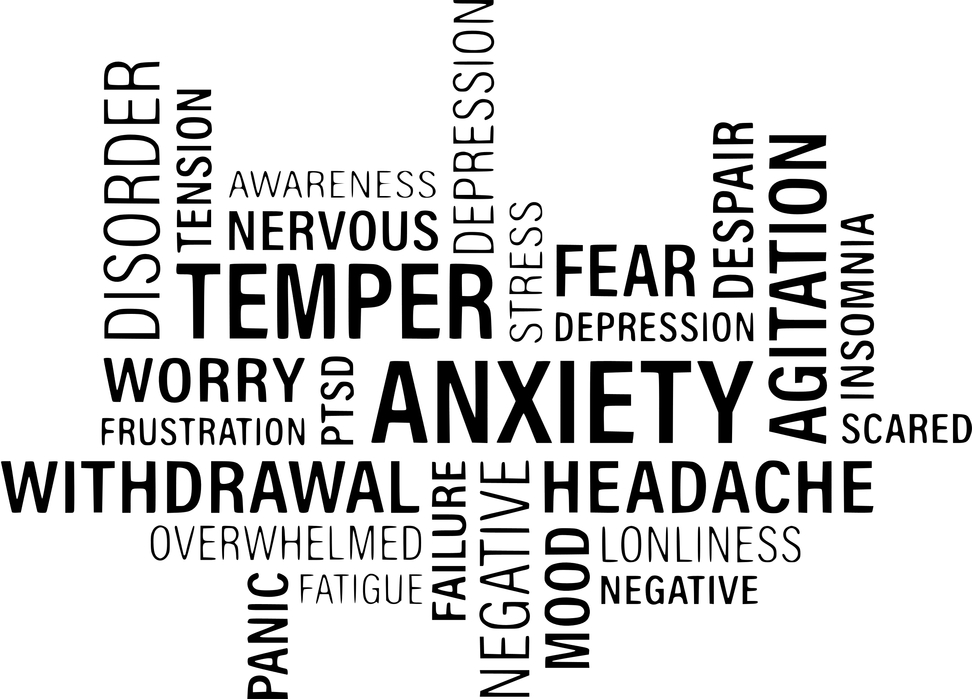
Bond, C. (2024) highlights that effective communication is vital for ensuring cultural sensitivity, developing rapport, and supporting a person-centred approach in mental health settings.


NHS (2023) states that community mental health services operate through partnership working that places individuals at the centre of care, delivering holistic support. This approach involves collaboration among professionals such as social workers, agency staff, nurses, and doctors.

TOPIC: THE PHARMACY SERVICE

According to the Royal Pharmaceutical Society (2026), chemists and druggists were central to the organisation they founded in1841. In the early years, medicines were neither restricted nor regulated, meaning anyone could purchase them. A royal charter introduced in 1843 required pharmacists and chemists to be formally registered. With the creation of the National Health Service in 1948, prescriptions became free, reflecting society’s expectation for safe, high-quality medicines. As the profession advanced, further regulation followed, including the Poisons and Pharmacy Act 1908, which ensured that the title pharmacy could only be used by those who officially registered.
Walker, C. (2022) explain The history of the Royal Pharmaceutical Society in her YouTube video. https://youtu.be/o95OP2wuOxQ
Community Pharmacy England (2024) states that community pharmacies are a key part of the NHS network and play a vital role in England’s healthcare system, with millions of people visiting their local pharmacy each day. This service minimised the strain on the emergency department and saved millions of GP appointments (National Health Service 2024).
Pharmacy widespread location on high streets makes them highly accessible to the public, with around 90%of the population living within walking distance. These pharmacies offer a range of services, including walk-in consultations, self-care support, vaccinations, and various health checks. However, in 2024 many community pharmacies were at risk of closure due to ongoing pressures. Despite this, thousands of pharmacies across England continued to provide NHS-commissioned services in 2025 (The King’s Fund, 2025).
The pharmacy service offers several advantages, including the ability for patients to access care without an appointment, helping to ease pressure on GP services, reducing hospital admissions, and contributing to prevention and health initiatives (Community Pharmacy England 2024). However, there are also limitations, as the standard of care can vary when delivering clinical services, and further training may be necessary to ensure pharmacies are fully equipped to provide this level of care.
According to the National Institute for Excellence, NICE (2015) A key role of the pharmacy services is medicines optimisation, which involves making sure that service users are provided with the most appropriate medications, in the correct dosages, and with clear guidance on safe usage. This approach helps to minimise medication mistakes, harmful side effects, and avoidable hospital admissions, especially for older people and individuals living with multiple health conditions. They also state that effective medicine optimisation leads to better clinical outcomes and helps individuals take an active role in managing their health. By improving adherence to prescribed treatments, pharmacy services support service users in maintaining their independence and carrying out everyday activities.
Pharmacies also support the management of chronic illnesses such as asthma, diabetes, and high blood pressure. Pharmacy help service users manage their symptoms and reduce the risks of complications (NHS England, 2019).
Pharmacies in England are widely known as the place where prescriptions are dispensed. They are also a key source of over-the-counter medicines and health advice. The sector includes both independent and multiple (chain) pharmacies, is highly accessible within communities, and mostly operates from physical locations, although some provide services online remotely (Community Pharmacy England 2026). However Digital transformation has also changed pharmacy practice. Electronic prescriptions and online pharmacies improve convenience but may reduce face-to-face interactions, which are important for personalised care and safeguarding.
Overall, pharmacy services significantly enhance the quality of life for service users by improving access to care, supporting safe and effective medication use, and enabling individuals, particularly those with long-term conditions, to maintain independence and manage their health more effectively. As healthcare needs continue to evolve, community pharmacy will remain a vital, front-line service in promoting wellbeing and reducing health inequalities across the UK.

REFERENCES

Apax, (2025) Community Mental Health Services. Community Mental Health Services
Bond C (2024) Skills for communicating effectively with people who have mental health issues. Nursing Standard. doi: 10.7748/ns.2024.e12444. Skills for communicating effectively with people who have mental health issues
Care learning,(2026) What is Record Keeping in Health and Social Care? – Care Learning
Care Quality Commission, (2025). High demand, long waits, and insufficient support mean people with mental health issues still not getting the support they need - Care Quality Commission
Care Quality Commission, (2025). Monitoring the Mental Health Act in 2022/23 - Care Quality Commission
The value of pharmacy - Community Pharmacy England
Community Pharmacy England (2024). Learn more about community pharmacy - Community Pharmacy England
Mental health and the NHS
NHS (2023) NHS England » Working in partnership with people and communities: statutory guidance
NHS England (2026) Community mental health services
Pharmaceutical Society (2026) A brief history of the RPS
National Institute for Health and Care Excellence (NICE) (2015) Medicines optimisation: the safe and effective use of medicines to enable the best possible outcomes. London: NICE. Introduction | Medicines adherence: involving patients in decisions about prescribed medicines and supporting adherence | Guidance | NICE
The King’s Fund (2025) Community Pharmacy Explained | The King's Fund
World Health Organisation (2021) Guidance on community mental health services: Promoting person-centred and rights-based Approaches. http://www.jstor.org/stable/resrep48381.8About the WHO Guidance and technical packages on community mental health services from Guidance on community mental health services: Promoting person-centred and rights-based approaches on JSTOR

Royal College of Psychiatrists (2023) Through the decades: A deep dive through 75 years of NHS history
Walker, C. (2022) The history of the Royal Pharmaceutical Society https://youtu.be/o95OP2wuOxQ

