Marketing Management – Assessment 2
Marketing Analysis of Volkswagon



Student Name: Noble Kuriakose Mathew
Student Number:21332211
Module:
Word Count: 2190
Table of Contents
Introduction 3
External Analysis of Volkswagen 3
2.1. PESTLE Analysis 3
Advantages and Disadvantages of PESTLE Analysis 5
2.2. Porter’s Five Forces Analysis 6
2.3. SWOT Analysis 7
Internal Analysis of Volkswagen 10
3.1. Segmentation and Positioning of Volkswagen 10
3.2. The Marketing Mix Strategy of Volkswagen 11
Conclusion 12
Recommendations 13
Reference list 14

Introduction
Volkwagen - the people’s car is one the world’s famous vehicles brand and this paper evaluates marketing strategies as well as the brand positioning of the company (The Editors of Encyclopedia Britannica, 2021). The aim of this marketing proposal is to see what strategies and tactics should a company adopt to market their product among the target oriented consumers. However, marketing analysis is a current situational analysis of the Volkswagen that explains the brand’s current positioning through its external and internal analysis by using PESTLE, SWOT, Porter’s 5 forces, and 4P analysis. The paper concludes that Volkswagen features a high competitive advantage and needs to focus on a new targeted population to enhance its market worth.

External Analysis of Volkswagen

2.1. PESTLE Analysis
PESTLE is the short form for various external factors like; Political, Economic, Social, Technological, Legal, and Environmental that guides through the company’s current state (Perera, 2017). PESTLE analysis is a fact-finding marketing tool used by the businesses.
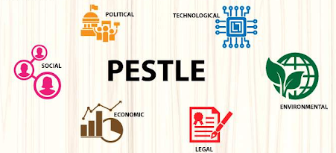
Fig.1 PESTLE analysis. Source: (Pathak, 2020)
Political:
The political changes have an impact on Volkswagen such as; breaks of any kind may affect the company in creating an image or situation that would raise their brand. The big business needs to raise their brand-worth internationally and globally (Friesendorf and Uedelhoven, 2021). Therefore, political stability in any country may affect the brand itself.
Economic:
Economic factors have directly affected the greatest automaker of the European Union “Volkswagen.” The organization has faced financial issues because it lowered the demands for vehicles in the market which ultimately demolished the sales and the revenue of the brand and thus, no profit was generated (Chodakowska, 2018). As it already survived from the unstable economic condition, the diesel scandal is a catastrophic event. Although it has exceeded its sales again.
Social:
Volkswagen is considered a much better vehicle maker due to its ecological nature. Also, they enjoy a excelling status as one of best manufacturers of Automotive cars.
Technological:
Where the technological factors are concerned it also has an impact on the brand. Volkswagen is popular for delivering productive quality and stylish vehicles. The competitor of the VW — Audi organization has a primary focus to develop the future mobility, but Volkswagen is a cornerstone of the innovative future mobility. Hence, gain popularity and dominance in the technological field.
Environmental:
Volkswagen is an environment-friendly manufacturer of automotive cars. As it is committed to meet advanced emission technology. Since 2015, countless cars can be recreated to meet the target standard of emission.
Legal:
Voklswagen has also often faced legal issues like the case of the diesel scandal (Blackwelder et al., 2016). For this concern, they had to submit an ample amount as fine, but it was saved from any restrictions by the law for manufacturing the vehicles. However, these types of issues can seriously damage the business’s brand imaging.

Advantages and Disadvantages of PESTLE Analysis
Advantages
- This model is easily understandable and conductible.
- It provides an in-depth understanding of the macro-environment factors.
- It develops strategic thinking among the members of the organization.
- It allows organizations to forecast threats that might be faced in future. Also identify the ways to minimize or eliminate the impacts.
Disadvantages
- Usually, PESTLE analysis uses insufficient data to simplify the decisions.
- Data should be relevant and concise. Otherwise, capturing and undertaking the excessive data may lead you in the wrong direction and thus paralysis the whole analysis.
- PESTLE analysis is based on the postulates that might be wrong or often outdated. Therefore, the risk of wrong outcomes.

2.2. Porter’s Five Forces Analysis
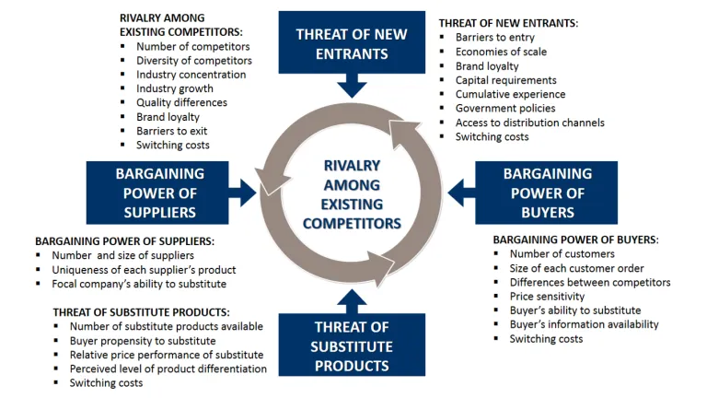
Fig.2: Porter’s five forces model. Source: (de Bruin, 2016)
Bargaining Power of Suppliers:
For Volkswagen, the supplier’s bargaining power is low that is mainly because of the reason that VW’s suppliers are scattered throughout the world, and they are bound to follow a specific code of conduct as proposed by VW. The company is a huge and financially strong entity with a strong global supply chain (Pandey and Kumar, 2016). The bargaining power of VW’s suppliers is also considered to be low as it keeps switching its suppliers. However, VW’s long-term partners get to bargain slightly.
Bargaining power of Customers:
Due to excessive brand presence in the market, the bargaining power of the customer has increased in previous years. Also, as the customers in the current era are smarter and informed, they, they tend to ask and bargain depending on the quality and safety aspects of the vehicle. Also, the competition has touched new limits and companies are in a continuous run to match with the customer’s expectations. Thus, overall, the bargaining power of the customer is high.
Threat of Substitute Products
In the current time, the threat of any substitute products is also quite high as the competition in the industry is quite high. Apart from product substitutes, the introduction and fame of other modes of public transport also works as a substitute of the VW’s vehicles. However, the impact is moderate for the VW as it is a financially strong company with a remarkable brand image. moderate.
Threat of New Entrants
For VW, the threat of any new entrants is very low as it poses high barriers for the new entrants. The company is spending a huge amount on the infrastructure including designing, manufacturing, supply chain, marketing, distribution and its human resources as well. Also, new entrants also find it difficult to enter the market due to the legal regulation they may have to face. Thus, the threat of new entrants is quite low or negligible.
Intensity of Rivalry
Where the threats are low to moderate for VW, the intensity of rivalry is quite high. That is because a huge number of competitors tend to offer similar products with similar quality but at a lower price. They heavily invest in marketing and R&D (research and development) to bring about new technologies into the competitive market. Overall, for VW, the intensity of rivalry is quite high.

2.3. SWOT Analysis
SWOT Analysis is also called the “situational assessment” which is a strategic management tool that helps the organizations to analyze its Strengths, Weakness, Opportunities, and Threats (Gurel, 2017).
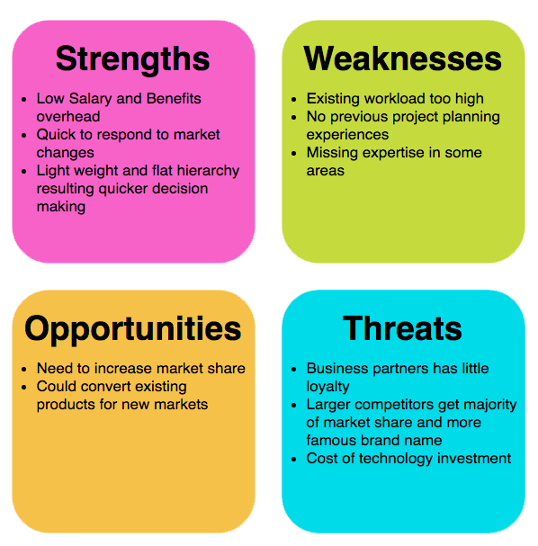
Figure 3: SWOT Analysis. Source: (Visual Paradigm, 2019)
Strengths:
- Volkswagen has been considered as the most trustworthy brand among all the automobiles vehicles industry.
- The diversification of the company in term social and culture factors brings a boost as a whole.
- They have faced the huge market around the world because it also has a partnership with the other brands (Olabi et al., 2022).
Weaknesses:
- The high negative publicity can worsen the brand image of Volkswagen around the world.
- The United State automotive car industry recreates the same model as of the Volkswagen.
- It has a low share with US based automotive markets.
- Vehicles that are operated on the battery are not considered as the innovative skills of the Volkswagen (Lee, Kim and Lee, 2021).
Opportunities:
- The prices of fuels will be expected to increase even more in future.
- As the automotive car industries rise, the demand for driverless vehicles is considered as a goldmine because it will boost the image of the organization.
- The prize of the Volkswagen dropped down as the Euro currency rate decreased.
Threats:
- The competition of the automobiles vehicles in the market has been raised in number.
- Still, the company must submit the further fine for the damages and also had paid in the past.
- The Government’s regulations are increasing for automotive cars.

STRENGTHS  Considered as World Best  Diversified nature  Partnership with another brand | WEAKNESSES  Bad publicity  Less US based markets  Negative consideration
OPPORTUNITIES  Driverless vehicles  Declination of Euro rate  Achievement policies | THREATS  Number of Competitors  Undue fines  Government regulations increase
Figure 3: SWOT Analysis of Volkswagen

Internal Analysis of Volkswagen

3.1. Segmentation and Positioning of Volkswagen
Geographical Segmentation
In terms of the target audience, Volkswgaen is very diversified including the upper class, upper-middle-class, and middle class. This premium brand has a defined target audience that has similar interests and needs therefore, only targeting the higher class towards their premium cars, for example, Bugatti, Audi and Lamborghini (Gaultier and Marcello, 2021).
Demographic Segmentation
Likewise, the brand has a defined demographic attributes to market their automobiles and car. It usually targets the audience aged between 25-44 years because, the people of age or in between have more interest or need toward the Volkswogen therefore demographic attributes is a factor. However, the design and the styles of the car may vary from person to person or may be replaced as a new trend is launched (Schlegelmilch, 2022).
Positioning
Undoubtedly, Volkswagen puts in impressive effort to launch intelligent innovations and new technologies to become the best brand of the automobile around the world and wins the heart of the customer with the quality designs. Hence, the success of the brand depends on the customer satisfaction. The higher customer satisfaction leads the brand to long term success (Fonseca, 2021).
Volkswagens has star Alex Morgan in the ad campaign as a celebrity endorsement. She is a notable and well-known US footballer and Volkswagen surprised the audiences by revealing her as a brand ambassador. This market strategy attracts the attention of the millions of the audience by viewing a girl as a star in the giant new car ad campaign.

3.2. The Marketing Mix Strategy of Volkswagen
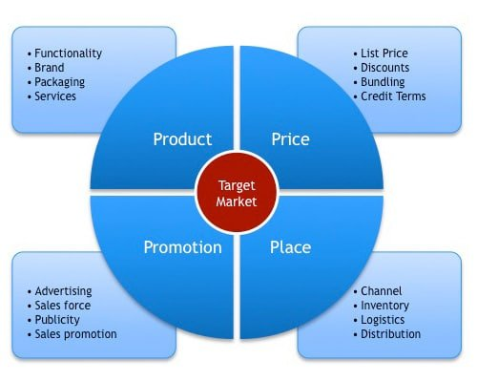
Figure 4: 4P’s Marketing Mix. Source: (Acutt, 2015)
Product
Volkswagen has built a strong brand image by selling the product under different companies and therefore, partnership with different brands enables the parent company to sell out the car models to fulfill the needs of all kinds of customers. It is also at the top list in terms of the product portfolio as it has the broadest products that offers a portfolio of 70 different models and 122 brands in its product portfolio. In addition, VW automobile company offers all kinds of cars, for example, SUV ,coupe, hatchbacks ,convertibles, sedan and sports (Guo, 2021).

Price
The price is one of the most pressing things that comes to the mind of the audience while buying a product. The price of the car depends on the model, size and engine power. While the price of the car ranges from the affordable price to the expensive price. The famous Volkswagen company serves their products to every segment with a cost-effective price and thus increase their brand selling (Helmold, 2020). Also, it has a large range of competitors that sell the product pricey. Volkswagen prices its cars through a competitive pricing strategy, and it prices its luxurious collection a little more expensive to keep it premium for the upper class.
Place
The famous brand, Volkswagen designed and distribute their car in a prime location. The company markets its assembling units and manufacturing globally including Mexico, Germany, China, Malaysia, USA and Indonesia. However, the company offers 124 manufacturing units to Market their products including 20 in European countries and 11 in other countries of Africa Asia, and America (Bai, 2021). Hence, the company that holds its presence on the international level can definitely attract a more positive brand image which also boosts the brand identity globally.
Promotion
As Volkswagen has invested in 360 promotions and advertising campaigns, it has promoted each model of its cars individually and even the same its parent company does. However, the company may use different mediums to market or promote their products like social media. Apart from digital media, they also use traditional means like newspaper and magazines, event organization, and roadshows to promote their products (John, 2020).

Conclusion
Undoubtedly, Volkswagen is a well-known and established brand. The company is still trying to manufacture dynamically designed and innovative products according to the new generation’s demands and needs. The structured product strategy helps the company to attracts customer geographically and internationally. The premium quality car with innovative technology has helped the company to gain a positive brand image which also boosts the brand’s reputation Internationally. The Volkswagen company due to its accuracy marketing strategies also help it to achieve more success.

Recommendations
Considering the Ansoff Matric that the company uses for its growth in the international market, the company can focus on its market penetration, market development, product development, and diversification to improvise as well as strengthen its competitive advantage. For better market penetration, the company can consider increasing its production capacity and marketing investment to grab new and better population along with enhancing its distribution at a competitive pricing. For this, the company can also consider reducing its operational costs without cutting an edge on quality and by acquiring its competitors by opting for different partnership and joint venture opportunities. For market development, focusing and investing in its R&D department will be a fruitful investment that, along with regional as well as international expansion, can ensure a stronger competitive advantage for the company. For product development, the company can consider modifying its previous products along with launching new products that meet the needs of the new era as well as the majority of the targeted audience in a specific age category. However, this cannot be possible without considering vertical or horizontal diversification.

Reference list
Acutt, M. (2015). 4Ps in Marketing – The Marketing Mix. [online] The Marketing Mix. Available at: https://marketingmix.co.uk/4ps-in-marketing/.
Bai, Y. (2021). Analysis of Overseas Management Strategy of the Volkswagen Group. [online] www.atlantis-press.com. doi:10.2991/aebmr.k.210319.042.
Blackwelder, B., Coleman, K., Colunga-Santoyo, S., Harrison, J. and Wozniak, D. (2016). The Volkswagen Scandal. Robin Case Network. [online] Available at: https://scholarship.richmond.edu/robins-case-network/17/.
Chodakowska, A. (2018). The mobility revolution in the automobile industry. Electric cars and battery management. [online] www.theseus.fi. Available at: https://www.theseus.fi/handle/10024/150259.
de Bruin, L. (2016). Porter’s Five Forces EXPLAINED with EXAMPLES | B2U. [online] B2U - Business-to-you.com. Available at: https://www.business-to-you.com/porters-five-forces/.
Fonseca, T.F.C.L. (2021). How can premium automotive brands maintain their status, while sharing technology with their respective auto groups? - the case of Audi and the Volkswagen automotive group. run.unl.pt. [online] Available at: https://run.unl.pt/handle/10362/123391.
Friesendorf, C. and Uedelhoven, L. (2021). Macro-Environment of Mobility. Mobility in Germany, pp.11–17. doi:10.1007/978-3-030-71849-7_2.
Gaultier, C. and Marcello, K. (2021). VOLKSWAGEN GROUP SUPPLY CHAIN ANALYSIS IN EUROPE. African Journal of Emerging Issues, [online] 3(8), pp.1–10. Available at: https://www.ajoeijournals.org/sys/index.php/ajoei/article/view/220.
Guo, J. (2021). Analysis of the Marketing Strategies of Luxury Cars in China—Porsche as an Example. [online] www.atlantis-press.com. doi:10.2991/assehr.k.211209.156.
Gurel, E. (2017). SWOT analysis: a Theoretical Review. Journal of International Social Research, 10(51), pp.994–1006. doi:10.17719/jisr.2017.1832.
Helmold, M. (2020). in the Automotive Industry. Management for Professionals, pp.107–113. doi:10.1007/978-3-030-46985-6_11.
John, A.J. (2020). How online reviews and its impacts affects brand loyalty and customer satisfaction of Volkswagen India Pvt. Ltd. [online] norma.ncirl.ie. Available at: http://norma.ncirl.ie/id/eprint/4672.
Lee, Y., Kim, Y.J. and Lee, M.C. (2021). Improving public acceptance of H2 stations: SWOT-AHP analysis of South Korea. International Journal of Hydrogen Energy, 46(34), pp.17597–17607. doi:10.1016/j.ijhydene.2021.02.182.
Olabi, A.G., Wilberforce, T., Sayed, E.T., Abo-Khalil, A.G., Maghrabie, H.M., Elsaid, K. and Abdelkareem, M.A. (2022). Battery energy storage systems and SWOT (strengths, weakness, opportunities, and threats) analysis of batteries in power transmission. Energy, 254, p.123987. doi:10.1016/j.energy.2022.123987.
Pandey, A. and Kumar, A. (2016). Application of Porter Model on Chinese Automobile S. [online] Available at: https://socrd.org/wp-content/uploads/2016/08/14BKK124-Application-of-Porter_s-Model-and-Johnson-Cultural-Model-on-Chinese-Automobile-Sector.pdf.
Pathak, R. (2020). What is PESTLE Analysis? Factors, Advantages and Disadvantages of PESTLE Analysis. [online] www.analyticssteps.com. Available at: https://www.analyticssteps.com/blogs/what-pestle-analysis.
Perera, R. (2017). The PESTLE Analysis. [online] Google Books. Nerdynaut. Available at: https://books.google.com/books?hl=en&lr=&id=ZWpLDwAAQBAJ&oi=fnd&pg=PA2&dq=what+is+pestle+analysis&ots=DudZwK1yMy&sig=fgtyrNFro2fSMM12htbBI1xOvL0
Schlegelmilch, B.B. (2022). Segmenting Targeting and Positioning in Global Markets. Management for Professionals, pp.129–159. doi:10.1007/978-3-030-90665-8_6.
The Editors of Encyclopedia Britannica (2021). Volkswagen Group | Overview, History, & Facts. In: Encyclopædia Britannica. [online] Available at: https://www.britannica.com/topic/Volkswagen-Group.
Visual Paradigm (2019). What is SWOT Analysis? [online] Visual-paradigm.com. Available at: https://www.visual-paradigm.com/guide/strategic-analysis/what-is-swot-analysis/.

