Assignment 2
By Dylan Matthews

1.The ground floor. Construction, detailing and junctions with external walls.
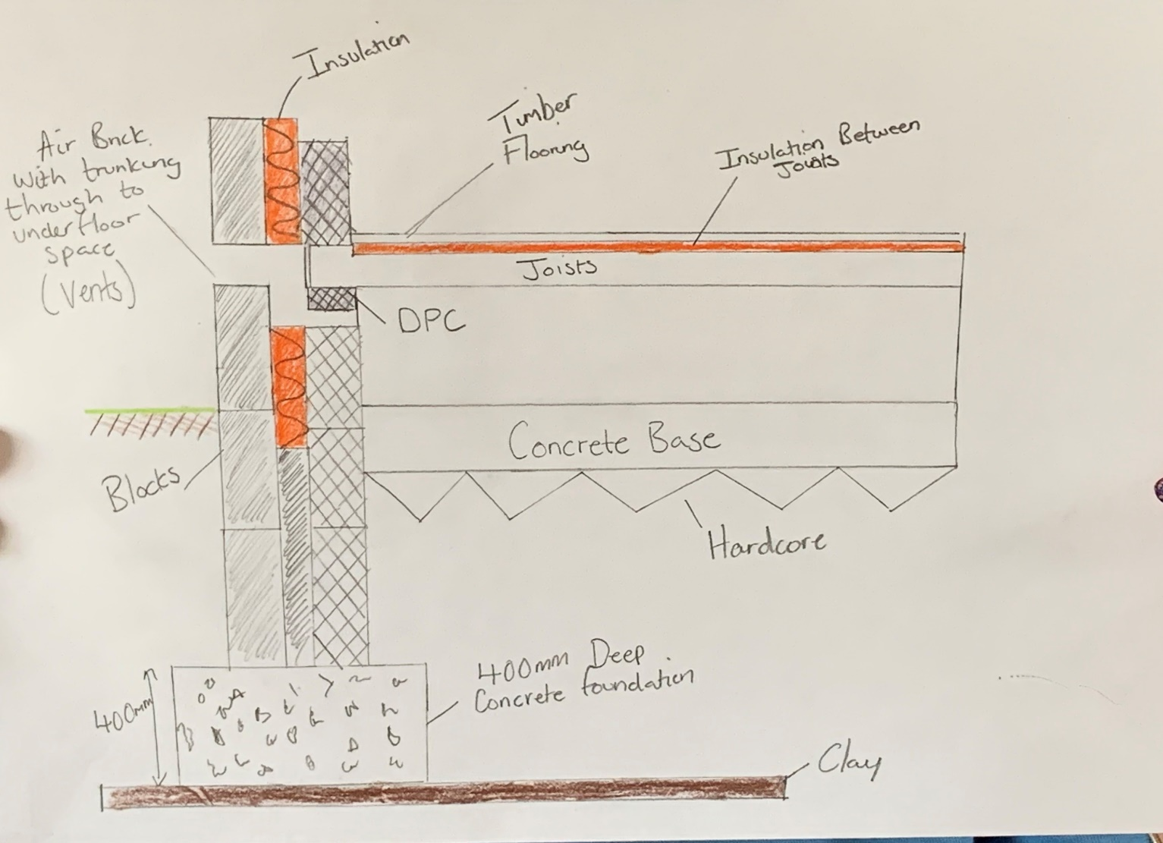
The First phase of constructing this house will be to excavate 450mm of top soil and use a 400mm deep concrete strip foundation.
The weather changes throughout the year dictate the clays density. The foundations I have chose is strip. These foundation must be cast at a minimum of 750 mm in low plasticity clays. 900mm and 1000 in high risk areas. Mine is a strip foundation excavated at 850mm.
The Trouble with trees
If you find tress to be within your area you may find out that these depths wont be enough. This is because when there isn’t rain for a long time trees suck up moisture from the clay. This can cause settlement and cracking within a house that has shallow foundations.
In the building regulation for ground floors the structure must be protected against growth of weeds and plants. This is formed by a concrete and built with a ventilation gap that requires 150mm between the underside of the concrete and timber. This is done so we be sure that moisture doesn’t gather in and around the joists effecting their jobs. The timber floor joists will need to be the exact same size and this will be dependant on its width. Then these will be put across the pan of the wall and the area underneath will need tp be left open and free.

A damp proof course should be put into place between the timber and the wall. The next stage is to fill all the joist up with insulate, the thickness on the insulation depends which products you used. The air ventilation must be put into place typically underneath timber flooring. Air should be able to travel throughout the building.
Air brick gaps are left to ensure ventilation is getting any moisture out.
The construction of the house will be block and block work with a smooth render finish. And also the flooring will be wood. No other detail is we will have wall ties in between blockwork to make sure that the outside wall does not fall out or collapse inside.
Pillars will also be added underneath the porch and the plinths and soldier courses will be in a sandstone material.
2. The first floor. Construction, detailing, junctions with external walls and restraints.
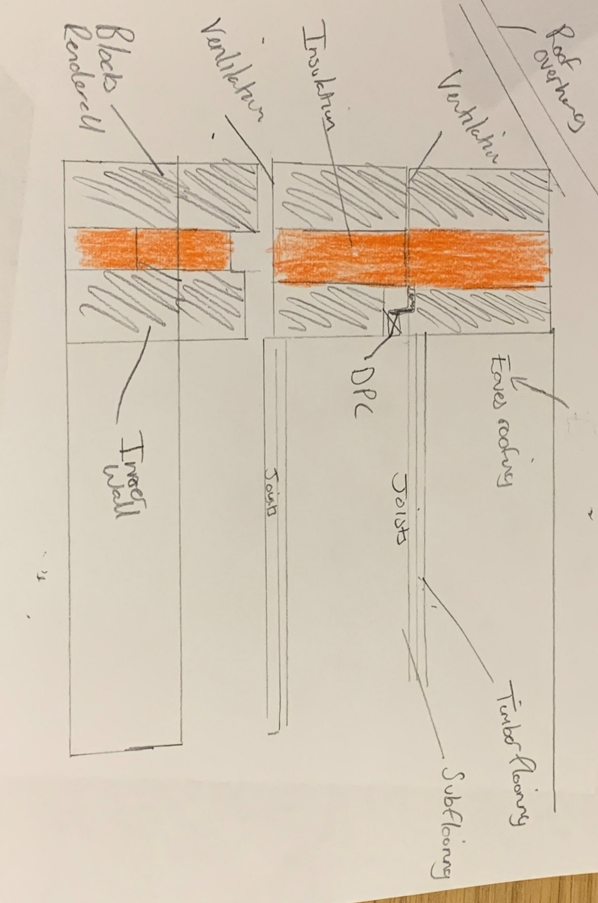
As we have timber joists it means they are going to be exposed to damp and rot if we do not lay them properly. They need to laid upon galvanised joist hangers and not embedded wall. The joist rests on the sleeper wall so there must be a damp proof course there between timber and wall.
We must ensure there is ventilation between the timber floors. If moisture is collected and not ventilated it will cause rot. Air bricks can be used and can be fitted on the external walls And ventilation through sleeper wall must be used. It is important to follow the building regulations.
We must ensure that we do not let weeds and plants grow underneath the surface of our building.

The regulations that are in place for 1st flooring are:
- Using concrete to prevent spread and growth of weed.
- Air bricks used to provide the ventilation from the outside underneath the hollow floor. If the space below ends up to be under 150mm sleeper walls can’t be used
- The specific spacing that joist needs to cover will be decided in the floors spans table.
- Calculations are used so that we can install openings through the floor which can be things like staircase. We normally just double up on joints.
- There must be damp proofing added, This must be in place where timber meets the walls.
- We use Joist hangers for when the joist meets the wall. This is preferred to embedding the joists into the wall.
- Insulation will have a minimum value on a new build of 0.11 watts

3. Openings. Solutions for lintels, sills and jambs.
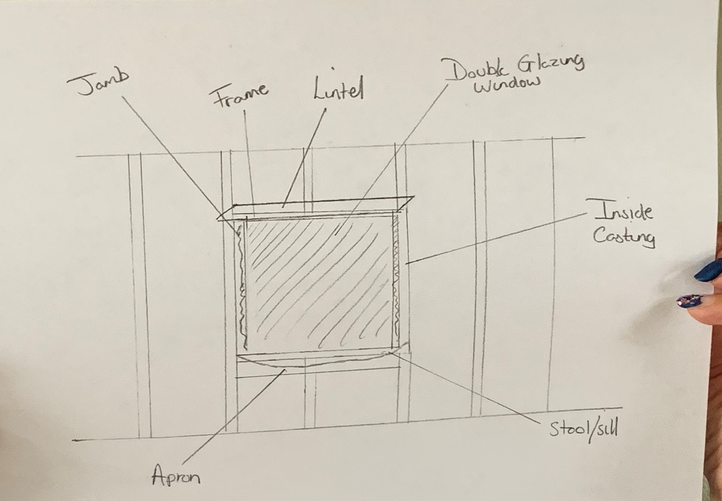
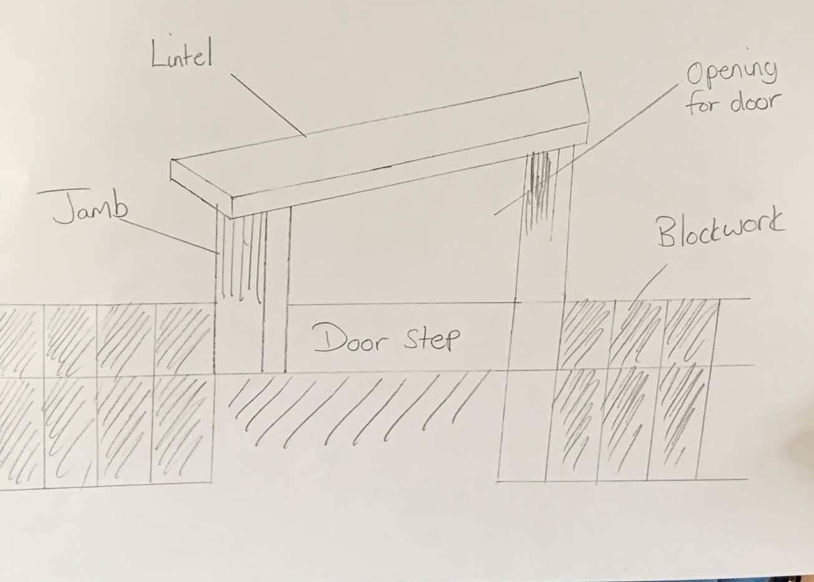

Building regulations in April 2002 it is to be deemed that regulations must meet both thermal and safety criteria, air supply , means of escape and ventilation.
The external window or door is a controlled fitting within regulations.
A piece called a lintel is used to go across the top of a door or window frame this is to help support the weight of the block on block work. Width of the lintel beam will exactly match the width of the wall. A lintel will be chose for the certain criteria of our build. Our lintel will be timber.

Thermal Heat Loss
There must be dwellings in place for it to be energy efficient. This is to reduce the heat loss we lose through windows and doors.
When it is time to install openings for our windows and doors it is extremely important to follow the building regulations for this. These regulations include the amount of heat that will go through the glass and the framework. This number is measured a U value. This value should never be go over.
Safety glazing
You will need safety glazing in particular areas because it is in a critical area of the build. This should be at least 0.33 square metres, it should also be 450mm in height and 450mm in width. The glazing of the door must be at least 1500m above the floor level.
Ventilation
Windows and doors will create natural ventilation, however the actual rate of ventilation is determined by the size of the room. Higher levels of ventilation is needed for different parts of house like a bathroom where it gets steamy and kitchen. This can also be done by installing mechanical fans and suitably sized window openings
The height and the width cannot be bellow 450mm in the open area and it also cannot drop below 0.33m2
The sill height should not exceed the height of 1100mm above the surface level. This should also be within the open area.

4.Eaves detailing and roof covering – indicating appropriate weathering, fixing and laps.
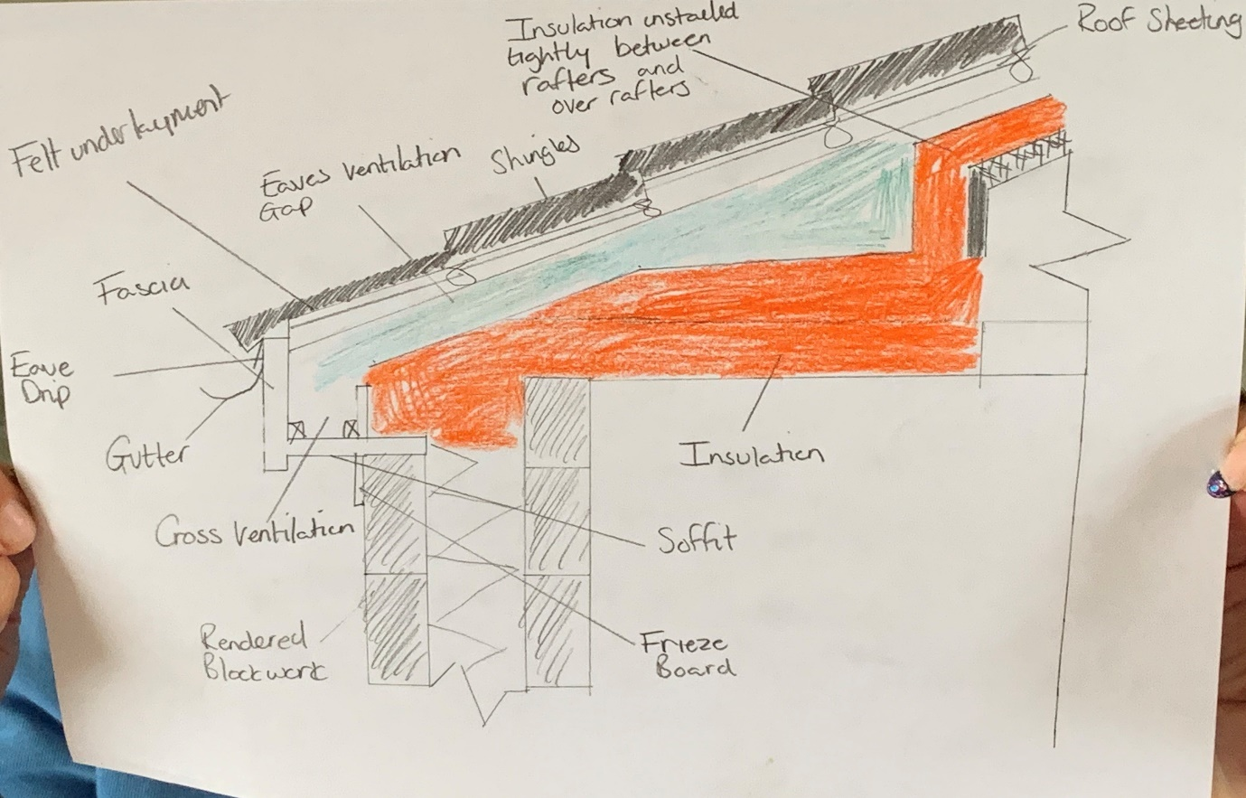

Eaves have practical functions for roofs, such as projecting out over the sides of the structure to provide shade and shelter from the rain and snow, as well as providing the aesthetic distinction between the walls and roof. Eaves can also prevent damage to the building by directing falling debris out and away from the building.
In hot climates, roof eaves can also provide a shelter for the interior from the sun.
An eave drip will be installed to provide the guttering with water that needs to be drained.
Usually, the eaves width relate directly to the pitch of the roof, for example, the steeper the pitch of the roof, the narrower the eaves are over the structure and vice versa.
The types of eaves that are used on constructions are as follows:
- Exposed eaves show the finished underside of the roof and the supporting rafters. These can be seen from underneath.
- soffited eaves are where the underside of the eaves is formed by panelling, creating a 90 degree angle connecting the bottom of the eaves to the side of the building.
Boxed in: boxed in eaves cover the roof rafters, but meets the side of the building at the same angle as the roof pitch. Most types of eaves include a fascia. A fascia is a horizontal board that runs around the edge of the eaves to cover the ends of the extended rafters.
To ensure sufficient ventilation of exposed, soffited and boxed in eaves, air vents are usually installed in the roof structure. This means that if any moisture is built then the ventilation will prevent any condensation from arising. Guttering can also be incorporated into the eaves to drain away any water from the roof into the correct drainage system.

A approved document dating back to 1995 in building regulations is under control for condensation in buildings. This is to ensure that it will not cause damage structural and thermal area and properties.
Condensation The requirement of Approved Document F2 is that condensation is reduced in order that it will not cause damage to the structural or thermal properties of materials in a roof. Dampness is caused by: weather, interstitial condensation, surface condensation, and construction water (in wet constructions).
Roof ventilation is so important in our building this is needed to avoid the issue of condensation. Cross ventilation is required to counter act the condensation. The openings placed on the longer sides of the rectangular roof. Most of the time the roof ventilation is relied on by wind by utilising the thermal up flow. The eaves that lead to the ridge also avoid the issue of stagnant air pockets because of the inadequate through flows.

5.The main roof structure. Construction, detailing and fixing.
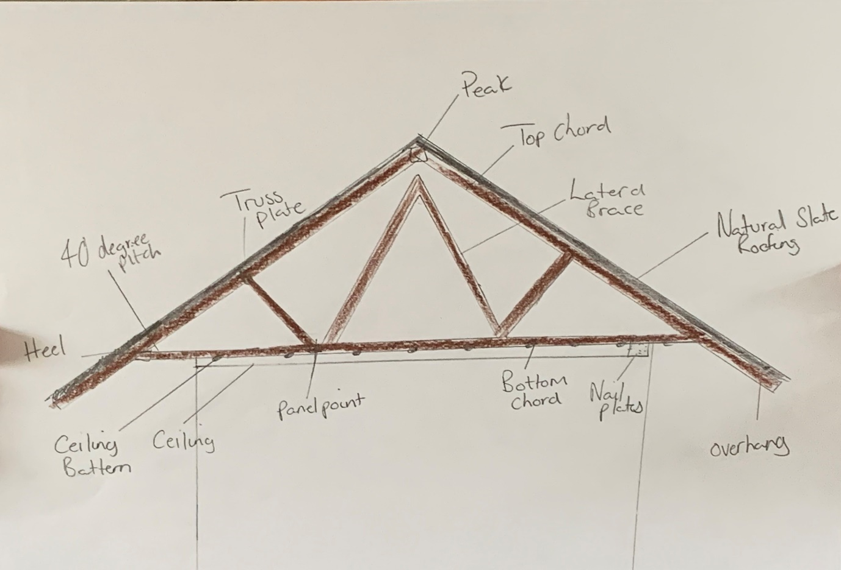

When construction traditional cut roofs, rafters and ceiling joists are combined to form triangles which are then supported by ceiling binders and purlins. These are usually fabricated at the construction site where they are then fixed to the wall plate, usually placed at 400mm centres along the wall plate. The wall plate is then fixed onto the supporting walls.

The roof members are formed into triangles to ensure the highest level of stability and prevention of roof spread is achieved. This can also be achieved by connecting the roof members together and to ridges, wall plates and purlins. In some cases of roof construction, structural timber may be bolted to ensure complete stability.

The size of the roof timber will vary from construction to construction. It can depend on the roof pitch, the weight of the chosen roof tiles, the span of roof members and whether supporting walls can be used to prop members.

Roof trusses

Roof trusses are usually constructed by joining steel plate connectors with timber members at the junctions. The plates need to be connected under factory conditions due to needing heavy pressure on both faces.
They are then transported to the construction site as prefabricated components and fixed to the wall plate, usually placed at 600mm centres, using appropriate metal plates. Wall plates are then attached to supporting walls. Trusses do not need any ridge board or purlins for support.
There are nail plates installed in either side so that the roof structure carrying slates and insulation is supported.
Longitudinal, diagonal and chevron timber braces are attached together to make sure maximum stability is achieved. These are then attached to rafter members, internal member and ceiling chords.
In the structure that we have which a detached two story timber house. The roof trusses are located there to take support of the ceilings and floors and takes the overall framework. The good thing about roof trusses is that they are very tough and reliable. You will be able to use roof trusses in many different types of buildings. They are known for being very quick to construct and also easy. The roof should have continually insulated areas. Only recently there has been changes to regulations which is to increase the insulation levels. A pitched roof will be used and there should be 100mm of fibre glass between our joists and it must fo another 170mm all the way across the joints.
The pitched roof at 40 degrees must have insulation at the rafter point. 150mm of Celotex double will be required between our rafters or we can even have a ventilated airspace at a size of 50mm.
The slates we will be using for our building will be made of natural slate for the dark finish.

Reference page
https://www.diydoctor.org.uk/projects/hollowfloor.htm
https://www.homebuilding.co.uk/foundations-explained
https://www.planningportal.co.uk/info/200130/common_projects/17/extensions/4
https://www.homebuilding.co.uk/floor-structure-guide/
https://en.wikipedia.org/wiki/Timber_roof_truss
https://www.designingbuildings.co.uk/wiki/Window

