A Commentary on the Mérode Altarpiece and its Iconography
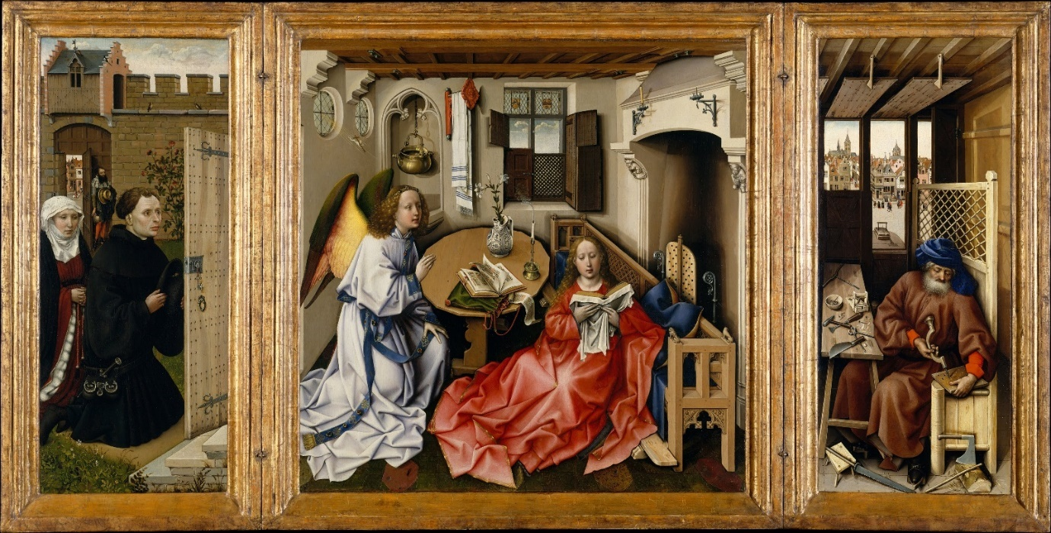
4. Assessment Four: Image Commentary This is 20% your module grade, and is c.2000 words
Write a commentary on an image that you have found via archival research (either digital or physical archives). This could be a page from a digitised manuscript or a painting, photograph, tapestry, map, etc. located in an archive.
The purpose of the commentary is for you to demonstrate that you understand the significance of a visual image, such as a painting or an illustrated page from a medieval manuscript. What we are asking you to do is to set a visual image it within its artistic, literary, social, cultural and/or historical context. You may wish to comment on the following:
Content: What is depicted in the image? What are its most notable aesthetic features? What artistic techniques were used in its production?
Context: What historical period is the image from and how might the image help us understand the historical period (and vice versa)?
Medium & Materials: What type of image is your source? What physical materials were used in its production?
Producer(s): Who made the visual source?
Audience/Setting: Which people was the source intended to be seen by? Where was the image originally situated?
Significance: Why does the source matter? Why do all of the above points matter?
You will also need to relate this to notions of ‘visual culture’ and give consideration to the significance of the particular medium of your chosen image (e.g. a painting, a tympanum, an illumination, photograph, manuscript).

The Mérode Altarpiece is a triptych of the Annunciation painted onto three wooden panels. The work is often attributed to the workshop of Robert Campin, also identified as the Master of Flémalle, in Tournai in the southern Netherlands and is dated to between 1427 and 1432. The triptych is oil painted on oak and is now located in Manhatten, New York at the Met Cloisters, a museum of medieval art and architecture. Painted onto the two smaller side panels on either side of the larger central panel is the workshop of Saint Joseph on the right and a depiction of the patrons in a garden on the left. These two smaller oak panels are hinged and can close. Thre dimensions of the entire altarpiece when open are 64.5 by 117.8 cm, the central panel is 64.1 by 63.2 cm, and the side panels are each 64.5 by 27.3 cm.
The middle panel depicts the scene of the Annunciation at the moment that the Virgin Mary conceives the Christ Child. The room depicted in this central panel is an easily recognisable contemporary Flemish domestic interior. This room is an intensely private and secluded space. Apart from the highest panes in the window, the shutters and screens on the windows are closed so that the only thing that can be seen from the interior are the clouds in the sky. Thus the privacy of preceding Annunciation artworks is maintained. However, the Mérode Altarpiece is the first known depiction of the Annunciation which does not take place in the more common setting of the young Virgin Mary’s bedchamber, the thalamus virginis, but in a contemporary and domestic living space.
The Angel Gabriel faces the Virgin Mary and is in the process of kneeling and bending towards her. This creates an impression that the angel is trying to catch the Virgin’s attention. Mary herself is seated on either the footrest of the long wooden bench or, perhaps, on the floor. She is wearing a loose fitting red robe and is reading from a book. Mary demurely looks at her book and seems to be so absorbed in the subject matter that she appears to be completely unaware of the presence of the angel Gabirel. Possibly she is reading the Old Testament, in particular the prophecies heralding the birth of the Messiah.
Nearly all the furniture and items in the room depicted in the central panel carry a significant religious connotation. The book in Mary’s hands is likely to be the Tanakh, the Jewish Bible and Old Testament, wrapped in a white cloth cover. On the table to her left are a second book and also a scroll. These two items are suggestive of the Old Testament, depicted as the older scroll, and New Testament, the more modern book. The sixteen sided table may be symbolically referring to the sixteen prophets of the Old Testament. The bench Mary leans against is very interesting. It is decorated with lions and dogs. The dog is a common symbol of devotion and the lions recall the Throne of Solomon which was decorated with lions. In medieval Europe The Throne of Solomon was a common Old Testament prototype of the Virgin. This bench is also evocative of the Throne of Heaven. The Virgin’s position against the bench draws attention to her humility and loyalty, intriguingly she has not sat on the bench, but also emphasises how the seat is unoccupied. There is a cushion on the bench and this placement of a cushion on an empty bench is a common symbol found in contemporary Flemish art meaning that the seat will soon be occupied by someone. This sense of readiness can be easily understood as representing the preparation of the world for the coming Messiah which at the same time being symbolic of the Throne of Heaven to which Christ will eventually ascend. The position of the bench in front of the fireplace is the position the master of the house or honoured guests would sit. Similarly this is evocative of making the world ready for the arrival of Christ. The bench is a common type of late medieval bench with a reversible back. Like most of the items in the triptych this piece of furniture serves a dual function. Whilst this reversible back is practical and enables the bench to face either direction it is also evocative of the two heavenly thrones, one of which is Mary’s own throne in Heaven.
The vase of three lilies on the table to Mary’s right most likely represent the Holy Trinity. The two open flowers represent the Father and the Holy Spirit and the third bud represents Christ, being conceived in this very moment. The white vase which the lilies are in is decorated with navy foliage. The three vines curling in the design are symbolic of the Tree of Jesse which is often associated with a vine as well as of the Trinity again. Interestingly the vase is also decorated with what appear to be Hebrew letters. The use of the colours white and navy are also meaningful. In Judaism the colour white is representative of God’s benevolence with navy being symbolic of divinity. These two colours are also commonly found in a tallit, a Jewish prayer shawl, one of which hangs on the wall beside the window. This shawl has often been identified as a towel which seemingly has no obvious symbolism. This would surely be unlikely within the context of the heavily religiously symbolic altarpiece especially when considering the central position of the shawl in the middle panel. The close proximity of this piece of fabric would also lend weight to the argument of it being a prayer shawl as it hangs close to the alcove in the wall which contains a hanging basin. This basin evokes rituals surrounding purification and is also evocative of medieval saint’s shrines you know the type with water fountains. This inclusion of a vase decorated with Hebrew letters and a tallit make this room almost instantly recognisable as being an interior belonging to an Ashkenazi Jewish home. This is perhaps symbolic of the transition of the world from the Old Covenant to the New Covenant, the Old Law into the New Law.
At the absolute centre of the central panel, and therefore the centre of the entire altarpiece, is a lone and recently extinguished candle. This extinction of the flame draws the eye to the very heart of the Annunciation, both in this triptych and its meaning theologically. The source of the gust of air which has blown out the candle’s flame is the Christ Child, the tiny figure of whom can be seen in the top left of the central panel. This sets the timing of the scene to be the second that Jesus is conceived. This symbolism of the extinguished flame is representative of the temporary end of the divinity of God as God is made flesh. This candle also evokes the passage in Isaiah 42:3, “A bruised reed shall He not break, and the smoking flax shall He not quench; He shall bring forth judgment unto truth.” The candle therefore also links to the words the angel Gabriel spoke to the Virgin Mary at the Annunciation which paraphrase those of the prophet Isaiah.
In the right hand panel Saint Joseph works in his carpenter’s shop. The tools at Joseph’s feet, an axe, a saw, and a rod, whilst common in a carpenters’ workshop, are a reference to Isaiah 10:15. During the late medieval period depictions of Saint Joseph shift from an elderly and unproductive figure to a hardworking man who provides for his family. The Mérode Altarpiece fits this newer type for Joseph with the saint hard at work in a contemporary Flemish carpentry shop. What Joseph has been making is displayed on the workbench and the shopfront bench at the outside of the window, mousetraps. The inclusion of mousetraps in the Mérode Altarpiece is probably a reference to a sermon by Saint Augustine, “The cross of the Lord was the devil’s mousetrap; the bait by which he was caught was the Lord’s death.”
What Joseph is currently working on is not entirely clear. Margaret B. Freeman makes a case that the wooden block Joseph is boring small holes into is a spike block. This is an item seen in depictions from the Low Countries of Christ carrying the cross. These spike blocks hang before his shins adding to his torture. This is not be the only cross bearing and crucifixion imagery seen in the Mérode Altarpiece. The tiny body of Christ, about to be conceived, is coming through a round window in the central panel with his cross already leaning on his shoulders. The mousetraps, although less obvious at first, are another image foreshadowing the fate of Christ. The nails on Joseph’s workbench could also fit this image. Perhaps these nails are intended to be placed into the holes in the block to create a spike block.
The city seen through the door and windows of Joseph’s workshop, and also through the garden gate in the left hand panel, is likely to be Liège. Jacques Duchesne-Guillemin makes a case for this in his paper On the Cityscape of the Mérode Altarpiece by comparing the two churches seen through Joseph’s window with the two Liège churches of Sainte Croix and Saint Pierre.
Charles Ilsley Minott, in his article The Theme of the Mérode Altarpiece, puts forward an argument that the mysterious bearded figure standing at the garden gate in the left hand panel is the prophet, Isaiah. Minott bases this argument in the detail of the badge worn by the bearded figure. this badge is bordered by twelve pearls which Minott believes represent the gates of the heavenly second Jerusalem of Revelation 21:21. The badge is also similar to the coat of arms of the city of Malines, three red pales on a field of gold, a city that the family of the patron had connection to. If this figure by the gate is Isaiah it is interesting to note that he has a hand placed on the gate of the garden, evoking the prophet’s role in the realisation of the Messiah and the subsequent opening of the gates of Heaven.
The patron of the altarpiece has tucked in his hat a small bud from the rose bush behind him. The rose is another flower that in the medieval period was symbolic of the Virgin Mary. The flowers of the rosebush are also the deep red colour of martyrdom. This colour is another image of the foretelling of the crucifixion as it is the colour representative of the martyrdom of Christ.
The door which leads from the domestic room of the central panel to the garden in the left hand panel is ajar and has been unlocked from the inside. This detail could reference Ezekiel 44:2, “Then said the Lord unto me, “This gate shall be shut. It shall not be opened and no man shall enter in by it, because the Lord, the God of Israel, hath entered in by it; therefore it shall be shut.” This passage is understood to be a reference to the Virgin Mary and the conception of Christ.
The resonances of the multiple symbolic details in the Mérode Altarpiece draw on the religious knowledge of its early fifteenth century audience. The altarpiece depicts the pivotal moment where the world is remade at the transition from the Old Law of the First Covenant to the New Law of the New Covenant.
Say something about the visual medium as the lingua Franca of the middle ages maybe?

Reference List
‘Annunciation Triptych (Merode Altarpiece)’, The Met, (undated), <https://www.metmuseum.org/art/collection/search/470304> [last accessed 29th April 2025]
‘Robert Campin’, The National Gallery, (undated), <https://www.nationalgallery.org.uk/artists/robert-campin> [last accessed 29th April 2025]
Campin, Robert, The Mérode Altarpiece, ca. 1427–32, oil on oak panel, 64.5 x 117.8 cm, 56.70a–c, The Cloisters Collection 1956, The Met Cloisters, New York
De Coo, Jozef. “A Medieval Look at the Merode Annunciation.” Zeitschrift Für Kunstgeschichte, vol. 44, no. 2, 1981, pp. 114–132.
Duchesne-Guillemin, Jacques., “On the Cityscape of the Mérode Altarpiece.” Metropolitan Museum Journal, vol. 11, 1976, pp. 129–131.
Freeman, Margaret B., “The Iconography of the Merode Altarpiece.” The Metropolitan Museum of Art Bulletin, vol. 16, no. 4, 1957, pp. 130–139.
Hahn, Cynthia., “'Joseph Will Perfect, Mary Enlighten and Jesus Save Thee': The Holy Family as Marriage Model in the Mérode Triptych.” The Art Bulletin, vol. 68, no. 1, 1986, pp. 54–66.
Minott, Charles Ilsley., “The Theme of the Mérode Altarpiece.” The Art Bulletin, vol. 51, no. 3, 1969, pp. 267–271.
Rousseau, Theodore., “The Merode Altarpiece.” The Metropolitan Museum of Art Bulletin, vol. 16, no. 4, 1957, pp. 117–129.
Schapiro, Meyer., “A Note on the Mérode Altarpiece.” The Art Bulletin, vol. 41, no. 4, 1959, pp. 327–328.
Stein, Wendy A., How To Read Medieval Art (The Metropolitan Museum of Art: New York, 2016).
Zupnick, Irving L. “The Mystery of the Mérode Mousetrap.” The Burlington Magazine, vol. 108, no. 756, 1966, pp. 126–133.

‘Annunciation Triptych (Merode Altarpiece)’, The Met, (undated), <https://www.metmuseum.org/art/collection/search/470304>, para. 1
W. A. Stein, How To Read Medieval Art (2016), p. 106; ‘Annunciation Triptych (Merode Altarpiece)’, (undated), para. 2; ‘Robert Campin’, The National Gallery, (undated), <https://www.nationalgallery.org.uk/artists/robert-campin>, para 1
Robert Campin, The Mérode Altarpiece, (c. 1427–32), oil on oak panel, 64.5 x 117.8 cm, 56.70a–c, The Cloisters Collection 1956, The Met Cloisters, New York
‘Annunciation Triptych (Merode Altarpiece)’, (undated), para. 4
Stein, (2016), p. 109
M. B. Freeman, The Iconography of the Merode Altarpiece (1976), p. 130
M. Schapiro, A Note of the Mérode Altarpiece (1959), p. 328; Stein, (2016), p. 109
Stein, (2016), p. 109; Freeman, (1976), p. 131
J. De Coo, A Medieval Look at the Merode Annunciation (1981), p. 114
De Coo, (1981), p. 115
Ibid.
De Coo, (1981), pp. 116-117
Ibid.
C. Hahn, ‘Joseph Will Perfect, Mary Enlighten and Jesus Save Thee': The Holy Family as Marriage Model in the Mérode Triptych (1986), p. 62
Schapiro, (1959), p. 328
Hahn, (1986), p. 63
Freeman, (1976), p. 134
C. I. Minott, The Theme of the Mérode Altarpiece (1969), p. 270
Ibid.
Hahn, (1986), pp. 57-58; Minott, (1969), pp. 267-268
Hahn, (1986), p. 56
I. L. Zupnick, The Mystery of the Mérode Mousetrap (1966), p. 126
Freeman, (1976), p. 138; Hahn, (1986), p. 57
Freeman, (1976), p. 138
J. Duchesne-Guillemin, On the Cityscape of the Mérode Altarpiece (1976), p. 129
Duchesne-Guillemin, (1976), pp. 130-131
Minott, (1969), p. 271
Ibid.
T. Rousseau, The Merode Altarpiece (1957) p. 126
Freeman, (1976), p. 136
Freeman, (1976), p. 135
Ibid.

