Student FEEDBACK FORM
This section details the extent to which the assessment criteria are demonstrated by you, which in turn determines your mark. The marks available for each category of skill are shown. Lecturers will use the space provided to comment on the achievement of the task(s), including those areas in which you have performed well and areas that would benefit from development/improvement.
Generic Assessment Criteria | Marks available | Marks  awarded
1. Engagement with Literature Skills  . | 10
2. Knowledge and Understanding Skills | 20
3. Cognitive and Intellectual Skills | 20
4. Practical Application Skills | 40
5. Transferable Skills for Life and Professional Practice | 10
Assessment Mark (Assessment marks are subject to ratification at the Exam Board. These comments and marks are to give feedback on module work and are for guidance only until they are confirmed. ) | Late Submission Penalties (tick if appropriate) |  | %
 | Up to 1 week late (40% Max) |  | %
 | Over 1 week late (0%) |  | %

Title page
Name: Dominic Hole
Student number: 1800402
Programme of Study: Outdoor Adventure education
Module: BMSP5007 Business Inquiry and Research
Tutor: Dr Roisin Mullins
Date: 12th March 2021 by 3pm

Contents
Introduction 3
Procedure 3
Data Presentation and Findings 5
Conclusion/Reflection 8
References 11

Introduction
This report presents the study of ‘How has the Covid-19 pandemic affected your relationship with nature?’

Nature relatedness is defined as “individual differences in cognitive, affective, and experiential connections with the natural environment” (Zelenski and Nisbet, 2014, p.4).
My positionality and reason for choosing this study was that during the pandemic and subsequent lockdowns I found my relationship with nature was being strained and that I could not fully connect with it, and thus wanted to investigate the impacts others had felt.
I used interviews as my data collection method, conducting three, twenty-minute, semi-structured interviews. The setting for these interviews were zoom calls, with the participants in their home environment. The purpose of these interviews was to collect phenomenological qualitative data. The analysis approach used for the interviews was thematic analysis. “Thematic analysis is a method for identifying, analysing and reporting patterns (themes) within data” (Braun and Clarke, 2006, p.79).

My participants were all female with a range of ages and professions; Participant-A is a 54-year-old receptionist; Participant-B is a 79-year-old retired Piano teacher; Participant-C is a 19-year-old university student.

Procedure
Qualitative research is “an iterative process in which improved understanding to the scientific community is achieved by making new significant distinctions resulting from getting closer to the phenomenon studied” (Aspers and Corte, 2019, p.155). The qualitative research method is appropriate to this research question as it “allows you to identify issues from the perspective of your study participants and understand the meanings and interpretations that they give to behaviour, events, or objects” (Hennink, Hutter, and Bailey, 2020, p.10).

Data collection
I asked three friends/family to each participate in 20-minute interviews, to collect qualitative phenomenological data using an interpretivist approach in response to my research question. Interpretivist means “that the approach seeks to understand people’s lived experience from the perspective of people themselves” (Hennink, Hutter, and Bailey, 2020, p.15). Phenomenology is the science of pure phenomena (Groenewald, 2004). Before the interviews the participants were informed about; the voluntary nature of the interviews, their right to withdraw without affecting their treatment, how their personal data would be secured and kept anonymous, and that the interviews would be recorded. After this I asked the participants to sign participant agreement forms before the interview started.
Following the interviews, I wrote up a verbatim transcription. These transcriptions allowed me to conduct thematic analysis to identify key themes and constructs.

For my data analysis I followed Braun and Clarke’s (2006, p.87) process of thematic analysis, as shown in Figure 1.
Figure 1 (Braun and Clarke, 2006, p.87):
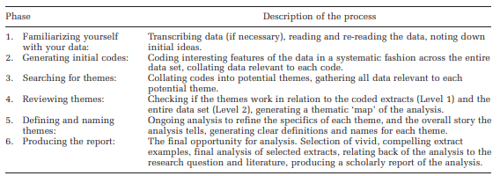

Data Presentation and Findings
Time after pandemic
A key theme through the interviews was that increases in time afforded by the pandemic caused participants to spend more time outside, exposed to nature than pre-pandemic amounts. However, this wasn’t true of all situations; from Participant C’s perspective, during the beginning of the first lockdown the workload was still high and unaffected by the pandemic which may negatively affect the ability to access nature.
“still having a full day of uni lectures from at home then I’m not going to be going outside as much as if my only walk normally was to and from lectures then I wouldn’t be able to go out” (Participant-C).
However, once workloads subsided, Participant-C followed the same theme of Participant’s A and B in spending more time in nature.
“I doubt I would have had the opportunity or time to try and learn to kayak and do other more adventurous sports outside” (Participant-C).
“being able to actually observe some of the changes in the structure of plants and trees and what have you is actually more extensive because there is time to see it” (Participant-B).
“normally, you don’t have as much time on your hands […] you’ve got different activities normally going on, whereas now you don’t have any limitation on time” (Participant-A).

Nothing else to do
One of the themes identified as a key motivator for participants time and exposure to and absorption within nature and the outdoors was the factor of there being nothing else to do. This factor relates to Participant-A’s previous comment on having more time.
“In summer I probably spent more time outside because there was nothing else to do so when I was free, I’d go outside really and go for walks and kayak and things” (Participant-C).
“one would be indoors most of the time unless there was a regular routine to make it out” (Participant-B).
“because during every lockdown that I haven’t been able to play tennis so the only thing left is walking” (Participant-A).

Relaxation
Being able to ‘escape’ into nature can be key to clearing your mental-bandwidth (Basu, Duvall, and Kaplan, 2019) which allows you to feel a sense of relaxation. This theme of relaxation was identified by all participants as a benefit of being outdoors in nature.
[Prefer inside or outside activities?] “outside because it’s more variety, more relaxing as well, being outside” (Participant-C).
“I just find the whole beauty of untamed nature very soothing very calming and certainly makes one feel a whole lot, you know better in one’s self” (Participant-B).
“you haven’t done as much in nature areas, you’ve stuck more to pavements, and then if you go back into a countryside […] it’s somehow far more relaxing walking in those areas” (Participant-A).

Appreciation of nature and the outdoors
One of the most mentioned changes in the participants relationships with nature that came about due to the pandemic was that of finding a greater appreciation of nature. This is preceded by Participant-C identifying how before the pandemic they lacked appreciation for nature, and the outdoors was more somewhere you went through to go elsewhere.
“I think I didn’t really appreciate it that much because it was just outside, because I was going outside just for short times and not really absorbing it” (Participant-C).
Following the pandemic however Participant-C along with Participant’s A and B all reported a greater appreciation of the outdoors.
“I think I appreciate more going on walks and being outdoors than I did before, it’s more exciting to go on a walk than it was pre-pandemic, I think” (Participant-C).
“I think it’s made me appreciate it even more than I hither to did, […] because ones scrutinised it rather more intensely one has appreciated it more” (Participant-B).
“appreciate far more that actually you can enjoy going for a walk, but there’s far more enjoyment going for that same length of time or distance walk if it’s in totally natural areas, rather than urban areas” (Participant-A).
This attitude shift may have been caused by the greater exposure to nature afforded due to the aforementioned extra time and lack of other activities

Appreciation of local area
Building upon this greater general appreciation for nature Participant’s A and B reported that not only had their general appreciation of nature improved but in fact their appreciation for the local area around where they lived had especially changed.
“it’s widened the areas that we have covered in our own location because we have found footpaths that hither to, we never knew existed, so it has widened our appreciation of the area considerably” (Participant-B).
“I think I now have a far better understanding of where nature is on our doorstep, whereas before I would’ve felt we had to drive somewhere to get to nature areas, or different areas, I now appreciate the countryside you can get to right on your doorstep” (Participant-A).

Benefits
As a result of these changes, spending time in nature, and appreciation of general and local natural environments the participants have reported several benefits from this greater appreciation of, and exposure to nature.
“I think being forced to go out on walks before made me realise how beneficial they can be” (Participant-C).
“I think less stressed, more relaxed, yeah happier” (Participant-C).
“the ability to be out in the weather, hearing the birds and seeing flowers and trees is a very good factor to make you feel much better in yourself” (Participant-B).
“I think it definitely has a calming effect, I think it definitely helps your mental wellbeing […] by doing it outdoors surrounded by nature, I think it has a far greater benefit mentally” (Participant-A).
These benefits experienced by participants after spending a greater time exposed to nature and connecting with nature follow the biophilia hypothesis (Zelenski and Nisbet, 2014).

Change in relationship with nature
The exposure to nature nurtured during the pandemic has created a change in the participants relationships with nature. The participants all reported an improved relationship with nature following the pandemic than they experienced before the pandemic.
[Greatest nature connection, before or after pandemic?] “With nature I would actually go as far as to say after the pandemic […], I would say it intensified during the pandemic, because it allowed you to stop still and stare” (Participant-B).
“I think you’ve become far closer, you’ve seen it on a far closer scale than you’ve ever seen before really” (Participant-A).
“now that I’ve realised how beneficial it can be, I make more of an effort to go outside and experience it than I did before” (Participant-C).

Conclusion/Reflection
Conclusion
My findings are that in the situations where the pandemic has afforded more spare time which is unable to be filled by participants normal activities, they have turned to the outdoors in order to fill that time. As a result, participants have experienced a greater exposure to nature and its inherent benefits. This has caused a shift in their perceptions of nature, causing an improved nature connection. Thus, creating active desires to include nature into their daily lives more frequently, even post pandemic restrictions.

Reflection
Figure’s 2 and 3 show a reflective account of the strengths, weaknesses, ethical concerns, and future changes of improvement following this research.
Figure 2:
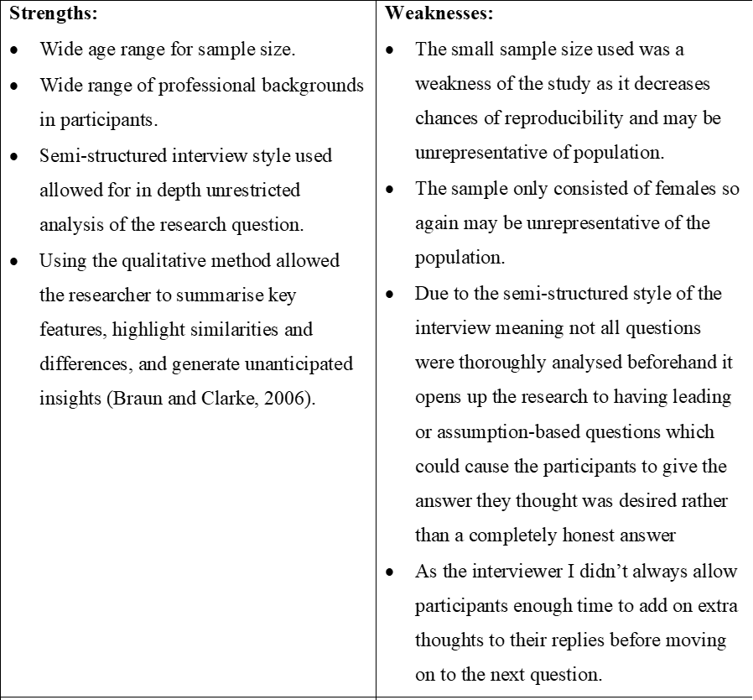

Figure 3:
Word count: 1644

References
Agee, J. (2009) ‘Developing qualitative research questions: a reflective process’, International Journal of Qualitative Studies in Education, 22(4), pp.431-447. DOI: 10.1080/09518390902736512.
Aspers, P. and Corte, U. (2019) ‘What is Qualitative in Qualitative Research’, Qualitative Sociology, 42, pp.139–160. DOI: https://doi.org/10.1007/s11133-019-9413-7.
Basu, A., Duvall, J. and Kaplan, R. (2019) ‘Attention Restoration Theory: Exploring the Role of Soft Fascination and Mental Bandwidth’, Environment and Behavior, 51(9–10), pp. 1055–1081. DOI: 10.1177/0013916518774400.
Braun, V. and Clarke, V. (2006) ‘Using thematic analysis in psychology’, Qualitative Research in Psychology, 3(2), pp.77-101. DOI: https://doi.org/10.1191/1478088706qp063oa.
Groenewald, T. (2004) ‘A phenomenological research design illustrated’, International Journal of Qualitative Methods, 3(1). Available at: http://www.ualberta.ca/~iiqm/backissues/3_1/pdf/groenewald.pdf (Accessed: 07/03/2021).
Hennink, M., Hutter, I., and Bailey, A. (2020) Qualitative Research Methods. 2nd edn. London: Sage.
Zelenski, J, M., and Nisbet, E, K. (2014) ‘Happiness and Feeling Connected: The Distinct Role of Nature Relatedness’, Environment and Behaviour, 46(1), pp. 3-23. DOI: 10.1177/0013916512451901.

