The Enquiring Teaching

PGCE Primary

ECPP7001

Student Number: 1702921

Word Count: 6176


Content Page
Aims, focus and purpose of the research  Research context  Short overview of relevant literature  Explanation of you lesson study design  Ethical consideration  Lesson study and analysis  Discussion of research findings in relation to related literature and research  Conclusion  Recommendations  Reference List | Page 2  Page 2-3  Page 3-4  Page 5-8  Page 9  Page 10-14  Page 15-16  Page 17-18  Page 19  Page 20-24

Appendix A  Appendix B  Appendix C  Appendix D  Appendix E  Appendix F  Appendix G  Appendix H  Appendix I  Appendix J  Appendix K | Observation sheet  Amended Observation sheet  Children’s assent and parental consent  Reflection notes from both observations  Ethics form  Explanatory statement  Lesson study 1 Lesson plan  Lesson study 2 Lesson plan  Lesson study 1 Observation notes  Lesson study 2 Observation notes  Parental consent form | Page 25  Page 26  Page 27  Page 28  Page 29  Page 30  Page 31  Page 32  Page 33-34  Page 35-37  Page 38
List of Appendices

Aim, focus and purpose of the research
During Professional Teaching Experience one (PTE1), I was placed in a reception class. The classroom was large as it had 50 reception pupils and 2 class teachers. All 50 children were placed in ability groups and would work in these groups throughout all focused activities. Whilst teaching and working with the children, it was brought to my attention that there was little peer support or peer learning during the focused activities. Most of the children would complete tasks independently or alongside the teacher or teaching assistant. In addition, the children would go and choice from the enhanced or continuous provision once the task was completed rather than support a friend in their learning. As a result of this, I wanted to conduct research to determine whether children support their peers learning naturally or if it is something that needs to be taught at home with siblings and in school with friends. This research project aims to examine if children use peer support within classroom activities such as focus tasks to aid their learning. Throughout this project, I will also consider how the children use collaborative learning in the classroom and if peer support is a process that the children need to practice in order to gain purposeful learning within the Foundation Phase. This small-scale research will be conducted over 2 days with a partner.

Research context
Both my partner and I were in a Foundation Phase classroom for PTE1 and were interested in peer learning within the classroom. Both my partner and I have seen peer learning be implemented well within a year 5 class and were interested to see if children support their peers naturally, go to their peers for help or if it is something that needs to be taught. I discussed this with my partner and she said that within her class, the children were used a strategy called talk partners during carpet time and also during focus tasks. During my time in reception, I saw little collaborative learning or children referring to their friends for support in their learning. After much discussion with my partner, we both decided that our research question would be ‘Do children use peer support within focus tasks to help their own and others learning within the foundation phase?’
Observations would be carried out within the Reception class first. From the observations, I would like to see if the children use peer support during this task without prompting from the teacher. The second observation will be implemented in my partners classroom within a year 1 class. During my partners observations, the children will be grouped in the hope that they support their peers during the activity. Within the year 1 class, the children are used to working with their talk partners during carpet time activities and task introductions. My partner and I are hoping that we see more peer support within the second observation as a result of this.

Short overview of relevant literature
According to Mastergeorge and Webb (2003) collaborative learning is where children support each other’s learning. This can potentially development pupils learning and attainment as well as motivation and self-esteem (Mastergeorge and Webb, 2003). Furthermore, peer learning can help develop a child’s self-esteem as they can explain a topic to a friend and receive praise and acknowledgement for their efforts (Mastergeorge and Webb, 2003; Topping, 2005).
Similarly, authors such as O’Donnell (1999) and King and O’Donnell (2009) state that children are more likely to learn from their peers and are also more likely to ask for help from peers than a teacher or adult. Children are also more likely to learn from their peers due to the high level of social interaction (King and O’Donnell, 2009). Additionally, Andrews and Manning (2016) suggest that peer learning can potentially be a powerful way for children to share knowledge and experiences with each other. Children with greater knowledge on a topic are more likely to share with knowledge with peers and siblings (Andrews and Manning, 2016).
Cohen et al. (2002) conducted research on 30 primary school children aged between 3 and 7. These children were split into 2 groups in total. The first group of children all had at least 1 sibling and the second group of children had no siblings. Cohen et al. (2002) then observed the children behaviour during focused and enhanced activities during school and noted whether the children were naturally showing examples of collaborative learning. From this research, Cohen et al. (2002) concluded that children with siblings are more likely to support their peers and also ask their peers for support within the classroom in comparison to children with no siblings. In addition, children with younger siblings are certain to show examples of peer support and learning.
These children were better at turn taking and sharing in comparison to children who were a younger sibling or children who had no siblings. Furthermore, children with younger siblings are also more likely to share with peers and take turns without prompts from teachers. In comparison, children with no siblings are less likely to share, take turns or ask for peer support within their learning (Cohen et al, 2002). However, this research was implemented on 30 children and is therefore small scale. Consequently, further research would be needed on this topic to conclude sound results.
Arthur and Cremin (2014) suggest that the theory of social constructivism highlights the collaborative learning within a social context. Furthermore, Vygotsky (1978) was a social constructivist and believed that there is a fundamental role in social interaction to develop understanding and making meaning (Vygotsky, 1978 cited in Smidt, 2009; Harland, 2003). Vygotsky (1978) suggests that children’s interaction can extend understanding and knowledge through talking and listening to others (Vygotsky, 1978 cited in Macblain, 2014).
Boud and Lee (2005) state that there are some limitations to peer learning. For insistence, Boud and Lee (2005) discuss the implication of talk partners during school where the teacher would have to allocate talk partners to the children based on their ability and personalities. Likewise, the children could also choose their talk partners and Boud and Lee (2005) suggest that children are likely to choose their friends and are less likely to talk about the subject but talk off topic. However, Muijs and Reynolds (2018) suggest that children need to be taught how to implement collaborative learning and talk partners correctly and effectively. Similarly, Bruegman and Jackson (2009) state that children are not born with this ability and such a skill should be modelled by a respected adult such as a parent or teacher.
Likewise, Soller (2001) states that children who have little social interaction will find activities that include peer support difficult. Soller (2001) explains that this could be due to a lack of confidence or an inability to express thoughts and feelings. This is similar to Cohen et al. (2002) research which suggested that children with no siblings find turn taking and sharing a challenge due to lack of experience. However, O’Donnell (1999) would disagree with Soller (2001) as O’Donnell (1999) suggests that peer learning increases social interaction and will increase the child’s confidence due to a high level of social interaction.

Explanation of your lesson study design
The aim of this research was to expand current knowledge on how children learn and use their peers for support within a classroom. The purpose of the research was to collect qualitative data to explore what elements of peer learning were being used within both classes in the same school. The children’s work was analysed in order to provide evidence on how children within the Foundation Phase use peer support within their learning. Furthermore, a lesson study design was chosen where two teachers worked together to plan, teach and reflect teaching and learning in the classroom.
Dudley (2015) suggests that the use of a lesson study should be adopted by all schools as part of a continuous professional development (CPD). Despite originating from Japan in 1870, it gained popularity in the West during this Century (Dudley, 2015). A lesson study allows collaboration between two teachers and also encourages teachers to be reflective on their own teaching and learning (Dudley, 2011). A lesson study allows teachers to plan a lesson collaboratively and address an activity that supports your research questions. Furthermore, a teacher should choose 3 target pupils to observe (Dudley, 2011).
In addition, a lesson should be implemented whilst your partner is observing the classes reaction to the activity. The observer should also be paying particular attention to the 3 target pupils. To conclude the lesson, the teacher and the observer should present the 3 target children with interview questions in relation to the research question (Dudley, 2011). Similarly, Appel et al. (2006) support this by stating that a lesson study is a professional development practice that allows two or more teachers to work collaboratively and reflect on a series of lessons. Furthermore, a lesson study allows teacher to investigate how children learn and what they can bring to the learning experience (Appel et al, 2006; Jones and Norwich, 2014).
However, some challenges have been acknowledged when implementing a lesson study. Authors such as McDougal and Takahashi (2016) state that teachers are often time constrained, so a plan should be made early to ensure that lessons and discussions suit all members within the lesson study. Consequently, authors such as Dudley (2011), Jones and Norwich (2014) and McDougal and Takahashi (2016) state that lesson study can often reveal and withhold sensitive information therefore making members feeling exposed during the lesson study. As a result of this, Dudley (2011) recommends building trust within a group to ensure that all members feel safe and comfortable during the lesson study. This has been emphasised by Hurd and Lewis (2011) and Dudley (2011) and as a result of this, it was agreed that all members conducting the lesson study will remain professional and non-judgemental during the process and focus solely on peer learning within the classroom.
During the lesson, observations were used as a method of collecting data. McNeill (1990) suggests a varied approach when conducting research as the teacher takes on the role of the participant observer and the remaining members take on the role of the non-participant observers. Palaiologou (2008) recommends using a non-participant observer when conducting observations within research as the non-participant is able to focus on the target children and allow a deeper insight to the learning. Although this is a strength, Dudley (2011) recommends that the observations remain specific to the research question.
In order to record our data, myself and my partner discussed using a written record method to record our data, as authors such as Cohen et al. (2007) and Punch and Smyth (2009) state that a written record is one of the most accurate forms of recording childhood observations. In addition, it enables the observer to write exactly what the participants are undertaking as the time that it occurs (Cohen et al, 2007; Punch and Smyth, 2009). Similarly, Moss (2013) states that it allows the observer to conduct the observation without formulating an end result. However, Beaver et al. (2015) suggest that a written record method is one of the longest methods of observations to record and is not always the best method of observation within a classroom environment due to the high level of distractions. Likewise, Beaver et al. (2015) state that an observer cannot observe a child’s learning and behaviour deeply and record data simultaneously.
After conducting further research, my partner and I decided to amend our original methodology and decided to combine the semi-structured observation schedule and the small-group observation form and created our own observation form as show in appendix A. This will be used by the non-participant. As a group, we decided that this would play to both of our strengths as we are both familiar with the written record method but felt that these combined observation strategies would allow us to stay on task. Likewise, Cohen et al. (2011) state that an observer should use the observation strategy or strategies that are comfortable to the individual and will get the best outcome.
According to Laevers (2011, cited in Bennett, 2018), well-being and involvement is apparent when children are focused and engrossed in an activity and are fixated on what they are operating, pushing to the limits of their capabilities. In order to measure this involvement, Laevers suggests following the five-point scale – the Leuven Involvement scale (Laevers, 2011 cited in Bennett, 2018). According to Laevers (2011, cited in Bennett, 2018), the Leuven Scale involved a range of applications such as observations and screening procedures where practitioners allocate a score 1 to 5 for well-being and involvement. During the lesson study, the observation sheet will include a Leuven Scale for involvement to record and allocate scores for the children’s involvement and engagement throughout the observation. The engagement and involvement will be score from extremely low (1) to extremely high (5).
The 3 target children were chosen based on parental consent and children’s assent. Myself and my partner then chose a more able, able and less abled child to conduct the focus task based on consent and assent as show in appendix C. This is in accordance with the United Nations Convention on the Rights of the Child (UNCRC) as it relates to article 3 and 12 which in summary, suggest that children have a voice in matters that affect them directly (UNICEF, 1989). Any changes to assent and involvement were also recorded on a consent and assent form as shown in appendix C as some children did not initially wish to participant but then decided to take part.
After each lesson was implemented, my partner and I would reflect on the outcomes. We would carry out informal discussions and share our thoughts and feeling on the situation. Cohen et al. (2011) state that informal discussions are a key part of developing research as it allows observer to share ideas and reflect on the findings in a non-judgemental environment. This was recorded and safely sorted on a word document as shown in appendix D.
As a pair, we decided to follow Brookfield’s’ method of reflection whilst conducting our own reflection. Brookfield (2017) suggests that there are 4 lenses that could be employed by teachers when critically reflecting on their practice: the autobiographical, the students’ eye, our colleagues’ experiences and the theoretical literature. Firstly, one must self-reflect as Larrivee (2000) and Moon (2006) suggest that this is the foundation of good teaching and an example of good practice if implemented on a regular and critical basis. The students’ eye refers to receiving feedback from students (Brookfield, 2017). This was implemented during the lesson study by conducting interviews with the target children once the lesson was complete. This was recorded on our observation sheet where each child gave us verbal feedback based on the lesson and in relation to the research question.

Once again, this related to the UNCRC article 3 and 12 (UNICEF, 1989). Our colleagues’ experience implies engaging in a critical conversation with a colleague or a critical friend (Brookfield, 2017). In this case, I conducted a critical conversation with my partner to reflect on our findings. Moon (2006) suggests that this allows the teacher to highlight areas for improvement within their own teaching. Finally, theoretical literature or benchmarking suggests that literature and theory can often provide an enriched insight to understand and develop our own practice (Brookfield, 2017). After the first lesson, I then conducted further research to improve teaching practice and then reported my findings to my partner before the second lesson commenced.

Ethical Consideration
Throughout the observation it is essential to follow the British Educational Research Association Guidelines (BERA, 2011), to ensure that all ethical considerations were met before, during and after the research. Before research could commence, an ethics form needed to be completed and permission needed to be granted by the university ethics committee and also the appropriate class teacher as seen in appendix E. There were a variety of considerations that needed to be made as this research was being concluded in a classroom with children participants. BERA (2011) suggests that before conducting research, consent must first be granted by all participants. As a result of this, parents were sent a consent form to grant permission to implement research on their children (see appendix K).
With regards to children, it related to article 3 and article 12 of the UNCRC (UNICEF, 1989). The best interest of the participant was paramount during the course of the research and that all participants have a voice throughout. Prior to the research, assent was obtained from all participants. The children had the right to not participant in the research and also had the right to withdrawn during the research. This was made clear to the children during the explanatory statement as shown in appendix F. My partner and I felt it is important to ensure that all children felt safe and comfortable throughout the research (EWC, 2017). Furthermore, children who were participating and not participating were treated equally during both lesson studies (EWC, 2017; BERA, 2011).
The data collected from the research was stored safely and securely, following the guidelines put in place by the Data Protection Act 1989 (GOV.UK, 1989). The Act emphasises the importance of participants data remaining confidential. Therefore, all participants names have been changed or emitted to adhere to anonymity (BERA, 2011; GOV.UK, 1989). This will also include the name of the school in which the observations take place.

Lesson study and analysis
After discussions with my partner, we decided that our lessons would have empathises on teamwork, peer learning and peer support as show is appendix G and H. Both lessons and observations were conducted within the same school and within the Foundation Phase, one in reception and one in year 1. Although the two lessons would be different as a result of the different year groups, the learning objective would be the same for both lessons. The first lesson would be taught in a reception class where one member of the pair taught the lesson, familiar to the children, whilst the other member observed. Similarly, with the second lesson.
The lesson was introduced to the whole class through the explanatory statement. Myself and my partner decided not to put an emphasis on peer learning during the introduction of the first observation as we wanted to see if the children displayed examples of peer learning and support during the activity without indication from the teacher. Therefore, the success criteria were not explained before the children became the task but instead during as we wanted to see if children used collaborative learning naturally. The children worked in focus groups of 2 to allow the non-participant observer to document the lesson.
Before the observations, my partner and I wanted to keep an open mind and did not want to make any predictions beforehand. However, as we have been working in these classrooms for the past 6 weeks, we were aware of the children who would work well together and bring out the best in each other. The focus groups were paired based on this and also on the consent and assent. The first pairing was mixed ability and had different personalities which includes Child Z. The second pairing were within the same ability group and in the same friendship group, which includes Child A and the final pairing was mixed ability but with similar quiet personalities, which includes Child E.
Within the first pairing, the more able child was withdrawn and typically quiet within the classroom whereas the less able child was vocal and confident. As the teacher, I was hoping that the mixed abilities and personalities would support each other. I wanted to see if Child Z would support his partner as Child Z is more able. However, as is can be seen from appendix I, Child Z is still withdrawn during the lesson study and shows little interest in interacting with his partner.
After further analysis, it was found that Child Z is an only child and has little interaction with children outside of school. As Cohen et al. (2002) suggest, child with no siblings or little interaction with other children have difficulty socialising and interacting with children. This can be seen within appendix I as child Z takes control during parts of the activity and works without communicating ideas with his partner and only works with his partner when prompted by the teacher. This relates to Muijs and Reynolds (2018) and Bruegman and Jackson (2009) as they believe that children are not born with the ability to work collaboratively with others and that this is a skill that needs to be taught by parents or during school.
As it is shown in appendix I, there are examples of peer learning and peer support shown by the children within this activity, mainly shown by Child A. This relates back to O’Donnell (1999) and King and O’Donnell (2009) who suggest that children are more likely to learn from their peers than ask for the teacher’s assistances. Further analysis was conducted on Child A and it was discovered that Child A is the older sibling. Therefore sharing and turn taking would come naturally to Child A in comparison to Child Z. Again, this refers back to Cohen et al. (2002) relating to the sibling and non-sibling experiment.
During the lesson study, all of the children showed between a 2 (low) or 3 (moderate) on the Leuven scale for involvement in terms of their collaborative learning. This could be that the children were not used to working in a pair and this was unfamiliar to them. The interview answers support this as 2 out of 3 of the target children prefer working on their own or with a teacher. It was only Child Z who stated that he enjoyed working with his friend as well as on his own or with a teacher. Although, Child E was adamant that they preferred working independently. Child E is an only child and offer quiet within the classroom. However, the observation between Child E and partner show promising signs of good collaborative learning between the pair.
However, my partner and I witnessed that all of the children were looking at the teacher for support at some point throughout the observation. Some of the children would not seek support from their peers unless prompted by the teacher as shown by Child Z and partner in appendix I. Appendix I also shows that the teacher had to prompt the children to work together during the course of the activity.
Whilst conducting the interview questions as the end of the observation, it was made apparent to myself and my partner that the children were copying each other’s answers. We felt that this did not give a true reflection on the lesson or how the children felt about working with their peers or independently. Upon reflection, we will conduct the interview questions individually before the next observation within the next class. In addition, my partner discovered that the observation template was not fit for purpose and did not allow the appropriate amount of room to record the data. This was discussed during the reflection after all 3 observations were completed during the first lesson study. Before the next observations commence, we re-evaluated the observation sheet and made the appropriate amendments. We amended the observation sheet and allowed a page per target child in order to record the data, as shown in appendix B.
In order to improve this activity, I would ensure that all of the QR codes were working on my own personal iPad. This was not checked beforehand and caused some problems. Also, I would take a step back and allow the children to work together rather than intervene and scaffold the children’s learning. I felt that my involvement with the activity may have prevented the potential for peer learning and support.
My partner and I will amend the appropriate changes before the next lesson commences. Authors such as Brookfield (2017), Larrivee (2000) and Moon (2006) suggest that reflection is an important part of being a good teacher. It expands current knowledge of teaching and how children learn. Furthermore, it is an example of good practice and allows teacher to examine current knowledge and how to develop the required skills (Brookfield, 2017; Larrivee 2000 and Moon, 2006).
The second observation would still be conducted in small focus groups of two to allow the non-participant observer to record sound evidence. My partner and I felt that the small focus groups worked well during the first observation. Similar to the first observation, my partner and I analysed the parental consent forms and made a note of this on a consent and assent form similar to appendix C. My partner would then ask the children for assent and choose the 3 target children based on parental consent and children’s assent. Although, my partner did not have as many willing participants within the classroom so was limited for choice of abilities during this lesson study. Some children also chose to withdraw from the research once giving assent.
My partner (the teacher) began the lesson by asking the children what they through peer learning was and how we should work with a partner. This was discussed amongst the children’s talk partners which is implemented during carpet time on a regular basis. It was from these discussions that the children concluded their own success criteria on how to work with a partner and this was written on the interactive whiteboard by the teacher. The teacher would then refer back to the success criteria during the lesson as a reminder to the children if it was needed or to reward good practice.
It was clear from the first observation with Child H that collaborative learning came naturally to this pair as there was a lot more interaction with his talk partner during carpet time and also support was given during the lesson study. There was little prompt needed from the teacher for Child H and his partner to work collaboratively during the lesson study. However, similar the Child Z in the first lesson study, Child H is an only child. Therefore, this research contradicts Cohen et al. (2002) findings. However, this is small scale research and further investigation is needed.
There was little interaction between Child I and his talk partner during carpet time and also during the lesson study. The teacher needed to prompt the pair to work together during the activity. It was made clear to myself and my partner that Child I the youngest sibling and has difficulty sharing and turn taking at home and also during school. In addition, this relates to Cohen et al. (2002) research. Again, more research who need to be undertaken. Although, it is clear that Child I is aware of the skills need in order to work as a team as a result of his answer when creating the success criteria when working on the carpet ‘working as a team’. However, this was not consistent behaviour during the lesson study. Child I showed moments of collaborative learning by supporting his partner by looking at the code and likewise his partner supported his learning (see appendix J).
The changes were made when implementing the interview questions. The children were taken out of the classroom, into the learning street which is located outside of the classroom. The child was then asked the same questions that was asked in the first lesson study and was recorded on the observation sheet as shown in appendix J. My partner and I felt that this method of implementing the interview question was successful compared to the first lesson study as we received 3 different and honest answers from the children. We felt that this would not have been achieved if the 3 target children completed the interview questions together.
With regards to the Leuven scale for Involvement, the children ranged between 2 (low and 4 (high). This activity did fall to the strengths of Child H as it was a mathematics activity and that collaborative learning is often used within this classroom. In addition, Child S expressive some promising signs of collaborative learning, turn taking and sharing within her partnership. It is important to note that Child S has younger siblings at home and takes part in drama and sport clubs inside and outside of school. Therefore, Child S is familiar with working in a group. In addition, Child I rated 2 (low) on the Leuven scale for Involvement during the lesson study as he was willing for his partner to complete the task at some stages of the observation. Child I was also easily distracted by his surroundings instead of supporting his partner. Child I is the youngest sibling and have less experience of sharing as it is shown in appendix J. This would suggest that further encouragement for collaborative learning and sharing is needed.

Discussion of research findings in relation to related literature and research
The majority of the results from this research are similar with the research in the literature review. Authors such as Andrews and Manning (2016) suggest that peer learning is a powerful tool to share knowledge and experiences during an event or activity. This can be seen in both lesson studies as all of the children showed signs of peer learning at some point during the activities. Some of these signs were prompted by the teacher and some were unaided. Upon reflection, I felt that I played a big role in the activity as the teacher. This was not my intention going into the activity as I wished to see what the children would produce when working together.
Cohen et al. (2002) suggests that children with siblings are better at sharing and collaborative learning than children with non-siblings. Both lesson studies show examples of this with Child Z and Child I. However, the research implemented by Cohen et al. (2002) and the research conducted in both lesson studies are small scale research projects and further research on a larger scale would need to be undertaken to received stronger results. However, as Muijs and Reynolds (2018) and Bruegman and Jackson (2009) state that children are not born with the ability to socialise and work well with others such as during group work or with talk partners. Likewise, this is a skill that needs to be taught during school or at home (Muijs and Reynolds, 2018; Bruegman and Jackson, 2009).
A consistent factor within both lesson studies was that the children looked to the teacher for support rather than their peer. This could be a result of seeking approval or seeking support. Although, Child I stated in the interview process that the teacher is his friend, therefore suggesting that he would rather ask his teacher over his peers. In terms of my own teaching, I feel that I need to take a step back and allow the children to engage with each other instead of immediately intervening. This can be shown in appendix I. I will ensure to restrain myself in the future to allow the children to develop social skills and engage collaborative learning.
Some of the children’s answers were also surprising during the interview process, for example, Child Z stated that he enjoyed working with friends as well as peers and independently. However, Child Z was the only child to express this feeling and the observation records would suggest differently as shown in appendix I. In addition, children such as Child A and Child E who showed promising signs of collaborative learning and seemed to enjoy working with their peers, stated in their interview questions that they preferred working with a teacher or on independently. However, when the children were asked to extend their answers, they contradicted the original answers. It was then that my partner and I realised that the interview questions should have been conducted individually. However, Mastergeorge and Webb (2003) would suggest that the children were supporting each other’s answers and learning.

Conclusion
This research project focused on how a lesson study design could be implemented to find out if children use peer learning and support within the Foundation Phase. The research uncovered that collaborative learning is indeed being use within the Foundation Phase, however, it also suggests that this is a skill that may need to be taught as Muijs and Reynolds (2018) would suggest. The research from the second lesson study shows more examples of collaborative learning without prompts than in the first lesson study. The teacher needed to prompt the children to work together during the first lesson study and although the children followed instruction, it would suggest that this does not come naturally to some children (Cohen et al, 2002).
The use of a lesson study proved beneficial and fitted the design of this research. It allowed time for personal reflection as well as the time to seek the opinion of a trust colleague who in this case would be my partner. This lesson study also gave the children a voice as their opinion was listened to and taken seriously. This links with article 12 of the UNCRC as the children’s voice was respect within the lesson study (UNICEF, 1989). This prevented my partner and I from making assumptions based on the observations but instead asking the children directly. The children’s opinions from the interviews also helped the shape the findings from the research.
Both lesson studies were conducted within 2 different year groups. This could have affected the results of the research as the attainment level could have been higher in year 1 in comparison to Reception. The children within the year 1 class could have more experience with collaborative learning in comparison to the children in Reception and this could have affected the results of the research. However, the results from both lesson studies show varied results of peer learning and support, both prompted and unprompted by the teacher. This would suggest that further research is needed on a larger scale for a longer period of time as this research was conducted over 2 days. This should be conducted within both year groups to have clearer results on peer learning and support.
During my next school experience, I hope to allow more opportunities for collaborative learning and teamwork activities as Mastergeorge and Webb, 2003 suggest that it helps to build confidence and self-esteem. It also allows children who are typically shy and have little to no interaction with other children outside of school the opportunity to develop social skills and build friendships. I am also more aware of the importance of reflective practice and what a powerful affect it can have on approaches to teaching and learning (Brookfield, 2017; Larrivee 2000 and Moon, 2006). As a result of this, I am more aware of my own approaches to teaching and look forward to experimenting with new teaching strategies in my next school experience. This is all a result of implementing the lesson studies.
Finally, I have found the use of a lesson study enjoyable and educational as this was a unique experience. I have enjoyed working with a respectful partner and also the opportunity to reflect upon my own approach to teaching. I hope to take these skills and implement a similar lesson study during my next school experience to help improve my approach to teaching and learning within the classroom.

Recommendations
As previously stated, this research was a small-scale research study. This research was also restricted for time and it would be recommended that this research be carried out further on a larger scale and for a longer period of time. This will also show if children’s social development from attendance increases self-esteem (Mastergeorge and Webb, 2003; Topping, 2005) and the likelihood of collaborative learning. It is also recommended that this research be repeated using a lesson study where the observations focus on one class or over several classes within the Foundation Phase that consist of similar ability and attainment groups. This would result is enhanced findings on peer learning and support within the Foundation Phase.
I would like to implement the lesson study again within a similar age group. I would also like to work with the same child twice as I wish to see if the child can explain the activity to their peer. Therefore, assessing the child’s learning and understanding of the activity, but also encourages peer support and learning. In addition, I would also like to video record the observation as well as a written record observation similar to the one used in the second lesson study. Both of these methods should ensure that no important information is missed during the observation. Likewise, it can be helpful to look back on teaching styles and how the children responded in the activity. Brookfield (2017), Larrivee (2000) and Moon (2006) would suggest that this is an example of good teaching practice.

Reference List
Andrews, M. and Manning, N. (2016) A Guide to Peer-to-Peer Learning. Paris: Effective Institutions Platform. [ebook]. Available at : https://www.effectiveinstitutions.org/media/The_EIP_P_to_P_Learning_Guide.pdf [Accessed: 23rd March 2018].
Appel, G., Leong, M., Mangan, M. T., Mitchell, M. and Stepanek, J. (2006) Leading Lesson Study: A Practical Guide for teachers and facilitators. California: SAGE. [ebook]. Available at: https://ebookcentral-proquest-com.ezproxy.uwtsd.ac.uk/lib/trinity/reader.action?docID=1051621&query [Accessed: 7th April 2018].
Arthur, J. and Cremin, T. (2014) Learning to teach in the Primary School. (3rd ed). New York: Routledge. [ebook]. Available at: https://www-dawsonera-com.ezproxy.uwtsd.ac.uk/readonline/9781315812960 [Accessed: 5th April 2018].
Beaver, R., Brown, B. B. and Mendenhall, W. (2015) ‘The Reliability of Observations of teachers’ classroom behaviour’, The Journal of Experimental Education. Volume 36. Issue 3, pp.1-10.
Bennett, J. (2018) Child care – Early childhood education and care. France: Encyclopaedia on Early Childhood Development. [ebook]. Available at: http://www.child-encyclopedia.com/sites/default/files/dossiers-complets/en/child-care-early-childhood-education-and-care.pdf#page=52 [Accessed: 9th April 2018].
BERA. (2011) Ethical Guidelines for Educational Research. British Educational Research Association: London, [e-book]. Available at https://www.bera.ac.uk/wp-content/uploads/2014/02/BERA-Ethical-Guidelines-2011.pdf [Accessed: 5th April 2018].
Boud, D. and Lee, A. (2005) ‘Peer learning as pedagogic discourse for research education’, Studies in Higher Education, Volume 30, Issue 5, October, pp.501-516. [on-line]. Available at: https://www.researchgate.net/profile/David_Boud/publication/232826954_%27Peer_learning%27_as_pedagogic_discourse_for_research_education/links/0deec52775a63b13cf000000.pdf [Accessed on: 14th March 2018].
Brookfield, S. (2017) Becoming a critically reflective teacher. San Francisco: Jossey-Bass. [ebook]. Available at: https://books.google.co.uk/books?hl=en&lr=&id=gmbbDQAAQBAJ&oi=fnd&pg=PA1&dq=Brookfield,+S.+(1995)+Becoming+a+critically+reflective+teacher.+Jossey-Bass:+San+Francisco.&ots=11NlbosQVF&sig=8P3zezT8sZKKDV92rWGbDAFUOnk#v=onepage&q=Brookfield%2C%20S.%20(1995)%20Becoming%20a%20critically%20reflective%20teacher.%20Jossey-Bass%3A%20San%20Francisco.&f=false [Accessed: 7th April 2018].
Bruegman, E. and Jackson, C. K. (2009) ‘Teaching students and teaching each other: The importance of peer learning for teachers’, American Economic Journal: Applied Econimics, Volume 1, Issue 4, October, pp.85-108.
Cohen, L., Manion, L. and Morrison, K. (2007) Research Methods in Education. (6th ed). London: Routledge. [e-book]. Available at: https://www-dawsonera-com.ezproxy.uwtsd.ac.uk/readonline/9780203029053 [Accessed: 5th April 2018].
Cohen, L., Manion, L. and Morrison, K. (2011) Research Methods in Education. (7th ed). Hoboken: Taylor and Francis. [e-book]. Available at: https://www-dawsonera-com.ezproxy.uwtsd.ac.uk/readonline/9780203720967 [Accessed: 5th April 2018].
Cohen, R., Kitzmann, K. M. and Lockwood, R. L. (2002) ‘Are only children missing out? Comparison of the peer-related social competence of only children and siblings’, Journal of Social and Personal Relationships, Volume 19, Issue 3, pp.331-337.
Dudley, P. (2011) ‘Lesson Study: a handbook’ Available at: http://lessonstudy.co.uk/wp-content/uploads/2012/03/Lesson_Study_Handbook_-_011011-1.pdf [Accessed: 5th April 2018].
Dudley, P. (2015) Lesson Study: Professional Learning for our time. New York: Routledge. [ebook]. Available at: https://books.google.co.uk/books?hl=en&lr=&id=ppleBAAAQBAJ&oi=fnd&pg=PP1&dq=dudley+2015+lesson+study&ots=5YDVRqwHv0&sig=CLFf0E7YAyZQgIYy1pkE0ByhLQ8#v=onepage&q=dudley%202015%20lesson%20study&f=false [Accessed: 7th April 2018].
EWC. (2017) Code of Professional Conduct and Practice and Registrants with the Education Workforce Council. Cardiff: Education Workforce Council. [ebook]. Available at: https://www.ewc.wales/site/index.php/en/fitness-to-practise/code-of-professional-conduct-and-practice-pdf/file [Accessed: 5th April 2018].
GOV.UK. (1989) ‘Data Protection Act’ Available at: http://www.legislation.gov.uk/ukpga/1998/29/data.pdf [Accessed: 5th April 2018].
Harland, T. (2003) ‘Vygotsky’s Zone of Proximal Development and Problem-based Learning: linking a theoretical concept with practice through action research’, Teaching in higher education, Volume 8, Issue 2, pp.263-272. [On-line]. Available at: https://www.researchgate.net/profile/Tony_Harland/publication/233309078_Vygotsky %27s_Zone_of_Proximal_Development_and_Problem- based_Learning_Linking_a_theoretical_concept_with_practice_through_action_rese arch/links/00b7d533a6772cbbf3000000/Vygotskys-Zo [Accessed: 3rd April 2018].
Hurd, J. and Lewis, C. C. (2011) Lesson study step by step: how teacher learning communities improve instruction. Portsmouth: Heinemann.
Jones, J. and Norwich, B. (2014) Lesson Study: making a difference to teaching pupils with learning difficulties. London: Bloomsbury Academic.
King, A. and O’Donnell, A. M. (2009) Cognitive Perspectives on Peer Learning. New York: Routledge. [e-book]. Available at: https://books.google.co.uk/books?hl=en&lr=&id=7_ZRAwAAQBAJ&oi=fnd&pg=PP1&%20dq=peer+learning&ots=fnL28YMFF-%20&sig=k1kVvIrDhL6krIswtPFYK_b4BwM#v=onepage&q=peer%20learning&f=false [Accessed: 3rd April 2018].
Larrivee, B. (2000) ‘Transforming Teaching Practice: becoming the critically reflective teacher’, Reflective Practice, Volume 1, Issue 3, pp.293-307. [On-line]. Available at: http://ed253jcu.pbworks.com/f/Larrivee_B_2000CriticallyReflectiveTeacher.pdf [Accessed: 7th April 2018].
Macblain, S. (2014) How children learn. (1st ed). London: SAGE.
Mastergeorge, A. and Webb, N. W. (2003) ‘Promoting effective helping behaviour in peer-directed groups’, International Journal of Educational Research, Volume 39, pp.73-97. [online]. Available at: https://s3.amazonaws.com/academia.edu.documents/42461847/Promoting_effective_helping_behavior_in_20160209-26324-152tsti.pdf?AWSAccessKeyId=AKIAIWOWYYGZ2Y53UL3A&Expires=1522752870&Signature=RAbdpXkQUwRt3PU8o5aU7WhEqgQ%3D&response-content-disposition=inline%3B%20filename%3DPromoting_effective_helping_behavior_in.pdf [Accessed: 3rd April 2018].
McDougal, T. and Takahashi, A. (2016) ‘Collaborative lesson research: maximising the impact of lesson study’, ZDM, Volume 48, Issue 4, July, pp.513-526.
McNeill, P. (1990) Research methods. 2nd. edition. London: Routledge.
Moon, G. (2006) Reflection in learning and professional development: theory and practice. London: Routledge Falmer.
Moss, J. (2013) ‘Visual research methods in education: in between difference and indifference’, International Journal on School Disaffection, Volume 20, Issue 2, pp.63-77. [online]. Available at: https://web-a-ebscohost-com.ezproxy.uwtsd.ac.uk/ehost/pdfviewer/pdfviewer?vid=1&sid=35403310-dcca-4f25-9461-f8927e1b0970%40sessionmgr4006 [Accessed: 5th April 2018].
Muijs, D. and Reynolds, D. (2018) Effective Teaching. (4th ed). London: SAGE. [ebook]. Available at: https://books.google.co.uk/books?hl=en&lr=&id=apc3DwAAQBAJ&oi=fnd&pg=PP1&dq=can+peer+teaching+be+taught+in+primary+schools%3F&ots=duW_k8s5Xu&sig=NIQDstdb_FfVW_3oL4od_jHN8wk#v=onepage&q=can%20peer%20teaching%20be%20taught%20in%20primary%20schools%3F&f=false [Accessed: 4th April 2018].
O’Donnell, A. (1999) Cognitive perspective on Peer Learning. London: Routledge.
O’Donnell, A. (1999) Cognitive perspectives on peer learning. London: Routledge.
Palaiologou, I. (2008) Childhood observation. Exeter: Learning Matters. [online]. Available at: https://www-dawsonera-com.ezproxy.uwtsd.ac.uk/readonline/9781844455942 [Accessed: 7th April 2018].
Punch, K. F. and Smyth, R. (2009) ‘Introduction to research methods in education’, British Journal of Education Technology, Volume 40, Issue 6, November, pp.1149-1150. [online]. Available at: https://web-b-ebscohost-com.ezproxy.uwtsd.ac.uk/ehost/pdfviewer/pdfviewer?vid=1&sid=085381c1-6f3d-4bc9-a5c3-95dd2351964b%40sessionmgr103 [Accessed: 5th April 2018].
Smidt, S. (2009) Introducing Vygotsky: A guide for practitioners and student in early years education. London: Routledge.
Soller, A. L. (2001) ‘Supporting social interaction in an intelligent collaborative learning system’, International Journal of Artificial Intelligence in Education, Volume 12, pp.1-23.
Topping, K. J. (2005) ‘Trends in Peer Learning’, Educational Psychology, Volume 25, Issue 6, December, pp.631-645. [online]. Available at: https://www.bvekennis.nl/Bibliotheek/05-0942_Trends%20in%20Peer%20Learning.pdf [Accessed: 3rd April 2018].
UNICEF. (1989) The United Nations Convention on the Rights of the Child. London: UNICEF. [ebook]. Available at: https://downloads.unicef.org.uk/wp-content/uploads/2010/05/UNCRC_united_nations_convention_on_the_rights_of_the_child.pdf?_ga=2.204395920.1234794192.1522928809-1805494325.1508092882 [Accessed: 5th April 2018].


Appendix A – Observation Sheet

Appendix B – Amended Observation Sheet


Appendix C – Children’s assent and parental consent

Appendix D – Reflection notes

Appendix E – Ethics Form
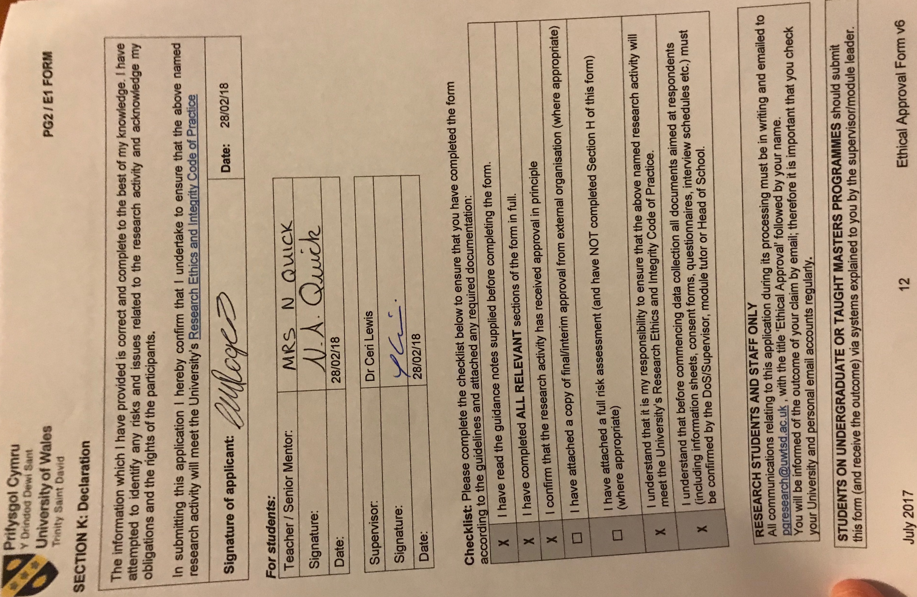

Appendix F – Explanatory statement

Appendix G – Lesson study 1 Lesson plan



Appendix H – Lesson study 2 Lesson plan


Appendix I – Lesson study 1 observation notes




Appendix J – Lesson study 2 observation notes




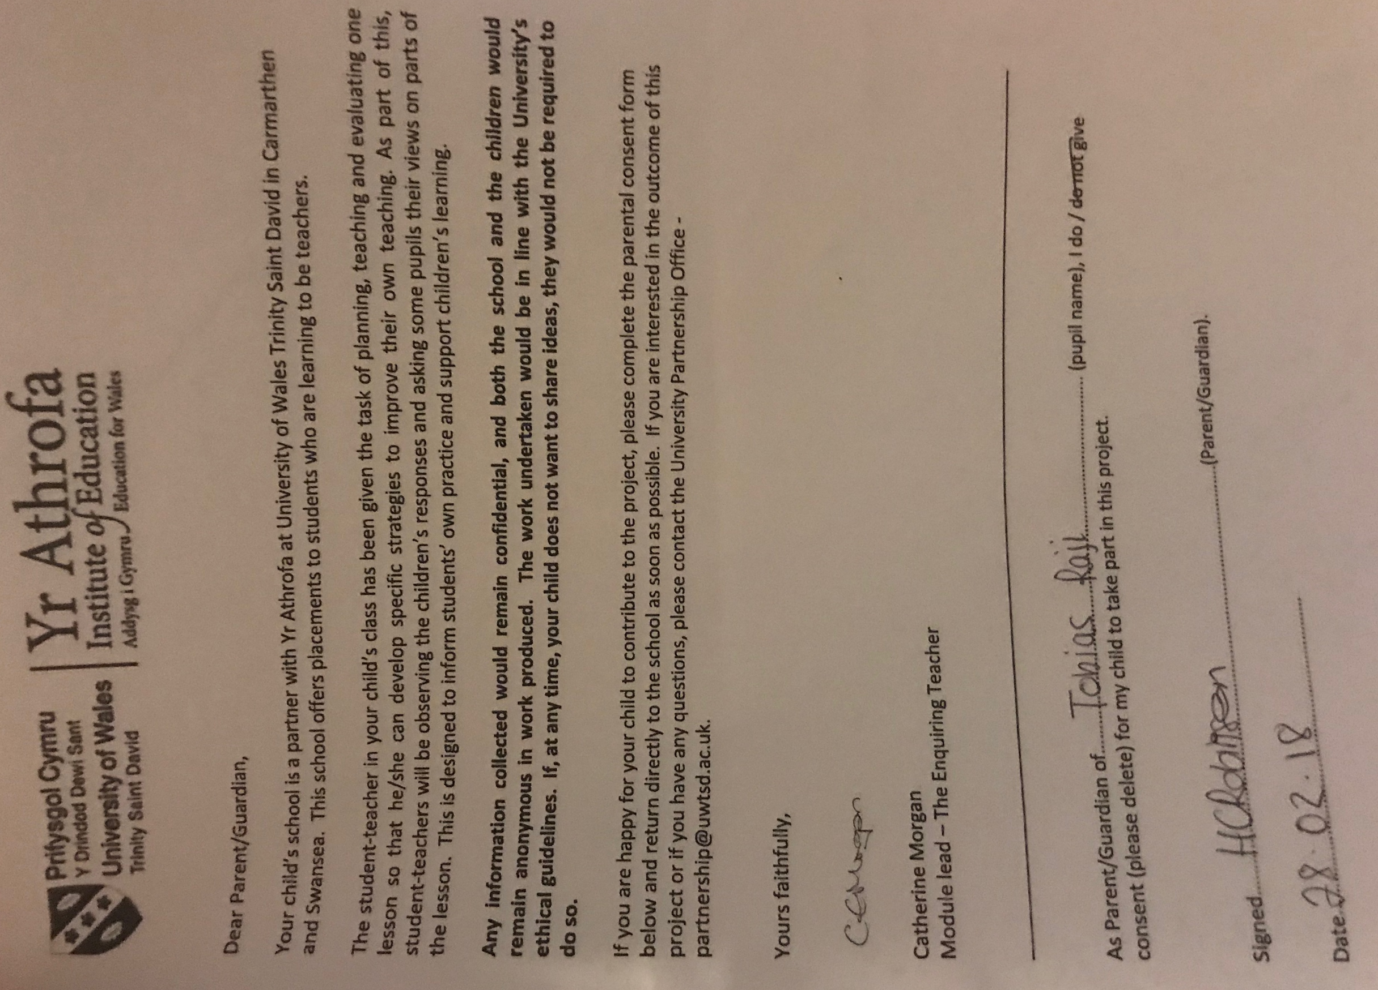
Appendix K – Parental consent form

