

University of Wales trinity Saint David

Engineering Academic Discipline

Engineering echnical report

Noah Newman

2411257

Automotive Engineering

1/12/2024

Workshop and practice ACHA4011

Word count: 2198 (including PPD)

Contents page

Page 1…………………………. Title page

Page2 ……………………………….. Chapter 1- introduction

Page 3 & 4 ……………………… Chapter 2- health and safety with risk assessment

Page 5 & 6 …………………………… Chapter 3- engineers role in society

Page 6 …………………………… Chapter 4- problem solving

Page 8 ………………………………. Flowchart

Page 9 & 10 ……………………………. Chapter 5- team structure

Page 11 & 12 ………………………… Personal development plan

Page 12 ……………………………… Conclusion

Page 13 & 14 ……………………. References

Chapter 1- introduction

This technical report covers many topics surrounding the responsibilities of an engineer. These topics consist of health and safety, which is fundamental practice of an engineer’s everyday life. Working environments also require a risk assessment which is also covered in this technical report as well as the safety protocols that come along with it. This report also goes into depth on the importance of an engineer today and how they are responsible for looking after the environment and how they need to adapt to new technologies in a fast-moving world and how much of an impact their work has on future developments.

This report also covers team structures and how important it is to choose the correct one depending on the project. It also highlights how important and how often engineers work in teams. Whilst working in teams this report covers the importance of solving problems on a task, and how important communication is to complete tasks.

Chapter 2- Health and safety with risk assessment

As Provision And Use of Work Equipment Regulation (PUWER) 1998 (UK) suggests the first thing operators must do before working on lathes is they must examine and make sure that the equipment is up to standard and the condition of the lathe is safe for its intended use. Operators should always wear the correct PPE such as, safety glasses to protect from potential chunks of metal flying into your eyes. This could cause serious injury to the operator if they do not wear safety glasses, such as grazing their eyes or in some serious cases blindness. (University of Cambridge, 2016)

It is also advised that operators should wear hearing protection as lathes can get loud over a period can damage your hearing especially if the operator is cutting through resilient materials. Safety boots are also mandatory as they can prevent your feet from getting damaged by heavy metals and tools, which could potentially cause some damage if the tools are not left in a safe place (Grisport, 2021). This also costs companies money as they will have to repair the tools or replace them if the damage is significant enough. Safety boots can also prevent people from slipping on potential fluids on the surface as the boots tread provides grip and stability.

they should also keep their hands a safe distance from the rotating chuck of the lathe to prevent getting hands caught in the chuck. every lathe should also have foot emergency stop buttons installed just in case of an accident whilst using the lathe. These emergency buttons will act as a kill switch so the user can avoid any sort of accident or fatality. Whilst examining the lathe operators should always use a risk assessment as reference as this can help with identifying any hazards which can cause harm to the user, it can also help with assessing how much harm it could cause to the user. (Zealand, W.N., 2017)

Another risk is loose clothing, as it could get caught in the fast-moving part of chuck. To prevent this from happening it is recommended that the user wears the correct PPE such as a lab coat which also prevents the hot pieces of metal and potential hot fluids from burning the skin. in the rare case of hot fluids bursting out, lab coats can be removed very quickly which can be the difference between a serious injury and the operator sustaining no injuries.

Whilst the lathe is in use, small chunks or shavings can get to high temperatures which could potentially hit the operator. This could lead to minor burns so it’s down to the person operating the lathe to let the shavings cool down before brushing them off the workpiece. There is also a lot of sharp tools which could pierce the skin whilst brushing away the shavings of metal. It is advised just before lifting the safety guard that the operator can either, wear a safety glove to protect their hands or they could use compressed air if it is at their workplace’s disposal as stated by (ehs.cornell.edu.)

Risk assessment table: (made in excel)
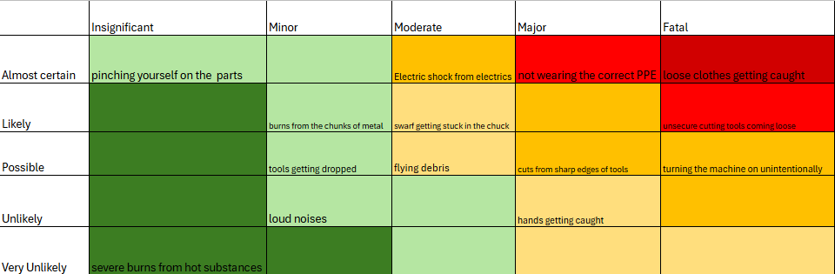

Chapter 3- Engineers role in society

Future of Electric vehicle and technology improvements in the automotive industry-

An engineer’s role in society as stated by (Institution of Mechanical Engineers, 2023) must promote sustainability and “we should engage responsibility with the environment” this is very important for engineers to consider because the Electric vehicles (EV’s) in the automotive industry are growing and improving at a fast rate. Electric Vehicles are not only improving but they are also gaining popularity with audiences across the world. In Europe specifically, almost 3.2 million latest models of electric cars were registered as new across Europe in 2023. Which saw an increase in comparison to 2022 as stated by (International Energy Agency, 2024). Moving forward EV’s Battey technology will also greatly improve resulting in faster charging times which massively reduces waiting times. With further development and investigation into the solid-state batteries it is believed that you will be able to charge a car in 10 minutes. Toyota are currently at the forefront of solid-state battery develop as they have already developed a battery that can do 1,200 km in one stint without having to stop. (Kleinman, Z, 2024)

The Institute of Electrical and Electronics Engineers have stapled themselves as one of the most recognisable organisations in the world of engineering, specifically in electrical engineering. One thing that IEEE prioritize is sustainability within the environmental sector as they are striving to encourage their employees to better their understanding towards technology and its potential impact on the environment. as development improves and engineers are getting encouraged to think about their environmental footprint, they will think about things such as, what sort of materials they can and can’t use. This is a key part to the development stage of design and manufacturing as this can help engineers gauge what materials have a longer lifespan than others which significantly helps with their environmental footprint. (IEEE, 2020)

Chapter 4- Problem solving

During the development phase of developing a new product engineers will be tasked with prototyping and testing the product before putting it up on the market. Prototyping and testing are vital for an engineering team to get through effectively as it can massively reduce the risk of the product having faults postproduction or on the market. Whilst engineers are prototyping and testing, engineers save a lot of time and money as they can pick up on any faults at the earliest part of development and quickly solve the problem with the product. Suggesting that, prototyping is the most important part of the development stage, as it can save the company a lot of time and money if these problems are found on the market according to research by (PlaybookUX, 2022).

Durability is also a key factor in testing the product, durability testing primarily focuses on how well the product works in certain environments over a period. This testing method is also important for gauging an understanding on the longevity of the product and how reliable it is, this ensures that the product meets its expected results.
(Rome, P. 2024).

In the automotive industry, specifically electric vehicles, prototyping the battery gives the engineers time to test the safety of the battery and performance of the battery. when engineering test the EV’s engineers use both virtual and physical prototyping.
(Group, E. 2024). These prototyping methods allow engineers to test things such as, the efficiency of the battery, the performance and whether the battery is safe enough for production as stated by (Indovance Blog, 2016).

Prototyping and testing flowchart

Start drawing and designing
Objectives of the project
Start the project

Are the objectives clear?
No
Yes
Start prototyping

Start testing
Does it function?

Yes
No

Chapter 5- team structure

After recently working with the MCR Team, me and a few others were tasked with taking the suspension apart. The goal of the project was to dismantle the suspension and weigh it to make sure that the car isn’t overweight for next season. We also dismantled it to check whether we could strip any other weight that wasn’t necessary, such as removing washers where they didn’t need to be. Each of us had an important role in completing this task with a tight timescale, for example me and one other were responsible for dissembling the suspension, two others were responsible for weighing the suspension and logging it somewhere, and two more people were responsible for reassembling the suspension.

Although there were a lot of people working on this task with different jobs it was very disorganised. Mainly because of things not being labelled and nuts & bolts being paired with different parts of the suspension. This made it confusing and very hard for us to figure out where each of the different bolts went when we went back to it the next day. On the other hand, I believe that peoples work ethic towards helping each other out and putting it back together was excellent. Which brought a wide range views and experiences which helped us complete this task.

We decided to assign different jobs to different people solely based on the fact of people’s different experiences and wanting to learn on different jobs, in hindsight this could’ve been done more efficiently as we could’ve involved less people. Involving less people would’ve improved the communication between the workstations which could’ve led to less confusion between teams. I do think it brought us several other benefits to the team. such as, being able to rely on people carrying on your job where you left off. This was a great benefit for the team, because if you needed to attend a lecture you didn’t have to worry about whether you could complete your job and meet the deadline.

I think as a team we could’ve done things a bit differently and we could’ve possibly used a different team structure. The team structure we used above is known as hierarchical structure, this structure is set out with a leader of the project, three teams and two different positions within the teams. The diagram below shows what the hierarchical structure looks like:
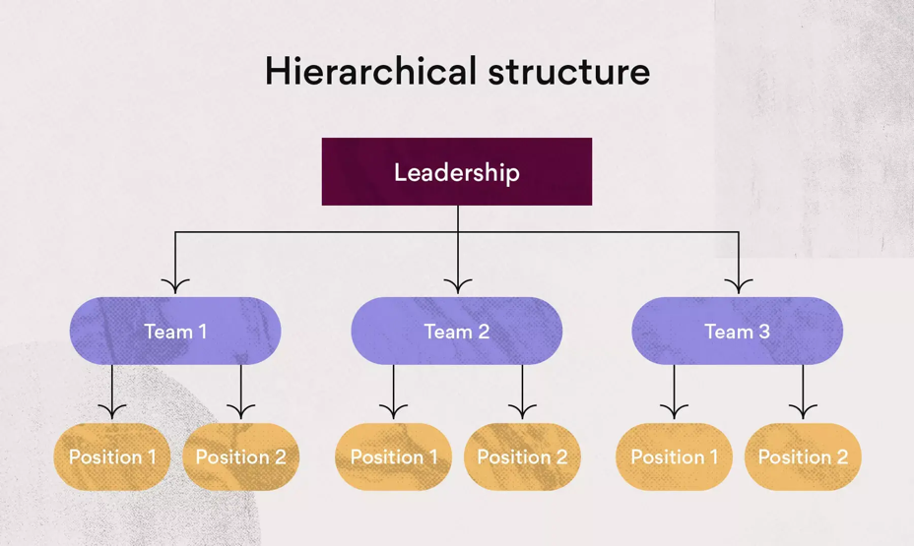

I believe the best team structure would’ve been a cross functional team structure, Cross-functional structure is a team of people who work together completing tasks as they go along. This brings people together which makes decision making simpler as there are more people sharing their thoughts on how they should approach each task. With cross-functional structure there is a higher chance of completing tasks to the best of everyone’s ability. With a smaller group this would’ve been the perfect structure to use for the suspension objective. (Team Asana, 2021)

Chapter 6- personal development plan

Name- Noah Newman

Degree- Automotive Engineering

Previous qualifications- A levels in Product design, Welsh back, and ICT.

Previous experience- Got experience in working in teams from team sports such as rugby and football.

Long Term Goals (5 to 10 years)
I would like to go travelling across Europe.
Learn a new instrument.
After I’ve completed my degree, I would like to get into Formula 1.
Short Term Goals (0 to 5 years)
To complete my degree
Complete all my grades for guitar.
To grow in confidence as an engineer whilst studying with UWTSD
Travel with the MCR team

Goal | Objective | Resources Required | Measurement | Target Date
Completing my guitar grades | I would like to complete all my grades for my guitar. I am currently on grade 5 out of 8. | Tools, equipment (tuner, new sets of strings etc.) a good workspace | Passing the grade 8 exam | 2025/ start of 2026
Competing with the MCR team | In year 1 and 2 of my degree I want travel up and down the country with the MCR Team. | Tools, camping equipment, transport to get to the races. | If I’ve been to 8 or more tracks over the 2 years | 2025 & 2026
Completing my degree | the most important goal for me is to complete my degree. | Laptop, computer, books, library, and online resources | Passing all 3 years and attending the graduation | 2027
Getting into F1 | Getting into Aston martin F1 team | A degree, skills required such as CAD,  And Problem-solving skills | Being on pit side with the team | 2028/29
Travelling to countries I’ve never visited. | To travel across most of Europe | Transport, accommodation, passport and money. | Travelling to the countries I’ve always wanted to visit. (E.g. Germany, south of France, Italy, and Belgium) | 2027-2028

Chapter 7- conclusion

In conclusion, this technical report has examined various topics regarding workshop and practice, looking at different methods and analyses of health and safety with risk assessments, an engineer’s role in society, problem solving and different team structures. Analysing health and safety has provided a lot of information with the inclusion of risk assessments. By providing us with a visual representation of the risks involved with lathing and how harmful different risks can be. Additional research in the problem solving might have been needed for this chapter. More research on different protypes could have been included, such as the mentioning of which of the choices could have been better for the project.

References-

Health and safety risk assessment ref

University of Cambridge (2016) Risk assessment L01: Lathe, Dyson Centre for Engineering Design. Available at: https://www.dysoncentre.eng.cam.ac.uk/system/files/documents/lathe-health-and-safety-pdf.pdf
(Accessed: 18 November 2024).
Grisport (2021). Safety Boots: A Complete Buyers Guide - Grisport. [online] Grisport -. Available at: https://www.grisport.co.uk/blog/safety-boots-a-complete-buyers-guide/
[Accessed 19 Nov. 2024].

Zealand, W.N. (2017). Metal turning lathes. [online] WorkSafe. Available at: https://www.worksafe.govt.nz/topic-and-industry/machinery/metal-turning-lathes/.
[Accessed 19 Nov. 2024].

‌ehs.cornell.edu. (n.d.). Metalworking Lathe Safety Awareness Guide | Environment, Health and Safety. [online] Available at: https://ehs.cornell.edu/campus-health-safety/occupational-safety/tool-and-machine-safety/metalworking-lathe-safety.
[Accessed 19 Nov. 2024].

Engineers role in society ref

Institution of Mechanical Engineers (2023). Code of Conduct explained - IMechE. [online] www.imeche.org. Available at: https://www.imeche.org/about-us/imeche-governance/governance-and-finance-reviews/code-of-conduct-explained.
[Accessed 21 Nov. 2024].

International Energy Agency (2024). Trends in electric cars. [online] IEA. Available at: https://www.iea.org/reports/global-ev-outlook-2024/trends-in-electric-cars.
[Accessed 24 Nov. 2024].

Kleinman, Z. (2024). Electric car battery charges in under five minutes in track test. BBC News. [online] 27 Jun. Available at: https://www.bbc.co.uk/news/articles/cz9dp3ye77do.
‌[Accessed 24 Nov 2024].

IEEE (2020). IEEE Code of Ethics. [online] ieee.org. Available at: https://www.ieee.org/about/corporate/governance/p7-8.html.
[Accessed 21 Nov. 2024].
[

chapter 4 ref-

PlaybookUX. (2022). 5 Ways How Prototype Testing Improves Product Development. [online] Available at: https://www.playbookux.com/5-ways-how-prototype-testing-improves-product-development/.
‌[Accessed 27 Nov. 2024].

Rome, P. (2024). The Importance of Product Testing. [online] Data Acquisition | Test and Measurement Solutions. Available at: https://dewesoft.com/blog/importance-of-product-testing.
[Accessed 27 Nov. 2024].

Group, E. (2024). Electric Vehicles Virtual Prototyping. [online] ESI Group. Available at: https://www.esi-group.com/industries/electric-vehicles
[Accessed 28 Nov. 2024]
‌
Indovance Blog (2016). Digital and Virtual Prototyping Differences | CAD Drawing Services. [online] Indovance Inc. Available at: https://blog.indovance.com/differences-between-digital-and-virtual-prototyping-2/
[Accessed 28 Nov. 2024].

‌

team structure ref-

Team Asana (2021). Team Structure: 10 Effective Ways to Organize Your Team • Asana. [online] Asana. Available at: https://asana.com/resources/team-structure.
[Accessed 28 Nov. 2024].
‌

