BMIH5001 Entrepreneurship
Student Name: Andreea Marin
Student ID: 2206723
Lecturer name: Chris Wilkin

Introduction
The following essay will examine the modern concept of Sweet Heaven Boutique, a boutique lodge that has been cautiously deliberate using the Business Model Canvas (BMC). Situated in the principal location of the United Kingdom, the inn units a new widespread for opulence with the aid of prioritising environmental sustainability. The BMC examines the distinct characteristics of Sweet Heaven Boutique, highlighting its commitment to environmentally sustainable methods, collaborations with local organizations, and tailor-made guest studies. Backed by using marketplace traits, Similar web records, and successful assignment examples, the boutique hotel emerges as an innovator in the hospitality zone, geared up to set up new benchmarks in luxury with a focal point on ethics. Finally, the reflection will be evaluated here.

Discussion
Sweet Heaven Boutique is a pioneering idea in the hospitality enterprise that effectively combines luxurious and environmental sustainability. Sweet Heaven Boutique is a completely unique place that combines luxury with caring of the environment, placing a new widespread in the hotel enterprise. By combining luxurious accommodation with sustainable practices in a constant manner, Sweet Heaven gives guests an supreme experience in that meets their need for luxurious while additionally meeting their developing demand for options which are suitable for the surroundings. Expressed through the utilisation of the Business Model Canvas (BMC), this boutique hotel located inside the central vicinity of the UK targets to redefine luxury even as last dedicated to environmentally sustainable practices. The BMC is intricately crafted to emphasize the specific traits that set Sweet Heaven Boutique aside from its competition in the marketplace (Canestrino et al., 2020). The thoughtfully designed Business Model Canvas at Sweet Heaven Boutique shows how the hotel sets itself apart by way of combining luxurious with environmental responsibility. A strong determination to eco-friendly practices is one of the boutique hotel's fundamental features. This is proven through its use of renewable power assets, waste reduction efforts, and long-lasting materials. In addition, its high-end services are topped off by custom adventures that immerse guests in luxurious even as being environmentally friendly (Blackwell, 2011). Enjoying an excellent place near the centre of the UK, Sweet Heaven Boutique modifications the manner hospitality is executed by putting environmental duty first without sacrificing luxury, growing a brand new general within the increasingly more competitive marketplace. The centre of sweet Heaven Boutique's appeal lies in its steadfast dedication to environmentally accountable strategies, which result in a mixture of the world of luxury. The inn's determination to sustainability is evident from its very beginning because it prioritises the utilisation of locally obtained materials during the development technique so one can lessen its ecological footprint. Sweet Heaven Boutique cares the surroundings and uses substances that are collected domestically while making its products. This lowers the hotel's impact on the environments. By the use of materials from natural resources, the hotel reduced the carbon emissions that come from delivery and helps the local economic system. This dedication to shopping for domestically not most effective facilitates the environment, however it additionally builds community strength and involvement. Sweet Heaven Boutique has constantly been dedicated to being environmentally accountable, as shown with the aid of its early efforts to reduce its environmental effect (Gabrielsson et al., 2020). The Customer Segments part of the Business Model Canvas (BMC) provides a strategic definition of the particular market that Sweet Heaven Boutique ambitions to goal. The lodge incorporates sophisticated travellers who actively pursue an engaging and environmentally aware luxury experience. Sweet Heaven Boutique capitalises on the growing fashion of green tourism by embracing the standards valued by cutting-edge purchasers (Champenois et al., 2020). The hotel positions itself as the top choice for folks who prioritise sustainability while nevertheless taking part in the high stage of comfort and beauty related to luxurious hospitality.
Sweet Heaven Boutique is not just saying it cares about being environmentally friendly; it is deeply combined into its core operations, establishing it as a pioneer in the dynamic landscape of boutique hotels (Haltiwanger, 2022). This pledge aligns with the developing worldwide recognition of the ecological consequences of the hospitality quarter, as customers regularly call for environmentally aware alternatives (Secundo et al., 2021). People in all around the world are getting more aware about how the hospitality industry influences the environments. Sweet Heaven Boutique's dedication to sustainability meets the demand from clients for sustainable choices (Nelson, 2013). In the Business Model Canvas, the value proposition is clear not only in processes that are right for the environments, but additionally in deliberate for nearby assets and working with nearby suppliers. This strategic technique ensures cost efficiency and competitive pricing while supporting sustainable practices (Alford and Jones, 2020). This now not best aids in diminishing the lodge's environmental effect but additionally positions Sweet Heaven Boutique as an engaged participant in the local economic system, cultivating network connections and endorsing sustainable techniques. With the hospitality industry's present process, a massive transformation closer to sustainability, Sweet Heaven Boutique carefully positions itself to attract a selective consumer (Canestrino et al., 2020). The growing phenomenon of sustainable tourism demonstrates that cutting-edge customers aren't best pursuing lavish reviews however also are turning more aware of the ecological consequences of their choices (Dana, 2021). Sweet Heaven Boutique sticks out as a pioneer in the hotel quarter, skillfully combining opulence with ecological sustainability.
The Channels and Customer Relationship additives of the Business Model Canvas (BMC) are crucial in defining the wonderful identity of Sweet Heaven Boutique and ensuring a clean guest experience in the ever-converting hospitality industry (Armuña et al., 2020). Channels, as designated within the Business Model Canvas (BMC), emphasise the vital want of green distribution and verbal exchange channels. Sweet Heaven Boutique utilises virtual media strategically to construct a sturdy online presence for marketing and reservation offerings. The most important traces of touch for potential visitors are a person-pleasant internet site and a committed cell application, which provide a simplified and handy manner to make bookings (Gabrielsson et al., 2020). The internet structures serve as transactional channels and communicative tools, enabling Sweet Heaven Boutique to correctly communicate with its target market (Molina, 2020). This method is in line with the tastes of contemporary travellers who prioritise environmental awareness.
Sweet Heaven Boutique places enormous emphasis on Customer Relationships, prioritising customized career and energetic interaction (Alford and Jones, 2020). The lodge pursues to create a long-lasting bond with its customers by presenting a personalised concierge provider, deviating from conventional hospitality practices. This carrier is going beyond the everyday hospitality offers by using imparting facts on sustainable practices and neighbourhood points of interest. The objective is to enhance the entire visitor experience by presenting greater than simply accommodation, but instead a comprehensive and culturally absorbing voyage. This willpower to customise assistance harmonises results easily with modern industry patterns and successful instances, emphasising the want of cultivating visitor allegiance via different and good-sized engagements (Armuña et al., 2020). Transitioning to the Revenue Streams segment, Sweet Heaven Boutique implements a numerous method for producing income. In addition to the traditional profits generated from room reservations, the resort carefully decided on environmentally pleasant sports. These alternatives embody a whole lot of activities, which include guided excursions of neighbourhood sustainable establishments and wellness packages that consist of green services (Canestrino et al., 2020). The primary objective of this strategic diversification is to now not only cater to the changing needs of the marketplace but also protect the lodge towards any volatility in its conventional revenue (Dana, 2021). Sweet Heaven Boutique's use of resilient Channels, emphasis on Customer Relationships, and numerous methods to Revenue Streams establishes it as a pioneering and progressive player in the hotel area. The boutique hotel distinguishes itself by presenting a smooth online revel, customised carrier options, and a clever method to generate earnings from many assets (Armuña et al., 2020). It caters to the needs of present-day guests and ensures its lengthy-term viability in an aggressive market (Santos and Liguori, 2020). The inn's complete technique demonstrates its dedication to surpassing the expectations of its visitors within the ever-converting realm of opulence and environmental duty.
Sweet Heaven Boutique has tough competitors like The Luxury Haven and Eco-Chic Retreat, which might be each famous boutique hotels within the UK. It also has to address opposition from famous high-end hotels like The Grand Manor and The Royal Oasis. These resorts provide expensive rooms but may not care the environment as Sweet Heaven does. Even with these problems, Sweet Heaven Boutique stands out due to the particular way it combines luxurious with sustainable practices.
The resort's success is based on the critical elements of Key Resources and Key Activities. Sweet Heaven Boutique allocates sources towards the use of renewable energy sources, the utilisation of eco-friendly construction substances, and the availability of a team of workers training on sustainable practices (Cardella et al., 2020). Partnerships with nearby artists and providers not only decorate the extraordinary visible appeal but additionally uphold the hotel's determination to sustainability, taking suggestions from boutique hotels that have efficiently incorporated those ideas. The significance of Key Partnerships is apparent inside the alliances formed with close-by organisations and enterprises that possess a shared willpower toward sustainability (Alford and Jones, 2020). The lodge can in addition to its social obligation create at the same time useful collaborations by way of interacting with environmental non-governmental companies, operating with eco-aware brands, and taking elements in community initiatives. Sweet Heaven Boutique represents a modern concept that correctly combines opulence and environmental focus (Dana, 2021). The Business Model Canvas offers a holistic perspective on the resort's dedication to environmental sustainability, neighbourhood collaborations, and tailor-made guest experiences. Based on market developments, Similarweb records, and previous instances, Sweet Heaven Boutique is placed to revolutionise boutique resort requirements within the UK, making it an exclusive and charming endeavour.

Reflection
Using the Gibbs reflective cycle to reflect on consideration on the effects of my in-class private entrepreneurial or managerial test, I positioned that my desires and trends for being an entrepreneur are very much like my traits for being a supervisor. The study showed that I actually have a robust preference to come up with new thoughts and problem solving, which suggests that I am certainly willing to become an entrepreneur. Additionally, my managerial inclinations had been clear within the way I organised things and gave jobs to other individuals. Using the proper academic models and frameworks, just like the Big Five personality tendencies and the Entrepreneurial Orientation (EO) framework, I did an important evaluation that helped me enhance my key skills and regions where I should improve. My excessive scores on traits like openness to experience and conscientiousness propose that I might be precise at beginning my personal enterprise, considering the fact that these tendencies are connected to being innovative, persistent, and aim-orientated (Mariotti and Glackin, 2012). I knew it was essential to enhance my willingness to take risks and my capability to be proactive, although, due to the fact these are important parts of the EO shape. I also found out a lot about my strengths and faults as an entrepreneur, which test my entrepreneurial mind-set and potential. The test confirmed me the area where I do well, like developing with thoughts and solving issues, and regions in which I want to improve, like dealing with risks and analysing markets. These insights helped me plan my future personal and expert increase, displaying me the way to improve my commercial enterprise acumen and make the maximum of my skills in starting my very own agencies. Overall, the system of thinking about and evaluating helped me learn greater about my motives for wanting to be a business and a supervisor. I need to broaden a entrepreneurial mindset and enhance my competencies as a future entrepreneur and manager by constructing on my strengths and working on areas where I need to enhance. (Gabrielsson et al., 2020). Ultimately, the utilisation of the Gibbs reflective cycle allowed for an intensive exam of my drive and aspirations in entrepreneurship and control. Utilising academic model facilitated a rigorous assessment, leading me to realistic observations and a proactive strategy for personal and professional boom. Adopting trade and fostering a more proactive entrepreneurial mind-set will virtually decorate my development as a talented entrepreneur and supervisor.

Conclusion
Sweet Heaven Boutique is a pioneering instance inside the resort quarter, skillfully combining opulence with ecological sustainability. The boutique hotel establishes itself as a frontrunner in responsible hospitality by adopting an all-encompassing Business Model Canvas this is based totally on green methods and neighborhood partnerships. Sweet Heaven Boutique prioritises customised visitor stories and the improvement of several sales assets to satisfy the converting demands of the industry and ensure long-term monetary stability. This modern layout embodies the future of one-of-a-kind accommodation, where opulence blends seamlessly with a profound dedication to sustainability, establishing a brand-new benchmark for incredible nice inside the United Kingdom. Hence, the reflection of this topic using Gibbs model has been also discussed the above essay.

References
Alford, P. and Jones, R., (2020). The lone digital tourism entrepreneur: Knowledge acquisition and collaborative transfer. Tourism Management, 81, p.104139.
Armuña, C., Ramos, S., Juan, J., Feijóo, C. and Arenal, A., (2020). From stand-up to start-up: exploring entrepreneurship competences and STEM women’s intention. International Entrepreneurship and Management Journal, 16, pp.69-92.
Blackwell, E. (2011), How to Prepare a Business Plan: Planning for Successful Start-up and Expansion, (5th Ed) Sunday Times Business Enterprise Series, Kogan Page
Burns, P. (2022) Entrepreneurship and Small Business, 5th Ed., Palgrave Macmillan: Basingstoke
Canestrino, R., Ćwiklicki, M., Magliocca, P. and Pawełek, B., (2020). Understanding social entrepreneurship: A cultural perspective in business research. Journal of Business Research, 110, pp.132-143.
Cardella, G.M., Hernández-Sánchez, B.R. and Sánchez-García, J.C., (2020). Women entrepreneurship: A systematic review to outline the boundaries of scientific literature. Frontiers in psychology, 11, p.1557.
Champenois, C., Lefebvre, V. and Ronteau, S., (2020). Entrepreneurship as practice: systematic literature review of a nascent field. Entrepreneurship & Regional Development, 32(3-4), pp.281-312.
Dana, L.P. ed., (2021). World encyclopedia of entrepreneurship. Edward Elgar Publishing.
Gabrielsson, J., Hägg, G., Landström, H. and Politis, D., (2020). Connecting the past with the present: the development of research on pedagogy in entrepreneurial education. Education+ Training, 62(9), pp.1061-1086.
Haltiwanger, J.C., (2022). Entrepreneurship during the COVID-19 pandemic: Evidence from the business formation statistics. Entrepreneurship and Innovation Policy and the Economy, 1(1), pp.9-42.
Hisrich, R.D., Peters, M.P. and Shepherd, D.A. (2008) Entrepreneurship, 7th Ed.,McGraw Hill: NY
Mariotti, S. and Glackin, C. (2012) Entrepreneurship: Starting and Operating a Small Business (3rd Ed), London: Prentice-Hall.
Molina, J.A., (2020). Family and entrepreneurship: New empirical and theoretical results. Journal of Family and Economic Issues, 41, pp.1-3.
Nelson, O. (2013) Enterprise development in SMEs and entrepreneurial firms dynamic processes. IGI Global.
Rae, D. (2008) Entrepreneurship: from opportunity to action, 2nd Ed., Basingstoke: Palgrave Macmillan
Rickman, C., and Roddick, D. (2013) The Small Business Start-Up Workbook: A step-by-step guide to starting the business you’ve dreamed of. London, How To Books
Santos, S.C. and Liguori, E.W., (2020). Entrepreneurial self-efficacy and intentions: Outcome expectations as mediator and subjective norms as moderator. International Journal of Entrepreneurial Behavior & Research, 26(3), pp.400-415.
Secundo, G., Del Vecchio, P. and Mele, G., (2021). Social media for entrepreneurship: myth or reality? A structured literature review and a future research agenda. International Journal of Entrepreneurial Behavior & Research, 27(1), pp.149-177.
Similarweb (boutiquehotel.me vs myboutiquehotel.com visitors comparison by gender and age distribution)https://www.similarweb.com/website/search.com/
Similarweb (boutique.me Website Traffic Demographics)www.similarweb.com

Appendix
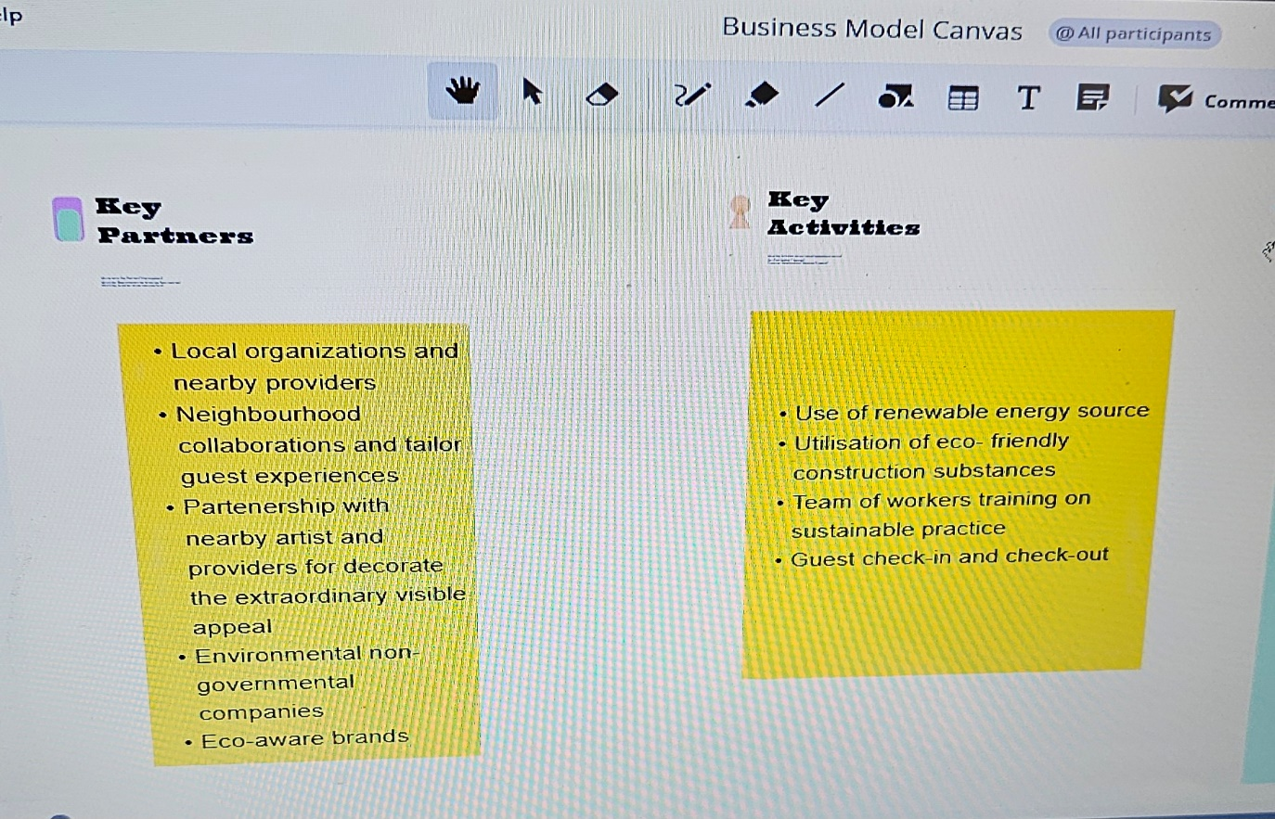
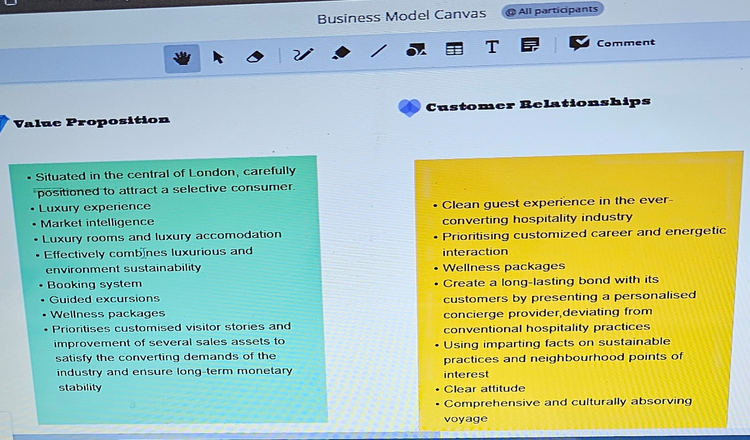
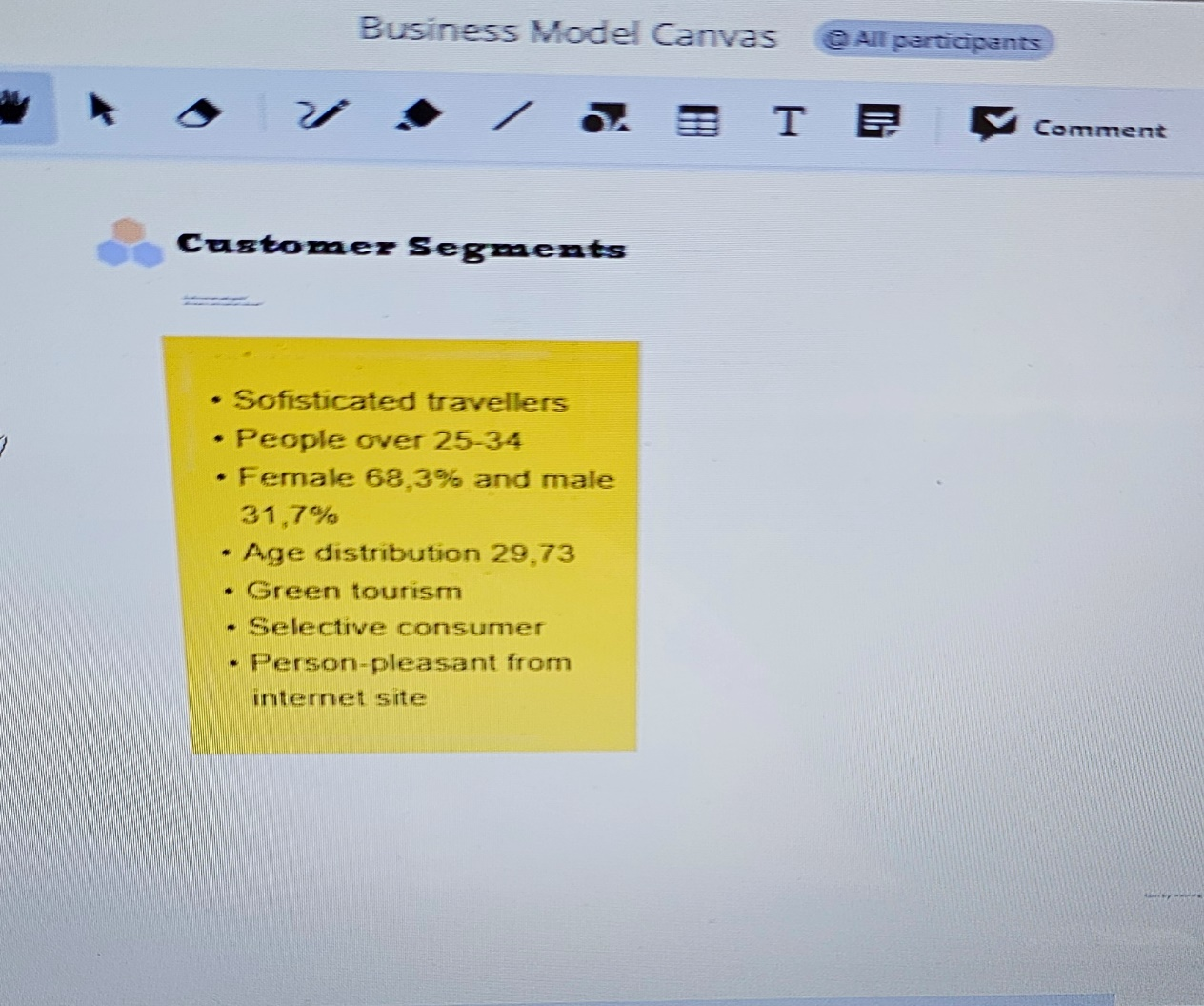
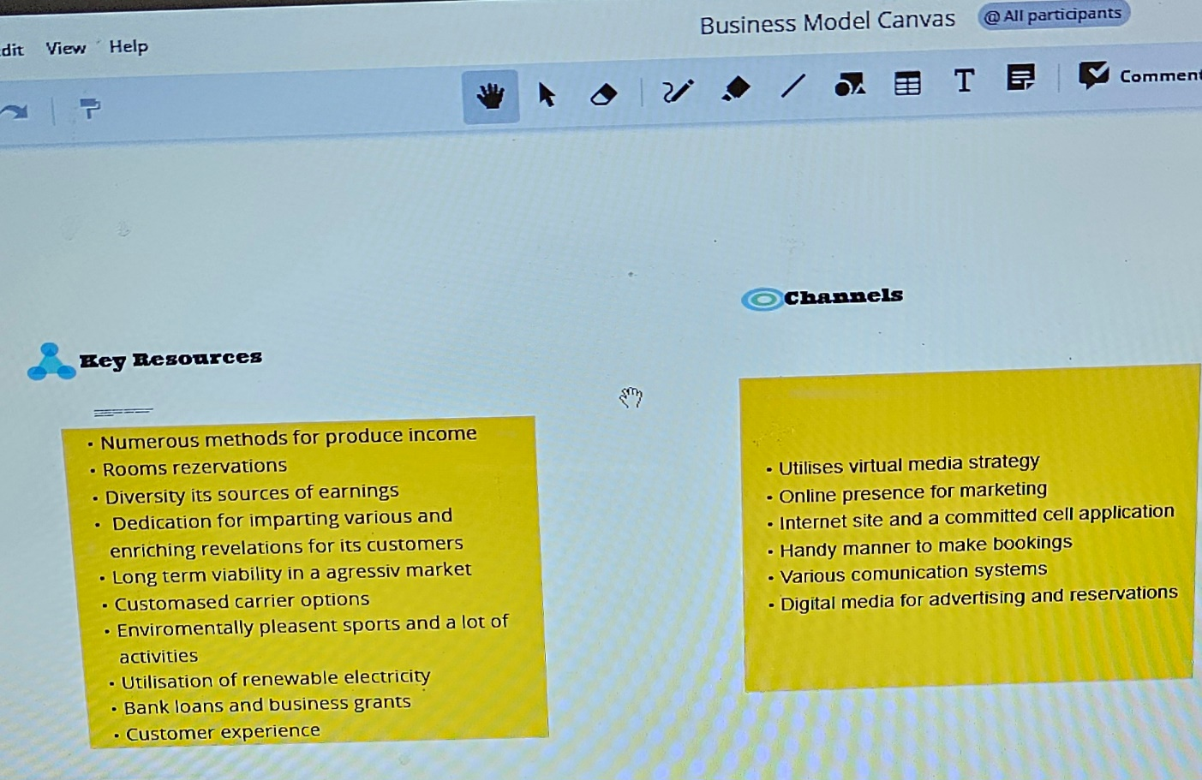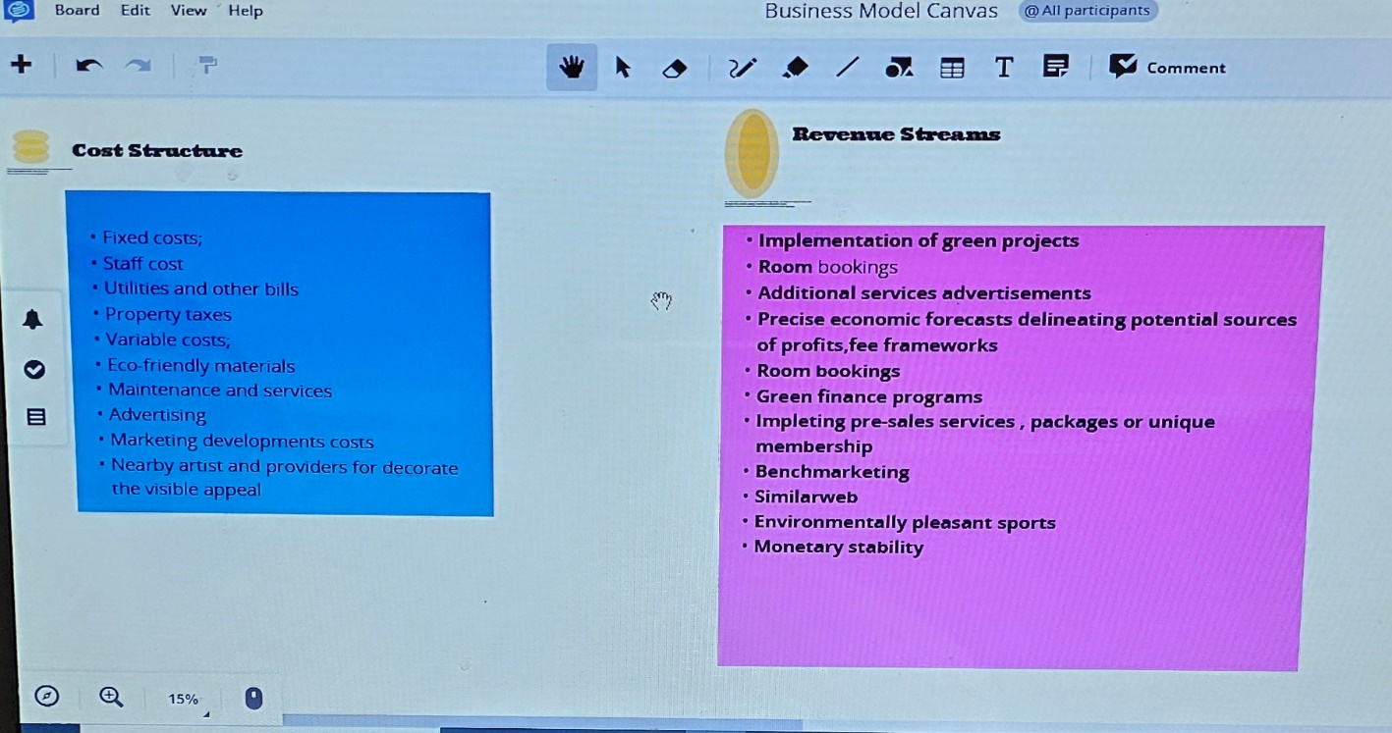
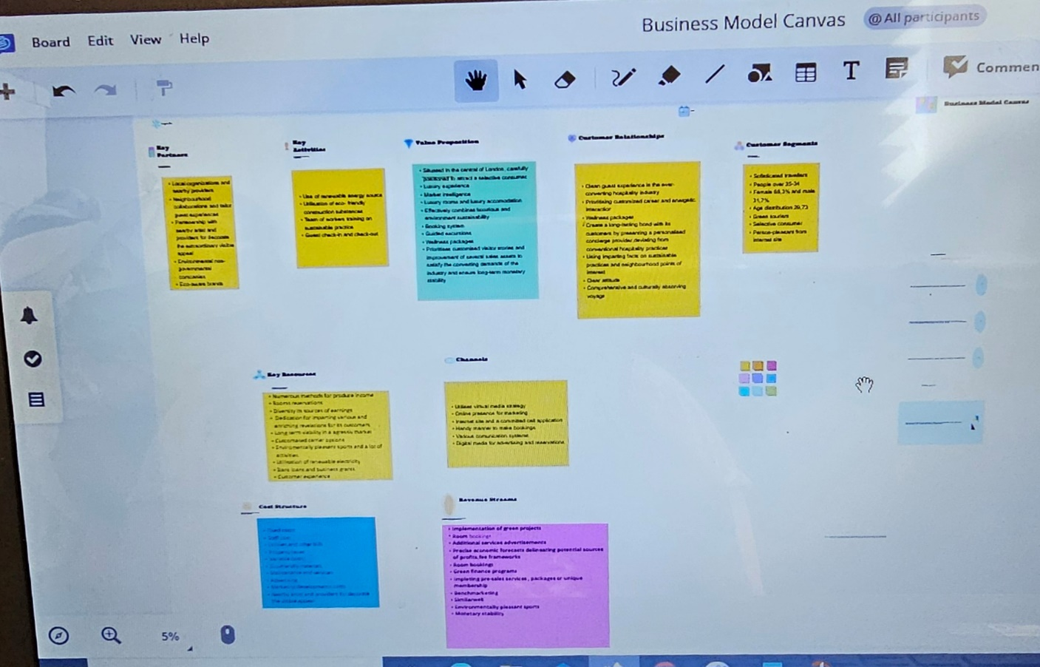
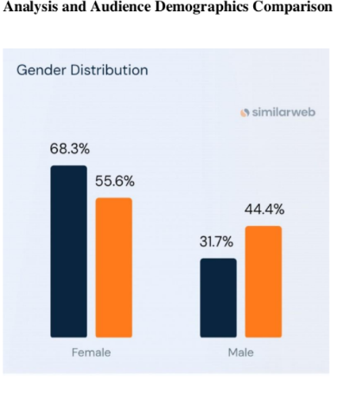
Sources:(Boutiquehotel.me Website Traffic Demografics)

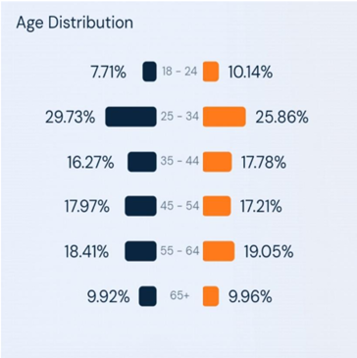
Source:(similarweb.com) Analysis and Audience Demographics Comparison

