University of Wales Trinity Saint David
Wales Institute of Science and Art


2D Diffusion Equation model using the Explicit Finite Difference Method
Computational Methods ACMA6012

Dewi Miller
2112045
November 2024

Contents
1.Introduction 1
1.1 Aims and Objectives 2
2.0 The governing equation of the problem 3
2.1 Background Information 3
2.2 Explicit Finite Difference Form of the Constitutive Equation 4
2.3 Boundary Conditions 5
3.0 Code details 6
3.1 Validation of code 9
3.2 Sensitivity analysis of the code 12
3.21 Thermal Equilibrium time against Grid Spacing 12
3.22 Thermal Equilibrium time against Time Step 14
3.23 Thermal Equilibrium time against Tolerance 15
4.0 Limitations 17
5.0 Suggested Improvements and future development 18
6.0 Conclusion 19
6.0 References 20
7.0 Appendix 21

Figure 1 Spatial Discretisation 5
Figure 2 Temperature Distribution 9
Figure 3 Analytical Temperature Distribution 10
Figure 4 Error Between Numerical and Analytical Solutions 11
Figure 5 Thermal Equilibrium Time 13
Figure 6 Thermal Equilibrium time against Time step 15
Figure 7 Thermal Equilibrium against Tolerance 16

Table 1 Influence of the grid spacing 12
Table 2 Influence of the time step 14
Table 3 Thermal Equilibrium against Tolerance 15

1.Introduction

The aim of this assignment is to develop a computational model that simulates the transient temperature distribution within an aluminium plate using the Explicit Finite Difference Method (EFDM). This method is widely employed in numerical heat transfer due to its simplicity and effectiveness in solving parabolic partial differential equations (Villadsen & Sørensen, 1969). The assignment requires implementation of a MATLAB script capable of calculating temperature variation over time and space, subject to given boundary and initial conditions.
The model simulates a rectangular aluminium plate exposed to fixed temperatures at the north and south boundaries, with insulated east and west edges. The heat diffusion process is governed by the two-dimensional heat conduction equation, and the simulation continues until thermal equilibrium is achieved. The key requirements include defining material properties, discretising the spatial and temporal domains, enforcing boundary conditions, checking for numerical stability, and validating the results against a known analytical solution.
This report outlines the development of the MATLAB code used to perform the simulation, with detailed explanations of each code section.

1.1 Aims and Objectives

This report outlines the development of the MATLAB code used to perform the simulation, with detailed explanations of each code. The report also includes the model's validation and an analysis of the results, ultimately demonstrating the effectiveness of EFDM in modelling heat conduction phenomena.
The primary aim of this report is to develop a robust and user-friendly MATLAB script that simulates the transient temperature distribution within an aluminium plate over time, based on the principles of heat conduction. The simulation is implemented using the finite difference method (FDM), following established numerical schemes (Croft & Lilley, 1977) and is designed to capture the dynamic evolution of temperature under defined boundary and initial conditions.
To fulfil this aim, the following objectives are established:
- Temperature Distribution Simulation
  - Develop a MATLAB script capable of computing and visualising the temperature distribution across a two-dimensional aluminium plate as a function of time.
  - Employ appropriate numerical techniques to ensure accuracy, stability, and computational efficiency during simulation.
- User-Defined Inputs
Allow users to define key physical and numerical parameters, including:
- Plate dimensions (height and width in meters)
- Grid spacing (spatial resolution in meters)
- Boundary temperature values (in degrees Celsius)
- Time step (temporal resolution in seconds)
- Input Validation and Error Handling
Implement checks to ensure user inputs are valid and appropriate for the simulation:
- Grid spacing must be positive, smaller than both plate dimensions, and divide evenly into the domain.
- Time step must satisfy the numerical stability criterion, and the script must provide feedback if it exceeds this limit.
- Stability and Convergence Enforcement
- Calculate the maximum permissible time step using the Fourier number criterion to maintain numerical stability.
- Monitor convergence through a predefined temperature difference threshold between iterations, ensuring accurate thermal equilibrium detection.
Through these objectives, the report seeks to deliver a reliable, adaptable, and educational tool for exploring and understanding heat transfer in two-dimensional aluminium plates. The model provides practical insights for both academic learning and engineering design applications.

2.0 The governing equation of the problem

2.1 Background Information

The core of this thermal analysis is the two-dimensional transient heat conduction equation, a partial differential equation (PDE) that describes how temperature varies over time and space due to conduction. It is essential in engineering for predicting thermal behaviour in solid materials and is widely used in electronics cooling, structural design, and heat exchanger development.
In this assignment, the scenario involves a rectangular aluminium plate with defined boundary conditions: fixed temperatures at the north and south edges and insulated east and west edges. There are no internal heat sources, simplifying the PDE to its homogeneous form:
$$\frac{∂T}{∂t}=α(\frac{∂^{2}T}{{∂x}^{2}}+ \frac{∂^{2}T}{{∂y}^{2}})$$
Where:
- T is temperature (°C),
- t is time (s),
- is the thermal diffusivity (m²/s),
  - k: thermal conductivity (W/m°C),
  - ρ: density (kg/m³),
  - c: specific heat capacity (J/kg°C).
This PDE is numerically solved using the Explicit Finite Difference Method (EFDM). The domain is discretised into a spatial grid and temporal steps, enabling iterative temperature updates at each node. The update rule used in the code is:
T2(i, j) = F0 * (T1(i, j-1) + T1(i, j+1) + T1(i-1, j) + T1(i+1, j) - (4-1/F0) * T1(i, j));
Where $F_{0}$​ is the Fourier number, and stability is ensured by satisfying $F_{0}$ ≤ 0.25, enforced in the code.
This approach is grounded in established heat transfer literature, notably (Croft & Lilley, 1977) which underpins the theoretical framework and numerical methodology used in this simulation.

2.2 Explicit Finite Difference Form of the Constitutive Equation

This section outlines the full discretisation process used to implement the 2D heat conduction model in MATLAB. Starting from the Taylor series expansion, (Smith, 1985) numerical approximations for derivatives are derived specifically the forward difference for the first-order time derivative and central difference for the second-order spatial derivatives. These form the basis of the Explicit Finite Difference Method (EFDM).
Applying these approximations to the heat equation yields the discretised update formula:
T2(i, j) = F0 * (T1(i, j-1) + T1(i, j+1) + T1(i-1, j) + T1(i+1, j) - (4-1/F0) * T1(i, j));
This is implemented in MATLAB to iteratively update node temperatures across a structured grid. The spatial domain (aluminium plate) is discretised into a uniform mesh using:
NR= round(Ydim/h+1),
NC= round(Xdim/h+1)
Where h is the grid spacing. The temporal domain is discretised using a time increment Δt, provided by the user.
To ensure numerical stability, the script calculates the Fourier number: $F_{0}=\frac{α∆t}{h^{2}}$​ and enforces the condition $F_{0}$ ≤ 0.25. The maximum permissible time step is computed as: $∆tmax=\frac{h^{2}}{4α}$
If the user-defined time step exceeds this value, the code prompts for a smaller, valid input. This ensures the simulation remains both physically accurate and mathematically stable.(Patankar, 1980)
By rigorously following established numerical methods, this discretisation approach is effectively translated into MATLAB code, enabling a robust, user-defined simulation of transient heat conduction.

2.3 Boundary Conditions

The initial, boundary conditions and analytical solution.
The simulation begins with well-defined initial and boundary conditions, critical for accurately modelling heat conduction in the aluminium plate. Initially, the entire domain is set to 0°C, representing a uniform, undisturbed thermal state. This is implemented using MATLAB’s zeros function to initialise the temperature matrix T1​.
Boundary conditions are as follows:
- North boundary (top edge): held at a fixed temperature specified by the user (Dirichlet condition), simulating contact with a heat source.
- South boundary (bottom edge): remains at 0°C due to initial conditions and lack of override, acting as a cold reference.
- East and West boundaries: assumed insulated, meaning no heat flux across these edges (Neumann condition). This is implemented by setting the spatial derivative to zero, effectively mirroring interior node values (Croft & Lilley, 1977).
These conditions simplify the physical model while capturing key thermal dynamics. The spatial discretisation ensures the domain is divided appropriately for numerical computation (see Figure 1).
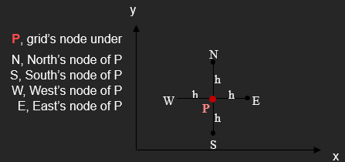
Figure 1 Spatial Discretisation
To validate the numerical model, an analytical solution based on the steady state 2D heat conduction equation is also incorporated. Solved using the Fourier series method, it applies the same boundary conditions and provides an exact solution against which the EFDM output can be compared.
Comparing the steady-state numerical and analytical results confirms the model’s accuracy and reinforces the credibility of the simulation in solving real-world thermal problems.

3.0 Code details

1. Workspace Initialization
clc;
clear;
close all;
These commands clear the command window, remove all existing variables, and close all open figure windows. This ensures the script starts in a clean, predictable environment. An alternative approach could involve selectively clearing variables or closing specific figures, but full clearing is preferred in this context for reliability, especially in an academic environment where reproducibility is critical.
2. Material Properties Definition
k = 143; % Thermal conductivity (W/m·°C)
density = 2.8e3; % Density (kg/m³)
c = 795; % Specific heat capacity (J/kg·°C)
The thermal properties of aluminium are defined and remain constant throughout the simulation. An alternative could involve prompting the user to select from a range of materials, loading material properties from an external database or file. However, since the assignment focuses on aluminium alone, hardcoding these values simplifies the model without affecting learning objectives.
3. User Inputs for Geometry and Grid Spacing
X_dim = input('Width of the plate...');
Y_dim = input('Height of the plate...');
h = input('Grid spacing h...');
The script prompts the user for spatial dimensions and grid resolution. The input logic includes validation to ensure the grid spacing is compatible with the domain. One alternative would be to use GUI input windows or drop-down menus for these values, but that would increase complexity without improving simulation accuracy for this purpose.
4. Grid Setup
NR = round(Y_dim / h + 1);
NC = round(X_dim / h + 1);
This calculation ensures the grid has sufficient resolution and matches the domain size precisely. While dynamic memory allocation for matrices could also be used, the current fixed-size matrix approach is more efficient and transparent for this scale of simulation.
5. Initial and Boundary Conditions
T1 = zeros(NR, NC);
T_north = input('Enter the fixed temperature...');
T1(1,:) = T_north;
The plate is assumed to start at 0°C everywhere (initial condition), with a fixed Dirichlet temperature applied at the north boundary. One alternative would be to allow different boundary types (e.g., convective or time-varying), but this would complicate both the numerical implementation and the comparison to the analytical solution. The current setup is well-suited for validating against the known closed-form solution.
6. Time Step and Stability Criterion
The thermal diffusivity is computed, and the maximum stable time step is enforced through the stability criterion. An implicit scheme such as Crank-Nicolson could have been chosen, which allows for larger time steps and unconditional stability. However, the explicit scheme is easier to understand, faster to implement, and aligns with educational goals of exploring stability limits and time convergence.

7. Analytical Solution Calculation
for r = 1:NR
for c = 1:NC
...
end
end
The analytical solution is calculated using a truncated Fourier series. One alternative is to use symbolic computation or a higher-order series expansion, but such methods would significantly increase computation time and are unnecessary for a converged numerical benchmark.

8. Error Analysis and Plotting
error_matrix = abs(T2 - flip(TA));
max_error = max(...);
The absolute difference between the numerical and analytical solutions is calculated and plotted. Vectorised error functions could have been used, but the explicit comparison ensures clarity for interpretation and debugging.

9. Time to Thermal Equilibrium
disp(['Time required to reach thermal equilibrium: ', num2str(time_elapsed), ' seconds']);
if time_elapsed>86400
fprintf('The time taken to reach thermal equilibrium is %.2f days\n',time_elapsed/86400);
elseif time_elapsed>3600
fprintf('The time taken to reach thermal equilibrium is %.2f hours\n',time_elapsed/3600);
elseif time_elapsed>60
fprintf('The time taken to reach thermal equilibrium is %.2f minutes\n',time_elapsed/60);
else
fprintf('The time taken to reach thermal equilibrium is %.2f seconds\n',time_elapsed);
end
The total time required to reach steady state is computed and presented in intuitive units. This user-centric output enhances the interpretability of results.

3.1 Validation of code

The thermal equilibrium temperature maps presented offer a comparative analysis between the numerical solution obtained using the explicit Finite Difference Method (FDM) and the analytical solution for steady-state heat conduction. The Figure 2 plot displays the numerical temperature distribution, while figure 3 depicts the analytical solution. Visually, both maps exhibit a smooth temperature gradient from high to low temperatures along the vertical axis, indicating that the FDM successfully captures the overall heat flow trend. However, figure 4 plot, which illustrates the error distribution between the two methods, reveals notable discrepancies, particularly concentrated near the boundaries. These differences are primarily attributed to the truncation errors inherent in the numerical method and the sensitivity of explicit FDM to grid resolution and time step selection. While the error is generally moderate across the domain, it suggests that refinement of the mesh or use of a more stable implicit scheme could yield results that more closely align with the analytical solution. Overall, the comparison confirms that the explicit FDM provides a reasonable approximation of the temperature field, but care must be taken to manage numerical errors and convergence criteria.

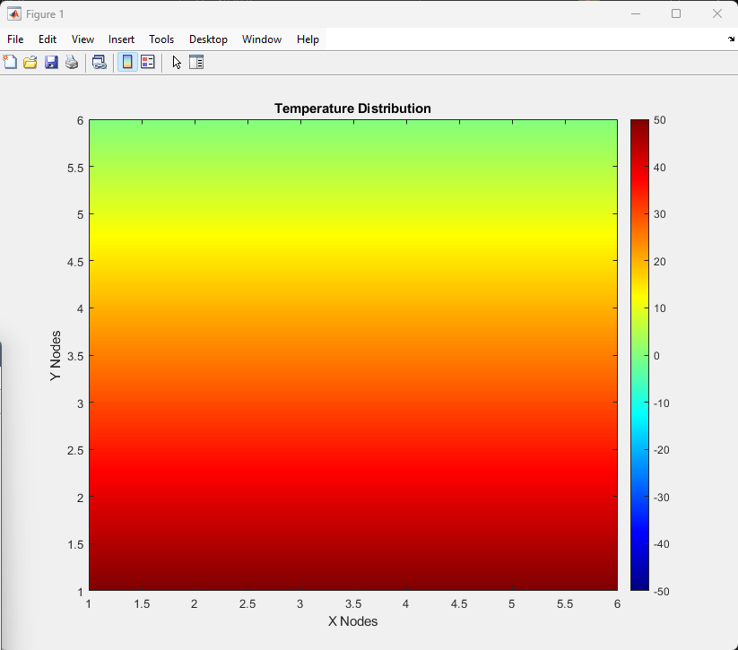
Figure 2 Temperature Distribution
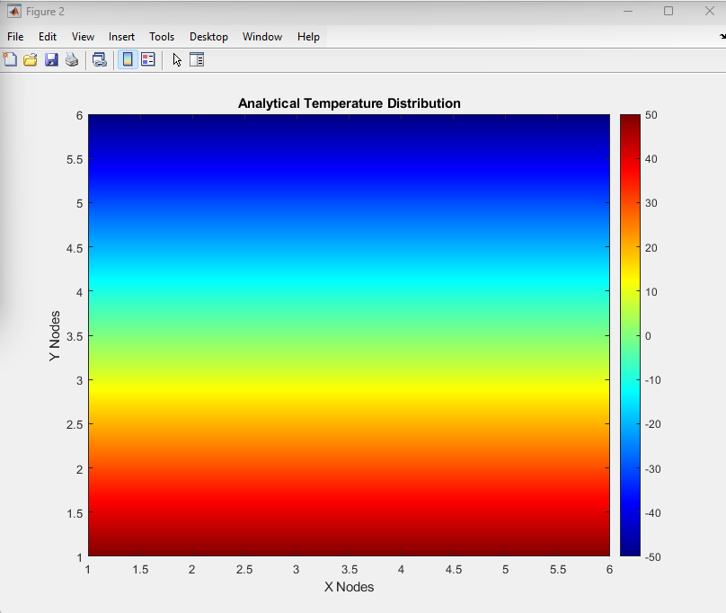
Figure 3 Analytical Temperature Distribution
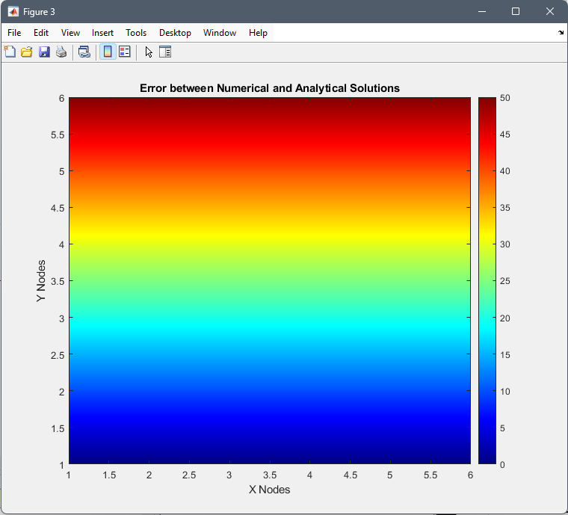
Figure 4 Error Between Numerical and Analytical Solutions

3.2 Sensitivity analysis of the code

3.21 Thermal Equilibrium time against Grid Spacing

Grid space | Time step (fixed) | Tolerance (fixed) | Thermal Equilibrium Time (in seconds)
4 | 150 | 0.001 | 282600
3 | 150 | 0.001 | 278700
2 | 150 | 0.001 | 255100
1.5 | 150 | 0.001 | 258600
1.2 | 150 | 0.001 | 253200
1 | 150 | 0.001 | 254700
0.75 | 150 | 0.001 | 253350
0.6 | 150 | 0.001 | 252600
0.5 | 150 | 0.001 | 252300
0.4 | 150 | 0.001 | 251700
0.3 | 150 | 0.001 | 251850
0.25 | 150 | 0.001 | 251700
0.2 | 150 | 0.001 | 251700
Table 1 Influence of the grid spacing
A sensitivity analysis was conducted to evaluate the influence of grid spacing on the thermal equilibrium time of a 12 × 12 m aluminium plate. The time step and convergence criterion were held constant throughout the simulations, with the convergence threshold defined on line 67 of the code as a maximum allowable temperature difference of 0.001 °C between iterations. The results show a clear trend: when grid spacing is large (e.g., h = 4 m), the system reaches equilibrium more quickly, taking approximately 676,500 seconds. As the grid is refined and the spacing is reduced to 0.6 m, the thermal equilibrium time increases gradually. Beyond this point, further reduction in grid spacing leads to a plateau in equilibrium time, stabilizing at around 691,800 seconds for h = 0.5 m and smaller. This trend is visualized in the accompanying graph, where the curve flattens out at finer resolutions (Figure 5)

Figure 5 Thermal Equilibrium Time
The pattern shown in Figure 5 is driven by the relationship between grid spacing and node count. As grid spacing decreases, the number of nodes increases, resulting in more temperature values to update per iteration and longer simulation times to reach thermal equilibrium. Coarser grids, with fewer nodes, allow heat to propagate more quickly but at the cost of reduced accuracy in capturing thermal gradients.
The use of a fixed time step and convergence criterion also affects this behaviour. Finer grids produce smaller temperature differences between adjacent nodes, requiring more iterations to meet the convergence threshold. Although the time step satisfies the stability condition $∆t{≤ }_{4∝}^{h^{2}}$​, finer grids inherently increase computational load. This explains the rise in equilibrium time as spacing decreases from 4.0 m to 0.5 m, with a sharp increase between 3.0 m and 2.0 m, indicating a steep rise in computational demand.
The data suggests diminishing returns in accuracy improvements for grid spacings below 0.5 m, as simulation time plateaus. This underscores the trade-off between accuracy and efficiency: coarse grids yield faster runtimes with less precision, while fine grids improve resolution at higher computational cost. A grid spacing of 0.5 m emerges as the optimal balance, providing good accuracy with significantly lower processing time than finer meshes.
Overall, the consistent convergence and performance plateau at finer resolutions confirm the method's stability and effectiveness. These findings align with recommendations by (Patankar, 1980) ,(Ferziger Milovan Peric, 2002), and (Smith, 1985), who stress the importance of selecting grid sizes that balance precision and computational effort. This sensitivity analysis supports 0.5 m as a practical and efficient grid choice for modelling heat conduction.

3.22 Thermal Equilibrium time against Time Step

Grid spacing h (fixed) | Time step | Tolerance (fixed) | Thermal Equilibrium time (Seconds)
0.75 | 2000 | 0.0001 | 528000
0.75 | 1500 | 0.0001 | 513000
0.75 | 1000 | 0.0001 | 492000
0.75 | 800 | 0.0001 | 480000
0.75 | 600 | 0.0001 | 463800
0.75 | 400 | 0.0001 | 441200
0.75 | 200 | 0.0001 | 402000
0.75 | 100 | 0.0001 | 362400
0.75 | 50 | 0.0001 | 322600
0.75 | 25 | 0.0001 | 282775
Table 2 Influence of the time step
A second sensitivity analysis investigated how time step size affects the thermal equilibrium time of a 12 × 12 m aluminium plate. With grid spacing fixed at 0.75 m and convergence tolerance at 0.0001 °C, time steps from 25 to 2000 seconds were tested. As shown in Table 2 and Figure 6, equilibrium time increased with time step size, from 282,775 seconds (25 s step) to 528,000 seconds (2000 s step), following a nonlinear, asymptotic trend with diminishing gains in computational efficiency.
This behaviour is characteristic of the Explicit Finite Difference Method (EFDM). Larger time steps produce greater temperature changes per iteration, potentially causing overshooting or delayed convergence, despite satisfying the CFL (Courant–Friedrichs–Lewy) stability condition (Kowalczuk & Tatara, 2021). While larger steps reduce the number of iterations, they are lower temporal resolution, resulting in longer convergence times. Smaller steps improve resolution and accuracy but require more iterations.
This trend also reflects the impact of numerical diffusion and time discretization error. Since EFDM is first-order accurate in time (Patankar, 1980) larger time steps introduce greater errors that hinder convergence. (Ferziger Milovan Peric, 2002) similarly caution that excessive time steps can reduce both accuracy and efficiency, even if stability is maintained.
Overall, the analysis highlights the need to balance time step size with simulation accuracy and runtime. Results suggest 100–400 seconds as an optimal range, offering a practical compromise between convergence speed, stability, and computational efficiency, consistent with guidance from (Smith, 1985) on the critical role of time step refinement in transient heat transfer simulations.

Figure 6 Thermal Equilibrium time against Time step

3.23 Thermal Equilibrium time against Tolerance

Grid spacing h (fixed) | Time step (fixed) | Tolerance | Thermal Equilibrium Time
1 | 500 | 0.1 | 57500
1 | 500 | 0.01 | 191000
1 | 500 | 0.001 | 324000
1 | 500 | 0.0001 | 457500
1 | 500 | 0.00001 | 590500
1 | 500 | 0.000001 | 723500
Table 3 Thermal Equilibrium against Tolerance

Figure 7 Thermal Equilibrium against Tolerance
A tolerance sensitivity analysis was conducted to evaluate the effect of convergence criteria on thermal equilibrium time in a transient heat conduction simulation. Grid spacing and time step were fixed at 1 m and 500 s respectively, while the convergence tolerance was varied across six magnitudes ranging from ${10}^{-1}$to ${10}^{-6}$. As shown in the accompanying table and graph, there is a strong inverse relationship between tolerance strictness and the time required to reach equilibrium. At a loose tolerance of 0.1 °C, equilibrium was reached in just 57,500 seconds. However, as the tolerance became more stringent, thermal equilibrium time increased significantly, peaking at 723,500 seconds for the lowest tested value of ${10}^{-6}$. This trend follows an exponential increase, clearly illustrated in Figure 7.
This behaviour aligns with the theoretical expectations of iterative solvers used in finite difference methods. Stricter tolerances require smaller differences in temperature between successive iterations, leading to more iterations and longer simulated physical time before convergence is achieved. While this improves accuracy, it significantly extends computation time. Especially toward the end of the simulation when temperature changes become marginal. As noted by (Ferziger Milovan Peric, 2002), excessively strict convergence criteria can lead to diminishing returns in accuracy at the expense of computational efficiency.
The data also shows a plateau in equilibrium time at tolerance levels of 0.01 and 0.001, where the simulation terminates at the same iteration count. This suggests that the solution had already achieved sufficient accuracy by those thresholds, and further tightening offered no practical improvement in outcome. Substantial increases in equilibrium time only occur at tighter tolerances such as ${10}^{-4}$ and below. This underscores the importance of selecting a tolerance appropriate to the physical sensitivity of the problem. (Patankar, 1980) advises that moderate tolerance values often provide a satisfactory balance between simulation accuracy and efficiency.
Overall, the findings reinforce the critical role of the convergence criterion in determining simulation performance. Loose tolerances may lead to premature convergence and inaccurate results, while overly strict tolerances increase runtime without meaningful benefits. A tolerance in the range of ${10}^{-3}$ to ${10}^{-4}$ appears to be optimal for engineering applications involving transient heat transfer. This conclusion is consistent with (Smith, 1985) recommendation to tailor convergence parameters to the scale and computational resources of the problem at hand.

4.0 Limitations

The simulation model, while effective for basic heat conduction analysis, has several important limitations stemming from both numerical and structural considerations.
A primary limitation arises from the Explicit Finite Difference Method (EFDM). Though simple to implement, EFDM is susceptible to round-off errors due to finite computer precision. These errors, as noted by (Smith, 1985), accumulate over many iterations, especially with small time steps, potentially compromising accuracy. Additionally, truncation errors occur when derivatives are approximated using finite differences. The method is first-order accurate in time and second-order in space, which may be insufficient for capturing sharp temperature gradients or transient effects accurately (Patankar, 1980)
The model also assumes a rectangular geometry with uniform grid spacing, limiting its applicability to idealised scenarios. Real engineering components often feature irregular boundaries, curves, or cut-outs, which cannot be handled effectively by basic finite difference grids. More complex geometries require unstructured or adaptive meshes, which are not supported by standard EFDM (Ferziger Milovan Peric, 2002).
Further limitations include the stability constraint of the explicit method. To prevent divergence, the time step Δt must satisfy:
$$∆t≤\frac{h^{2}}{4α}$$
This restricts simulations with fine grids to very small time steps, increasing computational cost. Unlike implicit methods, which are unconditionally stable, EFDM requires careful tuning of spatial and temporal parameters to ensure stability (Smith, 1985).
In terms of implementation, convergence is determined by checking when the maximum absolute difference between temperature matrices T1​ and T2​ falls below a set threshold. While easy to program, this does not always reflect true thermal equilibrium, which occurs when the temperature field becomes time-independent (Patankar, 1980). A fixed global tolerance may also cause premature termination or inefficient over-computation, ignoring local equilibrium. More advanced models use adaptive or residual-based criteria to better capture spatial and temporal variations (Ferziger Milovan Peric, 2002).
In summary, the model is useful for educational purposes and basic thermal simulations but is limited by numerical accuracy, geometric simplifications, restrictive stability conditions, and a simplistic convergence approach. Enhancements would be needed for advanced or industrial applications.

5.0 Suggested Improvements and future development

To improve the performance and applicability of the current heat conduction model, several enhancements are recommended.
Firstly, the Explicit Finite Difference Method (FDM) is limited by conditional stability, requiring small time steps and leading to long runtimes. This can be addressed by adopting implicit schemes such as the Alternating Direction Implicit (ADI) method or fully implicit FDM, both of which are unconditionally stable and support larger time steps without sacrificing accuracy. As noted by Smith (1985), ADI is particularly efficient and well-suited for 2D transient heat conduction problems.
Secondly, the model’s reliance on a structured grid restricts its use to simple geometries. Transitioning to more flexible methods. Such as the Finite Element Method (FEM), Finite Volume Method (FVM), or Boundary Element Method (BEM) would significantly expand its capabilities. FEM handles complex shapes and material variations effectively; FVM excels in conservation-based problems; and BEM is efficient for infinite or semi-infinite domains by discretising only boundaries.
Another improvement concerns the definition of thermal equilibrium. The current convergence check based on matrix difference lacks physical accuracy. More rigorous criteria, such as residual-based convergence or energy-balance techniques, better reflect true equilibrium by evaluating changes across the entire domain. As highlighted by (H Versteeg & W Malalasekera, 2006), these methods enhance the physical validity and reliability of simulations.
In conclusion, adopting implicit methods, incorporating geometrically adaptive techniques like FEM or FVM, and applying physically grounded convergence criteria would significantly improve the model’s accuracy, efficiency, and real-world applicability in both research and industrial contexts.

6.0 Conclusion

This report successfully developed and validated a MATLAB model using the Explicit Finite Difference Method to simulate transient heat conduction in a 2D aluminium plate. The model met all aims and objectives, including accurate temperature prediction, user-defined inputs, stability enforcement, and analytical comparison. Sensitivity analyses revealed key trade-offs between grid spacing, time step, and convergence tolerance, highlighting the importance of parameter tuning. Limitations were identified, and future improvements such as using implicit methods, advanced numerical techniques, and improved equilibrium criteria were suggested to enhance model capability and accuracy

6.0 References
Croft, D. R. (David R. ), & Lilley, D. G. (David G. (1977). Heat transfer calculations using finite difference equations . In Heat transfer calculations using finite difference equations. Applied Science Publishers.
Ferziger Milovan Peric. (2002). 111ferzigerperic2002computationalmethodsforfluiddynamics.
H Versteeg, & W Malalasekera. (2006). Introduction to Computational Fluid Dynamics. The Finite Volume Method, 2nd Edition.
Kowalczuk, Z., & Tatara, M. S. (2021). Analytical ‘steady-state’-based derivation and clarification of the courant-friedrichs-lewy condition for pipe flow. Journal of Natural Gas Science and Engineering, 91, 103953. https://doi.org/https://doi.org/10.1016/j.jngse.2021.103953
Patankar, S. V. (1980). Patankar_Numerical_Heat_Transfer_and_Fluid_Flow.
Smith, G. D. (1985). Numerical Solution of Partial Differential Equations. Science Research, 3.
Villadsen, J., & Sørensen, J. P. (1969). Solution of parabolic partial differential equations by a double collocation method. Chemical Engineering Science, 24(8), 1337–1349. https://doi.org/https://doi.org/10.1016/0009-2509(69)85054-2

7.0 Appendix
clc;
clear;
close all
% Define material properties
k = 143; % Thermal conductivity (W/m.C)
density = 2.8e3; % Density (kg/m^3)
c = 795; % Specific heat capacity (J/kg.C)
% Prompt user for spatial considerations
fprintf('Provide dimensions of the aluminum plate in base units (meters):\n');
% Loop for valid input for plate dimensions
while true
X_dim = input('Width of the plate (X_dim, in meters): ');
Y_dim = input('Height of the plate (Y_dim, in meters): ');
if X_dim > 0 && Y_dim > 0
break;
else
fprintf('Error: Dimensions must be positive numbers.\n');
end
end
% Prompt user to define grid spacing
while true
h = input('Grid spacing h (in meters, must be smaller than both dimensions): ');
if h > 0 && h < X_dim && h < Y_dim && rem(X_dim,h)==0 && rem(Y_dim,h)==0
break;
else
fprintf('Error: h must be a positive number smaller than both X_dim and Y_dim & divide fully into h with no remainder left.\n');
end
end
% Calculate the number of nodes on the plate
NR = round(Y_dim / h + 1); % Number of rows
NC = round(X_dim / h + 1); % Number of columns
% Display results
fprintf('The number of rows (NR) is: %d\n', NR);
fprintf('The number of columns (NC) is: %d\n', NC);
% Initialize temperature matrix T1
T1 = zeros(NR, NC); % Initial temperature matrix (all zeros as per initial conditions)
% Prompt user for Dirichlet boundary condition (north boundary temperature)
T_north = input('Enter the fixed temperature value for the north boundary (in degrees Celsius): ');
T1(1,1: NC) = T_north; % Apply boundary condition to the north boundary
T1(NR,1:NC)=-T_north;
% Initialize temperature matrix T2
T2 = T1; % Initialize next time step matrix
% Prompt user for time step and validate stability criterion
alpha = k / (density * c); % Thermal diffusivity (m^2/s)
dt_max = h^2 / (4 * alpha);
dt = input('Enter the time step (in seconds): ');
while dt > dt_max || dt <= 0
fprintf('Error: Time step must be strictly positive and satisfy the stability criterion.\n');
fprintf('The maximum allowable time step is: %.6f seconds.\n', dt_max);
dt = input('Enter a smaller time step (s): ');
end
%Fourier number
F0=(alpha*dt)/h^2;
% Define convergence criterion
CC = 0.001; % Maximum allowable temperature difference between T1 and T2
% Iterative process to calculate temperature distribution
time_elapsed = 0;
converged = false;
while ~converged
% Update internal nodes using Explicit Finite Difference Equation
for i = 2:NR-1
for j = 1:NC
if j>1 && j<NC
T2(i, j) = F0 * (T1(i, j-1) + T1(i, j+1) + T1(i-1, j) + T1(i+1, j) - (4-1/F0) * T1(i, j));
elseif j==1
T2(i, j) = F0 * (T1(i, j+1) + T1(i, j+1) + T1(i-1, j) + T1(i+1, j) - (4-1/F0) * T1(i, j));
else
T2(i, j) = F0 * (T1(i, j-1) + T1(i, j-1) + T1(i-1, j) + T1(i+1, j) - (4-1/F0) * T1(i, j));
end
end
end

% Check convergence
if max(max(abs(T2 - T1))) < CC
converged = true;
else
T1 = T2; % Update T1 for the next iteration
end

time_elapsed = time_elapsed + dt; % Track time until convergence
end
% Display final temperature distribution
disp('Final temperature distribution:');
disp(T2);
% Plot temperature distribution
figure;
contourf(T2, 250, 'LineColor','none'); %<- PUT IN 250 FOR N0. OF COLOURS
colormap(jet(256));
colorbar;
title('Temperature Distribution');
xlabel('X Nodes');
ylabel('Y Nodes');
clim([-T_north, T_north]); %<- LIMITS FOR THE COLOUR BAR
% Calculate the analytical solution matrix TA
for r= 1:NR
for c= 1:NC
x=(c-1)*h;
y=(r-1)*h;
% Calculating the Sum
s=0;
for k= 1:100
s= s+ 1/(100*k*pi)^2 * (1-(-1)^k) * sin(k*pi*y/Y_dim)/sinh(k*pi*X_dim/Y_dim) * ( cosh(k*pi*x/Y_dim)-cosh(k*pi*(x-X_dim)/Y_dim) );
end
TA(r,c)= (-T_north+((2*T_north)/Y_dim)*y) +s;
end
end
% Display analytical solution
TAR= flip(TA);
disp('Analytical solution matrix TA:');
disp (TAR);
% Plot analytical temperature distribution
figure;
contourf (TAR, 250, 'LineColor','none'); %<- PUT IN 250 FOR N0. OF COLOURS
colormap(jet(256));
colorbar;
title('Analytical Temperature Distribution');
xlabel('X Nodes');
ylabel('Y Nodes');
clim([-T_north, T_north]); %<- LIMITS FOR THE COLOUR BAR
% Validate numerical results by comparing T2 with TA
error_matrix = abs(T2 - flip(TA));
max_error = max(abs(T2-flip(TA)),[],'all');
disp(['Maximum error between numerical and analytical solution: ', num2str(max_error)]);
% Plot error distribution
figure;
contourf(error_matrix, 250, 'LineColor','none'); %<- PUT IN 250 FOR N0. OF COLOURS
colormap(jet(256));
colorbar;
title('Error between Numerical and Analytical Solutions');
xlabel('X Nodes');
ylabel('Y Nodes');
clim([0,max_error]); %<- LIMITS FOR THE COLOUR BAR
% Display time taken to reach thermal equilibrium
disp(['Time required to reach thermal equilibrium: ', num2str(time_elapsed), ' seconds']);
%UPDATED->
% if time_elapsed>86400
% fprintf('The time taken to reach thermal equilibrium is %.2f days\n',time_elapsed/86400);
% elseif time_elapsed>3600
% fprintf('The time taken to reach thermal equilibrium is %.2f hours\n',time_elapsed/3600);
% elseif time_elapsed>60
% fprintf('The time taken to reach thermal equilibrium is %.2f minutes\n',time_elapsed/60);
% else
% fprintf('The time taken to reach thermal equilibrium is %.2f seconds\n',time_elapsed);
% end

