Harvard Referencing Activity 1

On the pages that follow there are 20 reputable sources from either books, journals, or websites.

Using your new knowledge of referencing, along with the UWTSD Harvard Referencing Guide (from our Moodle page), please provide the citation for each source, and the full correctly formatted reference for each source in the spaces provided.
The images of the webpages all contain hyperlinks – this means you can click on the link and look around the webpage to search for the information you need.
When referencing journal articles, keep in mind that not all journals will have an issue number.
When you are finished, ensure you save your document and upload it to the correct submission link for Activity 1.

Good luck!

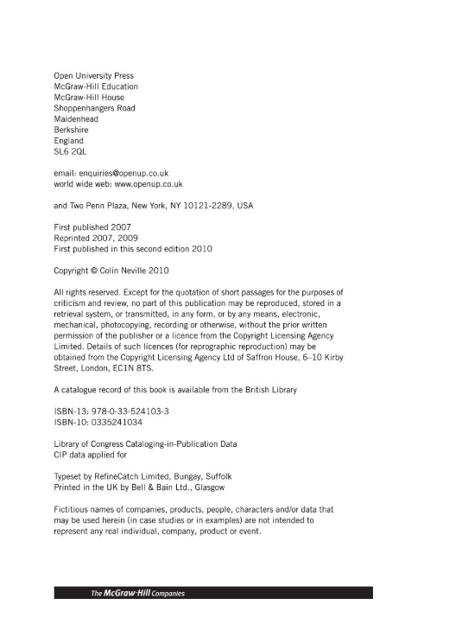

Citation :
Reference : Neville, C. (2010) The Complete Guide To Referencing and Avoiding Plagiarism. 2nd edn. Glasgow: The McGrow-Hill companies.
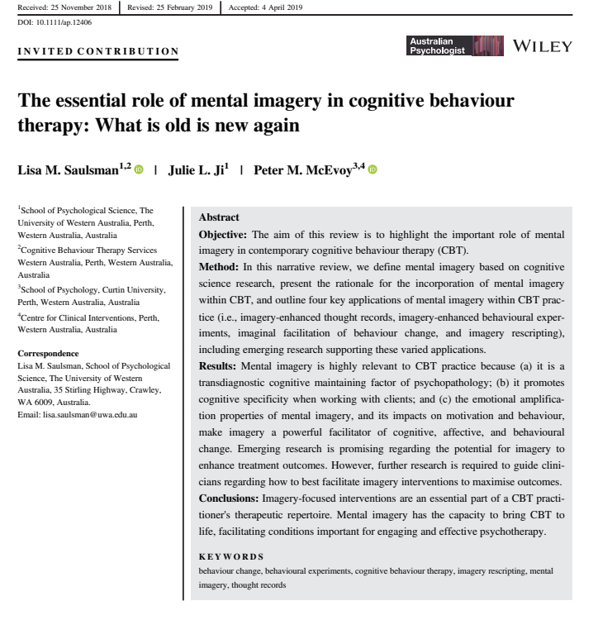
Citation : web page
Reference : Australian Psychologist (2019) The essential role of mental imagery in cognitive behaviour therapy :What is old is new again.

Citation : journal article
Reference : Westgate, E.C. Workington, S.V. Oleson, K.C. and Lindgren K.P. (2017) ‘ Productive procrastination’, Journal of Applied Social Psychology, pp. 124-135

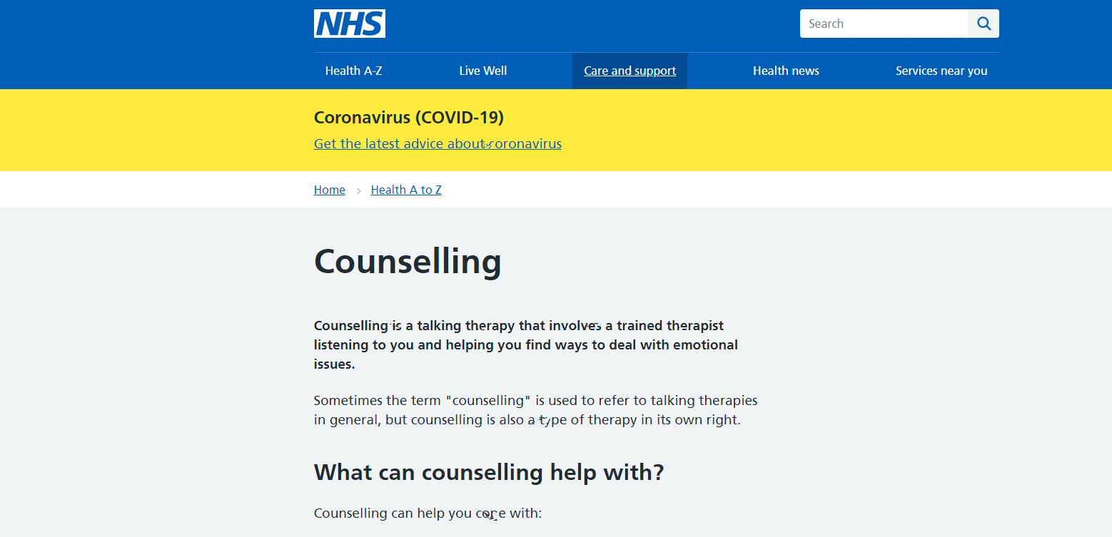

Citation : web page
Reference : NHS (2018) Counselling. Available at: Counselling - NHS (www.nhs.uk) (Accessed 9th February 2021)

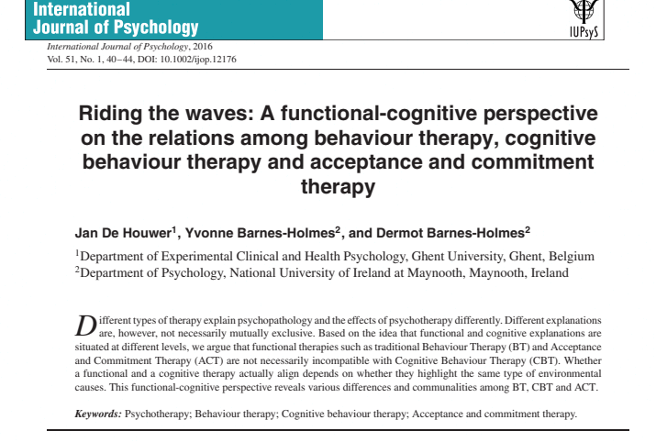

Citation : Journal
Reference : Jan De Houwer, Yvonne Barnes-Holmes, and Dermot Barnes-Holmes. (2016) Riding the waves: A functional-cognitive perspective on the relations among behaviour therapy, cognitive behaviour therapy and acceptance and commitment therap, 51(1), pp. 40-44.
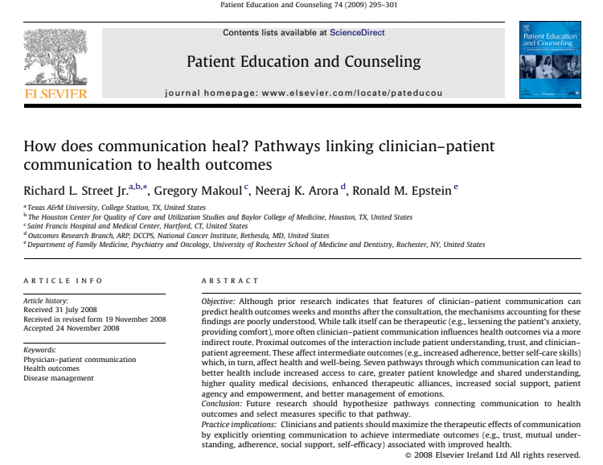

Citation : Journal article

Reference : Richard L, Street JR. Gregory Makoul, Neeraj K. Arora, and Ronald M. Epstein. (2009) ‘How does communication heal?’ Patient Education and Counselling, 74, pp. 259-301

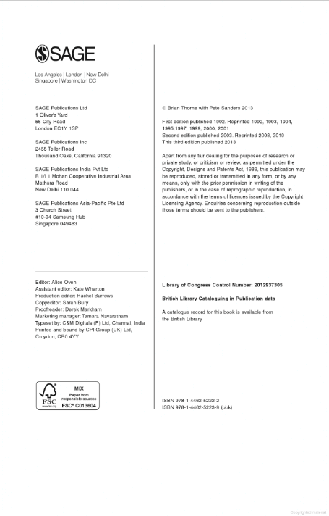

Citation :
Reference :

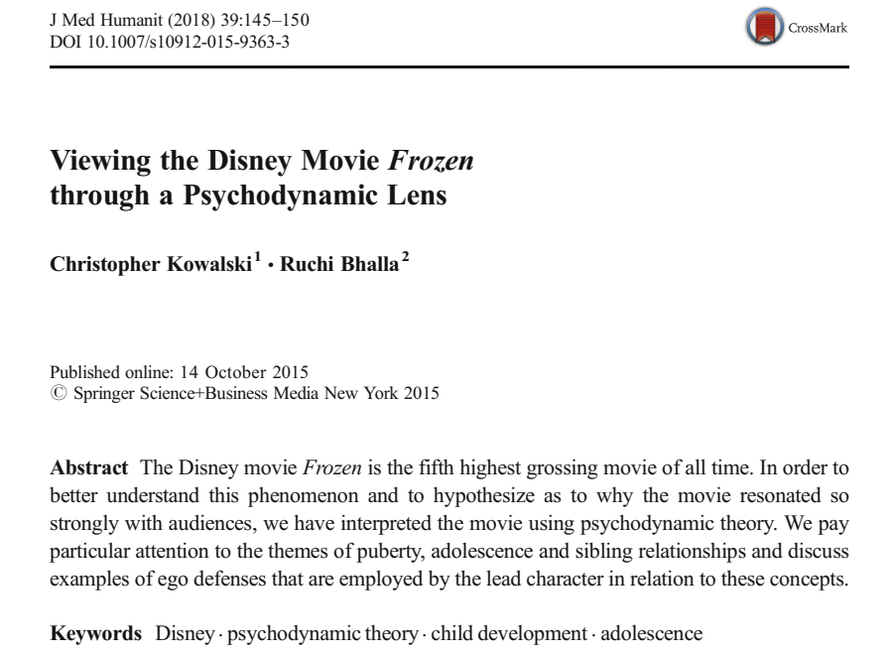

Citation : Journal article
Reference : Christopher, K. and Ruchi, B. (2018) @Viewing the Disney Movie Frozen through a Psychodynamic Lens’ Crossmark, 39, pp. 145-150
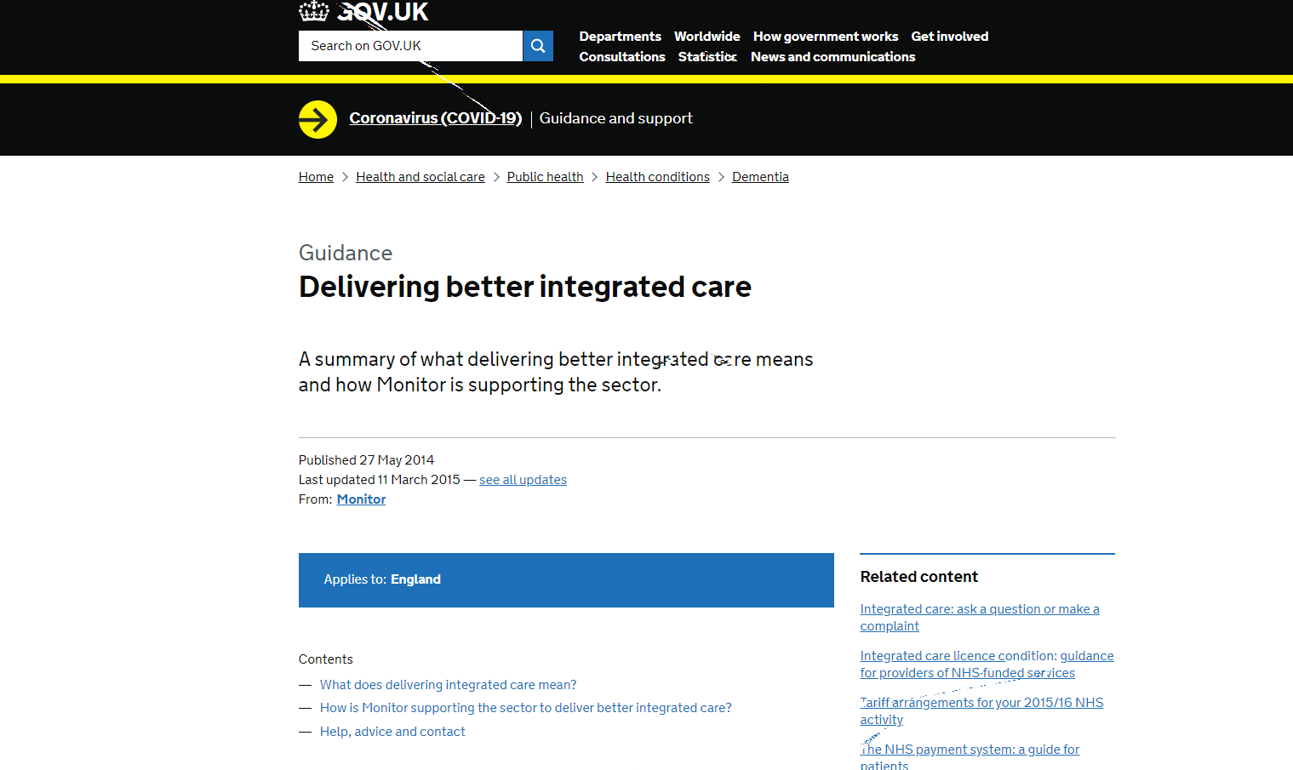

Citation : Web page
Reference : Gov.uk (2014) Delivering better integrated care. Available at Delivering better integrated care - GOV.UK (www.gov.uk)
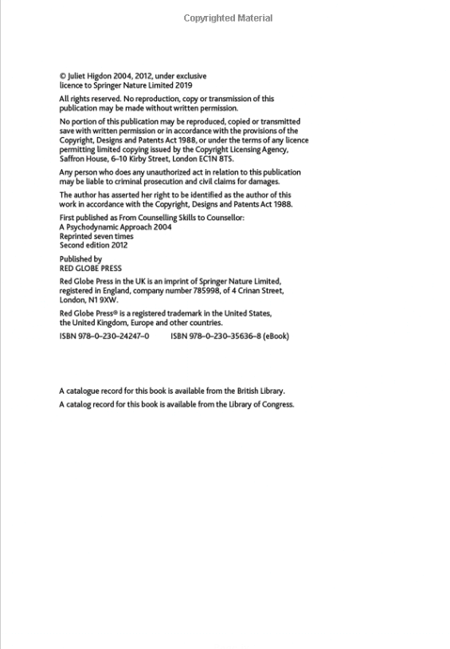

Citation : Book
Reference : Juliet, H. (2004) Psychodynamic Theory for Therapeutic Practice. 2nd edn. London: Red Globe Press.
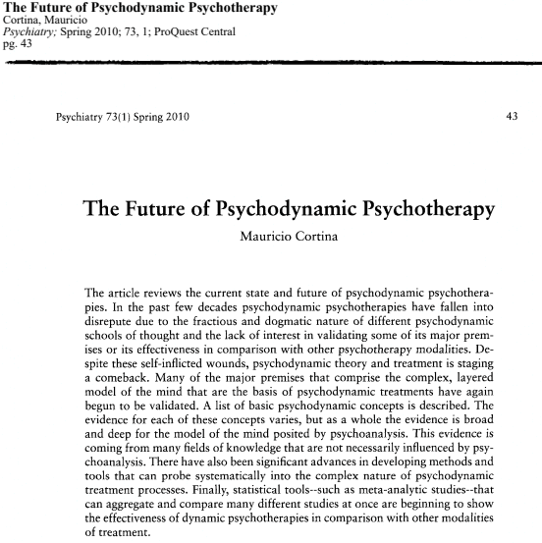
Citation : Journal article

Reference : Mauricio, C. (2010) ‘The Future of Psychodynamic Psychotherapy’ 73(1), pp. 43

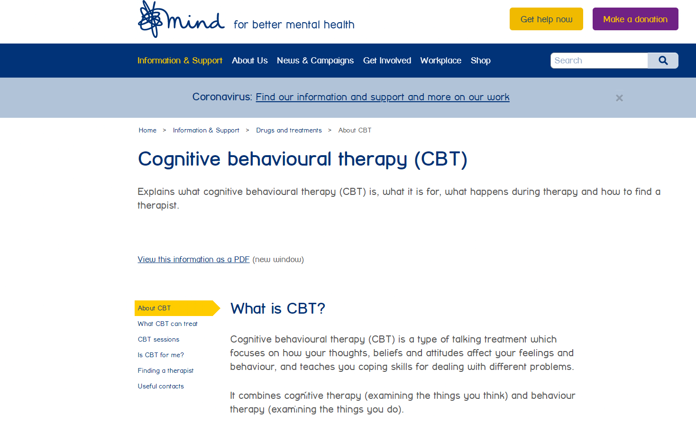
Citation : web page
Reference : Mind for better mental health (2017) Cognitive behavioural therapy: Explains what cognitive behavioural theraoy is, what it is for, what happens during therapy and how to find a therapist. Available at https://www.mind,org.uk/information-support/drugs-and- treatment/cognitive-behavioural-therapy-cbt/about-cbt/
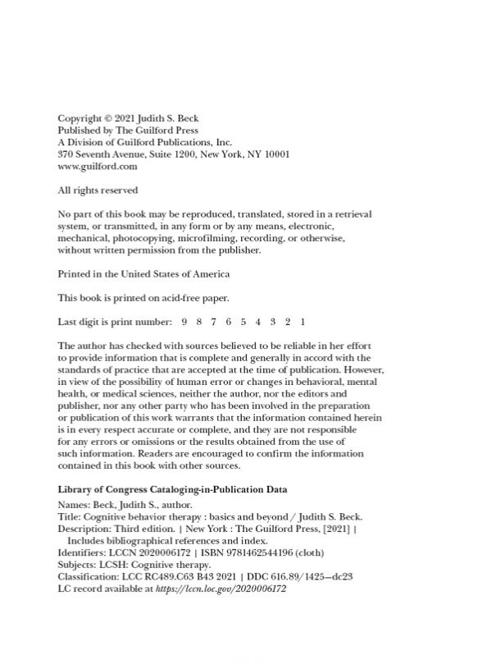
Citation : book
Reference : Judith S. Beck. (2021) Cognitive Behaviour Therapy: Basics and Beyond. 3rd edn. New York: The Guildford Press
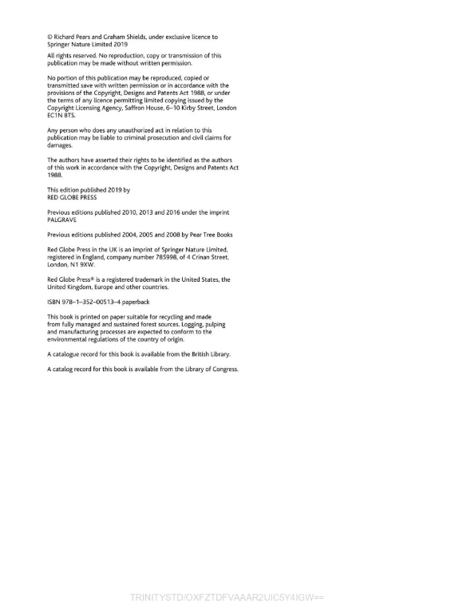
Citation : book
Reference : Richard Pears and Graham Sheilds (2019) Cite Them Right the essential referencing guide 11th edn. New York. PALGRAVE.

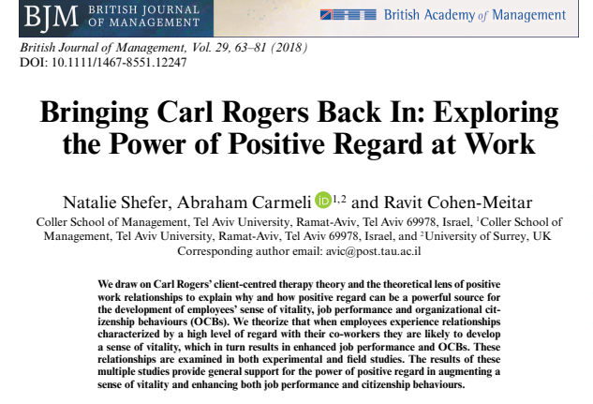

Citation : journal
Reference : Shefner N., Carmelo, A and Cohen- Meitar,. R.,2018,Brining Carl Rodgers back in:Exlploring Power Of Positive Regard Back To Work. British Jorunal Of Management, 29(1)
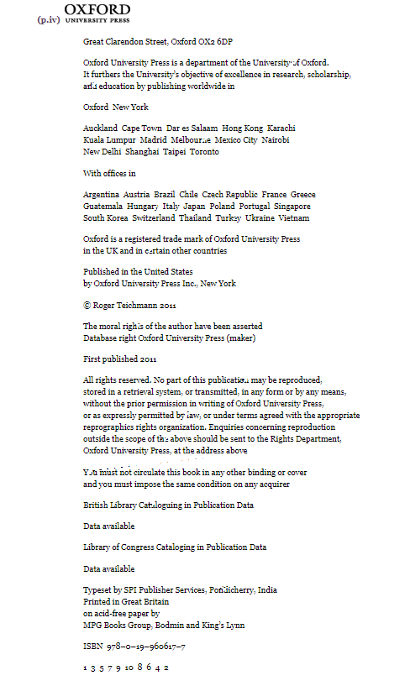
Citation : Book
Reference : Teichmann, R., 2011. Nature, reason, and the good life. Oxford: Oxford University Press.

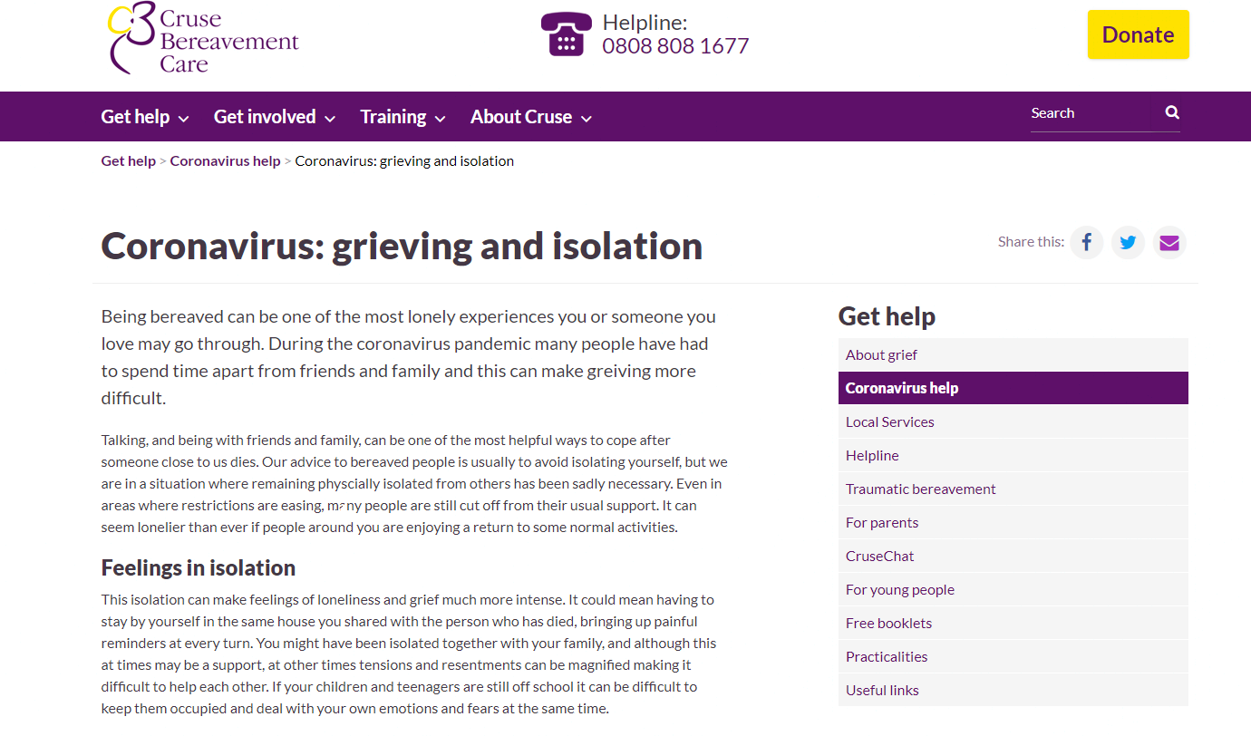

Citation : website
Reference : Cruse.org.uk. 2020. Coronavirus: grieving and isolation | Cruse Bereavement Care. [online] Available at: <https://www.cruse.org.uk/coronavirus/grieving-and-isolation> [Accessed 14 February 2021].
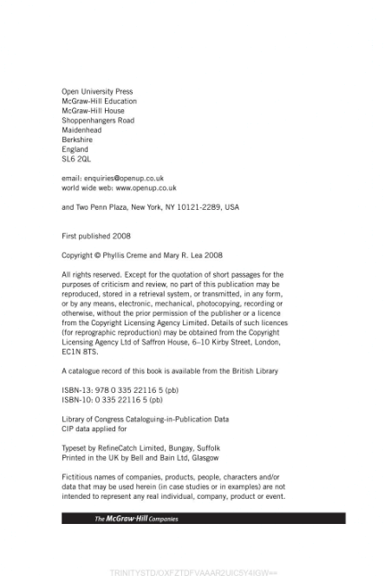

Citation : book
Reference : Creme, P. and Lea, M., 2012. Writing at university. Johanneshov: TPB.

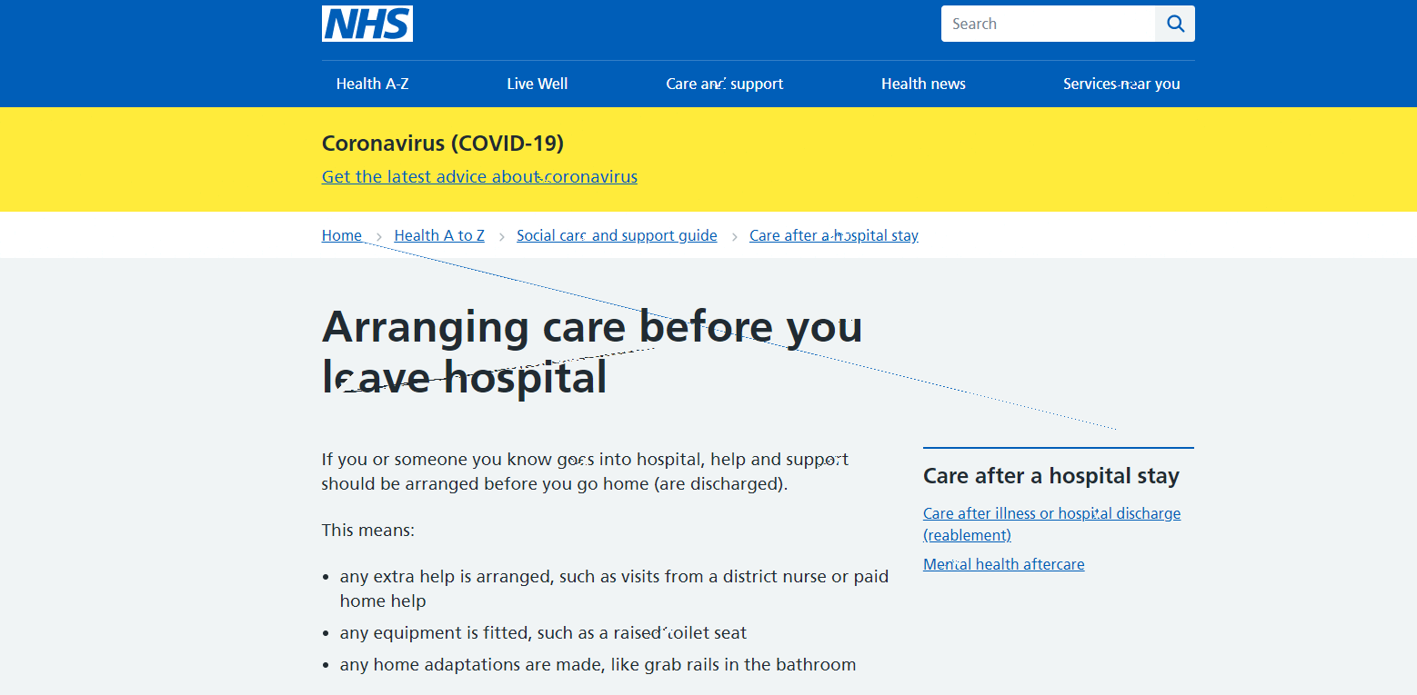

Citation : Website
Reference : nhs.uk. 2018. Arranging care before you leave hospital. [online] Available at: <https://www.nhs.uk/conditions/social-care-and-support-guide/care-after-a-hospital-stay/arranging-care-before-you-leave-hospital/> [Accessed 14 February 2021].
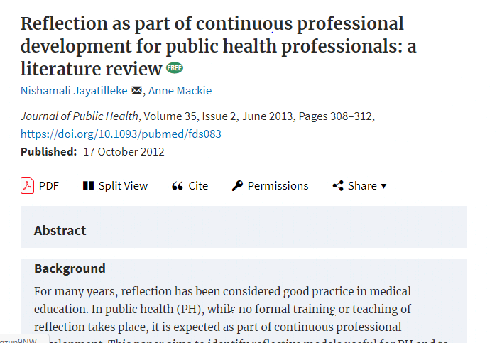

Citation : Journal
Reference : Jayatilleke, N. and Mackie, A., 2012. Reflection as part of continuous professional development for public health professionals: a literature review. Journal of Public Health, 35(2), pp.308-312.

