  Component One:  What are the key skills required when working in the housekeeping team? 750 words (+/- 10%)  Contribution to Overall Module Assessment: 25% | Student  No: 2207646  Module  Title: Operating Hotel Facilities  Module Code: BMIH4006  Lecturer: Lola Villard
Association or institution - Housekeepers can organize clutter in a systematic way if they have hierarchical skills. Arrangements of the wet bar and a variety of other items throughout the room must be kept as ordered as possible for housekeepers to maintain order in the room. A well-organized and coordinated room will make those using it feel comfortable and untroubled (Purves, 2019).
Communication - Having a good ability to communicate is essential for housekeepers in hotels, who frequently interact with different kinds of visitors. The amount of personal items they must provide goes far beyond towels, soap, and toilet paper. There may be circumstances in which a housekeeper can assist a guest who complains about a room not meeting their expectations. This requires effective communication in order to succeed.
Honesty - A housekeeper may make a mistake or encounter an accident while performing their duties. While they are doing the washing, they may damage the sofa or other furniture that belongs to a visiting guest or to the hotel where they work, or even rip a section of a sofa while they are doing the washing. Hurst, (2019) recommends acknowledging their error, explaining what happened, and ensuring it does not happen again. Continually ignoring the problem is a sign of negligence and wastefulness on the part of the on-call housekeeper.
Meticulousness - Keeping on top of even the tiniest details is crucial for Premier Inn hotel housekeepers. Assuring that everything is in its right place should be a part of their duties. Several housekeepers take pictures of all items before beginning their shifts to ensure they are returned to their rightful places when they end it.
Active hearing - Communicating with the house manager is easier if you are able to listen to what they say. If a housekeeper is very good, she will pay attention to each instruction and ask questions when necessary to clarify. Due to their ability to listen attentively and respond courteously, this skill set will assist the janitorial team in their career advancement.
Adaptability - Housekeepers, especially live-in ones, are generally preferred by managers. Taking care of the children, cleaning up after them, and cooking may fall to the domestic. Flexible housekeepers are capable of completing most of the day's tasks, but less flexible ones may not be able to help in many circumstances.
Reliability - When it comes to doing a good job for the employer, a good housekeeper is always reliable, dependable, and committed to the task at hand. Taking advantage of the experience acquired by the previous employee is essential. It is essential for individuals to have the confidence of the organization by being reliable, and dedicate and enthusiastic to their work in order to make a positive difference for the organization (Doremus & Becker, 2022).
Hardworking- It is imperative that housekeepers spend the necessary time and effort on cleaning thoroughly. It is crucial that he or she maintain a clean working environment in order to be diligent. The employee must show greater fortitude at work in order to gain the employer's approval.
Caring- An essential item can easily be damaged or misplaced by a domestic during the course of her duties. The domestic, however, should treat the items with the same consideration she would her own.
Trustworthiness - Employees who can demonstrate reliability may have their residence seized by their employer. Professionalism and trustworthiness should be cultivated among live-in housekeepers. There is a significant liability associated with the work of housekeepers and housekeeping personnel in inns, making it essential there is a high level of trust shown by them (Lazenby, 2017).
Self-Control - Maintaining a professional demeanor is expected of maintenance staff, which allows them to remain emotionally stable and avoid aggressive behavior. Regularly observing the expressions of satisfaction on the faces of their employees will help the business avoid believing that people are dissatisfied with their jobs. An enthusiastic laborer must take over their residence in place of a sadist.
Innovation - To solve work-related problems and generate new ideas, housekeepers on a team must be imaginative in incorporating the perspectives of others. Progress is typically noticeable during testing segments of a gig. New strategies can be implemented that increase job performance (Bowers, 2021).
760
Word Count

References
Bowers, J.J. (2021) ‘Housekeepers on a team need to be creative in order to come up with new ideas and solve problems that are related to their work using other people’s perspectives. ’, Creative Ideas For Teaching Evaluation, pp. 301–309. doi:10.1007/978-94-015-7829-5_35.
Doremus, S. and Becker, L. (2022) ‘Active listening’, Feedback: Active Listening for a Shared Understanding [Preprint]. doi:10.4135/9781071896068.
Hurst, K. (2019) ‘Do housekeepers make a difference on wards?’, Nursing Standard, 25(7), pp. 15–15. doi:10.7748/ns.25.7.15.s19.
Lazenby, M. (2017) ‘Trustworthiness’, Oxford Medicine Online [Preprint]. doi:10.1093/med/9780199364541.003.0002.
Purves, D. (2019) ‘Association or organization’, Brains as Engines of Association, pp. 37–47. doi:10.1093/oso/9780190880163.003.0004.

Component Two:
Contribution to Overall Module Assessment: 25%
In this scenario – I have just been promoted to team leader for a floor within the hotel. A guest complains that on their arrival, their room had not been properly cleaned. Create an action plan and answer the following questions.
Problem | What caused it? | Is there anything you can do? | If this happens again, what will you do to prevent it? | How would you improve the effectiveness of your team?
Hotels have housekeeping departments. This department's main responsibility is hotel cleaning. It serves several niches. It affects how customers see the hotel. Visitors will dislike a spotless hotel. A dirty, chaotic luxury hotel won't impress visitors. Housekeepers often confront issues while cleaning customers' houses. Ineffective sweeping, vacuuming, and refilling may affect the cleanliness and air quality of your house. | There is a problem here because there was not enough time to clean the toilet and the room. | Probably we will need more staff to handle cases like this if the timeframe is tight, so I will let the management know about it. | If the consumer needs a short period of time after reconfirmation in order to get their accommodation, I am ready to expend additional staff in order to meet their requirements. The best hotels have a tendency to believe that they do not require as many cleaning supplies as they really need. Many individuals find that they use fewer items when they clean independently, since they use fewer items when they do the task alone. If your housekeeper wants to perform her job quickly and efficiently, she needs access to a large number of materials. In order to prevent any shortages of supplies, check the supplies every time you clean, so that you know what needs to be replenished before you clean again. | Work ethic and intelligence will be key to increasing the performance of my team. In order to accomplish this, I will reward them when they complete a task according to the client's specifications in order to boost their creativity and give them autonomy over decisions. Approximately 15 to 20 days will pass before this is completed.
The towels and bed are not arranged properly. | They were not inspected by Housekeepers, and the arrangements were not made according to the client's requirements. | To begin with, I apologize to them, and then as a team leader, I ask for time to make the room compliant. In between those times, I touch up the room to ensure that everything is as it should be. | In order to monitor whether each member of the team completes his or her assigned task within the allotted time and according to the specifications of the customer, I will keep a written record of all tasks. | Using a modern strategy will facilitate my ability to manage the Marriott Hotel staff and reduce potential hazards. It is our expectation that our skills can be improved over the next 20-25 days.
Neither the door hangings nor the window hangings have been altered. | People don't care and don't have time to stop it, so it continues. | To monitor the progress of my team members, I will create a digital chart of activities, which will be distributed to them via text message and phone calls, requiring them to take photographs of their work updates. | My plan is to keep the chart work going and encourage students to work in groups through communication, so they can get the work done on time and have time to monitor activities to find out whether they are completed significantly and if they can repeat a particular task not completed according to the Marriott Hotel requirements. | Time management theory will help me increase the effectiveness of my team. Ten to fourteen days should be enough for us to improve our team administration skills.
There was dirt on the carpet. | Some stains do not disappear after every imaginable task on these carpets because they are very ancient. | The Marriott Hotel's policies will be shared in meetings so that managers can learn about it. In addition, I will provide training on those policies through video, PDF, or online platforms so that my team members won't make the same mistakes again. | To ensure my team members are aware of Marriott Hotel policies, I will inform them that resources that aren't attracting and desired by customers will have to be promptly replaced.  Since their break times and log-off times aren't the same, I'll give them this information online. | My goal is to increase my team's productivity and rating by informing them of all the policies they need to know in five to ten days.

Presentation on
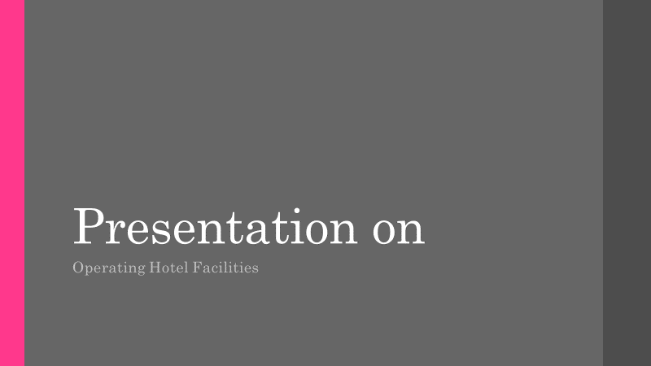

Introduction
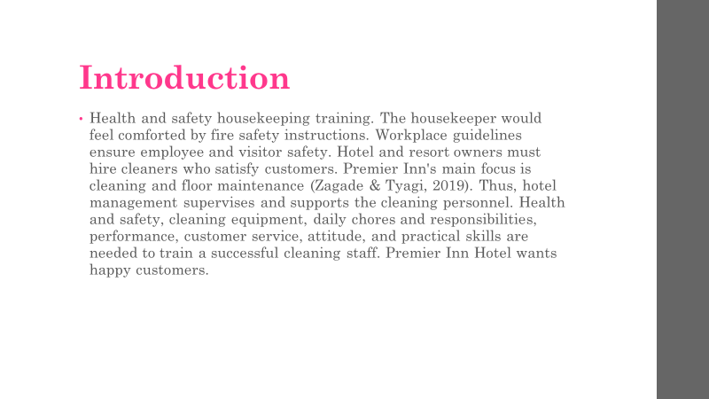
Health and safety housekeeping training. The housekeeper would feel comforted by fire safety instructions. Workplace guidelines ensure employee and visitor safety. Hotel and resort owners must hire cleaners who satisfy customers. Premier Inn's main focus is cleaning and floor maintenance (Zagade & Tyagi, 2019). Thus, hotel management supervises and supports the cleaning personnel. Health and safety, cleaning equipment, daily chores and responsibilities, performance, customer service, attitude, and practical skills are needed to train a successful cleaning staff. Premier Inn Hotel wants happy customers.

Training schedule
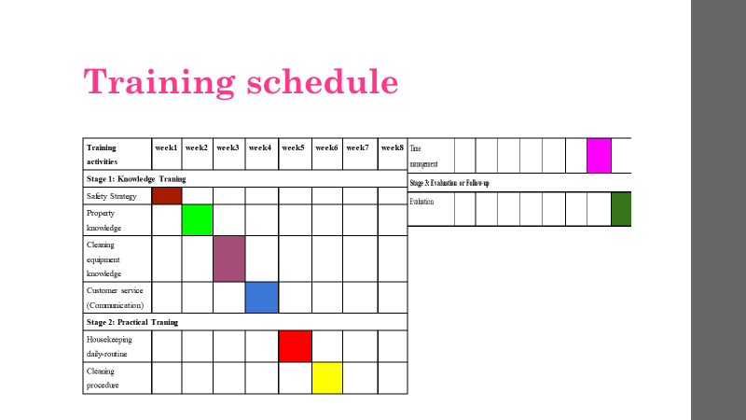
Proper attire will be taught to the cleaning crew. This course will introduce students to floor cleaning agents, acids, and the hazards associated with them. To train housekeepers, we will demonstrate how to store, handle, and use the product. (Fatchiya & Susanto, 2021) The safety training of housekeeping employees will include protective footwear, personal protective equipment, helmets, and gloves.

Property knowledge
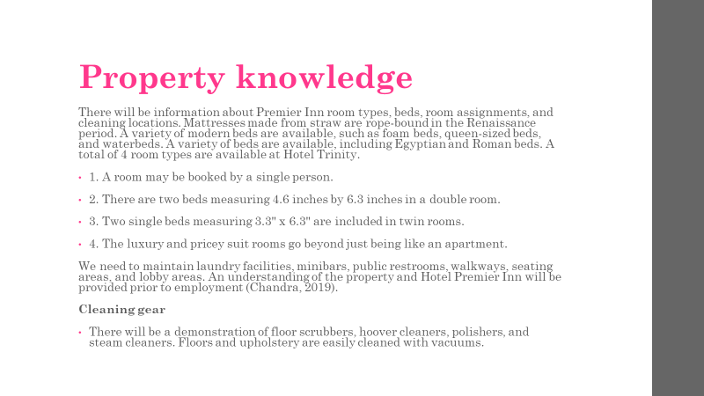
There will be information about Premier Inn room types, beds, room assignments, and cleaning locations. Mattresses made from straw are rope-bound in the Renaissance period. A variety of modern beds are available, such as foam beds, queen-sized beds, and waterbeds. A variety of beds are available, including Egyptian and Roman beds. A total of 4 room types are available at Hotel Trinity.
1. A room may be booked by a single person.
2. There are two beds measuring 4.6 inches by 6.3 inches in a double room.
3. Two single beds measuring 3.3" x 6.3" are included in twin rooms.
4. The luxury and pricey suit rooms go beyond just being like an apartment.
We need to maintain laundry facilities, minibars, public restrooms, walkways, seating areas, and lobby areas. An understanding of the property and Hotel Premier Inn will be provided prior to employment (Chandra, 2019).
Cleaning gear
There will be a demonstration of floor scrubbers, hoover cleaners, polishers, and steam cleaners. Floors and upholstery are easily cleaned with vacuums.

Client service
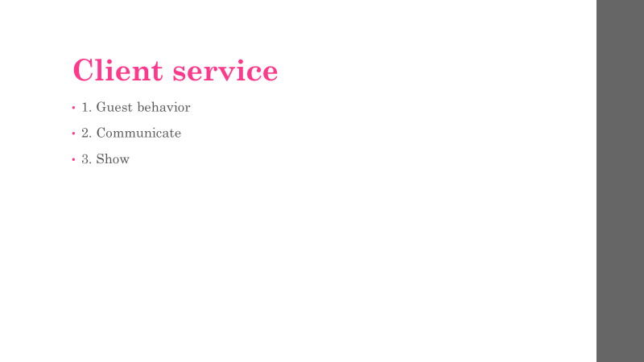
1. Guest behaviour
Customers will be satisfied and happy if housekeeping personnel are polite and have good interpersonal skills. A pleasant body language and posture will be taught throughout training so that staff understands cultural differences, first impressions, and friendly body language. As a result, cleaning teams will be more confident and communicate more effectively (Shafaghi & Ghodrati, 2022).
2. Communicate
The Premier Inn Hotel's Housekeeping department and other departments need to communicate with each other. Keeping guests informed about scheduling details or making last-minute adjustments is crucial to the success of any organization.
3. Show
The ability to behave in an etiquette-like manner. Those who work in cleaning at Premier Inn Hotels will represent the hotel and brand externally. A brand's image is affected by the cleanliness of its employees and the behavior of its visitors. Housekeepers at Premier Inn will thus be able to present effectively.

Housekeeping daily
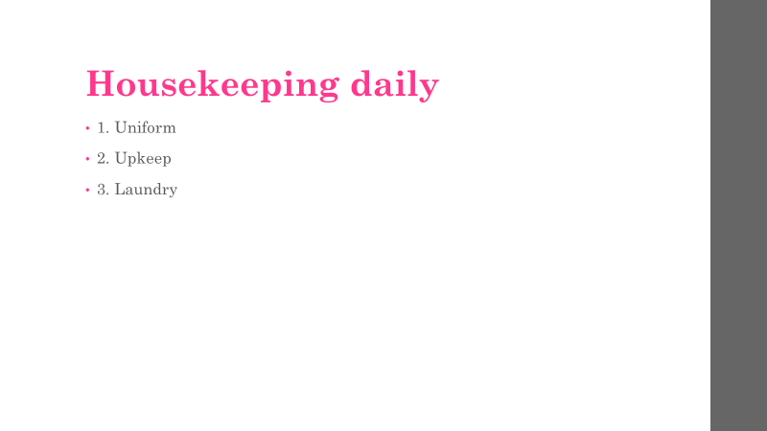
1. Uniform
The purpose of uniforms can be divided into two categories. Housekeepers protect themselves from stains and chemicals by wearing uniforms. The professional appearance of the staff is in line with the brand of the Hotel Trinity.
2. Upkeep
Rather than performing maintenance, housekeepers report it. Electric equipment, TV remotes, and lights that are not working must be reported to housekeeping. Guest complaints are reduced as a result of knowledge of housekeeping staff (MORGAN, 2021).
3. Laundry
With the Premier Inn Hotel's enormous size, laundry services are not overseen by the housekeeping staff. It is also necessary for them to explain how the washing process works. Workforce members must be adept at folding clothes, making beds, and hanging towels in order to provide customers with high-quality service (Shafaghi & Ghodrati, 2022).

Cleaning method
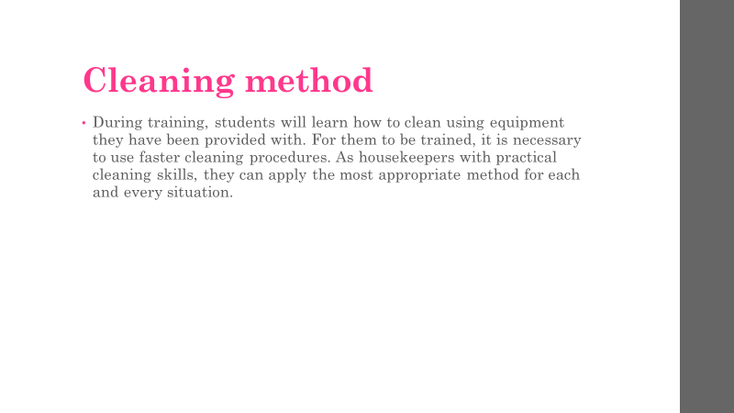
During training, students will learn how to clean using equipment they have been provided with. For them to be trained, it is necessary to use faster cleaning procedures. As housekeepers with practical cleaning skills, they can apply the most appropriate method for each and every situation.

Managing time
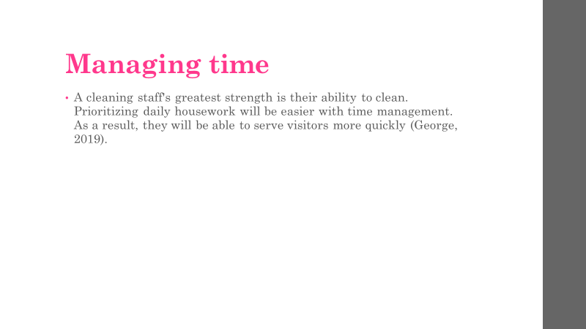
A cleaning staff's greatest strength is their ability to clean. Prioritizing daily housework will be easier with time management. As a result, they will be able to serve visitors more quickly (George, 2019).

Evaluation
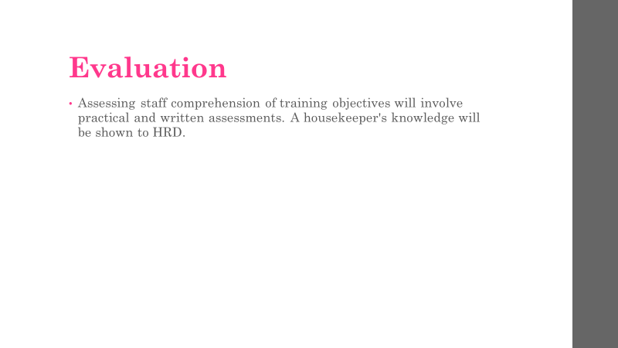
Assessing staff comprehension of training objectives will involve practical and written assessments. A housekeeper's knowledge will be shown to HRD.

Safety plan
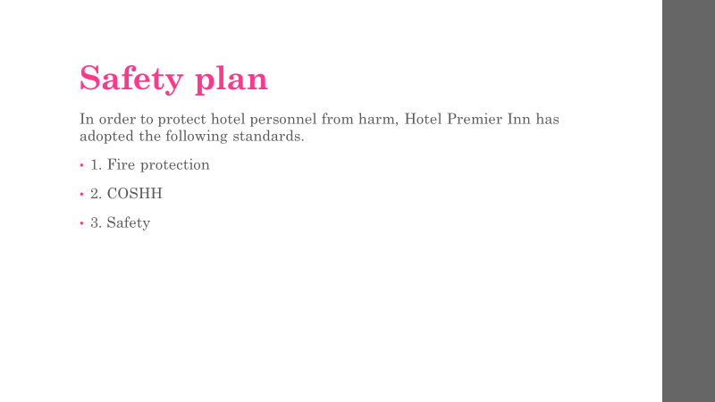
In order to protect hotel personnel from harm, Hotel Premier Inn has adopted the following standards.
1. Fire protection
The 2005 Fire Safety Act must be followed in Wales and England. In Scotland, safety regulations are governed by the Safety Regulation Act 2006. As a result of these revisions, non-domestic establishments are now provided with fire safety. -
- Detecting fire dangers through fire risk assessment.
- Source identification and identification of fuel.
- Each of these groups is at risk, including visitors, customers, employees, and contractors.
- Establish precautionary guidelines for the rest of the hazards after removing as many as possible.
- Keeping flammable equipment and fuel in a safe place.
- Creating a site for emergencies.
- Reports and reviews of fire plans should be conducted regularly (Mohammed Shobri & Putit, 2019).
2. COSHH
Control of Substances Hazardous to Health (COSHH). Employees' safety will be ensured by storing, using, and transporting toxic drugs by the employer. Biological agents, asphyxiating gases, hazardous gases, and gaseous products are all included in COSHH. Detecting and analyzing dangerous compounds will be the responsibility of the management team. A course will be offered on these compounds. Establish emergency plans and monitor health status (Brannigan, 2022).
3. Safety
Premier Inn's management team will ensure the health and safety of Housekeeping and other staff "to the extent reasonably practicable" under the 1974 Health and Safety Regulation Act. Worker safety will be ensured through training and induction. Hazardous items will be handled and stored responsibly using safety equipment. Providing personal protective equipment (Brannigan, 2022).

Conclusion
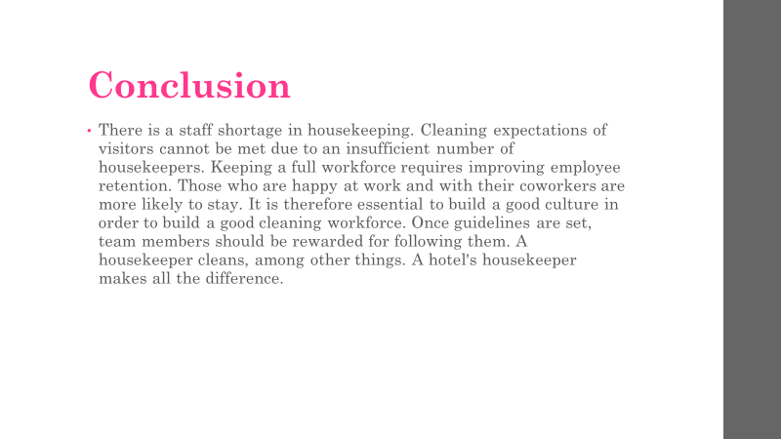
There is a staff shortage in housekeeping. Cleaning expectations of visitors cannot be met due to an insufficient number of housekeepers. Keeping a full workforce requires improving employee retention. Those who are happy at work and with their coworkers are more likely to stay. It is therefore essential to build a good culture in order to build a good cleaning workforce. Once guidelines are set, team members should be rewarded for following them. A housekeeper cleans, among other things. A hotel's housekeeper makes all the difference.

References
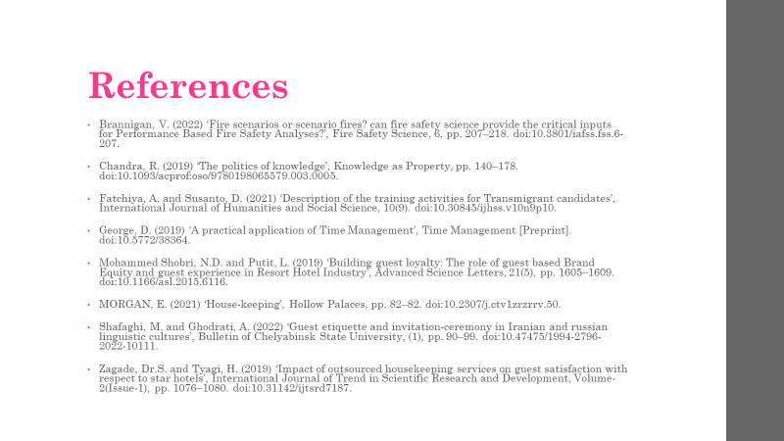
Brannigan, V. (2022) ‘Fire scenarios or scenario fires? can fire safety science provide the critical inputs for Performance Based Fire Safety Analyses?’, Fire Safety Science, 6, pp. 207–218. doi:10.3801/iafss.fss.6-207.
Chandra, R. (2019) ‘The politics of knowledge’, Knowledge as Property, pp. 140–178. doi:10.1093/acprof:oso/9780198065579.003.0005.
Fatchiya, A. and Susanto, D. (2021) ‘Description of the training activities for Transmigrant candidates’, International Journal of Humanities and Social Science, 10(9). doi:10.30845/ijhss.v10n9p10.
George, D. (2019) ‘A practical application of Time Management’, Time Management [Preprint]. doi:10.5772/38364.
Mohammed Shobri, N.D. and Putit, L. (2019) ‘Building guest loyalty: The role of guest based Brand Equity and guest experience in Resort Hotel Industry’, Advanced Science Letters, 21(5), pp. 1605–1609. doi:10.1166/asl.2015.6116.
MORGAN, E. (2021) ‘House-keeping’, Hollow Palaces, pp. 82–82. doi:10.2307/j.ctv1zrzrrv.50.
Shafaghi, M. and Ghodrati, A. (2022) ‘Guest etiquette and invitation-ceremony in Iranian and russian linguistic cultures’, Bulletin of Chelyabinsk State University, (1), pp. 90–99. doi:10.47475/1994-2796-2022-10111.
Zagade, Dr.S. and Tyagi, H. (2019) ‘Impact of outsourced housekeeping services on guest satisfaction with respect to star hotels’, International Journal of Trend in Scientific Research and Development, Volume-2(Issue-1), pp. 1076–1080. doi:10.31142/ijtsrd7187.

