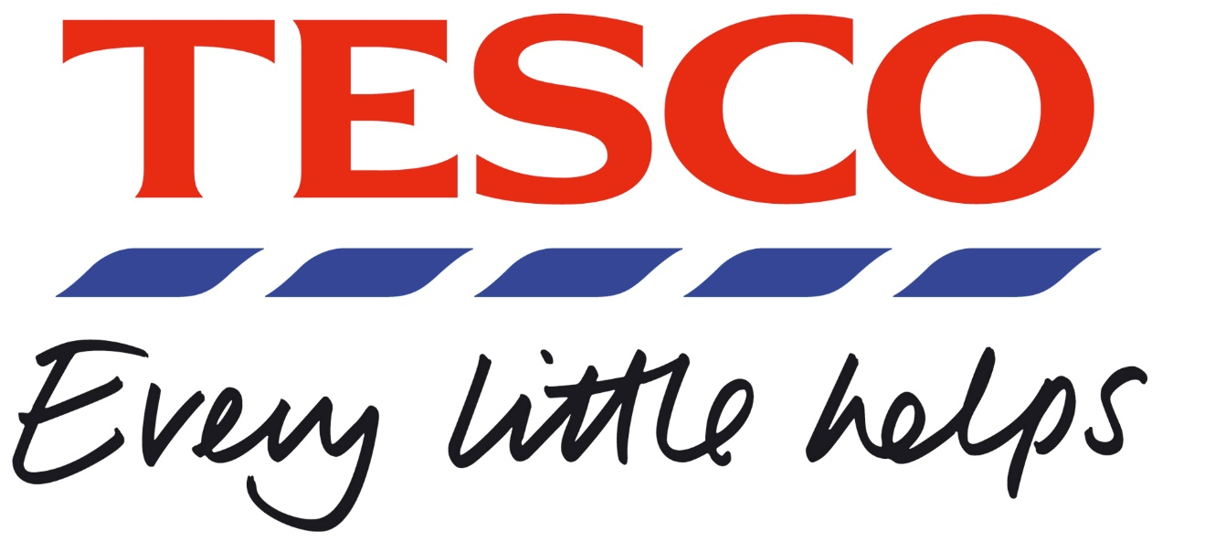

The impact of new technologies in tesco

  - by
Ziolek Michal
Digital Skills and Research Methods
Lecturer’s name: Amitave Banik
Student ID: 1916656

(I was not accepted by other groups, I did my assignment on my own)

Introduction
This case study aims to identify and analyze the impact of modern technology in Tesco. This report is a PowerPoint slide supported by speaker notes. The history and background information will be analyzed, the newly implemented technologies and the lesson learned from this case study.

Slide 1

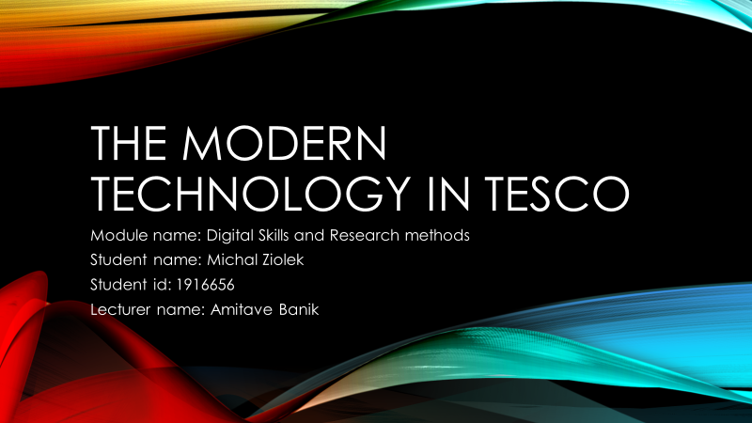

Slide 2 – Background information
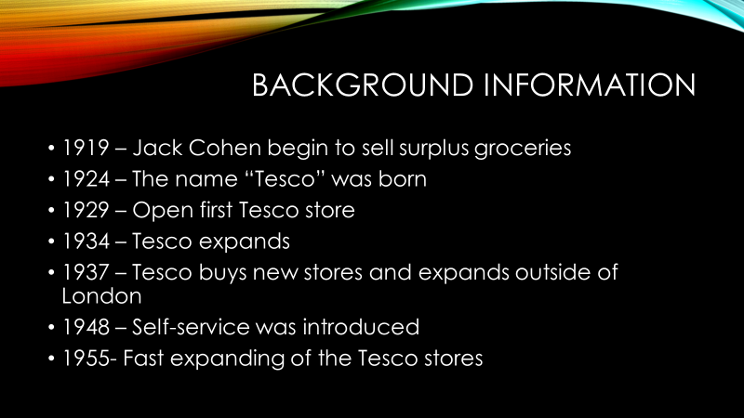

Slide 2 – speaker notes

Jack Cohen formed Tesco in 1919 when he started selling discounted groceries from a shop in London's East End. His first-day earnings were £1 and gross sales of £4. Jack launched his very first-brand product, Tesco Tea, in 1924 and this was before the business was renamed Tesco. The name derives from the initials of TE Stockwell, a shareholder in the tea distributors company, and J CO from Jack’s surname (Simms, 2007).
Jack Cohen opened his first Tesco shop in Burnt Oak, Edgware, north London, in 1929. Tesco Stores Limited became a registered liability company in 1932. In 1934, two years later, Jack Cohen bought a piece of land on Angel Road in Edmonton, North London to construct a new warehouse and premises (Simms, 2007)
It was the nation's first industrial food facility and implemented new central stock management concepts. Besides, Tesco Stores (Holdings) Ltd floats on the bourse in 1947 at a price performance of 25p, and in 1956 the first self-service supermarket in Maldon opened in a transformed theatre.
After a research visit to North America Jack Cohen wanted to expand into self-service. In 1948 the first of these new stores opened in St Albans, Hertfordshire with a varied consumer response at first.

In 1955 Tesco rapidly expanded. Tesco has purchased 19 stores in Burnards and in the next five years, it has bought 500 retail locations (Simms, 2007).

Slide 3 – Background information

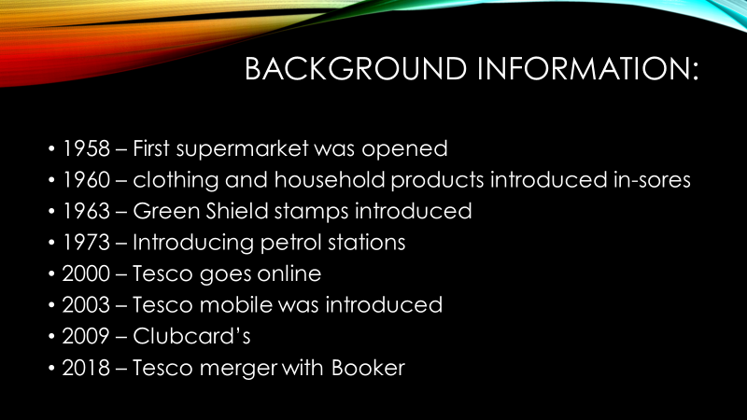

In 1955 Tesco opened the first supermarket in Maldon, Essex. Counter service was included in the new model shop, offering cheese, dairy and, meats weighing by cashiers.
Later in 1960, Tesco began selling household items and clothes to help reduce prices around the house. In northern England, they have acquired 212 branches of Irwin stores.
In 1960 they launched Green Shield stamps. Stamps earned at checkout may be redeemed from a Green Shield catalog for a selection of items of significant value.
Bringing affordable rates to commuters in the UK by the implementation of petrol stations at local sites in 1973 (Ryle, 2013).
In 2000, Tesco goes online and introduced Tesco.com. The website has evolved to support more than 20,000,000 clients who visit the site each month.

With nearly five million buyers around the UK, Tesco Mobile is a partnership with O2, introduced in 2003. Tesco Mobile was initially introduced as a Pay as You Go operation, and now provides exclusive deals, No-sim contracts and pay monthly.
In 2009, following a £150 million expenditure Clubcard was rebooted in the UK, giving consumers the ability to double their rewards (Ryle, 2013).
In 2018 Tesco combines with the wholesaler Booker Group. The two companies are bringing both wholesale and retail resources to form the biggest food company in the UK. The alliance opens possibilities the company anywhere food is cooked and consumed, either 'in-home' or 'out-of-home' and will add value to consumers, suppliers, employees, and shareholders (Barnes, 2011).

Slide 4 – Challenges before modern technologies

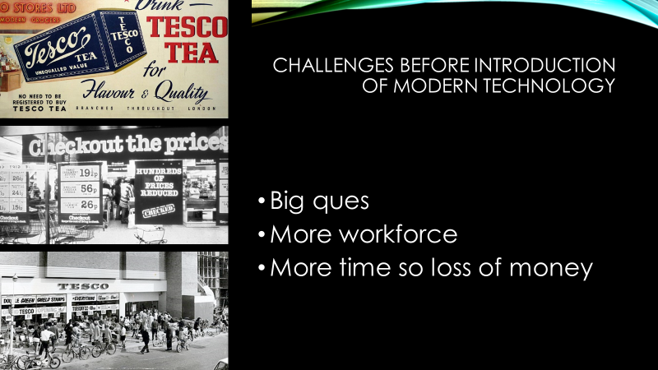

Slide 4 – speaker notes

To maintain leadership and be the UK’s biggest retail Tesco had to implement innovations that will make customers choose them.
To reduce queues in stores Tesco introduced a technology that will allow customers to check the price of the products instead of asking a seller assistant. This change saved time for employees and allowed consumers to make their own choices.
Later, when self-checkout was introduced, that, as well as reduced waiting time in the queue and more customers, were served at the time.
With the new technologies that Tesco implemented, they could reduce the number of staff, save money and time (Barnes, 2011).

Slide 5 – Modern Technology

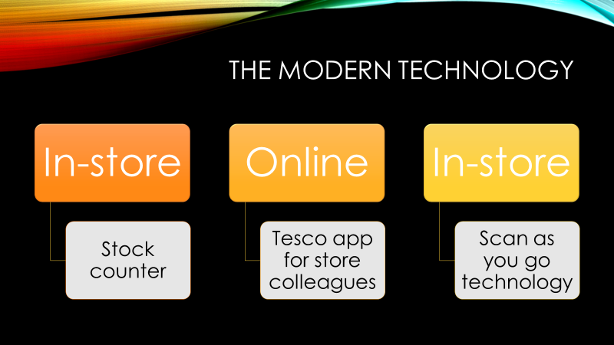

Slide 5 – speaker notes

Stock counter

To make it much easier for the workers in charge of inventory counting, Tesco has created a new RFID-enabled barcode into their in-store collection of F&F apparel. That enables for automated counting and removal of the items after entry and exit the shop, pre and post buying. This data is often away-tracked to the store's suppliers to give them an effective stock depletion and boost the total customer’s in-store experience (Ryle, 2013).

Tesco app for store colleagues
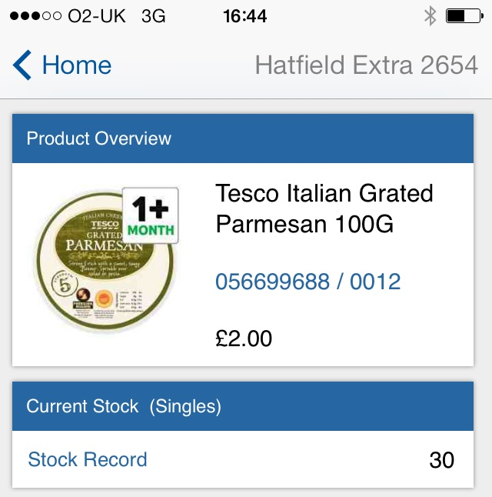

Tesco has carried the first ever device expressly tailored for employees, that can be used on the supermarket's own Hudl tablet and other tablets and devices. The app offers product inventory information to coworkers, and details about the exact position of all items in store.

Scan as you go technology

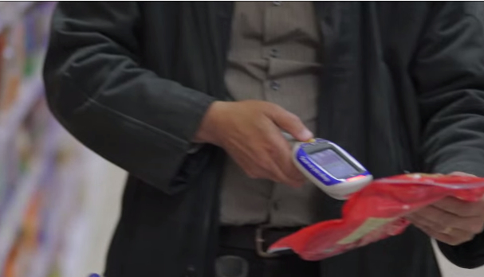

The portable scanners allow consumers to monitor expenditure as they go and then pay at the self-scan without unloading items. In 2010 Tesco first presented the concept to its customers.

Slide 6 – Modern technology

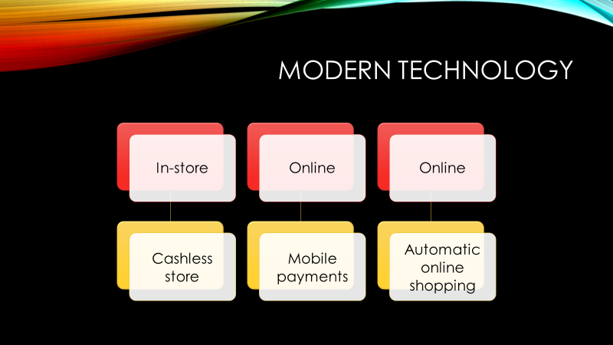

Cashless store

Such is the number of shoppers paying for products by the card that Tesco feels it necessary to test its first cashless store – though in an intent-built convenient Express at its Welwyn Garden City offices.
Testing out this design to stores would have strong productivity and cost advantages for Tesco, but CEO Dave Lewis is mindful of the dangers and possible consequences of making these changes before other customers.
More interesting from a technological perspective around the same Welwyn store is the trial of a 'Scan Pay Go' app between 100 Tesco workers which allows for an asymmetric shopping experience. It helps them to scan and pay their goods on their cell phone while eliminating the need to go through a checkout process. They can only go out of the store like shoppers in the Amazon (Simms, 2012).

Mobile payments

Tesco improved its digital payment functionality by introducing Pay+, which reflects an improvement in its earlier approach to PayQwiq. One of the major benefits is that it interacts directly with the Clubcard rewards program.
Such a step demonstrates the attempts being made to tie together the different components of the Tesco sector and have a consistent customer experience (Simms, 2012).

Automatized online shopping

Online shopping is now one of the most exciting areas in retail. Customers are connected from home and this technology helps them to make actual purchases.
It helps buyers to simplify their online shopping by adding different products to their cart after certain requirements have been activated, such as if the price of a certain commodity exceeds a certain amount (Simms, 2012)

Slide 7 – the impact of new technologies

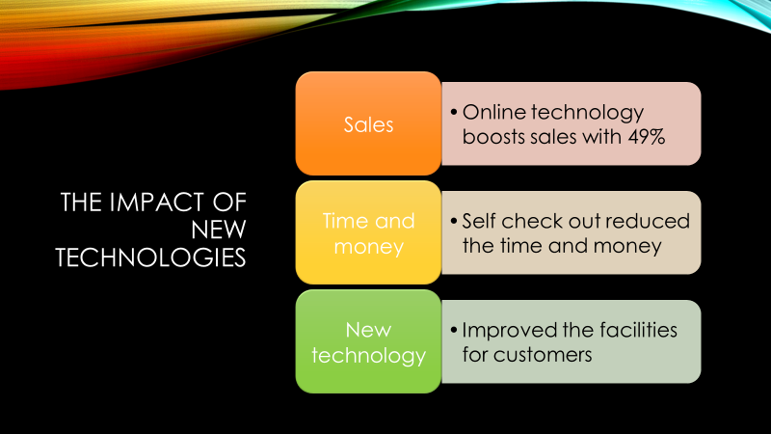

Tesco is one of Britain's largest supermarkets, and Tesco wants an advancement that may be in the piece of technology as well as reducing staff costs and increasing its income as well as competing with competitors including Morrison’s, Sainsbury's and Asda. There are several benefits for Tesco since launching the above-mentioned online shopping and self-checking facilities, shoppers can easily place orders at anywhere online, which is good for Tesco to raise its clients as well as to sell and reduce staff costs.
This technology is necessary or successful for Tesco as after implementing the online shopping system, Tesco's revenues increased by up to 49 percent (Menzim, 2004).

Tesco was the first company to set up this system, and the self-checkout facilities are also very relevant for Tesco since, with the aid of these checkouts, Tesco saves money and time, reduces its workforce, and also offers its customers better facilities.
Slide 8 – Conclusions

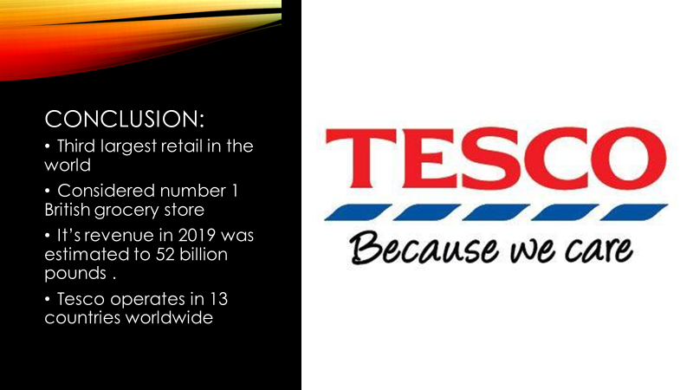

Changing this development / innovation is one of the department's significant changes. Tesco wants to manage consumer needs by using effective technology. Therefore, Tesco is considered the number one British grocery store with revenue estimated to 52 billion pounds (Menzim, 2004).

Slide 9 – References

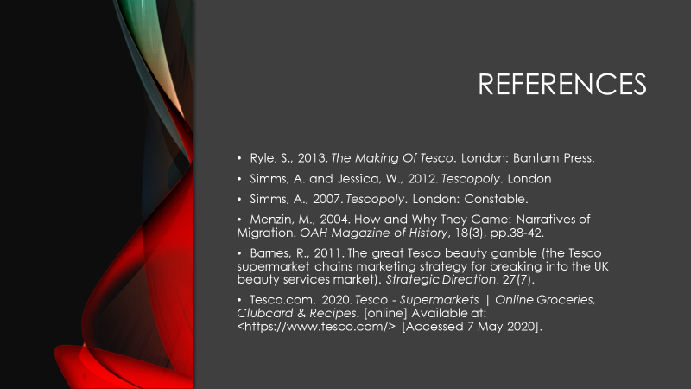
References:

Ryle, S., 2013. The Making Of Tesco. London: Bantam Press.
Simms, A. and Jessica, W., 2012. Tescopoly. London
Simms, A., 2007. Tescopoly. London: Constable.
Menzin, M., 2004. How and Why They Came: Narratives of Migration. OAH Magazine of History, 18(3), pp.38-42.
Barnes, R., 2011. The great Tesco beauty gamble (the Tesco supermarket chains marketing strategy for breaking into the UK beauty services market). Strategic Direction, 27(7).
Tesco.com. 2020. Tesco - Supermarkets | Online Groceries, Clubcard & Recipes. [online] Available at: <https://www.tesco.com/> [Accessed 7 May 2020].

