Youth work practice level 5


  - 2219820 Jenna Evans


Information sheet
I will discuss the goals and objectives of the team I will be practicing in. This year I will rely on my placement provider and the location of my placement will be my role in the youth service. This team is organized team within the county, and there are currently four teams that support youth between the ages of 9 and 25, the school-led team, youth justice team, post 16 team and the universal team.
These teams work with children and young adults ages 8 to 25 to realise their full potential in terms of their personal, social, and educational development, our program offers a wide variety of support, from open access to specialized support.
The youth workers will address issues pertaining to mental health, drugs, alcohol, homelessness, problems at home, and young people not in engaged into education or working. Within the post 16 team where I will be undertaking my placement, we have small groups of teams focused on prevention of homelessness, emotional lead workers, floating support workers, also dedicated youth workers to areas like Carmarthen, Llanelli, and Ammanford. All members of our team receive funding from various sources, we will subsequently report on our results based around the progress of the young people. We will collaborate with other teams, including school to help children move into higher education or employment, we will coordinate outdoor activities with the Universal team, and work with Youth Justice to help young people under the age of 18 who are subject to community orders or other directives.
We multi agency work with Choices, Probation, Camhs, Iecha Da, Career Wales, Community for Work, Inspire, social services, and housing are just a few of the external agencies with which we collaborate with. Since it is a voluntary program, young people can work with us for as long as they like, provided that our funding permits us to provide support in the areas they desire. In addition to offering events all year long, we will offer youth work centre drop-in to our young people who would like to attend in a safe setting and interact with other young people.
Within the post 16 team we also monitor children’s attendance in school and when they leave to acknowledge whether they are engaged in education or employment or not engaged in education and employment.
Our team's goals and aspirations are to give our youth a better journey and provide choices, and to be able to advocate on their behalf to acquire the finest experience and activities possible so they can strive and realize their potential. As a service, we aim to provide an informal learning environment with the youth and are nonjudgmental and helpful.
I will read and abide by the rules and regulations set forth within the workplace as a trainee youth worker and I will discuss my practice with my supervisor during the placement and engage in at least six supervision sessions to help revalue my practice and receive guidance throughout my placement.
Working with young people in the community, I will be concentrating on the system for preventing homelessness, assisting them in becoming self-sufficient, and communicating and advocating on their behalf when it comes to housing. In addition, I will work with the youth to provide them with additional focused forms of support, grants, assistance with schooling and work, emotional support, and referrals to specialists for issues involving substance abuse or mental health. I will be communicating with supervisors for assistance and reporting any safeguarding issues.
While working on the placement, I will be dedicated, professional and ethical. I will also make sure that I deliver my practice with the youth work principle and purposes in mind, as well as the five pillars of youth work by being inclusive, empowering, expressive, participatory, and educational. (principles and purposed of youth work in wakes, n.d.) in my capacity as a trainee youth worker, I will also engage in the Kolb reflective practice cycle and exhibit reflective practice during my supervision. (rood, 2023)
I will also take into consideration the national youth work curriculum while working with the young people within the service as this will help me identify how I would use interventions and activities to be able to support the young people’s personal, social, political development of the young people. This will also help to identify the diversity of the young people’s needs, interests and concerns. This curriculum is vital while in placement as this is young person led and responds to the young person’s needs while the young worker supports. (National youth work curriculum – national youth agency, 2024)

Reference
YOUTH WORK IN WALES: PRINCPLES AND PURPOSES, (n.d). Available at:
https://educators.wales/sites/default/files/20202/YOUTH%20WORK%20IN%20WALES%20PRINCIPLES%20AND%20PURPOSES%202022.pdf. (accessed 12th March 2025)
Rood, A (2023). Kolb’s reflective cycle: Learning through self- assessment. [online] Making business matter (MBM) Available at: https://www.makingbusinessmatter.co.uk/kolbs-reflective-cycle/ (accessed 12th March 2025)
National Youth Work Curriculum - National Youth Agency (2024). https://nya.org.uk/national-youth-work-curriculum/ (accessed 12th March 2025)

Community profile
As part of my level 5 portfolio, I have been given the task to undertake a non-biased and comprehensive community profile of the area I shall be working within my placement. A community profile should be carried when a youth worker is working within a location to build a picture on the needs, resources of a community, statistics to the community.
Borough of Llanelli
The Welsh market town and community of Llanelli is in the preserved counties of Dyfed and Carmarthenshire. It is the biggest town in the Carmarthenshire County and is located on the estuary of the River Loughor. There are five electoral wards in the town of Llanelli which would be Bigyn, Glanymor, Elli, Tyshia and Lliedi.
Llanelli is largely a labour voting community, and its leader of Llanelli town council is currently David Darkin.
In 2024 it had stated that Llanelli would be seeking city status of the town. (Wikipedia)

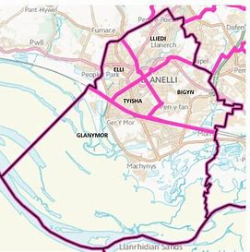

Wider Community

According to city population, 2023 the total population of Llanelli in 2021 were 42,175 people living in Llanelli, the statistics show that 20,506 were male and 21,673 were female. The highest popularity of age groups shows that 50–59-year-olds were the highest ranking, however the amount of people who were born within the UK out of the current population of Llanelli stands at 38,859 and 96.4% were white out of the ethic group and 51.9% had no religion.

The population of the young people who we would work with as youth workers would be 5,064 up the age of 19 years old and 4,806 of the age of 19 and over.
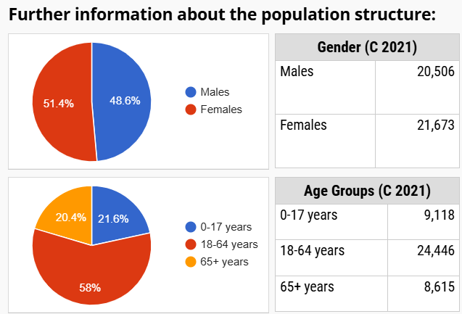
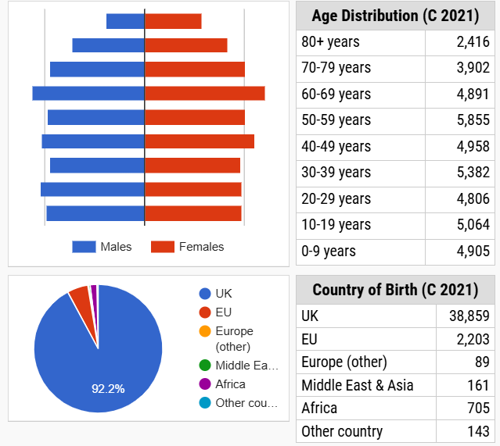
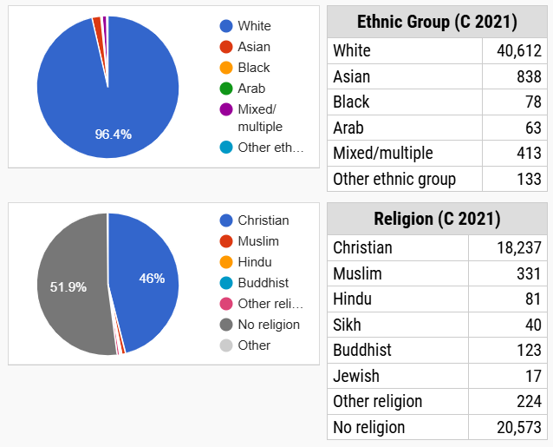

Housing
Llanelli and within Carmarthenshire is currently in a housing crisis and this involves the need for more affordable housing and support for those who face homelessness. There are services that help which are Carmarthenshire County council and shelter Cymru.
Business new Wales states that 70 new homes will be built within the Llwyn Hendy area of Llanelli with the development of beacon Cymru, this will be part funded by the governments social housing grant. This will be situated near the scarlets home ground. Tata steel purchased the site and will help with the materials, the site will span over 2.02 hectares. (Businessnewwales, 2025)
Furthermore, development happening in the heart of Llanelli is within Tyisha ward and the multi-million-pound regeneration project which will help tackle crime and anti-social behaviour and build new housing and facilities. (Carmarthenshire county council)
More positive developments stand within Llanelli, helping homeless veterans Uk have seeked to develop the former old Raffles nightclub to convert into 16 self-contained units for the homeless and will contain a hub and communal area where rehabilitation sessions, counselling and employment training will take place. (walesonline,2025).
Employment and training
Census, 2021 state that 10.6% of 16 years and over are currently unemployed.
Pentre Awel which is currently being built will not only enhance health and wellness, but the initiative will also generate more than 1,800 job and training/apprenticeship opportunities, and it is anticipated to increase the local economy by £467 million over the next 15 years. Working with some of the young people within the post 16 team had the opportunity to attend employment open day to help be part of the built for Pentre Awel.

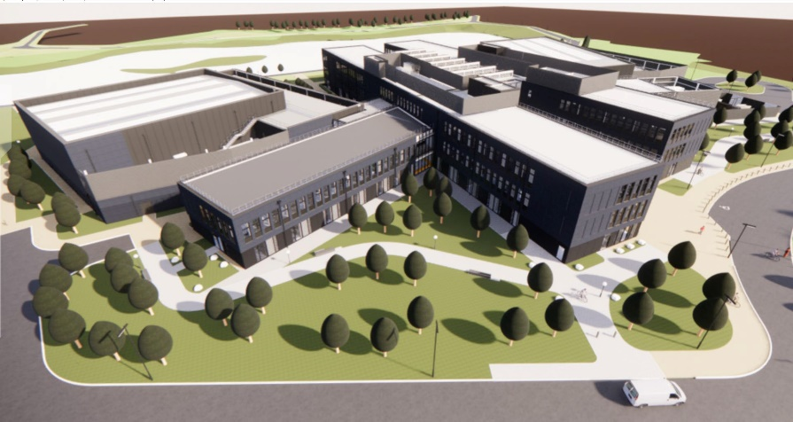
Coleg sir gar is Llanelli local college where young people attend to study for further education and offers a range of courses a level, vocational, apprenticeships, higher education and short courses. However not all young people may want to attend a college therefore they could access alternative education such as LRC training. LRC delivers a traineeship programme throughout Carmarthenshire.


Crime
Llanelli is recognized as the most dangerous medium-sized town in the preserved county of Dyfed and ranks among the top 5 most unsafe places overall out of Dyfed's 199 towns, cities, and villages. In 2023, the total crime rate in Llanelli was 117 incidents for every 1,000 residents. This figure stands in stark contrast to Dyfed's overall crime rate, being 72% greater than the Dyfed average of 68 incidents per 1,000 daytime inhabitants. In the context of England, Wales, and Northern Ireland, Llanelli holds the 64th position as the most dangerous medium-sized town and ranks 666th among all towns, cities, and villages for safety.
In March 2024, Llanelli experienced the highest rate of criminal damage and arson in Dyfed, with 2 incidents reported and a crime rate of 0.07 per 1,000 of the daytime population. June 2021 also proved to be a challenging month for residents in Llanelli, as it was identified as Dyfed's most dangerous area for shoplifting, tallying 25 crimes at a rate of 0.92 per 1,000 of the daytime population.
The primary types of crimes in Llanelli are violence and sexual offences, which totalled 1,531 incidents in 2023, resulting in a crime rate of 57. This represents a 25% decrease from 2022's total of 2,039 incidents and a difference of 18.78 from last year's crime rate of 75. The rarest crime in Llanelli is robbery, which had 12 reported cases in 2023, reflecting a 29% decline from the 17 offences recorded in 2022. (Crimerate,2024)
What’s available in the area
- Myrtle house youth on a Fridays is a place where young people school years of 7-11 that can come with their friends to have fun and play high energy games and enjoy music and make new connections.
- Eastgate Llanelli has a variety of eateries, cinema along with a theatre.
- Trostre retail park has a variety of things to enjoy such as shops, coffee shops.
- Post 16 drop in.
- Llanelli leisure centre
In conclusion I feel that Carmarthenshire County council could incorporate the views and wishes of the community for forward planning of exploring promoting and advancing the town of Llanelli. Along with introducing free activities for young people to access to prevent young people from becoming bored and committing crimes. Such as more youth clubs or free sports clubs. I do feel there could be more funding backing the Carmarthenshire council for further housing and this is detrimental to today’s society and is causing many issues.
References
Wikipedia, (2025), Llanelli, available at: https://en.wikipedia.org/wiki/Llanelli (accessed on 8th April 2025)
Wikipedia, (2025), Llanelli Town Council, available at: https://en.wikipedia.org/wiki/Llanelli_Town_Council (accessed on 8th April 2025)
Census, (2021), Employment history, available at: https://www.ons.gov.uk/census/maps/choropleth/work/employment-history/has-ever-worked/not-in-employment-worked-in-the-last-12-months?msoa=W02000167 (accessed on 8th April 2025)
Carmarthenshire county council, (no date), Pentre Awel, available at: https://www.carmarthenshire.gov.wales/home/business/development-and-investment/pentre-awel/ (accessed on 8th April)
Crime rate, (2024), Crime and safety in Llanelli, available at: https://crimerate.co.uk/dyfed/llanelli#:~:text=Llanelli%20is%20the%20most%20dvuuangerous%20medium-sized%20town%20in,in%202023%20was%20117%20crimes%20per%201%2C000%20people. (accessed on 8th April 2025)
Myrtle house, (2024), Myrtle house youth, available at: https://www.myrtlehouse.org.uk/whats-on/youth (accessed 8th April 2025)
Coleg sir gar, (no date), available at: https://www.csgcc.ac.uk/en (accessed on 8th April)
Llanelli rural council, (no date), LRC training, available at: https://www.llanelli-rural.gov.uk/your-council/lrc-training/ (accessed on 8th April)
Eastgate, (2025), available at: https://eastgatellanelli.co.uk/, (accessed 8th April 2025)
Parc trostre retail park, (2025), available at: https://www.parctrostreretailpark.co.uk/ (accessed on 8th April)
Family information service Carmarthenshire, (2025), Post 16 youth workers Carmarthenshire, available at: https://fis.carmarthenshire.gov.wales/post-16-youth-workers-carmarthenshire-county-council/, (accessed on 8th April)
Business news Wales, (2025), social housing development set for parc y scarlets site, available at: https://businessnewswales.com/social-housing-development-set-for-parc-y-scarlets-site/ (accessed 8th April 2025)
Carmarthenshire county council, (no date), Transforming tyshia, available at: https://www.carmarthenshire.gov.wales/home/business/development-and-investment/tyisha/ (accessed on 8th April)
Staff writer, (2025), Pentre Awel: a transformative development for Llanelli, available at: https://www.building.co.uk/buildings-design-and-specification/pentre-awel-a-transformative-development-for-llanelli/5134079.article (accessed on 8h April)
Richard youle, (2025), former Llanelli nightclub to be given new future, Available at: https://www.walesonline.co.uk/news/wales-news/former-llanelli-nightclub-given-new-31175899?int_source=nba (accessed on 8th April)

Naomie
Having undertaken my placement at level 5 within the post 16 team and dealing with the homelessness team, what strikes me that the lack of affordable or accessible housing and the young people not having the skills to being able to live independently along with the budgeting skills to be able to set them up for future independence. This is something I wanted to touch upon within my NAOMIE as I feel this is a topic that need’s a solution.
Needs | - Lack of affordable housing and a lack of properties  - Young people accessing food banks and vouchers due to being homeless  - Young people spending their money within days of having it on take aways, drink or drugs.  - Lack of availability for young people to access showers or washing facilities  - Lack of knowledge of independent living skills
Aims | - To support the young people in accessing housing and advocating on their behalf  - To support young people in accessing food when in crisis and how to cook meals.  - To help the young people budget and to be in control of their finances  - To make young people aware of what is needed to maintain a home financially  - To use more creative ways for engagement and participation  - To improve young people’s living skills
Objectives | - Getting the young people to acknowledge when they are in financial difficulty and to ask for help  - Plan fun, educational budgeting session and independent living skills such as pre tenancy training  - Sign posting young people to housing charities such as shelter Cymru for support for homelessness  - Reduce the need of emergency food banks and vouchers by helping to teach the young people to budget  - To explain to the young people of the demands of housing and if there is a family member they can stay with
Method | - Identify how I and other agencies can meet the needs of the young people  - Liaise with colleagues and housing team.  - Discuss with the young people about their difficulties  - Advocate on behalf of the young people if they want to express their wishes, views and feelings.  - Ask the young people if they would want 1:1 sessions or group sessions regarding budgeting or living skills sessions.  - Offer rewards for engagement within sessions such vouchers for food.  - Offer rewards at the end of living skills sessions if you feel they have improved their independence skills.
Implementation | - Use the SWOT process and highlight the young people’s strengths, weaknesses, opportunities and threats  - Research creative and fun activities to incorporate within budgeting sessions and living skill sessions.  - Discuss access to vouchers from a manager in readiness for rewards at the end of sessions.  - Liaise with other youth workers about the sessions  - Arrange the sessions at appropriate venue and time that would suit the young people such as the afternoons.  - Set boundaries and rules and an agenda within the sessions  - Offer snacks within the sessions  - Get the young people to do the housing system form entitled.to which will go through all the budgeting questionnaires.  - Advertise budgeting and pre tenancy sessions on the post 16 social media page
Evaluation | - Evaluation sheets or feedback links online to feedback on the sessions.  - Discuss with the young people on how they feel after it  - Take notes during the sessions and any alterations I feel I needed to change  - Reflect on what went well and what did not go well.  - Review how the session went from last time to now where they are at now  - Monitor’s the young people’s progress  - Monitor how often people are accessing food vouchers  - Offer refresher sessions or more advance  - Discuss the SWOT outcomes with the young people and get them to express their views.  - Liaise with external agencies

In depth analysis
Working within the post 16 youth service for my placement practice I felt that it was important to undertake a method of analysis for the work that was being undertaken while I was there.
It was important for us as youth workers to advocate and to meet standards of the UNCRC such as Article 20 - If a child cannot be looked after by their immediate family, the government must give them special protection and assistance. This includes making sure the child is provided with alternative care that is continuous and respects the child’s culture, language and religion. Along with article 12 - Every child has the right to express their views, feelings and wishes in all matters affecting them, and to have their views considered and taken seriously. This right always applies, for example during immigration proceedings, housing decisions or the child’s day-to-day home life. (UNCRC, 1992)
Sapin states that SevenS or a SWOT analysis can be a useful tool when compiling a portfolio of evidence of work-based learning for a youth training program or professional development course. (Enoch, 2024)
A SWOT analysis is essential for all youth organizations. SWOT sessions are held to strategize and establish objectives. This approach is not only applicable for organizational planning but can also be utilized personally to recognize your strengths and weaknesses. (youthworknews admin, 2017)
Lehal also informs us that youth workers are empowered to make the best possible provision for young people by analysing their work. They are better equipped to decide how to utilize resources and plan programs to make their interventions effective. (Enoch, 2024)
I will focus on analysing the service and multi-agency working within youth services and housing based within Carmarthenshire County council and the prevention of homelessness within the post 16 team within a SWOT analysis
Strengths  - Good working relationships  - Understanding what each service does and where their specialities lie  - Housing understanding that we advocate on behalf of the young people and fight to meet UNCRC standards  - Out of hours housing services  - Youth workers have an understanding on the housing procedures to be able to breakdown to simple form for young people  - Youth workers have more access to communication to housing officers  - Youth work supervisor sits within housing department one day a week which gives us good access to housing updates  - Housing hwb where young people can turn up  - Drop in youth clubs where young people can access a meal or wash their clothes | Weaknesses  - Lack of housing properties  - Housing officers are hard to contact for the young people due to the demand on them from hundreds of cases  - Housing unable to meet the demands or duty to house due to limited places to place young people  - No suitable temporary accommodation for high-risk young people  - Not enough suitable under 18’s temporary accommodation  - No access to emergency homelessness packs such sleeping bags or tents from housing  - Too much paperwork  - The lack of properties on the housing bidding system or confusion of some properties on there.  - No access to shower facilities that are free  - Expectations from young people from services can be unrealistic
Opportunities  - Local authority has a duty to house  - Housing do use B and B’s as temporary accommodation  - Joint housing assessments for under 18’s to be able to choose if they would want housing process at the age of 18 or social services route under 18.  - Youth workers can help direct young people to speak with charities such as shelter Cymru for support to challenge the local authority  - Opportunity to access DAF grants and white goods  - Young people can engage with pre tenancy training to understand the expectations  - Once young people are housed, they have access to wrap around support from floating support workers, pre tenancy. | Threats  - Lack of homes or temporary accommodation which will leave some young people street homeless or sofa surfing  - Deterioration of the young people’s mental health or resorting to drugs and alcohol  - Tyshia ward closure of supported housing was a massive threat and created to less housing  - Having no suitable accommodation can jeopardise the young people’s attendance in college or work and losing their place  - Volume of referral for youth homeless and family breakdowns  - Lack of engagement to be involved with mediation  - Private rental properties being expensive  - Private rental agencies asking for references, guarantors and young people do not have these

After completing my SWOT analysis i feel as a trainee youth worker it is important we imbed what the national occupation standards of youth work state such as working towards early intervention and identification to help support the child but also their wider family and support network. Along with young people accessing information and making informed decisions and tackling problems in a realistic approach. (NYA,2002)
References
Youthworkwales, 2002, national occupational standards for youth work, available at: https://www.youthworkwales.org.uk/wp-content/uploads/2017/11/nos_youth.pdf (accessed on 16th april 2025)
Enoch.A, 2024, ECYW5002 Youth work practice 2: developing practice, Programme Analysis PowerPoint (accessed on 16th April 2025)
UNICEF, (nodate), a summary of the un convention on the rights of the child available at: https://www.unicef.org.uk/what-we-do/un-convention-child-rights/ (accessed 16th April)
Youth work news admin, 2017, how to facilitate a SWOT session with your youth work staff, available at: https://www.youthworknews.com/how-to-facilitate-a-swot-session-with-your-youth-work-staff/#:~:text=SWOT%20is%20an%20integral%20part%20of%20any%20youth,and%20weaknesses.%20SWOT%20%3D%20Strengths%2C%20Weaknesses%2C%20Opportunities%2C%20Threats, (accessed 16th April 2025)

Summary of my own learning.
During my time on my level 5 placement, I struggled to get through this year more than any previously due to home life, work and children demands. It had tested me at times was this worth it however after some fighting force within me I feel passionate about making a difference within my young people’s lives and within the workforce of youth work. Another way I looked at this was if my own children needed help, I would want someone to feel just as passionate to helping them in times of need.
Comparing my placement from last year’s school based this role was opposite of age group and the issues that were arising. The young people were classed young adults going into life with the expectations of acting more mature and taking responsibility for their own actions and not always under the parent responsibility. Giving leeway for them to grow and be independent without being there every step of the way.
Within working within this team, we worked within a group environment however much more of one-to-one targeted support where I had to find the confidence to be able to advocate and support the young people and have the knowledge to be able to back up my skills. Still very aware I had a lot to learn along the way and being able to adapt to each individual young person and being able to manage conflict and challenge services while also building on my own personal development plan during the placement.
I would always introduce myself to the young person prior to face-to-face meetings to be able to build on the relationship and trust. I would then offer an adaptable and open face to face meeting however considering the young person’s views, wishes and feelings.
When working with young people It was paramount that as a youth worker I would maintain youth work policy and procedures and youth work national occupation standards and maintain links with multidisciplinary sector and receive on going care within interventions and this is only possible if we all come together to utilise our skills and expertise to articulate a plan for the young person’s future care and support needs while promoting inclusion, diversity and values.
During support sessions I have advocated and helped the young people access housing systems, filling in necessary paperwork, liaising with housing on the need for emergency housing, receiving updates from housing officers, helping young people access food banks, vouchers, housing essential items, Universal credit, DAF grants for money or white goods for properties. Along with taking the young people to youth club to be able to access food and washing facilities for clothing.
I have helped with sessions such as budgeting sessions, pre tenancy living skills, cooking skills, early intervention and mediation within the family home, I have undertaken a vital role in advocating for the young people through multi agency services such as housing, social services, college and housing charities.
While doing this work I have embedded the youth work five pillars of being educative by explaining the demands of housing and how the procedures work and what is expected from living independently, expressive by expressing their views, wishes and feelings during the process of the housing process, empowering them that they have a voice and verbalise how they feel and how to be proactive and engage within he services. While doing this making sure it was inclusive and participative and making sure they were involved within meetings and decisions regarding their housing situation and process.
In order to be a good youth worker the aim was to get the young people to reach their full potential when they move on to independent living this is the reason we embedded sessions such as pre tenancy workshops to be able to get the young people to understand what is expected to be able to own a tenancy or what is expected in shared properties to prevent breakdown of placements and ending of duty from housing. However, this isn’t always possible due to the trauma or ACES that some of these young people have faced within their lives some of them live chaotic lifestyles and struggle to adapt. This then put them as high risk within housing, and this can cause issues placing them correctly within the housing sector which can lead them to be sofa surfing or street homeless.
While working within the placement I feel major concern regarding youth homelessness is family breakdown and the lack of housing that is available to young people within Carmarthenshire. The high rate of homelessness is increasing daily however the resources are not which then results in poor outcomes.
This put’s pressure on the youth service to be able to strive for outcomes for young people along with housing colleagues the pressure of them being overloaded with amount of homelessness people presenting to the local authority.
During my placement I engaged within supervision sessions, and we touched upon many cases of youth homelessness and what went well, what could have been better and what I would do differently next time. We would touch upon meeting the needs of the young people and touched upon the hierarchy of needs and if the basic need is not met then this can jeopardise their progress.
While working with young people within this placement it gives me a true realisation of resilience is and how the procedure is never plain sailing, at times I felt hopeless and unable to help however with the support of managers and reflection you cannot always have the outcomes out want and there are obstacles to overcome. It has been a learning experience I will take away and a fulfilled role from building meaningful relationships, helping in crisis and challenging services when needed. It has been an honour to see the progress of some young people’s growth and empowerment and given me hope that we can make a difference when there are resources available.

References
Youthwork Wales: Principles and purposes, 2018, available at: https://www.cwvys.org.uk/wp-content/uploads/2018/11/YOUTH-WORK-IN-WALES-PRINCIPLES-AND-PURPOSES.pdf (accessed at 16th April 2025)
Saul McLeod, 2025, Maslow’s hierarchy of needs, available at: https://www.simplypsychology.org/maslow.html (accessed 21st April)

