Blog 1 –
Child Sexual Exploitation
This blog will be looking into child sexual exploitation. It will be looking at what child sexual exploitation is, what organisations are doing to try to prevent children and young people from getting involved, and support victims, such as the police and schools. Finally, it will be looking into what professionals such as youth workers can do to also support young people that have been victims. CEOP (no date) defines what child sexual exploitation is, and notes that
It occurs where an individual or group takes advantage of an imbalance of power to coerce, manipulate or deceive a child or young person under the age of 18 into sexual activity (a) in exchange for something the victim needs or wants, and/or (b) the financial advantage or increased status of the perpetrator or facilitator. The victim may have been sexually exploited even if the activity appears consensual.
(CEOP, no date, no page given)
There are many signs that a child or young person has been sexually exploited. The Children’s Society (2019) notes some of these signs:
- Sudden changes in their appearance and wearing more revealing clothes,
- Becoming involved in drugs or alcohol, particularly if you suspect they are being supplied by older men or women,
- Often returning home late or staying out all night.
(The Children’s Society, 2019)

Any child or young person can be a victim of child sexual exploitation. However, children are considered to be at a greater risk if they are homeless, are in care, or have had a recent bereavement or loss (NHS, 2018). Professionals such as teachers, youth workers, social workers and parents should know the signs of child sexual exploitation so that they can intervene at the earliest possible time to get the support they need before it is too late.
Making sure that an early intervention procedure is put in place for children and young people that experience exploitation is vital. This means that a multi-agency approach would be needed. NHS England (no date) discusses how healthcare staff and agencies can work together in order to promote an effective early intervention to support children and young people who are being sexually exploited. They note that ‘Local multi-agency teams are set up to combat Child Sexual Exploitation and are fully representative, including professionals from primary and secondary physical and mental health care’.
Working with Parents
Public Health England (2017, p. 20) discuss the important role that parents/carers have in protecting their children, and notes that ‘Research repeatedly highlights the critical role that (non-offending) parents/carers have to play in helping to protect their children from CSE and other forms of harm and abuse’. Parents have got a key and important role in helping build their child’s resilience, providing a safe space for them and ensuring open channels of communication between the parent and child. They also play an important role in early intervention and the recovery of those who have been abused.

Working with children & young people
It is important to work with children and young people, to educate them on what CSE is, the signs and dangers. This can be done in school through lessons such as PSHE. Research also states that there is a need to educate children and young people around related topics such as consent, healthy and unhealthy relationships and pornography (Public Health England, 2017, p. 18). It is important that children and young people know and understand the dangers and know who to go to if they are being exploited. The NSPCC (2018) estimates that in 2017 ‘Almost 560 children were trafficked for sexual exploitation last year’.
Working with the Wider Community
It is important that agencies work with communities to educate them on what CSE is, and on what the signs are. Public Health England (2017, p. 22) talks about how communities may have misconceptions surrounding child sexual exploitation, and what that means for children and young people, and notes that a
Lack of awareness and misconceptions about CSE amongst the general public can leave children and young people at considerable risk. It can also result in those who experience abuse being blamed.
(Public Health England, 2017, p. 22)

To conclude, this blog has looked into what child sexual exploitation is, some of the signs that a child or young person may be being exploited, and the importance of multi-agency working. It is vitally important that early intervention strategies are put in place, so if a child or young person is displaying signs of exploitation, organisations and parents can act on this. It is important that both professionals and parents safeguard their children and make sure that they understand and look out for signs of exploitation.

References
England.nhs.uk. (2019). NHS England » Child sexual exploitation. [online] Available at: https://www.england.nhs.uk/ourwork/safeguarding/our-work/cse/ [Accessed 24 Mar. 2019].
Nwgnetwork.org. (2019). Definition and Types Of CSE - NWG Network. [online] Available at: https://www.nwgnetwork.org/definition-types-of-cse/ [Accessed 29 Mar. 2019].
Public Health England: Child sexual exploitation: How public health can support prevention and intervention. (2017). [online] London: Public Health England. Available at: https://assets.publishing.service.gov.uk/government/uploads/system/uploads/attachment_data/file/629315/PHE_child_exploitation_report.pdf [Accessed 24 Mar. 2019].
The Children's Society. (2019). Knowing The Signs Of Child Sexual Exploitation. [online] Available at: https://www.childrenssociety.org.uk/knowing-the-signs-of-child-sexual-exploitation [Accessed 22 Mar. 2019].

Blog 2 –
County Lines
This blog will be looking into county lines. County lines is become a big problem within today’s society, with one of the biggest problems of children being recruited into these drug gangs. This blog aims to explore what county lines are, and what the issue is. Fearless (no date) discusses about what county lines are, and notes
County Lines is a very serious issue where criminal gangs set up a drug dealing operation in a place outside their usual operating area. Gangs will move their drug dealing from big cities to smaller towns in order to make more money.
(Fearless, no date)
Being involved within things like this can have disastrous consequences for those involved, it can destroy their lives. An article written by the BBC (2018) discusses how drug gangs are destroying lives and communities. The article notes that ‘Drug gangs from large urban areas are using violence and intimidation to operate a practice called county lines in smaller towns in rural areas’.
Grierson (2019) discusses about how gangs recruit young people, and notes that
Many victims are recruited over social media, with offenders luring them by showing off images of cash, designer clothing and luxury cars, but vulnerable girls and women are being targeted by men who create the impression of a romantic relationship before subjecting them to sexual exploitation.
(Grierson, 2019, no page given)

For many young people, they may see this as a quick and easy way of getting money. If they come from a poor background, this may seem even more tempting. A danger of young people being involved in this is that they may get addicted to the drugs themselves. Once involved in this, young people may feel scared to leave, they may feel that if they do leave, the gang may do something to them. I personally find it shocking the age of some of the people that operate within these gangs. The National Crime Agency (2017, p. 15) notes that ‘65% of forces reported that the exploitation of children. The youngest reported child was 12 years old’. One of the reasons why these drug gangs use children is because the police would not suspect them of carrying drugs. The National Crime Agency (2016, p. 9) discuss the types of children and young people that these county lines gangs recruit, and notes that
Most commonly children from poor backgrounds engaged in offending behavior, facing difficulties at home or in care of social services are amongst those most vulnerable to gangs. They are often listed as a missing person and/or have poor school attendance.
(National Crime Agency, 2016, p. 9)
These groups of children are especially at risk of being targeted as they are more vulnerable than other children and young people. They may join these gangs for many reasons, such as they may need money or they may join because the do not know any better. The article carries onto state that ‘No one really knows how many young people across the country are being forced to take part, but The Children’s Commissioner estimates there are at least 46,000 children in England who are in gang activity’. Things are put in place to protect children from things like this. One of them being the UNCRC. Article 33 of the UNCRC states that ‘Governments must protect children from the illegal use of drugs and from being involved in the production or distribution of drugs’. The Home Office is looking to provide nearly £100,000 in funding to help tackle this issue. Government is also looking at providing gang members with an alternative, in the form of education, training and employment to help steer them from the impact they are having on society. (Newton, 2017). Schools also need to do more to try and safeguard young people from this. North Yorkshire Police (2018) discuss how police are working alongside schools to raise an awareness of county lines and note that ‘Police across York and North Yorkshire are working with local schools to help raise awareness of “county lines” drug dealing and the impact it has on vulnerable young people’. It is good to see that both Government, police service and schools are working to stop children and young people going into these gangs before it is too late, and helping gang members themselves by providing them with a second chance.
To conclude, this blog has looked into county lines. It has looked into the dangers and consequences that are posed from being involved in activites like this. It is vitally important that firstly, professionals and parents know the signs of a child or young person that is being exploited. Secondly, it is important to have a multi-agency approach if a child or young person is being exploited.

References
Fearless.org. (n.d.). County Lines. [online] Available at: https://www.fearless.org/en/campaigns/county-lines [Accessed 24 Feb. 2019].
Grierson, J. (2019). 'County lines': huge scale of £500m drug industry revealed. The Guardian. [online] Available at: https://www.theguardian.com/society/2019/jan/29/county-lines-criminal-drug-networks-rapidly-expanding-national-crime-agency [Accessed 10 Mar. 2019].
National Crime Agency: County Line Gang Violence. Exploitation & Drug Supply. (2016). [online]. Available at: http://www.nationalcrimeagency.gov.uk/publications/753-county-lines-gang-violence-exploitation-and-drug-supply-2016/file [Accessed 10 Mar. 2019].
National Crime Agency: County Lines Violence, Exploitation & Drug Supply. (2017). [online] National Crime Agency. Available at: http://www.nationalcrimeagency.gov.uk/publications/832-county-lines-violence-exploitation-and-drug-supply-2017/file [Accessed 10 Mar. 2019].
United Nations (1989) Convention on the Rights of the Child. [Online]. Available at https://www.unicef.org.uk/what-we-do/un-convention-child-rights/. [Accessed 23 Feb. 2019]
The Children's Society. (n.d.). What is county lines?. [online] Available at: https://www.childrenssociety.org.uk/what-is-county-lines [Accessed 10 Mar. 2019].

Blog 3 –
Gypsy Childhood
This blog will be looking into childhood. It will be looking into childhood and will be focusing on looking at what Gypsies and Traveller’s childhood looks like. I work with Gypsy and Traveller children and young people and have learnt a lot about their culture and history. I have also been learning about how childhood is and means for them.
Childhood can be a very confusing time for children. Childhood is not going to be the same for everyone, as children experience childhood differently. The UNCRC defines childhood as being a ‘Person under 18 years of age. It acknowledges the primary role of parents and the family in the care and protection of children, as well as the obligation of the State to help them carry out these duties’ (UNCRC, 1989).
This part of the blog will be looking into childhood from a Gypsy and Traveller perspective. An article written by Freeman (2009) who is a gypsy herself, talks about her experiences of childhood and growing up, and notes that
Instead of going to school, my siblings and I, like many children from travelling families, were taught about the arts, music and dance. Our education was learning about wildlife and nature, how to cook and how to survive.
(Freeman, 2009, no page given)

She carries onto state that ‘By the age of eight or nine I could light a fire, cook dinner for a family of 10 and knew how to bake bread on an open fire’. (Freeman, 2009) Looking back to the definition of childhood given by the UNCRC, it is clear that Freeman has taken on more responsibility at her age than most other children. Should children her age taking on such big responsibilities? One question that I have is, to what extent does the constant travelling have on the gypsy and traveller children and young people? Would the constant travelling have an impact on their health and wellbeing? In my opinion, I believe that constant travelling can have an effect on children and young people’s health and wellbeing. Within my reading, I have not come across anything that supports or denies this statement or opinion.
Gypsy and Traveller children and young people face an array of issues and problems. One of the biggest problems Gypsy and Traveller children face is bullying. Bullying and prejudice against Gypsy and Traveller children is a huge contributing factor to their poor attendance and a common reason for families choose home schooling. A study done by The Children’s Society (2007) discovered that ‘63% of Gypsy and Traveller children have been bullied, with both physical and verbal abuse’. The Department for Education Report Improving the Outcomes for Gypsy, Roma and Traveller Pupils (2017) highlights how primary schools often create a positive environment for Traveller pupils including a positive promotion of Traveller culture, but that secondary schools often fail to do this. Secondary schools can do more to develop an identity of inclusion that welcomes diversity and encourages feelings of belonging. Families, Friends and Travellers (no date) discuss about the amount of gypsy and traveler children that fail to move from primary to secondary school and note ‘20% of Gypsy and Traveller pupils fail to transfer from primary to secondary education’. Should all schools now educate children and young people on the history and culture of gypsies and travellers? I believe that all schools should educate students on Gypsy and Traveller history and culture. Figures 1 and 2 below show the average absence rates in both primary and secondary schools within the 2007/08 academic year.
Figure 1.

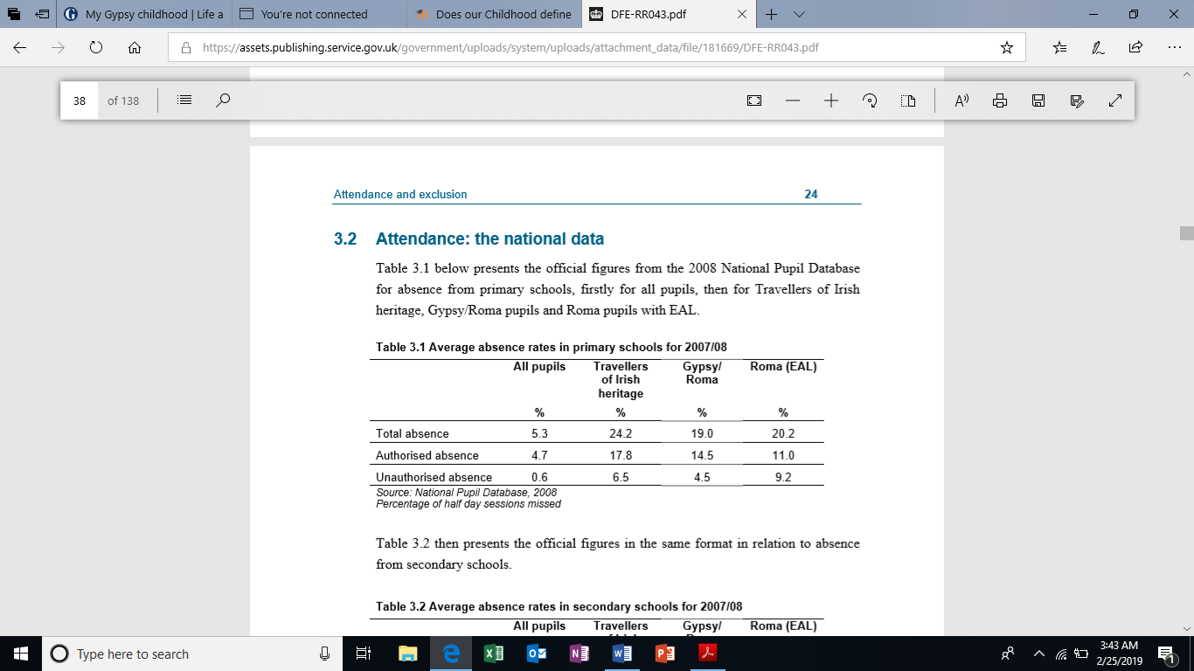
(Department for Education, 2017, p. 24)

Figure 2.
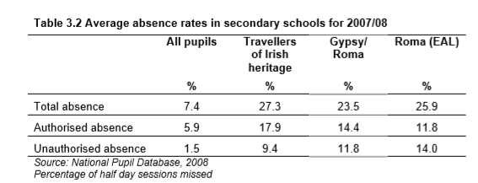
(Department for Education, 2017, p. 24)

The above tables clearly show that nationally in both primary and secondary schools Travellers of Irish heritage, Gypsy and Roma pupils have a higher absence rate than other ethnic pupils.
Another thing that I have learnt since working with Gypsies and Travellers is that many children and young people are taken into care. A study conducted by Family, Friends and Travellers looks at the number of looked after Gypsy and Traveller children and young people in England. Family, Friends and Travellers (2017) notes that ‘In a recent analysis of the population of ‘looked after’ children and young people in England, Dan Allen estimated that Gypsy and Traveller children were three times more like to be taken into care than any other child. Between 2009 and 2015, there has been an increase of 733% of Gypsy and Roma children in foster care and an increase of 200% of Traveller children in foster care’.
In conclusion, I believe that more needs to be done to support Gypsy and Traveller children and families. This blog has briefly looked into what childhood can be like for children and young people. It has also looked into some of the problems that are faced by Gypsy and Traveller children and young people. I believe that schools should incorporate Gypsy and Traveller culture and history.

References
Freeman, R. (2009). My Gypsy Childhood. The Guardian. [online] Available at: https://www.theguardian.com/lifeandstyle/2009/sep/07/gypsy-childhood-prejudice-education [Accessed 25 Feb. 2019].
Friends, Families and Travellers. (2018). Bullying Facts and Figures | Friends, Families and Travellers. [online] Available at: https://www.gypsy-traveller.org/resource/bullying-facts-and-figures/ [Accessed 23 Feb. 2019].
Sweeney, S. and Matthews, Z. (2017). A guide for professionals working with Gypsies, Roma and Travellers in Children’s Services. [online] Family, Friends and Travellers. Available at: https://www.gypsy-traveller.org/wp-content/uploads/2017/03/A-guide-for-professionals-working-with-Gypsies-and-Travellers-in-the-public-care-system.pdf [Accessed 21 Feb. 2019].
United Nations (1989) Convention on the Rights of the Child. [Online]. Available at https://www.unicef.org.uk/what-we-do/un-convention-child-rights/. [Accessed 23 Feb. 2019]
Wilkin, A., Derrington, C., Martin, K., Foster, B., Kinder, K. and Rutt, S. (2017). Improving the outcomes for Gypsy, Roma and Traveller pupils. [online] Department for Education. Available at: https://assets.publishing.service.gov.uk/government/uploads/system/uploads/attachment_data/file/181669/DFE-RR043.pdf [Accessed 22 Feb. 2019].

