BSc Cloud Computing
Learning in the Digital Era
ACCA4025
Assessment 1: E-Portfolio
[Shahzad Khawaja 2128045]

Automatic Referencing tool
Mendeley is a programme for adding references lists and in-text citations to Microsoft Word documents [1]. By clicking "References" to locate a Mendeley Cite-O-Matic section, we may choose citations from our desktop Mendeley and insert them as in-text citations in your Word document. We can also choose our required reference style from the Style option box. We will select "Insert Citation" from the Mendeley Word plug-in bar and then use the search box to look up the pertinent citation [2].
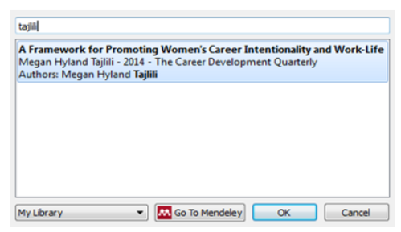
Figure 1: Mendeley Search Box [2]
Additionally, by choosing "Go to Mendeley" and selecting "Cite," we can choose a citation from our Mendeley library and add it to our work.
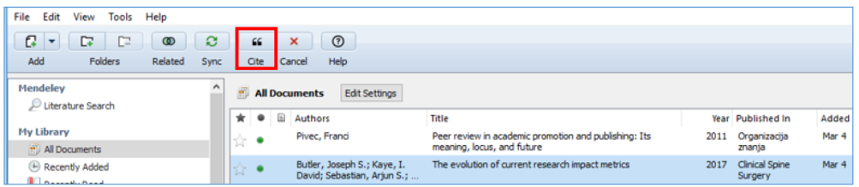
Figure 2: Mendeley library [2]
After making the necessary changes in our Mendeley library, we will amend the in-text citations in our Word document by clicking the "Refresh" button on the Mendeley Word plug-in bar [3].
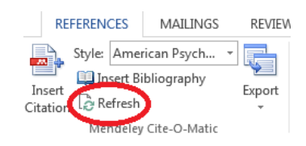
Figure 3: Editing in-text citations [2]
When we click an in-text reference in your document, the button labelled "Insert Citation" in the Mendeley Word plug-in bar changes to "Edit Citation," allowing us to delete an author or add a page number [4].
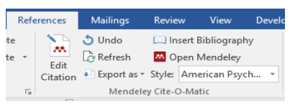
Figure 4: Edit citation [2]
We'll select "Insert Bibliography" to begin compiling our list of references. Each time we include a new in-text citation in our document, the reference will be immediately added to our reference list.
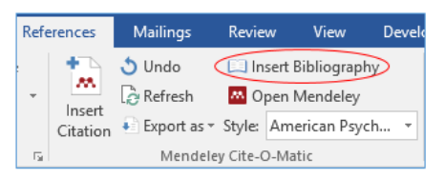
Figure 5: Insert Bibliography [2]

References

[1] | Mendeley, "Getting started with Mendeley Reference Manager," 2022. [Online]. Available: https://www.mendeley.com/guides/mendeley-reference-manager/.
[2] | A. Library, "Using Mendeley Cite," 1 April 2022. [Online]. Available: https://aut.ac.nz.libguides.com/mendeley/word.
[3] | ULS, "Introduction to Citation Management," 29 April 2021. [Online]. Available: https://pitt.libguides.com/citationmanagement/mendeley.
[4] | U. o. C. Irvine, "Mendeley Research Manager: Why Mendeley?," 15 June 2022. [Online]. Available: https://guides.lib.uci.edu/Mendeley.

