
Placement Research Project
BMIH6014

- Report Title: Research Report
- Student Name: Simona Patrascu
- Student Number: 2123259
- Lecturer Name: Natalie Brailsford

I confirm that I have not used any AI tools in the research and creation of this
assignment. I confirm that I have not presented any AI generated materials as my own work. I confirm I have copies of my drafts, notes, and other resources I used, which I may be asked to provide in evidence.

Abstract
The aim of this paper is to examine the impact of lack of training on the services and performances of hospitality industry workers with Novotel as one of the examples to consider. The paper examines the impacts of training gaps in the operations of the hotel, that is, in the front office and the reception desk, on the consistency and quality of service delivery to the customers. The study will explore the correlation between employee training and the main dimensions of service quality, namely reliability, responsiveness, and customer satisfaction. Through the examination of the impacts of bad training, the research will attempt to present practical managerial suggestions to fix the problem and enhance service delivery.
Novotel, the international corporation in the section of the hotel sphere called midscale, has had to encounter issues regarding maintenance of consistency in providing services, especially during the periods of time when the hotel industry experiences the highest levels of demand. The study discovers that a lack of proper training causes poor communication, stress experienced during peak periods and poor delivery of services.
The lack of training makes employees to feel less confident in their work and also leads to lack of knowledge in operational processes, making them employees more likely to make mistakes and deliver a poor customer service to existing guests. These negative impacts are more likely to be seen during peak times or usual busy hours. On the long term, the lack of training leads employees to emotional burnout and decreased performance.
The most striking findings include that well-organized continuous training programs are required in order to improve the performance of employee as well as service quality. Novotel can close the gap in performance of staff by ensuring comprehensive training sessions and by focusing on developing communication skills as well as SOPs in order to become more consistent in its operations. Performance monitoring of the training sessions can ensure that training remains topical and useful.
Considering the findings of this research, Novotel needs to be more systematic in terms of training and performance evaluation so employees can develop more knowledge about operational processes, handling customer complaints, adapting to operational changes and responding to the continuous changing needs of the hospitality environment and ultimately have a better effect on employee satisfaction and customer loyalty.
Table of Contents
Abstract 2
Chapter 1: Introduction 5
1.1 Background of the Hotel 5
1.2 Research Problem 5
1.3 Significance of the study 5
1.4 Research aim and objectives 6
Chapter 2: Literature review 7
2.1 Training and Employee Performance 7
2.2 Service Quality ( SERVQUAL) 8
2.3 Customer Satisfaction and Loyalty 9
2.4 Gap between Theory and Practice 10
Chapter 3: Methodology 12
3.1 Research Approach 12
3.2 Methods of Data Collection 12
3.3 Data Analysis 12
3.4 Limitations 13
3.5 Ethical Considerations 13
Chapter 4: Findings and Discussion 14
4.1 Findings 14
4.1.1 Thematic analysis table 14
4.1.2 Theme 1: Lack of training and its effect on staff performance at Novotel 17
4.2.3 Theme 2: Poor communication due to inadequate training at Novotel 18
4.2.4 Theme 3: Inconsistent service quality at Novotel 19
4.2.5 Theme 4: Stressful peak-time situations at Novotel 20
4.3 Discussion 21
4.3.1 Scenario 1: If training remains poor, service quality will decline 21
4.3.2 Scenario 2: If structured training is introduced, service improves 21
Chapter 5: Conclusion and Managerial Recommendations. 23
5.1 Conclusion 23
5.2 Recommendations 23
References 25
Appendix 29
Interview transcript 29

List of Figures
Figure 1: Conceptual Framework 8
Figure 2: Theoretical Framework 11
Figure 3: Training and employees’ performance 18
Figure 4: Strategies and tactics proposed by the professionals. 19
Figure 5: Service Quality 20

List of Tables
Table 1: Thematic analysis table 15

Chapter 1: Introduction

1.1 Background of the Hotel
Novotel is a midscale internationally recognised hotel brand that is part of the Accor Group and is focused on providing consistent service standards and customer experience (Accor, 2025). The chosen Novotel hotel operates in a dynamic operational environment with high levels of guest turnover and intensity of service provision. The present research is located within the front office/reception department, where direct contact with the customer is most important, and the overall level of services is immediately visible and has a significant impact on forming guest perception and satisfaction.

1.2 Research Problem
Despite of strategic service quality is component of hospitality organisations, there is still a lack of systemised and effective employee training. Past studies show that when training is insufficient, the degree of service consistency and the performance of employees are reduced (Waqanimaravu and Arasanmi, 2020). In reality, a lack of training will often lead to employees who lack confidence, make mistakes and provide inconsistent service. This would have a direct impact on the important dimensions of service quality including reliability and responsiveness (Mrs et al., 2019). Thus, the lack of training and the subsequent effects on service level and worker performance within the operational environment of Novotel are the core issues of this study.

1.3 Significance of the study
This study is significant as service quality directly influences customer satisfaction, online reviews, and organisational performance. Studies have indicated that more than 81% of travellers use online reviews prior to making a hotel reservation (Roelen-Blasberg, 2025). Unfavourable opinion can be created by providing poor service because of lack of adequate training. This must be observed - poor training will follow poor service. This recognition of the training gap in hospitality industry and its implications is very important in providing good services to customers and gaining an edge over competitors.

1.4 Research aim and objectives
Aim: The aim of this research is to investigate the impact of inadequate training on customer service quality within the hospitality industry.
Objectives:
- To analyse the link between employee training and service quality
- To analyse the impact of training on service consistency
- To analyse the impact of training on clarity of communication.
- To develop practical strategies for improving training with a positive impact on customer service.

Chapter 2: Literature review

2.1 Training and Employee Performance
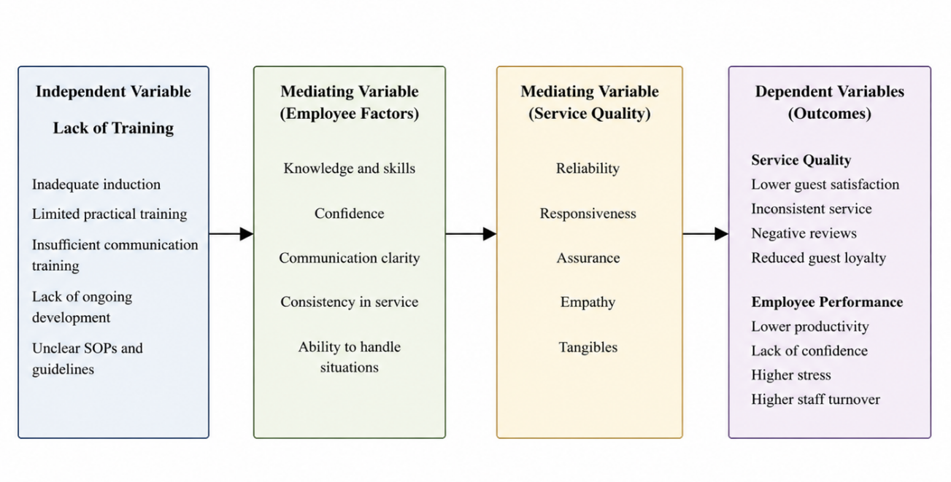
Figure 1: Conceptual Framework
Source: Self-Created
Training is commonly held to be a key factor in relying on employee service delivery in the hospitality industry where service delivery is intrinsically people-oriented. Human capital-wise, the cost of investment in training experiences a net uptake in both technical and interpersonal skills of employees, subsequently increasing their productivity and service delivery according to Chauhan and Mishra (2026). Vardan (2024) reinforces this opinion and argues that structured training can contribute greatly to employee confidence and minimisation of performance errors, especially in environments where observations frequently occur the high contact service.
This effective correlation between training and performance has been questioned by researchers who explain that training does not necessarily lead to performance improvement. Flegl, Depoo and Alcázar (2022) note that the determinant of training outcomes is the organisational context that relates to the managerial support and workplace culture. In the same vein, Polo, Cervai and Kantola (2018) argue that training programmes that are poorly-designed, can raise little or no performance, especially when they do not adequately address operational real challenges.
Moreover, overdependence on training as the only solution to a problem can fail to capture other important issues like motivation and job design. Conversely, untrained employees tend to be low in confidence, experiencing greater stress, and increased level of error, which negatively impacts on their individual and organisational performance. So training is very important but again it is only useful when it is relevant, of good quality and is incorporated in the larger organisational practices.

2.2 Service Quality ( SERVQUAL)
Service quality has long been known as the focal concept of research on hospitality, with the SERVQUAL model providing a detailed model of assessing customer perceptions according to Ayvaz-Çavdaroğlu, Iyanna and Foster (2024). The model points out five dimensions namely; reliability, responsiveness, assurance, empathy and tangibles, each representing a critical point on service delivery. Reliability is the use of consistent and reliable service provision, whereas responsiveness is the focus of fast help. Assurance deals with the competence and capability of the employees in instilling the trust and on empathy which deals with the personalised service. Tangibles are the physical setting, and appearance of workers.
Proponents of SERVQUAL propose that it is a holistic instrument in detecting the shortcomings of various services as stated by Albuquerque and Ferreira (2021). Training in this respect is critical in ensuring that employees are able to meet these service expectations, especially in providing responsiveness, as well as assurance. This opinion is also supported by Hsu, Her and Hou (2021) who argues that service quality is co-created between employees and customers and therefore making staff competence a necessity.
However, the model has been subject to criticism. Czajkowska and Kaczmarska (2025) maintain that the dependence of SERVQUAL on gaps between expectations and perceptions may not be a good reflection of actual service performance suggesting a performance-based alternative. Also, Jonkisz, Karniej and Krasowska (2021) doubts the universality of the model, arguing that the aspects of service quality can differ among contexts. Regardless of such criticisms, SERVQUAL is still relevant in terms of highlighting consequences of poor training. The workers who have received poor training are likely not to provide any reliable and responsive service, which can result in inconsistency and dissatisfaction.
Therefore, although SERVQUAL is a helpful conceptual framework that enables organisations to develop employee competencies elaborately through systematic training, its practical effectiveness is always contingent on the capability of an organisation to develop employee competencies at an elaborate level through systematic training.

2.3 Customer Satisfaction and Loyalty
Service quality refers to consistent and high-quality service that leads to increased customer loyalty and repeat business. According to Kurniawan et al. (2025) online reviews result in further amplification of customer perceptions in the digital age which have a significant impact on booking decisions. By adding views, Singh et al. (2023), stated that favourable service experiences help in positive reviews and loyalty to the brand in the long term and unfavourable service experiences can lead to reputational damage.
However, other researchers believe that satisfaction is a multifaceted construct that is affected by other factors as well as the quality of services according to Asawawibul et al. (2025). Nevertheless, empirical evidence continues to show that poor service, which is in many cases due to the lack of adequate training of the service staff), leads to the negative feedback and discontent. It implies that although there is a multi-faceted aspect to satisfaction, it can still be dominated by service quality.
It is therefore imperative to enhance training practices to improve service delivery, as well as to contribute towards customer loyalty and maintenance of competitive edge in the hospitality sector.

2.4 Gap between Theory and Practice
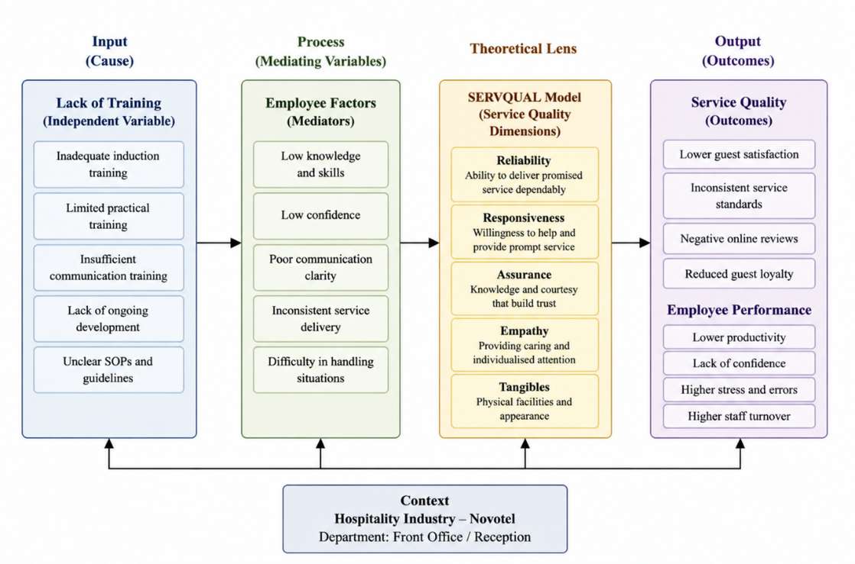
Figure 2: Theoretical Framework
Source: Self-Created
The literature is always preoccupied with training as a strategic priority to the achievement of service excellence and organisational performance (Jonkisz, Karniej and Krasowska, 2021). Nonetheless, there is a long-standing gap between these conceptualised notions and the reality of the actual practice in the hospitality organisations. Although training is identified as a necessity, its practice is usually not consistent and inadequate.
The reason why there is a gap in this regard could be explained by the fact that the hospitality industry is operational. The high employee turnover discourages long-term investment in the training since organisations may get the perception of low returns in the investment in training (Polo, Cervai and Kantola, 2018). Also, budgets and time limitations often result in little or no formal training practices, inadequate to meet the challenging service needs. Singh et al. (2023) continue to claim that the lack of organized systems of training leads to uneven skills among employees.
On the contrary, other researchers indicate that organisations are more interested in short-term efficiency of operations rather than in the long-term development of capabilities, thereby compromising the effectiveness of training. This indicates that strategic misalignment between the theoretical recommendations and the managerial practices has been experienced.
Thus, the disparity between theory and practice is not a failure to recognise the need but rather an inability to operationalise training. To help solve this problem, organisations need to break through structural barriers and be more strategic in their approach to developing employees, as well as ensuring that there is also adherence between the theoretical framework and practical implementation.

Chapter 3: Methodology

3.1 Research Approach
The given research must be viewed within the framework of a qualitative research approach in order to investigate the effects of training on the quality of services and performance of employees within a real organisational setting. In order to allow a detailed analysis of the operational practices and workers' experiences, a case study approach where the centre of interest is Novotel is considered. The qualitative approach is especially suitable when it comes to the examination of the complex social interactions within the sphere of hospitality (Saunders et al., 2019). Despite the potential limitations on the generalisability of qualitative research, the study helps to create a qualitative rich set of context-specific data that can be essential within the analysis of the training-related issues in service settings.

3.2 Methods of Data Collection
Several approaches to qualitative data collection are used to increase the richness and validity of the results. The observation is participant in nature, and during this observation, the study researcher can directly observe how the employees behave, interact and what challenges they face in the course of providing such services. This way makes it possible to identify real-time service problems which would not be reflected in the normal data collection procedures (Chand, 2025). Further, the study includes informal interviews with staff members with an aim of getting their input on their experiences, their perception of training, as well as the challenges they face in the delivery of their services. This can be attributed to the fact that these discussions provide a good context for the research but at the same time suffer from the response bias. Furthermore, this research makes use of the document analysis method to examine issues related to training materials, SOPs and organizational policies in order to compare the two.

3.3 Data Analysis
The data collected is analysed thematically using thematic analysis, which is the ability to identify and determine patterns which replicate in qualitative data (Braun and Clarke, 2006). A method allows arranging data in major themes like training gaps, communication gaps, and inconsistencies in the services. Thematic analysis is flexible and interpretable but may be prone to interpretation by the researcher (theoretically, leading to bias). Nonetheless, close coding and systematic analysis allow establishing that results do not go beyond the data collected and the goals of the research.

3.4 Limitations
The small sample size and the use of a single case study limit the generalisability of the study. Interactions of researchers in the environment can cause bias, and the results cannot be fully applicable to the larger practices within the hospitality industry.

3.5 Ethical Considerations
The maintenance of ethics is through the provision of participant confidentiality and anonymity. Staff are not harmed in any way, and the participation is on a voluntary basis (Al Habsi, 2024). Before the observation process and informal interviews, permission is sought to conduct the study within the ethical limits of research and organisational ethics.

Chapter 4: Findings and Discussion

4.1 Findings

4.1.1 Thematic analysis table
Table 1: Thematic analysis table
Theme | Code | Subcode | Description | Interview Transcript Code
Theme 1: Lack of Training and Its Effect on Staff Performance at Novotel | Training Inadequacy | Lack of Confidence | Employees lack the confidence to perform tasks, leading to hesitation and mistakes, ultimately impacting service quality and efficiency. | "Lack of confidence is the chief problem. You are in uncertainty and therefore, you hesitate, which influences the speed and quality of service." (Interviewee A)
 |  | Error Frequency | Insufficient training leads to increased mistakes, which directly affect service delivery, especially during busy times. | "There is a mess in the busy times. In the absence of explicit training, it leads to stress, and errors occur more frequently." (Interviewee B)
Theme 2: Poor Communication Due to Inadequate Training at Novotel | Communication Breakdown | Misunderstanding with Guests | Inadequate communication training leads to errors in guest interactions, particularly in handling complaints, resulting in poor guest experiences. | "It was sometimes unclear to me what to say and how to respond professionally, making communication difficult with guests." (Interviewee A)
 |  | Stress and Confusion | Poor communication leads to confusion and stress, especially under pressure, affecting employee performance. | "Sometimes when employees serve guests during breakfast, some food orders are complied with by improperly trained employees, particularly with international guests." (Interviewee B)
Theme 3: Inconsistent Service Quality at Novotel | Service Inconsistency | Variation Between Staff | Differences in service delivery occur between experienced and new employees due to a lack of structured training, leading to inconsistent guest experiences. | "Other staff who have been around longer know how to handle things better, but the newer staff members often handle things differently." (Interviewee A)
 |  | Lack of SOPs | The absence of clear Standard Operating Procedures (SOPs) contributes to varying service quality. | "There is a lot of role in training. Standard training is absent, and in that case, every employee will form his/her way of working, which will influence consistency." (Interviewee C)
Theme 4: Stressful Peak-Time Situations at Novotel | Employee Stress | Overwhelmed Staff

4.1.2 Theme 1: Lack of training and its effect on staff performance at Novotel
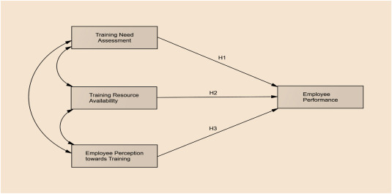
Figure 3: Training and employees’ performance
Source: (Gebrehiwot and Elantheraiyan, 2023)
A variety of sources, such as interviews with the staff members and literature books on employee performance, were used to develop the theme of lack of training and its impact on staff performance at Novotel. The deficiencies of training were constantly mentioned, with the staff mentioning the lack of confidence, ineffective communication process, and the lack of consistency in the delivery process among the key consequences of insufficient education. As an example, Interviewee A emphasised the poor confidence, and without appropriate training, employees are reluctant to handle their tasks effectively, resulting in slow service provision and mistakes. On the same note, Interviewee B noted that the poor training led to stress during peak hours, and this affected the overall quality of service, thus leading to customer dissatisfaction.
Gebrehiwot and Elantheraiyan (2023) argue that low productivity and a higher rate of error are due to a lack of training. This is the same observation as the interview results when employees explained that they had problems handling customer service issues that required real-time attention because of the little training that employees were given. Additionally, this is supported by research by Dhoundiyal and Mathur (2022), which finds that employees without training are more susceptible to stress and perform poorly under stress. All these factors eventually lead to poor performance of employees and the quality of services that customers experience at Novotel.
Therefore, evidence-based and structured training programs would be necessary to improve employee performance as well as improve service delivery at Novotel.

4.2.3 Theme 2: Poor communication due to inadequate training at Novotel
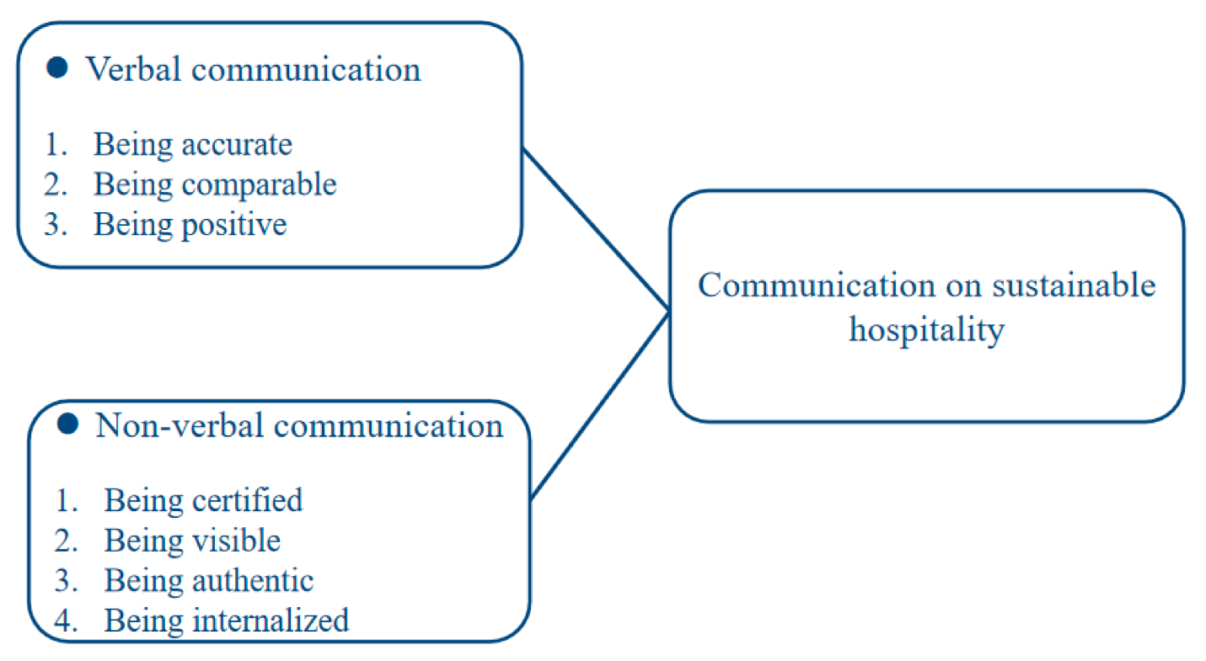
Figure 4: Strategies and tactics proposed by the professionals.
Source: (Shen, Qian and Chen, 2020)
The problem of poor communication due to insufficient training at Novotel was one of the crucial factors that affected workers' performance and the service they provided. Communication breakdowns were highlighted by interviews with the staff of the Novotel company, where Interviewee A noted misunderstandings over the way to handle the customers' complaints, especially when the staff had not been trained to effectively communicate in a concrete and professional manner. On the same note, Interviewee B became confused by the fact that there was no formal communication training, which led to poor customer experiences during peak times.
In the literature, Shen, Qian, and Chen (2020) highlight the significance of communication strategy in sustainable hospitality, and they note that effective training in communication boosts employee engagement and service delivery. Nevertheless, Campbell et al. (2020) state that there is no line of communication between the management and the employees; hence, they argue that this makes the problems worse, and individuals end up feeling unprepared to address the needs of customers. This is also supported by Atasoy, Turkay, and Sengeul (2022), who indicate that unclear communication in the organisational setting is one of the factors that contribute to service inconsistencies and has an effect on employee confidence.
The findings, therefore, confirm the existing literature and indicate that a lack of communication training leads to the scattering of services and prompts negative comments about the services. These problems could be resolved through a structured communication training programme, which would lead to improvement in the performance of the employees and the quality of services provided by Novotel.

4.2.4 Theme 3: Inconsistent service quality at Novotel
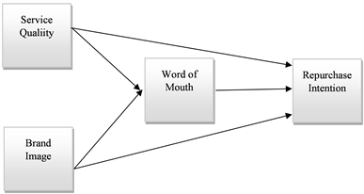
Figure 5: Service Quality
Source: (Prabowo, Astuti and Respati, 2020)
Service quality inconsistencies within the company were also noted as a critical concern, both in the answers received during the interview and in the literature. Staff members said that there was variation in the delivery of services because it is not in an organised way of training new staff members. Interviewee A observed that more experienced employees knew more about the service standards, as compared to new employees who could not maintain consistency. Interviewee B also added that this non-uniformity affected the satisfaction of guests, and this was more pronounced during the times of peak season when the staff were under pressure.
These findings are backed by the literature, where Ali et al. (2021) mention that service consistency is pivotal to increasing customer satisfaction. Poorly trained employees or a lack of a structured training programme increases the likelihood of the employee providing inconsistent services, and this will result in lower customer satisfaction and lower repurchase intentions (Prabowo, Astuti, and Respati, 2020). As Myo et al. (2019) point out, customer loyalty depends largely on good service, which in turn can only be realised through consistent service.
This theme shows the necessity for Novotel to adopt a consistent training procedure to guarantee uniform service quality that would probably result in enhanced customer satisfaction and loyalty.

4.2.5 Theme 4: Stressful peak-time situations at Novotel
The theme of stressful peak-time situations at Novotel became a powerful factor in responding to the interview questions as well as the literature. According to interviewees, high number of guests during the peak seasons, together with poor training, was a contributing factor to the high level of stress within staff. Interviewee A pointed out that failure to train on handling situations of high pressure tended to cause failure and delays, negatively affecting service quality. Equally, in Interviewee B, there were feelings of overwhelm during the busy periods, hence emotional fatigue and reduced job satisfaction.
These findings are supported by the literature: Grobelna (2020) argues that emotional exhaustion caused by heavy workloads and a lack of supervisor support can directly affect the quality of service. According to Mohsin, Brochado, and Rodrigues (2022), stressful work situations, especially in peak periods, increase employee turnover. This is in line with the interviews, where employees complained that they felt highly stressed and that they made more errors during peak times, which also contributed to the inconsistency in service quality.
In order to deal with such problems, it is important to provide adequate training for the management of stress and to improve the level of supervisor’s support during peak periods in order to help them cope with stress and provide more services during peak periods.

4.3 Discussion

4.3.1 Scenario 1: If training remains poor, service quality will decline
As long as training is not sufficient at Novotel, the quality of service will gradually decrease. All of these are related to inadequate training, poor communication, inconsistent service delivery, and the stress in the peak times, as pointed out in the thematic analysis. Interviewee A indicated that in the absence of training, the staff cannot effectively address customer complaints or service failures, thus resulting in a decrease in guest satisfaction. As Grobelna (2020) claims, the occurrence of emotional exhaustion among employees, which happens due to the lack of preparation to confront a stressful environment, also contributes to the decline in service quality. Also, Ali et al. (2021) highlight that a lack of consistency in service will affect customer loyalty and brand image. In case of such a scenario, not only does Novotel stand to lose negative reviews on the Internet due to poor service, but it also loses the chance of attracting repeat customers in the long term, which can affect its long-term profitability.
The lack of addressing the training problems as the future manager will create a chain of high employee turnover and low staff morale and will eventually harm the reputation of the hotel.

4.3.2 Scenario 2: If structured training is introduced, service improves
Conversely, by introducing an organised and ongoing training, there would likely be a massive step forward in the quality of the offered service. As the results of the literature, especially of Prabowo, Astuti and Respati (2020) prove, well-trained employees are more consistent and more reliable in their service, which results in better customer satisfaction. Training would also assist in reducing stress during peak times and enhancing clarity of communication to ensure that the employees feel more comfortable about their jobs.
Additionally, Myo et al. (2019) maintain that training plays an important role in cultivating a service excellence culture, where workers are prepared to deal with both normal and stressful situations in optimal ways. It is possible to address the inconsistencies in the services by structuring the training, which would make the employees aligned in terms of the standard operating procedures (SOPs) and expectations by the customers, which would result in improved guest loyalty and positive reviews.
A designed training program would fill the training gaps identified in the thematic analysis, improve employee performance, reduce stress, and improve the level of service delivery at Novotel. Further monitoring and feedback mechanisms would be the best way of ensuring that training is relevant and effective in addressing the needs of employees and customers.

Chapter 5: Conclusion and Managerial Recommendations.

5.1 Conclusion
The objective of the research was to explore how poor training affects the service quality and employee performance in the hospitality industry, which in the research case was at Novotel. The main conclusions of the study imply that, when training is insufficient, the services are not consistently of good quality, and inadequate communication also results in high levels of stress at the busiest times. According to the thematic analysis and the response of the interview, there is a tendency to refer to the employees who were not properly trained as more likely to give a faulty result, have communication problems and are less able to deliver consistent service, especially in cases of bottlenecks. This ultimately manifests itself in reduced customer satisfaction, negative online customer reviews and reduced employee morale.
The literature review supported the findings and the studies by Ali et al. (2021) and Grobelna (2020) further reinforce the critical role of training in determining the quality of services and the well-being of its employees. Moreover, the study showed that the use of structured training measures can be important to enhance the consistency of the service offered, the type of confidence the employees have, and the overall performance.
The competitive value of this service can also be enhanced by filling in the gaps so that Novotel will be able to improve its competitive positioning in terms of achieving satisfaction by both the employees and the guests, thus increasing the competitive value of this service.

5.2 Recommendations
To be able to eradicate the problem areas detailed in the study, a list of managerial suggestions are offered to the Novotel:
Staff Training Program Onboarding Training and further growth
To make new hires familiar with service standards and operations processes, Novotel will need to adopt an extensive onboarding training program with the new employees to prevent any scenarios where new employees do not understand what is expected of them in terms of their service quality and operational efficiency. The emphasis of this training must be placed on such practical skills as dealing with customer complaints, communicating, and managing time. Also, continuous development programmes are to be initiated to constantly update the knowledge of the staff, especially in aspects such as managing stress during peak times. This shall help minimise the occurrence of emotional burnout and service failure, as evident in Grobelna's (2020) findings.
Training in Communication: enhancing staff communication with customers
One of the greatest improvement aspects is communication training, where the deficiency in communication was a constant point of concern raised by interviewees. Training on verbal and non-verbal communication should then be put together by Novotel to ensure that the employees are well equipped to deliver messages in the right manner, and in a positive and professional manner. This will boost staff confidence and minimise confusion during interactions with customers. Training on coping with stressful peak-time situations should also be included in the training since poor communication during peak hours can aggravate service problems.
Standard Operating Procedures (SOPs): Simple Rules of Service Provision
It is critical to develop clear SOPs to cover all customer service activities. These policies must be outlined in writing and made readily available to every employee in order to ensure service provision uniformity. The most common service problems that SOPs should cover are the check-in/check-out procedure, how to handle guest complaints, and the expectations of the restaurant service. The development of standardised processes will help Novotel raise the service quality and the satisfaction of guests, as outlined in the results of the research.
Performance Monitoring: A Feedback System to Measure Training Effectiveness
A performance monitoring system is the solution to be implemented to monitor the effectiveness of training programs. Such a system will involve routine feedback trends with employees in order to determine their confidence and competencies to manage real-life scenarios. There should also be a provision of guest feedback via surveys and reviews in order to determine the satisfaction of the customers. This system will allow the management to see the areas of improvement and amend the training programs to ensure they meet the changing needs of both employees and customers.
With the above recommendations, not only is Novotel going to improve service quality, but it is also going to improve employee performance, leading to increased customer loyalty and profitability.

References

Accor (2025) Our Hotel Brands, Accor Group. Available at: https://group.accor.com/en/brands-and-experiences/our-hotel-brands (Accessed: 01 May 2026).
Adams, A. (2026) 20+ impact of online travel reviews statistics [2026], hotelagio.com. Available at: https://hotelagio.com/impact-of-online-travel-reviews/ (Accessed: 01 May 2026).
Al Habsi, S.S. (2024) Ethical Considerations in Obtaining Informed Consent in Research Participation. International Journal of Educational Contemporary Explorations, 1(1), pp.22–32. DOI:10.69481/DIVL1152.
Albuquerque, R.P. and Ferreira, J.J. (2021) ‘Service quality, loyalty, and co-creation behaviour: A customer perspective’, International Journal of Innovation Science, 14(1), pp. 157–176. doi:https://doi.org/10.1108/ijis-06-2021-0101.
Ali, B.J. et al. (2021a) ‘Hotel Service Quality: The impact of service quality on customer satisfaction in hospitality’, International Journal of Engineering, Business and Management, 5(3), pp. 14–28. DOI:10.22161/ijebm.5.3.2.
Asawawibul, S. et al. (2025) ‘The influence of cost on customer satisfaction in e-commerce logistics: Mediating roles of service quality, technology usage, transportation time, and production condition’, Journal of Open Innovation: Technology, Market, and Complexity, 11(1), p. 100482. doi:10.1016/j.joitmc.2025.100482.
Atasoy, B., Türkay, O. and Şengül, S. (2022) ‘Strategic responses of Chain Hotels to covid-19 from a Situational Crisis Communication Theory Perspective’, Journal of Hospitality and Tourism Insights, 5(5), pp. 1118–1136. doi:10.1108/jhti-02-2021-0047.
Ayvaz-Çavdaroğlu, N., Iyanna, S. and Foster, M. (2024) ‘Smart Service Quality in hospitality – a quantitative assessment using MCDM and clustering methods’, International Journal of Hospitality Management, 123, p. 103931. doi:10.1016/j.ijhm.2024.103931.
Braun, V. and Clarke, V. (2006) ‘Using thematic analysis in psychology’, Qualitative Research in Psychology, 3(2), pp. 77–101. doi:10.1191/1478088706qp063oa.
Campbell, S., Sharon Campbell-Phillips and Daneil Phillips (2020) ‘Lack of communication between management and employees’, SIASAT, 4(3), pp. 32–39. DOI:10.33258/siasat.v4i3.67.
Chand, S.P. (2025) ‘Methods of data collection in qualitative research: Interviews, focus groups, observations, and document analysis’, Advances in Educational Research and Evaluation, 6(1), pp. 303–317. 10.25082/AERE.2025.01.001.
Chauhan, L. and Mishra, A. (2026) Impact of Training and Development on Employee Performance and Satisfaction in the Hospitality Industry: A Systematic Review. International Journal for Multidisciplinary Research (IJFMR), 8(1). Available at: https://www.ijfmr.com/papers/2026/1/68213.pdf. (Accessed: 14 May 2026).
Czajkowska, A. and Kaczmarska, B. (2025) ‘Application of the SERVQUAL method to highlight the significance of customer satisfaction in the process of shaping quality of services and the nature of required innovation’, Advances in Science and Technology Research Journal, 19(3), pp. 172–183. DOI: https://doi.org/10.12913/22998624/197428
Dhoundiyal, A. and Mathur, D. (2022) ‘Impact of training on employee satisfaction and change management: A pragmatic study with special reference to employees working in Luxury Hotels of Mumbai’, PUSA Journal of Hospitality and Applied Sciences, 8(1), pp. 1–17. https://doi.org/10.48165/pjhas.2022.8.1.1.
Flegl, M., Depoo, L. and Alcázar, M. (2022) ‘The impact of employees’ training on their performance improvements’, Quality Innovation Prosperity, 26(1), pp. 70–89. doi:10.12776/qip.v26i1.1665.
Gebrehiwot, G. and Elantheraiyan, P. (2023) ‘A study on the effect of training on employee performance in the case of Mekelle City, Tigray, Ethiopia’, Social Sciences &amp; Humanities Open, 8(1), p. 100567. doi:10.1016/j.ssaho.2023.100567.
Grobelna, A. (2020) ‘Emotional exhaustion and its consequences for hotel service quality: The critical role of workload and supervisor support’, Journal of Hospitality Marketing &amp; Management, 30(4), pp. 395–418. doi:10.1080/19368623.2021.1841704.
Hsu, T.-H., Her, S.-T. and Hou, J.-J. (2021) ‘Developing universally applicable service quality assessment model based on the theory of consumption values and using fuzzy linguistic preference relations to empirically test three industries’, Mathematics, 9(20), p. 2608. DOI:10.3390/math9202608.
Jonkisz, A., Karniej, P. and Krasowska, D. (2021) ‘Servqual method as an “old new” tool for improving the quality of Medical Services: A literature review’, International Journal of Environmental Research and Public Health, 18(20), p. 10758. doi:10.3390/ijerph182010758.
Kurniawan, A. et al. (2025) ‘Enhancing customer loyalty: The role of service quality in customer satisfaction’, Journal of Lifestyle and SDGs Review, 5(2). DOI:10.47172/2965-730X.SDGsReview.v5.n02.pe04412.
Mohsin, A., Brochado, A. and Rodrigues, H. (2022) ‘Mind the gap: A critical reflection on hotel employee turnover’, International Journal of Contemporary Hospitality Management, 35(7), pp. 2481–2495. DOI:10.47172/2965-730X.SDGsReview.v5.n02.pe04412.
Mrs E.A., Joao, E.S., Spowart, J. and Taylor, M.A. (2019) Employee training contributes to service quality and therefore sustainability. African Journal of Hospitality Tourism and Leisure, [online] 8(2). Available at: https://www.researchgate.net/publication/343473271_Employee_training_contributes_to_service_quality_and_therefore_sustainability. (Accessed: 4 May 2026).
Myo, Y.N., Khalifa, G.S.A. y Aye, T.T. (2019) The Impact of Service Quality on Customer Loyalty of Myanmar Hospitality Industry: The Mediating Role of... [online] ResearchGate. Available at: https://www.researchgate.net/publication/335134584_The_Impact_of_Service_Quality_on_Customer_Loyalty_of_Myanmar_Hospitality_Industry_The_Mediating_Role_of_Customer_Satisfaction. (Accessed: 4 May 2026).
Polo, F., Cervai, S. and Kantola, J. (2018) ‘Training culture’, Journal of Workplace Learning, 30(3), pp. 162–173. doi:10.1108/jwl-01-2018-0024.
Prabowo, H., Astuti, W. and Respati, H. (2020) ‘Effect of service quality and brand image on repurchase intention through word of mouth at Budget Hotels Airy Rooms’, Open Journal of Business and Management, 08(01), pp. 194–207. 10.4236/ojbm.2020.81012 .
Roelen-Blasberg, T. (2025) Online review statistics every hotel needs to know in 2025, MARA Solutions. Available at: https://www.mara-solutions.com/post/online-review-statistics-every-hotel-needs-to-know (Accessed: 4 May 2026).
Saunders, M., Lewis, P. and Thornhill, A., (2019) Research methods for business students. 8th ed. Harlow, England: Pearson.
Shen, L., Qian, J. and Chen, S.C. (2020) ‘Effective communication strategies of sustainable hospitality: A qualitative exploration’, Sustainability, 12(17), p. 6920. doi:10.3390/su12176920.
Singh, V., Sharma, M.P., Jayapriya, K. and Kumar, B.R. (2023) Service Quality, Customer Satisfaction And Customer Loyalty: A Comprehensive Literature Review. [online] ResearchGate. Available at: https://www.researchgate.net/publication/371809524_Service_Quality_Customer_Satisfaction_And_Customer_Loyalty_A_Comprehensive_Literature_Review. (Accessed: 4 May 2026).
Vardan, V., (2024) ‘Impact of employee training programs on service performance in restaurants’, Journal of Hospitality and Tourism, 4(3), pp. 10–20. doi:10.47672/jht.2381.
Waqanimaravu, M. and Arasanmi, C.N. (2020) ‘Employee training and service quality in the hospitality industry’, Journal of Foodservice Business Research, 23(3), pp. 216–227. DOI:10.1080/15378020.2020.1724850.

Appendix

Interview transcript
What do you say about the training that you have had when you first assumed your role, and how much do you think you have been prepared to deliver high-quality customer service?
A: Well, the training was very rudimentary. It paid much attention to the use of the systems, such as check-in and check-out, but not to the handling of aggressive guests. I did not consider myself well-equipped enough to deal with a real customer scenario, particularly during peak times.
B: The training was extremely brief. I picked up a majority of the things on the job. It was akin to learning through observing others as opposed to being actually trained.
C: A: It was limited. The majority of my skills grew over time through experience. It was necessary, not just to receive formal training but to be prepared to face real-life situations.
D: A: It was primarily demonstration-based. I did follow the senior staff, but they did not explain to me specifically or even provide training.
How does the level of training given influence the uniformity of service offered to the guests?
A: It most certainly influences consistency. Other staff who have been around longer know how to handle things better, but the newer staff members often handle things differently. Therefore, service is not necessarily standard.
B: It breeds differences. Other staff adhere to the right standard, whereas other staff do things differently. That results in variation in service.
C: There is a lot of role in training. Standard training is absent, and in that case, every employee will form his/her way of working, which will influence consistency.
D: Yes, it has an impact on it. The rooms are also prepared differently based on the person working in the room, which depicts inconsistency.
What are some of the situations in which inadequate training has impacted communication?
A: Yes, particularly with grievances. It was sometimes unclear to me what to say and how to respond professionally, making communication difficult with guests.
B: Sometimes when employees serve guests during breakfast, some food orders are complied with by improperly trained employees, particularly with international guests.
C: Yes, particularly when dealing with complaints. Other workers are facing increasing problems when there is no necessity to do so, since they are not trained on how to address such problems.
D: A: Instructions given by the supervisor are sometimes not clear, and because the supervisor is not trained, the instructions are not clear, leading to mistakes.
What is the problem you have with providing customer service as a result of the lack of or ambiguity in training?
A: Lack of confidence is the chief problem. You are in uncertainty and therefore, you hesitate, which influences the speed and quality of service.
B: There is a mess in the busy times. In the absence of explicit training, it leads to stress and errors occur more frequently.
C: The greatest threat is how to handle new employees who are not well-trained. It makes work burdensome for supervisors.
D: A: No articulateness in tasks. At other times, I do not know what level is supposed.
Which training strengths or weaknesses would you recommend be improved to improve the quality of customer service in your department?
A: Practical training and role plays would be beneficial, and this would especially apply to dealing with customer complaints.
B: Experienced guidelines and appropriate training on induction would help, especially in areas relating to communication with guests.
C: It would be beneficial to enhance the quality of services by means of implementing a structured training programme and a continuous development programme.
D: Detailed guidelines and good training sessions would come in handy, particularly with the new employees.

