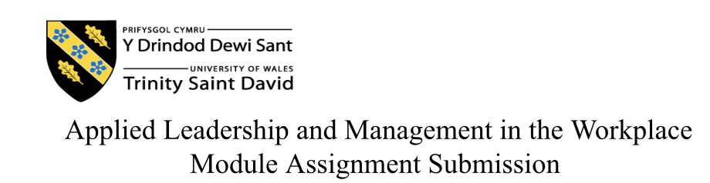
Student Name: | Charlotte wilkins
Student Number: | 2234143
Module No: | BMSK4015
Module Title: | Academic and research skills

Report title
The Advantages and Disadvantages of working remotely.

Contents
: introduction
: Managers advantages of working remotely
: Managers disadvantages of working remotely.
: Employees Advantages of working remotely
: Employees Disadvantages of working remotely
: Companies Advantages or working remotely.
: Companies Disadvantages of working remotely.
: Reflection
: Conclusion
: References

Introduction
In this Assignment I will be discussing working remotely and how its advantages and disadvantages effect both managers, employees, and companies. Working remotely, or telecommuting is a work arrangement in which an employee can work from a location outside of the traditional office setting. This can include working from home or anywhere if there is Wi-Fi connection to complete all aspects of their work. With technology improving over the years, it has made working remotely easier and more popular, however, this has also resulted in some disadvantages as well as a variety of advantages. As we examine all sides of the equation, we’re able to uncover the details of remote work, emphasising the potential benefits and potential drawbacks that managers, employees, and company organisations may encounter when participating in remote work.

Main discussion

Managers advantages of working remotely
Managers can benefit greatly from working remotely it is an ongoing trend that has been thriving in popularity due to advancements in technology making remote working far more accessible allowing them to stay connected and oversee their teams with the use of video calls and virtual communication platforms from anywhere around the world.
Flexibility
One of the more popular advantages for managers that work remotely is that they have the flexibility to choose their own working hours instead of the standard 9 till 5 office hours giving them the opportunity to work around their family life and other commitment's that may arise. Flexible work schedules can also lead to increased productivity and more efficient and effective leadership.
Cost effectiveness
Cost-effectiveness is one of the biggest benefits for remote work for managers, businesses can save a lot of money by letting they're employee's work remotely as there is no extra costs to rent facilities for office spaces. There is also the advantage of saving costs when it comes to commuting and saving money on fuel prices and public transport.
Remote work also lowers operating costs as fewer employees are physically present in the office and using office supplies like stationary, work desks and computers.
Remote work in particular removes overhead expenditures like lease fees, insurance, utilities and office furnishings. For example, IBM saved $50 million in real estate expenses by permitting remote work, the corporation eliminated more than 58 million square feet of office spaces and dramatically decreased lease costs, according to the source – Global workplace analytics workplace cost and benefits statistics. Forbes (2021)

Increased productivity
Many different studies have demonstrated that working remotely from home is a lot more productive than when working in an office. Working from home allows managers to work an extra day a week, saving 10 minutes per day of inactivity and increase productivity by 47% on average. Those who work from home throughout the work week tend to be more reliable, work more hours and tend to accomplish more. (2021) Apollo technical LLC.
Evidence suggests that productivity appears to have increased with remote / mixed work, most corporate executives stated that throughout the previous 12 months, their company outperformed staff performance and productivity and expectations.
Most of the workplaces have seen a temporary increase in productivity due to a result of hybrid /remote working with 57% of their respondents saying that their organisation did better over the last 12 months in terms of work performance and productivity targets with only 4% saying that it performed noticeably worse. Pwc (2021).

Managers disadvantages of working remotely.

Poor communication
While working remotely has its advantages it also comes with disadvantages and challenges, one being communication challenges, for remote working to be successful this depends on effective communication, to better serve remote workers needs for collaboration and communication, many organisations have implemented unified communication tools. However, communication will suffer if there is not enough tools or staff are not taught well enough to use them. Technology issues is one of the main miscommunications whilst working remotely whether it may be a network problem or from the manager ends devices when technology malfunctions it can prevent managers from corresponding with their work team/employees, this can also cause disruption's when it comes to video and audio calls , communication has become far more challenging for managers who are no longer able to interact with their team members face-to-face on a daily basis.
According to research that was conducted by Albert Mehrabin, only 7% of communication is based on the actual words spoken, while 38% is based on tone of voice and 55% is based on our body language so when managers are communicating with their employees through various online platform's such as email or maybe over teams , managers lose the ability to interpret these nonverbal cues , which in turn can lead to significant misinterpretations and misunderstandings.
There is also the loss when it comes to being able to connect with their employees in a traditional office setting being able to walk over to a team members desk for a brief chat to maybe discuss impromptu and important matters, which may lead to delays in decision-making and problem solving.
Feelings of isolation
Lack of face-to face interaction can lead to a sense of isolation, especially when it comes to managers who are used to working and interacting with other employees or colleagues. This can cause managers to feel isolated and can eventually lead to low morale and decrease in productivity.
In a study by Pellegrini, E, & Rapp, A. (2021) they investigated weather perceptions of social.
Isolation and stress can affect productivity within a remote working environment during the COVID-19 pandemic. Previous research has shown that social isolation and stress can negatively impact job performance, but no study has explored this relationship in a remote work context during a pandemic. The study hypothesised that higher levels of perceived social isolation and stress would be associated with lower self-reported productivity.one.
Pellegrini, E., & Rapp, A. (2021). Social isolation and stress: Their effects on productivity in remote work during COVID-19. International Journal of Environmental Research and Public Health, 18(2), 472. https://doi.org/10.3390/ijerph18020472.
Lack of control
Another main drawback for managers that work remotely is not being able to oversee and control their staff when are not physically present, this can result in a lack of productivity, this can in turn lead to a lack of trust and this lack of control can make it difficult to evaluate their workers.

Employees advantages of working remotely.
Work life balance.
Working remotely for employees offers a better work life balance, a study by kabarak university examined how effects of work life balance had on employee's performance.
This was demonstrated by questionnaires that were used to collect data for their research, this was done using a case study approach that is specifically descriptive in nature. The statistical package for social science (SPSS) was used to analyse all the data.
The study had found that performance by the employees had a significant negative impact when it came to family/ work priority conflict. As a result, the study had concluded that work life balance shows an important role when it comes work and family life which it turn improves employee's performance. From this it can be concluded that to lessen the imbalance and improve employee's performance, programmes and policies should be put in place that support employees' work and home life balance. The results can be used by Kabarak university's human resources department and other organisations to encourage work life balance among employees. Lucy Mwangi, Etoll (2017)
Cost savings
Cost savings is also a good advantage for employees who work remotely, whilst working from home employees are saving large amounts of money by cutting back on fuel prices and parking tolls by not commuting back and forth to work daily. Employees also save on food costs by being able to prepare their meals at home instead of purchasing food or beverages out at cafes or restaurant's.
Employees also have the option to wear casual clothes or what they feel comfy in lowering costs purchasing uniform and other work attire.
A survey by owl labs have revealed that employees who work remotely will save on average of $4,000 per year on travelling expenses, meals out and purchasing work wear this benefit them greatly and helps to better overall job satisfaction and work life balance.
Increased productivity
According to research by Stanford university, Chinese call centre workers reported a 13% gain in productivity, of this 4% came from making more calls per minute and 9% came from working longer hours per shift, when given the option have of the workers decided to work in the office instead of at home, they're performance increased by almost 22%, however whilst working from home enhanced employee happiness and decreased staff churn by 50%. To completely understand the advantages and disadvantages of working remotely, more research is necessary as the study only examined productivity over a few months for one type of employee in one location of the world. Individual results may also differ depending on personal preferences and other factors. Jason DeMers (2019)

Employees disadvantages from remote working
Feelings of isolation
Feelings of isolation can be a major challenge for employees who work remotely as they often must spend the entire day alone with no one to engage with or offer support if needed while at work. To overcome this, it's important for employees to be able to have some sort of interaction regarding their work, or to have a coffee break/ lunch break so they can connect with employees to combat feelings of isolation. Wang, Chen and Li (2020) reported that employee's that work alone are prone to feelings of isolation and even loneliness, this can cause them to feel a sense of disconnection from their work objectives.

Distractions
Whilst working remotely has its benefits for some, others with family at home may find it very challenging with multiple distractions, this may be interruptions from children, pets, friends and even neighbours. With many distractions going on at home, employees can lose concentration therefore productivity may be affected.
In a survey in June 2020 employees were asked what they thought the biggest distraction was for them, when they were questioned 53.7% of those had gone on to say that using their smartphones had the biggest impact on productivity, 30.4% had said that playing computer games had caused them to become distracted from completing their work.
The biggest distraction was looking through social media with 61.6%. Statista (2024).

Work life balance.
While working remotely may benefit some employees, others may find it hard to switch off when finishing their work for the day which can lead to emotional burnout and stress resulting in their mental health being affected.
A poll by RSPH have revealed that employees who had switched to remote work due to the COVID-19 pandemic had reported that they were not exercising as much working at home 46% of these developed musculoskeletal issues as well as 67% reporting that they felt disconnected from their colleagues causing an impact on their mental well-being, 56% of colleagues had difficulty switching off , only 34% of those were offered support with their mental health . This suggests that employees should be doing more for the well-being of their employees. RSPH (2021).

Companies' advantages of working remotely
Saving on costs
Companies running businesses may find that in addition to the advantages for employees, working remotely helps their business save money. For example, working remotely has been shown to reduced real estate expenditure costs buy $68 million annually for sun Microsystems, while non-real estate costs have been reduced by more than 30% for Nortel and Dow chemical. As per Global Workplace Analytics, around 60% of business consider cost reductions to be a noteworthy advantage when it comes working remotely. According to calculations, the total amount of money saved yearly for all jobs that are compatible with remote work will exceed $700 billion if all employees choose to work remotely just half the time. This adds up to more than $11,000 annually for each employee.
There are many other costs to be saved for companies including relocation expenses, these are reduced by working remotely. Many employers will cover costs of major staff relocation. Cleaning services will also be reduced, this shows a big reduction in company costs when there are less office spaces to be cleaned or when there is little staff on site.
Working remotely also reduces security expenses, if you do not have many office spaces in use there will be less Need for security guards or any other type of security measures.
Another good advantage is lower food expenses, most companies offer highly regarded cafeteria and coffee services, water delivery, and conference refreshments. This can me a major saving cost for companies when their employees are working remotely. Baruch Silvermann (2020).

Companies disadvantages of working remotley
Remote communication
Communication can be a major issue for companies that have employees working remotely, giving a detailed explanation on work related topics works far better than doing so over email or txt, body language also plays a significant role when it comes to communicating, and is far simpler to understand what someone is saying from their nonverbal signs. Many of the benefits and drawbacks of working remotely will centre on communication inside the organization. It's also far easier to be able to have a conversation with employees face to face to clear up any doubts or follow up work related issues straight away rather than wait for returned emails.
Monitoring employees
A common downside for companies is not being able to monitor their employee's performance as well as would the would be able to in an office setting. Employers use monitoring as a tool to track employee activity and maximise productivity on an individual basis. When monitoring workers progress, they can boost morale, reduce pain points, and boost their revenue.
The most effective way for companies to keep an eye on their work team is to use technology and other tools for employee monitoring. These tools can therefore assist companies enhance business procedures by identifying patterns of inefficiency through automatic analysis and real-time monitoring and reporting.
Productivity concerns
A big concern for companies is not being able to oversee overall performance causing unease with the status of their company, and not being able to monitor if employees are performing their tasks given to maintain their overall performance in their place of work.
Anon (2021)
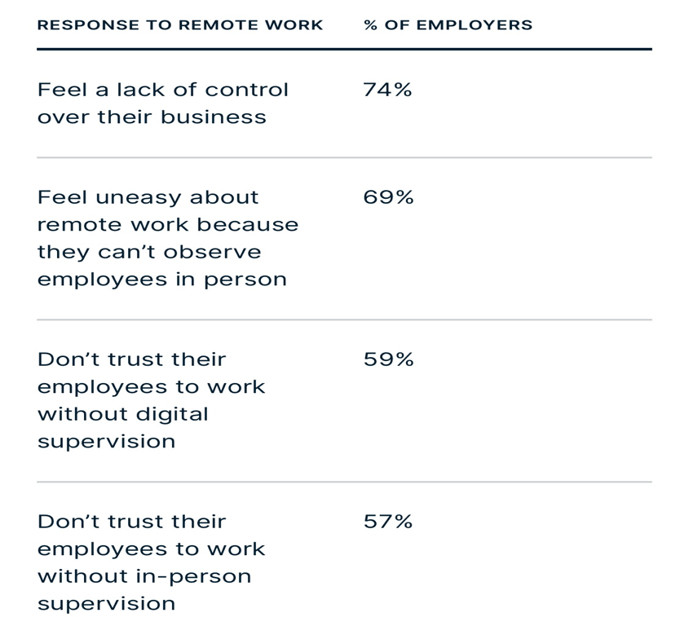

Reflection
Looking through all my research i have found that there are many advantages and disadvantages with remote work that can affect manager, employee and Companies overall satisfaction and productivity, whilst working remotely would be beneficial to most with advantages such as flexibility, cost savings and increased productivity, many would feel the disadvantages including high levels of stress, lack of productivity due to distractions and a poor work-life balance.
In my previous employment the main issue for myself was flexibility and the choice to work hours that would fit in with my family life. My manager at the time wasn't very accommodating and i therefore struggled trying to juggle both work and home life. This meant I wasn't able to stay at my previous job. I think had I had an opportunity to work at remotely this would have benefited me greatly and would have been able to stay at my place of work. Finding a balance between personal life and work obligations is a problem for many workers. Having an employer that is understanding and accommodating is beneficial for these employees.
As a future manager I would show empathy and consideration for my employees who have families at home. I would offer flexible work schedueles , work from home options and leave for any employees who have emergency situations at home. As a manager I would establish a channel for communication where my employees can voice their concerns and feel comfortable enough to approach me.

Conclusion
In conclusion, thoughtful preparation and awareness of the individual needs of each team member are necessary for efficient management of a remote team. Although working remotely has many advantages for both employees and employers, there are certain difficulties that must be overcome to guarantee success and productivity.
Establishing a cooperative and effective remote work environment requires a proactive and adaptable strategy in addition to open communication and assistance. A remote team can function just as well as those who work in an office setting if the appropriate tactics are implemented.
References
Anon
Year:2021 | container: Home of internet privacy | URL: https://www.expressvpn.com/blog/expressvpn-survey-survailance-on-the-remote-workforce/
Apollo Technical
Year 2021 | container: Apollo Technical LLC | URL: https://www.apollotechnical.com/working-from-home-productivity-statistics/#:~:text=Several%20studies%20over%20the%20past
Baruch Silvermann
Year 2020 | container: business.com |URL: https://www.business.com/articles/working-from-home-save-money/
Forbes
https://www.forbes.com/sites/theyec/2021/10/13/how-remote-work-can-increase-business-profits/?sh=4f7a113717b8
Jason DeMers
Year :2019 | container: Email Analytics: visualise your teams email activity (Gmail & outlook) |https:// emailanalytics.com/does-working-from-home-increase-productivity/#:

Lucy Mwangi, Caroline Boinett, Emily Tomwet and Dav Bowen. (2017. Effects of work life balance and employee's performance in institutions of higher learning: A case study of Kabarak journal of research & motivation

Pellegrini, E., & Rapp, A. (2021). Social isolation and stress: Their effects on productivity in remote work during COVID-19. International Journal of Environmental Research and Public Health, 18(2), 472. https://doi.org/10.3390/ijerph18020472.

Pwc |: year 2021|containerpwc|URL: https://www.pwc.com/gx/en news-room/press-releases/2021/pwc-future-of-work-survey-2021/html

RSPH |year2021 | container: www.rsph.org| URL: https://www.rsph.org.uk/about-us/news/survey-reveals-the-mental-and-physical-health-impacts-of-home-working-during-covid-19.html

Statista | URL: https://www.statista.com/stastistics/1139757/vs-distactions-while-working-from-home-during-coronavirus

Wang, j., Chen, Y., Li, x. (2020). Does telework stress employees out? A study on the impact of telework on psychological well-being. Personal review, 50(5) 1034-1050

