Theodor Adorno famously claimed that “to write poetry after Auschwitz is barbaric.” Choose a depiction of the Holocaust, and asses how successfully it engages with the complexities of representing genocide.

In this essay I intend on using my chosen depiction of the holocaust to explain how successful it is when engaging with the complexities or representing genocide. I intend on getting a better understanding of the holocaust, how people were treated, and the awful conditions that they endured through its duration. I then aim to use my chosen depiction to compare how well the points I have raised are represented. After recently visiting the Auschwitz-Birkenau Memorial and Museum I would like to use a combination of information that I recall from the tour guides as well as the information I have gathered from various sources as I have researched the matter in hand. These various sources include theatlantic.com, the website from which I choose my depiction of the holocaust. It also includes Laurence Rees’s book ‘The Holocaust: A New History’, which I shall refer to as a background reading as well as a website relating to the subject, and a book written by Jack Fischel named ‘The Holocaust’.
My chosen depiction:
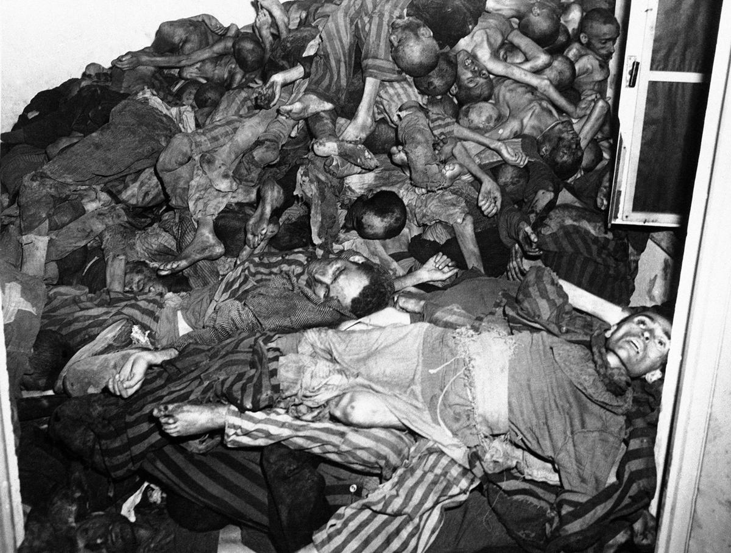
To begin with I would just like to give a brief overview of my opinion on the statement given by Theodor Adorno about writing poetry after Auschwitz and the fact that his opinion is that it is barbaric. In my opinion one must always consider the circumstances in which individuals are writing, it could mean rather a lot for sentimental reasons as well as feeling of hatred. The point I would like to make here is that if an individual was fortunate enough to survive the terrible conditions of the holocaust, the writing of poetry may be a way of them expressing themselves and the only way they can speak about their ordeal. I would imagine that many people who survived the holocaust do not like speaking about the things they experienced and find it useful to portray them in other mediums and depictions. This is down to the fact that the matter in hand is of an extremely sensitive nature with many of the survivors seeing several loved ones dying down to neglect, abuse, malnutrition, poor living conditions, illness and an extremely long list of other terrible reasons. Looking at the other side of the statement given by Theodore Adorno there is a possibility that there are various poets that have not actually experienced the trauma of the holocaust and are therefore merely just writing poetry based on facts, maybe even research and I believe that if the facts are correct, and they are mindful and respectful of what those people went through it is acceptable to write poetry based on the event. I mean there are various sources and depictions available that represent what was genocide from this area in history, some depictions are better than others and much more reliable than others.

Firstly, I would like to take to overview the holocaust it is describe on the BBC website as “the Nazis assault on the Jews between 1933 and 1945.” This fitting description of the holocaust being exactly what it was, although I do believe that many people today fail to appreciate how long before the second world war began that the Jewish communities had already endured suffering. There is evidence to support this in the book that I have previously mentioned in my introduction ‘The Holocaust’. The way it is described here is that the holocaust was evident resulting in the foundation of the Nazi party. The way it is put in the book is that “The founding of the Nazi party in 1920 transformed the German völkisch or radical antisemitism into a political movement, which had as its primary objectives the removal of Jews from Germany.”

I would now like to turn my attention towards the photograph that I have decided to assess and how it engages with complexities of representing genocide. I would like to explain where it is from and what it depicts exactly. The website where I came across this photograph is cited in the footnotes and specialises in the second world war, mainly the holocaust. The website contains several photographs of numerous happenings during the holocaust, however, this photograph left a mark in my memory. Having researched several different websites and numerous sources I felt that this depiction in a simple photograph stood out for me, the most likely reason that I have not forgotten this photograph is down to the fact that what it is depicting is most certainly disturbing. The website included a description underneath the photograph which read “Bodies lie piled against the walls of a crematory room in a German concentration camp in Dachau, Germany. The bodies were found by U.S. Seventh Army troops who took the camp on May 14, 1945.” When one considers how successfully this photograph engages with the complexities of genocide, I do not think it could be engaged in a much more successful way than it is here. The point I would like to highlight here is that this photograph is a case of what one sees is how it was. This photograph is one that has come from the time that this form of genocide came to an end, and what this photograph is particularly highlighting is what the people who helped bring it to an end were then dealing with. Firstly, when considering the content of this photograph, I would estimate that there are at least one hundred bodies featured in that photograph, I mean originally in the room that they were found, for them to be stacked against the wall to such a high extent I would estimate a hundred easily, give or take a couple. Secondly, despite there being many bodies in the photograph, it is also possible to see how poorly treated they look, each one looks undernourished and have a drawn look about them. When engaging with the complexities of genocide, seeing such a distressing photograph certainly makes one ask questions such as how did these people die? Are they victims of the gas chambers? What have they previously endured? I suppose one of the main factors that one should remember is that these people were most likely everyday folk prior to being taken to this camp and were possibly killed merely because they were Jewish. The fact that they have simply been dumped up against the wall and likely awaited cremation just shows how brutally these camps were operated and that the objective was to kill as many people as possible and make them suffer for as long as they could. When comparing this depiction of the holocaust and the objective that was genocide, I believe that it engages in a far more direct manner than other forms of depictions such as forms of poetry, art work, films and television episodes. Not that I am being disrespectful to these other forms of depiction, it is just personally I find these other forms of depicting the holocaust far more reserved in showing what took place.

When considering the complexities of genocide, this photograph I feel is quite self-explanatory, when considering what genocide is and what its aims are it is plain and simply a mass killing. Granted, this implies to different people in different ways in the respect of who is involved and how it will be done but, in this case, it was the Jewish citizen’s mainly, and the technique was to make them suffer in a concentration camp before they either died of illness due to the conditions or finally ended up in the gas chamber. What this photograph also depicts is that many of them are wearing striped pyjamas, what this demonstrates is that who you were and where you were from did not matter in this situation, again when engaging with the complexities of genocide this is another factor to remember, many of the people that were placed in the concentration camps were also numbered. This is not an unnoticed if one looks at different sources, most people were labelled with a number, which again showed nobody cared what your name was or what you did, you were simply there to be killed so that the Nazi’s could achieve their pure race and for racial and ethnic reasons only. In the book ‘The Holocaust: A New History’ by Laurence Rees there is evidence of the experiences of an everyday Jewish citizen who experienced going to the concentration camp in the prologue of the book. The way that it is written just shows how prejudicially Jews were treated it written as follows:
“To the Nazis, Freda Wineman’s crime was simple. She was Jewish. In May 1944, at the age of twenty, she was arrested in Saint-Etienne in France by collaborators belonging to the parliamentary Milice. Together with her parents and her three brothers she was taken first to the notorious holding camp at Drancy in the suburbs of Paris and thence to Auschwitz Birkenau in Nazi-occupied Poland. In early June 1944, the train carrying Freda, her family and nearly a thousand other Jews from France passed under the red-brick guardhouse of Birkenau and down a railway line directly into the camp.”
From the experience of Freda Wineman, we can get a better understanding of what might have happened to the individuals in the photograph. What can also be said is that the point I made earlier about those people being everyday folk is highly likely, for here we have a young girl who was arrested for no reason at all at the age of twenty. It raises the question of how many of the bodies in that photograph ended up that way under similar circumstances? Despite ending up in different camps, I would imagine that the experiences were very similar, and when considering how the photograph engages with the complexities of genocide it really portrays how absolute the procedure of genocide was. People who see this photograph may not consider how innocent the people feature in it were, the photograph may portray how evil and disgusting they were treated but until one considers the actual reasons why they were killed, one can then engage with how barbaric the photograph is. Another factor that one can not engage with by merely analysing this photograph when considering the complexities of genocide is the thoughts of the individuals as they arrived. Going back to the experiences of Freda Wineman to get a better a better picture of this point, she recalls a certain smell, one which was ‘awful’ is how it is described in the book, but what the book goes on to tell us is that Freda was still not aware of the purposes of Auschwitz-Birkenau. This just makes one realise how truly innocent and oblivious these people were and how this can probably engage with the bodies in the photograph. I mean how many of them would have realised at the time that the reason they were going there was to be killed as a part of a brutal genocide scheme. Having recently visited Auschwitz-Birkenau Memorial and Museum, I can recall there being words inscribed the gates of Auschwitz one if I remember correctly. These words were ‘Arbeit Macht Frei’ as can just about be seen from a photograph that I was permitted to take before entering the camp below:
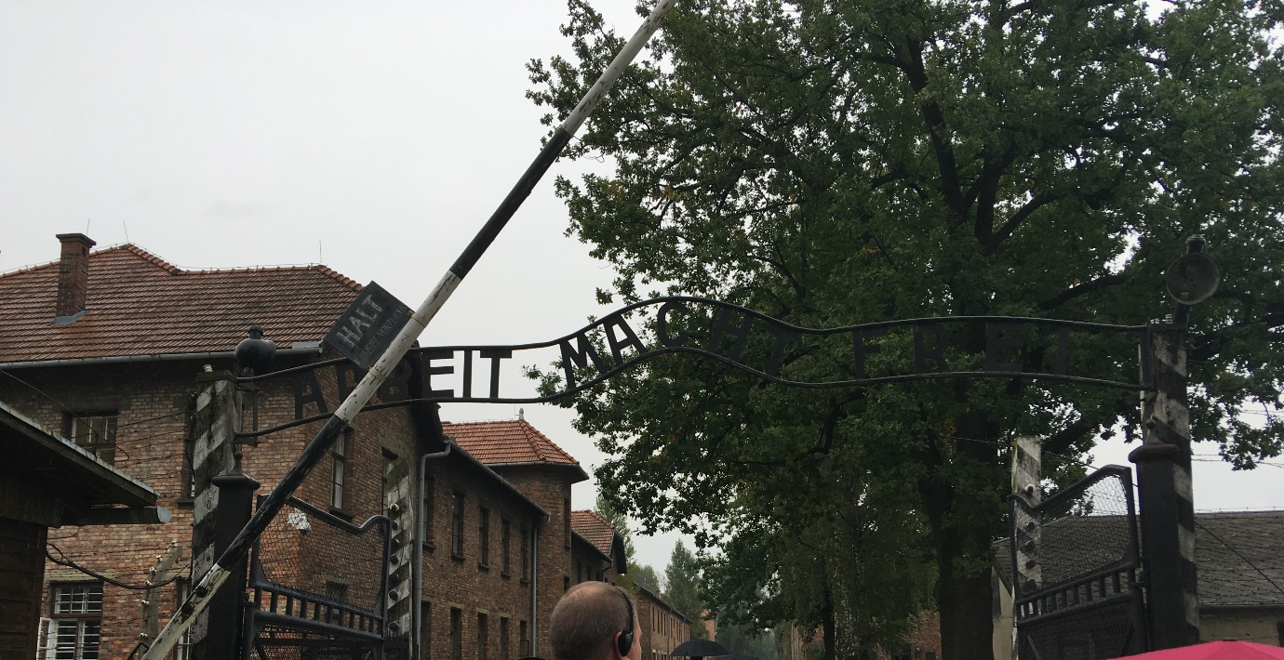

After having this sign pointed out to us by our tour guide, she then explained what the meaning of these words which were foreign to me at the time. The meaning being ‘Work sets you free’ in English if I recall correctly. From what I can remember from this part of the tour, many of the prisoners were mislead by this slogan, in the belief that if they worked hard and behaved themselves they would eventually be set free. Although Freda Wineman was taken to the much larger camp in Auschwitz, her book also has evidence that people believed this, the description and opinion given in the books says “The place was huge and teeming with prisoners. Perhaps the new arrivals would all be put to work?”. What the photograph that I have included of those bodies at the camp in Dachau reflects is the reality of the whole the holocaust. Whether or not the camp they were sent to would enforce the same slogan is not relevant, the people were only sent here for one reason, and one reason alone and that was to suffer and die, and that is one of the more successful aspects of the photograph and how it engages with the complexities of genocide. The photograph that I have included below is one of the many I was able to take during my tour of Auschwitz-Birkenau, the reason I have entered in this essay is to give an idea of some of the conditions in the camp. Believe it or not this would have been a sleeping quarters for hundreds of Jewish people, another point I would like to make here is that it is one of the better sleeping quarters when considering the conditions the people endured in camp two, having straw on the floor would be like having a luxury.
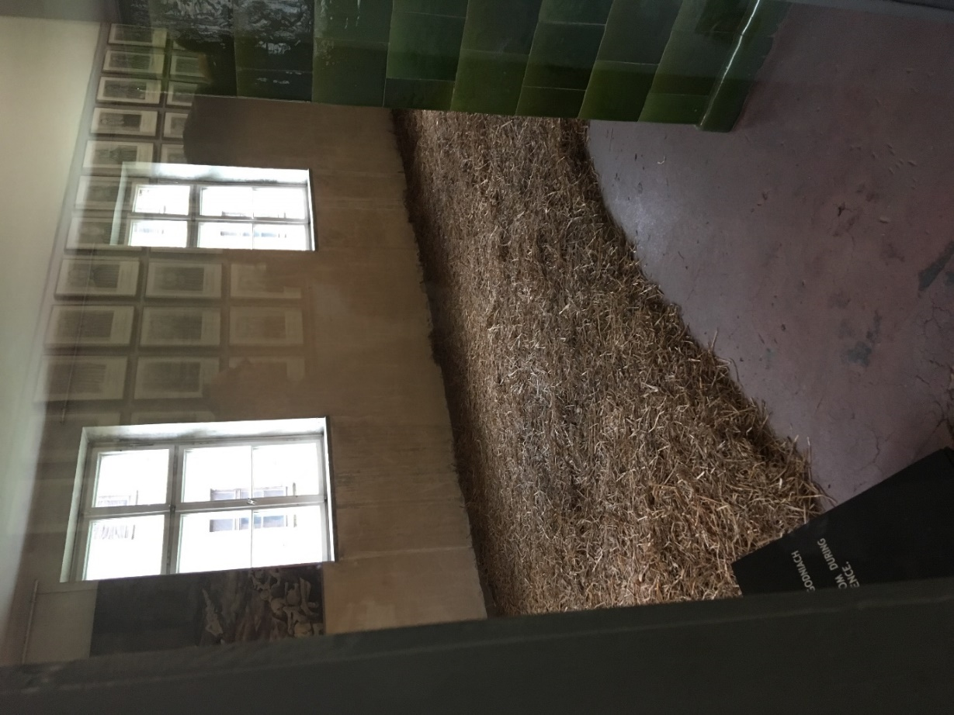
To conclude I would just like to make the point of when considering the complexities of genocide and how successfully different depictions engage with it, I believe it is a very grey area. From my research I suggest that it is a matter of opinion how depictions engage with such complexities. As I have previously mentioned some depictions are far more reserved others are far more direct, and it is up to individuals to decide which they consider to be engaging with the complexities of genocide. It is important to remember for individuals this is an extremely sensitive are to research. I mean for a moment, why not consider museums? One museum I visited whilst in Poland was the famous Schindler’s Factory. Without getting side tracked with the experience, the tour of this factory was an experience which made you realise how awful the Jewish people’s lives were during the holocaust. Therefore, I would suggest that museums can be successful when engaging with the complexities of genocide, especially if one is accompanied by a tour guide and has a reasonable understanding of the history. Personally, I would say that a direct depiction is the most successful way. It depicts that these individuals had suffered whilst they were living in the camp and were killed merely because of them being there and that they were not even given a respectful cremation or burial, they were piled up and pushed to one side. Another aspect that I would here like to point out is that when one assesses how successfully depictions engages with the complexities of genocide, one hopes that people consider that any forms of genocide that have been committed in the past is equally as horrific as the ordeal that was the holocaust, genocide can not be measured on how great or small it was or what techniques were used, it can be considered despicable worldwide.

Bibliography
Photographs
- Taylor, ‘World War Two: The Holocaust’, (oct 16 2011), Available: (https://www.theatlantic.com/photo/2011/10/world-war-ii-the-holocaust/100170/)

Books
J. Fischel, ‘The Holocaust’, (London, Greenwood Press: 1998)
L. Rees, ‘The Holocaust: A New History’, (London, Penguin: 7TH September 2017)

Websites
S. Paulsson, ‘A View of the Holocaust’, (http://www.bbc.co.uk/history/worldwars/genocide/holocaust_overview_01.shtml), (17/02/2011)

Taylor, A, ‘World War Two: The Holocaust’, (oct 16 2011), Available: (https://www.theatlantic.com/photo/2011/10/world-war-ii-the-holocaust/100170/), (Accessed 14/05/18}
Paulsson, S, ‘A View of the Holocaust’, (http://www.bbc.co.uk/history/worldwars/genocide/holocaust_overview_01.shtml), (17/02/2011) {Accessed 15/05/18}
Fischel, J ‘The Holocaust’, (London, Greenwood Press: 1998)
Taylor, A, ‘World War Two: The Holocaust’, (oct 16 2011)
Rees, L, ‘The Holocaust: A New History’, (London, Penguin: 7TH September 2017), Prologue.
Rees, L, ‘The Holocaust: A New History’, Prologue

