University of Wales Trinity Saint David

Digital Skills and Research Method

Assignment 2

Student’s Name: Abdul Alim
ID: 1706728

Teacher’s Name: Renuga Jayakumar

Table of Contents
Introduction: 1
Digital skills and Workplace improvement of Nestle: 2
Research methods for the Research Methodology: 3
Design and Strategy of the Research: 3
Sampling for the research: 3
Ethical consideration of the research: 4
Data collection and Interpretation: 4
Survey result with interpretation: 4
The findings from the survey questionnaire how Nestle will use digital skills to improve customer’s satisfaction: 9
Conclusion: 9
Recommendation to improve workplace using digital skills at Nestle: 10
References 11
Appendix: 12

Introduction: In the current age of technology, digital skills are required by every employee whereas the employers are reporting that the new starter has a shortageof digital skills. Digital skills are shortly described as someone’s ability to access both the information and methods of communication using technological tools such as Smartphone, tablets., laptops, and desktop etc. Digitals skills are valued highly in all the work currently and this is also expected that these skills will be vital in future for all level of the workplace(Ferraro, 2012). These digital skills are not required by the IT firm only, almost all of the workplaces need employees how to have better digital skills. This report will cover the necessity and belongingness of digital skills with the employees of Nestle to improvethe workplace performance to get customer satisfaction. The company has targeted that it will provide better product and service and it will use digitally skilled worker in the workplace to get customer satisfaction. Thus the report will identify whether digital skill will improve the workplace to get customers satisfaction.

Digital skills and Workplace improvement of Nestle:
Here the customer’s experience refers the involvement of the customers by different level such as by emotion, rational, sensorial, physical, spiritual etc. The company has to keep in mind to serve the customers both directly and indirectly. Nestle will have the idea about the impression of the customers while the customers will come to the company to purchase goods, this is the direct contact of the customer with Nestle. The customers also make indirect contact with the company while the company advertises their products and service through the newspaper, an online portal and social media(Van Deursen, 2016).Therefore, the background of the research has been set whether the digital skills will be able to improve the efficiency of the workers as well as the workplace of Nestle. Using the digital skills the improvement of the employees and the workplace will be judged through survey and interview. Whether and how much the improvement have been taken place will be determined the result of survey and interview will be interpreted and also the customer satisfaction will be determined.
Here the concerned organization Nestle is going with its slogan “Good Food, Good Life”. The company is currently holding more than 2000 brands, 323000 employees, and operation in 189 countries, 413 factories in 85 countries, and sales 89.8 billion in 2017. This company has been exploring its excellence since last 150 years. The workplace with digital skills will be analyzed in this report through interview and survey.

Research methods for the Research Methodology:
Design and Strategy of the Research: The underlying research will be done through both the quantitative and qualitative methods. The quantitative analysis will be done by analyzing the market and statistical data and also by trend analysis. From the quantitative analysis, the experts will find out the exact figure which will interpret the result, whether this is positive or negative in for that organization. For this report, the quantitative analysis will be done by taking market data by asking for the customer's experience with the products and service of Nestle. By analyzing the market, the roles of digital skills used and the requirement for the company will be determined. The company has an operation in many markets (Ferraro, 2012). To analyze all the market is a matter of a long time for that reason the study will be done by focusing 50 random markets of different countries. Based on the customer's speeches the result of the survey will be shown using a pie chart. In that chart, this will be shown that how many customersare satisfied with the workplace of Nestle in terms of digitals skilled worker, and how many believe Nestle need more digital skilled workers to improve its workplace.
There will also qualitative analysis to make the research rigorous to find out the roles of digital skills to improve the workplace. The qualitative research is done to figure out the human behaviour and the reason for such behaviouron a particular circumstance. How digital skills can improve the workplace, the idea can be found by analyzing the current workplace environment of the company and also finding out the lacking in that workplace (Johnson, 2011). To find out the idea of digital skills within Nestle, the employees will be interviewed. The interview session will be done to find out the current workplace environment and the roles of digital skills to improve the workplace.
Sampling for the research: While taking data for the research, reasonableness has been considered to find a practical result. The data has been taken on the basis of random sampling the magnitude of data is so vast and the study will go against any reasonable result (Ashmore, Grogg& Weddle, 2012). Thus to make the study observable random sampling has been done to get the customers experience from different market 50 people are taken as a sample. While making the sample any exceptional data such as the market where the company is only the loyal brand has been taken into consideration.
Ethical consideration of the research: To be free from all kind of biases data has been collected from the very confidential source and also tested by wisdom. Proper privacy has been maintained while collecting information from different parties (Johnson, 2011). To avoid all the legal complications the rules and regulation have been maintained while collecting data. As the research the sources and the participants of the data, all are unconditional. Therefore, ethics have been maintained properly in this research.

Data collection and Interpretation:

Survey result with interpretation:
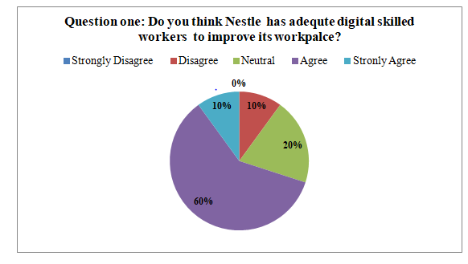
The company has been operating for more than 150 years so it must have efficiency in its workplace. The company has the record to keep a close connection with its customers using social media and another communication channel. Among the 50 participants 30 people believe that the company has enough digital skilled worker and they trust that is the reason the workplace of Nestle is so improved and thus it offers so quality products(Ashmore, Grogg& Weddle, 2012). In this regard, the workplace with digitally skilled workers has been compared with the workplace where the workplace has been less digitalized.

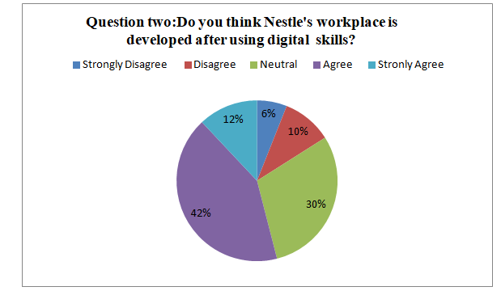
42% people off 40 have said that this is digital skills which make the workplace so improved of Nestle. Many othershave said that the workplace improvement just depends on the digital skills rather the attitude and characters are also important to improve the workplace(Page & Thomas, 2011). The participants have said that Digital skills are just system and the human being has to operate them. There is the operator has no idea about the skills and if he has any bad intention, he might do something harmful to the organization. A study has shown that the UK should have still at least 740000 digital workers in the workplace to have 13 billion in the economy.

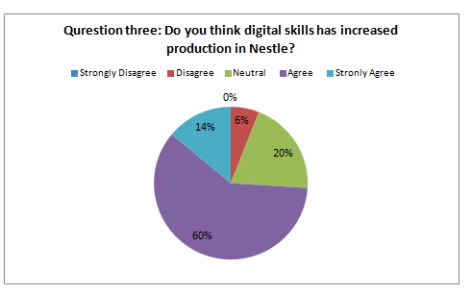
In the earlier, the company has to use manual labour to produce any goods which was much time consuming and costly. Using digital skills just putting input intothe machine the company can now produce a huge volume of product within a very short time, so digital skill has increased the production of the company. 60% people have complete faith that the company has increased its production while production has been done through using digitals skills (Johnson, 2011). The skills gap between the employees and the problem the company is facing are also to be considered to improve the customer satisfaction.The skills gap between the employees and the problem the company is facing has been considered to improve the production.

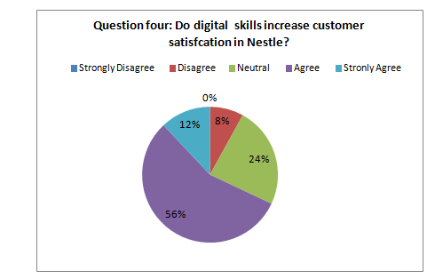
The 56% people of the survey believed that the company has increased its satisfaction in that vast level using digital skills. The company has appointed employees who do the jobs to answer the question of the customer through online and offline, which increase the connection of the company with its customers. This is also helpful for the company to know the heart of the customer to serve them accordingly to increase the customers’ satisfaction (Van Deursen, 2016). The employees have said that all the employees of the company have clear basics to work with Nestle such as using email, social media, the detail about the company website to make people aware of the company. Theybelieve if the company can avoid the misunderstandings in communicating with the employees using social media, email etc digital skills will improve the workplace truly for the employees which will work for customer satisfaction.

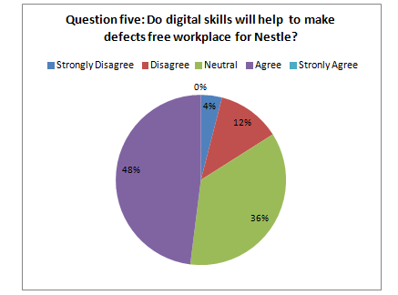
As the technologies are used by the human beings, this cannot be said that digital skills itself will make any workplace defect free. 36% people keep themselves neutral on this question as its the human being who will run the system (Ashmore, Grogg& Weddle, 2012). If the person is defect fee the digital skills will be used perfectly that will ensure the defect-free workplace.
For doing the qualitative research, the research team has talked to the employees of Nestle to get the idea about the workplace environment of the company. The employees have confessed that the company has been using the latest digital skills to expand its operation all over the world. Once again the country is now inthe growth stage. Therefore, the company has no need to use digital skills for branding rather needs to do the daily operations using proper digital skills so that the efficiency and excellence are ensured.

The findings from the survey questionnaire how Nestle will use digital skills to improve customer’ssatisfaction:
Based on the information taken from the employees as well as the customer, this is to be concluded that the company has been using digitals skills to get the marker coverage, as well as they,make the employees efficient. Now the company needn’t go to the distant part of the world where it has set its outlet to get the news about how much product available at the store and what is the level of demand on that market. The company now can control all of it's from the main office(Johnson, 2011). It can make all the impressive advertisements using digital skills in SocialMedia, online portal etc. Using digital skills the company has made an efficient website from where the customer can get all the details, thus the digital skills contribute a lot to getting customers satisfaction.
Conclusion: The uses and necessity of digital skills have been too vast to describe in all types of the workplace for the current era of technology. In earlier, the organization uses the plain note to keep a record of the performance of the organization. The calculation was also very traditional and slow. In the current era, everything has been changed from taking an order of product to make the delivery. All the companies are using laptop, tablet, desktop to design the product, to connect with the supplier; machines are used to produce products (Ferraro, 2012). In fact, manual labours are hardly used to do anything in this 21st century. The record of the huge volume of trade, the record of customers, debtors etc all is now recorded inthe company database. Nestle is that much big company, it was totally impossible for being like in today’s position without implementing digital skills.

Recommendation to improve workplace using digital skills at Nestle:
- Digital skills are used to keep connected with all the parties of the company so the productivity of the company will definitely increase.
- Digital skills such as creating an efficient website the company can keep itself connected with the customers always which will improve the customer experiences and customers satisfaction.
- By creatinga database, the company can keep data of thousands of customers and give notifications about new products, offers, discounts etc thus digital skills will help to increase the sale of the company.
- Using social media the company can get the customer concentration which willincrease new customers for the company.
- Digital skills make able the employees work even from outside the factory and they are also supportive of the company culture.
- One of the most important facts is that for sharing information to the stakeholder, appropriate tools should be used in an appropriate way so that no misunderstandings arise.
- In recent time losing information for being hacked the website, database etc by other is the common phenomena, therefore the company has to create a database with proper security.

References
Nestle, (n.d.). Brands | Nestlé Global. [online] Available at: https://www.nestle.com/brands [Accessed 2018].
Blackstone, W. (2010). Commentaries on the laws of England, in four books. [Place of publication not identified]: Nabu Press.
del Río, M. and Strasser, K. (2012). Preschool Children’s Beliefs about Gender Differences in Academic Skills. Sex Roles, 68(3-4), pp.231-238.
Ferraro, E. (2012). Investigations in the workplace. Boca Raton, Fla.: CRC Press.
Johnson, R. (2011). Security policies and implementation issues. Sudbury, Mass.: Jones & Bartlett Learning.
Lanier, L. (2010). Professional digital compositing. Indianapolis, Ind.: Wiley Pub.
McDonald, L. and Goergen, T. (2017). EVALUATION OF KNOWLEDGE MOBILIZATION IN GERONTOLOGY: DIGITAL TOOLS, PAPER TOOLS, OR BOTH?. Innovation in Aging, 1(suppl_1), pp.626-627.
Page, R. and Thomas, B. (2011). New Narratives. Lincoln: University of Nebraska Press.
Perlitz, L. (2015). Professional Business Skills. Melbourne, VIC: Cengage Australia.
Radovanovic, D. (2012). Digital Divide and Social Media: Connectivity Doesn’t End the Digital Divide, Skills Do. SSRN Electronic Journal.
Sejnost, R. (2009). Tools for Teaching in the Block. Thousand Oaks: SAGE Publications.
Tapscott, D. (2009). Grown up digital. New York: McGraw-Hill.
Van Deursen, A. (2016). Digital skills. [Place of publication not identified]: Palgrave Macmillan.
Vaughan, W. (2012). Digital Modelling. Berkeley, Calif: New Riders.

Appendix:
Questions | Strongly disagree | Disagree | Neutral | Agree | Strongly agree
Do you think Nestle has adequate digital skilled workers to improve its workplace? | 2 | 5 | 15 | 22 | 6
Do you think Nestlé’s workplace is developed? | 2 | 5 | 13 | 22 | 8
Do you think digital skills have increased production in Nestle? | 0 | o | 10 | 30 | 10
Do digital skills increase customer satisfaction? | 0 | 3 | 12 | 28 | 7
Will digital skills help Nestle to make defects free workplace? | 2 | 5 | 18 | 20 | 5

