University of Wales Trinity Saint David
Wales Institute of Science & Art

Technical Report Writing
Academic Skills (ACHA4005)

Isaac Revans
2304556
November 2024

Introduction
Within the world of motorsport carbon fibre has evolved and become a standard for both safety and performance. It has evolved through years of research and become the main material used within many motorsport racing series to this day. The following sections analyse the growth or carbon fibre and its popularity increase within the world of racing.

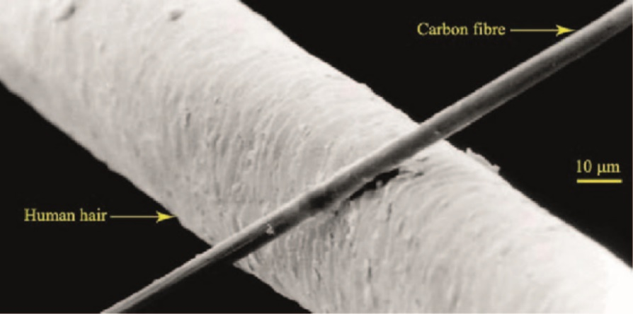
Carbon fibre is a polymer composed of strong filaments of carbon that are securely bonded together, forming a high strength structure. These fibres average between 5-10 micrometres (see figure one) in diameter, with them being pure carbon with little to no impurities. Once made into the lattice sheets, it is easy to shape around moulds, allowing it to be designed and shaped for specific purposes (1). Carbon fibre is known for its strength and lightweight, making it perfect for its use within motorsport, where weight is a very important factor. In Formula One roughly 10 Kilograms can make up for around 0.3 seconds in a lap. In a sport where they are fighting within milliseconds of each other weight is a very important factor. With its great fatigue and corrosion resistance, it makes a great material for a shell of a race car.
Figure 1
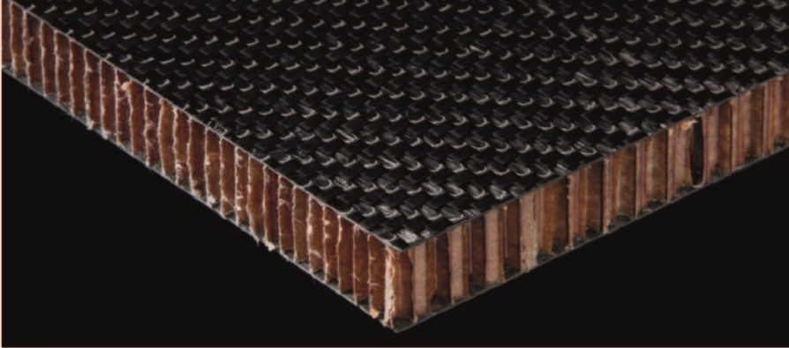
It was first implemented in formula one with the Mclaren MP4/1, being the first full carbon composite monocoque (2). This helped inspire other teams within racing, and by 1983 Ferrari had made the first full carbon structure formula one car. Today about 85% of formula one cars composite components are carbon fibre. Because of its reliability and great strength to weight ratio it is now the main material used within the helmets and cockpits within formula one. It can be combined with other materials such as Nomex honeycomb to create a composite sandwich (see figure 2) for additional strength to be utilised within the cockpit and other intrusion panels.
Figure 2
Carbon fibre is not always used within motorsport because of its high costs and the environmental concerns behind its manufacturing. Porsche have launched a 718 Cayman GT4 CS MR with a full natural fibre bodywork kit (3). Transferring to a lower carbon-emitted alternative materials offer additional benefits including improved vibration dampening, and they are safer in a crash because they tend to fracture without sharp splinters, unlike carbon fibre which tends to shatter. Flax fibre has become the new natural alternative fibre. Bcomp’s innovative new ampliTex and powerRibs technology are bringing a new view into sustainability within motorsport and the materials around it (4). They have designed a new car for Extreme E with 100% sustainable panelling. Theophile Gouzin, technical director of spark racing technology stated “Bcomp’s natural fibre technologies are a perfect match for the goals we set for ourselves in Extreme E” (5).
Where these sustainable alternatives are a renewable and have a lower environmental footprint, the Carbon fibre lacks due to its non-renewable resources and lack of recyclable ability, contributing to environmental concerns. Unlike the flax fibre which is biodegradable. The flax fibre also tends to fracture and break in a safer manner reducing risk upon impact for both the driver and additional damage to the vehicle. However, for the main use within motorsport carbon fibre is still a headstrong choice within the industry due to its large tensile strength and durability.

References

Bcomp. (2020). Porsche Uses Sustainable Alternative To Carbon Fibres For Nürburgring 24h Race. [online] Available at: https://www.bcomp.com/news/porsche-uses-sustainable-alternative-to-carbon-fibres-for-nurburgring-24h-race/.
Bcomp. (2021). Extreme E Embraces High-performance Natural Fibre Composites. [online] Available at: https://www.bcomp.com/news/extreme-e-embraces-high-performance-natural-fibre-composites/.
Editor, G.H.-D. (2019). How are composites used in motorsport? [online] Racecar Engineering. Available at: https://www.racecar-engineering.com/tech-explained/how-are-composites-used-in-motorsport/.
piran composites (2023). What is Carbon Fibre? - Piran Composites. [online] Piran Advanced Composites. Available at: https://pirancomposites.com/news/what-is-carbon-fibre/.
www.motorsport.com. (n.d.). F1: The McLaren that changed Formula 1 history. [online] Available at: https://www.motorsport.com/f1/news/the-car-that-changed-formula-1-history/4779400/.

