

MODULE CODE/ COD Y MODIWL: EMPL4011
SMART TECHNOLOGY IN THE WORKPLACE

Programme | Certificate of Higher Education in Skills for the Workplace
Lecturer | Renuga Jeyakumar  Ze Zook  Anly Vathana  Gurunathan Srinivasan
Assignment Title | Smart Technology in the Workplace
Student Name | Ida Sley
Student ID | 1605823

Table of Contents
Introduction 3
Part 1: Evaluation of the appropriate use of technology to improve workplace efficiency and employability 4
Cloud Storage: Google Drive VS Dropbox 4
Smartphone VS Tablet: iPhone X VS iPad Pro 6
Part 2: Demonstrating the appropriate use of technology and its applications in the workplace 8
A. Creating own professional accounts in several social media 8
B. Evaluating the possibilities for communication and collaboration in the workplace and appropriateness in safeguarding personal and professional security and safety online 9
Conclusion 10
References 11

Introduction
Organisations are changing rapidly with the changes and development in modern technologies. Modern technology in information and communication is a new dimension and blessing for organisations in this era of the digital globe. It is creating a net for working people in a frame. Cloud service for unlimited space without bearing any extra gadget; Smartphones and tablets for having all the digital facilities in hand for all the time (Melissinos, 2017). Mail services like Yahoo, Gmail for instant messaging with attachments from any corner of the world; Social media platforms like Facebook, Twitter connecting people from anywhere, any border, any class, any genre. With these facilities, employees are connecting with each other very easily, getting done with work quickly and finding joy in work. Online security is another inspirational reason for using modern technologies in the workplace.

Part 1: Evaluation of the appropriate use of technology to improve workplace efficiency and employability
If it comes in talking about technologies using in the workplace for increasing efficiency and employability then it must come to the smart devices are being used nowadays. Almost everyone is using smart technologies and devices in hand for making life more flexible (Deane, 2017). I’ll be choosing one smartphone iPhone X and one tablet iPad Pro for demonstrating their capabilities in making our daily professional and personal life better and easier. On the other side, cloud storage is another innovation of technology that is reducing our time in sharing files from one place to another at a glance. In this sector, I’ll be choosing Google Drive and Dropbox to demonstrate their facilities.

Cloud Storage: Google Drive VS Dropbox
Criteria | Google Drive | Dropbox
Storage Capacity | This cloud storage by Google is initiative free for its users. One must have a google account to use this drive. Initially, google drive gives 15 GB free storage to every user. Then one can get 100 GB starts for €1.99 monthly. Following to 200 GB, 2 TB, 10 TB, 20 TB and 30 TB paid plans. Drive under this plan is called Google One. | Dropbox can be used by opening an account in dropbox through any kind of mail id. Initially, Dropbox gives 2 GB free only. Which is very uncountable at working size or even attracting user for it (Benson and Morgan, 2017). And then it starts from €9.99 monthly for 1 TB. Then again it has 1 TB professional, 2 TB professional and 2 TB business plans. And those are high cost.
Capable Devices | Google Drive a file sharing online or cloud storage has both online and offline offers. It is capable to work in Windows and macOS computers, and iOS and Android devices. | Dropbox is capable to work in Windows and macOS computers, and iOS and Android devices. Dropbox has also the capabilities to work in windows phone and Linus computers.
Pop Up Ads | Google Drive has many third-party apps and pops up news and advertisement during online activation. | Dropbox does not have any third party apps and pops up news and advertisement during online activation.
Flexibility | Google Drive is very flexible to use. It does not have any complex operating function. Simple filing, easy to upload, offline saving and secure file sharing (Quigley, 2017). Every uploaded file has a web link. One can just copy and share with others. | Dropbox has the direct sharing facility form the folder instant. It does not require copying web link, making it public then paste the shared link with others to complete sharing a file or folder. So it is a bit easier and faster than other cloud storages.
File Sharing | Uploading files are comparatively slower than Dropbox. It is a heavyweight to upload a file of more 1 GB. But aftermath, sharing the web link to get the file is easier. One can download or stream online to see the attachment in a few moments. | Uploading files or folders are comparatively less timing and smoother than Google drive. It has super speed in uploading and even downloading. Fast speed is one the reasons for Dropbox's excess costing.
Security | Google drive has a weak security system. Though it has the facility to remain one's files secret until that body does not make it public. But it has an automation system for reading caches and serving ads according to browsing tastes in front of your monitor. | Dropbox has tight security for its users. As it does not have any master engine machine who controls the whole web. So, it does not have the need or interest to read caches from users’ device and providing offers according to them (Wheeler and Winburn, 2016). It does not show any advertisement as well.

Smartphone VS Tablet: iPhone X VS iPad Pro
Criteria | iPhone X | iPad Pro
Storage Capacity | iPhone is a signature creation of Apple Inc. iPhone X is the latest model from last year. It has a total internal memory of 256 GB with 3 GB RAM. iPhone does not support any external memory installation (McDevitt, 2016). | iPad is a professional dimension by Apple for its professional users in various fields. Especially for the artists, iPad is a name of an easy and reliable trust. iPad Pro is the latest segmentation. It has a total of 512 GB internal memory with 4 GB RAM for operation.
Battery Backups | iPhone X has a fast charging battery of 2716 mAh with fast charging built-in Qi. It gives 21 hours of 3G talk time backup, 6 hours of internet using backup, 60 hours of music playback backup, 13 hours of video playback. | iPad pro has a powerful battery of 8134 mAh with fast charging capacity. It gives 10 hours of internet using backup, 60 hours of music playback backup, 13 hours of video playback.
Features | iPhone X is a mega experience with high sensors, notification bar, best audio, video, capturing power. Apple A11 bionic chip has been used for the best experience. 7 mp front and 12mp rare cameras. The OLED display and HDR video support. Exciting face recognition feature for phone unlock. | iPad Pro is a totally satisfying device for professional users. It has an IPS LCD display. The single-camera of 12mp. Quad LED flash facility. Fingerprint touch for unlocking the device. Apple A10X Fusion chip. High performance in creating art, smart mailing, mixing sound, editing videos and arts.
Operating system | iPhone X operates with Apple's own operating system. Which is called iOS (iPhone operating system). Random software update and apps update to keep the experience smooth. | iPad pro operates with Apple's built-in operating system called iOS (iPad operating system). Random software update and apps update to keep the experience smooth.
Flexibility | iPhone X is very flexible and comfortable in using. It has a dimension of 6.65×2.79×0.30 inches which is very thin to hold. And it weighs only 174 grams. It is completely water and dust resistant. App store is the main flexibility for iOS users. It is so easy to get apps for free and paid. And random update keeps the experience up to the mark. | iPad Pro is very reliable and convincible in using. It has a dimension of 9.87×6.85×0.24 inches which is very thin and dashing in look. It weighs only 477 grams. It does not have water and dust resistance. App store is the main flexibility for iOS users. It is so easy to get apps for free and paid. And random update keeps the experience up to the mark.
Purpose | iPhone X is mainly created for the ultramodern experience of a mobile phone. Which does have full security, antivirus facility, solid working RAM; high tech audio, video and picturising experience? High cost for full satisfaction. | iPad pro has created for all in one experience for the professional employees and artist. It has the dimensional look and high-speed working capacities with all the necessary features one may need (Shaffer and Simon, 2016). Make life better and smaller in one hand is their target value.

Part 2: Demonstrating the appropriate use of technology and its applications in the workplace

A. Creating own professional accounts in several social media
According to the requirement I have created accounts in some social media platforms like Facebook, Twitter and LinkedIn. Screenshot and the profile links of those accounts are given below:
Facebook Link: https://www.facebook.com/idasley.sley
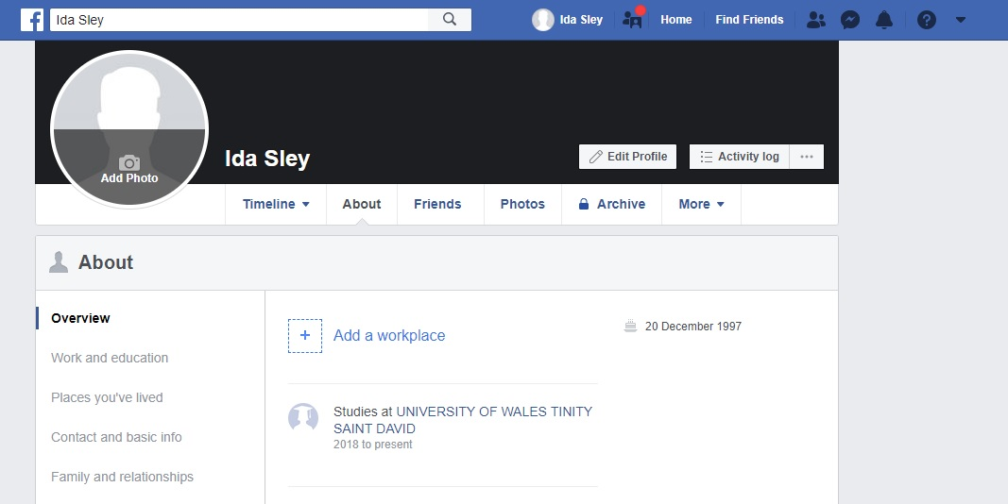

Twitter Link: https://twitter.com/SleyIda
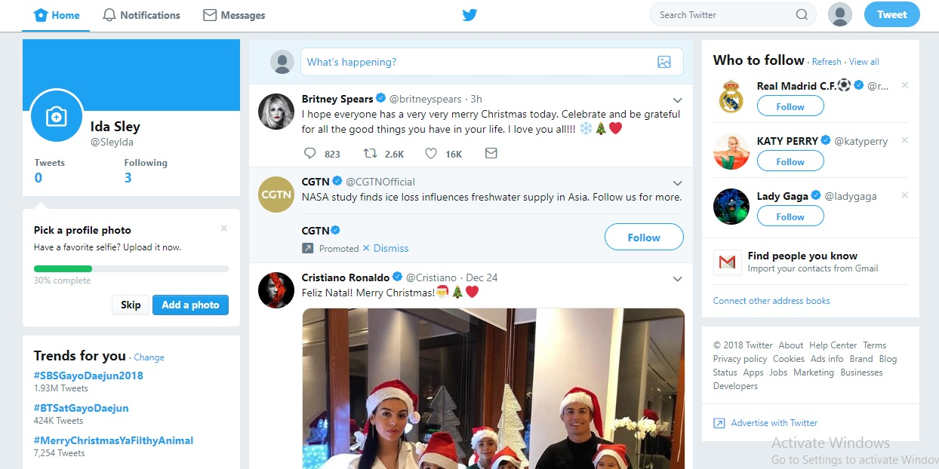
LinkedIn Link: https://www.linkedin.com/in/ida-sley-b33594178
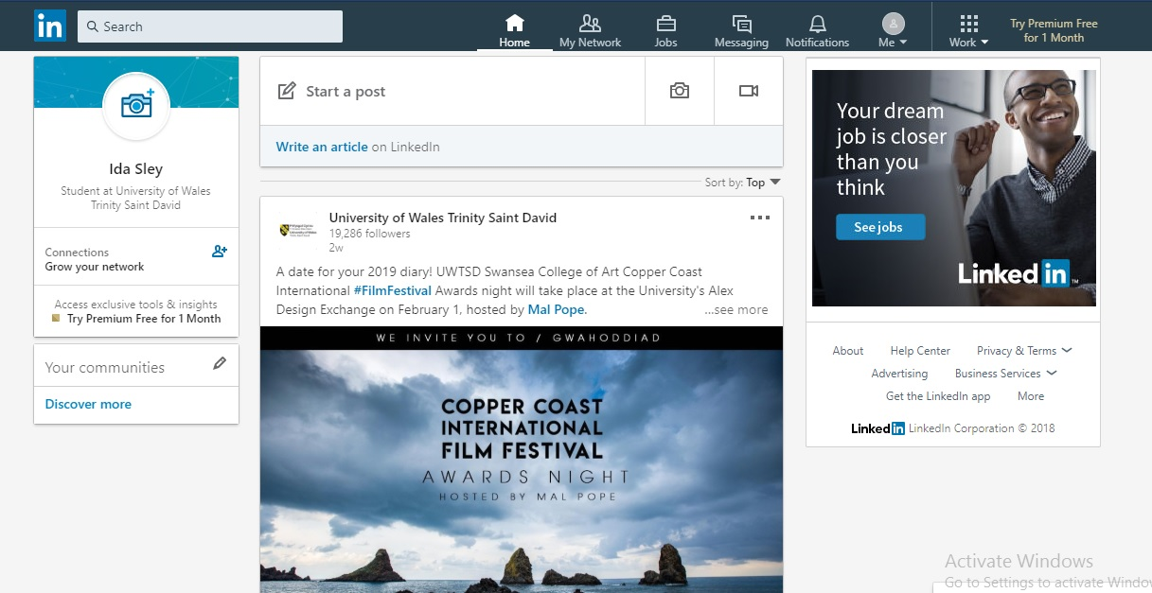

B. Evaluating the possibilities for communication and collaboration in the workplace and appropriateness in safeguarding personal and professional security and safety online
Communication and collaboration in the workplace through social media: Social media has made the communication and networking system vast open. Through this mediums, people from any border getting close and in touch. Recently the rapid advancement of technology has changed the total scenario then existing. It has crossed the border from personal interaction to professional. Popular social media like Facebook, Twitter, LinkedIn, and Instagram are providing easy actions and privileges to business organisations for connecting people through online marketing (Shaffer and Simon, 2016). Especially through the Facebook messenger, employees are keeping their communication from any border of this world. This is helping immensely for standing against any problems instantly. For example, the employees of O₂ use Facebook messenger for keeping contact and communication internally. Mail is for formal approaches but for internal relation between co-workers, even some short notices which is bothered and boring as formal notices are sent through messenger texts. Using this technology employee of O₂ can solve simple or big problem discussing smart technologies through text or video conference at anywhere, anyplace. Even on vacation one can attend virtually in an emergency.
Safeguarding personal and professional security and safety online: At the working time, employee and executives share so many files internally or externally for work purpose. So, in this modern era, everyone uses cloud storage for sharing online. This cloud storage facility has brought a rapid revolution in business. It saves time and money at a time for sharing any file, folder in a few seconds from one corner to another (Benson and Morgan, 2017). But it has a risk to be hacked those social platforms to thief the information. So users need to aware of this risk and should protect their data very time while sharing or working. For this several tools and settings are available in technologies which are being used. For example, someone has shared his personal information on Twitter. Personal information includes certificates, emails, contact numbers, check-ins etc. Confidential information can be harmful to important personas. And with the general information like the background, emails, contact numbers many hackers can find out personal accounts and can blackmail for financial benefits. So one needs to be very careful all the time, for acknowledging the steps and always protect data at best possible.

Conclusion
Modern technologies are complete blessings for a new generation. Technology has made personal and professional life much easier and flexible. It is more time and energy saving. Technology is a matter of continuous upgradation for providing its users more comfort and joy (Benson and Morgan, 2017). So the visible tools those making our life better must be coming in advanced mode and will be serving advanced facilities to make our life one more degree flexible. It is obvious to say that every creation has pros and cons at the same time. But the blessings of modern technology has crossed the border of thinking cons. Making the best deal with it is the smart option.

References
Apple (UK). (2018). Buy iPad Pro. [online] Available at: https://www.apple.com/uk/shop/buy-ipad/ipad-pro [Accessed 25 Dec. 2018].
Baker, R. (2017). Computer security handbook. Blue Ridge Summit, PA: TAB Professional and Reference Books.
Benson, V. and Morgan, S. (2017). Implications of social media use in personal and professional settings.
Breeding, M. (2016). Cloud Computing for Libraries. Chicago: ALA Editions.
Cloud storage. (2016). [Place of publication not identified]: Betascript Publishing.
Deane, Q. (2017). Inside modern technology. London: Marshall Cavendish.
Li, W., Yang, Y. and Yuan, D. (2017). Reliability assurance of big data in the cloud.
Low, D. and Pittaway, A. (2016). The ‘iPhone’ induction – a novel use for the Apple iPhone. Pediatric Anesthesia, 18(6), pp.573-574.
McDevitt, M. (2016). Why Google Drive?. Editorial Office News, 9(6), pp.11-12.
Melissinos, A. (2017). Principles of Modern Technology. Cambridge, GBR: Cambridge University Press.
Quigley, M. (2017). Encyclopedia of information ethics and security. Hershey: Information Science Reference.
Shaffer, S. and Simon, A. (2016). Network security. Boston.
Wheeler, A. and Winburn, M. (2016). Cloud storage security.

