IMPACT OF VIRTUAL LEARNING ENVIRONMENT
Table of Contents

1. Introduction 3
2. Background 3
3. Aims and objectives 5
4. Method 6
5. Results 6
6. Discussion 12
7. Conclusion 13
References 14

1. Introduction
The paper will present the impact of VLE, that is Virtual learning environment, in respect to the learning process of University of Wales Trinity Saint David London Campus. The impact of the VLE on different students will be recorded with a questionnaire. The perception of the students in the Virtual learning classes, its advantages and the disadvantages will be discussed based on the responses made on the questionnaire. The learning regarding the impact and importance of VLE will be undermined through multiple literary sources and the analysis will be made clear with the responses of the students. By analyzing the research, a recommendation and future analysis will also be given in respect to the findings. The differences found in the collected primary and secondary data will be evaluated and the comparison will be considered in generating the conclusion of the paper. Thus, the paper will conduct primary and secondary research both with help of questionnaire and literature analysis.

2. Background
Literature Review
The impact of Virtual Learning Environment is different for people in regard with the availability of technology, the learning procedure of the faculty, the learning process and the environment that the professor or the administrator can create in inferring involvements of students. Thus, students have different perceptions in this. As observed by Lyndon and Hale (2014), through virtual knowledge students are not able to develop their appropriate social knowledge and enhance appropriate peer to personal development. As observed by Bogusevschi, Muntean and Muntean (2020), this impacts in less interaction which is incapable of generating proper development and insight towards the society and responsibility towards the environment and might impact in social withdrawal due to lack of interactions.
However, Tsay et al. (2020), have observed that, blended use of virtual learning has the essence of impacting on the learning process of the students and make worth to the universities situated in the UK. In respect to University of Wales Trinity Saint David London Campus, the students have attained the module learning process and the satisfaction of them emerges through the flexibility they attained. The e-learning classes have a huge flexibility for students to join classes and do not need any specific etiquette regarding dresses and gestures to be followed. It has efficiently saved the time of the pupil too. On the other hand, the e-learning materials are also very accessible for the users like google meet platform joining or the joining of classes through Teams can be accessed easily in case people have a proper network connection. Furthermore, Tsat et al (2020), stated that VLE develops efficient community sense in both staff and the students by reducing the inefficiencies of engagement and helps in generating confidence in the students and enraging the engagement as well. However, the measurement of success in students with VLE remains undecided as it lacks the parameter to undermine if the process is scant.
As assessed by Blin and Munro (2008), the gamification of learning has a mixed impact in the learning of the students. The Gamification of learning is said to be a limited formative research type that lacks the characteristics of underexplored users. This VLE that is the gamified VLE has been developed to address a different learning system and procedure for the students, and it has eminently impacted in increasing the involvement and engagement of the students. This further impacted in reducing the tendency of being involved in a learning system that is completely assisted by computers. This gamification of learning is further regulated to the perception of the students in intrinsic and extrinsic manner.
As asserted by Hanson, Andersen and Dunn (2020), the implication of this intrinsic as well as the extrinsic learning can also be effective for people in the sense it brings coherence, meaning in the engagement initiatives for the students and helps in overcoming the issues that are predominant. E-learning has the efficiency in transforming as well as disrupting the practices of teaching that will lead students towards higher education. This incorporates opportunities regarding the flexibility and adaptability of students in a homely atmosphere. As stated by Herrera Mosquera (2017), multiple e-learning and training approaches have also been generated to help students feel the process effective. The VLE of the University, has been developed with efficiencies of effective teaching process and made it effective to understand the requirements of the students and connect to their essence (Larmuseau et al. 2018).
The attempts of VLE does not lie only in completing the module, but it also covers the primary intentions of learning, that is, the essence of the students, attaining coherence and proper coordination with them, sharing knowledge specific videos and learning notes for them. These have benefited students to a great extent as the learning could have been done with proper concentration and also it has been a cost-effective process of learning (Kliziene et al. 2021). However, the physical environment and the environment is a vital factor. Based on the Constructivism learning theory, the perceptions of cognitive and social factors are both important for successfully associating with the learning process. Thus, the VLE disregards the social aspects to some extent, however, collaborating with a number of students in a single platform, carrying on an entire learning course module and interacting with each-other also conveys potential social information (Schutte, 2020). Thus, VLE has scope to associate the learning thirst of students and satisfy their intensity regarding the course they are pursuing from University of Wales Trinity Saint David London Campus.

3. Aims and objectives
Aims
1. The paper aims at establishing the issues associated with VLE and addressing those for further improvements.
2. The aim of the research lies in identifying the disadvantages associated with the e-learning process and comparing those to that of the literary sources to find solutions.
3. Furthermore, the paper aims to establish effective learning techniques that can be added to e-learning procedures so that it can improvise the efficiencies of the students and may better impact the ability of the students.
Gantt Chart

Tasks | Week1 | Week2 | Week3 | Week4 | Week5 | Week6 | Week7 | Week8 | Week9
Questionnaire design
Sending questionnaire
Collecting primary data
Data analysis
Findings
Literature review
Comparison of two types of data
Discussion
Conclusion
Recommendation
Table 1: Timetable
(Source: Self-created)

4. Method
For conduction of the research questionnaire form of data collection has been chosen. Close ended questionnaire has been chosen to proceed the survey so that it might not consume much time from the students, and they also feel convenient to share the details. Interview process has not been selected as the data collection through interviews can be performed well when it is conducted face to face. In case the data collection is being done in an offline mode, surveys are the best form to target students from different locations and different courses as well. Focusing on the ages of the students, their geographic locations, gender perception five questions have been designed to ask 25 students at the same university. The ranges of the data covered the further development factors, evaluation of learning development techniques and the extent of satisfaction among the students based on their ages. The survey has been decided to conduct through a survey monkey site so that contactless data finding can be attempted and better understanding on the different perception of the students can be attained. This will reduce the issues with unwillingness of the students in meeting and answering questions fact to face also. The geographic location selected for the data collection was Kennington Park Business center, London, UK.

5. Results
a. What is your gender?
Respondents | No of respondents | Total no of respondents | Percentage (%)
Male | 12 | 25 | 48
Female | 13 | 25 | 62
Table 2: Gender of the respondents
(Source: Self-created)
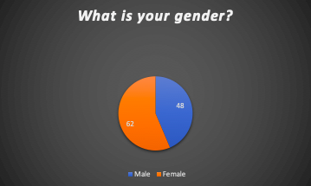
Graph 1: Percentage of male and female
(Source: Self-created)
The result above illustrates that the female respondents are more in respect to the male respondents and they agreed to take part in the survey regarding their perceptions over the VLE.
b. What age group do you belong to?

Respondents | No of respondents | Total no of respondents | Percentage (%)
18-20 | 11 | 25 | 44
21-23 | 6 | 25 | 24
22-25 | 8 | 25 | 32
Table 3: Gender of the respondents
(Source: Self-created)

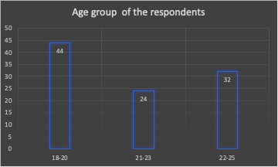
Graph 2: Age group of people
(Source: Self-created)
The graph reveals that most of the respondents belong to the age group of 18-20 and 24% from the group 21-23 and remaining 32% from the 22-25 age group.
c. To what extent do you believe VLE is effective for your proper educational development?

Respondents | No of respondents | Total no of respondents | Percentage (%)
Agree | 7 | 25 | 28
Strongly agree | 8 | 25 | 32
Disagree | 4 | 25 | 16
Strongly disagree | 6 | 25 | 24
Table 4: Effectiveness of the VLE
(Source: Self-created)

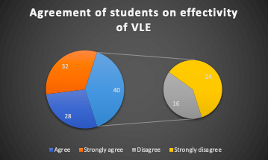
Graph 3: Effectivity agreement/disagreement on VLE
(Source: Self-created)
The diagram reveals the proportion of agreement is more than the disagreement in regard to the analysis of effectiveness of VLE among students. However, 32% of them are strongly like the skill of e-learning, whereas 24% found it completely ineffective to expand their educational growth.
d. What is the constraint for successful implementation for e-learning?

Respondents | No of respondents | Total no of respondents | Percentage (%)
Casual attitude of the students | 6 | 25 | 24
Communication issue with the educators | 9 | 25 | 36
Regularity in time scheduling | 6 | 25 | 24
Improper educational environment | 4 | 25 | 16
Table 5: Success of e-learning implementation
(Source: Self-created)

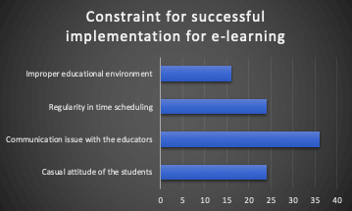
Graph 4: Constraints of e-learning implementation
(Source: Self-created)
e. What according to you are the main benefits of VLE?

Respondents | No of respondents | Total no of respondents | Percentage (%)
Flexibility of learning | 6 | 25 | 24
Time saving | 9 | 25 | 36
Cost saving | 8 | 25 | 32
Proper homely environment | 2 | 25 | 8
Table 6: Benefits of VLE
(Source: Self-created)

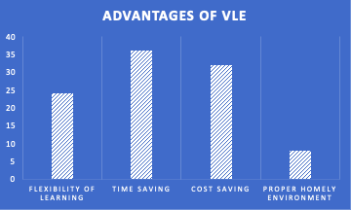
Graph 5: Advantages of VLE
(Source: Self-created)
The graph and the table reveals that, most of the respondents prefer VLE as it is time saving, and next to that, 32% people prefer it for the platform being cost effective. Hence it is shown that the VLE incorporates people with proper flexibility and benefits with low cost. In the least number of people, the preference for it being home specific has been revealed.
f. What is the main disadvantage of VLE?

Respondents | No of respondents | Total no of respondents | Percentage (%)
Network issue | 3 | 25 | 12
Barriers of proper interaction and concentration | 9 | 25 | 36
Distracting activities from homely environment | 8 | 25 | 32
Dissociates proper coordination | 5 | 25 | 20
Table 7: Disadvantages of VLE
(Source: Self-created)

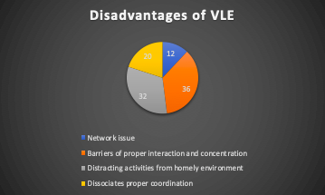
Graph 6: Disadvantages of VLE
(Source: Self-created)
The analysis reveals that, 36% that is the most of the respondents find coordination issues as main constraint for the system and 12% respondents, that is the least number of respondents address the issue as a connectivity problem. Other two potential reasons for the VLE being disadvantageous are deficiency of coordination and distracting activities.

6. Discussion
Based on the above analysis, it has been made clear that the advantages and disadvantages are in common to the VLE but the preferences lie in accepting the process as it is cost effective and time saving. As addressed by Lyndon and Hale (2014), the e-learning process serves as a flexible means of learning and it makes students be adaptive to the advanced process of learning and developing concepts in a more advanced way. As undermined in the survey, 18-20 aged people find it highly beneficial to learn and get educated in an online platform. As pointed by Tsay et al. (2020), the geographic area of the students is an important factor, because the distant locations are often found with poor connectivity issues which might leave a bad impression regarding the VLE procedure.
On the other hand, through the primary research, most of the people find VLE highly effective as a learning process. Those who find the system dissatisfactory might have constraints regarding technological advancement, or issues in homely environments that distract their attention from learning. This makes more distraction and makes people be less attentive towards their studies. As assessed by Blin and Munro (2008), through secondary research, the single platform in developing knowledge of a number of people at a time by sharing a single screen has better implication as it covers the ranges of collaborative learning. However, video sharing, learning through educational videos, sharing study notes and materials strengthen the learning process and understating of the students in a better way. The physical presence in an educational environment might have a different significance, but the VLE has better implications from an overall perspective as it is economic, advantageous for the educators to use all possible means of learning and similarly effective for students too, to adopt the learning means staying at home.

7. Conclusion
Future work/Recommendation
As analysed above, the e-learning process has both advantages and disadvantages as it offers learning from a different angle. However, the learning process has complied with different approaches and advanced ways to reduce the issues with the students, but the method differs based on the acceptance of the students and the educational background or the subject they are studying. In the case of subjects, least efforts can be taken as chemical lab functioning cannot be ideal by giving only theoretical knowledge. It is obvious to be performed practically. But in case of other subjects like management, business, sociology the trainers can advance their knowledge with pepper techniques of advancing the learning process so that students might get more involved, more engaged and attain more coordination.

References
Blin, F. and Munro, M., 2008. Why hasn’t technology disrupted academics’ teaching practices? Understanding resistance to change through the lens of activity theory. Computers & Education, 50(2), pp.475-490.
Bogusevschi, D., Muntean, C. and Muntean, G.M., 2020. Teaching and learning physics using 3D virtual learning environment: A case study of combined virtual reality and virtual laboratory in secondary school. Journal of Computers in Mathematics and Science Teaching, 39(1), pp.5-18.
Hanson, J., Andersen, P. and Dunn, P.K., 2020. The effects of a virtual learning environment compared with an individual handheld device on pharmacology knowledge acquisition, satisfaction and comfort ratings. Nurse Education Today, 92, p.104518.
Herrera Mosquera, L., 2017. Impact of implementing a virtual learning environment (VLE) in the EFL classroom. Íkala, revista de lenguaje y cultura, 22(3), pp.479-498.
Kliziene, I., Taujanskiene, G., Augustiniene, A., Simonaitiene, B. and Cibulskas, G., 2021. The Impact of the Virtual Learning Platform EDUKA on the Academic Performance of Primary School Children. Sustainability, 13(4), p.2268.
Larmuseau, C., Evens, M., Elen, J., Van Den Noortgate, W., Desmet, P. and Depaepe, F., 2018. The relationship between acceptance, actual Use of a virtual learning environment and performance: An ecological approach. Journal of Computers in Education, 5(1), pp.95-111.
Lyndon, S. and Hale, B., 2014. Evaluation of how the blended use of a virtual learning environment (VLE) can impact on learning and teaching in a specific module. Enhancing Learning in the Social Sciences, 6(1), pp.56-65.
Schutte, N.S., 2020. The Impact of Virtual Reality on Curiosity and Other Positive Characteristics. International Journal of Human–Computer Interaction, 36(7), pp.661-668.
Tsay, C.H.H., Kofinas, A.K., Trivedi, S.K. and Yang, Y., 2019. Overcoming the novelty effect in online gamified learning systems: an empirical evaluation of learner engagement and performance.
Tsay, C.H.H., Kofinas, A.K., Trivedi, S.K. and Yang, Y., 2020. Overcoming the novelty effect in online gamified learning systems: An empirical evaluation of student engagement and performance. Journal of Computer Assisted Learning, 36(2), pp.128-146.

