Portofolio of Work
BMSW 4005 Task 2

Student ID: 2019388 | Student Name: Ghegea Mariana Florentina
Lecturer: Crisford Chogugudza Professional and career development

Table of Contents
CV 2
Cover Letter 3
Job Advertise 4

CV
Ghegea Mariana Florentina Date of Birth: 29/08/1981
Address: 100 Bridge St W, Birmingham Phone number: 07222756312
Post code: B19 2YX Email: marianaghegea@gmail.com
Civil Status: Divorced
Current Job:
Employer: Cypflo Trans (2015-present)
Role: Transport Manager
UK
Preview Experience:
Employer :GBI Transport SRL. 2003-2010
City Oradea, Romania
Supervisor assistant in HR Transport and Logistics
Employer: Gi-Gorup LTD 2010-2015
Address: Louis Blanc Offices, Strada Louis Blanc Nr. 1, Etaj 5, București 011751, Romania
Role: Transport supervisor
Skills:
As an experienced manager, thru the years I achieve strong skills of Communication, people skills, leadership and management, Problem solving, IT Skills, Project management , Decision Making and other job Related Skills.
Education :
- University of Wales Trinity Saint David -Certificate of higher education skills for workplace and health and social care (2021-2023)UK
- IAM -course of Transport and technology Level 3 (2002-2003)Romania
- Andrei Saguna College (1995-2001) Romania

Cover Letter
February, 14 2022
Address: The Boulevard,
Shire Park, Welwyn Garden City,
Hertfordshire, AL7 1EL
To: HandEPay

Dear Hiring office,
Due to research regarding the company and experience I already held, I am interesting in applying as an HR Administrator. I am the perfect candidate for this position as I have the necessary skills and education, and also I have experience in this sector for more then 2 years, and this organisation is good for me as I have the possibility of career development. The skills I poses are problem solving; data analysis and research methodology skills; communication and people skills; time management and organization skills.

All had been seed I also want to thank you for the job opportunity and I hope I will hear from you soon.

Kind Regards,
Mariana-Florentina Ghegea

Job Advertise
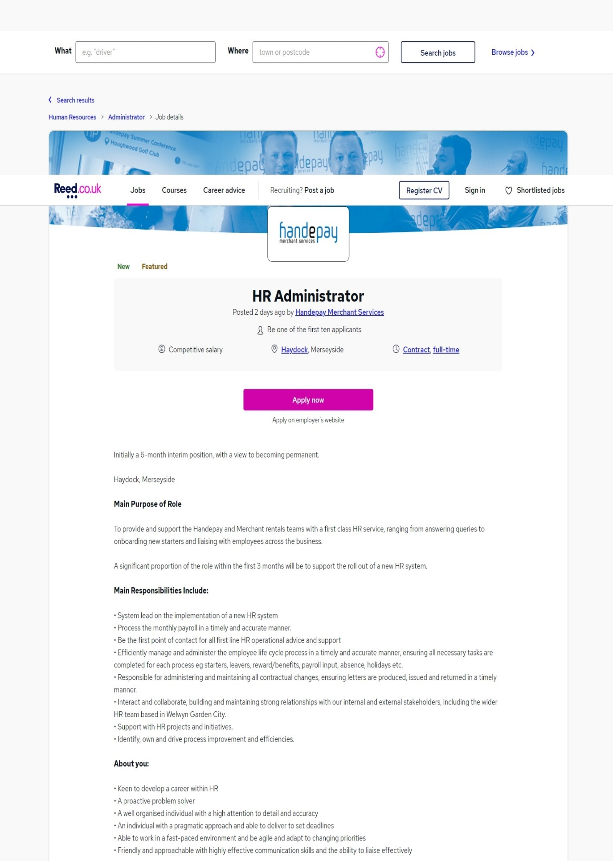
Available on: HR Administrator - Reed.co.uk
[accessed on 13/02/2022]

