Hospitality and guest services

Hotel standards, reputation management, building and retaining customer loyalty

Student Name : Julquife Ahmed
Student ID : 2209480
Module: BMIH4003
Tutor: Muhammad Cassamo

Executive Summary
This research study claims that the UK hotels deploy a dedicated team to examine and monitor online customer reviews for responding any negative feedback of customers. Effective strategic actions and cognitive planning attitudes help those brands to improve reputation management, customer loyalty and business standards in the hospitality industry. Ethical staff behaviour and legislative frameworks benefit the UK hotels such as Marriott, Hilton and many more brands in increasing firm competency to remain reputable and commendable in the competition.

Table of Contents
Introduction 4
Purpose of brand consistency standards 4
• Impact of law regulations on the business standards of hotels 4
How can hotels manage their reputation effectively 4
Importance of effective guests reviews management 5
The impact of negative reviews 6
• How hotels can build and retain customers’ loyalty 6
• Purpose of building and retaining customer loyalty 7
Obstacles faced by certain businesses 8
Conclusion 8
Recommendations for hotels regarding market trends 8
Reference list 10

Introduction
This report is based on an evaluation of hospitality and guest services in consideration of hotel standards, reputation management as well as building and retaining customer loyalty. For this, multiple hotels have been exemplified in a meaningful context by highlighting obstacles that are currently faced by the hotel chains.

Purpose of brand consistency standards
Brand consistency standards are critical in hotels because they help to maintain the integrity and image of the hotel brand across all locations and touchpoints. The purpose of brand consistency standards is to establish a strong brand identity. As stated by Chung and Byrom (2021), brand consistency enables building customer loyalty and increasing brand awareness of hotels or hospitality services. For the instance of hotels, brand consistency is purposive to maintain reputation standards by increasing quality and operational efficiency. By standardizing procedures and processes, hotel brands are subjective to facilitate marketing efforts to gain customers' loyalty. For example, Marriott hotel creates brand consistency standards through product and service expectations of the guests as they believed in scaling up brand consistency rather than a star-rating system (Marriott, 2023).

Impact of law regulations on the business standards of hotels
It is true that not all hotels have the same standards. Standards can vary depending on the hotel's location, type and levels of luxury. For example, a budget hotel in a rural area may have more basic amenities than a luxury hotel in a metropolitan city. Consumer Rights Act is a valid legislation of the UK which helps hotels in maintaining business standards and this legislation helps Marriott to increase its reputation. On the other hand, the Federal Trade Commission regulate hotels in the United States of America and focuses on Hospitality Law to influence hotels in providing social and legal practices to guests. These two different legislations of different countries impact the brand’s hotel performance to impact service standards.

How can hotels manage their reputation effectively
Hotels heavily rely on their reputation to attract and retain customers. As studied by Huang and Rust (2021), a reputation management strategy focuses on providing excellent customer service. For this instance, Hilton has a dedicated team that monitors online reviews and responds promptly to negative feedback. With this, they gain feasibility to manage their reputation and encourage guests to deal with them. Not only this, Hilton has created a social spotlight to build its reputation on the aspect of raising the standards of visitors' or guests' experiences (Grano, 2021). Most importantly, the use of digital key technology has given the utmost feasibility to maintaining a business reputation as it enables contactless check-in and check-out facilities. In contrast to this, social media reviews and mentions are highly effective in managing a business's reputation in the competitive market. For example, Marriott hotel uses re-vine as a reputation tool that offers reputation management along with automation marketing solutions (Hoteltechreport, 2022).
As per current trends, posting and updating information on social media enables interaction with a brand reputation that empowers hotel brands to stay and gain high profitability and intense competition. Therefore, hotels like Marriott hotel and Hilton are highly cautious about managing brand reputation to compete in the market and are concerned with gaining sustainability.

Importance of effective guest reviews management
Effective guest reviews management is essential for hotels to maintain their reputation and attract guests. Nowadays, most travellers rely on reviews and ratings, which are highly important for hotel brands to manage their reputation. On the other hand, effective guest review management helps hotel brands respond to negative reviews, address issues, and highlight positive feedback (Lee et al., 2020). For example, 81% of Hilton travellers use review sites such as TripAdvisor to determine the favourable option for accommodations (Iresponze, 2023). Not only this, guest reviews have provided valuable feedback for the next levels of improvements in the operation and services of hotels. With this, they can interact with corrective action to get in touch with reputation management and customer satisfaction. It is true that when hotels respond to guest reviews, it creates a positive image regarding the brand and ensures commitment to providing excellent services. In words of Abdulwase et al. (2020), hotels that respond to guest reviews can create opportunities for gaining competitive advantages as it highlights differentiation from other competitors. Moreover, effective guest reviews are highly valuable to hotel brands to be subjective to position the hotel brand at the top in the SEO. Therefore, positive reviews can help hotels to rank higher in search outcomes and attract more traffic to their websites. In this sense, it is transparent that guests positive reviews enable hotel brands to identify the potential and loyal customers. This way of identifying potential customers fosters the brand’s relations and increases customer loyalty.

The impact of negative reviews
Negative reviews can have a significant impact on hotels in today’s digital age as online reviews are widely accessible and highly influential. Negative reviews can lead to decreased bookings as potential guests may choose other hotels with better reviews. Consequently, hotels can be impacted by revenue loss. On the contrary, negative reviews have impacted drastically upon hotels' reputation management. For example, Marriott hotels have experienced negative reviews from their visitors that affected its brand reputation to some extent (Faife, 2022). Not only this, but Marriott hotel also confessed that they were hit by data breaching scandals that exposed customer information, including credit records. As a result of this, its reputation and customer engagement have been dominated by the other competitors. Therefore, negative reviews drastically decrease revenues and consumer trust, which may force hotel brands to ramp down business operations in the global market. BBC (2021) reported that mandatory hotel quarantine is a fundamental breach of human rights which leads to the false imprisonment of people. This evidence-based research finding indicates that UK hotel’s initiative to attain customers during the COVID-19 pandemic unknowingly became the reason of legal issue. This legal issue is the personification of the breach of human rights, and that is why guests provide negative reviews and receive uncivilized hospitable services. Due to poor service standards, UK hotel brands witnessed lesser customer involvement during 2020 and 2021 (Figure Shown Below).
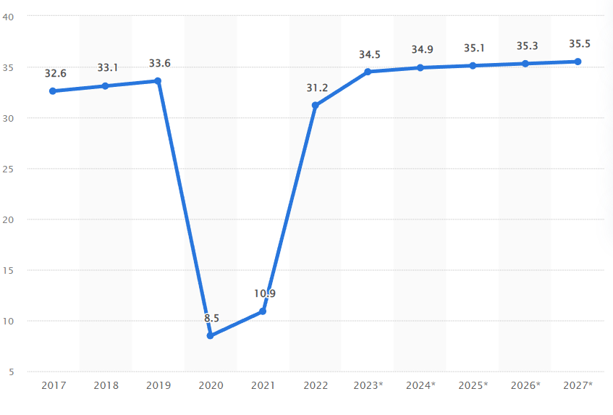
Figure 1: Number of Guests in the UK Hotel Market
(Source: Statista, 2023)

How hotels can build and retain customers’ loyalty
Hotels can build and retain customers' loyalty in various ways, including providing excellent personalized services. Along with this, effective customer service, the creation of a strong identity can also provide opportunities for the hotel brands to retain customers' loyalty. It can be exemplified that Hilton's loyalty program, "Hilton honour", is highly popular among frequent travellers. With this, Hilton Honors ensures consumers can gain exclusive perks that other 7000 hotels cannot be able to provide (Hilton, 2023). Not only this, they have ensured elite customer service that can allow them to build and retain customers' loyalty. On the other hand, According to the grounded theory of customer loyalty, the customer service training strategy is also effective in building and retaining customer loyalty that empowers hotels to stay and achieve the degree of intense competition in the hospitality industry (Sun et al. 2019). In consideration of this, it can be exemplified that Marriott develops a loyalty program called " Marriott Bonvoy" that offers rewards to frequent guests with points that can be redeemed for free stays, continuous upgrades details and other perks (Marriott. (2023).
Apart from this, including a more personalized customer service strategy enables to encourage the value of customer loyalty that gives plausible opportunities for hotels to survive in the competitive world. In this consensus, AccorHotel also develops a loyalty program, ALL (Accor Live Limitless), that offers rewards such as free homestays, discounts and others. Therefore, hotel brands are aggressive in dealing with loyalty programs to encourage consumers to stay connected with loyalty.
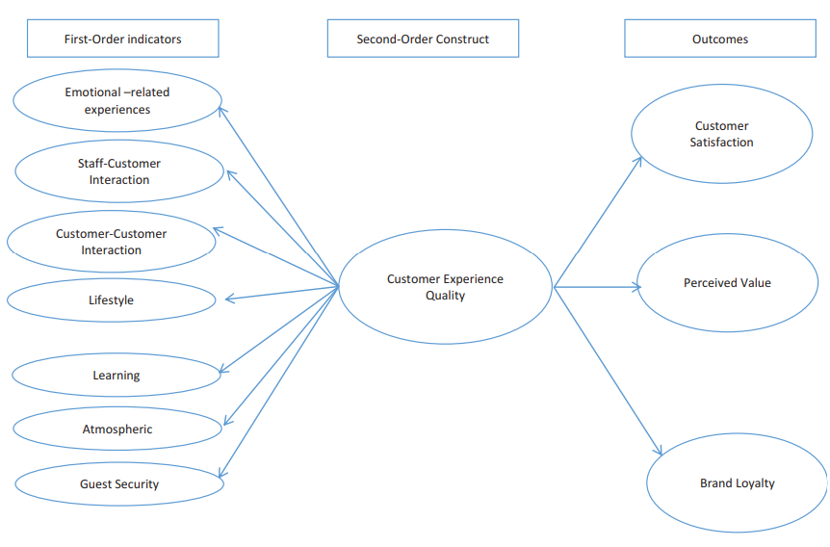
Figure 2: Customer Experience Quality in the Hotel Industry
(Source: Alnawas and Hemsley-Brown, 2019)

Purpose of building and retaining customer loyalty
Building and retaining customer loyalty is essential for hotels as it enables them to achieve customers’ lifetime values, reduce customers' acquisition costs, and improve brand reputation. Guest security is concerned with preserving consumers’ possessions and property (Alnawas and Hemsley-Brown, 2019). Thus, hotel companies ensure suitable guests services and attains customer loyalty. A customer loyalty program aims to retain reliable consumers to compete with other brands in the hospitality industry. In the case of Marriott hotel, it can be stated that its Marriott Bonvoy program has over 120 million members, which becomes the key driver of its retention of customer loyalty (Marriott, 2023). Along with this, it is also purposive to uphold a brand reputation with which hotel brands can promote their ability to enrich the value of their services in front of other competitors. In contrast, customer loyalty also gives the hotel brands confidence as it enables them to reduce investment for retaining new consumers. But, extreme dependency on loyal customers can shrink the ability to innovate business practices to reach more new customers and prove business competencies in the hospitality industry.

Obstacles faced by certain businesses
It is evidenced that Hotel businesses are faced with obstacles in dealing with intense market competition that decreases sales and performing competencies. As per the current situation, it can be highlighted that the ripple effects of the Covid-19 pandemic have led to pressure on the growth and development of hotel companies. Due to this, requirements of safety and security have become a barrier to hotel companies, and in case it leads to failure to satisfy changing demands of customers. Moon (2021) identified that Hilton suspended service operations at 275 properties mostly in the United States and Europe. This suspension at properties reduced the chances of meeting consumer needs and this is how Hilton’s inability to meet consumer safety has led to obstacles in managing business during the COVID-19 pandemic.

Conclusion
Thus, it can be concluded that hotel brands are concerned with communicating with hotel standards, reputation management as well as building and retaining customer loyalty. In this aspect, Different company examples, such as Marriott, Hilton and AccorHotels, have been used to highlight the significance of reputation management, customers loyalty retention along with hotel standards.

Recommendations for hotels regarding market trends
The following recommendations can be effective for hotel brands to stay competitive in dealing with current marketing trends:
- Advancement in the use of personalized technology will be highly effective in encouraging consumers to feel free to use the websites of the hotel brands to gain the required support and contribute to reputation management. By supporting this, Buhalis et al. (2019) have stated that personalized technology empowers hotels to create more opportunities for firms in the context of gaining customer loyalty.
- Prioritizing environmental sustainability will be more valuable to hotel brands for their reputation management and is capable of dealing with hotel standards to gain a competitive edge.

Reference list
Abdulwase, R., Ahmed, F., Nasr, F., Abdulwase, A., Alyousofi, A. and Yan, S., 2020. The role of business strategy to create a competitive advantage in the organization. Open Access J Sci, 4(4), pp.135-138.
Alnawas, I. and Hemsley-Brown, J., 2019. Examining the key dimensions of customer experience quality in the hotel industry. Journal of Hospitality Marketing & Management, 28(7), pp.833-861.
BBC., 2021. Quarantine hotel rules face legal challenge | BBC News. [online] BBC. Available at: <https://www.bbc.com/news/business-58180307> [Accessed 2 March 2023].
Buhalis, D., Harwood, T., Bogicevic, V., Viglia, G., Beldona, S. and Hofacker, C., 2019. Technological disruptions in services: lessons from tourism and hospitality. Journal of Service Management.
Chung, S.Y. and Byrom, J., 2021. Co-creating consistent brand identity with employees in the hotel industry. Journal of Product & Brand Management, 30(1), pp.74-89.
Faife, C. (2022) The Marriott hotel chain has been hit by another data breach, The Verge. The Verge. Available at: https://www.theverge.com/2022/7/6/23196805/marriott-hotels-maryland-data-breach-credit-cards (Accessed: March 1, 2023).
Grano, M. (2021) Social spotlight: Hilton's pandemic strategy proves the business value of social, Sprout Social. Available at: https://sproutsocial.com/insights/social-spotlight-hilton/ (Accessed: March 1, 2023).
Hilton. (2023) Benefits and member tiers with Hilton Honors. Available at: https://www.hilton.com/en/hilton-honors/member-benefits/ (Accessed: March 1, 2023).
Hoteltechreport (2022) All of Marriott's Hotel Brands explained - hotel tech report, hoteltechreport.com. Available at: https://hoteltechreport.com/news/marriott-hotel-brands (Accessed: March 1, 2023).
Huang, M.H. and Rust, R.T., 2021. Engaged to a robot? The role of AI in service. Journal of Service Research, 24(1), pp.30-41.
Iresponze (2023) Hotel Review responding | hotel social media | iresponze, iresponze.com. Available at: https://iresponze.com/sites/default/files/pdf/Hilton-Hotels-2020-Success%20infographic_Dec2019%20final.pdf (Accessed: March 1, 2023).
Lee, M., Cai, Y., DeFranco, A. and Lee, J., 2020. Exploring influential factors affecting guest satisfaction: Big data and business analytics in consumer-generated reviews. Journal of Hospitality and Tourism Technology, 11(1), pp.137-153.
Marriott. (2023) About Marriott International: Corporate Information, About Marriott International | Corporate Information. Available at: https://www.marriott.com/marriott/aboutmarriott.mi (Accessed: March 1, 2023).
Marriott. (2023) Marriott Bonvoy™ Rewards Program, Discover Marriott Bonvoy | Join The Best Hotel Rewards Program. Available at: https://www.marriott.com/loyalty.mi (Accessed: March 1, 2023).
Moon, J., 2021. Hilton earnings disappoint as pandemic pains linger, shares fall | Reuters. [online] Thomson Reuters. Available at: <https://www.reuters.com/business/hilton-posts-quarterly-loss-pandemic-hit-2021-05-05/> [Accessed 2 March 2023].
Statista., 2023. United Kingdom (UK): Number of hotel guests 2017-2027 | Statista. [online] Statista. Available at: <https://www.statista.com/forecasts/515591/number-of-users-in-the-hotels-market-in-the-united-kingdom> [Accessed 2 March 2023].
Sun, H., Wu, S., Li, Y. and Dai, G., 2019. Tourist-to-tourist interaction at festivals: A grounded theory approach. Sustainability, 11(15), p.4030.

