University of Wales Trinity Saint David
School of Engineering
Report
ACCA4016_CT
Jericho Uzzell
1702201
19/01/20


Context menu
- Introduction
- UML
- BPMs
- Robot (pictures of result, robot and code)

Introduction
This is documentation on the use case and business process modeling notation diagrams. It will go over the four requires shapes, most of their functionality and attempting to reduce the amount of code to use.

UML
For the use case diagrams, the following had to be compiled. A diagram for the sequence of a rectangle, triangle, join symbol and a sequence for a square and a circle together.
The first use case diagram will be the rectangle.

Rectangle
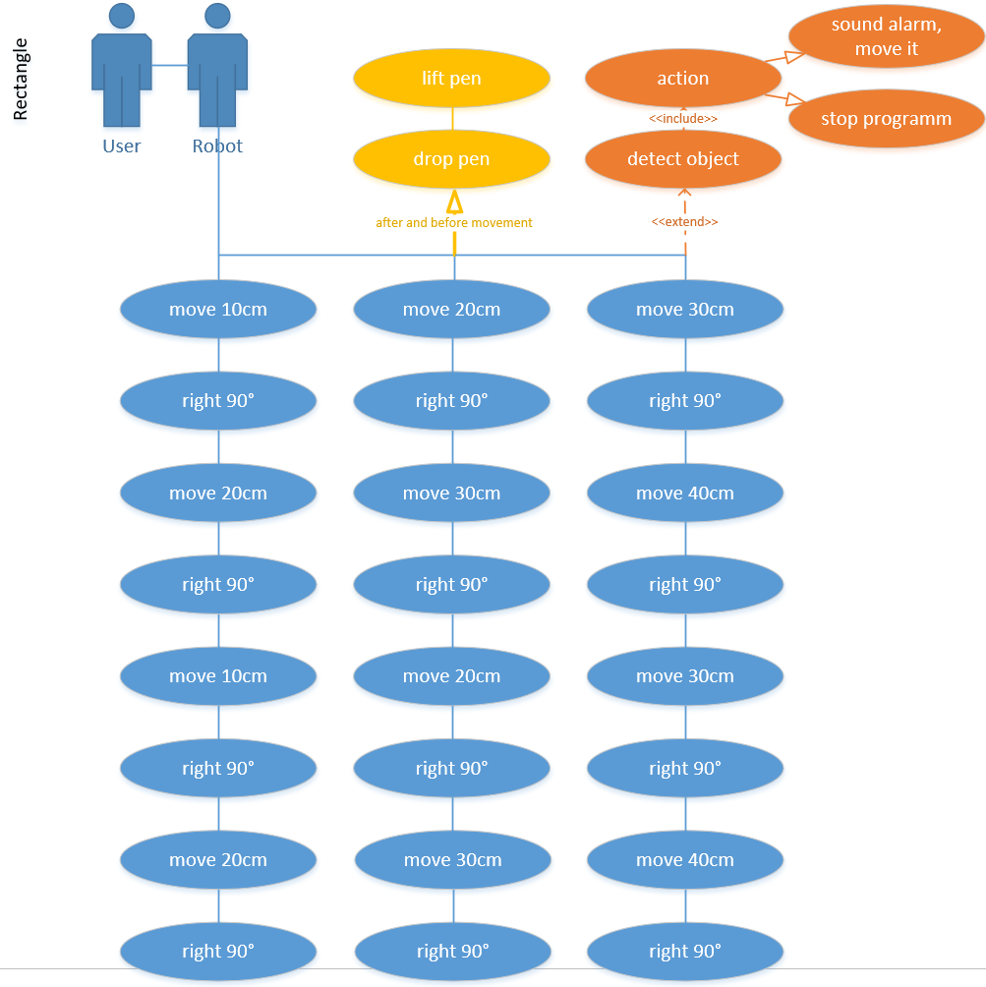
Within this documentation, the use case diagram shows the user that the task has to be done sequentially. The dropping and lifting of the pen are a task all of the sequences do before and after movement (lifts pen before turn, drops pen when finished turn). The extension is for when the colour sensor detects blue or red, if it detects blue it will stop the program and if it detects red it will sound an alarm and move it.

Triangle
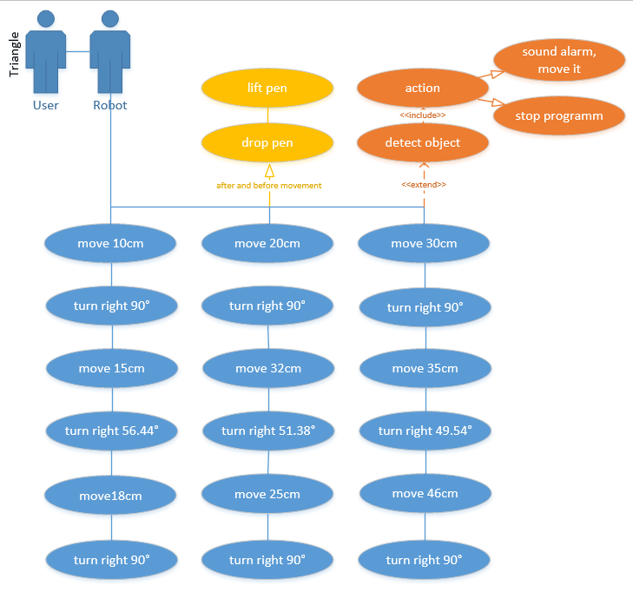
The triangle is the essentially the same as all the other diagrams, the only the thing that is different are the actions it must complete. It needs to turn on a certain angle depending on the stage of the program, it needs to calculate the angle and hypotenuse for the right-angle triangle.

Join symbol
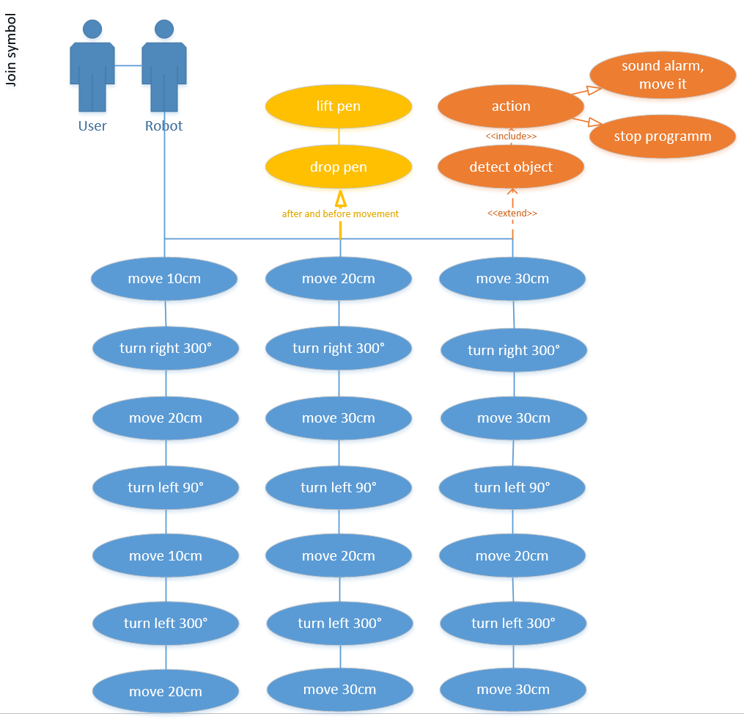
This program will be required to increase the move to distances but the angles remain the same. It follows the other use cases where it extends and generalizes the pen lifting and dropping.

Square and the circle.
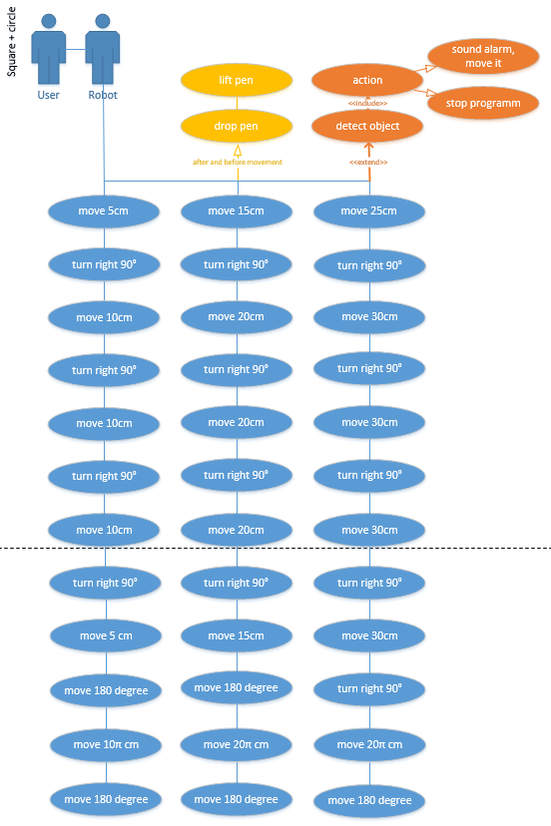
The same extensions and generalisation is the same for this uml, this are the longest diagram and more complex. The robot completes half of the length it is on, for example, if the length was 10cm it will do 5. It will then make a square, once completed it needs to rotate 180 degrees, complete a circle and rotate 180 again.

BPMNs
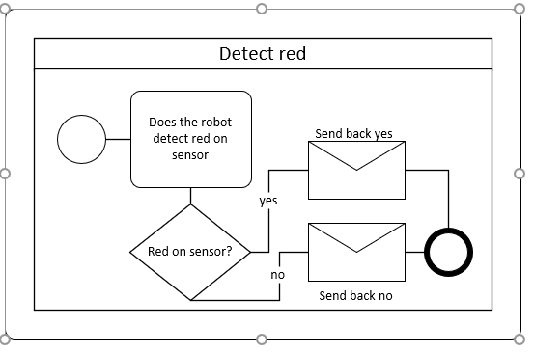
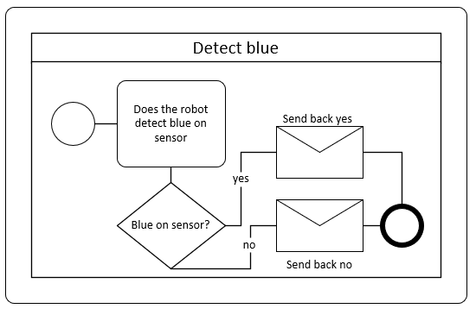
The BPMNs had five reused functions, those being: move forward, detect red, detect blue, the main function and move object; they are shown below.
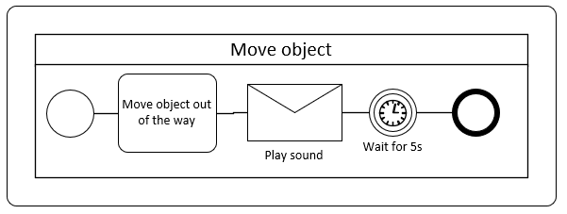
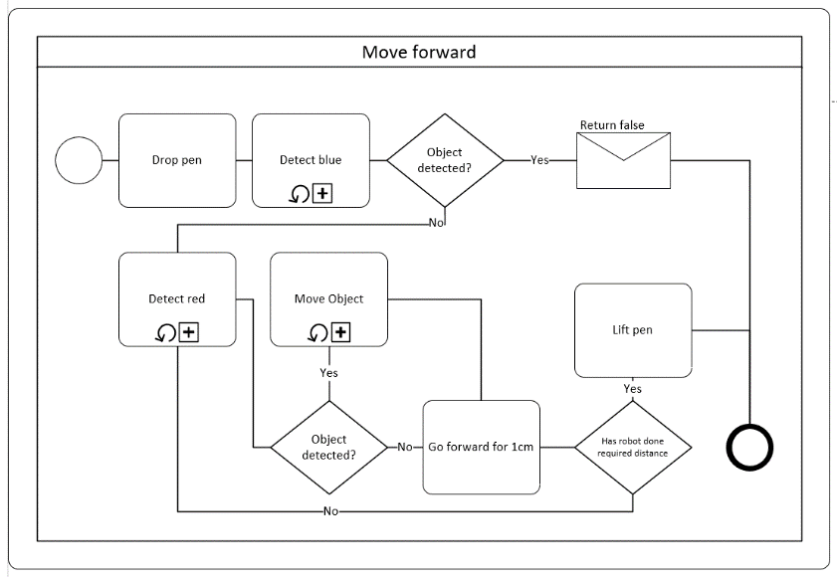
The diagrams reuse these functions, the detect blue detects if the sensor is sensing blue, if it does it must stop the program. In the detect red sub process, if it detects red it must stop, play a sound and then simulate it moving the object out of the way which in itself is a sub process. The move forward script is also a general script that is reused, it is the main way the script detects the blue or red line and how far it has gone forward.
Lastly being the main function, although you may think this would change, it does not as all it does is sets a count, checks the counter, moves the robot and detects if a return of false was detect. Then end the program.

There were four objects to plan, those being: rectangle, triangle, join symbol and a square with a circle after each completion; the only thing that is unique is that the simple move has been changed and that some diagrams have additions to add or work something out.

The rectangle is below:
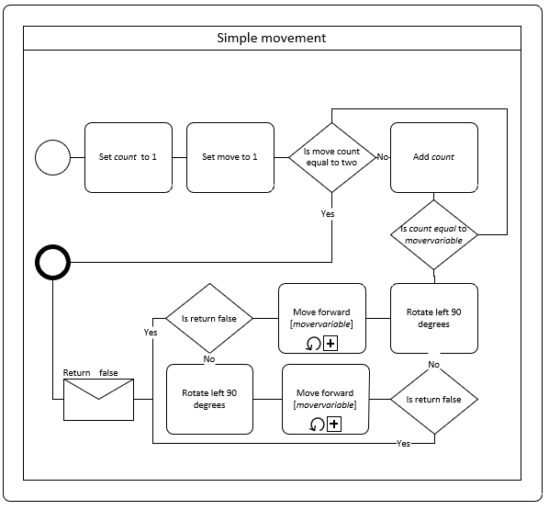
Within this function, it moves initially, it will return false if it could not and if it does then the program must end, that in it of itself returns false to the main process. Each time, the move forward script must return whether to end or continue to program.

Square and the circle:
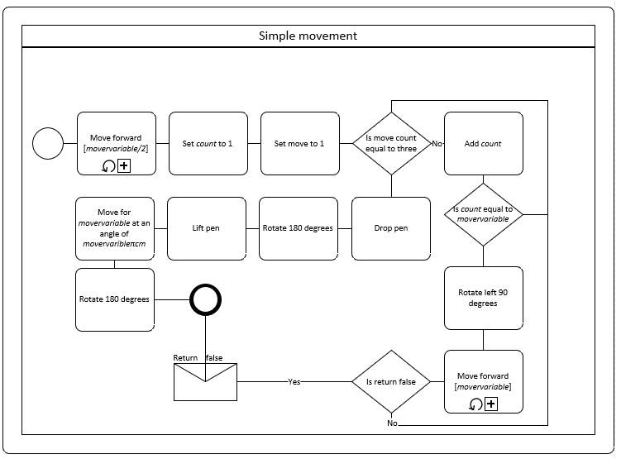
This diagram uses a loop within the simple movement to ensure that code is not being reused unnecessarily. Once again, if the move forward function detects it was returned with a false statement it will cut the program.

The below are essentially the same so there will not be any description posted.

Triangle:
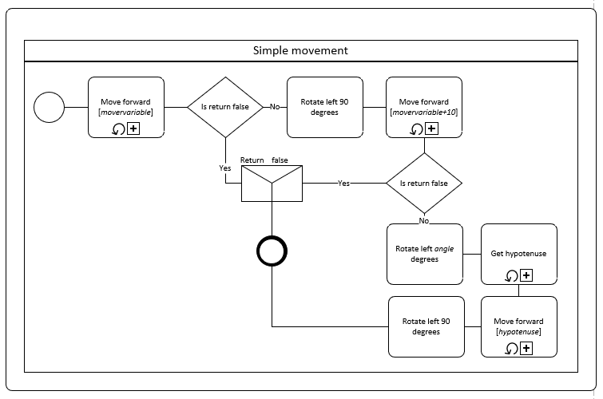

Join symbol:
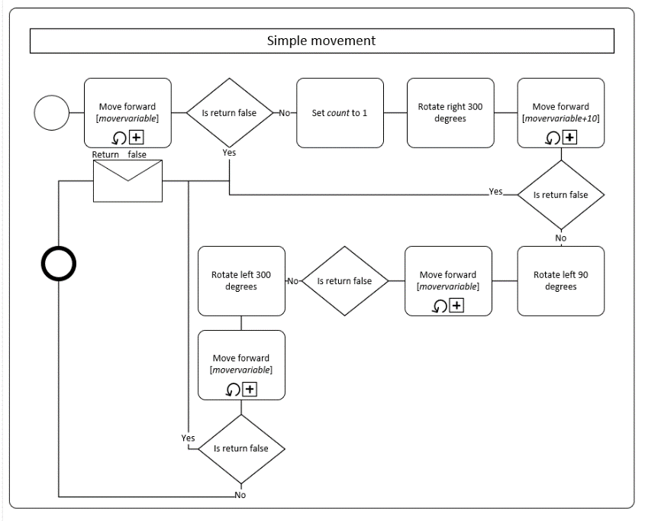

Robot (code)
The task went well, we managed to code three out of the four required shapes. The rectangle went fantastic, it was a little off due to the robot leaning to one side (being the left), but the shape was a rectangle. The next shape for the right-angle triangle which was difficult, to code and to demonstrate. After coding it, it did take some time to make sense of what was going wrong, unfortunately we could not resolve this error – it is assumed the robot was going to too fast.
The last design we done was the join symbol, this code was rather easy (we did only do one go, it did not loop or grow), however with that said the robot did do a shape that resembled a join symbol. The robot did break itself after running off the paper, we ran out of time and could not amend this.

The results
The rectangle:
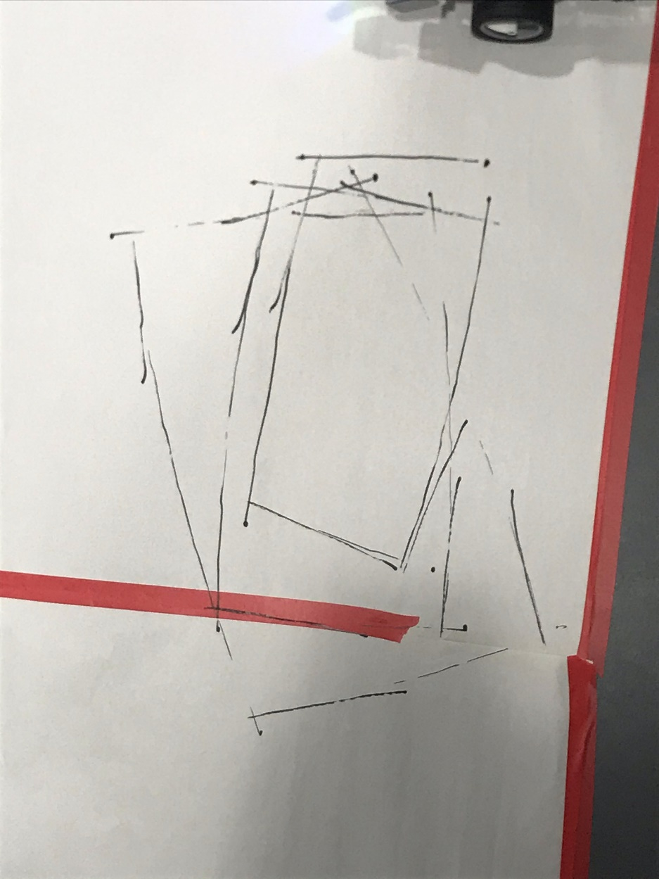

The triangle:
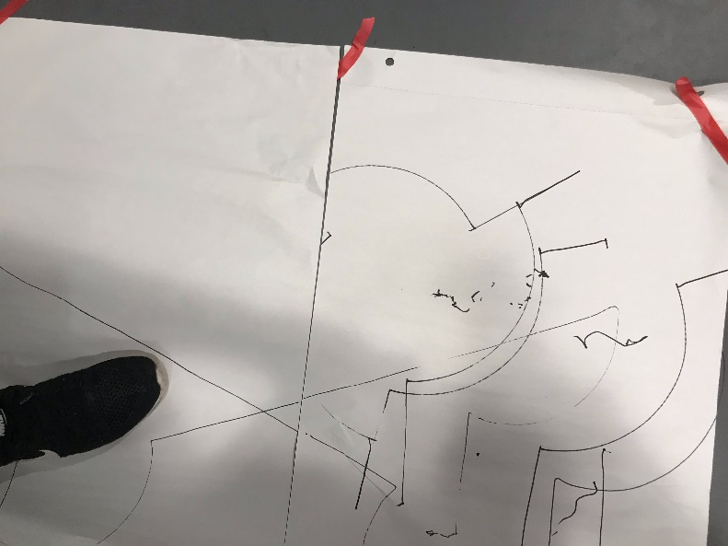
The join symbol:
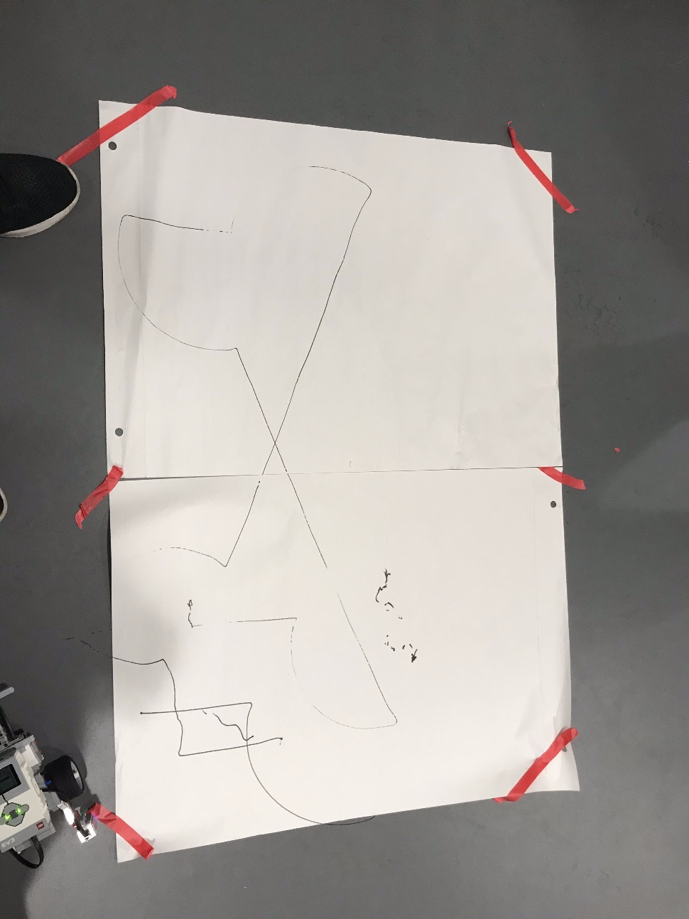

Our robot
Our robot looked like this:
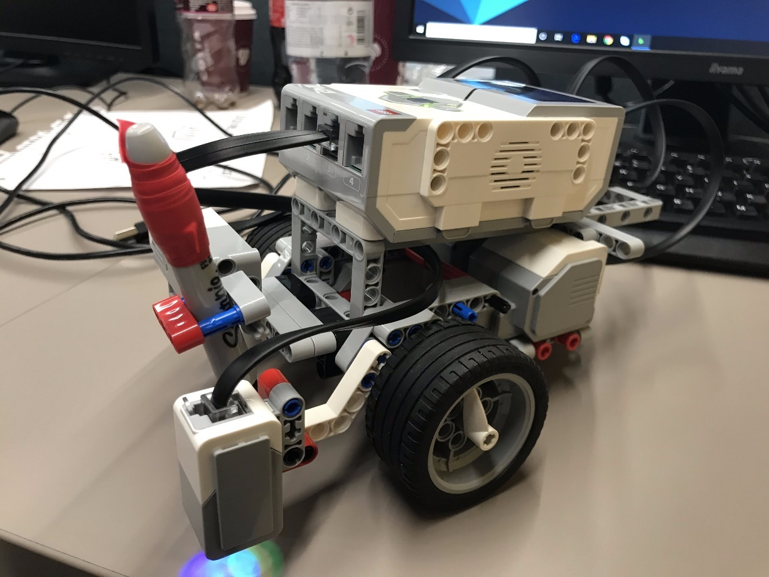
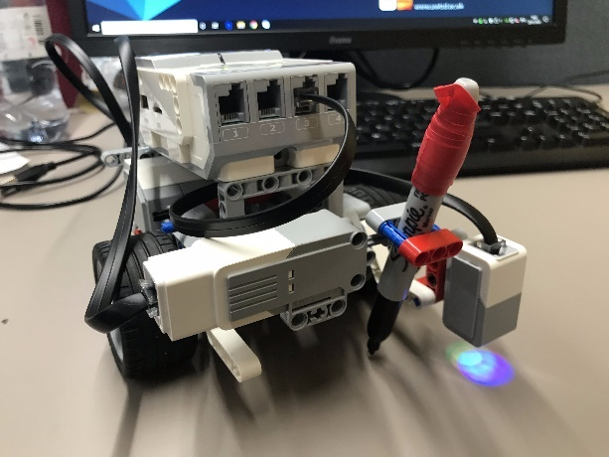
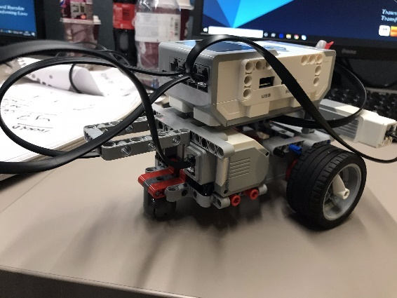

Our code
The code for the rectangle was intended to be easy to fix, easy to update and not to reuse code – it include the red line, blue line and loops.
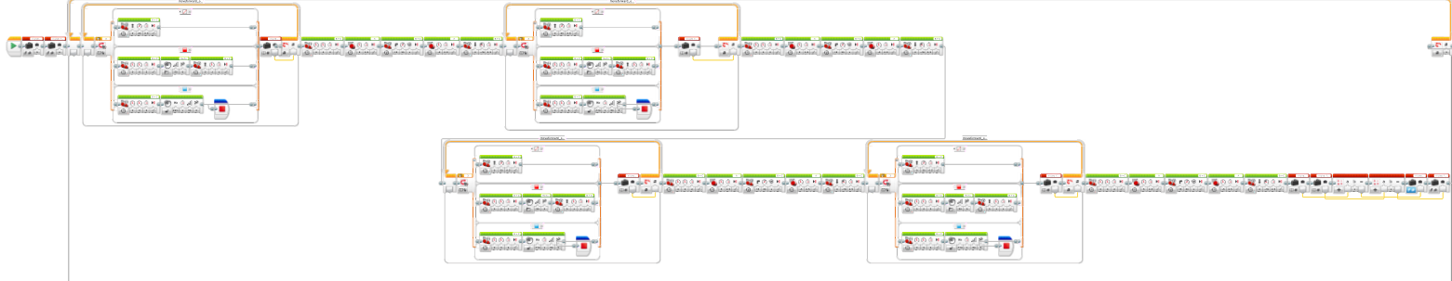

The triangle was in its own loop however had no variables to control it.
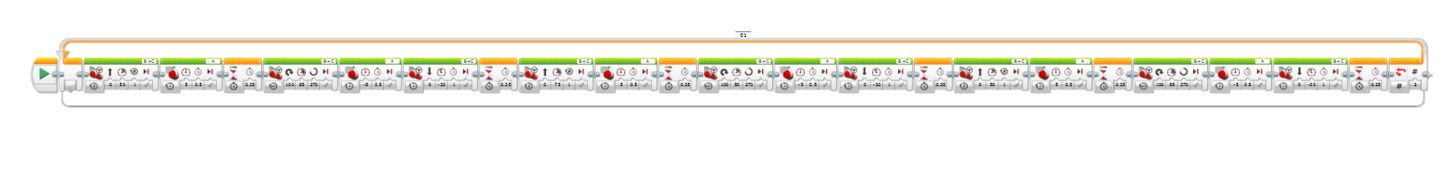
The triangle was initially meant to run this code, which calculated the hypotenuse and the angle, we did not use this code as the results was not accurate, we could have increased the distance and stuck with it but we thought getting valid code done is best.
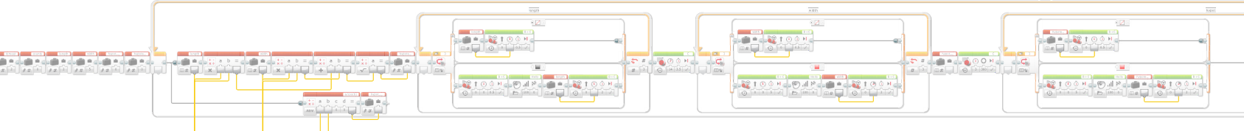
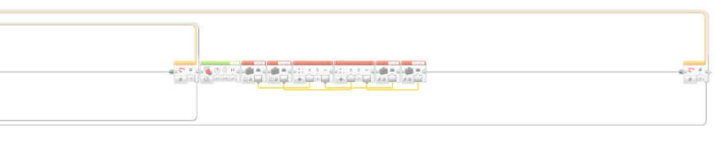

The robot for the join symbol only had one line, it should have been placed into a loop and could have had variables to help change it.


