Katarzyna Kolowrocka (1805961)
14.10.2022
Special constables’ retantion at gwent police.
UWTSD, SWANSEA

Contents
1 Introduction 2
2 Literature Review 3
2.1 Reasons for resignations 3
2.2 Relationship with Regular Constables 3
2.2 Training 4
3 Methodology 5
3.1 Methodological Choices 6
3.2 Sampling strategy. 7
4. Findings. 8
4.1 Service length. 9
4.2 Satisfaction with the volunteering experience 10
4.3 Training 11
4.4 Relationships with Regular Officers. 12
4.5 Relationship with the Special Constables Management Team 14
4.6 Retention 14
5. Conclusion 15
6. References 17
7. Appendix 19

1 Introduction

Special Constables are unpaid volunteers who work alongside full-time police and hold the same powers (Caless et al, 2010). The data for academic research was collected from Special Constables operating in Gwent Police (2022), which employs seventy-five Special Constables.
According to Callender et al. (2020), police forces invest around £ 2,775 to recruit, train, and equip a volunteer officer. To be cost-effective, the organisation must understand retention challenges and ensure that Special Constables serve at least two years to return the investment.
The literature review revealed that Special Constables leave the role as they do not feel valued and there is a lack of adequate initial training. Therefore, this research aims to answer which factors may impact Special Constables’ resignations and influence their volunteering career lengths, develop guidance to help Gwent Police better understand the situation, and implement best practices to improve the volunteering experience and retention for Special Constables.
The primary data collection method was selected based on an analysis of the advantages and disadvantages associated with alternative methods. Due to the nature of the knowledge needed to answer the research question for this study, mixed methods, qualitative and quantitative, were chosen as the techniques focus on obtaining an awareness of volunteering experiences. A survey was utilised as a collection method. The open-ended questions enabled participants the space to voice their opinions.

2 Literature Review

2.1 Reasons for resignations

According to the Bureau of Labour Statistics Quantum Workplace (2022), employees leave their organisations because they are no longer satisfied in the workplace. They will struggle to succeed if they do not receive the attention, support, and resources necessary to fulfil their role. When employees feel misunderstood, ignored, and unsatisfied in the workplace, they become frustrated. Hence they will leave.
Previous findings (Britton et al, 2021) suggest that police forces fail to understand the nature of the Special Constabulary challenges, mainly reasons associated with special constables’ resignations. A broader literature in policing (National Research, 2010; Callender et al, 2020) suggested, that the main reasons for leaving the volunteering role are to join the Regular Constabulary or change work or family commitments. Callender et al (2020), stated that for those reasons, there is not much that can be done to avoid the loss rate of Special Constables. Nonetheless, while high turnover is present across volunteering domains, it is noticeable that internal factors are associated with the decisions of Specials to resign and which organisations have control over. These factors include poor management and supervision, insufficient initial training, a lack of meaningful development, not feeling valued, negative attitudes from police colleagues, and uninteresting duties.

2.2 Relationship with Regular Constables

Previous studies (NPIA, 2010; Prins, 2018, Britton et al., 2018b;) highlighted that a positive relationship with regular officers impacts on the Special Constables’ experience. According to NPIA (2010), Lock (2013) and Britton et al (2021) being integrated within policing teams and feeling valued by full-time constables are significant factors in shaping the retention and experience of volunteers. Previous studies, such as Britton et al (2022) identified challenges within these relationships.
Frayling (2018) identified the perspectives of Regulars toward volunteers, summarising the relationship as far from being friendly. 79% of the Regulars the author examined, felt that Special Constables are helpful to police. The same proportion indicated that volunteers are insufficiently trained. According to regular police officers, the training needs to improve so that volunteers can confidently support them in this challenging role.

2.2 Training

The views of the special constables have echoed those of regular officers’ opinions regarding special constables’ training. NPIA (2010) highlighted the insufficiency of initial training. Bullock and Leeney (2016) discovered that only half of surveyed volunteers felt their training prepared them for police duties. Statistics were mirrored in the study by Prins (2018, p 54) who determined that volunteers spoke about how unprepared they were at the beginning of their ‘Special’ career. Several studies (Hieke, 2015; Bullock and Leeney, 2016; Prins, 2018;) identified the association between initial training and the Special Constables’ confidence to practice. Inadequate training and lack of meaningful deployment to the station influenced the decision of 17 % of Specials to leave the organisation.

3 Methodology

This research project aims to understand how Gwent Police can improve the retention of SCs, and improve the support and experiences in the Special Constabulary.
The objectives of the research are:
- To critically analyse literature on the volunteering experience within the police forces and consider this in the context of Gwent Police.
- To critically evaluate the research methods and choose the most appropriate one to assess Special Constables’ level of role satisfaction.
- To critically analyse, present and discuss findings on Special Constables retention at Gwent Police.
- To develop a set of recommendations.

3.1 Methodological Choices

Traditional police research has a long history of utilising ethnographic studies. This method enables researchers to “observe, participate in and understand the society which they are studying’ (Fox, 2004, p.234). More recently, the police literature has been based on quantitative surveys or secondary data analysis.
The researcher has access to the Special Constabulary, enabling observational methods for data collection. However, the research outcome could be subjective and limited only to the researcher’s views, opinions, and experience. Therefore mixed research methodology was undertaken, and qualitative and quantitative data were gathered to mitigate bias. Quantitative research reveals a broader view of the process is concerned. However, collecting quantitative data has limitations, as it restricts the respondents to specific ways of thinking. It could be deemed narrow and unrealistic as it only enables capturing a small portion of the concepts under study, hence the lower validity of the design. Qualitative research offers the opportunity to fill this gap (Krosnick and Presser 2010). To understand the subject in depth, the researcher used open-ended questions. Utilising only the qualitative method results in a subjective conclusion (Hair et al, 2020). Qualitative research aims to produce in-depth data, requiring content analysis rather than statistical. Utilising both approaches prevents researcher bias. According to Frayling (2018), research bias is difficult to remove from any piece of study. However, it is essential to recognise it. Despite the theoretical framework used throughout the analysis stages, the study was designed with assumptions regarding the Special Constabulary and its role within policing. These assumptions will have been influenced to some degree by the relevant literature and the researcher’s own experiences as a Special Constable.
The researcher used a survey as a research tool. The online survey was designed with a mixture of closed and open-ended questions. Respondents were asked to score their agreement with a series of statements, utilising a 5-point Interval scale (strongly agree, agree, neutral, disagree, strongly disagree).
The researcher included open-ended questions, to avoid unconscious bias and helped Specials to express their perceptions about the satisfaction of being a volunteer worker. Additionally, the open-ended questions enabled the recognition of the challenges specific to Gwent Police.
The questionnaire was disseminated via e-mail, using the Special Constabulary tool – Duty Sheet. The researcher chose this method over alternatives as this method offers anonymity to responders. When requesting individuals to answer questions using paper format there is more risk that the data will be disclosed. Additionally, this method does not offer anonymity for the participants. Web-based surveys enable a cost-effective method of examining more individuals.
Interviews or focus groups could be difficult to organise; these require a location and a mutually convenient time for all participants and involve travelling time. An additional benefit of the chosen method is the convenience of analysing the data. Closed questions enabled the researcher to analyse data more efficiently. At the same time, analysing responses from interviews or focus groups might easily misinterpret the results.

3.2 Sampling strategy.

The survey was entirely anonymised. According to Ryba (2022), anonymity enables responders to express their perceptions freely. The questionnaire was designed to protect the identity of participants fully. For instance, removing potentially identifying contents, the gender and rank to not indicate the individual.
The survey was undertaken over two weeks in August 2022 and targeted operational Special Constables across Gwent Police. This investigation sought opinions from Special Constables willing to remain in the voluntary role for longer. The response rate was satisfactory, with 31 special constables taking part In the research project and completing the survey. At the time of the survey, there were seventy-five Special Constables in the Gwent Police (2022). Fifty individuals were selected to complete an online retention survey, excluding the individuals in training and individuals who had already been accepted to join the regular Constabulary.

4. Findings.

Results were organised into five subheadings, including service length and future intentions of service length, Satisfaction or general experience in the volunteering role, Initial training and development, Relationship and recognition from the regular and special constables management team, Barriers and reasons for considering leaving.

4.1 Service length.

It is essential to recognise individuals who intend to remain longer within Special Constabulary and place efforts and time towards them.

Image 1 indicates how long responders have served as Special Constables.
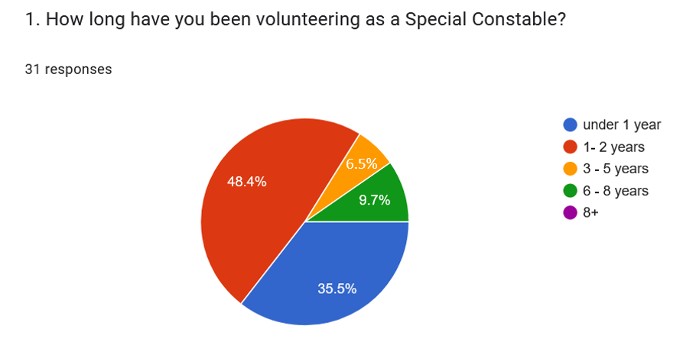
Figure 1 Service Length in the Special Constabulary

Nearly 50 % of Special Constables served at Gwent Police for up to two years, and 35 % served under one year. Nearly 10% were longer with Special Constabulary service over 6 years and only 6.5% served between three to five years.
Image 2 introduces intention of remaining in the Special Constabulary
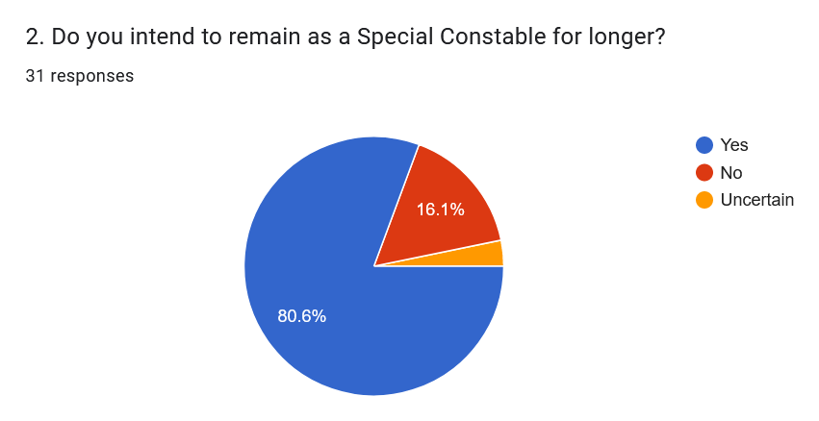
Figure 2 Intention of remaining in the Special Constabulary.

Encouragingly 80% of Specials were interested in remaining in the volunteering role. Of those who were planning to leave in the next year, almost 17% stated that they are going to join the Regulars. 3% of responders were uncertain if they stay with the organisation.

4.2 Satisfaction with the volunteering experience

Image 3 visualises the satisfaction with the volunteering role. Encouragingly twenty-eight individuals are satisfied with the role, and only three are neutral.
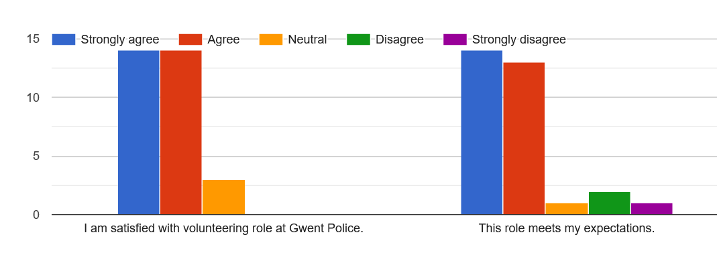
Figure 3 Satisfaction with the volunteering role.

4.3 Training

Figure 4 indicates that Special Constables were satisfied with the initial training.

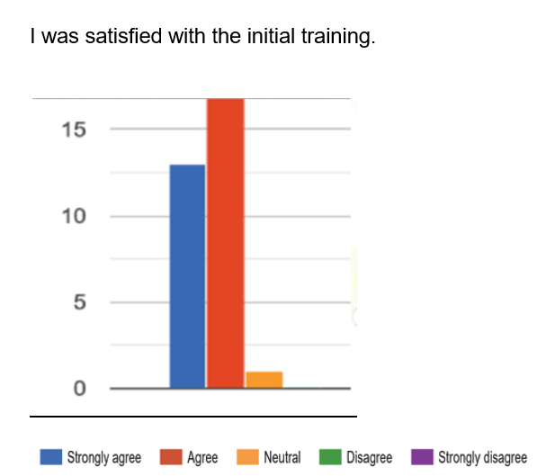
Figure 4 Level of satisfaction with the initial training.

Consistent with the results of previous studies (Callender et al., 2018a; Whittle, 2014), twenty-eight of the Special Constables evaluated the quality of initial training positively. A high proportion of Specials (93%) suggested that more practical sessions during their initial training could improve confidence when starting their initial practice on the front line. Less enthusiasm they show about getting more sessions on how to use police equipment such as radio, only half of the responders agreed with this solution.
The initial practice and deployment to the station received more negative results than training. The time after the initial training and deployment to the station needs to be addressed, as the responders indicated in the open-ended questions that they have been left without support. The findings suggest that deployment to the station was less well managed, and more structure is required. Twenty-one respondents recommended a dedicated mentor after initial training.

4.4 Relationships with Regular Officers.

According to the literature (Bullock and Leeney, 2016), the relationship with regular officers significantly impacts the Special Constables’ experience. Examined responders stated that they do have good relations with regular officers (see figure 5).
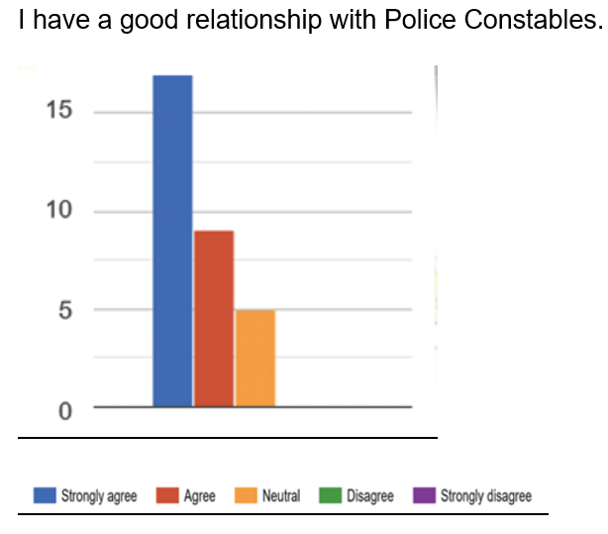
Figure 5 Relationships with the Regular Officers.

The length of service also impacted relationships with regular police officers. Results indicate that the more experienced special have better relationships with the regular officers.
The results differ from other UK forces. National research projects highlighted that Regulars have a negative attitude toward Specials. Gwent Police (2022) is a small force suffering significant shortages of front-line officers. Therefore, Gwent Police Regular Officers appreciate the support from Specials and value their contribution.

4.5 Relationship with the Special Constables Management Team

Specials agreed that they felt sufficiently supported by the special management team. Image 6 visualises the responses about the relationship with Special Constabulary.
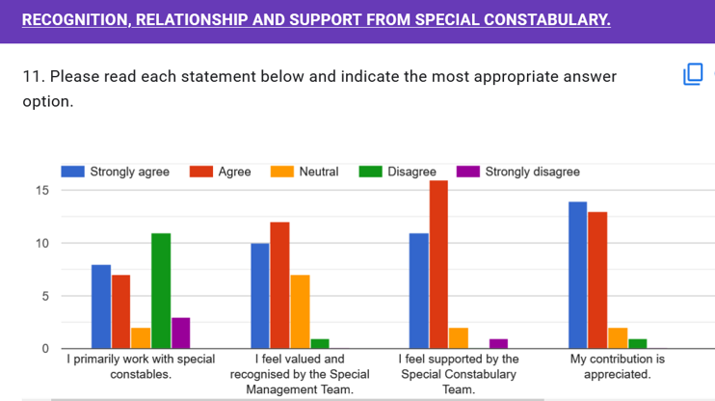
Figure 6 Relationships with the Special Constabulary.

4.6 Retention
This section discusses what factors impact volunteer resignations and influence their career lengths (see image 7).

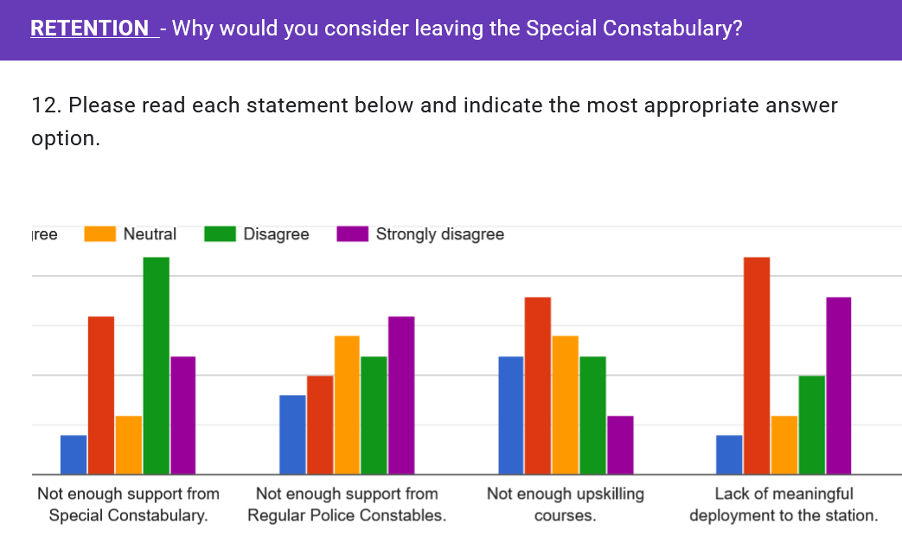
Figure 7 Retention.

The survey results revealed constraints and negative effects were experienced; these included work-life balance (5 responders), lack of equipment (3 individuals), and lack of meaningful deployment to the station (13 responders). Half of the volunteers stated they would leave the special constabulary because of the lack of upskilling courses. Additionally, more than half of the responders stated, that there is a lack of integration between Regular and Special Constabulary.

5. Conclusion

The research project aimed to find out about the Special Constables’ experience and satisfaction with the volunteering role to provide recommendations to encourage retention. National statistics highlighted the main reasons for Special Constables’ resignations. Those reasons were a perceived lack of support, poor management, a negative relationship with Regular Constables and insufficient training and development opportunities. The results from the Gwent Police showed different results compared with the results from other forces in the UK. The findings showed that Special Constables are satisfied with the force, role, training, and relationship with Regular Officers. However, current results resonate with the findings of previous research regards initial training. The results identified weaknesses in training that could be addressed. Gwent Police constables recommended more practical sessions. An allocated mentor would be beneficial after initial training so that volunteers feel more confident when joining regular constables.
The literature (NPIA, 2010) reflects the high importance of relationships with Regulars and that these relationships could be challenging. Contrary to national research results, responders from Gwent Police stated that they have a positive relationship with Regular Officers. However, they noted that better integration between regulars would improve their satisfaction with the role.
The study can be interpreted as a starting point for further exploration in research regards Special Constables retention. It could also contribute to a deeper understanding of the volunteering experience. However, the results of this research should be treated with caution due to the small sample size. To understand retention better at Gwent Police, it would be beneficial to disclose the perception and experiences of volunteers who have left the force.

6. References

Anslow S., (2019) Specials Recruitment – Quarterly Report. Essex Police. Available on https://www.essex.pfcc.police.uk/wp-content/uploads/2019/06/4.0-Special-Constables-March-2019-v2.docx (accessed 7. 09. 2022).
Britton I. (2017). Developing an evidence base for the Special Constabulary. Paper presented to the national conference of the Association of Special Constabulary Chief Officers, Moreton-in-March, UK.
Caless B., Bownas J., Simpson M., Spruce B., Underwood R. (2010). Blackstone’s Handbook for the Special Constabulary. Oxford: Oxford University Press.
Britton I., Callender M., Cahalin K., Knight L., (2021) ‘Regular police officer perspectives on the Special Constabulary: An exploratory study, Policing: A Journal of Policy and Practice, 15( 4), pp. 2053–2069.
Britton, I., Callender, M., & Farquharson, L. (2022). Special beginnings: An explorative study of the early career experiences of volunteer special constables. The Police Journal
Bullock K., Leeney D. (2016) ‘On Matters of Balance: An Examination of the Deployment, Motivation and Management of the Special Constabulary. Policing and Society 26(5): pp. 483–502.
Caless B. (2017). ‘On the Nature of Volunteering and the Special Constabulary: A Critical Reflection’. In Bullock K., Millie A. (eds), The Special Constabulary: Historical Context, International Comparisons and Contemporary Themes. Abingdon, UK: Routledge, pp. 149–168.
Callender M., Pepper M., Cahalin K., Britton I. (2018). ‘Exploring the police support volunteer experience: findings from a national survey). Policing and Society,
Callender, M., Cahalin, K., Britton, I., Knight L. (2018a ) National Survey of Special Constables. Institute for Public Safety Crime and Justice. Available at http://nectar.northampton.ac.uk/12207/1/Callender_etal_IPSCJ_2018_National_Survey_of_Special_Constables.pdf (accessed 17.06.2022)
Callender, M., Cahalin, K., Cole S.,J., Hubbard L., Britton I., (2020) Understanding the Motivations, Morale, and Retention of Special Constables: Findings from a National Survey, Policing: A Journal of Policy and Practice, Volume 14, Issue 3, pp 670–685,
Citizens in Policing Community of Practice. (2016). Citizens in Policing: National Strategy 2016-2019. London: National Police Chiefs’ Council.
Frayling A., J., (2018) The Role of the Special Constabulary within Contemporary Policing. University of the Exeter.
Gaston K., Alexander J. (2001). ‘Effective Organisation and Management of Public Sector Volunteer Workers: Police Special Constables’. International Journal of Public Sector Management 14(1): pp 59–74
Gwent Police (2022) ‘Overview’. [online] Available at: https://www.gwent.police.uk/police-forces/gwent-police/areas/about-us/about-us/verview/ (accessed 02.06.2022).
Hair J.F., Page M., Brunsveled N., (2020) Essentials of Business Research Methods, 4th Edition, London: Routledge, Taylor and Francis.
Krosnick J.A., Presser S., (2010) Question and Questionnaire Design. Handbook of Survey Research, Second Edition, Emerald Group Publishing Limited.
Leon C. (2017). Special Constables and the Birth of ‘Regular’ Policing. In Bullock K., Millie K. (eds), The Special Constabulary: Historical Context, International Comparisons and Contemporary Themes Abingdon: Routledge, pp. 28–45.
Locke, M., Ellis, A., Smith, J.D. (2013) ‘Hold on to what you’ve got: the volunteer retention literature. Voluntary Action, 5 (3) pp. 81-99.
National Police Chiefs’ Council (2018) Recruitment and Retention Survey Summary of Key Findings. [online] Available at: https://www.npcc.police.uk/Publication/Surveys%20.pdf (accessed 11.06.2022).
National Police Chief Council (NPCC) (2018) Recruitment and Retention Survey Summary of Key Findings’. Available at: https://www.npcc.police.uk/Publication/Surveys%20.pdf (accessed 11.06.2022).
NPCC (2018) Special Constabulary National Strategy. Available at https://www.npcc.police.uk/Local%20Policing%20Committee%20RH/Nat%20Special%20Constabulary%20Strategy%2018%2023.pdf (accessed 05.08.2022).
National Policing Improvement Agency (NPIA), (2010), Special Constabulary National Strategy Implementation Advice. http://library.college.police.uk/docs/npia/Specials-Imp-Strategy-updated.pdf (accessed 20.06.2022).
NPIA (2010) Special Constabulary Recruitment Marketing and Retention Surveys. Available at https://docplayer.net/18431042-Special-constabulary-recruitment-marketing-and-retention-surveys-report-of-findings-july-2010.html (accessed 09.09.2022).
Ryba, K. (2022) How to Reduce Turnover With an Employee Retention Survey. Quantum Work. Available at https://www.quantumworkplace.com/future-of-work/employee-retention-survey 25.06 (accessed 25.06.2022).
Saksida T., Alfes K., ShantzA., (2017). ‘Volunteer Role Mastery and Commitment: Can HRM Make a Difference?’. International Journal of Human Resource Management 28 (14): pp 2062–2084.
Streefkerk R., (2022) Qualitative vs. Quantitative Research; Differences, Examples & Methods. Scribbr. Available at: https://www.scribbr.com/methodology/qualitative-quantitative-research/ (accessed 20.07.2022).
Quantum Workplace (2022) Managing Turnover: 8 Tips for Keeping Your People and Engaging Your Best Talent. Available at https://marketing.quantumworkplace.com/hubfs/Managing%20Turnover%20-%208%20Tips%20for%20Keeping%20Your%20People%20and%20Engaging%20Your%20Best%20Talent.pdf (accessed 25.06.2022).

Whittle J. (2014). ‘The Rise of the Special Constabulary: Are Forces Getting Value for Money from Their Voluntary Officers?’. Police Journal: Theory, Practice and Principles 87(1): pp 29–40.

7. Appendix
The questionnaire. Please access the provided link to fully view the questionnaire disseminated among Special Constables. https://forms.gle/nwZyuK1geYADLfwD7
Dear participants,
I would like to invite you to participate in academic research. The research results will be published in the report produced for the University of Wales Trinity Saint David in September 2022. The advantage of the research project is helping Gwent Police better understand Special Constable’s engagement and satisfaction with the volunteering role. The research project will aim to develop recommendations to improve practice at Gwent Police to enhance the volunteering experience and improve Special Constables’ retention. Therefore, your views are very important.
The questionnaire contains mostly closed questions and will require approximately 5-10 minutes to complete the form. The questions will be based on training efficiency, satisfaction with the role, and what factors may impact SC’s resignations and influence their volunteering career lengths.

Confidentiality
All data collected in the study will be used solely for the academic research project and remain strictly confidential. The responses will remain anonymous and individuals participating in this research will not be identified. You can withdraw your participation in this research at any time, and all the information and data collected from you to date will be destroyed. Your data's processing, storage, and destruction will comply with the Data Protection Act 1998. There will be no follow-up once you complete the questionnaire.
Expenses and payments
There will be no expenses covered for taking part in this study. However, I greatly appreciate the time taken, as your answers will assist me in completing my research.
Leave your email address if you would like to receive a copy of the finished report.
For further information or if there are any issues when completing this questionnaire, do not hesitate to get in touch with the researcher Katarzyna Kolowrocka via email at 1805961@student.uwtsd.ac.uk

1. I confirm that I have read and understood the above information for the research project.
Yes
No

2. I understand that my participation is voluntary and that I can withdraw anytime.

Yes
No

3. I agree that the anonymised information I provide will be used in an academic study about the satisfaction and retention of special constables at Gwent Police.

Yes
No

4. I agree to take part in this study.

Yes
No

5. I agree to answer all questions per my personal views and opinions without any other person's influence.

Yes
No

1 GENERAL.

1 a. How long have you been volunteering as a Special Constable?

under one year
1-2 years
3-5 years
6-8years
8+
1 b. Do you intend to remain in the Special Constabulary?
yes
no
uncertain

2. INITIAL TRAINING AND GAINING COMPETENCIES. | Strongly agree | Agree | Neutral | Slightly Disagree | Strongly disagree
I was satisfied with the initial training.

I was given the support and resources I needed to succeed throughout the initial training.

The initial training helped me to feel competent and confident in my role.

I would rate my knowledge after initial training very high.

I would prefer more practical sessions during the initial training to feel more confident when joining regular constables.

I would prefer more training on how to use the police equipment such as radio, phone and others.

I would prefer to be assigned to a mentor before joining the regular officers.

I feel, it would be beneficial if the mentor assigned to support my development received a monetary reward.

2a. What else could help you develop competencies and gain confidence quicker?

3. RECOGNITION, RELATIONSHIP AND SUPPORT FROM REGULAR OFFICERS. | Strongly agree | Agree | Neutral | Disagree | Strongly disagree
I have a good relationship with regular constables.

The regular police officers respect and value my contribution as a special constable.

Regular Officers support me in my progress and development.

I feel part of a team.

I feel empowered to state opinions and views.

I feel more of a burden than a help for regular officers.

I feel being seen as a second-class employee.

4. RECOGNITION, RELATIONSHIP AND SUPPORT FROM SPECIAL CONSTABULARY. | Strongly agree | Agree | Neutral | Disagree | Strongly disagree
I feel valued, recognised and supported by the Special Management Team.

My efforts are well recognised.

My contribution is appreciated.

I feel part of a team.

I feel empowered to give feedback and the supervisor act upon it.

5 .SATISFACTION WITH THE ROLE
I am satisfied with my volunteering role at Gwent Police, and this role meets my expectations.

6. RETENTION Why would you consider leaving the Special Constabulary, or What barriers and challenges are impacting the satisfaction of the volunteering role? | Strongly agree | Agree | Neutral | Disagree | Strongly disagree
Poor volunteering experience,

Not enough support from Special Constabulary

Not enough support from Regular Police Officers

Not enough upskilling courses,

Lack of meaningful deployment to the station

Other – please specify

7. If given the opportunity, what changes would you make at Special Constabulary?

Thank you for taking the time to assist me with this research. I truly appreciate your insight and your time.

