

Enhancing Data Security Governance and Regulatory Compliance at AeroLink Logistics (ALL)

Data Security, Governance and Compliance
ACCA7028

Student Name: Komal Nakum
Student ID: 2537633
Programme: Msc Cybersecurity and Digital Forensics
Lecturer: Dr Ayman El Hajjar

Abstract
AeroLink Logistics (ALL) is a multinational logistics firm that is currently facing several cybersecurity, governance, and compliance challenges, including data breaches, weak governance frameworks and poor regulatory compliance. Internationally recognized frameworks that are evaluated and considered appropriate for meeting the organizations security needs are the NIST Cybersecurity Framework (CSF) 2.0, ISO/IEC 27001:2022, COBIT 2019, and ITIL 4. Based on this evaluation, an integrated security governance framework is proposed, incorporating enterprise risk management, Zero Trust Architecture, Identity and Access Management (IAM), vendor security governance, incident response, business continuity, and continuous compliance monitoring. The proposed framework provides for the strengthening of the organisational resistance, more effective compliance with laws, the redirection of information resources to more critical areas of business, the support of strategic decision-making.

Table of Contents
Abstract 2
1 3
2 Introduction 3
3 Case Scenario Analysis 4
4 Security Framework Research 7
4.1 NIST Cybersecurity Framework (CSF) 2.0 7
4.2 ISO/IEC 27001:2022 Information Security Management System 8
4.3 COBIT 2019 Governance Framework 9
4.4 ITIL 4 10
5 Proposed Security Governance and Compliance Framework for AeroLink Logistics 11
5.1 Proposed Governance Structure 11
5.2 Security Policies 12
5.3 Enterprise Risk Management Framework 12
5.4 Zero Trust Security Architecture 13
5.5 Identity and Access Management 13
5.6 Business Continuity and Disaster Recovery 14
5.7 Compliance Strategy (GDPR & ISO/IEC 27001) 14
6 Implementation Roadmap 14
7 Importance of Continuous Updates to Regulations and Standards 15
8 Conclusion 16
9 Bibliography 18

List of Figures
Figure 1 Evolution from Traditional Industrial Automation to IoT-, Cloud-, and Edge-Enabled Industrial Systems. 5
Figure 2 Shared Responsibility Model Across On-Premises, IaaS, PaaS, and SaaS Cloud Service Models 6
Figure 3 Multi-Layer IoT Security Architecture 7
Figure 4 Data Lifecycle Phases for Secure Information Management 8
Figure 5 ISO/IEC 27001 8
Figure 6 NIST Cybersecurity Framework (CSF) 2.0 Core Functions 9
Figure 7 Plan-Do-Check-Act (PDCA) cycle 10
Figure 8 COBIT 2019 Governance and Management Framework 11
Figure 9 ITIL 4 Service Value System (SVS) and the Four Dimensions of Service Management 12

Introduction
Cloud computing, Internet of Things (IoT) devices, Artificial Intelligence (AI) and outsourced information technology services are priorities and key components of today's interconnected workplace, helping organisations to make best use of their resources, streamline operations and boost business performance. Cloud computing, Internet of Things (IoT) devices, Artificial Intelligence (AI) and outsourced information technology services are the priorities and key components of today's interconnected workplace that enable organisations to maximise the use of their resources, streamline their operations and maximise business performance. These technologies offer many operational advantages, but also pose complex cybersecurity risks such as regulatory compliance concerns, insider threats, unauthorised access and data breaches [1].
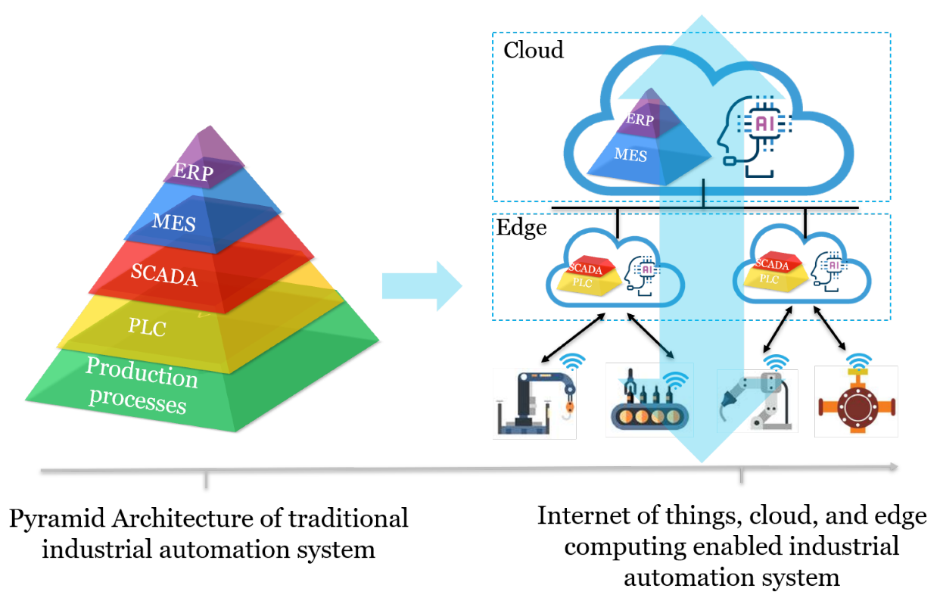
Figure 1 Evolution from Traditional Industrial Automation to IoT-, Cloud-, and Edge-Enabled Industrial Systems.
Source: [1]
It is critical that organisations have effective governance principles, compliance frameworks and data security considerations in place to maintain the confidentiality, integrity, and availability of information assets of consequence. Data security governance provides the strategic direction, policies, and accountability required to manage organisational information security, while compliance ensures adherence to legal, regulatory, and industry standards such as GDPR and ISO/IEC 27001[2]. As a combined strategy, governance and compliance help organisations build their cyber resilience and manage organisational risks, while also fostering trust with stakeholders in a constantly changing threat environment. This report analyzes the security risks, governance issues, and compliance problems that are occurring with AeroLink Logistics (ALL), a multi-national logistics company that has adopted a variety of cloud-based services, IoT-based tracking systems, outsourced facilities, and remote operations.

Case Scenario Analysis
AeroLink Logistics (ALL) works in a logistics environment that has heavily embraced technology, including cloud computing, IOT (Internet of Things) devices, artificial intelligence (AI), and outsourced digital services to support global operations. Though these technologies provide operational efficiency and real-time visibility, the overall security posture in this example shows serious gaps and vulnerabilities that can put the organisation at risk for cyber threats, regulatory non-compliance, and operational disruptions. Around 88% of the organisation's IT infrastructure is outsourced to Infrastructure-as-a-Service (IaaS) and Software-as-a-Service (SaaS) providers, which means that the organisation has a very high attack surface with little control over critical information assets.

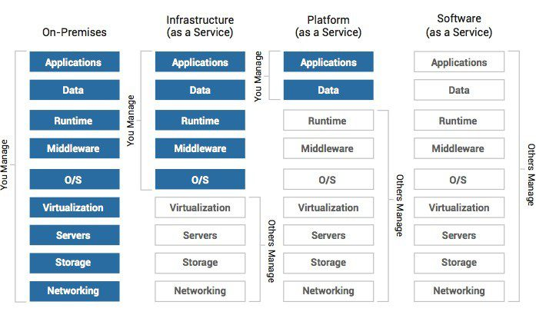
Figure 2 Shared Responsibility Model Across On-Premises, IaaS, PaaS, and SaaS Cloud Service Models
Source: [3]

A lack of a program for vendor governance results in weak security assurance and accountability throughout the supply chain. In addition, using devices like sensors with IoT technology and understanding the big data with the help of AI opens new risks arising from the insecure devices, integrity of the data and unauthorized access to the system, unless the technology is deployed consistently and with secure measures.
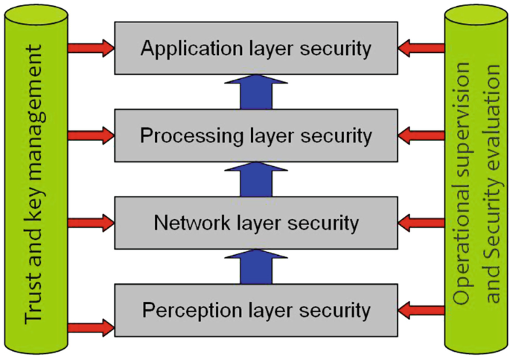
Figure 3 Multi-Layer IoT Security Architecture
The use of remote working practices coupled with unmanaged user devices deployed from various cities, locations and regions around the world, further compromises the security landscape [4]. The lack of standardized endpoint security, robust identity verification and centralized access management puts businesses at risk of credential theft and unauthorized access of critical business systems. Recently, data loss experienced by clients involving shipment information, personally identifiable information (PII), and weaknesses in data protection systems, encryption methods, and ongoing security monitoring suggest that there is a lack of data protection, encryption, and ongoing security monitoring.
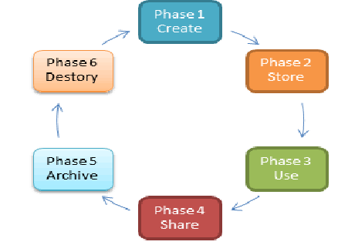
Figure 4 Data Lifecycle Phases for Secure Information Management
Source: [5]
The incidents also reveal gaps with governance as the organisation still does not have a coherent security architecture, a well-defined security policy framework and an enterprise-wide process for risk management. Furthermore, without proper compliance with internationally recognised standards, like ISO/IEC 27001 and data protection laws, like GDPR, ALL is put at risk of getting penalised, in addition to reputational harm and loss of customer trust.
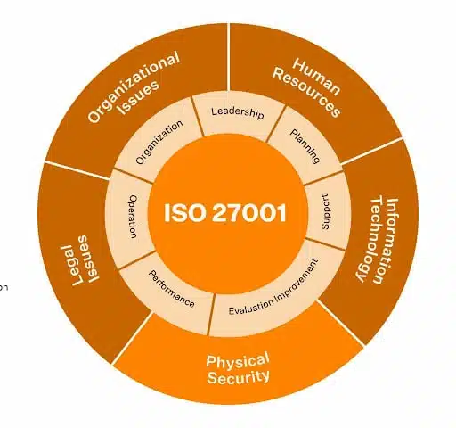
Figure 5 ISO/IEC 27001

Security Framework Research

NIST Cybersecurity Framework (CSF) 2.0
The NIST Cybersecurity Framework (CSF)2.0 is a new framework developed by the National Institute of Standards and Technology (NIST) that offers a risk-based manner for managing cybersecurity across organizations of all sizes and industries[6]. The framework was released in 2024 and can now be applied to ANY infrastructure, as in the recent release of the Govern function, alongside the Identify, Protect, Detect, Respond and Recover functions. This improvement highlights executive accountability, Cyber security governance, organisation risk management and continuous improvement.
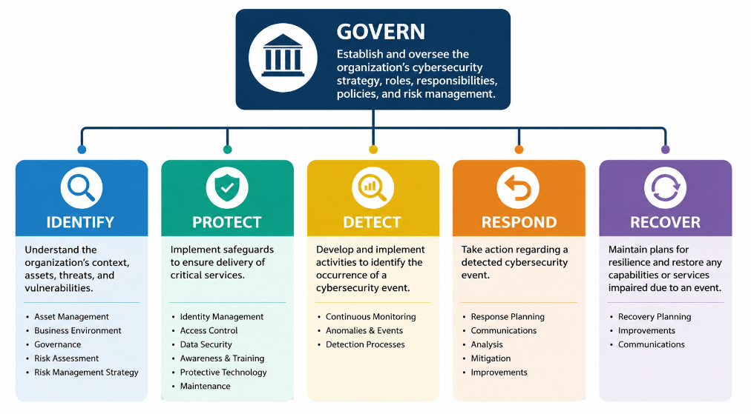
Figure 6 NIST Cybersecurity Framework (CSF) 2.0 Core Functions
Source: Created by using draw.io
The NIST CSF 2.0 offers AeroLink Logistics a structured approach to the identification of some areas of weakness from its perspective. The Govern function addresses the lack of coordinated governance of the company by establishing roles, policies and risk owners of security. The Identify function allows extensive cloud service, IoT, AI and outsourcing asset inventory and risk assessment. Protect adds additional identity and access management, encryption and Zero Trust controls to ensure the security of data for the customer and to protect personally identifiable information (PII). The Detect, Respond, and Recover features enhance Resilience, Incident Response, and Continuous Monitoring after a Cybersecurity Incident[7]. The key benefits of NIST CSF 2.0 are its flexibility and risk-driven nature, enabling organisations to make use of current security methods and adjust controls to meet business goals instead of following a rigid set of rules.

ISO/IEC 27001:2022 Information Security Management System
The new ISO/IEC 27001:2022 is the new internationally recognised standard for creating, building, developing and constantly enhancing an Information Security Management System (ISMS). Unlike the guidance-based frameworks, ISO 27001 offers certifiable requirements that allow organizations to systematically safeguard information assets using risk-based IT security control, governance processes and continuous improvement. The standard uses the Plan-Do-Check-Act (PDCA) cycle, which is used to ensure that information security is in line with organisational goals and changing threat scenarios[8].
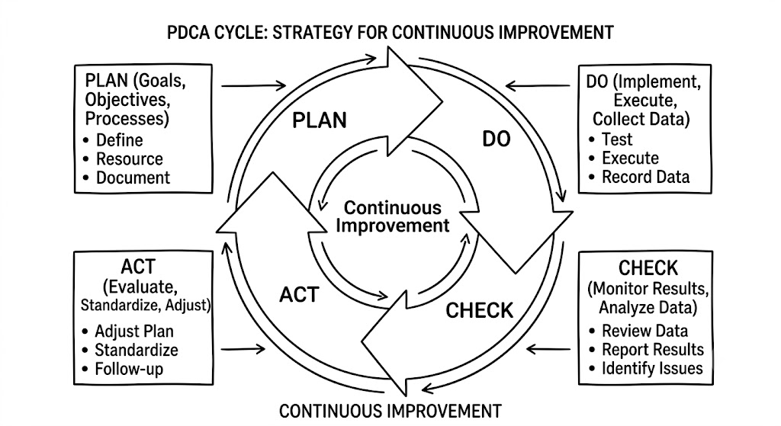
Figure 7 Plan-Do-Check-Act (PDCA) cycle
Source: Create using draw.io
For AeroLink Logistics, ISO/IEC 27001 goes on the nose into the dearth of a formal security management framework. They need to have security policies documented, undertake periodic risk assessment, prioritise information resources, deploy technical and organisational security controls, and keep monitoring security effectiveness. These practices would make a huge contribution to the governance of ALL and to the protection of customer data, cloud-based services, AI platforms and IoT devices. One of the major advantages of ISO/IEC 27001 is its universal recognition of the certification process, signifying compliance with regulations, build customer trust, and positively impact supplier reassurance throughout global business operations.

COBIT 2019 Governance Framework
COBIT 2019, created by ISACA, is an extensive governance and administration body that helps organizations incorporate data technological innovation with strategic business goals, control and measure performance, and effectively manage risk and regulatory compliance. COBIT's emphasis is on governance (at the executive level), decision making bodies, accountability and the creation of value through well founded governance processes whereas the technical security frameworks are more about technical security measures[9].
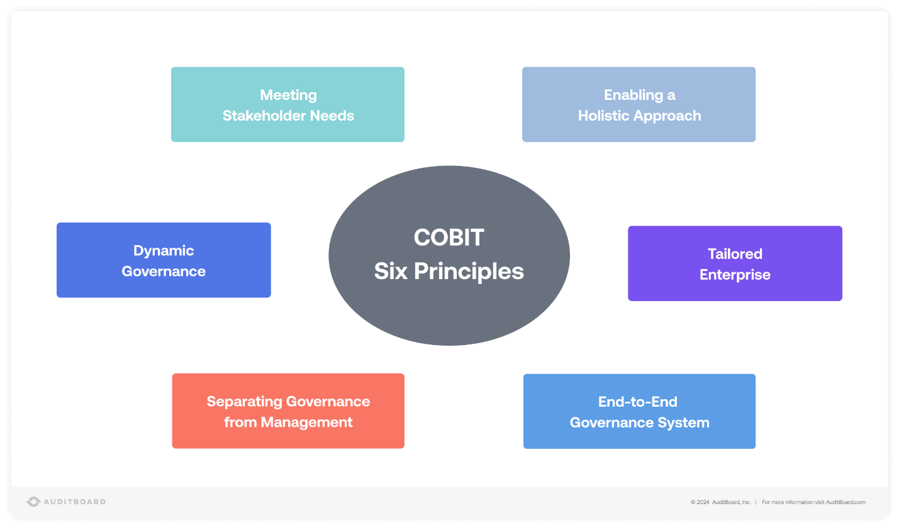
Figure 8 COBIT 2019 Governance and Management Framework
COBIT 2019 reflects one of the biggest shortcomings of the organisation – the lack of Executive level security governance and explicit accountability. The framework allows senior management to set up governance committees, define security duties, track organisation's progress and make sure that any investment in security is in line with business priorities. Moreover, COBIT enhances vendor governance by setting management guidelines for external service providers, a key skill as around 88% of ALL's infrastructure is outsourced. A key benefit of COBIT is that it brings together governance, compliance, risk management and performance in one enterprise-wide framework.

ITIL 4
ITIL 4 is an IT Service Management (ITSM) framework recognised worldwide for driving the continuous improvement of IT services and effective service governance to deliver secure, reliable and value for money services[10]. The frame work embraces the Service Value System (SVS) including governance, service management practices, continual improvement and stakeholders value.
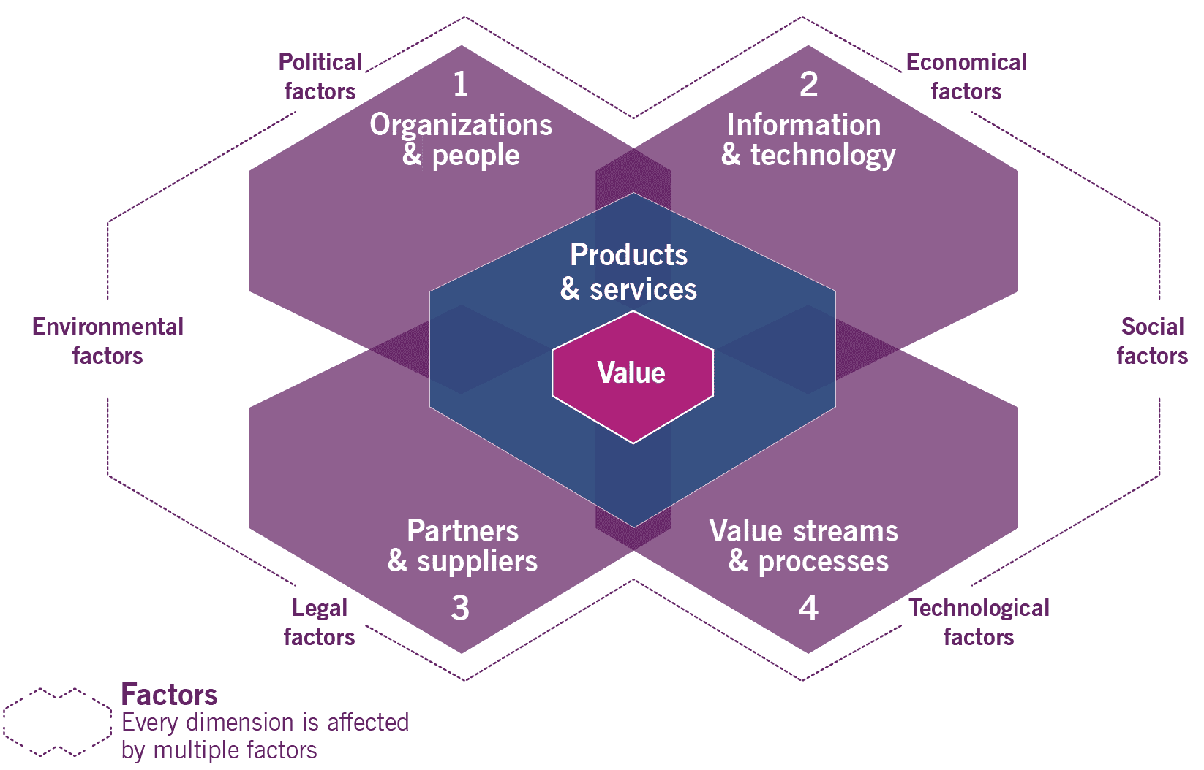
Figure 9 ITIL 4 Service Value System (SVS) and the Four Dimensions of Service Management
While ITIL 4 is not a cybersecurity subject, the principles are largely reinforced in operational security by IT change management procedures, incident management, problem management, configuration management, and service continuity management. To AeroLink Logistics, ITIL will help the organisation to handle a variety of security incidents efficiently, reduce operational disruptions, increase availability of their services, and assist in cases of severe business interruptions that may occur in multi-cloud architectures. The biggest gains of using ITIL are that they can improve the performance of the operations and make the delivery of IT services more standardised.

Proposed Security Governance and Compliance Framework for AeroLink Logistics

Proposed Governance Structure
AeroLink Logistics (ALL) should solve the governance issues it identified, including a proposed centralised cyber security governance. The framework provides clear accountability by codifying executive leadership, operational security teams, compliance capabilities and third-party vendor oversight into one set of governance. A dedicated Cybersecurity Steering Committee is responsible to the Board of Directors for directing governance, risk management, compliance and cyber business resilience programs, and cyber investments are directed by the Board of Directors. The Chief Information Security Officer (CISO) will be responsible for the organisation's overall security strategies, and coordinating the organisation's security operations, in addition to reporting on the cyber risk of the organisation to the executive management.

Security Policies
ALL should establish a complete framework of information security policy in accordance with ISO/IEC 27001:2022 and the directions of the organisation. Information Technology policies should cover: Information Security Policy, Access Control Policy, Data Classification Policy, Acceptable Use Policy, Incident Response Policy, Remote Working Policy, Vendor Security Policy, Backup Policy and Business Continuity Policy. Responsibilities, security requirements, enforcement provisions, and review dates should be specified in each policy[11]. By standardizing security policies across departments, the organization can ensure consistent implementation of security controls, eliminating operational inconsistencies that have led to data breaches in the past.

Enterprise Risk Management Framework
Implementation of a continuous risk management programme should be guided by the NIST Cybersecurity Framework and consider ISO 27005 risk assessment principles. Risk management should be a continuous program that involves the following steps: Risk identification, Asset identification, Vulnerability assessment, Risk evaluation, Treatment planning, Continuous monitoring, Periodic review. Cloud platforms, AI analytics, IoT sensors, customers' databases and third-party services are just some examples of critical assets that should be assessed regularly for accessibility and business impact[12]. The High-risk findings results should be addressed immediately using technical controls, changes to policy or the transfer of risk. By monitoring constantly, with Security Information and Event Management (SIEM) systems, you can detect new threats and have executive management supervising all the risks at play in the enterprise.
Table 1 Risk Assessment Matrix
Risk | Likelihood | Impact | Risk Level | Mitigation
Cloud Misconfiguration | High | High | Critical | CSPM, Continuous Auditing
IoT Device Compromise | High | Medium | High | Device Authentication
Credential Theft | High | High | Critical | MFA + Zero Trust
Vendor Data Breach | Medium | High | High | Vendor Security Audits
Ransomware | Medium | High | High | Immutable Backups & EDR

Zero Trust Security Architecture
Traditional perimeter security is not enough in today's world of NOT anywhere, NO infrastructure but cloud-first, and NO workers but outsourced. The expectation therefore is for a Zero Trust Architecture (ZTA) to be in place where the axiom "Never Trust, Always Verify" is followed. All users, devices, apps and workloads need to be continually authenticated and authorized to access organizational resources. The decisions made should take into account user identification, device health, location, behavioural analytics and risk scores. Micro-segmentation should restrict sensitive workloads in order to reduce the scope of lateral movement in a cyberattack.

Identity and Access Management
Access control should be the base of ALL's use of Identity and Access Management (IAM). Allow them to only access the systems in which they need to have access, provide RBAC (Role Based Access Control), and use Privileged Access Management (PAM) for privileged accounts. All users, especially administrators, remote workers and third-party vendors, should be required for multi-factor authentication[13]. Frequent access reviews, automated account provisioning and behaviour monitoring should detect and prevent dormant accounts, over-privileges and unusual authentication activities to bring security to a large extent into the enterprise.

Business Continuity and Disaster Recovery
Cyber Incident or Infrastructure Failure Business continuity planning should provide availability of critical logistics operations. The recovery time objectives (RTO) and recovery point objectives (RPO) should be used to prioritise critical business in the way of service delivery. Using cloud-based backups, geographically distributed DR sites, immutable backup storages, and regular testing of the DR process will help to minimise the operational disruption. Disaster recovery exercises should be conducted every year to test organisation readiness and keep recovery process current with evolving business/existing technology environment.

Compliance Strategy (GDPR & ISO/IEC 27001)
To ensure regulatory compliance, AeroLink Logistics (ALL) should establish an enterprise-wide compliance programme aligned with the requirements of the General Data Protection Regulation (GDPR) and ISO/IEC 27001:2022. The programme should include comprehensive compliance monitoring, regular audits, policy reviews, employee awareness and training, and continuous risk assessments.

Implementation Roadmap
The implementation should be staged to avoid disruption during operations and sustainable change for the organisation. In the first phase, the organization's governance can be set up, a holistic security risk assessment can be carried out, and security policies can be formulated. Security controls that include Zero Trust Architecture, Identity and Access Management, encryption and SIEM monitoring should be put in place in the second stage. The third phase should deal with collaboration with certification authorities to get ISO/IEC 27001 certified, auditing the compliance of GDPR, performing vendor security tests, and undertaking business continuity testing.
Table 2 Implementation Roadmap
Phase | Activities
Phase 1 (0–3 Months) | Governance, policies, risk assessment
Phase 2 (3–6 Months) | Zero Trust, IAM, encryption, SIEM
Phase 3 (6–12 Months) | ISO 27001 implementation, GDPR audits, vendor governance
Phase 4 (Ongoing) | Continuous monitoring, awareness training, governance reviews

Importance of Continuous Updates to Regulations and Standards
In a fast-changing cybersecurity landscape, organisations face a constant challenge to review and revise their security policies, governance structures and technical solutions to maintain cyber resilience against the newest cyber threats. Internet of Things (IoT) product and productivity innovation is important, and for companies like AeroLink Logistics (ALL), which heavily depend on cloud computing, outsourcing, digital products and advanced technologies like AI, static security programmes are quickly rendered obsolete. AI has had a profound impact on defense and attack in cybersecurity. AI can help automate threat detection and behaviour analytics, but the cybercriminals can also use AI for creating agile and advanced phishing campaigns, malware variants, credential attacks, and automated recon methods[14]. Organisations must therefore regularly review their detection strategies and awareness-raising initiatives, as well as their governance policies, to effectively challenge the threats posed by AI. Likewise, the proliferation of the cloud and IoT technology has made organisations vulnerable to attack in multiple ways. The fact that cloud environments are constantly evolving through multi-cloud deployments, application programming interfaces (APIs), and dynamic workloads and the increased vulnerability of IoT devices which are victims of weak authentication creates an intricate burden on the organizations. Continuous assessment, configuration and vulnerability management is, consequently, important in maintaining a safe operating environment. With ransomware and supply chain attacks continuing to show there are cyber threats outside the organisation. Multi-organization attacks are becoming common as attacks target third-party vendors, managed service providers and vulnerabilities of the software and dependencies in use. Evaluating vendors, reviewing security measures in contracts, and ongoing compliance check with external service providers become key pieces of enterprise governance, as AeroLink Logistics relies heavily on outsourced infrastructure and vendors. The regulatory requirements are also prone to changes more regularly to meet new edge-cutting concerns on privacy and the technological developments. Gaps in regulations, such as the General Data Protection Regulation (GDPR), and new security controls of cloud services, threat intelligence, data masking, and the secure development practices are filled in regularly by new regulatory guidance and enforcement requirements, such as the ISO/IEC 27001:2022 standard[15]. In both instances, the NIST Cybersecurity Framework 2.0 helped to improve the organisational governance changing the Framework by including the Govern role and assigning executive responsibility and cross-enterprise management of cybersecurity risk. Organisations should put continual monitors, security measurement and audit, governance examination, and legal and regulatory review, staff awareness, and periodic evaluation of the controls in place with respect to future threats and their overall compliance with law and industry standards.

Conclusion
In this report, current cybersecurity, governance, compliance matters that AeroLink Logistics (ALL) is experiencing were analyzed and various crucial points were made concerning outsourced infrastructure, cloud computing application, Internet of Things (IoT) technology, remote operations, inadequate governance and insufficient compliance. After careful consideration of existing cybersecurity standards, such as NIST Cybersecurity Framework 2.0, ISO/IEC 27001:2022, COBIT 2019, and ITIL 4, it was concluded that none of these frameworks alone makes it fully compliant with the organisation's risk and compliance needs. Consequently, a strategic governance, enterprise risk management, Zero Trust Architecture, Identity and Access Management, vendor security governance, Incident response planning, business continuity plan and continuous compliance monitoring were suggested to be incorporated into a governance model. This integrated solution increases the resilience and effectiveness in organisations, satisfies regulatory needs and offers accountability on all business matters.

Bibliography
[1] | Y. Liu, Z. Ni, M. Karlsson, and S. Gong, “Methodology for Digital Transformation With Internet of Things and Cloud Computing: A Practical Guideline for Innovation in Small- and Medium-Sized Enterprises,” Sensors, vol. 21, no. 16, p. 5355, Aug. 2021, doi: https://doi.org/10.3390/s21165355.
[2] | L. Magnusson, S. Iqbal, P. Elm, and F. Dalipi, “Information Security Governance in the Public Sector: Investigations, Approaches, Measures, and Trends,” International Journal of Information Security, vol. 24, no. 4, July 2025, doi: https://doi.org/10.1007/s10207-025-01097-x.
[3] | The Acora Press Team, “IaaS, PaaS & SaaS Explained,” Acora, May 30, 2018. https://acora.com/news/archive/iaas-paas-and-saas-explained/ (accessed July 29, 2026).
[4] | K. Qollakaj, L. E. Larsson, and S. Memeti, “Cybersecurity of Remote Work Migration: A Study on the VPN Security Landscape Post Covid-19 Outbreak,” Array, vol. 27, p. 100437, June 2025, doi: https://doi.org/10.1016/j.array.2025.100437.
[5] | N. Hemalatha, A. Jenis, A. Cecil Donald, and L. Arockiam, “A Comparative Analysis of Encryption Techniques and Data Security Issues in Cloud Computing,” International Journal of Computer Applications, vol. 96, no. 16, pp. 1–6, June 2014, doi: https://doi.org/10.5120/16875-6873.
[6] | A. Dimakopoulou and K. Rantos, “Comprehensive Analysis of Maritime Cybersecurity Landscape Based on the NIST CSF V2.0,” Journal of Marine Science and Engineering, vol. 12, no. 6, p. 919, June 2024, doi: https://doi.org/10.3390/jmse12060919.
[7] | A. Aljohani, “Zero-Trust Architecture: Implementing and Evaluating Security Measures in Modern Enterprise Networks,” SHIFRA, vol. 2023, pp. 60–72, July 2023, doi: https://doi.org/10.70470/shifra/2023/008.
[8] | C. L. Cofino et al., “New Management Standard for Digital Data Protection Using a PDCA Model Anchored to ISO/IEC 27001 and R.A. 10173,” International Journal of Emerging Technology and Advanced Engineering, vol. 13, no. 5, pp. 84–89, May 2023, doi: https://doi.org/10.46338/ijetae0523_08.
[9] | Á. Vaya-Arboledas, M. Ferrer-Oliva, and J. A. Medina-Merodio, “Evolution and Perspectives in IT Governance: A Systematic Literature Review,” Computers, vol. 14, no. 12, p. 520, Nov. 2025, doi: https://doi.org/10.3390/computers14120520.
[10] | M. Saraiva and R. Ribeiro, “Analysis of the ITIL V3 and 4, Exploring the Impacts on ITSM of Implementing the New Version,” AIS Electronic Library (AISeL), 2025. https://aisel.aisnet.org/capsi2025/28/
[11] | A. Mishra, Y. I. Alzoubi, A. Q. Gill, and M. J. Anwar, “Cybersecurity Enterprises Policies: A Comparative Study,” Sensors, vol. 22, no. 2, p. 538, Jan. 2022, doi: https://doi.org/10.3390/s22020538.
[12] | Ioannis Chrysovalantis Panagou, S. Katsoulis, Evangelos Nannos, Fotios Zantalis, and Grigorios Koulouras, “A Comprehensive Evaluation of IoT Cloud Platforms: A Feature-Driven Review With a Decision-Making Tool,” Sensors, vol. 25, no. 16, pp. 5124–5124, Aug. 2025, doi: https://doi.org/10.3390/s25165124.
[13] | S. VITLA, “Role-Based Access Control (Rbac) and Its Impact on Organizational Cybersecurity Policies,” Jan. 2025, doi: https://doi.org/10.2139/ssrn.5079310.
[14] | N. Mohamed, “Artificial Intelligence and Machine Learning in Cybersecurity: A Deep Dive Into State-of-the-Art Techniques and Future Paradigms,” Knowledge and Information Systems, vol. 67, pp. 6969–7055, Apr. 2025, doi: https://doi.org/10.1007/s10115-025-02429-y.
[15] | C. Labadie and C. Legner, “Building Data Management Capabilities to Address Data Protection Regulations: Learning From EU-GDPR,” Journal of Information Technology, vol. 38, no. 1, pp. 16–44, Nov. 2022, Accessed: July 29, 2026. [Online]. Available: https://journals.sagepub.com/doi/pdf/10.1177/02683962221141456

