12/02/2020

'I've sacrificed my sanity for work': TV workers on mental-health crisis in the industry

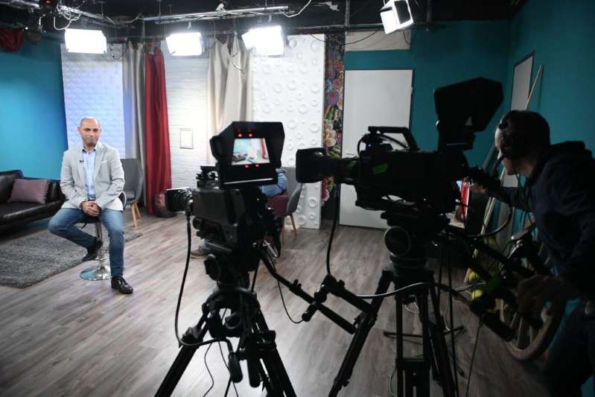

The first time Alicia* made coffee for one of her bosses, he poured it over her shoes and told her to “try harder”. Instead of using her name, he called her “Number Five”, because he referred to members of his team by numbers, which related their importance.
“And he loved me!” she says. “This is the way he treated someone he thought was amazing.”
As a third assistant director (AD) in film production, this is just one of the horror stories Alicia, 31, recalls from her seven years in the industry, and she isn’t alone.
A ground breaking study by the Film & TV Charity has revealed shocking working conditions and a mental health crisis among those who work behind the camera in the UK film and TV industry. According to its findings, 87 per cent of workers in the industry have experienced mental health problems compared with 65 per cent in the general population, and more than half have considered taking their own life.

Bullying, low pay and sexual harassment
Along with bullying, more than 9,000 respondents to the study cited long and irregular working hours, social isolation, low pay, sexual harassment and a lack of support as reasons for poor mental health.
Alicia isn’t surprised. On another set, she was bullied so badly she “genuinely contemplated driving into oncoming traffic. I didn’t see how I could cope with the situation.”
Since allegations about Harvey Weinstein were made public in October 2017 helped kickstart the #MeToo movement, the entertainment business has been reflecting on its failures. With evidence of systemic sexual harassment and bullying, as well as woeful diversity statistics, the sparkle is rubbing off the world’s most glamorous industry. There have been calls for change, from suggestions of inclusion riders (contractual demands for gender and racial equality) to intimacy co-ordinators (to ensure professionalism during the filming of sex scenes).
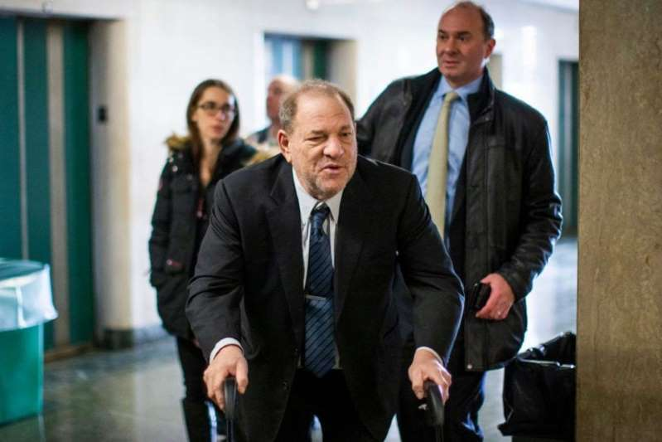

Industry insiders suffering in silence
But while much has been promised, the majority of the attention has remained focused on the on-screen talent. Alex Pumfrey, CEO of the Film & TV Charity, says that this report is evidence that the estimated 260,000 people working behind the scenes across the UK, the people she considers “the lifeblood of our creative industry” are suffering in silence. “The majority of our industry is a freelance workforce for whom the person that you might talk to about your mental health, is also the person who would hire you for your next job,” she says. “So the tendency is to keep quiet.”
This has been Stephen’s* experience as a director and producer with more than 20 years in television. “If you air any kind of grievance as a freelancer, you’re exposing yourself to losing that contract and jeopardising future employment,” the 43-year-old says. “In my area, TV is all about returnable contracts [shows with multiple series] so you simply cannot sour any of those relationships. It really leaves you nowhere to go.”
Stephen’s ex-wife also worked in the industry but the relationship “didn’t really stand a chance” against financial instability and extensive travel. His dream of being a stay-at-home dad when their children were young wasn’t an option. “It’s incredibly hard maintaining relationships,” he continues. “I’ve missed weddings, Christmases, funerals and birthdays. I love what I do and I’ve made a decent living from it but in reality, I’ve had to make a lot of sacrifices, not least of all my sanity.”

Unsustainable commitment and sleep deprivation
Alicia says that the industry requires “unsustainable” commitment and blames sleep deprivation, in particular. For the duration of projects, “you’re theirs”, she says. “You’re constantly in a wave of never knowing what day it is, what time it is, what’s normal, what’s not normal.” Despite living with a chronic health condition, Alicia tries to hide the symptoms at work: “You can’t have [a condition], so I don’t. It can’t affect you.”
The industry’s culture of stoicism leaves vulnerable people isolated and only 7 per cent say they would approach a manager with a mental health issue. “That you have to tough it out is widely accepted as the way the industry works and that’s really problematic. It’s also exclusionary,” says Pumfrey. “If you don’t conform to the norm then it’s much more challenging for you to speak up.” The report shows that BAME, LGBTQ+ and disabled workers suffer even worse with poor mental health and feel even less well supported than their peers.
The fluidity of the industry makes it difficult to identify patterns and keep tabs on people; it’s easy to slip through the cracks. Pumfrey describes it as “a lack of responsibility for people” and the first step towards change is to acknowledge this. Working with Mind, the Film & TV Charity is launching an urgent two-year response in April, as part of a 10-year plan. With £3m investment, it will initially focus on addressing bullying, an improved support helpline and working alongside a new Film and TV Taskforce on Mental Health made up of industry leaders, who Pumfrey says are open to change: “They haven’t been in the slightest bit defensive. There’s been a sort of sad recognition that this is the case, coupled with a real willingness to change it.”

'I don't like the industry, but I love the job'
Despite this evidence, the UK’s film and TV industry is still an incredibly desirable place to work. So competitive in fact, that workers are all too aware of the queue of people willing to take their place – the most common words respondents used to describe themselves were “disposable” and “expendable”. So why stay? “Despite everything, I love working in telly,” Stephen says. “I cannot imagine doing everything else.”
Alicia agrees: “I don’t like the industry; I love the job. It’s my personality in a job. For me, it’s just like breathing. But is it worth more than my health? No, absolutely not.”

The Film & TV Charity findings
Two in three workers have suffered from depression. 25 per cent have self harmed –three times the national average. One in 10 has attempted to take their own life. 84 per cent have witnessed bullying at work. Two thirds have considered leaving the industry due to mental health concerns. Four in 10 women employees have experienced sexual harassment. Two thirds of women have been bullied in the workplace compared with half of men. 43 per cent said fear of losing future work had prevented them from seeking help.
*Names have been changed

Q: Identify the number of problems faced by the ‘TV workers on mental-health crisis in the industry’ and recommend solutions to solve these problems.
https://inews.co.uk/culture/television/mental-health-bullying-tv-industry-397207
accessed on 09/10/2020

