

Programs: MSc Public Health and Social Care in Practice
Module: Health Care System Organisation and Leadership
Module code: LCHS7002
Assignment Title: Case Study Analysis Report
Professor: Dr. Pascal Navelle
Case study 2

Student name: Mohammad Samir Shaikh
Student ID number: 2535799
Abstract
The key aim of this report is to examine the complex and interacting systemic vulnerabilities in Patient X's case. It has been recognised that the need to follow a temporary clinical interruption for a minor bleed with a subsequent minor medical procedure. Ineffective bed management and flow prioritisation within Patient X’s case signified the presence of operational and regional governance weaknesses. Empowering frontline clinicians such as resident doctors, ward nurses, and allied health professionals can be helpful for making strong clinical governance. Thus, providing frontline medical teams with mobile workstations and unified digital task-management systems can eliminate paper-based workarounds, transcription errors, as well as address delayed prescribing.

Keywords: Health Care System, Leadership, Person-centred services, multi-departmental delays, bed capacity mismatches and poor communication.

Table of Contents
Introduction 5
Main Body and Analysis 6
a. Problem and Setting the System Context- Applying Systems Thinking and the Rich Picture 6
b. Centralisation or Decentralisation within the Case Study 10
c. Leadership Theories and Application to the Case Study 13
d. Improvement and Lessons Learned 17
Recommendations 20
Conclusion 21
Reference 22

List of figures
Figure 1: Prevalence of global medication error reporting market growth in 2026 7
Figure 2: Rich Picture diagram 9
Figure 3: Root cause analysis using Fishbone diagram 10
Figure 4: Leadership models for the Patient X 13
Figure 5: Right implications for clinical governance 16

List of Tables
Table 1:CATWOE framework 19
Table 2: Identified problems and their probable improvement 20

Introduction
Background and purpose of your chosen case study
The report aims to investigate a critical patient safety incident within the Health Services Safety Investigations Body (HSSIB). Patient X, an 87-year-old male, suffered from a fatal ischemic stroke following a 10-day omission of his regular direct oral anticoagulant, apixaban (Hossib, 2026). The primary purpose of this report is to examine the complex and interacting systemic vulnerabilities in Patient X's case, such as spanning clinical decision-making, care pathways, bed capacity, cross-speciality communication, and digital health technology. The presence of such issues has been affecting health and care services to a great extent.
Context and importance of leadership styles in health and social care
Leadership within the health and social care context is considered to be a fundamental process of inspiring and influencing individuals, such as multidisciplinary teams, in terms of achieving shared, high-quality care goals and driving continuous improvement (Weiss et al., 2023). Leadership styles such as transformational, transactional and situational leadership are considered to be the most significant approaches for health and social care services. Demeke et al. (2024) have highlighted that effective leadership in health and social care relies on clear communication, emotional intelligence as well as compassion. In essence, analysing the potential leadership approach in the case of Patient X can help to deliver safe, high-quality, and person-centred services while supporting staff well-being.
Centralisation and decentralisation healthcare structure
It has been recognised that a centralised healthcare structure concentrates decision-making authority, strategic direction, and policy formulation at senior executive levels in terms of ensuring standardisation across an organisation (Shishkin et al., 2025). On the other hand, a decentralised healthcare structure delegates decision-making power down to frontline clinical teams by fostering rapid operational responsiveness and localised adaptability (Åhlin et al., 2026). In essence, understanding the form of healthcare structure under which Patient X was admitted can help this report suggest an effective leadership style in terms of addressing the issue faced by the patient.
Importance of leadership
It has been recognised that selecting appropriate leadership in health and social care is considered to be pivotal for ensuring high-quality patient outcomes, strong staff retention and overall organisational safety (Fadhel and Alqurs, 2025). Good leaders ensure care is safe, timely as well as focused on the needs of the people using the service.
Report structure
The report aims to evaluate systemic problems faced by Patient X by contextualising local clinical omissions within global, national as well as organisational safety statistics. Additionally, the report is going to develop a Rich Diagram of Patient X’s case scenario that comprises a complex interaction of clinical, governance, and structural factors. Apart from this, the need for effective leadership for addressing the issues in the case of Patient X will be recommended within this report.

Main Body and Analysis

a. Problem and Setting the System Context- Applying Systems Thinking and the Rich Picture
The major and central issues in the case of Patient X are considered to be the failure to re-evaluate, manage as well as timely restart time-critical anticoagulant medication (apixaban). The case scenario illustrates a breakdown in perioperative anticoagulation management during care transitions and procedure delays. Moster and Bolliger (2022) have highlighted that perioperative anticoagulation management involves stopping and restarting blood thinners around surgery to balance bleeding and clotting risks. The need to follow a temporary clinical interruption for a minor bleed as well as a subsequent minor medical procedure. It has been recognised that Patient X’s apixaban was initially paused due to acute epistaxis (nosebleed) and kept paused while awaiting a pleural aspiration for worsening pleural effusion. The case scenario highlights that multi-departmental delays, bed capacity mismatches and poor communication caused the pause to stretch to 10 days.
Global statistical information reveals the problem
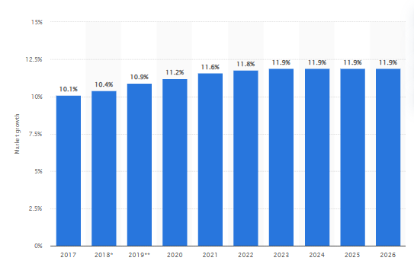

Figure 1: Prevalence of global medication error reporting market growth in 2026
(Source: Minhas, 2026)
According to the report of the World Health Organisation, the cost associated with medication errors has been estimated at 42 billion USD annually; however, it aims to reduce severe avoidable medication-related harm by 50% in the next 5 years (World Health Organisation, 2026). Apart from this, the key findings of Wudu et al. (2025) highlight that more than 53% of medication error-related harm occurs at the prescribing stage, while 36% occurs at the reporting stage. According to the report of Statista, about 44,000 to 98,000 people die annually due to medication errors in the U.S., making it the eighth leading cause of death in the country (Minhas, 2026). Additionally, the WHO also highlights that medication errors affect 1 in 30 patients globally, with over a quarter of these adverse events resulting in severe harm or death (World Health Organisation, 2026). The information signifies that the prevalence of such problems is increasing at a rapid rate and needs to be addressed in terms of addressing issues such as Patient X's case.
National statistical information reveals information about the problem
It has been recognised that medication safety incidents in the NHS UK consistently rank among the most frequently reported incidents to the NHS Learn from Patient Safety Events (LFPSE) database as well as Strategic Executive Information System (StEIS). For instance, 237 million medication errors occur in England annually, costing 462 582 euros and consuming 181 626 bed-days as well as contributing to 712 to 1708 deaths (Elliott et al., 2022). As per BBC News, patients in England were hospitalized for at least 14 days; an average of 1,791 a day were unable to be discharged due to the lack of a bed in a residential or nursing home (Maisner, 2026). Similar to the context, the new report by Bawden (2026) has highlighted that about 2,000 members of the public and NHS staff across England had experienced poor communication from the health service in the past 5 years, with 1 in 10 saying their care had been affected as a result. Thus, the prevalence of medication errors in the NHS is considered to be increasing at a rapid rate.
National organisations reveal the problem in connection with worldwide presentation
It has been recognised that adverse drug events present the single greatest risk of harm to patients in hospitals, as 10 to 20% of errors are ever reported and 90 to 95% cause no harm to patients (Ihi, 2026). Apart from this, older adults face the highest risk due to multiple health issues as well as taking many medicines at once. Thus, the report of IHI signifies a positive aspect of the problem.
Identifying the level of governance and explaining how this problem reflects systemic weaknesses
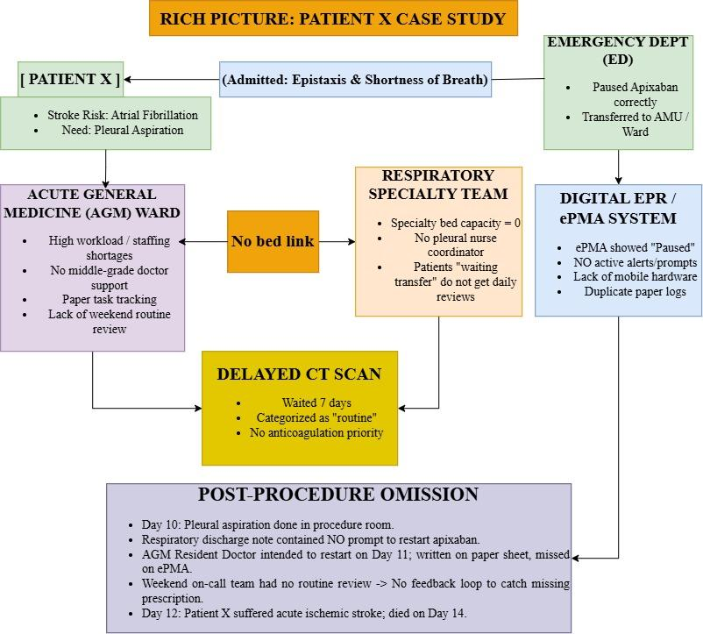

Figure 2: Rich Picture diagram
(Source: Self-developed)
The case scenario of Patient X illustrates systemic vulnerabilities across multiple levels of healthcare governance, such as clinical governance, regional governance and digital governance. The presence of outdated local clinical governance and lack of standardisation between acute general medicine and speciality teams has been identified as a systemic weakness of the Patient X case scenario. Hazwani et al. (2024) highlighted that outdated local clinical governance can lead to compromised patient safety, increased medical errors, and wide variations in the quality of care. Apart from this, ineffective bed management and flow prioritisation within Patient X’s case signify the presence of operational and regional governance weaknesses. Additionally, the presence of fragmented Electronic Prescribing and Medicines Administration (ePMA) and Electronic Patient Record (EPR) systems signifies digital governance failure. This signifies leadership failure in the case of patient X.
Data on underlying challenges to illustrate underlying challenges
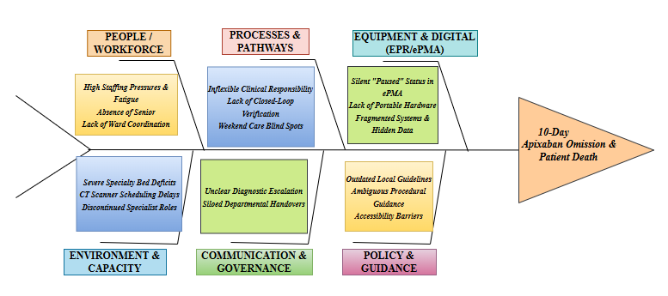

Figure 3: Root cause analysis using Fishbone diagram
(Source: Self-developed)
It has been recognised that the AGM medical team relied on paper handover sheets in terms of tracking pending tasks due to poor ePMA system usability as well as a lack of mobile hardware. The presence of such feedback loops is considered to be one of the potential challenges identified in the case of Patient X. As per the opinion of Wong et al. (2022), a negative reinforcement loop within healthcare task management can lead to severe burnout, chronic underreporting of errors, and compromised patient safety. Apart from this, the absence of Post-Procedure Safeguards has been another challenge monitored within the case of Patient X.
Rigorous analysis of Patient X’s case, a clear boundary gap existed between Respiratory and AGM teams. As per the opinion of Jerjes et al. (2026), a communication gap with healthcare management leads to increased medical errors, compromised patient safety and disrupted continuity of care. Apart from this, poor capacity and staffing interdependencies have been the potential challenges identified in the Patient X case. Thus, the identified challenges are required to be addressed in terms of enhancing health and care service qualities in the coming times.

b. Centralisation or Decentralisation within the Case Study
Rigorous analysis of Patient X's case reveals that it operates as a hybrid organisational model. As per the opinion of van der Weert et al. (2022), a hybrid organisational model is characterised by structural centralisation in policy governance, IT architecture as well as bed management. It also co-exists with decentralised, siloed clinical operations across speciality wards. However, centralisation aims to standardise quality and control resources, whereas decentralisation allows clinical adaptability. The presence of such an integration breakdown between these two structures created critical safety vulnerabilities that contributed directly to Patient X's adverse outcome.
Centralised systems:
- Explaining how decision-making is concentrated
It has been recognised that authority, policy formulation as well as resource control are considered to be concentrated at top-tier executive and administrative levels within a centralised healthcare system (Ramsay et al., 2025). For instance, the trust in which Patient X was admitted uses a centralised, single-supplier EPR and ePMA system (Hssib, 2026). As per the analysis of Scott et al. (2023), a single-supplier EPR system helps to make faster and safer clinical decisions by providing unified data access, built-in clinical decision support and a single source of truth. Apart from this, the case scenario also highlights that bed management is centrally governed by site matrons as well as bed management teams. Thus, the presence of poor decision-making within the system has led to a shortage of beds.
- Advantages and disadvantages
According to Sugadev et al. (2022), centralisation within healthcare promotes standardisation across different departments as well as allows high-level monitoring regarding trust-wide performance metrics. However, centralised policies as well as software designs lack operational agility. For example, the centralised ePMA system has allowed clinicians to pause apixaban but lacked a built-in automated prompt. It has been recognised that centralised guidelines have been critical to access by the trust.
- Support this discussion with relevant data
The analysis highlights that centralised scheduling delays within the Trust’s management signify that the patient’s apixaban was paused for 10 consecutive days without an automated system prompt. Apart from this, a routine CT scan requested on the second day of hospitalisation was delayed by 7 days due to the presence of centralised radiology (Hssib, 2026). This has prioritised the protocols that routinely pushed non-urgent inpatient scans behind urgent cases. Apart from this, the centralised system has interim guidelines that have governed Patient X’s apixaban by bridging therapy that had not been updated since December 2016, which is over 7 years overdue for review.
Decentralised systems:
- Distribution of Authority and Examples
Decentralisation delegates operational decision-making to local clinical teams, ward units, as well as individual specialities (Åhlin et al., 2026). Under the decentralised system, the clinical care and decision-making authority can rest strictly with the support of the local ward team where the patient physically resides. This system can promote speciality governance and set responsibility boundaries. Furthermore, the respiratory team did not maintain ongoing clinical oversight while the patient remained on AGM ward when a respiratory referral was accepted. On the other hand, the local units established informal, and decentralised adaptations due to system friction due to system friction. For instance, the respiratory staff printed the physical paper guide to bypass hard-to-navigate central intranet policies. In addition, the AGM resident doctors relied on informal paper handover sheets for tracking tasks despite the centralised digital task manager.
- Advantages and Disadvantages
Advantages of a decentralised system in healthcare include local decentralisation, grants for the frontline staff to make immediate clinical judgments for balancing acute risks. On the other hand, the disadvantages of decentralisation in healthcare leads to fragmented communication and inconsistent practice (Oliveira et al., 2023). The healthcare team performs independently of the primary ward team, resulting in a post-procedure care plan, and it can be the reason for failure to communicate instructions regarding restarting paused treatment.
- Supporting Numerical and Empirical Data
The zero respiratory reviews in 7 days, variable staff knowledge and inadequate medical staffing ratios are evidence of a decentralised system. For instance, the patient received zero specialty respiratory reviews while waiting on the AGM ward between referral acceptance on “Day 3 and the procedure on Day 10”. In addition, the decentralised protocols established clinical variation where ward nurses stated apixaban should be paused for 72 hours. Lastly, the 28-bedded AGM ward routinely managed 29 to 30 patients, which defines a lack of the “recommended middle-grade doctor for senior oversight”.
Critical analysis
It has been recognised that the hospital's structural configuration has hindered proactive crisis management, as the presence of centralised bed management has failed to account for dynamic clinical risks. However, Anumolu and Samant (2026) have argued that centralised bed management in a healthcare system can lead to shorter emergency wait times, faster bed turnaround and better resource use. On the other hand, the centralised EPR has failed to surface critical historical context during a previous cardiology stay of Patient X.

c. Leadership Theories and Application to the Case Study
Discussion of Relevant Leadership Theories
It has been recognised that in complex healthcare environments, leadership directly impacts clinical governance, operational performance and patient safety (Ahmed et al., 2026). In this NHS trust HSSIB case, there are three prominent leadership frameworks recognised.
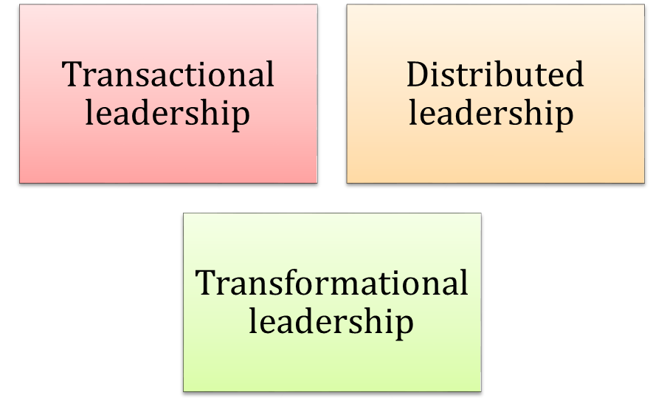

Figure 4: Leadership models for the Patient X
(Source: Self-developed)
The transactional leadership model relies on strict hierarchies, rigid process adherence and task-oriented supervision (Galloway, 2026). Implications of this model often foster transactional compliance rather than proactive risk management, while effective for immediate crisis stabilisation regarding treatment delay due to operational pressure. On the other hand, distributed leadership conceptualises that leadership does not always work as a top-down mandate held by a single individual. As per Silva et al. (2022), distribution of shared leadership in healthcare indicates the practices shared across multidisciplinary teams. This can empower frontline clinicians such as resident doctors, ward nurses, and allied health professionals. The case of Patient X can be handled in a prominent way depending on clinical autonomy, bridging operational silos, as well as continuously reassessing patient risk. Lastly, transformational leaders motivate workforce commitment through a shared vision, individual support and purpose-driven alignment (Lindstrom, 2025). It is paired with high emotional intelligence, including empathy, active listening, and situational awareness. Psychological safety within a critical healthcare environment can be established where staff feel empowered to use their voice for safety concerns of patient X and escalate dynamic clinical risks without fear of hierarchy pushback.
Connection of Theories to Case Study Examples
- Transactional Leadership in Ward Management
Considering the case of patient X, transactional leadership is recognised to apply in ward management. As per Pervaiz et al. (2024), transactional leadership helps in making clear decisions within a healthcare segment following ethical guidance and prioritising urgency. It has been recognised that the original decision related to pausing apixaban on Day 1 was clinically made due to nosebleeds. However, the leadership oversight is recognised to have defaulted to a rigid, transactional mindset as the patient’s condition stabilised. Transactional leadership can provide guidance on maintaining the “paused status” despite significant delays. On the other hand, clinical oversight remained strictly regulated by speciality protocol when the respiratory consultant accepted the referral on Day 3. No speciality bed was vacant, and clinical responsibility defaulted back to the AGM team without an ongoing respiratory review. The lack of a purpose-driven approach can be addressed through overarching clinical authority. It allowed the pause on a time-critical anticoagulant in order to extend to 10 consecutive days without a dynamic risk reassessment.
- Distributed Leadership Across Multidisciplinary Teams for Effective Performance
The critical situation of patient X happened due to communication silos and lack of frontline empowerment. It has been recognised that the patient's critical risk profile, the past stroke and atrial fibrillation, was accessible to EPR. However, it was never integrated into daily medical handovers. The lack of frontline empowerment defines the drainage procedure; a resident doctor intended to prescribe the restart of apixaban on the ePMA. As per the views of Debono et al. (2025), a high ward workload, competing tasks, as well as a reliance on informal paper tracking sheets in healthcare, influence the situation of task was omitted. In the NHS trust, systems such as double-check or active nursing were not recognised as mainly creating the safety buffers. Distributed leadership in healthcare provides guidance to the healthcare team to work with their own style, following ethical rules (Svensson and von Knorring, 2025). This empowerment of staff can make them concerned about patient safety and quality of services.
- Systemic Operational Pressures and Deficits in Transformational Governance
Leadership at a healthcare organisation demonstrated a reactive stance towards chronic resource constraints based on purpose-driven risk mitigation (Saldivar, 2024). The case of patient X has highlighted that leadership failed to focus on the ineffective safety-backed protocol for managing accepted patients awaiting transfer. In response to high patient demand as well as limited specialty bed capacity, the ward doctors were forced to re-refer delayed patients manually. In addition, the trust previously maintained a dedicated pleural nurse in terms of coordinating speciality transfers and procedures. Thus, implications of transformational governance promote situational awareness and influence the patient-centric system.
Synthesis of Supporting Performance Data, Safety Statistics, and Staff Engagement Evidence
The effectiveness and appropriateness of clinical leadership can be directly reflected through organisational safety metrics, staff feedback and performance data outlined through the investigation.
Clinical safety outcome data has indicated that the most critical performance indicator was the patient’s fatal ischaemic stroke on Day 12. It was directly tied to the 10-day interruption of apixaban as well as the subsequent failure to restart it post-procedure. On the other hand, the workforce and engagement evidence have been recognised through the interview. Interviews revealed that resident doctors and AGM wards explicitly raised concerns to the ward consultant. As per Miller and Hemberg (2023), heavy workloads, the lack of senior medical leadership, and high patient complexity are the core limitations of a healthcare system. Furthermore, the nursing leadership noted that the co-ordinators were present on only one out of six day shifts during the patient's stay. The structural deficit mainly created in this segment, where a deficit severely impaired the ward's capacity to follow up on mainly transfers and diagnostic scheduling.
Critical Evaluation: Appropriateness, Proactivity, and Alternative Leadership Approaches
- Appropriateness of the leadership style
It has been recognised that the dominant command-driven as well as compartmentalised leadership style was inappropriate for managing high-risk and dynamic inpatient care such as patient X. As per Alpert et al. (2026), command-and-control structures are applied to maintain order in acute emergencies; however, their application to routine inpatient flow often creates severe blind spots. Leaders operate in rigid operational silos by focusing on static local responsibilities rather than holistic patient safety, which made the situation more critical.
- Reactive vs. Proactive Leadership
Leadership throughout this safety event within the NHS trust was reactive as the system waited for clinicians on general wards to re-refer patients, even when the delays became excessive. In addition, the aspect of clinical urgency was not investigated while conducting a CT scan schedule. The ePMA system highlighted the medication as “paused” whereas ERP prompts to trigger mandatory clinical reviews.
- Ways that can be done differently
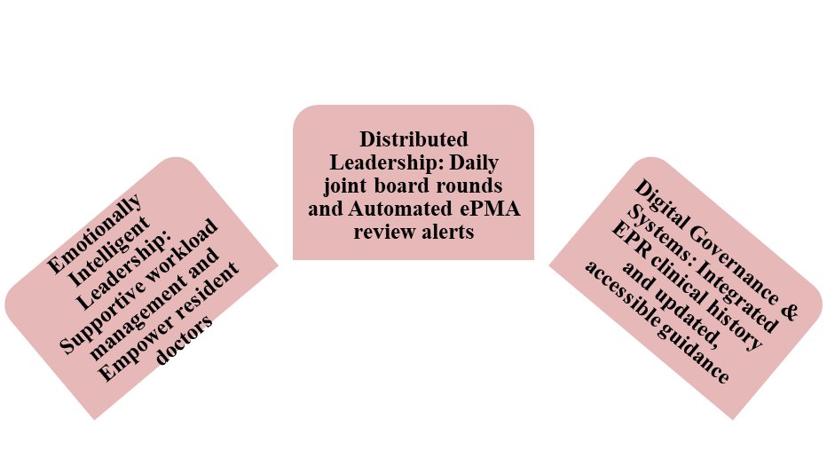

Figure 5: Right implications for clinical governance
(Source: Self-developed)
The above figure highlights the right implications for healthcare leadership with the target of effective safety management. For instance, distributed leadership includes daily joint board rounds and shared cross-speciality oversight. Purpose-driven leadership can prioritise psychological safety and supportive staffing allocations. Lastly, digital clinical governance can ensure streamlining task management, ensuring clinical guidelines are updated, peer-reviewed, and easily accessible.

d. Improvement and Lessons Learned
Critical evaluation of leadership and governance outcomes
Leadership and governance in hospital management provide a strategic roadmap and operational oversight that is required to deliver safe and high-quality patient care (Babu, 2024). Effective governance establishes the fiduciary boundaries, transparency, and accountability mechanisms which are necessary to achieve clinical, operational and financial objectives in preventing organisational challenges (Unver, 2023). In this case, interaction between leadership and governance shows a lack of clear ownership of the risk of anticoagulation and a fragmented decision-making environment. The governance structure of the organisation allocates specific guidance to leadership behaviour that helps to implement in practice and review this. According to the Health Services Safety Investigations Body, local pleural guidance existed, but it was found hard to access by the staff (HSSIB, 2025). Moreover, a separate bridging anticoagulation guideline was not revised for more than 7 years (Dresti, 2025). This insight demonstrates poor governance accountability for guideline currency and poor leadership in raising awareness of obsolete or duplicate documents. Therefore, in this case, governance was responsible for establishing the rules and leadership for applying them at the ground level, as well as both failed in implementation practice.
This interaction is also representative of the governance weaknesses of the system, which extend beyond this one Trust. Unsafe care delivery is a challenge that disproportionately impacts settings with governance mechanisms unable to ensure the implementation of the national safety policy at the local level (World Health Organisation, 2024). This is relevant to the case because national provision guidelines on bridging anticoagulation have already been made, but local practice has failed to include updated national guidelines. Additionally, there was a lack of leadership practice at the ward level in terms of political authority and awareness of challenges related to governance decisions regarding ownership guidelines. Therefore, effective improvement needs improvement in governance arrangements that ensure updated guidelines and leadership that has the mandate to identify gaps.
The institute also faces governance challenges, including a lack of integration of documents that are only available in the specialist and unable to provide organisation-wide control of clinical guidance. The pleurals excluded reviews from the areas of pharmacy and haematology and thus cross-speciality risk was unable to be considered (HSSIB, 2025). This illustrates the impact of multidisciplinary representation in governance, which can lead to a restricted leadership perspective. Furthermore, leadership models that emphasise autonomy of each speciality but lack a common escalation pathway facilitate specific shortcomings. Therefore, governance and leadership need to work hand in hand to resolve the issue of split ownership of patient risk.
Identification of missed opportunities and evidence-based solutions and discussion of the problems and solutions
Application of Soft Systems Methodology
Soft Systems Methodology (SSM) is a structured way of analysing complex, ill-defined challenges by comparing the actual problem situation with conceptual models of desired system behaviours. Application of SSM in the organisation helps to engage stakeholders in articulating the purpose of the system (Fountzoula et al., 2026). In this case, providing safe, continuous anticoagulation management from one care setting to another, which acts against the current practice.
Root definition: CATWOE Analysis
Element | Application to the Kota Case
Customers | Patient X and his family (They have experienced harm from missed medication)
Actors | Emergency, respiratory and general medicine doctors, nurses and pharmacists
Transformation | Successfully managing a paused apixaban prescription requires confirming adequate hemostasis and assessing thrombotic as well as bleeding risks by avoiding unnecessary delays
Worldview | Patient safety depends on continuous, shared clinical ownership across transitions.
Owners | Trust board, clinical governance leads and respiratory/general medicine leadership
Environmental Constrains | Bed shortages, staffing gaps, outdated guidance, and fragmented digital systems

Table 1:CATWOE framework
(Source: Self-developed)
The CATWOE table (Table 1) illustrates that leadership and governance responsibilities of the organisation have multiple owners, and they share multiple Actors, including the Emergency department, respiratory and general medicine doctors, nurses and pharmacists. This dispersal reduced governance, as there was a lack of clear accountability of the owner from paused to safety-restarted medicine. Moreover, worldview reveals leadership, and it also foresees continuous ownership as a shared cultural value across different transitions. This analysis demonstrates Environmental Constraints, including Bed shortages, staffing gaps, outdated guidance, and fragmented digital systems, which reduced leadership's ability to achieve consistent standards of governance within the HSSI trust. Therefore, CATWOE demonstrates that governance improvement needs leaders to actively manage environmental constraints without solely depending on policy in isolation.
Missed opportunities and evidence-based solutions
Problem 1: Fragmented speciality guidance led to ambiguity around the duration of the pause and who is responsible for reviewing the anticoagulation.
Data: Two different and unexplained pause durations were shown for apixaban on the local guideline table (HSSIB, 2025).
Improvement: The organisation needs to develop one multidisciplinary-reviewed anticoagulation guideline, in collaboration with the pharmacy and haematology teams.
Problem 2: The ePMA system failed to remind staff to reconsider a medication that had been on the 'paused' list for a long time and had a high-risk factor.
Data: There is a lack of automatic review prompts identified for paused anticoagulants in the digital prescribing system (HSSIB, 2025).
Improvement: The organisation needs to add a requirement that medications paused beyond a defined safe threshold are flagged on the digital alert system.
Problem 3: The patient was not being watched closely enough in bed while being transferred, and was not seen by a specialist for many days.
Data: There is a lack of respiratory bed capacity by the Trust in an entire afternoon, and then there was availability after the procedure (HSSIB, 2025).
Improvement: The organisation needs to implement shared accountability mechanisms with speciality review of all accepted referrals awaiting transfer, which includes contacting providers to make bed availability available to patients.

Table 2: Identified problems and their probable improvement
(Source: Self-developed)
Linking with findings
In this case, the multiple factors of system structure, system leadership and system feedback collectively prevented the identification of the missed medication restart early. However, the increasing risk is compounded by centralised guidance lacking multidisciplinary input and decentralised clinical discretion lacking shared accountability, and with no digital feedback loops. Other health organisations can learn that safety can be realised by having governance ownership and empowered leadership at each care transition. Evidence and data need to be part of routine cycles of governance review with the help of prompters on automated systems and regular multidisciplinary audits of guidelines to ensure ongoing improvement and accountability.

Recommendations
● Recommendation 1: Strengthening Governance, Guidance and Digital Systems
Standardised and consolidated guidelines maintenance is one of the main gaps within the treatment of Patient X. Addressing this problem, it is important to establish trust and an overarching multidisciplinary policy for peri-procedural anticoagulation. Radcliffe et al. (2023) have stated that guidelines on establishing multidisciplinary policy in the healthcare environment explicitly outline clear roles for reviewing paused medications as well as resolving historical ambiguities. During treatment pause durations such as patient X, cross-review by pharmacy, haematology, and specialty teams can manage the treatment flow in an effective manner. On the other hand, managing such critical healthcare cases is also handled through ePMA System Re-Engineering. Visual escalation and time monitoring are made easy using the software of ePMA System Re-Engineering (Bajmalu Rostami et al., 2024). In the case of Patient X, the clinicians can explicitly declare whether anticoagulation should be restarted, bridged, or kept on hold, analysing the previous dataset depending on the software.
● Recommendation 2: Enhancing Clinical Oversight and Efficiency
It has been recognised that the establishment of speciality in reach and transfer governance is suggested to the healthcare team to eliminate clinical “blind spots”. The trust can implement a daily multidisciplinary bed-management review and automatically flag any patient waiting over 24 hours for a speciality transfer (Hssib, 2026). On the other hand, providing frontline medical teams with mobile workstations and unified digital task-management systems can eliminate paper-based workarounds, transcription errors, and address delayed prescribing. By enhancing clinical oversight, patient treatment delays can be managed based on the critical situation of the patient (Anagi et al., 2025). Further efficiency of clinical governance can be promoted automatically when patients get timely treatment.
● Recommendation 3: Leadership Style for Sustained Improvement
Improvement of leadership style is one of the significant suggested areas to ensure a sustained environment in the current safety system. Based on the views of Alanazi et al. (2026), distributed leadership empowers ward nurses, resident doctors, as well as pharmacists to actively double-check medication statuses and share clinical oversight across specialty boundaries. Senior executives and consultants can foster a culture of psychological safety by improving leadership. For cases such as patient X, leaders must actively listen to the frontline staff to manage the bed shortage and reporting workload pressure. Thus, the implication of shared or distributed leadership can encourage near-miss reporting without fear of blame.

Conclusion
It can be concluded from the above discussion that a failure to re-evaluate, manage, as well as timely restart time-critical anticoagulant medication (apixaban) were the key constraints of Patient X. The WHO also highlights that medication errors affect 1 in 30 patients globally, resulting in severe harm or death. In this case, the ineffective bed management and flow prioritisation within Patient X’s case reflect the presence of operational as well as regional governance weaknesses. This case indicates the need for centralisation that aims to standardise quality and control resources, whereas decentralisation allows clinical adaptability. Distribution or shared leadership in healthcare can promote the practices shared across multidisciplinary teams and address critical healthcare issues.
Leadership across a healthcare organisation used to demonstrate a reactive stance towards chronic resource constraints despite proactive as well as purpose-driven risk mitigation. The case of Patient X has highlighted the context of resource adaptations. The trust previously maintained by the team of dedicated pleural nurses. However, the post was disestablished because of financial constraints. Leadership relied on informal adaptations by frontline staff in response to high patient demand and limited speciality bed capacity. Therefore, the current leadership of this healthcare trust can be considered to have failed to establish a structured and safety-backed protocol for balancing the accepted speciality patients awaiting transfer.

References
- Åhlin, P., Almström, P. and Wänström, C., (2026). ‘Decision‑making in hospital‑wide patient flow: a multiple‑case study of leading academic hospitals’. Production Planning & Control, pp.1-19. Available at: https://doi.org/10.1080/09537287.2026.2655748
- Ahmed, S., Ashrafi, D.M., Ahammad, M.F., Rahman, M.K. and Sakib, M.N., (2026). ‘Role of governance on patient safety in private hospitals through the mediating effects of teamwork and continuous improvement’. International Journal of Quality & Reliability Management, 43(2), pp.406-434. Available at: https://doi.org/10.1108/IJQRM-04-2025-0115
- Alanazi, A.K., Traynor, M., McFetridge, L., McKeaveney, C. and Clarke, S.A., (2026). ‘Linking transformational leadership to patient care quality: the role of structural empowerment and registered nurses’ clinical leadership’. Journal of Nursing Management, 2026(1), p.7518764. Available at: https://doi.org/10.1155/jonm/7518764
- Alpert, E.A., Weiser, G., Kobliner-Friedman, D., Schwaber, M.J., Mayo, A., Kedar, R., Blumberg, N. and Merin, O., (2026). ‘The framework and best practices of emergency medical teams: lessons learned from Israel’s international field hospital response’. Israel Journal of Health Policy Research, 15, p.10. Available at: https://doi.org/10.1186/s13584-026-00751-6
- Anagi, S., Chamberlain, D., Taypin-Shaw, D., Jennings, C., Pusapati, R. and Lin, F., (2025). ‘Exploring delayed admissions to ICU: A qualitative study of clinician perceptions and observations of the ICU admission process’. Intensive and Critical Care Nursing, 89, p.104075. Available at: https://doi.org/10.1016/j.iccn.2025.104075
- Anumolu, S. and Samant, M., (2026). ‘Optimizing Hospital Bed Capacity: How Lean-AI Integration Prevents Capacity Constraints from Multiplying Demand. Intelligent Hospital, p.100048. Available at: https://doi.org/10.1016/j.inhs.2026.100048
- Babu, A.S. and Subramanian, B. eds., (2024). Effective Leadership and Governance in Medical Institution of Higher Learning-E-Book. Elsevier Health Sciences.
- Bajmalu Rostami, R., de Souza Ciacco, P., Viali Muñoz, M.C., Simoes, L.F. and Garcia, C.I., (2024). ‘Influence of High-Temperature Deformation on the Dissolution of δ-Ferrite in Stainless Steels’. Metals, 14(7), p.783. Available at: https://doi.org/10.3390/met14070783
- Bawden, A., (2026). Chaotic communication by NHS in England ‘causing treatment delays’. Available at: https://www.theguardian.com/society/2023/nov/27/chaotic-communication-by-nhs-in-england-causing-treatment-delays
- Debono, D., Greenfield, D., Lipworth, W., Carter, D.J., Black, D., Hinchcliff, R., Carland, J.E. and Braithwaite, J., (2025). ‘I know I shouldn't but…” the inevitable tension of using workarounds to be a “good nurse’. Frontiers in Health Services, 5, p.1579265. Available at: https://doi.org/10.3389/frhs.2025.1579265
- Demeke, G.W., van Engen, M.L. and Markos, S., (2024). ‘Servant leadership in the healthcare literature: A systematic review’. Journal of healthcare leadership, pp.1-14. Available at: https://doi.org/10.2147/JHL.S440160
- Dresti, S. (2025). Medication not given: anticoagulation before and after a procedure. Available at: https://www.hssib.org.uk/patient-safety-investigations/medication-related-harm/second-investigation-report/ (Accessed: 28 July 2026).
- Elliott, R.A., Camacho, E., Jankovic, D., Sculpher, M.J. and Faria, R., (2022). Economic analysis of the prevalence and clinical and economic burden of medication error in England. BMJ Quality & Safety, 30(2), pp.96-105. Available at: http://dx.doi.org/10.1136/bmjqs-2019-010555
- Fadhel, R. and Alqurs, A., (2025). Enhancing occupational health and safety through strategic leadership: the mediating role of total quality management in Hodeida Hospitals, Yemen’. Risk Management and Healthcare Policy, pp.823-842. Available at: https://doi.org/10.2147/RMHP.S506296
- Fountzoula, C., Aravossis, K. and Tatsiopoulos, I. (2026). ‘Application of soft system methodology (SSM) in structuring decision support for evaluation of “green” development programs.’ Sustainable Futures, 11, p.101813. Available at: https://doi.org/10.1016/j.sftr.2026.101813
- Galloway, L., (2026). Leadership: Perspectives from practice. SAGE Publications Limited.
- Hazwani, T., Hamam, H., Caswell, A., Madkhaly, A., Al Saif, S., Al Hassan, Z., Al Sweilem, R. and Arabi, A., (2024). Proactive patient safety: enhancing hospital readiness through simulation-based clinical systems testing and healthcare failure mode and effect analysis. Advances in Simulation, 9(1), p.26. Available at: https://doi.org/10.1186/s41077-024-00298-z
- HSSIB (2025). Medication not given: anticoagulation before and after a procedure. Available at: https://www.hssib.org.uk/patient-safety-investigations/medication-related-harm/second-investigation-report/(Accessed: 28 July 2026).
- Hssib, (2026). Medication not given: anticoagulation before and after a procedure. Available at: https://www.hssib.org.uk/patient-safety-investigations/medication-related-harm/second-investigation-report/pdf/?utm_source=chatgpt.com (Accessed: 28 July 2026).
- Ihi, (2026). IHI Trigger Tool for Measuring Adverse Drug Events. Available at: https://www.ihi.org/library/tools/ihi-trigger-tool-measuring-adverse-drug-events (Accessed: 28 July 2026).
- Jerjes, W., Chan, S.C.C., Klingbajl, M. and Majeed, A., (2026). The hidden impact of workforce instability on patient trust. Frontiers in Health Services, 6, p.1751923. Available at: https://doi.org/10.3389/frhs.2026.1751923
- Lindstrom, P., (2025). ‘Purpose at Work: How Purpose and Innovation Drive Transformational Change’. Taylor & Francis.
- Maisner, S., (2026). NHS discharges: Reasons for hospital departure delays revealed. Available at: https://www.bbc.com/news/uk-england-66284404 (Accessed: 28 July 2026).
- Miller, M. and Hemberg, J., (2023). ‘Nurse leaders' perceptions of workload and task distribution in public healthcare: A qualitative explorative study’. Journal of clinical nursing, 32(13-14), pp.3557-3567. Available at: https://doi.org/10.1111/jocn.16428
- Minhas, A., (2026). Global medication error reporting market growth from 2017 to 2026. Available at: https://www.statista.com/statistics/1042245/medication-error-reporting-market-growth-worldwide/?srsltid=AfmBOooio9ZQV9GS8ZCXQdZHkN2Z8TCGQfo3yJXdkOLX8_2Q63q9lX5L (Accessed: 28 July 2026).
- Moster, M. and Bolliger, D., (2022). Perioperative guidelines on antiplatelet and anticoagulant agents: 2022 update. Current Anesthesiology Reports, 12(2), pp.286-296. Available at: https://doi.org/10.1007/s40140-021-00511-z
- Oliveira, R., Santinha, G. and Sá Marques, T., (2023). ‘The Impacts of health decentralization on equity, efficiency, and effectiveness: a scoping review’. Sustainability, 16(1), p.386. Available at: https://doi.org/10.3390/su16010386
- Pervaiz, S., Khowaja, A.J., Shah, M.A., Taggens, J. and Nabi, S., (2024). ‘Leadership and ethical decision-making in public health crises: balancing public safety and individual rights’. Pak-Euro Journal of Medical and Life Sciences, 7. Available at: https://doi.org/10.31580/pjmls.v7isp2.3165
- Radcliffe, E., Servin, R., Cox, N., Lim, S., Tan, Q.Y., Howard, C., Sheikh, C., Rutter, P., Latter, S., Lown, M. and Lawrence, B., (2023). ‘What makes a multidisciplinary medication review and deprescribing intervention for older people work well in primary care?’ A realist review and synthesis. BMC geriatrics, 23, p.1. Available at: https://doi.org/10.1186/s12877-023-04256-8
- Ramsay, A.I., Ramsay, A., Tomini, S.M., Tomini, S., Gandhi, S., Fulop, N.J., Fulop, N. and Morris, S., (2025). Centralisation of specialised healthcare services: a scoping review of definitions, types, and impact on outcomes. Health and Social Care Delivery Research, (43), pp.1-70. Available at: https://doi.org/10.3310/REMD6648
- Saldivar, J.M.N., (2024). ‘Mission-driven leadership: An emergent theory’. Ignatian International Journal for Multidisciplinary Research, 2(9), pp.328-342. Available at: https://doi.org/10.5281/zenodo.13733732
- Scott, P., Heigl, M., McCay, C., Shepperdson, P., Lima‐Walton, E., Andrikopoulou, E., Brunnhuber, K., Cornelius, G., Faulding, S., McAlister, B. and Rowark, S., (2023). Modelling clinical narrative as computable knowledge: The NICE computable implementation guidance project. Learning Health Systems, 7(4), p.e10394. Available at: https://doi.org/10.1002/lrh2.10394
- Shishkin, S., Sheiman, I., Potapchik, E., Vlassov, V. and Sazhina, S., (2025). ‘The impact of centralization on structural changes in healthcare: when it works’. Frontiers in Health Services, 5, p.1484225. Available at: https://doi.org/10.3389/frhs.2025.1484225
- Silva, J.A.M., Mininel, V.A., Agreli, H.F., Peduzzi, M., Harrison, R. and Xyrichis, A., (2022). ‘Collective leadership to improve professional practice, healthcare outcomes and staff well‐being’. The Cochrane database of systematic reviews, 2022(10), p.CD013850. Available at: https://doi.org/10.1002%2F14651858.CD013850.pub2
- Sugadev, M., Rayen, S.J., Harirajkumar, J., Rathi, R., Anitha, G., Ramesh, S. and Ramaswamy, K., (2022). Implementation of combined machine learning with the big data model in IoMT systems for the prediction of network resource consumption and improving the data delivery. Computational Intelligence and Neuroscience, 2022(1), p.6510934. Available at: https://doi.org/10.1155/2022/6510934
- Svensson, I. and von Knorring, M., (2025). ‘Connecting distributed leadership and leadership-as-practice to increase understanding of leadership as distributed in healthcare practice’. Journal of change management, 25(1), pp.11-30. Available at: https://doi.org/10.1080/14697017.2025.2453136
- Unver, M.B. (2023). ‘Governing fiduciary relationships or building up a governance model for trust in AI? Review of healthcare as a socio-technical system.’ International Review of Law, Computers & Technology, pp.1–29. Available at: https://doi.org/10.1080/13600869.2023.2192569
- van der Weert, G., Burzynska, K. and Knoben, J., (2022). An integrative perspective on interorganizational multilevel healthcare networks: a systematic literature review. BMC health services research, 22(1), p.923. Available at: https://doi.org/10.1186/s12913-022-08314-6
- Weiss, D., Tilin, F. and Morgan, M.J., (2023). T’he interprofessional health care team: Leadership and development’. Jones & Bartlett Learning.
- WHO (2024) Global Patient Safety Report 2024. Geneva: WHO. Available at: https://www.who.int (Accessed: 28 July 2026).
- Wong, A.H., Sabounchi, N.S., Roncallo, H.R., Ray, J.M. and Heckmann, R., (2022). A qualitative system dynamics model for effects of workplace violence and clinician burnout on agitation management in the emergency department. BMC health services research, 22(1), p.75. Available at: https://doi.org/10.1186/s12913-022-07472-x
- World Health Organisation (2026). Medication Without Harm. Available at: https://www.who.int/initiatives/medication-without-harm (Accessed: 28 July 2026).
- World Health Organisation (2026). Patient safety. Available at: https://www.who.int/news-room/fact-sheets/detail/patient-safety (Accessed: 28 July 2026).
- Wudu, M.A., Bayked, E.M., Bekalu, Y.E. and Birhanu, T.A., (2025). Prevalence of medication administration errors and its determinants among nurses in Ethiopia: a systematic review and meta-analysis. BMC nursing, 24(1), p.544. Available at: https://doi.org/10.1186/s12912-025-03186-7
.

