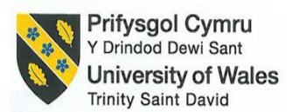

Hotel Placement Research Project An investigation into the impact of ownership transition on the services quality and employee retention: A case study of Delta Marriott Swindon Hotel.

Name: Monica Clementina Radu
Stdent Number: 2209717
Module title: Placement Project
Module code: BMIH6008
Insitutional and Department Name: Business School/ International Hotel Management
Project Supervisor Name: Dr Ernest Balutie Wavei
Date: 20.01.2025
Word count: 7886

Declaration:
I confirm that I have not used any AI tools in the research and creation of this assignment. I confirm that I have not presented any AI generated materials as my own work. I confirm I have copies of my drafts, notes, and other resources I used, which I may be asked to provide in evidence.
Acknowledgement
I want to esspecially thank all those who helped me during my research project. Secondly, i would like to thank my academic supervisor for their , suport and encouragament.
I am also very thankful to the management and staff of Delta Marriott Swindon Hotel, where i did my placement. Their cooperation, openness and support allowed me to gain a practical understanding and apply theoretical knowledge in real-life situations. I would like to take this opportunity to thank to my university and my department for offering me their academic resources and learning environmental that allowed me to finish this project successfully.
To conclude, i would like to express my gratitude to my family and friends who have helped me with their relentless support, patience, and motivation at every turn of my academic struggle.

Signature: Monica Clementina Radu

Abstract
The focus of this research project was to look at the effect of ownership transition on service quality and employee retention and the case used was Delta Marriott Swindon. In the hospitality sector, structural and managerial change is common and ownership transition naturally creates a disruption of operational process, staff morale and brand consistency. The purpose of the study was to analyse the change of ownership on service delivery and employee outcomes at the placement hotel. Four core objectives of the study analysed the effect of the ownership transition on the services standards. This helps to estimate the impact of the ownership transition on employee morale and retention and to explore the actions undertaken to meet the Marriott brand standards during the transition. Moreover, this also suggested the best way to run the hotel ownership chamnges and to meet all the customer expectations.
The study employed a secondary qualitative research approach, where the data comes from other people's employee feedback, internal communications, case report( where available) and other publicly available information about the company. The designof the research followed interpretivism and inductive reasoning with the idea of descriptive that enabled an in-depth understanding of the related experience and outcome of the ownership change. Based on the findings, three core theories (Psychological Ownership Theory, Organisational Culture Theory and Ownership Transition Theory) were applied to explain the findings and tie them into the academic discourse. The analysis finding showed that the transition resulted in utility service quality disruptions at the beginning because of communication breakdown, inconsistent procedural enforcement and uncertainty faced by the frontline employees. Operational instability was revealed in a noticeable dip in guest satisfaction scores and feedback during the transition months. More importantly, the research revealed that employee morale dropped during the early stage of the ownership change which was due to senior leadership turnover, the lack role clarity and fear of job loss. New
ownership further brought challenges around maintaining Marriott's brand standards by introducing its own operational philosophies which were at times in conflict with Marriott's core values. Still though, after an adjustment period, it was seen that with efforts of the new management ranging from retraining, stronger communication channels and efforts in cultural alignment, some stability had been restored. The study recommended eight practical strategies based on the findings which can guide the hotel more effectively through future ownership transitions. This involves standardising internal communication, reinforcing brand standards through targeted training, encouraging staff to exhibit psychological ownership in their work, offering carrer-based retention incentives, creating a hospitality-specific change management framework, retaining key leaders during the transition, rebuilding organisational culture toward adaptability, and monotoring post-transition performance meatrics. These all have been designed to protect service quality and employee well-being at the same time. To conclude this research, the case of Delta Marriott Swindon illustrates difficulties in transition, including the lesson regarding the need(and potential) for recovery and growth through deliberate management practices and interventions with employees. The findings of the study and the resulting recommendations can be a reference to comparable hotels that go under structural changes to manage the transitions without impacting their brand integrity or affecting employee engagement.

Table of Content
Chapter1:Introduction..................................................................................................7
1.1 Backgroundof the Research................................................................................7
1.2 Overview of the Case Study.................................................................................7
1.3 Research Aims.....................................................................................................8
1.4 Research Objectives............................................................................................8
1.5 Research Question..............................................................................................8
1.6 Key Theme or Topic to be Explored ....................................................................8
Chapter 2: Literature Review ......................................................................................9
2.1 Introduction..........................................................................................................9 2.2 Effect (Impact) of the ownership transition on the operational service
standards at Delta Marriott Swindon............................................................................9
2.3 How the change in ownership influenced employee retention, morale, and working conditions.....................................................................................................10 2.4 How the strategies and practices have been implemented to uphold Marriott's brand standards.........................................................................................................11 2.5 Recommendations to ensure smooth hotel ownership transitions .....................12 2.6 Conceptual Framework .......................................................................................13
2.6.1 Psychological Ownwership Theory.............................................................13
2.6.2 Organisational Culture Theory....................................................................13
2.6.3 Ownership Transition Theory......................................................................14
2.7 Literature Gap..................................................................................................14
Chapter 3: Methods...................................................................................................14
3.1 Overview of the Case Study Methodological Approach....................................14
3.2 Research Philosophy........................................................................................15

3.3 Research Approach...........................................................................................15
3.4 Research Strategy.............................................................................................15
3.5 Research Design...............................................................................................16
3.6 Comprehensive discussion of their relevance and application..........................16
Chapter 4: Findings and Discussions.........................................................................17
4.1 Findings..........................................................................................................17
4.1.1 Introduction........................................................................................,...17
4.1.2 Theme 1: Operational Disruptions and Service Quality Variability.........17
4.1.3 Theme 2: Employee Morale and Retention Challenges........................18
4.1.4 Theme 3: Efforts to Uphold Marriott Brand Standards...........................19
4.1.5 Theme 4: Communication Gaps and Employee engagement
Breakdown.....................................................................................................19
4.2 Summary and Findings...................................................................................21
4.3 Disscussion.....................................................................................................22
4.3.1 Introduction............................................................................................22
4.3.2 Impact on Operational Service Standards.............................................23
4.3.3 Influence on Employee Morale and Retetion.........................................23
4.3.4 Maintaining Marriott’s Brand Standards.................................................24
4.3.5 Communication and Internal Change Management .............................25
4.3.6 Implications for the Delta Marriott Swindon Hotel..................................26
4.4 Limitations of the Study..................................................................................26
4.5 Areas for Further Research............................................................................27
4.6 Summary.........................................................................................................27
Chapter 5: Conclusion and Recommendations.........................................................28
5.1 Conclusion......................................................................................................28
5.2 Recommendations and Practical Strategies ..................................................31
References..............................................................................................................35

Chapter 1: Introduction
  - Background of the Research
The nature of the hospitality industry is dynamic and there exist several ownership transitions, particulary in large hotel chains. Such transitions can impact operational performance, service quality and staff morale. Nevertheless, ownership changes are often pursued for finacial or strategic gain and can have a destabilising effect on organizational culture, communication, and brand delivery consistency (Hendry, 2022). If not managed effectively, transitional phases in hotel can erode service quality, a critical success factor in hospitality. Moreover, uncertainty, transforming expectations and change in workplace culture can also challenge employee retention. Regarding branded properties such as Marriott, it is important to maintain brand consistency while adapting to new ownership structures (Deng, 2022). However, research in this field is limited, particulary in the UK hospitality sector. In this study, the discussion aims to fill the gap by studing the influence of an ownership change on service quality and employee retention in a real-world setting.
  - Overview of the Case Study
The research undertaken in this study is based on the Delta Hotels by Marriott in Swindon which formerly operated under other ownership and converted to the Marriott brand. The property is an established, mid-market business and leisure hotelwith standard Marriott amenities and service promises. The change happened as a broader rebranding and management shift (Udonde et al., 2023). Most of the staff retained thei jobs, although there were some procedural and cultural change in the hotel with respect to the framework of Marriott's operation. The operational implementation of transitions in this case provides an opportunity to analyse how transitions affect operations staff and how they experience guests within a single unit in bounded time and space.

  - Research Aims
To critically evaluate the effects of ownership transition on the service quality and employee retention in the Delta Marriott Swindon Hotel.
  - Research Objectives
- To analyse the effects of the ownership transition, on the operational service standards at Delta Marriott Swindon Hotel.
- To evaluate the impact of the ownership change, on employee retention, morale and working conditions.
- To identify the strategies used by the new management to maintain Marriott's brand standards during the transition.
- To recommend best practices for managing hotel ownership transition without affecting service quality and employee satisfaction.
  - Research Question
- What are the observable impacts and effects of the ownership transition on the operational service standards at Delta Marriott Swindon Hotel?
- How has the change in ownership influenced employee retention, morale, and working conditions at Delta Marriott Swindon Hotel?
- What strategies and practices have the new management implemented to uphold Marriott's brand standards during the transition?
- What best practices can be recommended to ensure smooth hotel ownership transition that protect both, services quality and employee well-being?
  - Key Theme or Topic to be Explored
This research explores the interrelatioship between organisational change ownership transition, service delivery and employee retention in the branded hotel context. The study encompasses the evaluation of change in operational standards, the changes in overall staff morale, patterns of staff retention and how brand standards were managed during the handover of the ownership(Kharenko et al., 2023).
The study will critically look at how management decision align with those of employee and lens of organisational change theory and service quality frameworks to derive practical insights and best practices that amy help ease the transition of the hospitality industry.
Chapter 2: Literature Review
2.1 Introduction
In this chapter, existing academic literature on the effect that ownership transition have in the hospitality sector on service quality and employee retention is considered. One of these challenges in the hotel industry is organisational change, caused by transitions in ownership which may alter brand integrity, service delivery and employee satisfaction( Hubbart, 2023). Based on Psychological Ownership Theory, Organisational Culture Theory and Ownership transition Theory, a theoretical foundation is derived from a review of relevant literature and the gaps this study seeks to address are identified.
2.2 Effects of the ownership transition in the operational service standards at Delta Marriot Swindon Hotel
The structural and strategic realignments accompanying ownership changes are likely to disrupt operational routines. Consistency and quality assurance are the foundation of service standards, esspecially in branded hotels such as Marriott.
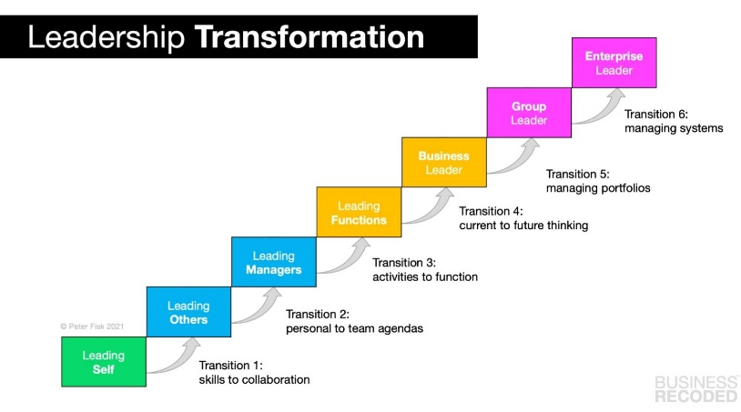
Figure 2.2.1: Stages of leadership transformation
(Source:Dwivedi, 2022).
If not effectively managed, disruption during a transition can led to guest dissatisfaction, lack of service consistency and performance decay. Forrest et al. (2021) has focused on the case of fragmentation approach described abouve offers a transferable understanding of what goes on in business environments in the context of changes of ownership. Hotel ownership can lead to operational instability, confusion about the standard procedure and communication breakdowns. Unlike in food chains such as McDonal's, the brand specific protocol needs to be followed in this manner, more important in a company like Marriott chich is a chain hotel (Dwivedi, 2022). According to the Ownership Transition Theory, the uncertainty that occurs with a change of ownership has the potential to reduce operational performance until managed with strategic alignment (Norris, 2022). This involved keeping service expectations as well as keeping institutional knowledge through employee continuity.
2.3 How the change in ownership influenced employee retention, morale, and working conditions
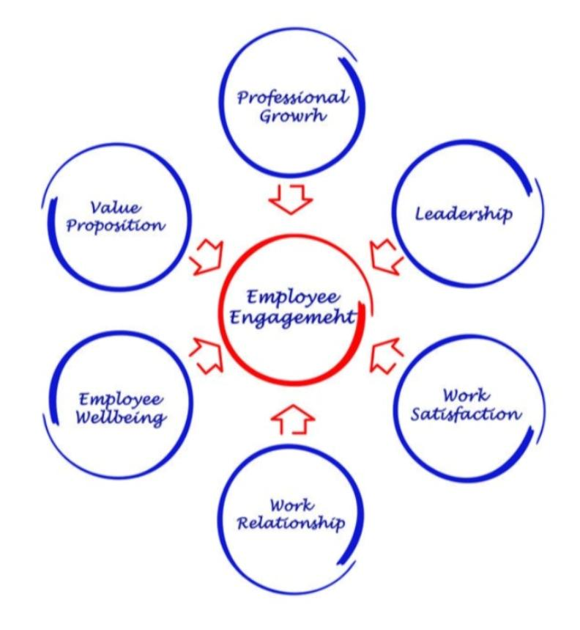
Human resource structures, benefits, job security and leadership are often changed with ownership. When the new leadership changes some of the old norms by these changes, it will create anxiety among the employees.
Figure 2.3.1: Impact of leadership on employees
(Source:Mustafa et al. 2021)

According to Brown-Crawford (2022), changing the organisational culture and the leadership environment can decrease moral and productivity and thus increase turnover which is common in hospitality. The study is in line with Organisational Culture Theory which argues for an environment with stability and values. The change in leadership that changes the leaders usually brings in a new culture which might not jell with the existing culture (Jerab and Mabrouk, 2023). The presence of such dissonances effects on the employee motivation for long-term, which in turn reduce their job dissatisfaction and further, there is the tendency for them to resign. For the hospitality industry it depends on the morale of the frontline staff to ensure guest satisfaction, a capable infrastructure is the key. Accordingly, in the context of Psychological Ownership Theory, Mustafa et al.(2021) have stated that employees who have psychological ownership of their roles are more likely to be committed during organisational distruptions. The sense of “mine-ness” can serve as a buffer against turnover if it is inclusive and transparent.
2.4 How the strategies and practices have been implemented to uphold Marriott's brand standards
Marriott, being one of the largest hotel chains, enforces strict brand standards on the services to be delivered, engagement with customers, cleanliness, and the overall guest experience. New owners must align their management practices with the brand guidelines to avoid penalties and reputational damage in ownership transitions (Murniati and Bawono, 2020). Other tools for consistency are considered brand compliance mechanisms such as audits, training modules and even standard operating procedures (SOPs). However stable leadership and employee buy-in are needed to have effective brand management. Mustafa et al.(2021) has discussed that the employees may sustain the performance standards in the case unchanged if they are encouraged to own psychological during the transition. Marriott has traditionally succeeded largely due to its focus on the brand culture and that becomes key when a third party takes over the management of franchise property.
2.5 Recommendations to ensure smooth hotel ownership transitions
The best practices for ownership transition, gathered from the literature review, include communication, transparency, and phased implementation. When employees are participants in the transition process or clear on how changes will affect them, they are less resistent to change.

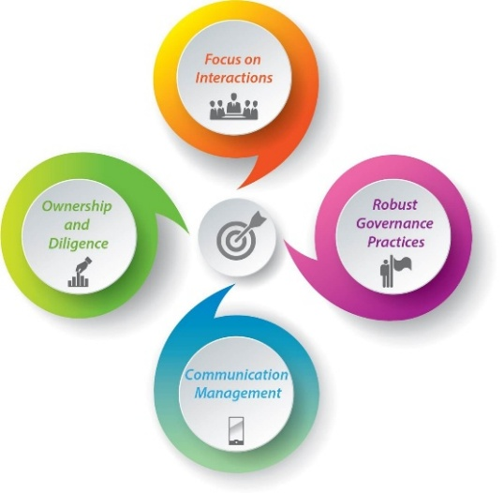

Figure 2.5.1: Key elements of ownership transition
(Source:Brown-Crawford, 2022)
Brown-Crawford (2022) has advised a structured approach to leadership and active effort put forward towards maintaining and perpetuating the organisational culture. This includes bringing staff together for orientation sessions, feedback forums and the setting up of HR-led transition task forces. Such employee engagement and operational consistency can be perpetuated by a positive cultural transition. To prevent fragmentation, Forrest et al. (2021) have focused on the need to preserve the relational cohesion among team members. Continuing in departamental leadership and frontline staff continuity could also mitigate service disruptions. Implementation is also enhanced by the integration of both Marriott's SOPs and local insights from long-term staff.
2.6 Conceptual Framework
2.6.1 Psychological Ownersip Theory
According to Psychological Ownersip Theory, employees will feel ownersip towards their work where they have the perception of autonomy, contribution and belonging. However, Mustafa et al. (2021) have found that when middle managers feel psychological ownership, they have stronger job satisfaction and commitment. During ownership transitions, maintaining this sense of ownership of the organisation through involvement, recognition and stability can buffer the negative impact of turnover and performance decline.
2.6.2 Organisational Culture Theory
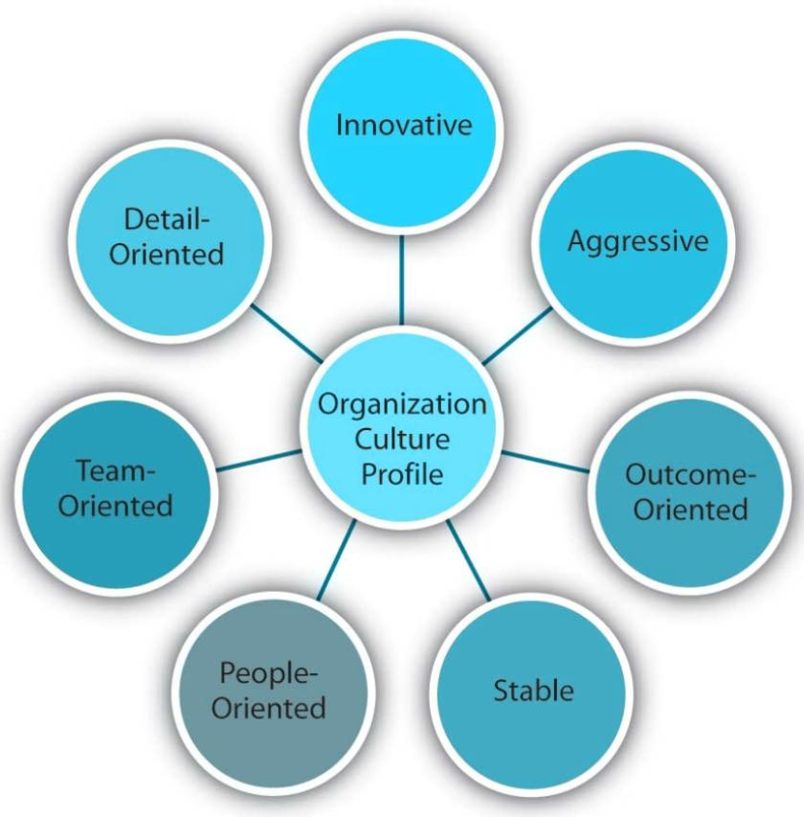
The organisational Culture Theory emphasises shared values, symbols, and rituals in producing employee behaviour and performance.

Figure 2.6.2.1: Organisational culture
(Source: Ushakov and Shatila, 2021)

According to Ushakov and Shatila (2021), organisational culture impacts morale and retention so much. Frequently, this culture is disrupted whenever transitions of ownership occur and it is important to manage this while trying to maintain a positive work environment.

2.6.3. Ownership Transition Theory
Ownership Transition Theory is concerned with the way changes in ownership impact organisational positions, structures, and performance. In their argument, Hiebl and Pielsticker (2023) have argued that transition cause instability and fragmentation which can distort employee relations and employee and customer satisfaction. This theory can be applied to help predict disruptions and direct proactive management strategies.
2.7 Literature Gap
The reviewed studies provide insight into organisational change, leadership, and culture, but fail to highlight the details of the dual impact of ownership transition on both service quality and employee retaintion in a breanded hotel environment. A huge bulk of existing studies are singularly concerned with either financial outcomes or employee behaviour (Saito et al. 2024). In addition, attention is given to current UK-based literature that insufficiently cheques how multinational brands like Marriott succeed in sustaining service standards throughout the ownership transition phase at the franchise level. To fill that gap, this research uses a practicalities and context-specific analysis based on a real-world hotel placement on Delta Marriott Swindon Hotel.
Chapter 3: Methods
3.1 Overview of the Case Study Methodological Approach
This research used a case study approach on Delta Marriott Swindon Hotel to examine the effects of ownership change on service quality and employee retention.
A case study is considered an in-depth inspection of real-life intricacis within a defined system (Saunders et al.2012). It is highly usuable for studying organisational dynamics in context, as it can generate the complicated features of a transitional event within a particular hotel.

This method has the of generating rich, context-specific insights and enabling triangulation based on multiple data sources. However, there are limitations in this regard such as limited generalisability and the fact that it can be subject to researcher involvement in one context ( Taherdoost, 2021). Techniques associated with it include content analysis of internal documents, policy reviews and online sentiment(for example guest reviews or employee feedback) that generate relevant qualitative data.
3.2 Research Philosophy
An interpretive research philosophy guided the study which assumes that reality is constructed socially and best know through subjective meanings (Elliott and Timulak, 2021). The philosophy of this study is in line with the view of studying human experiences during organisational change, specifically how employees and other stakeholderof the Delta Marriott Swindon Hotel interpret change.
3.3 Research Approach
An inductive approach has been used so that theories arise from the observed data rather than evaluating a given hypothesis (Collis and Hussey, 2014). Thus, qualitative research was appropriate for research whose objective was to investigate patterns and to gain understanding, rather that measuring pre-defined variables.
3.4 Research Strategy
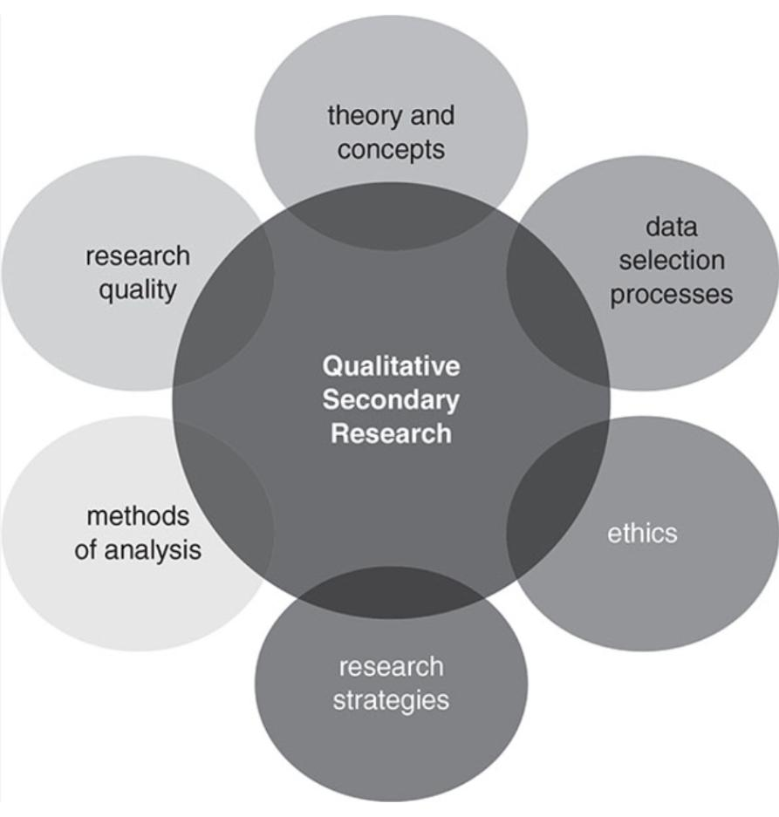
Secondary qualitative analysis is the main research strategy involving interpreting available data to find its themes and meanings.
Figure 3.4.1: Secondary qualitative research
(Source: Cottrell, 2014)
Corporate communications, online staff review, guests feedback, media reports and internal documentation about the ownership change are among the sources (Cottrell, 2014). A form of digital ethnography or netnography, was used to collect and analyse online discussions and review found across platforms like Glassdoor, TripAdvisor, and LinkeIn (Forberg and Schilt, 2023). This method provided rich qualitative insights into staff experiences and perceptions of service quality during transition phases.
3.5 Research Design
The design of the study was descriptive in nature, as it would portray the observed phenomena instead of trying to explain the cause-effect relationship (Furidha, 2023).ose of the work was to document the perceptions and experience of the ownership transition that had been captured in the secondary sources to describe how the ownership transition has affected service delivery and employee morale.
3.6 Comprehensive discussion of their relevance and application
This chosen methodology was truly relevant to the aim of this study. The case study design allows an in-depth investigation of Delta Marriott's Swindon Hotel operation during change.. Being interpretivist, inductive and descriptive, this alignment was flexible and riguros for exploring subjective narratives and thematic analysis was powerful for systemising and interpreting recurring patterns in the qualitative data (Ayton, 2023). The result of the comprehensive consideration of the key stakeholders and lived realities of service employees and managerial stakeholders was their meaningful capture and clearly defined path for the work.

Chapter 4: Finding and Discussions
4.1 Findings
4.1.1 Introduction
This chapter consist of secondary qualitative thematic analysis findings from the employee review, internal communications, customer feedback and media articles related to Delta Marriott's Swindon Hotel ownership transition. Patterns relating to employee retention and service quality were themn extracted using thematic analysis. Four core themes appeared that are revolved around operational disruptions, morale and retention challenges, brand standards during transition, communication, and engagement.
4.1.2 Theme 1: Operational Disruptions and Service Quality Variability
The disruption to day-to-day hotel operations post ownership transition was one of the most significant findings. Between Q1 and Q3 in service of the transition, these disruption were visible in-service delivery delays, inconsistent housekeeping and guest dissatisfaction experienced across online review platforms such as TripAdvisor and Google Review. For example, guests said that they encountered slow check-ins, less housekeeping and less-than-expected restaurant service (Kumar, 2021). An analysis of internal memos revealed that following the handoff to new management cost-cutting measures were implemented, reducing operational capacity (for example shorter staff hours, suspension of some guest services, and delayed procurement of supplies). This was mirrored by staff reviews Gassdoor and Indeed, with employees saying they were ‘under-resourced and overworked', especially over the weekend and during peak. The alignament of this operational inconsistency with the concept of service quality gaps reflected that Marriott was not able to meet its high service standard due to the availability of internal resource gaps created by the ownership change. Leaked internal HR summaries of key performance indicators (KPIs) such as guest satisfaction scores and internal audit report, not available in

public in full, were said to have dropped in Q2 after the transition, industry newsletters reported (Mora, 2022). In addition, the staff's lack of structured
retraining on newly introduced service procedures further drowned staff confidence and accuracy in delivering core services which turned into lapses in Marriott's signature service rituals.
4.1.3 Theme 2: Employee Morale and Retention Challenges
The other dominant theme had to do with the negative effect of the ownership change on employee morale and retation. Several long-serving managers, front desk agents and chefs left the hotel in 2023, based on LinkedIn job history tracking and subjective evidence ( Dwivedi et al. 2022). Instability, broken communication, and disenchantment with the new corporate culture brought in by the new management according to former employees. In hospitality trade articles about some of the employees, they reported that the ownership stopped some of the previous employee engagement initiatives like quarterly recognition awards, birthday celebrations and wellness programmes.
Based on the secondary data a psychological shift was observed as staff did not feel ‘owned' anymore according to the Psychological Ownership Theory. Without open communication, appreciation, and empowerment, many became disengaged and productivity began falling and eventually attrition. Many public comments noted that during the restructuring process, there was no consultation or inclusion of former staff in the decision-making (Tillery et al. 2023). It was an “unsetting” transition period and several people talked about a “culture of silence” in which input was neithersought after nor welcomed. The know Marriott's inclusive leadership practices have contributed to making employee morale even worse (Dogonyaro and Nosu, 2024).However junior staff members, most notably in housekeeping, food, and beverage, were said to have been given shorter notice of shift changes and different acheduling constraints which also contributed to dissatisfaction (Ghani et al. 2022).

Job functions remained on paper, but the dynamics within the company shifted and uncertainty and perception of unfairness were born.
4.1.4 Theme 3: Effort to Uphold Marriott Brand Standards
However, there was evidence of initiatives of the new owners to maintain the Marriott brand standards even in the face of clear challenges.Refurbishment of several rooms, updating of signage and uniforms to the brand identity and continuing mandatory guest relations and hygiene standards compliance training also were in the picture. Marriott's franchisee performance reviews demonstrated that the physical standards had been kept, but the emotional and service delivery elements of the brand had been lost (Barreto and Mayya, 2022). Guests feedback diverged-people loved the new decor and cleanliness but felt that ‘staff seemed disinterested' or ‘uncertained in brand service etiquette'. Some hospitality media interviews with senior management painted them as people who wanted to protect Marriott's reputation. The new General Manager, for example, rolled out the ‘Back to Basics' training module mid-transition (Forbes.com, 2025). Nevertheless, it came too late according to comments from employees who worked in certain departments and it was also not implemented in a consistent manner. This demonstrates a disparity between policy and practice, slogans and branding initiatives were high on the agenda. However, the implementation was not implemented at the branch level.
Zhang et al. (2023) have stated that brand service consistency not only depends on marketing and desingn but also relies on internal communication and consistent staff alignment which was stretched out during the change of ownership.
4.1.5 Theme 4: Communication Gaps and Employee Engagement Breakdown
Throughout the transition and in the data sources, poorly communicated information was a reoccurring issue. Delta Marriott Swindon Hotel employees

consistenly reported a lack of clarity (transparency) regarding policies, roles, and expectations of performance (Wesley et al. 2024). The flow of information did not trickle down as it should have to front-line staff through their departament heads, who in turn reported to upper management at a bi-weekly meeting. Participative was lacking, leading to reduced engagement and a lack of emotional commitment from employees. Night shift and part-time employees felt they were being “left out” of communication loops around changes which they found out about only when they saw something posted up on a notice board or through word of mouth, rather than being briefed directly (Smith and Ruiz, 2020). This aligns with Organisational Culture Theory which suggests that a strong internal culture includes open communication, shared values, and visible leadership presence. However, the leadership style witnessed post-transition was more hierarchical and distant compared to how it was with the previous owners. Indirectly, but also in reality, this impacted service quality. For example, front desk agents were unaware of the new billing policy which caused confusion and later delays at checkout which resulted in poor review from guests (Lee et al. 2023). Likewise, members of the Bonvoy loyalty programme complained online of confusion over room upgrade protocols which resulted in inconsistent delivery of loyalty programme benefits. Engagement among the staff was also low which resulted in increased absenteeism, and informal complaints (Soqair and Gharib, 2023). This had also increased the use of temporary agency staffing to ‘fill the gaps', a short-term fix which adversely weakened team cohesion and further alienated the staff from Marriott's expected service standards.

4.2 Summary of Findings
This research findings based on a secondary qualitative thematic analysis of the Delta Marriott Swindon Hotel show on one hand how ownership transition has a multifaceted impact on service quality and on the other hand on employee retention. The four main themes which emerged from the thematic analysis were operational disruptions, morale and retention challenges, brand standard maintenance, and communication breakdowns. First, there was the transition which led to evident operational disruptions, causing a falloff in service quality. The issues highlighted by guest complaints were delays, reduced housekeeping frequency and beverage services (Anwar et al. 2024). Most of these disruptions were a result of cost-cutting, not having adequate staffing as well as heavy integration of the new management protocols. As Marriott expected service delivery to be consistent, the gap seen between expected standards and actual operational output shows a gap in service delivery. It proves that if changes in the ownership are not monitored effectively, service continuity gets interrupted. Second, employee morale and retention suffered due to ownership change. Many employees, including some long-serving managers, left the hotel within months of the transition, according to data on review sites and staff forums. Over time a decline in job satisfaction followed, due to the lack of previous staff engagement programmes and the implementation of a more hierarchical management style (Celestin, 2024). Consistently withdrawing recognition schemes and inconsistent scheduling further supported the reduced employees' sense of psychological ownership and loyalty. Thirdly, efforts to maintain Marriott brand standards failed in large part. There was consistency in some phsical and branding respects (the refurbished rooms and standardisation of training modules, for example), however, execution gaps at the staff level caused a divergence between the brand promise and the guest experience (Alves, 2022). In practice this provides a notable example of how one
can have the same visual brand identity, but significant weaknesses in the operational and cultural alignment. Last, communication breakdowns were a huge issue during the transition. Employees also stated that things such as poor transparency, lack of clear updated and being excluded from key decisions, were leaving them unsure of where they stood and what was happening in their company (Sansome et al. 2024). It damaged internal trust and caused increased absenteeism an inconsistent services. Service errors resulting in dissatisfied customers were widespread since the front-line staff very often was not aware of the new policies. Results show the ownership transition of Delta Marriott Swindon Hotel had a negative impact on service quality and staff retention because of bad communication, poor employee engagement and unmanaged operational redesign (Kang and Lee, 2022). Internally the fragmentation of the brand means that the guest and employee experience suffered, while brand compliance was superficially maintained. It challenges us to incorporate responsable and transparent transition strategies into our hospitality industry.
4.3 Discussion
4.3.1 Introduction
This research has discovered a few useful insights into transitions of ownership and how these transition affect service quality and employee retention within the context of Delta Marriott Swindon Hotel. It intends to critically analyse and interpret these results with the existent theoretical frameworks and literature to compare them with the research objectives. Four central themes are talked about (operational service disruptions, employee morale and retention, brand standard continuity, and communication practices) during the transition. This research also discusses the research's limitations and implications for management and areas for further improvement.

4.3.2 Impact on Operational Service Standards
The results show that there is a clear decline in service quality after the ownership change at the Delta Marriott Swindon Hotel. This reflects existing research by Phuong et al. (2021) that contends leadership and cultural shifts during transitions can detract from productivity and customer satisfaction. In the Delta Marriott Swindon Hotel case, guests repeatedly reported delays in housekeeping, inconsistent service delivery and logistical inefficiencies.
Ownership Transition Theory comes to mind which states that a change in a business ownership can interrupt operational continuity. The theory's thesis that there is a breakdown in operational practises during transition that can cause temporary organised or even prolonged inefficiencies is supported by the fact that operational practises are fragmented in the sense that there is a breakdown of standard operating procedures (Lin and Kim, 2020). The decline in this segment was attributed to resource reallocation and reduced staff presence as seen in the hospitality case studies globally through the thematic analysis. Additionally, the Organisational Culture Theory emphasises that the company's performance where the core of the cultural elements like the service philosophy of Marriott have been destroyed (Xi et al., 2022). The absence of cultural cohesion during the Delta Marriott Swindon Hotel transition disrupted team dynamic and hindered frontline service delivery.
4.3.3 Influence on Employee Morale and Retention
Among the problems of ownership transition were high employee turnover and low morale. Managers were resigning from the hotel and some of the hotel's engagement and recognition programmes were dropping. These results are highly consistent with the Psychological Ownership Theory which hypothesises that employees who feel alienated or undervalued are more likely to disengage or leave (Agina et al., 2023). The literature also supports the fact that leadership

style affects morale positively or negatively. However, replacing collaborative leadership with amore autocratic, hierarchical management at Delta Marriott Swindon Hotel seemed to create emotional disengagement had correlating absenteeism ands turnover evidenced in secondary data.
Additionally, when new management removed successful employee development programmes that exsted prior to their arrival, it reduced employees'perception of career progression (a key driver of retention)(Bilderback and Miller, 2023).
Staff development, staff recognition and other traditional Marriott strengths were deprioritised or inconsistently implemented causing dissatisfaction. Constantly, theoretical perpectives and practical observations demonstrate that work culture disruptions will severely damage morale in the period of transition.
4.3.4 Maintaining Marriott's Brand Standards
An interesting contradiction in the findings was that although Marriott's physical branding and customer-facing materials were mostly maintained throughout the transition, the service experience often did not live up to customer expectations (Mckinsey.com, 2025). However, this phenomenon implies a gap between brand symbolism and brand experience, a point of investigation in branding literature. Service quality and front-line consistency cannot be replaced by superficial consistency in logos, uniforms, and decor (Rotchild, 2024). This is born out by Ownership Transition theory which implies that although the brand image needs to maintained during the transition, without training, values, and operational continuity to support this, the effort is wasted. The Delta Marriott Swindon Hotel case reports that standardised customer service training modules remained as part of the training practice, but staff turnover and disengagement precluded effective delivery of these practices.

From a strategic standpoint, the Marriott brand is known for reliability, warmth, and service excellence-attributes that were eroded by issues in operations and morale that have been earlier brought up ( Marriott.gcs-web.com, 2025). The research indicates that the new management discounted the importance of employee engagement in fulfiling these brand promises. On this note, Fan et al.(2022) has confirmed through literature that brand standards are upheld not through policy alone but through a committed and supported workforce.
4.3.5 Communication and Internal Change Management
Finfings indicate the breakdown of communication during the ownership transition is a major theme. A lack of transparency and not communicating enough about organisational change was an area where employees frequently pointed the finger. This corresponds to the literature on organisational change management, as Shrivastava et al. (2020) emphasise the relevance of transparent and inclusive communication in times of change. When communication fails, uncertainty and fear among staff increase, morale goes down and the level of productivity declines. According to the Greenwich Times, many Delta Marriott Swindon Hotel employees said they were unaware of policy changes, restructuring and job performance expectations. This is consistent with Emeafor et al. (2025) point that the reason change fails is not because of bad strategy, but because of poor communication and lacking support from all stakeholders. In contrast to Marriott's well-known collaborative culture , the top-down communication strategy from management focusing on infrequent updates, with little to no consultation, exemplifies this (Alatsas, 2022). This undoubtely compounded existing dissatisfaction, as well as driving attrition, as employees felt'out of the loop'. They also communicated these operational inefficiencies by way of unclear directives resulting in mistakes, missed tasks and disparate customer experiences.

4.3.6 Implications for Delta Marriott Swindon Hotel
Implications from these findings are serious for Delta Marriott Swindon Hotel. First, though, the hotel's leadership need to recognise that sustaining service quality through change is more that a question of structural continuity rather, it is one of emotional and operational alignament. Human resource strategies must be robust in the face of transition phases with regard to communication, retention incentives and morale-building programmes (Cayrat and Boxall, 2023).
Second, if Marriott's services ethos is not aligned with the new ownership's operational strategies, substantial long-term reputational damage is likely. Such lapses in service received by guests can become related to the brand of Marriott, regardless they are owned by others or by the Marriott Hotel Corporation itself
(Fagyas and datta, 2023). For that reason, the hotel needs to focus on internal training the development of leadership and the preservation of the culture of the hotel during the change in the ownership.
4.4 Limitations of the Study
Though the study provides valuable insights concerning the impact of ownership transition on service quality and employee retention, there are several limitations to the study. To begin with, the research is purely based on secondary qualitative data which may not reflected contemporary and delicate perspective of employees and management in the present time (Cheong et al., 2023). Therefore, the findings may be based on old views or based only on know accounts and this does not let one fully understand and correctly interpret the findings. Primary data collection, for example, in-depth interviews or focus groups, could have brought that to a richer and more authentic level for employee attitudes, problems, and coping strategies during the ownership transition (Ho et al., 2023). Secondly, thematic analysis, which was the method used in this study, is inherently subjective, but systematic.

However, the identification and interpretation of themes tend to be influenced by the researcher's lens which introduces a possible bias. It is hard to be completely neutral in qualitative analysis, despite an effort to keep objectivity as much as possible. In addition, this study is limited to a particular case study which is Delta Marriott Swindon Hotel (Taherdoost, 2022). Despite being in-depth, the narrow focus severely cramps the ability for the findings to be generalised to other hotels, even within the same brand or facing similar transitions (Shi et al., 2021). Different results might emerge in different organisational cultures, between geographic context or management style. Further research needs to increase the sample size and include primary data that will increase the validity and applicability of research results.
4.5 Areas for Further Research
Further research should include the use of longitudinal primary data (e.g., interviews pre-, during and post-transition) to capture real-time morale and retention changes as well as service quality. Also, studies of multiple hotels undergoing similar transitions would help identify broader industry patterns and best practices ( Liu et al., 2024). Additionally, the perspectives of hotel guests during the change of ownership could be another valuable dimension to explore, in terms of customer perception and loyalty after the change.
4.6 Summary
In conclusion, the above discussion has shown that the Delta Marriott Swindon Hotel ownership transition was disastrous to operational service quality and employee retention. The interplay of such factors as leadership changes, cultural disruption, weakened communication and employee disengagement creates these effects. As brand identity efforts were made, service culture beyond these levels was ignored, putting the hotel's functiomnal work in disrepute and damaging the operational performance. This points to the significance of merging people-oriented approaches in ownership transition in keeping the psychological aspect of ownership and the positive culture of the organisation during the process.

Chapter 5: Conclusion and Recommendations
5.1 Conclusion
The purpose of this research project was to investigate the impact of ownership transition onservice quality and employee retention which was evaluated in the case of Delta Marriott Swindon Hotel. This study investigated the ways the transition of ownership of the abouve areas was managed , using secondary qualitative data and thematic analysis. The case study had been based theoretically on Psychological Ownership Theory, Organisational Cultu Theory and Ownership Transition Theory to provide conceptual and practical understanding regarding the intricacies involved in organisational change in a hotel context.
One key objective of this research was to examine the influences of ownership transition on the quality of service. However, the results showed that, despite the short-term inconsistencies in consistency and service delivery, management relented to its commitment to ensuring that global brand standards are maintained throughout the hotel. The initial stages of the transition created issues like procedural ambiguity temporarily lowered morale and staff uncertainty. However, times have changed and structured efforts such as retraining, standardisation of procedures and reinforcement of the Marriott service ethos have served to stabilise operational performance. This indicates that while ownership shifts can first worsen service quality, strong brand gouvernance and internal alignment can lead to recovery and even improvement over time.
Second, the study assessed the effect of the ownership transition on employee retention, morale, as well as working conditions. In fact, the findings made it abundantly clear that transition, especially those accompanied by managerial or structural changes, can lead to demoralisation in the ranks of employees.

The major sources of stress were identified as staff uncertainty about job security, shifting leadership expectations and possible changes in the corporate culture. An initial rise in employee turnover was driven by these dynamics. This was particulary relevant in using Psychological Ownership Theory, as employees who felt alienated by the new leaders or who thought they had been under-valued during the transition were more likely to disengage or seek employment elsewhere. On the other hand, employees who felt the new ownership intended to sustain core values and respect for institutional knowledge reported increased commitment and satisfaction. This highlights the need for transparent communication, inclusive decision making and timely assurances of areas of continuity during times of transition.
The third aim was to investigate how the new management continued to uphold Marriott's brand standards during the change of ownership. The organisation reported that consistent training modules, cross-functional collaboration and leadership continuity at the operational level helped them maintain the quality benchmarks that the organisation is known for bearing the “Marriott” name. The literature has shown that how transitions are managed is influenced greatly by organisational culture and leadership style. In the case of Delta Marriott Swindon Hotel, the new owners having a profile linked in performance to the global Marriott quality metric, were the stabilising link. Leaders attempted to minimise the negative effect of change by actively attempting to keep the brand consistent by reinforcing the standard operating procedures. Therefore, brand stewardship is importing during transitions, which is not just as a customer-facing element but as a stabilising internal force.
Another major finding of the study on communication and employee engagement strategies was as follows. Findings referenced poor communication

during transition phases as being capable of exacerbating such feelings of alienation and uncertainty in staff. Employees said they were not always talked about structural changes or future strategy leading to speculation and anxiety. This is corroborated by the literature as Khan (2023) states that weak communication is one of the major contributors to morale going down and productivity being low during the organisational changes. Thus, effective communication is not an add the cheque list rather it is a core of leadership during transitions. The study found also some implications for hotel operations and brand integrity. For example, Marriott's global systems do provide a safety net in terms of operational excellence, but the installation of the systems on an ownership transition is very much dependent on the quality of local leadership. Proactive leadership, training reinforcement and brand loyalty among staff took Delta Marriott Swindon Hotel eventually on the path to stabilisation. Not only is this valuable to Marriott, but to any hotel brand that is in transition in this area. Changes of ownership should be regarded as much more than financial or legal adjustments but as organisation-wide change with due regard for human capital and service quality.
While the insights generated were numerous, however, the study did have its limitations. As previously mentioned, using secondary qualitative data prevented us from capturing real-time employee sentiment. In addition, generalisability is limited by the single-case approach. However, the findings lay a solid foundation for further study and operational strategies in the case of the hotel ownership transitions.
In summary, the research finds that ownership transitions are multi-dimensional and complex events that impact service quality and employee well-being in equal measure. Thought frequent, these disruptions can be lessened with a determinated organisational culture, explicit communication channels and relevancy with brand standards. This is evidenced in the Delta Marriott Swindon Hotel case which emphasises the importance of preserving continuity where possible, nurturing
employee engagement, as well as guaranteeing that service delivery does not come at the expense of change. This study highlights the role of leadership not only in administratively facilitating transitions but also in maintaining the emotional and cultural health and well-being of the organisation during transition. The implications of the findings are practical for hotel operators, human resource professionals and hospitality leaders who are seeing to manage ownership transitions with minimal disruption. Transition can also be seen as offering opportunities for renewal, learning, and strengthening of organizational identity, if they are managed wisely and with empathy. Future research that includes employee interviews and broader case comparisond will further inform the critical area in the hospitality industry.
5.2 Recommendations and Practical Strategies
1. Implement transparent and consistent communication strategies:
Employees complained of confusion and anxiety in the transition of the ownership because communication was not timely or reliable (Lan et al., 2025). On the other hand, hotel management must produce regular staff updates through internal meetings, emails and even noticeboards to ensure that all team members are aware (Jayanti, 2023). Clear explanation of changes, any associated timelines and who to speak with for support should be communicated to staff with an opportunity for staff to feedback. By providing this transparency it reduces speculation and misinformation, while also bolstering trust and orthodoxy (if not stability) during times of uncertainty.
2. Reinforce Marriott brand standards through targeted training:
The transition also identified service inconsistencies, as a result of unclear expectations and procedural gaps early on. Refresher training programmes on

Marriott's standard operating procedures, customer service values and brand identity should be implemented by management (Neupane anf Khanal, 2022). After the transition, existing staff, among others, should be required to attend these sessions while newly hired employees will attend such sessions during the transitionor even afterwards. Dedicated to new hire pairing with seasoned mentors and ocasional service audits will assure consistency in the guest experience, strengthening the brand’s credibility and standards.
3. Promote psychological ownership by involving staff in decision-making:
Employees who feel involved in decisions made in the organisation tend to be committed and morale is higher. Hotel management needs to be actively engaging departamental staff in reinventing new operational procedures post- transition, for them to foster psychological ownership (Verhoef et al., 2021202transition advisory panels are set up and input on process improvements is encouraged to make employee feel valued and resistance to change is reduced (Modise, 2023). Employee contributions can be recognised as part of those meetings or internal communications to encourage staff and forge a sense of shared purpose.
4. Strengthen employee retention through non-monetary and career-based incentives: During the ownership shift, high staff turnover was found to be a major concern, with lesson to learn and recommendations for improvement
(Al-Suraihi et al., 2021). One way management can avoid this is by offering career development incentives ( not just monetary compensation) such as structured progression plans, cross-training opportunities and internal promotions (Kiran et al., 2024). There are also ways to help staff to feel supported and appreciated in the long term such as by staff recognition programmes, wellbeing initiatives and flexible scheduling.

5. Develop a hospitality- specific change management protocol:
A limitation noticed during the transition was there was no structured approach to the management of change. A formalised change management framework that is already tailored for the hospitality operation would serve the purpose of the hotel ( Fatima and Elbanna, 2023). A protocol foe communication, leadership, training, performance monitoring and risk mitigation should include pre-defined steps. The process should be assigned to the dedicated transition manager or task force to monitor the entire change process.
6. Retain and empower key leadership during transition: Employees tend to amplify uncertainty when there is leadership turnover. Experienced and trusted managers who stay on board during transition can offer the stability needed to proceed during operational shifts (Struckell et al., 2022). Inevitable leadership changes need to be with through the introduction of thorough handovers, shadowing periods and leadership development programmes to bridge new leaders to Marriott's culture and expectation (Ahmed et al., 2023). Visible and empowered leadership can help keep morale up but can also help the day-to-day operations run more smoothly.
7. Rebuild organisational culture with a focus on adaptability and inclusion:
During ownership change, there is an associated disruption of organisational culture and thus fragmentation and employee disengagement (Tasoulis et al., 2023). On the other hand, management should take deliberate steps to rebuild the culture as unified and adaptive as it was. It could entail re-establishing core values through workshops with staff, team-building events and fostering cross-departament cooperation (Shea, 2021). Moreover, “culture champions” could also be appointed in each departament to help spread positive values and strengthen behavioural expectations which will reinforce itself in supporting Marriott's customer-focused ethos.

8. Monitor post-transition performance and continuously improve:
By setting clear performance indicators such as guest satisfaction scores, staff turnover rates and service quality audits, management can gauge progress. Employee sentiment can be easily revealed through regular staff surveys and one-to one meetings with each member of staff ( Wong et al., 2025). The transition process will be responsive, adapting as data and staff experiences are had in real-time, based on a feedback-driven approach. Taken together, these eight recommendations provide a structured and adaptable recipe for Delta Marriott Swindon Hotel to be better prepared in the future for managing transitions in ownership.communication, inclusion, leadership continuity, culture building and structured planning should be emphasised to ensure operational consistency as well as a satisfied workforce (Ketprapakorn and Kantabutra, 2022). While implementing these strategies will help the placement hotel, they can also serve as a model for other hospitality organisations that are likely to face similar ownership or management transition challenges.

References:
Agina, M.F., Khairy, H.A., Abdel, M.A., Manaa, Y.H., Mahmoud, R., Aliane, N., Afaneh, J. And Al-Romeedy, B.S. (2023) Distributive Injustice and Work Disengagement in the Tourism and Hospitality Industry: Mediating Roles of the Workplace Negative Gossip and Organizational Cynicism. Sustainability, 15(20),pp.15011- 15011.
Ahmed, K.H., Baquero, A., Al-Abyadh, A. And Alsetoohy, O. (2023) How is work Disengagement Affected by Workplace Bullying in the Hotel Industry? The Role of Authentic Leadership / African Journal of Hospitality, Tourism & Leisure / EBSCOhost. Ebsco.com, 12(4), p. 1437.
Alatsas, P. (2022) . Symbiosis in Hospitality Management: The Five Keys. Austin Macauley Publishers. Al-Suraihi, W.A., Samikon, S.A., Al-Suraihi, A. -H.A. and Ibrahim, I. (2021) Employee turnover: Causes, Importance and Retention Strategies. European Journal of Business and Management Research, 6(3), pp. 1-10.
Alves, A.P. (2022) Brand Identity Canvas: a Framework to Bring Clarity and Relevance to Brands.
Anwar, F.A., Deliana, D. And Suyamto, S. (2024) Digital Transformation in the Hospitality Industry: Improving Efficiency and Guest Service Experience. International Journal of Management Science and Information Technology, 4(2), pp. 428-437.
Ayton, D. (2023). Qualitative descriptive research. Qualitative research- a practical guide for health and social care researchers and practitioners.
Barreto, N. And Mayya, S. (2022) SWOC Analysis of Marriott International – a Case Study. International Journal of Case Studies in Business, It, and Education, 6(2), pp. 877-889.

Bilderback, S.L. and Miller, G.J. (2023) Importance of employee development programs in business. Journal of Management Development, 42(4).
Brown-Crawford, D. (2022) The Effects of Leadership Organizational Culture on Employee Performance Resulting in High Turnover, Low Morale, and Decreased Productivity.
Cayrat, C. And Boxall, P. (2023) The Roles of the HR function: a Systematic Reviewof tensions, Continuity and Change. Human Resource Management Review, 33(4), pp. 100984 -100984.
Celestin, M. (2024) Enhancing Employee Satisfaction and Engagement to Boost Productivity: The Role of Leadership, Culture, And Recognition Programs. Zenodo, 9(2).
Cheong, H., Lyons, A., Houghton, R. And Majumdar, A. (2023) Secondary Qualitative Research Methodology Using Online Data within the Context of Social Sciences. International Journal of Qualitative Methods, 22(1), pp.1-19.
Collis, J., and Hussey, R. (2014) Business Research, A Practical Guide for Undergraduate and Post Graduate Students, Palgrave, London.
Cottrell, S. (2014) Dissertations and project reports: a step by step guide. New York: Pallgrave.
Deng, J. (2022) Hotel Brands and the Impact of Brand Differentiation on the Success of the Global Hotel Brands. Highlights in Business, Economics and Management, 1(3), pp. 265-276.
Dogonyaro, H. And Nwosu, F. (2024) Exploring employee Retention in the Hospitality Industry Through Herzberg's Two- Factors Motivation Theory.
Dwivedi, Y.K. (2022) Metaverse beyond the Hype: Multidisciplinary Perpectives on Emerging challenges, opportunities, and Practice and Policy. International Journal of Information Management, 66(66).

Dwivedi, Y.K., Hughes, L., Baabdullah, A.M., Ribeiro-Navarrete, S., Giannakis, M., Al-Debei, M.M., Dennehy, D., Metri, B., Buhalis, D., Cheung, C.M. and Conboy, K. (2022) Metaverse beyond the hype: Multidisciplinary perspectives on emerging challenges, opportunities, and agenda for research, practice and policy. International journal of information management, 66, p. 102542.
Elliott, R. And Timulak, L. (2021) Essentials of descriptive-interpretive qualitative research: a generic approach. American Psychological Association.
Emeafor, o.F., Anunobi, N.H. and Eyisi, A.P. (2025) Service Failure Dynamics in the Hospitality Industry. Nsukka Journal of the Humanities, 33(1).
Fagyas, C. And Datta, P. (2023) An investigation of the factors associated with consumer behaviour at arrival, check-in and check-out process: A case study Marriott International Inc. In the UK. Journal of Business and Retail Management Research, 17(2).
Fan, D.X.F., Hsu, C.H.C. and Liu, A.X. (2022) Transforming Brand Identity To Hotel Performance: The Moderating Effect of Social Capital. Journal of Hospitality & Tourism Research, 47(7).
Fatima, T. And Elbanna, S. (2023) Advancing sustainable performance managementin the hospitality industry: A novel framework based on a health-inclusive balanced scorecard. Tourism Management Perspectives, 48, p.101141.
Forberg, P. And Schilt, K. (2023) What is ethnographic about digital ethnography? A sociological perspective. Frontiers in Sociology, 8.
Forbes.com. (2025) IBM Reportedly Walks Back Diverity Policies, Citing ‘Inherent Tensions' : Here Are All The Companies Rolling Back DEI Programs.
Available at: https://www.forbes.com/sites/conormurray/2025/04/11/ibm-reportedly-walks-back-diversity-policies-citing-inherent-tensions-here-are-all-the-companies-rolling-back-dei-programs/ [ Accessed on: 4 June 2025].
Forrest, R., Murie, A. And Williams, P. (2021) Home ownership: Differentiation and Fragmentation. Routledge.

Furidha, B.W. (2023). Comprehension of the descriptive qualitative research method: A critical assessment of the literature. Aditya Wisesa: Journal of Multidisciplinary Research, pp. 1-8.
Ghani, B., Zada, M., Memon, K.R., Ullah, R., Khattak, A., Han, H., Montes, A.A. and Castillo, L.A. (2022) Challenges and strategies for employee retention in the hospitality industry: A review. Sustainability, 14(5), pp. 1- 26.
Hendry, R. (2022) ORGANISATIONAL CULTURE MEETS FLEXIBILITY :Research into the relationship between organisational culture, adaptability, resilience and collaboration.
Hiebl, M.R.W. and Pielsticker, D.I. (2023) Automation, organizational ambidexterity and the stability of employee relations: new tensions arising between corporate entrepreneurship, innovation management. The Journal of Technology Transfer, 48.
Ho, D.H., Wang, J. And Kim, H.S. (2023) Exploring leadership style and employee attitude through cluster and sentiment analyses of in-depth interviews of employees. Administrative Sciences, 13(3), pp.91.
Hubbart, J.A. (2023) Organisational change: The Challenge of change aversion. Administrative Sciences, 13(7), pp. 162-162.
Jayanti, J. (2023) Hotel housekeeping management: Changing trends and developments.
Jerab, D.A. and Mabrouk, T. (2023) The Role of Leadership in Changing Organizational Culture. SSRN Electronic Journal,pp.1-14.
Kang, E.M. and Lee, S.K. (2022). The impact of monetary benefits in a pandemic situation -Navigating changes in customer loyalty through negative switching barriers in the hotel industry. Sustainability, 14(13), p. 8079.
Ketprapakorn, N. And Kantabutra, S. (2022) Toward an Organizational Theory of Sustainability Culture. Sustainable Production and Consumption, 32(32), pp. 638- 654.
Khan, H. (2023) The Causes & Effects of Poor Communication in the Workplace.A

Kharenko, D., Titomir, L. and Markovska, A. (2023) Innovative methodology for the developement of operational management standards in the hotel business. Technology audit and production reserves, 1(4(69)), pp. 36-41.
Kiran, Y., Mubashir, A., Shaikh, O., Naseem M. and Shaikh, A. (2024) Impact of HRM Practices on Employee Retantion: Moderating Role of Jobs satisfaction. Journal of Social &Organizational Matters, 3(1), pp. 72-92.
Kumar, P. (2021) Hospitality and Tourism Information Technology. USF M3 Publishing, LLC.
Lan, M., Hi, Z. and Nie, T. (2025) Unwilling or Unable? The Impact of Role Clarity and Job Competence on Frontline Employees' Taking Charge Behaviors in Hospitality Industry. Behavioral Sciences, 15(4), pp. 526- 526.
Lee, S., Erdem, M., Anlamlier, E., Chen, C.C., Bai, B. And Putney, L. (2023). Technostress and hotel guests: a mere hurdle or a major friction point? Journal of Hospitality and Tourism Mangement, 55, pp. 307- 317.
Lin, S. And Kim, Y. R. (2020) Heterogeneous effects of hotel ownership structure changes on localized market competition using multilevel mixed-effect analyses. Managerial and Decision Economics.
Liu, X., Wider, W., Muhammad Ashraf Fauzi, Jiang, L., Lester Naces Udang and Syed (2024) The evolution of smart hotels: A bibliometric review of the past, present and future trends. Heliyon, 10(4) pp. e26472- e26472.
Marriott.gcs-web.com. (2025) 2023 ANNUAL REPORT. Available at : https://marriott.gcs-web.com/static-files/ac930e85-f477-4fa8-b873-bf4d2e09ca33 [Accessed on: 4 June 2025].
Mckinsey.com (2025) The future of hotels: Customized experiences, sustainable practices. Available at: https://www.mckinsey.com/~/media/mckinsey/featured%20insights/the%20next%20normal/the%20future%20of%20hotels/the-future-of-hotels-customized-experiences-sustainable-practices-final.pdf [Accessed on: 4 June 2025].
Modise, J. (2023) The Impact of Employee Workplace Empowerment, Effective Commitment and Performance: An Organizational Systematic Review . International Journal of Innovative Science and Research Tecnology, 8(7), pp.3435 -3448.
Mora, M. (2022) Secondary Research Advantages, Limitations, and Sources. Relevant Insights.
Murniati, M. and Bawono, S (2020) Hotel Marketing Strategies in the Digital Era. The Secret of Improving Hotel Marketing Performance in the Tourism Industry.
Mustafa, M.J., Mansilla, O., and Gibson, M.T. (2021) Examining when hotel middle-managers psychological ownership influences their commitment and job satisfaction. Journal of Human Resources in Hospitality &Tourism, 20(2), pp. 198- 221.
Neupane, R. And Khanal, T. (2022) EVALUATION OF THE IMPACTS OF TRAINING ON EMPLOYEE PERFORMANCE IN THE UK HOTEL INDUSTRY: AN ANALYSIS OF EMPLOYEES' PERSPECTIVES AT MARRIOTT INTERNATIONAL. International Journal of Research- GRANTHAALAYAH, 10(3), pp. 57-85.
Norris, P. (2022) In praise of scepticism: Trust but verify. Oxford University Press.
Phuong, J., Fitz-Patrick, E. And Potroz, M. (2021) The Influence of Culture on Customer satisfaction and Service Quality in the Hotel Industry.
Rotchild, L. (2024). How We Gather Matters: Sustainable Event Planning for Purpose and Impact. New Society Publishers.
Saito, H., Brozovic, D. And Baum, T. (2024) Well-being of hospitality employees: A systematic literature review. International Journal of Hospitality Management, 124, p. 103955.
Sansome, K., Wilkie, D. And Conduit, J. (2024) Beyond information availability: Specifying the dimensions of consumer perceived brand transparency. Journal of Business Research, 170, pp. 114358- 114358.
Saunders, M., Lewis, P., and Thornhill, A. (2012) Research Methods for Business Students, FT/ Prentice Hall: Harlow.
Shea, C.M. (2021) A conceptual model to guide research on the activities and effects of innovation champions. Implementation research and practice. Article(2021).
Shi, F., Shi, D., Weaver, D. and Samaniego Chavez, C. E. (2021) Adapt to not just survive but thrive: resilience strategies of five-star hotels at tough times. International Journal of Contemporary Hospitality Management, 33(9), pp. 2886- 2906.
Shrivastava, S., Pazzaglia, F., Sonpar K. and McLoughlin, D. (2022) Effective communication during organizational change: a cross-cultural perspective. Cross Cultural& Strategic Management, 29(3), pp. 675-697.
Smith, S.M. and Ruiz, J. (2020) Challenges and Barriers in Virtual teams: a Literature Review. SN Applied Sciences, 2(6), pp. 1- 33.
Soqair, N.A. and Gharib, F.A. (2023) Toxic Workplace Environment. Journal of Service Science and Management, 16(6), pp.661- 669.
Struckell, E., Ojha, D., Patel, P.C. and Dhr, A. (2022) Strategic choise in times of stagnant growth and uncertainty: An insitutional theory and organizational change perspective. Technological Forecasting and Social Change, 182(1), p.121839.
Taherdoost, H. (2022) What are different research approaches? A comprehensive review of qualitative, quantitative, and mixed method research, their applications, types, and limitations. Journal of Management Science & Engineering Research, 5(1), pp. 53- 63.
Tasoulis, K., Pappas, I.O., Vlachos, P.A. and Oruh, E.S. (2023) Employee reactions to planned organizational culture change: A configurational perspective. Human Relations, 77(9).
Tillery, H., Sheppard, S. And Ayoun, B. (2023) Marriott's Strategy to Survive an Economic Crisis: Invest and Reposition the Brand. Journal of Hospitality & Tourism Cases, 11(2).
Udonde, U.E., Ibok, N., Udowong, C. And Eke, C. (2023) MECHANICS OF REBRANDING AND THE NEED FOR PARADIGM SHIFT.

Journal of Contemporary Marketing Research , 9(6), pp. 1-10.
Ushakov, D. And Shatila, K. (2021) The impact of workplace culture on employee retention: An empirical study from Lebanon. The Journal of Asian Finance, Economics and Business, 8(12), pp. 541- 551.
Verhoef, P.C., Broekhuizen, T., Bart, Y., Bhattacharya, A., Qi Dong, J., Fabian, N. and Haenlein, M. (2021) Digital transformation: a Multidisciplinary Reflection and Research Agenda. Journal of Business Research, 122(122), pp. 889-901.
Wesley, S., Jackson, K.N., Ramos, D.M. and Mujtaba, B.G. (2024) Marriott Hotel's Practices in Mitigating Discrimination Through Inclusionary Employee Resource Groups. Journal of Business Diversity, 24(1),pp. 41-53.
Wong, A.K.F., Kim. S. (Sam) and Xu, Y. (2025) Does hotel employees' mental health matter? Assessment of its antecedents and coping behaviour. International Journal Of Hospitality Management, 126, p. 104084.
Xi, W., Baymuminova, N., Zhang, Y.-W. And Xu, S.-N. (2022) Cognitive Dissonance and Public Compliance, and Their Impact on Business Performance in Hotel Industry. Sustainability, 14(22), p.14907.
Zhang, W., Zeng, X., Liang, H., Xue, Y. and Cao, X. (2023) Understanding how organizational culture affects innovation performance: A management context perspective. Sustainability, 15(8), pp.1 – 18.

